# ELE 613

# Switch Mode Power Supply

# Homework 2

## Problems:

Figure 1 Step-down/Up dc-dc (Buck-Boost) Converter

At Figure 1, Buck-Boost Converter circuit schematic is shown . Buck-Boost converter can regulate voltage in higher or lower output voltage than input. The output voltage is negative-polarity.

Nominal Values are shown in Table 1.

Table 1 Nominal Values of Circuit Parameters

|  |  |
| --- | --- |
| Parameters | Values |
| $$V_{d}$$ | $$8.5 V_{dc}$$ |
| $$L$$ | $$10μ H$$ |
| $$r_{L}$$ | $$10mΩ$$ |
| $$C$$ | $$100μ F$$ |
| $$R_{load}$$ | $$8Ω$$ |
| $$f_{s}$$ | $$100 kHz$$ |
| $$D$$ | $$0.75$$ |

In steady state, average voltage of inductor in one period is zero and average capacitor current in one period is zero, too.

The inductor voltage and current, the output voltage and current, the capacitor current observed in one period is enough to deduce the characteristic of the converter.

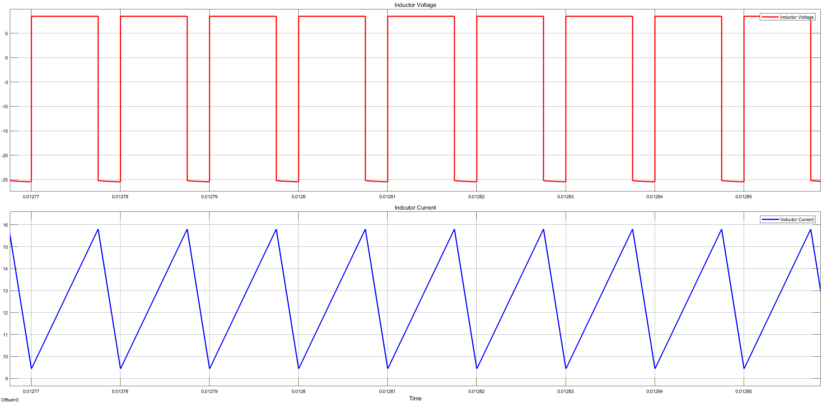

Figure 2 Inductor Voltage and Current Waveform

At Figure 2 shows the inductor current and voltage waveforms. From the waveform, non-zero inductor current, it is understood that the converter works in CCM (Continuous-Conduction Mode). In addition, the voltage of ınductor has no DC components in steady state. (Voltage-Second Balance)

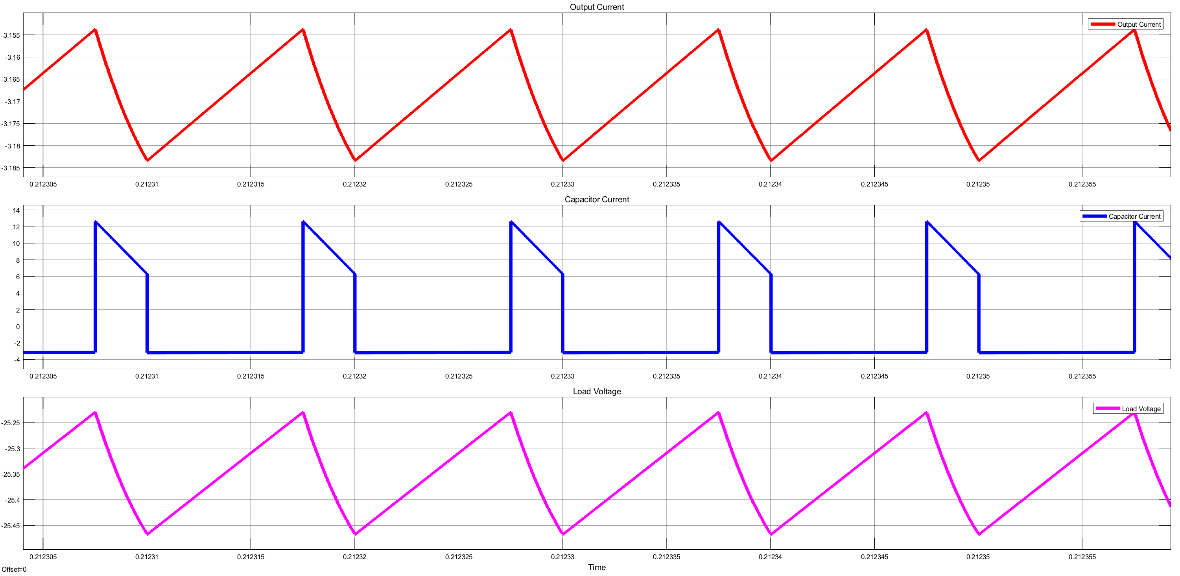

Figure 3 Output Voltage, Current and Capacitor Current Waveform

As can be seen Figure 3, the output voltage and current have the same waveform because of only resistive load and the capacitor current has no DC components in steady-state.(Charge-Second BaLance )

In CCM mode, the output voltage is directly calculated by using input voltage and duty cycle if the parasitic components are ignored.



$$V_{o}=\frac{-D}{1-D}V_{in}$$

At buck-boost converter, diode carries the average of the output current because the output capacitor cannot transfer dc current at steady state. Thus, the DC components of diode current is equal to output current.

To obtain diode current by means of Fourier analysis, the fundamental of diode current is chosen as switching frequency. In addition, resolution of FFT is chosen as 1kHz by using 100 cycles of fundamental period.



Figure 4 Diode current Waveform

Table 2 Harmonic Components of the Diode Current

**Simulink FFT Tool :**

Sampling Time: 1e-08 s

Sample per Cycle= 1000

DC Component = 3.169

Fundamental = 5.716 peak

THD= 247.73 %

|  |  |  |  |
| --- | --- | --- | --- |
| Frequency | Harmonic coefficient | Percentage wrt DC | Real Value |
| 0 Hz | DC | 100 | 3.169 A |
| 100 kHz | Fundamental | 180.34 | 4.042 Arms |
| 200kHz | 2nd | 128.47 |
| 300kHz | 3rd | 63.03 |
| 400kHz | 4th | 15.94 |
| 500kHz | 5th | 37 |
| 600kHz | 6th | 42.32 |
| 700 kHz | 7th | 26.22 |
| 800 kHz | 8th | 8 |
| 900 kHz | 9th | 20.89 |
| 1000 kHz | 10th | 25.37 |
| 1100 kHz | 11th | 16.42 |
| 1200 kHz | 12th | 5.36 |
| 1300 kHz | 13th | 14.65 |
| 1400 kHz | 14th | 18.11 |
| 1500 kHz | 15th | 11.88 |
| 1600 kHz | 16th | 4.06 |
| 1700 kHz | 17th | 11.33 |
| 1800 kHz | 18th | 14.08 |
| 1900 kHz | 19th | 9.26 |
| 2000 kHz | 20th | 3.28 |
| 2100 kHz | 21st | 9.28 |
| 2200kHz | 22nd | 11.51 |
| 2300kHz | 23rd | 7.55 |
| 2400kHz | 24th | 2.77 |
| 2500kHz | 25th | 7.88 |
| 2600kHz | 26th | 9.73 |
| 2700kHz | 27th | 6.35 |
| 2800kHz | 28th | 2.40 |
| 2900kHz | 29th | 6.86 |
| 3000kHz | 30th | 8.43 |



Increasing load resistance causes the light load for converter and it can make the converter pass to DCM mode. If the inductor current crosses the zero, the converter works in DCM mode. It disturbs the relation between output and input.

Figure 5 shows the inductor current and voltage waveform for resistive load with 80 ohm.

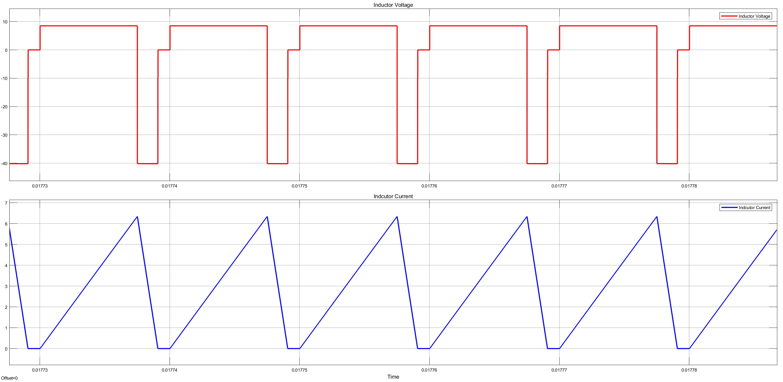

Figure 5 Inductor Current and Voltage Waveform in DCM Mode

Analytically, the relation between output and input does not depend on only duty cycle. For both volt-second law and charge-second law should be used to calculate the relation. The relation is shown at

$$D=V_{o} \sqrt{\left(\frac{2Lf}{R\left(1-D\right)V_{s}\left(V_{s}+V_{o}\right)}\right)}$$

For analytically, if it is in CCM, we observe that 25.5 V at output. However, the output voltage is bigger than the value because the converter works in DCM.



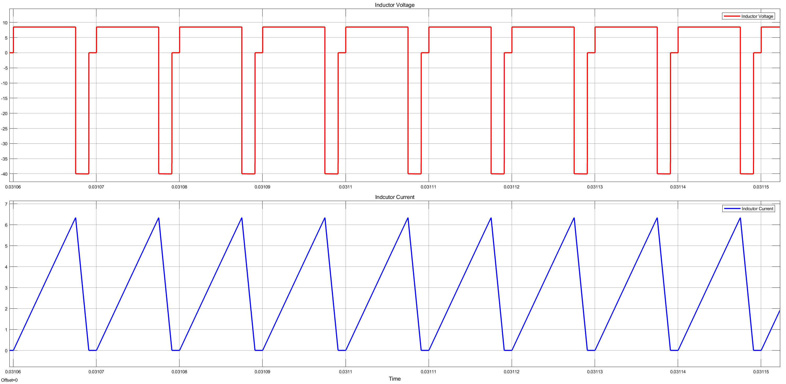

Figure 6 Inductor Current and Voltage at steady-state with resistive 80 ohm

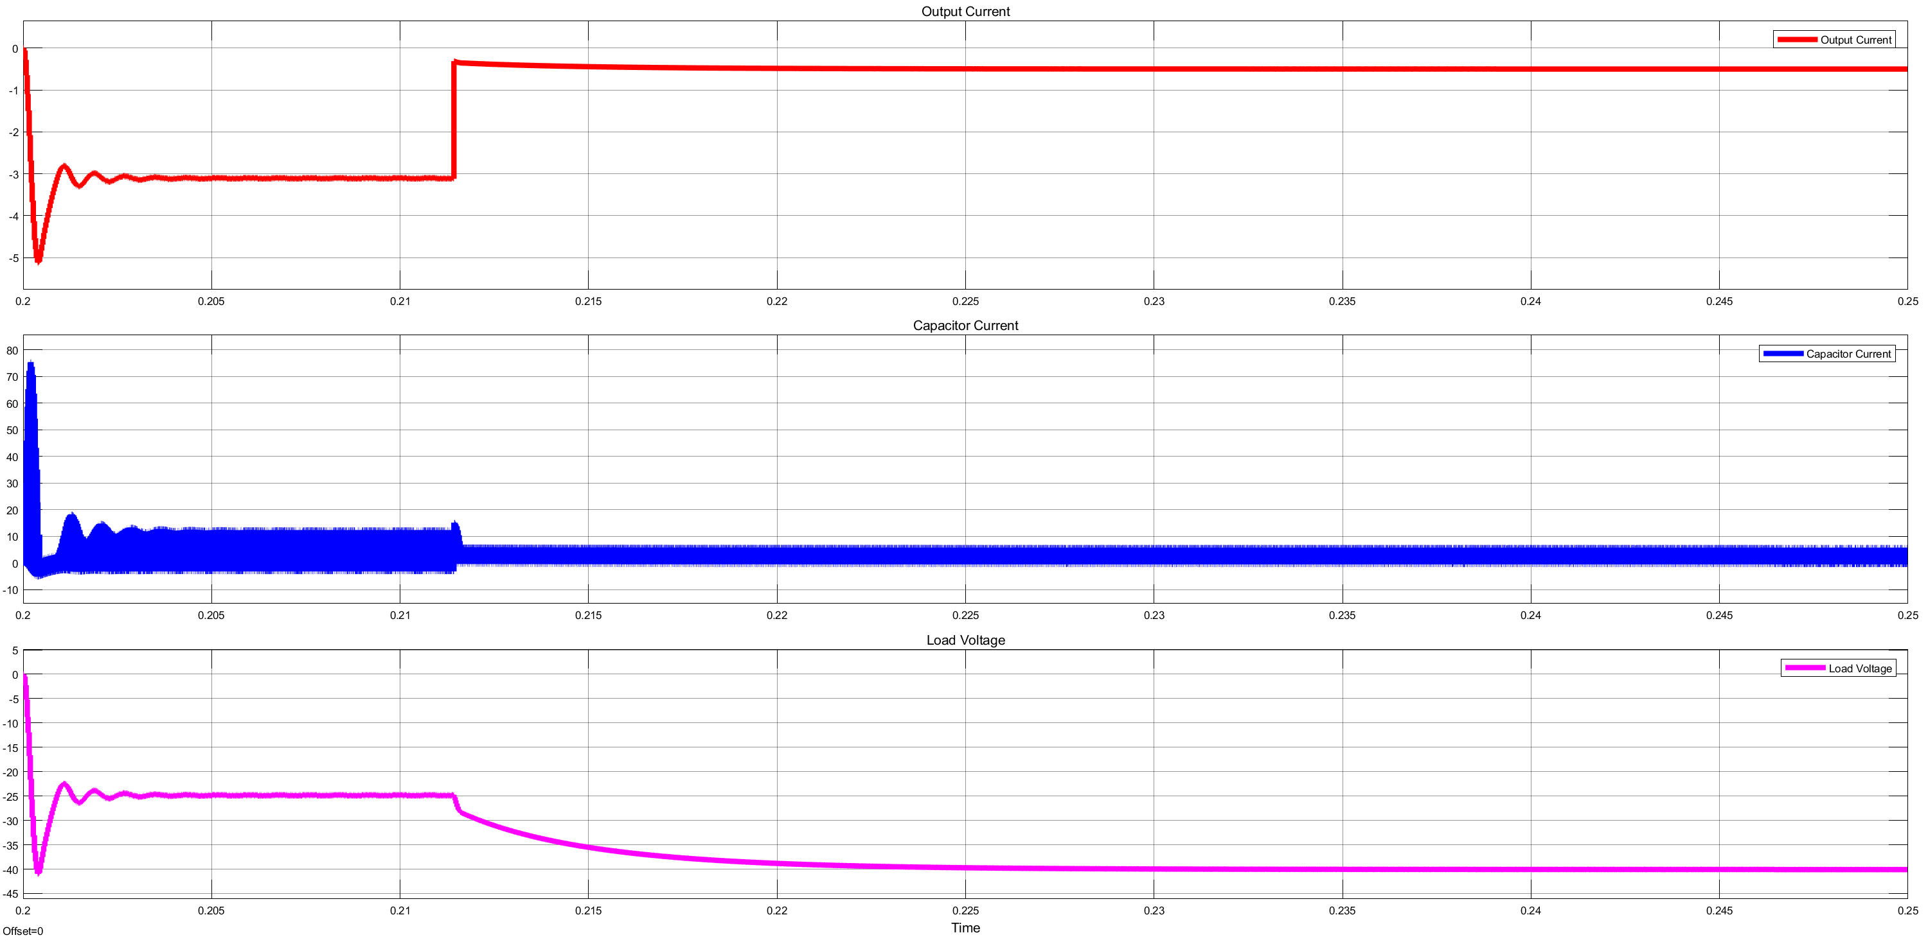

Figure 7 Output Voltage and Current Waveform for step change in load

Figure 6 and Figure 7 shows the load changes from 8 to 80 ohm. This changes led the converter transfer from CCM to DCM.



Load is fed from capacitor during on-state transistor. Then, the output voltage ripple depends on current (constant) from load, capacitance value, switching period and duty cycle.

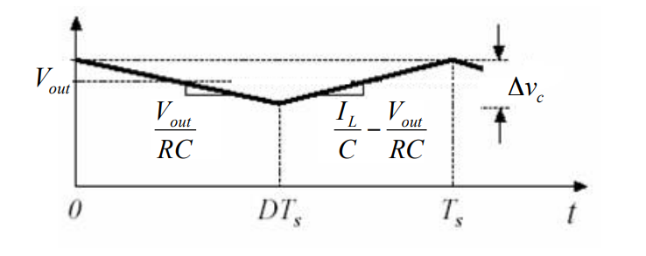

Figure 8 Output Voltage Ripple of Buck-Boost Converter

Output ripple can be calculated by using Figure 8 and equation below.

$$Δv_{c}=\frac{V_{out}}{RC}.D.T_{s}$$

For our case, peak-to-peak voltage ripple is ‘0.248’ V by analytically.

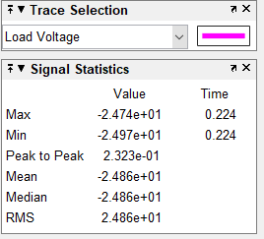

Figure 9 Output Voltage Statistics

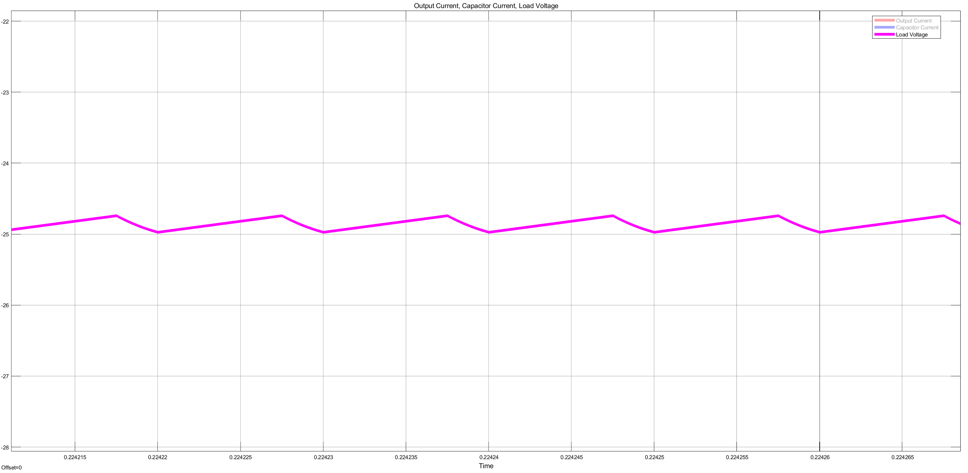

Figure 10 Output Voltage Waveform

Analytically and simulation results are almost the same.

6.

Capacitor current is ramp-on- square wave as shown Figure 11

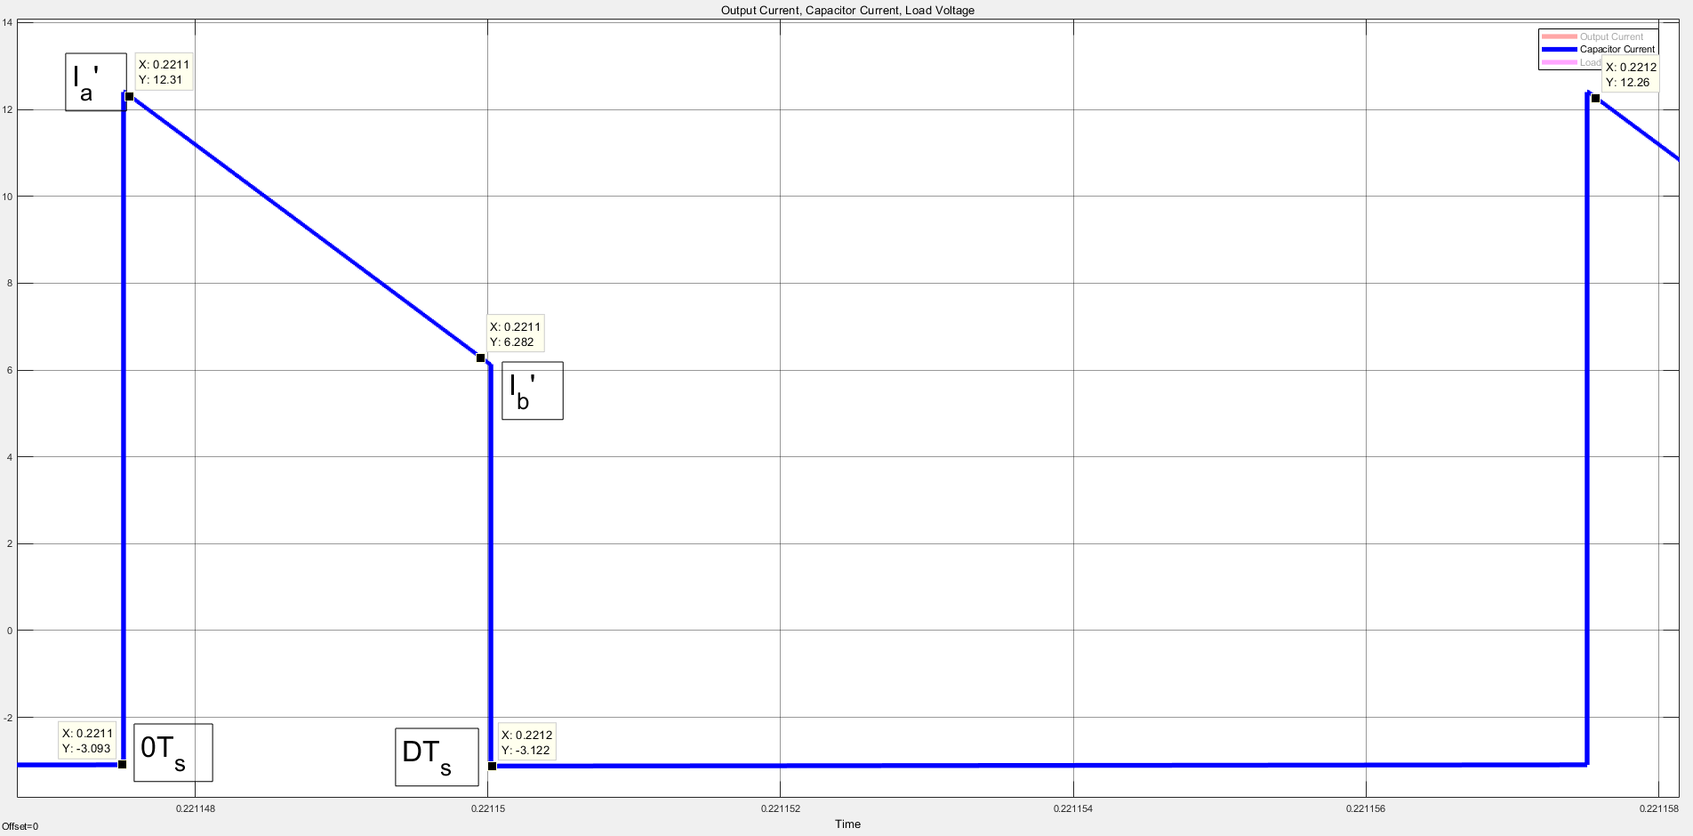

Figure 11 Ramp-on-square Waveform of Capacitor Current

RMS value of this waveform depends on $I_{a}, I_{b}$ ( stem from $I_{a}’ and I_{b}’$ subtracted $I_{dc}$) and Duty cycle.

$$I_{rms}= \sqrt{D.\frac{I_{a}^{2}+I_{b}^{2}+I_{a}.I_{b}}{3}}$$

$$I_{rms}= 3.184 A \left(I_{dc}= 3.169 I_{a}= 9.141 I_{b}= 3.113 D= 0.25\right)$$

$$\frac{I_{rms}}{I_{o}}=\frac{3.184}{3.169}= 1.004$$