**ELE 613**

# **Switch Mode Power Supply**

# **Homework 2**

## **Problems:**

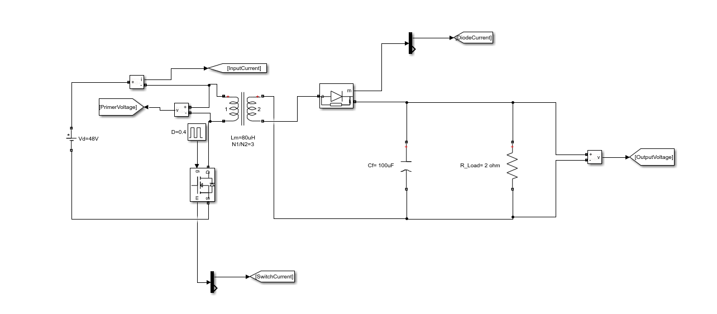

Figure 1 Flyback dc-dc Converter

At Figure 1, Flyback circuit schematic is shown .Flyback converter can regulate voltage as isolated in higher or lower output voltage than input.Nominal Values are shown in Table 1.Table 1 Nominal Values of Circuit Parameters

|  |  |
| --- | --- |
| Parameters | Values |
| $V_{d}$ | 48 V |
| $D$ | 0.4 |
| $N_{1}/ N_{2 }$ | 3 |
| $f_{s}$ | 200 kHz |
| $L_{m }$ | 80 µH |
| $C_{f }$ | 100 µF |
| $R_{L }$ | 2Ω |

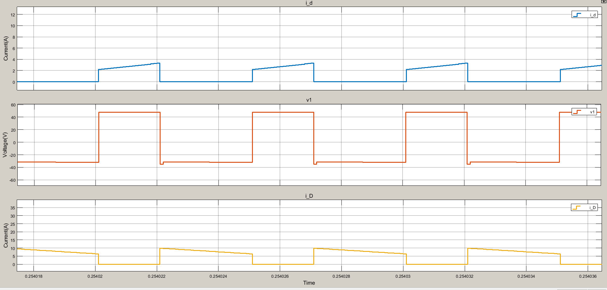

Figure 2 Flyback dc-dc Converter Primer Voltage, Diode and Input Current

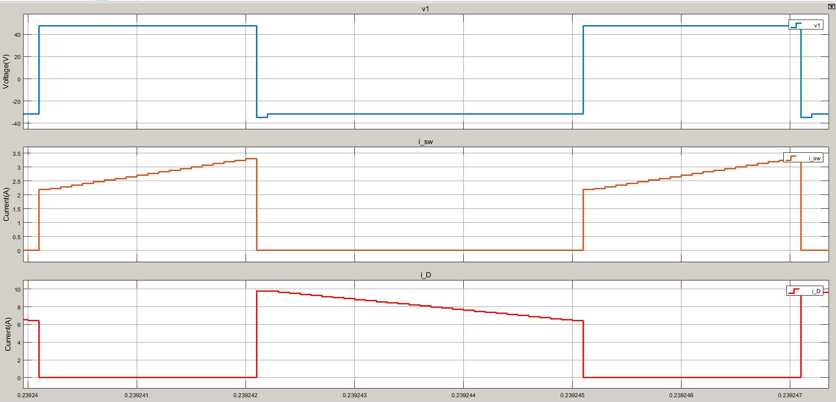

Figure 3 Flyback dc-dc Converter Primer Voltage, Diode and Switch Current at switching transition

We can observe that sum of diode and switch current gives the magnetizing current and it is created by primer voltage.

Average of diode current is equal to DC output current because capacitor at output only conduct ripple of output, not DC current.

$I_{d }/ I_{o }= V_{o}/ V_{d }$ (1)

Equation 1 must be hold due to power conversion. Input and Output power is equal if all losses are taken as zero.

$<i_{d }> =1.192$

$<i_{D}> =5.321$

$V_{o} =10.6$

$V_{d} =48$

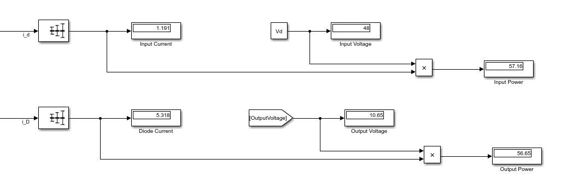

Figure 4 Input and Diode Current Average

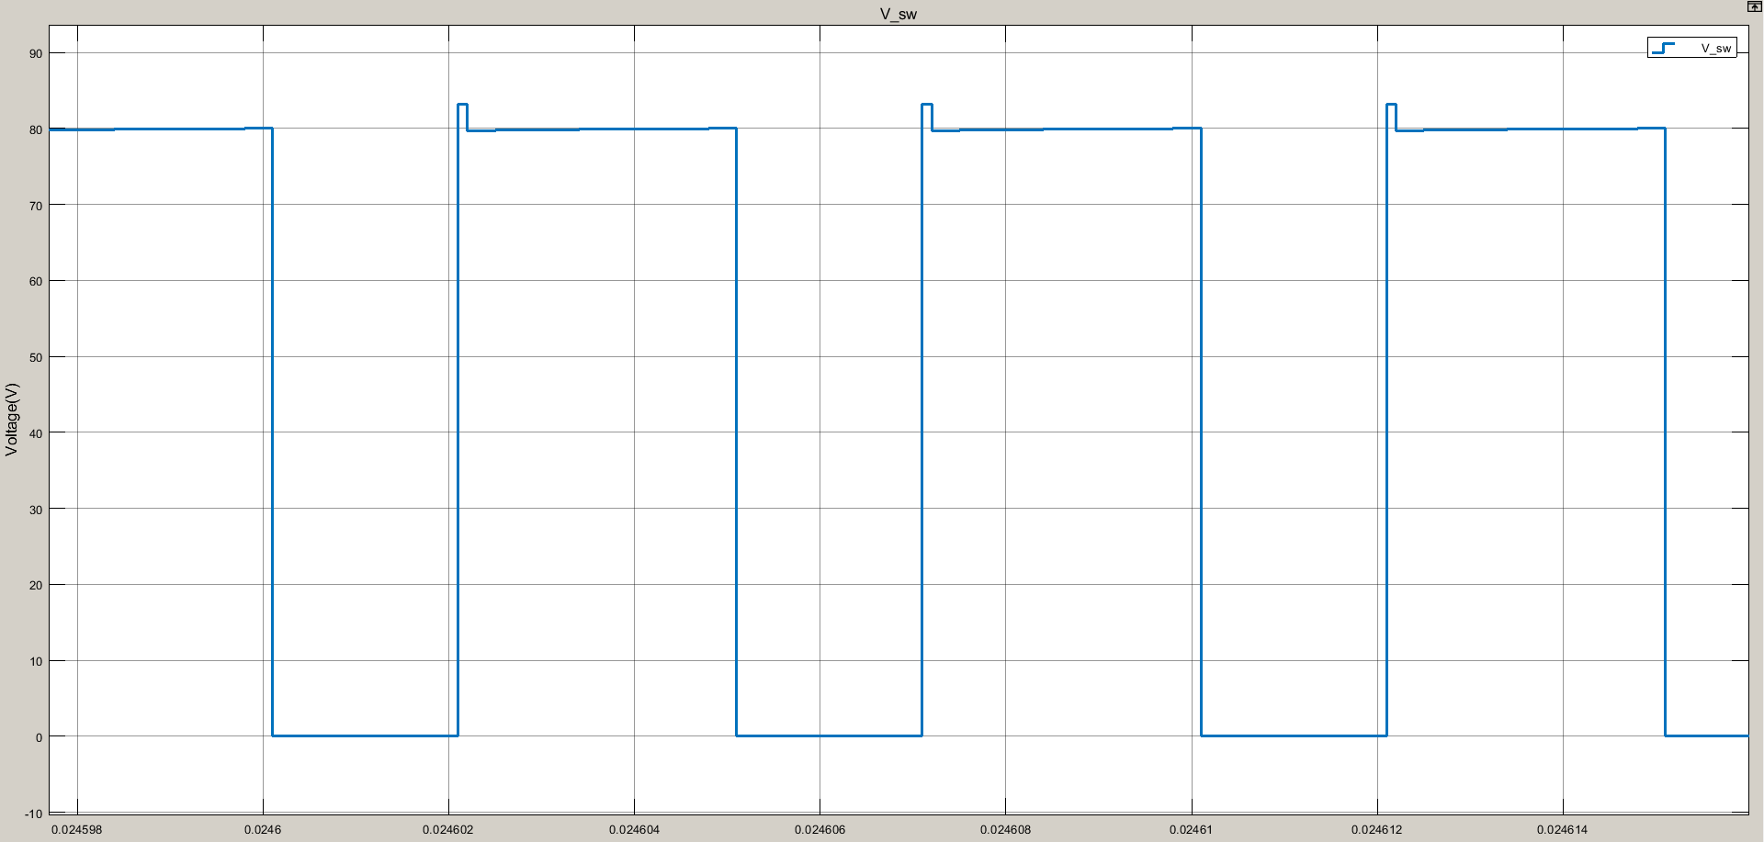

Figure 4 Switch Voltage

Switch voltage is sum of input voltage and primer voltage which is reflected from output.

$V_{sw }= V_{d }+ V_{1}$ (2)

$V_{1 }= V_{o }N1/N3 = V_{d }( N3/N1) D (N1/N3 ) = V_{d }D$/(1-D) (3)

from 2 and 3,

$V_{sw }= V_{d }/ (1-D)$ (4)

5.

For 2 ohm resistance, flyback works in continuous conduction mode. We observed that magnetizing current did not cross zero at above. Thus, we observe that input and diode current is ramp on square wave.

For 50 ohm, we observe that ramp current waveform and magnetizing current cross to zero. Thus, the flyback works in discontinuous conduction mode.

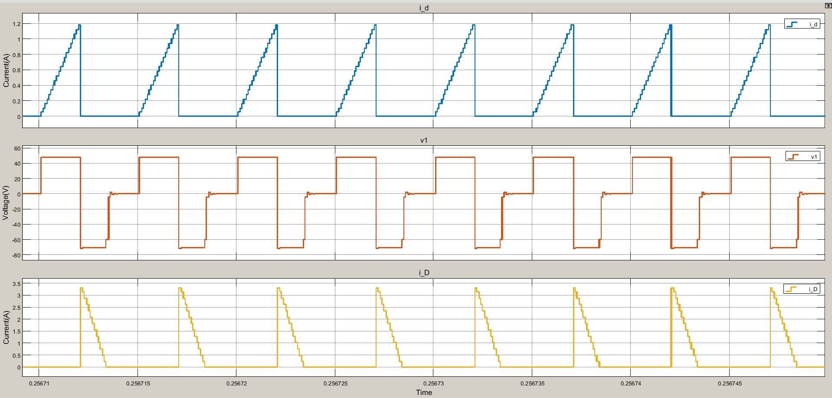

Figure 5 Flyback dc-dc Converter Primer Voltage, Diode and Input Current

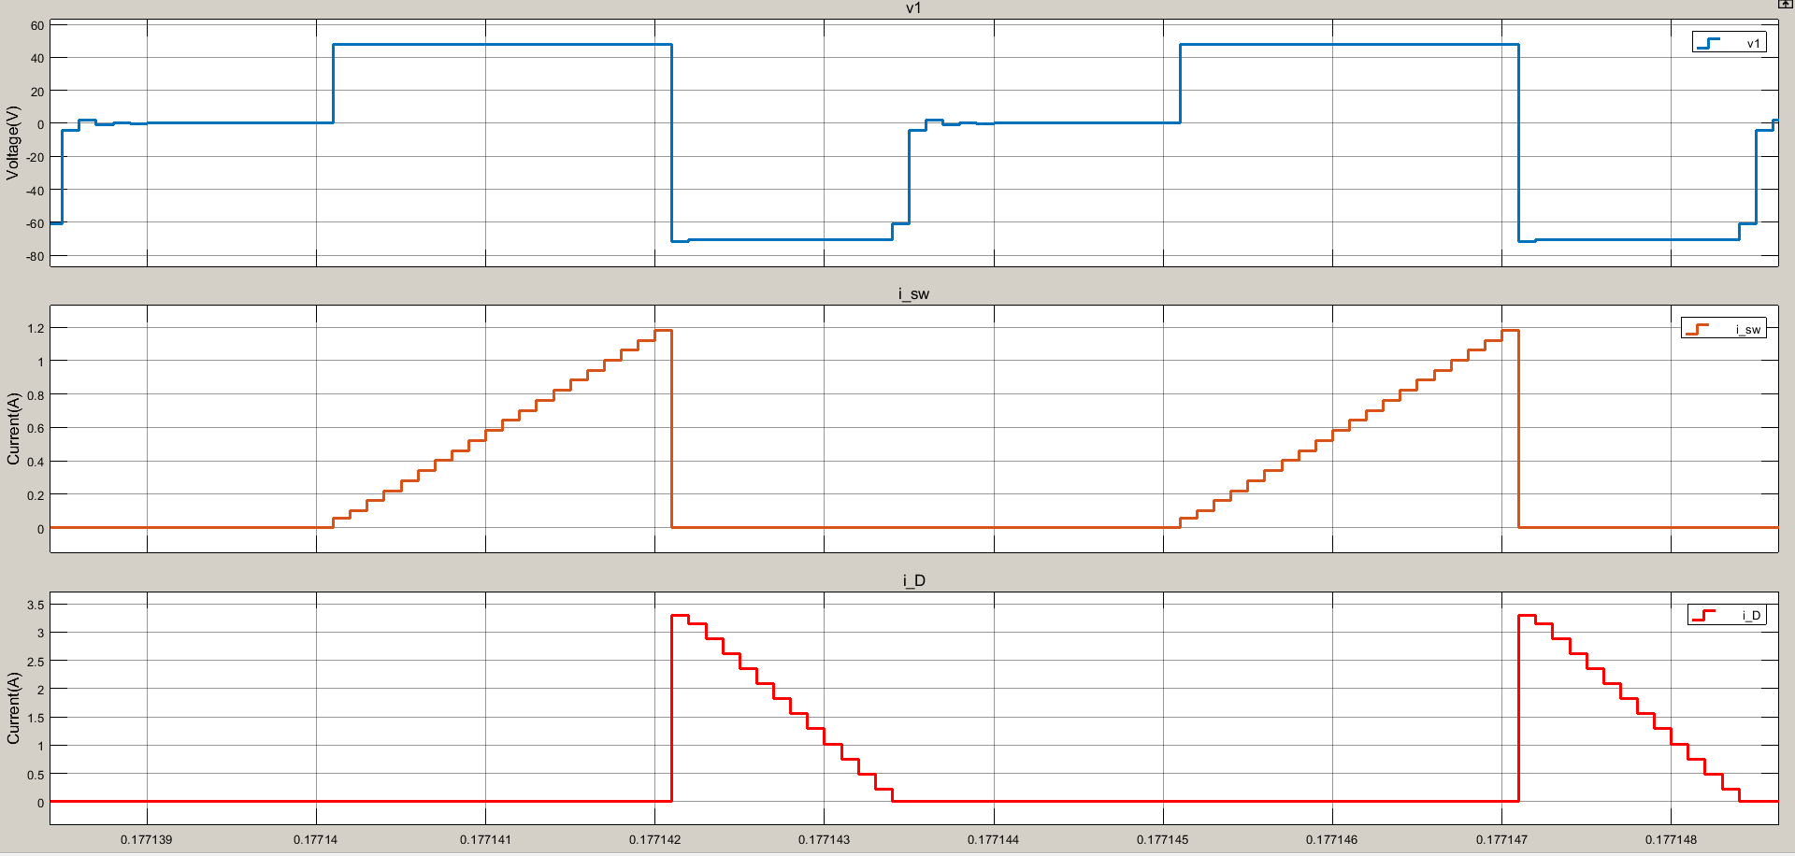

Figure 6 Flyback dc-dc Converter Primer Voltage, Diode and Switch Current at switching transition