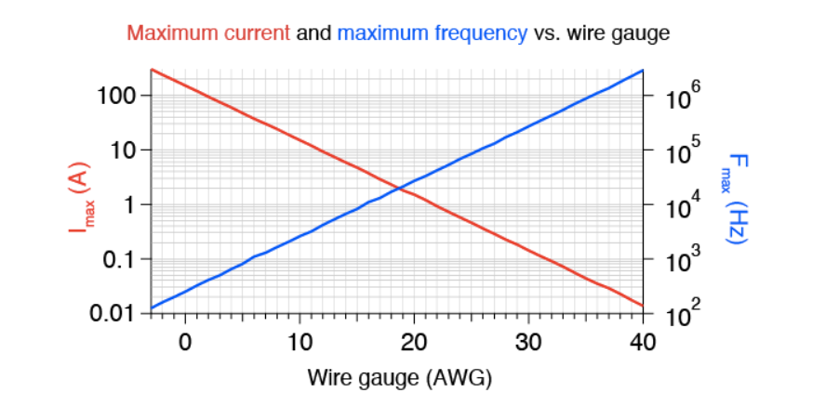

AWG 25 is chosen for 40 kHz application.

|  |  |  |  |  |  |  |  |  |  |  |  |  |  |  |
| --- | --- | --- | --- | --- | --- | --- | --- | --- | --- | --- | --- | --- | --- | --- |
| ***AWG*** | ***Diameter*** | | ***Turns of wire, without insulation*** | | ***Area*** | | [***Copper***](https://www.wikiwand.com/en/Copper)***wire*** | | | | | | | |
| [***Resistance/length***](https://www.wikiwand.com/en/Resistivity)[**[7]**](https://www.wikiwand.com/en/American_wire_gauge#citenoteresperlength7) | | [***Ampacity***](https://www.wikiwand.com/en/Ampacity)***,***[**[8]**](https://www.wikiwand.com/en/American_wire_gauge#citenoteampacity8)***at 20 °C insulation material temperature rating, or for single unbundled wires in equipment for 16 AWG and smaller***[**[9]**](https://www.wikiwand.com/en/American_wire_gauge#citenotesmallgaugeampacity9) | | | ***Fusing current***[**[10]**](https://www.wikiwand.com/en/American_wire_gauge#citenoteSHEE10)[**[11]**](https://www.wikiwand.com/en/American_wire_gauge#citenoteBrooks11) | | |
| ***60 °C*** | ***75 °C*** | ***90 °C*** | ***Preece*[[12]](https://www.wikiwand.com/en/American_wire_gauge" \l "citenotePREECE112)**[**[13]**](https://www.wikiwand.com/en/American_wire_gauge#citenotePREECE213)[**[14]**](https://www.wikiwand.com/en/American_wire_gauge#citenotePREECE314)[**[15]**](https://www.wikiwand.com/en/American_wire_gauge#citenoteBROOKS1ADAM115) | ***Onderdonk*[[16]](https://www.wikiwand.com/en/American_wire_gauge" \l "citenoteSTAUFF16)**[**[15]**](https://www.wikiwand.com/en/American_wire_gauge#citenoteBROOKS1ADAM115) | |
| ***(in)*** | ***(mm)*** | ***(per in)*** | ***(per cm)*** | ***([kcmil](https://www.wikiwand.com/en/Circular_mil" \o "Circular mil))*** | ***(mm*2*)*** | ***(mΩ/m***[**[a]**](https://www.wikiwand.com/en/American_wire_gauge#citenoteresm17)***)*** | ***(mΩ/ft*[[b]](https://www.wikiwand.com/en/American_wire_gauge" \l "citenoteresft18)*)*** | ***(A)*** | | | ***~10 s*** | ***1 s*** | ***32 ms*** |
|  |  |  |  |  |  |  |  |  |  | | |  |  |  |

|  |  |  |  |  |  |  |  |  |  |  |  |  |  |  |
| --- | --- | --- | --- | --- | --- | --- | --- | --- | --- | --- | --- | --- | --- | --- |
| 25 | 0.0179 | 0.455 | 55.9 | 22.0 | 0.320 | 0.162 | 106.2 | 32.37 | — | — | — | 24 A | 49 A | 276 A |

For 40 kHz skin depth is

|  |  |  |
| --- | --- | --- |
| |  |  | | --- | --- | | **Skin Depth:** | **326 μm** | |

Ampacity is 1.3-2.1 ==1.7 == 10.5 A/mm^2