**Enes Ayaz** received the B.Sc. and M.Sc. degree from the Department of Electrical and Electronics Engineering, Middle East Technical University (METU), Ankara, Turkey, in 2019 and 2022.

His current research interests include resonant converters, wireless power transfer, and power electronics.

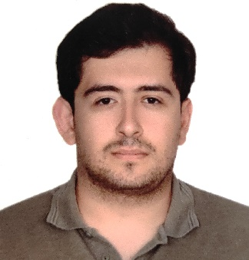

**Ogün Altun** received his B.Sc degree from the Department of Electrical and Electronics Engineering, Middle East Technical University, Ankara, Turkey in 2020. He is pursuing his M.Sc. degree at Middle East Technical University.

His current research interests are power converters, renewable energy, and wireless power transfer.

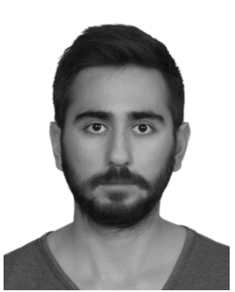

**Hakan Polat** received the B.Sc. and M.Sc. degrees from the Department of Electrical and Electronics Engineering, Middle East Technical University (METU), Ankara, Turkey, in 2018 and 2021.Then, he joined Vrije Universiteit Brussels- MOBI EPowers as a Ph.D. student in 2021 and is currently pursuing a Ph.D. His current research interests include electric car chargers, renewable energy, resonant converters, and wireless power transfer.

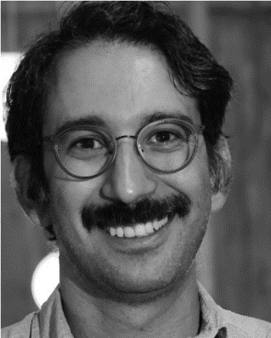

**Ozan Keysan** received the master’s degree from Middle East Technical University (METU), Ankara, Turkey, in 2008, and the Ph.D. degree from The University of Edinburgh, Edinburgh, U.K., in 2014.

He is currently an Associate Professor with the Department of Electrical and Electronics Engineering, METU.

His current research interests include wireless power transfer, renewable energy, design and optimization of electrical machines, smart grids, superconducting machines, and permanent-magnet machines.