# Introduction

In this document, an experiment series is explained for the system shown in Figure 1.

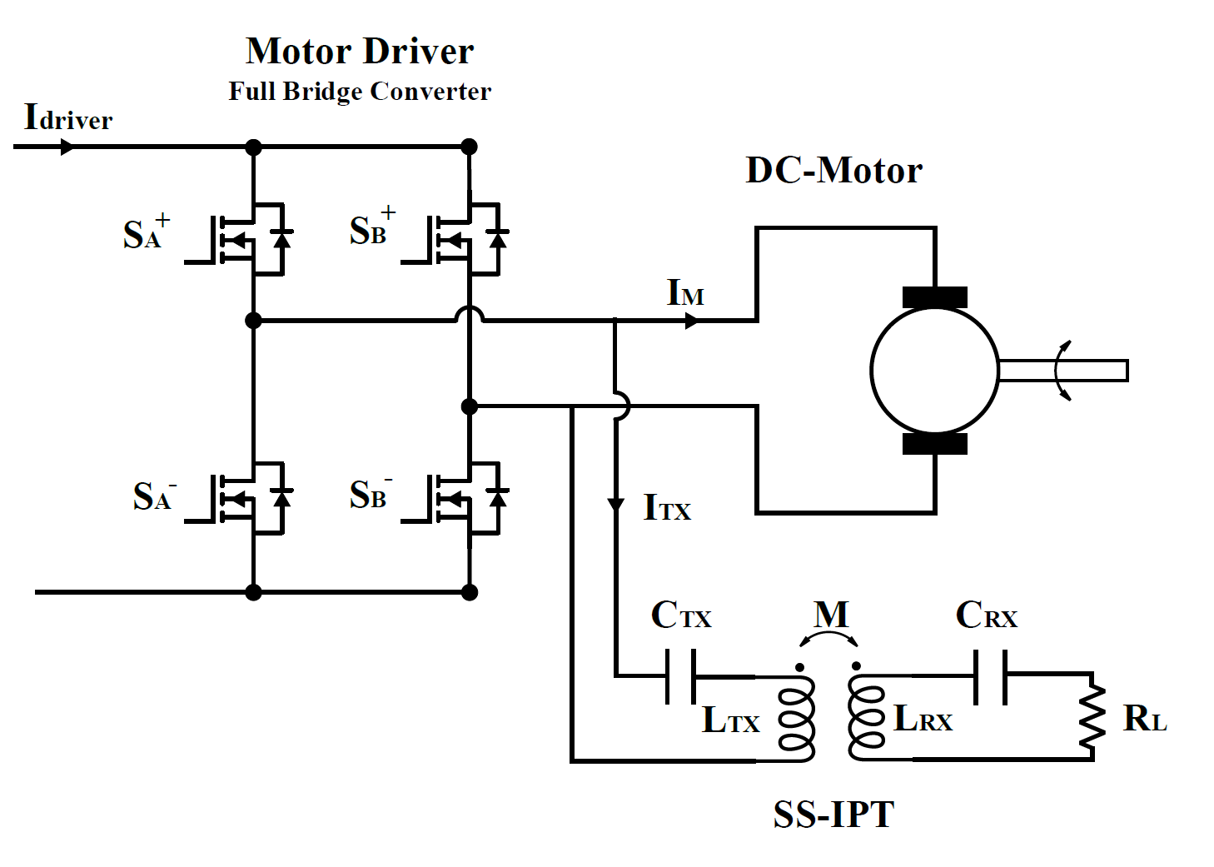

*Figure 1 IPT-MOTOR*

Firstly, only the SS-IPT systems are tested and compared with simulation results.

Secondly, the motor is tested for both no-load and load with a generator for various duty cycles and frequencies.

Finally, the IPT and Motor are controlled. The duty cycle is selected, and a frequency is calculated to keep the gain constant. (Izohips )

# SS-IPT

Fill the values in Table 1.

*Table 1 IPT- Parameters*

|  |  |
| --- | --- |
| **Parameters** | **Values** |
| $L_{p}$ |  |
| $L_{s}$ |  |
| $M$ |  |
| $C_{p}$ |  |
| $C_{s}$ |  |
| $R_{L}$ |  |

## Simulation-Results

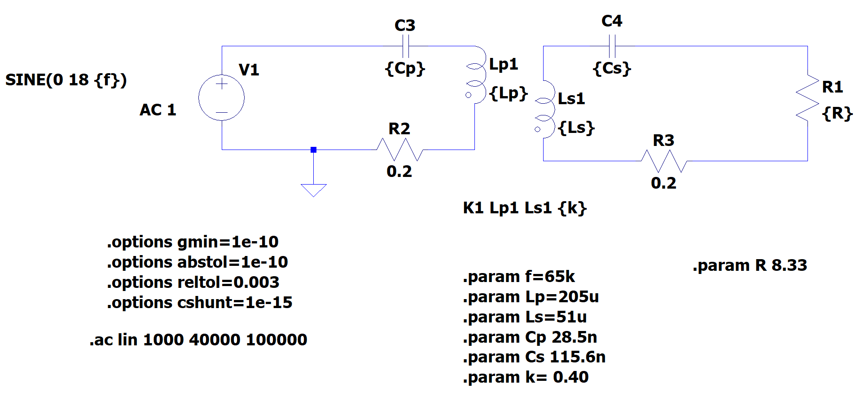

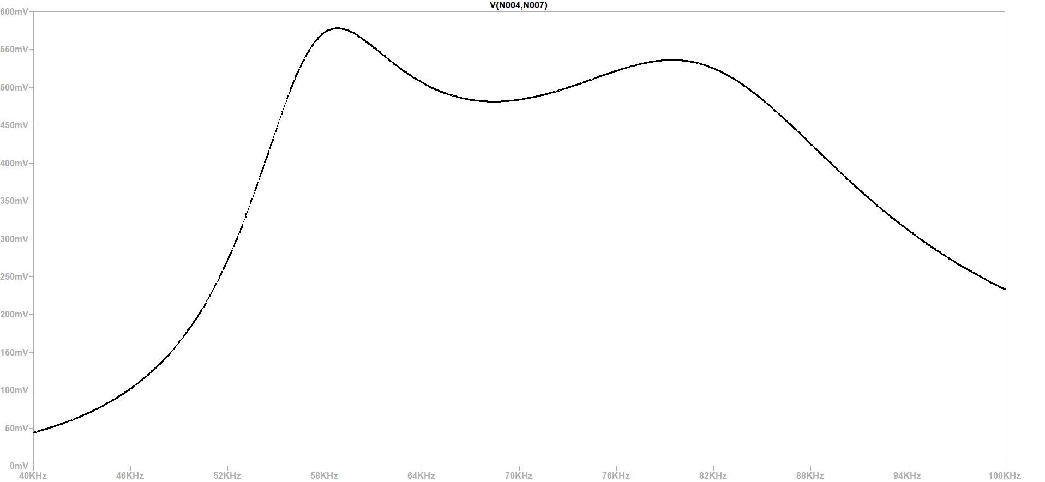

|  |  |  |  |  |  |  |
| --- | --- | --- | --- | --- | --- | --- |
|  |  | **Experiment** | | | | |
| **Frequency (kHz)** | **Simulation Gain** | **Primer Akım** | **Sekonder Akım** | **Sekonder Voltaj** | **Input Akım** | **input voltaj** |
| **40** | 0.044 |  |  |  |  | 40 |
| **42.5** | 0.062 |  |  |  |  | 40 |
| **45** | 0.080 |  |  |  |  | 40 |
| **47.5** | 0.129 | 640 | 482 | 4,07 | 0 | 40 |
| **50** | 0.194 | 862 | 770 | 6,49 | 0,14 | 40 |
| **52.5** | 0.297 | 1184 | 1255 | 10,66 | 0,38 | 40 |
| **55** | 0.446 | 1474 | 1856 | 15,7 | 0,78 | 40 |
| **57.5** | 0.562 | 1566 | 2315 | 19,6 | 1,18 | 40 |
| **60** | 0.568 | 1388 | 2284 | 19,3 | 1,17 | 40 |
| **62.5** | 0.526 | 1216 | 2142 | 18,1 | 1,05 | 40 |
| **65** | 0.496 | 1113 | 2112 | 17,8 | 0,99 | 40 |
| **67.5** | 0.482 | 1086 | 2119 | 17,94 | 0,98 | 40 |
| **70** | 0.483 | 1129 | 2110 | 17,85 | 0,99 | 40 |
| **72.5** | 0.496 | 1229 | 2168 | 18,33 | 1,01 | 40 |
| **75** | 0.515 | 1363 | 2330 | 19,65 | 1,21 | 40 |
| **77.5** | 0.530 | 1470 | 2420 | 20,45 | 1,28 | 40 |
| **80** | 0.535 | 1502 | 2321 | 19,64 | 1,2 | 40 |
| **82.5** | 0.520 | 1480 | 2164 | 18,3 | 1,06 | 40 |
| **85** | 0.484 | 1340 | 1901 | 16,08 | 0,8 | 40 |
| **87.5** | 0.436 | 1278 | 1759 | 14,92 | 0,67 | 40 |
| **90** | 0.385 | 1123 | 1477 | 12,5 | 0,48 | 40 |
| **92.5** | 0.337 | 1010 | 1269 | 10,74 | 0,36 | 40 |
| **95** | 0.296 | 932 | 1140 | 9,68 | 0,29 | 40 |
| **97.5** | 0.262 | 540 | 635 | 5,38 | 0,09 | 40 |
| **100** | 0.233 |  |  |  |  | 40 |

|  |  |  |  |  |  |  |
| --- | --- | --- | --- | --- | --- | --- |
|  |  | **Experiment** | | | | |
| **Frequency (kHz)** | **Simulation Gain** | **Primer Akım** | **Sekonder Akım** | **Sekonder Voltaj** | **Input Akım** | **input voltaj** |
| **40** | 0.044 |  |  |  |  | 40 |
| **42.5** | 0.062 | 527 | 390 |  | 0 | 40 |
| **45** | 0.080 | 620 | 460 |  | 0 | 40 |
| **47.5** | 0.129 | 741 | 600 |  | 0.08 | 40 |
| **50** | 0.194 | 930 | 850 |  | 0.16 | 40 |
| **52.5** | 0.297 | 1188 | 1300 |  | 0.37 | 40 |
| **55** | 0.446 | 1477 | 1880 |  | 0.78 | 40 |
| **57.5** | 0.562 | 1588 | 2280 |  | 1.17 | 40 |
| **60** | 0.568 | 1398 | 2330 |  | 1.19 | 40 |
| **62.5** | 0.526 | 1201 | 2200 |  | 1.06 | 40 |
| **65** | 0.496 | 1107 | 2100 |  | 0.97 | 40 |
| **67.5** | 0.482 | 1075 | 2100 |  | 0.96 | 40 |
| **70** | 0.483 | 1132 | 2130 |  | 1 | 40 |
| **72.5** | 0.496 | 1223 | 2190 |  | 1.08 | 40 |
| **75** | 0.515 | 1344 | 2310 |  | 1.18 | 40 |
| **77.5** | 0.530 | 1470 | 2380 |  | 1.26 | 40 |
| **80** | 0.535 | 1516 | 2360 |  | 1.24 | 40 |
| **82.5** | 0.520 | 1492 | 2240 |  | 1.10 | 40 |
| **85** | 0.484 | 1404 | 1980 |  | 0.88 | 40 |
| **87.5** | 0.436 | 1265 | 1710 |  | 0.67 | 40 |
| **90** | 0.385 | 1145 | 1480 |  | 0.51 | 40 |
| **92.5** | 0.337 | 1033 | 1280 |  | 0.38 | 40 |
| **95** | 0.296 | 924 | 1120 |  | 0.29 | 40 |
| **97.5** | 0.262 | 847 | 1000 |  | 0.22 | 40 |
| **100** | 0.233 | 770 | 890 |  | 0.17 | 40 |

* A primary capacitor has a fivefold input voltage at 50 kHz. Consider this? Rather than, it keeps the DC part.

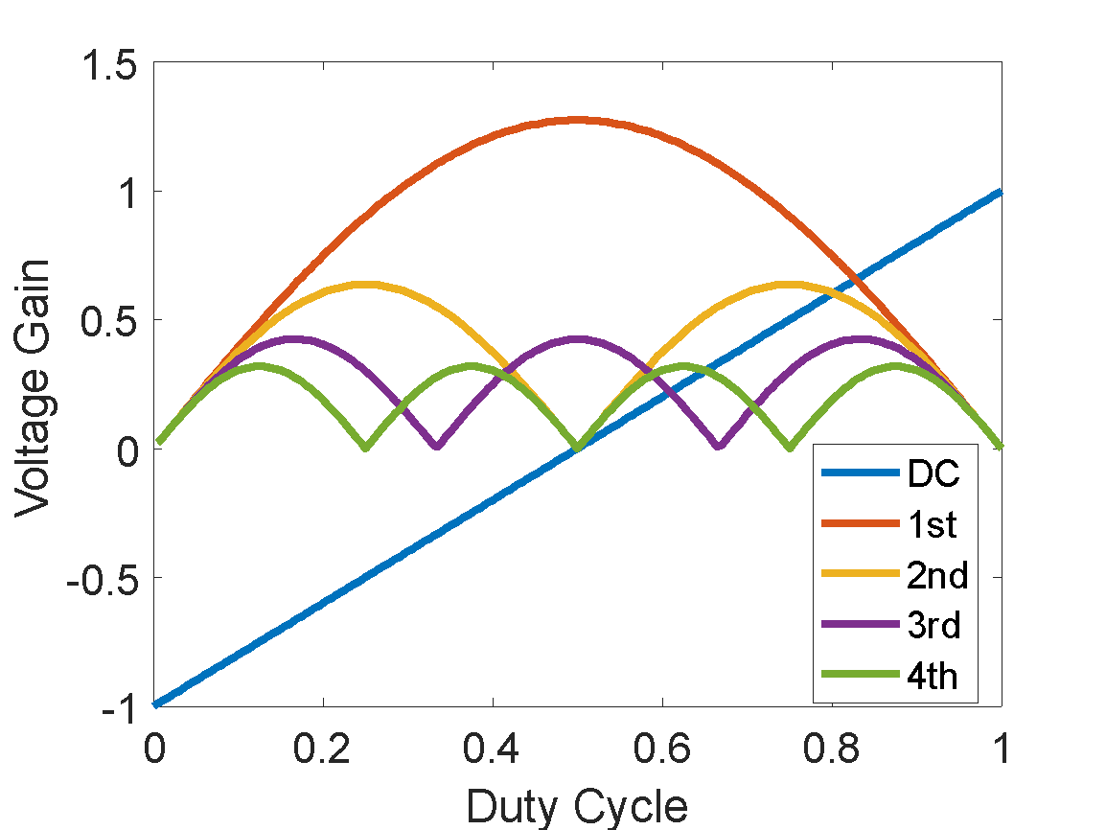

|  |  |  |  |  |  |
| --- | --- | --- | --- | --- | --- |
|  |  | **Experiment** | | | |
| **Duty Cycle** | **Simulation**  **Gain** | **Pirmer Akım** | **Seconder Akım** | **Input Current** | **Input Voltage** |
| **0** | 0 |  |  |  | 40 |
| **0.05** | 0.20 | 230 | 430 | 0 | 40 |
| **0.1** | 0.39 | 458 | 720 | 0.11 | 40 |
| **0.15** | 0.58 | 675 | 1040 | 0.24 | 40 |
| **0.20** | 0.75 | 872 | 1350 | 0.41 | 40 |
| **0.25** | 0.90 | 1054 | 1630 | 0.60 | 40 |
| **0.30** | 1.03 | 1212 | 1870 | 0.79 | 40 |
| **0.35** | 1.13 | 1342 | 2080 | 0.97 | 40 |
| **0.40** | 1.21 | 1437 | 2230 | 1.11 | 40 |
| **0.45** | 1.26 | 1496 | 2330 | 1.20 | 40 |
| **0.50** | 1.27 | 1517 | 2360 | 1.24 | 40 |
| **0.55** | 1.26 |  |  |  | 40 |
| **0.60** | 1.21 |  |  |  | 40 |
| **0.65** | 1.13 |  |  |  | 40 |
| **0.70** | 1.03 |  |  |  | 40 |
| **0.75** | 0.9 |  |  |  | 40 |
| **0.80** | 0.75 |  |  |  | 40 |
| **0.85** | 0.58 |  |  |  | 40 |
| **0.90** | 0.39 |  |  |  | 40 |
| **0.95** | 0.20 |  |  |  | 40 |
| **1** | 0 |  |  |  | 40 |

# Motor-Test

The test setup of the motor is given Figure 2

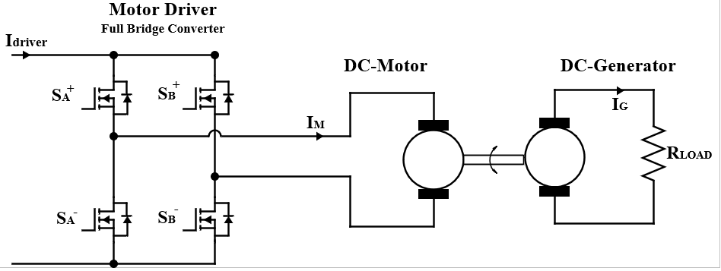

*Figure 2 Motor-Setup*

The basic representation of the system is given in Figure 3.

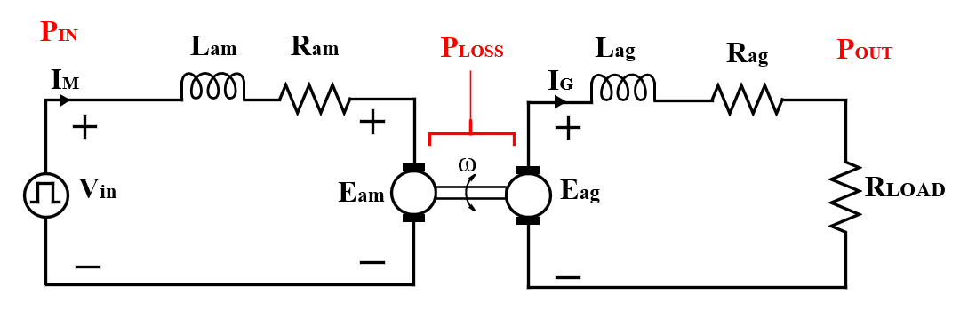

*Figure 3 Basic Representation Motor-Generator*

|  |  |
| --- | --- |
| **Motor and Generator Parameters** | **Values** |
| **Ram** |  |
| **Lam** |  |
| **Kam** |  |
| **Rag** |  |
| **Lag** |  |
| **Kag** |  |

If we want work on constant torque (the motor current is same)

|  |  |  |  |  |
| --- | --- | --- | --- | --- |
| **Duty Cycle** | **Input Current** | **Motor Speed** | **Load Voltage** | **Load Current** |
| **0** |  |  |  |  |
| **0.05** |  |  |  |  |
| **0.1** |  |  |  |  |
| **0.15** |  |  |  |  |
| **0.20** |  |  |  |  |
| **0.25** |  |  |  |  |
| **0.30** |  |  |  |  |
| **0.35** |  |  |  |  |
| **0.40** |  |  |  |  |
| **0.45** |  |  |  |  |
| **0.50** |  |  |  |  |
| **0.55** |  |  |  |  |
| **0.60** |  |  |  |  |
| **0.65** |  |  |  |  |
| **0.70** |  |  |  |  |
| **0.75** |  |  |  |  |
| **0.80** |  |  |  |  |
| **0.85** |  |  |  |  |
| **0.90** |  |  |  |  |
| **0.95** |  |  |  |  |
| **1** |  |  |  |  |

# IPT and MOTOR

For different Frequency and duty cyle

|  |  |  |  |  |  |
| --- | --- | --- | --- | --- | --- |
| **Duty Cycle** | **Frequency** | **Motor Current** | **Motor Speed** | **Tx Current** | **Rx Voltage** |
| **0** |  |  |  |  |  |
| **0.05** |  |  |  |  |  |
| **0.1** |  |  |  |  |  |
| **0.15** |  |  |  |  |  |
| **0.20** |  |  |  |  |  |
| **0.25** |  |  |  |  |  |
| **0.30** |  |  |  |  |  |
| **0.35** |  |  |  |  |  |
| **0.40** |  |  |  |  |  |
| **0.45** |  |  |  |  |  |
| **0.50** |  |  |  |  |  |
| **0.55** |  |  |  |  |  |
| **0.60** |  |  |  |  |  |
| **0.65** |  |  |  |  |  |
| **0.70** |  |  |  |  |  |
| **0.75** |  |  |  |  |  |
| **0.80** |  |  |  |  |  |
| **0.85** |  |  |  |  |  |
| **0.90** |  |  |  |  |  |
| **0.95** |  |  |  |  |  |
| **1** |  |  |  |  |  |