# Introduction

In this document, an experiment series is explained for the system shown in Figure 1.

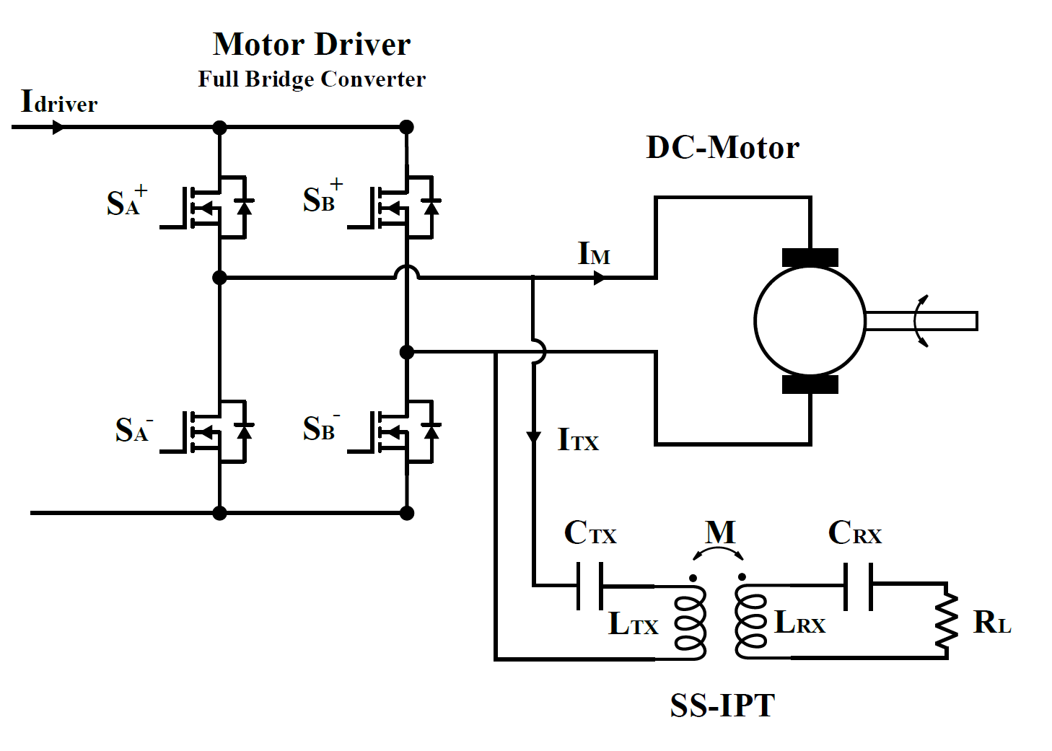

Figure IPT-MOTOR

Firstly, only the SS-IPT systems are tested and compared with simulation results.

Secondly, the motor is tested for both no-load and load with a generator for various duty cycles and frequencies.

Finally, the IPT and Motor are controlled. The duty cycle is selected, and a frequency is calculated to keep the gain constant. (Izohips )

# SS-IPT

Fill the values in Table 1.

Table IPT- Parameters

|  |  |
| --- | --- |
| **Parameters** | **Values** |
| $$L_{p}$$ |  |
| $$L_{s}$$ |  |
| $$M$$ |  |
| $$C_{p}$$ |  |
| $$C_{s}$$ |  |
| $$R_{L}$$ |  |

## Simulation-Results

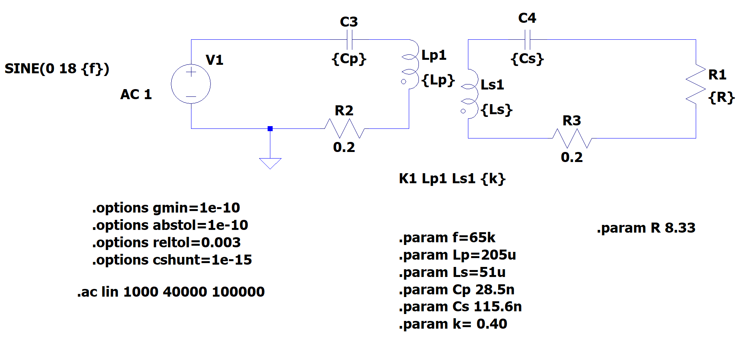

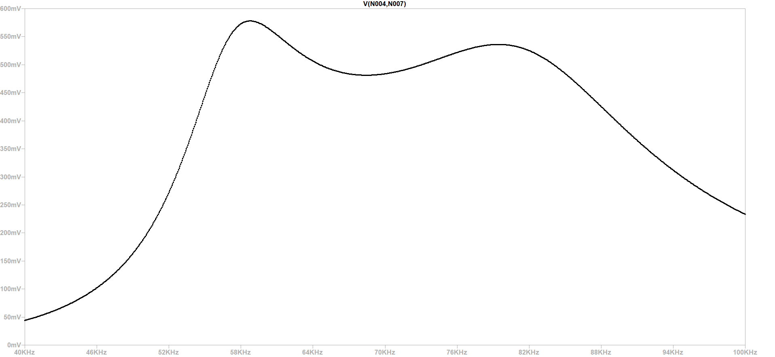

|  |  |  |  |  |  |
| --- | --- | --- | --- | --- | --- |
|  |  | **Experiment** | | | |
| **Frequency (kHz)** | **Simulation Gain** | **Output Voltage** | **Input Voltage** | **Input Current** | **Tx- Current** |
| **40** | 0.044 |  |  |  |  |
| **42.5** | 0.062 |  |  |  |  |
| **45** | 0.080 |  |  |  |  |
| **47.5** | 0.129 |  |  |  |  |
| **50** | 0.194 |  |  |  |  |
| **52.5** | 0.297 |  |  |  |  |
| **55** | 0.446 |  |  |  |  |
| **57.5** | 0.562 |  |  |  |  |
| **60** | 0.568 |  |  |  |  |
| **62.5** | 0.526 |  |  |  |  |
| **65** | 0.496 |  |  |  |  |
| **67.5** | 0.482 |  |  |  |  |
| **70** | 0.483 |  |  |  |  |
| **72.5** | 0.496 |  |  |  |  |
| **75** | 0.515 |  |  |  |  |
| **77.5** | 0.530 |  |  |  |  |
| **80** | 0.535 |  |  |  |  |
| **82.5** | 0.520 |  |  |  |  |
| **85** | 0.484 |  |  |  |  |
| **87.5** | 0.436 |  |  |  |  |
| **90** | 0.385 |  |  |  |  |
| **92.5** | 0.337 |  |  |  |  |
| **95** | 0.296 |  |  |  |  |
| **97.5** | 0.262 |  |  |  |  |
| **100** | 0.233 |  |  |  |  |

* A primary capacitor has a fivefold input voltage at 50 kHz. Consider this? Rather than, it keeps the DC part.



|  |  |  |  |  |  |
| --- | --- | --- | --- | --- | --- |
|  |  | **Experiment** | | | |
| **Duty Cycle** | **Simulation**  **Gain** | **Output Voltage** | **Input Voltage** | **Input Current** | **Tx Current** |
| **0** | 0 |  |  |  |  |
| **0.05** | 0.20 |  |  |  |  |
| **0.1** | 0.39 |  |  |  |  |
| **0.15** | 0.58 |  |  |  |  |
| **0.20** | 0.75 |  |  |  |  |
| **0.25** | 0.90 |  |  |  |  |
| **0.30** | 1.03 |  |  |  |  |
| **0.35** | 1.13 |  |  |  |  |
| **0.40** | 1.21 |  |  |  |  |
| **0.45** | 1.26 |  |  |  |  |
| **0.50** | 1.27 |  |  |  |  |
| **0.55** | 1.26 |  |  |  |  |
| **0.60** | 1.21 |  |  |  |  |
| **0.65** | 1.13 |  |  |  |  |
| **0.70** | 1.03 |  |  |  |  |
| **0.75** | 0.9 |  |  |  |  |
| **0.80** | 0.75 |  |  |  |  |
| **0.85** | 0.58 |  |  |  |  |
| **0.90** | 0.39 |  |  |  |  |
| **0.95** | 0.20 |  |  |  |  |
| **1** | 0 |  |  |  |  |

# Motor-Test

The test setup of the motor is given Figure 2

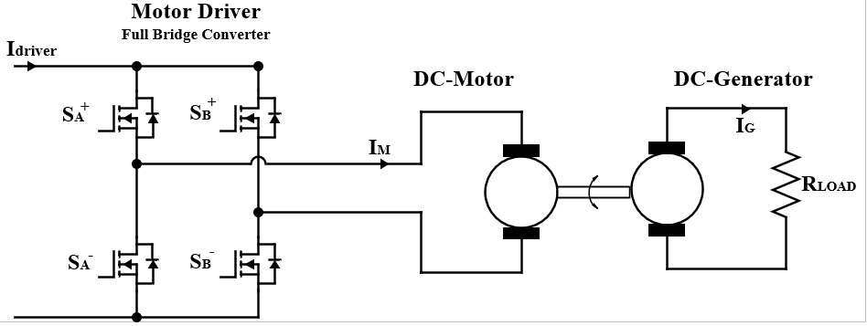

Figure Motor-Setup

The basic representation of the system is given in Figure 3.

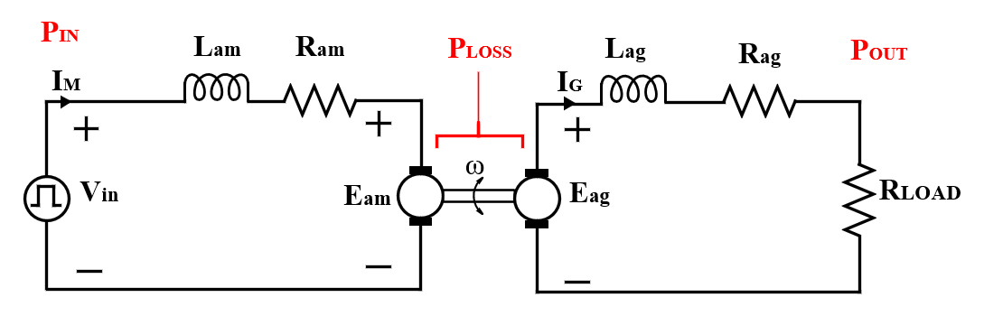

Figure Basic Representation Motor-Generator

|  |  |
| --- | --- |
| **Motor and Generator Parameters** | **Values** |
| **Ram** |  |
| **Lam** |  |
| **Kam** |  |
| **Rag** |  |
| **Lag** |  |
| **Kag** |  |

If we want work on constant torque (the motor current is same)

|  |  |  |  |  |
| --- | --- | --- | --- | --- |
| **Duty Cycle** | **Input Current** | **Motor Speed** | **Load Voltage** | **Load Current** |
| **0** |  |  |  |  |
| **0.05** |  |  |  |  |
| **0.1** |  |  |  |  |
| **0.15** |  |  |  |  |
| **0.20** |  |  |  |  |
| **0.25** |  |  |  |  |
| **0.30** |  |  |  |  |
| **0.35** |  |  |  |  |
| **0.40** |  |  |  |  |
| **0.45** |  |  |  |  |
| **0.50** |  |  |  |  |
| **0.55** |  |  |  |  |
| **0.60** |  |  |  |  |
| **0.65** |  |  |  |  |
| **0.70** |  |  |  |  |
| **0.75** |  |  |  |  |
| **0.80** |  |  |  |  |
| **0.85** |  |  |  |  |
| **0.90** |  |  |  |  |
| **0.95** |  |  |  |  |
| **1** |  |  |  |  |

# IPT and MOTOR

For different Frequency and duty cyle

|  |  |  |  |  |  |
| --- | --- | --- | --- | --- | --- |
| **Duty Cycle** | **Frequency** | **Motor Current** | **Motor Speed** | **Tx Current** | **Rx Voltage** |
| **0** |  |  |  |  |  |
| **0.05** |  |  |  |  |  |
| **0.1** |  |  |  |  |  |
| **0.15** |  |  |  |  |  |
| **0.20** |  |  |  |  |  |
| **0.25** |  |  |  |  |  |
| **0.30** |  |  |  |  |  |
| **0.35** |  |  |  |  |  |
| **0.40** |  |  |  |  |  |
| **0.45** |  |  |  |  |  |
| **0.50** |  |  |  |  |  |
| **0.55** |  |  |  |  |  |
| **0.60** |  |  |  |  |  |
| **0.65** |  |  |  |  |  |
| **0.70** |  |  |  |  |  |
| **0.75** |  |  |  |  |  |
| **0.80** |  |  |  |  |  |
| **0.85** |  |  |  |  |  |
| **0.90** |  |  |  |  |  |
| **0.95** |  |  |  |  |  |
| **1** |  |  |  |  |  |