Q3)

A boost converter is step-up converter that increases the voltage ( while decreasing the current). The converters have basically at least two semiconductors ( 2 mosfets or 1 diode and 1 mosfet) to switch. Also, it has energy storage elements such as capacitor and inductor. The energy storage elements can used for the filtering the output.

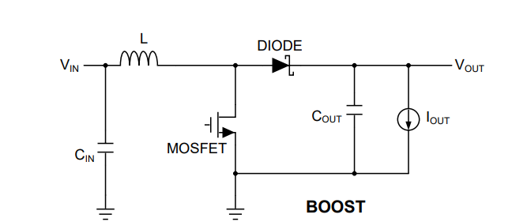

Figure 1 Basic Circuit of Boost Converter

Diode can be replaced by a Mosfet and it is called synchronous boost converter. Diode on resistance is bigger than mosfets on resistance in general. Thus, the synchronous boost converter is more efficient.

Ref:

<http://www.ti.com/lit/an/snva731/snva731.pdf>

Q. 3.1)

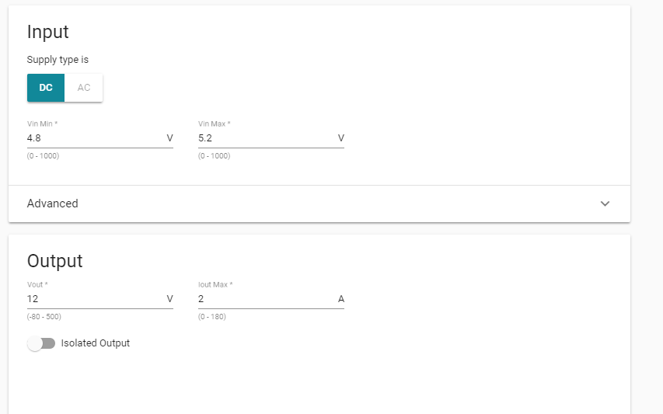

Figure 2 Input and Output of the Boost Converter

Figure 2 illustrates the input and output relations of the converter.

The Power Designer gives some selection about design consideration. I chose the ‘high efficiency’ design because the efficiency affects the other parameters indirectly. For example, power loss is determined by efficiency and it affects thermal cooling.

For the advanced selection:

Regulator Type: Converter(Integrated Switch)

Design Attributes:

Efficiency: %90-98

BOM Cost: 3-5 Dollars

BOM Area : 191-578 (mm^2)

Switching Frequency : 300-500 (kHz)

Inductor Ripple current: 0-1.6 (A)

Crossover Frequency : 1-33 (kHz)

Phase Margin : 24-68 (°)

BOM Count: 16-44

Topology : Boost

IC Features: Frequency Synchronization

My design is based on high efficiency, low-power dissipation and high power density because that the features are figure of merit of any design. The cost can be added to them.

3.2)

I chose TPS61088-Q1

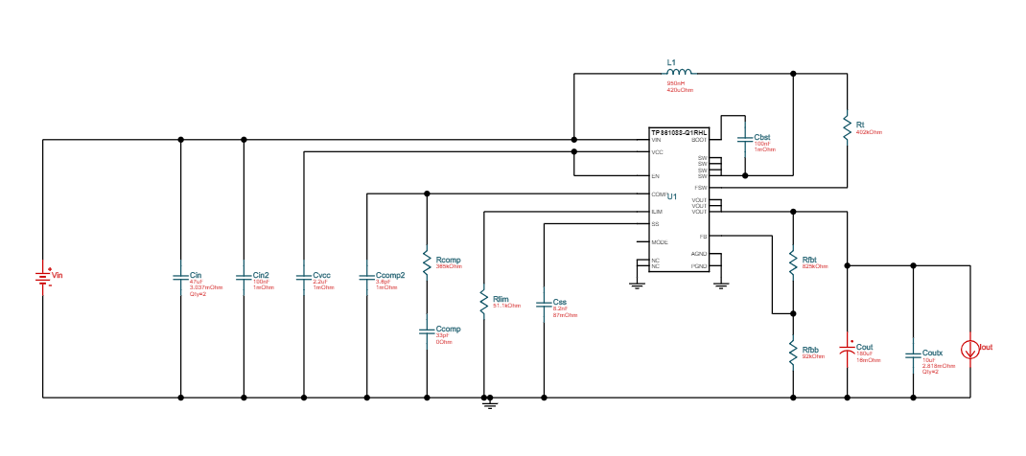

Figure 3 The Circuit Schematic of the Bus Converter

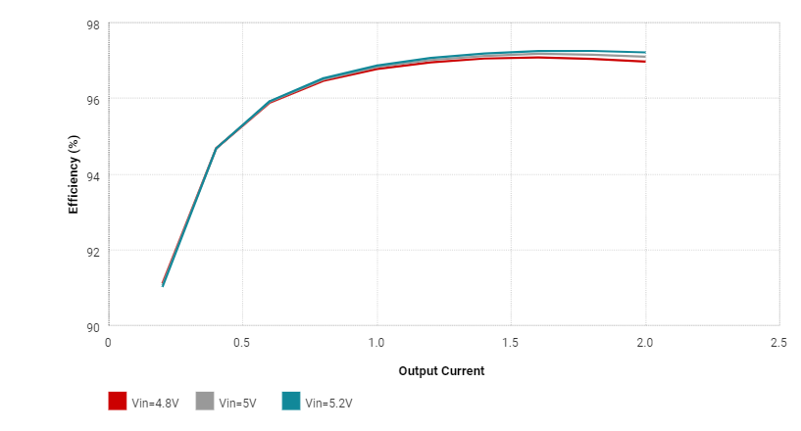

Figure 4 Efficiency vs Output Current Graph

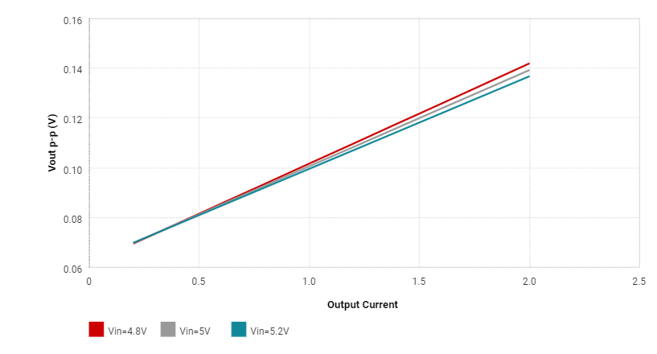

Figure 5 Output Voltage Ripple vs Output Current Graph

|  |  |
| --- | --- |
| * Inductor Current Peak to Peak Value | 7.74 A |
| * Output Voltage Peak to Peak Value | 141.96 mV |
| * Efficiency | %97 |
| * IC Junction Temperature | 49.43 |
| * Mode | BOOST CCM |
| * Footprint | 394 mm^2 |
| * BOM Cost | 5.26 Dollars |

Table 1 : Table of Some Operation Properties

|  |  |  |  |
| --- | --- | --- | --- |
| Cin Pd | 7.59 mW | Power | Input capacitor power dissipation |
| Cout Pd | 56.66 mW | Power | Output capacitor power dissipation |
| L Pd | 13.03 mW | Power | Inductor power dissipation |  |
| IC Pd | 671.04 mW | Power | IC power dissipation |  |
| Coutx Pd | 1.38 mW | Power | Output capacitor_x power loss |  |
| Total Pd | 749.92 mW | Power | Total Power Dissipation |  |

Table 2 :  Power Loss of all Components

Simulations :

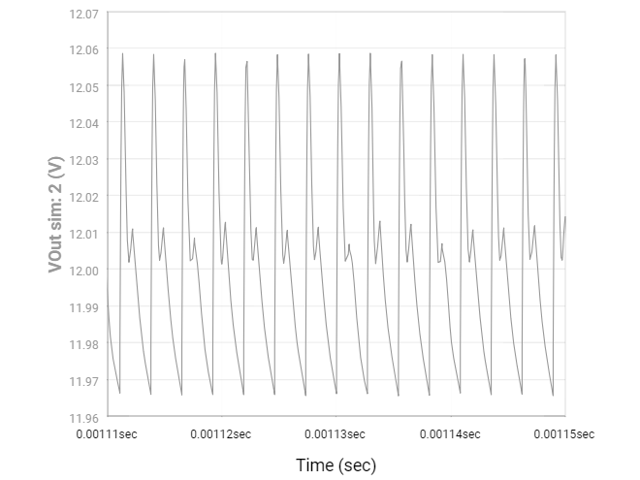

Figure 6 Output Voltage vs Time Graph for Steady-State

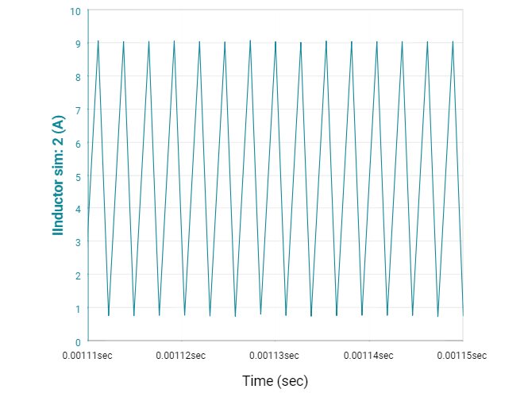

Figure 7 Inductor Current vs Time Graph for Steady-State

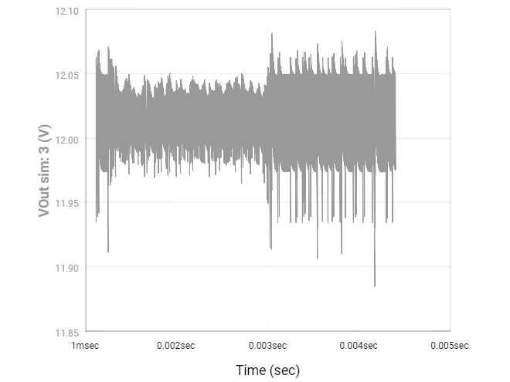

Figure 8 Output Voltage vs Time for Load Transient

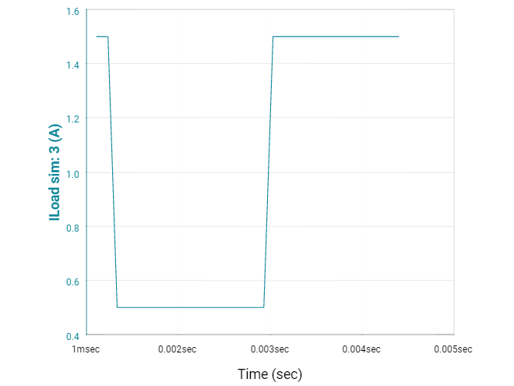

Figure 9 Load Current vs Time for Load Transient

Comments:

Firstly, we examined the efficiency and output voltage ripple in respect to different output current at Figure X and X+1. It was observed that output ripple increases while the output current increases. However, the ripple is very small and negligible for all of current until 2 Amperes (Rated Power). The efficiency is low when the converter is at discontinues mode, the output current is low.

Secondly, Our design is based on low power loss, high efficiency. Table 1 and 2 shows that the design provides them. Efficiency is % 97.

Finally, there are 4 simulation results which are steady-state output voltage, steady state inductor current and transient load voltage and current.

Steady state output voltage is almost purely DC. It swings between 11.97 and 12.06. Voltage ripple is low and the converter works properly at steady state.

Steady state inductor current shows that the inductor charges for the time without connection of load. Then, the charges flow the load when connection of load starts and the inductor current decreases.

As thinking about the basic asynchronous boost converter:

DT:

$\frac{di_{l}}{dt}=\frac{V_{in}}{L}$ (2)

(1-D)T :

$\frac{di_{l}}{dt}=\frac{V_{in}-V_{out} }{L}$ (3)

For the transient of the load, the output voltage was increasing to 12 volt fastly and swings. The load current is smaller for the transient time