

MIDDLE EAST TECHNICAL UNIVERSITY

Electrical & Electronics Engineering

Simulation Project #3

EE 463

Enes Ayaz – 2093318



# Introduction

In this project, we are supposed to drive motor by using thyristor full bridge rectifier, design a buck converter for fixed load at Simulink and design boost converter by using ‘Webench’ online design tools.

Firstly, Dc motor speed will be controlled by changing firing angle of three phase fully-controlled thyristor rectifiers. The system is closed loop and the speed of motor will be controlled real time. Secondly, a buck converter will be designed. Switching frequency and components will be chosen. Finally, a boost converter will be designed for wanted value of input and output. In addition, a design strategy will be chosen and basis of the strategy will be explained.

In short, AC to DC and DC to DC converter topologies, theoretical information and simulation results will be investigated at the report.

# Question-1)

In this question, we examined that Dc motor speed control by using fully controlled 3-phase thyristor rectifier.

## Rectifier Circuit:

3-phase thyristor rectifier are used for obtaining high voltages at output with small ripple. The output voltages are not smooth DC but the voltage ripple is much less than single phase pairs. In addition, the output of rectifier can be controlled by changing firing angle of thyristors. If the firing angle is smaller than 90 degree, the circuit operates at rectification.

The output voltage formula is stated as:

(1)

Vm is the peak value of line to line voltage and ‘a’ is the firing angle.

## DC MOTOR:

In this part, we used a permanent magnet DC motor. Thus, the dc motor has back-emf constant by considering the field is independent of the motor operations. The motor is loaded by 24 N.m mechanically.

Dc motor can be controlled by armature or field. The motor is controlled by armature control because the motor is permanent magnet and no field control. Speed of the motor is related to back-emf of the motor. However, we do not control directly the back-emf. Thus, we control the terminal voltage to control speed of the motor. The speed control can be closed loop to ensure that the motor speed converges the desired speed. The closed loop is created by directly switch on-off algorithm or combinations of ‘PID’ controller.

## CONROLLING:

The speed of motor is controlled by terminal voltage. The terminal voltage can be adjustable by changing the firing angle. Thus, the speed of motor is controlled by firing angle. However, the relationship of firing angle and speed is not linear and it is in opposite-relation. In addition, maximum voltage restricts the maximum speed of the motor. The speed of the motor can not climb over the speed.

## SIMULATION:

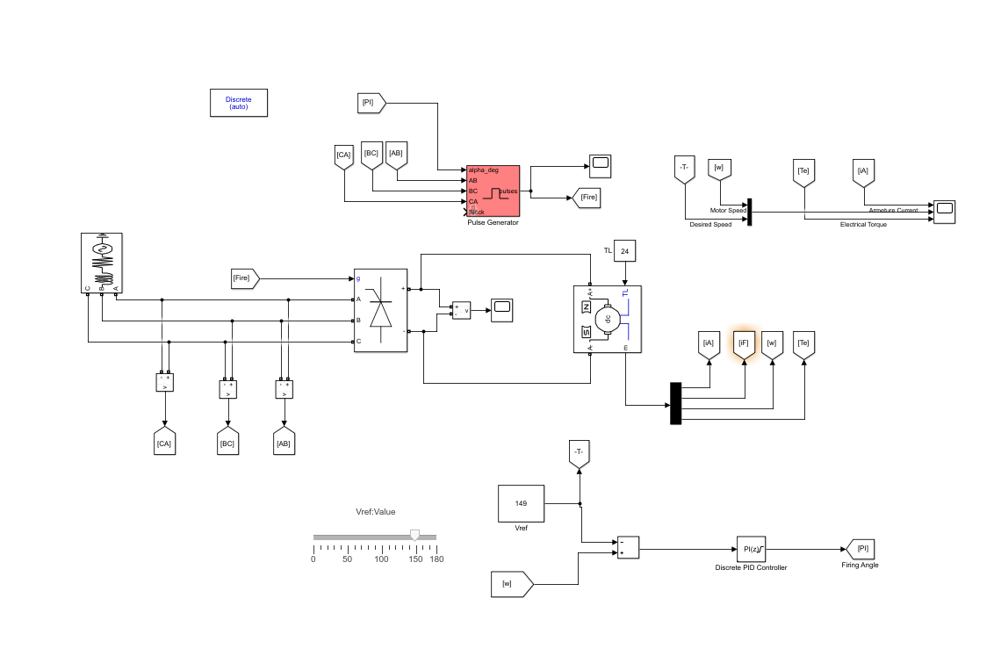

Figure 1 Overall Circuit Diagram of the Speed Control of the DC Motor

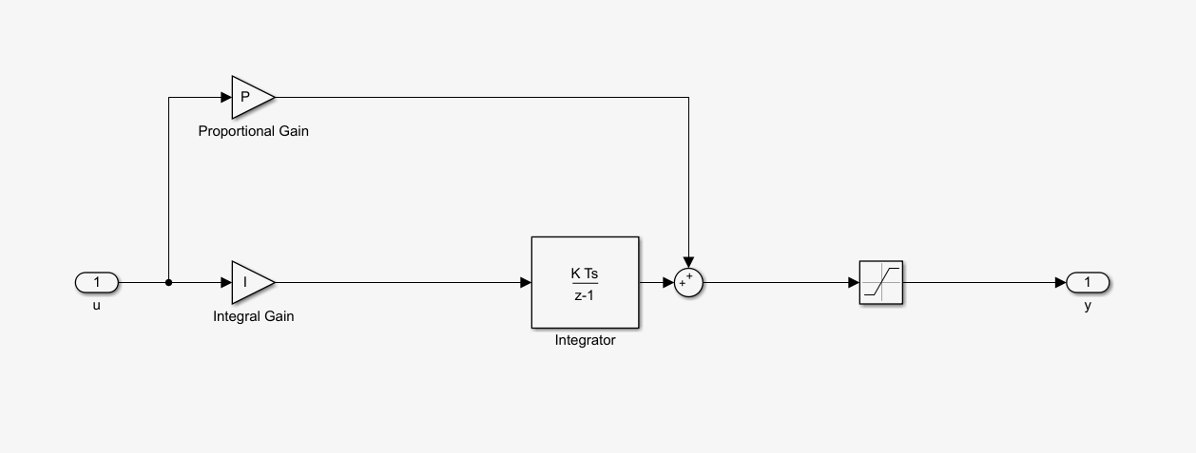

Figure 2: PI Controller

The AC-DC converter and DC motor controlling system are illustrated at Figure 1. The PI controller is illustrated at Figure 2. PI controller has a saturation block because the firing angle is restricted between 0 and 180 degree.

## SIMULATION RESULTS:

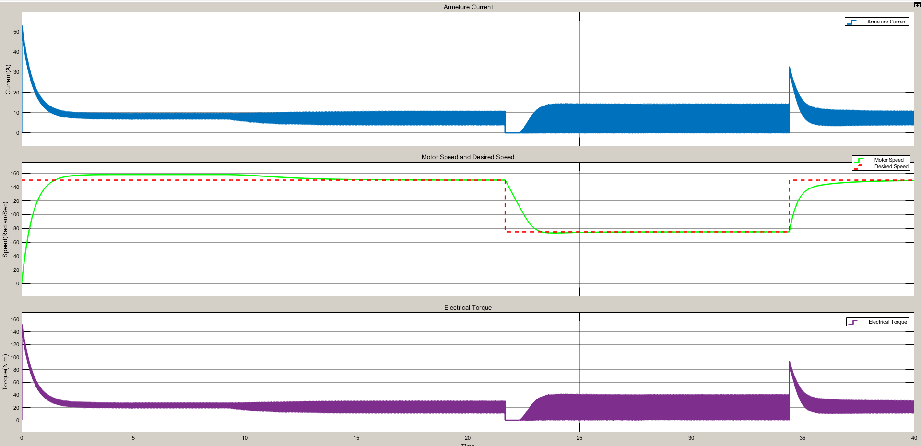

Figure 3 Armeture Current ,Motor Speed,,and Electrical Torque with 150 rad/sec and 75 rad/sec Desired Speed

The desired speed is adjusted to 150 rad/sec until the 22 second. The motor maximum speed is 157 rad/sec with restriction of terminal voltage. Thus, the overshoot effect can not be observed at initial. If there was no restriction, overshoot could be observed. For the, 150 rad/sec to 75/rad sec transitions are much smoother than initial because the inertia of the motor was overcame at initially. Thus, there is no overshooting effect at 150 to 75 and 75 to 150 rad/sec transitions at t=22 sec and t=34 sec.

The desired speed can be increased by slowly. The response of the motor changes.

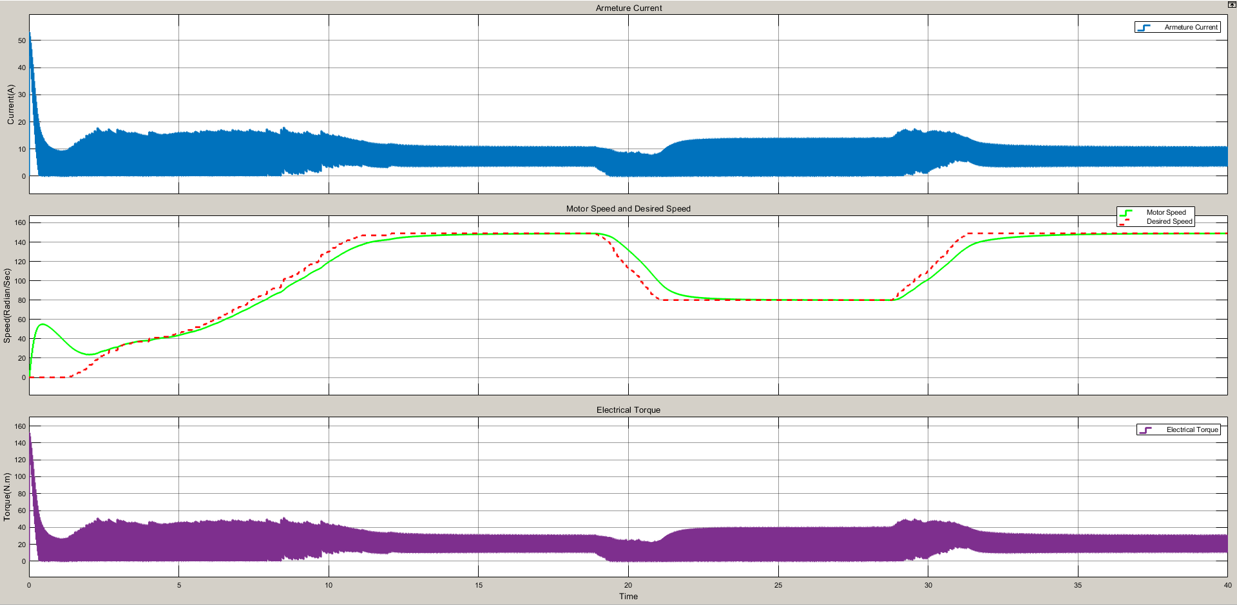

Figure 4 Armeture Current ,Motor Speed,,and Electrical Torque with Slowly Changing Desired Speed

The motor speed follows the desired speed narrowly by avoiding abrupt changes at desired speed. Also, the overshoot is observed at initially.

# Question-2)

# Question-3)

A boost converter is step-up converter that increases the voltage ( while decreasing the current). The converters have basically at least two semiconductors ( 2 mosfets or 1 diode and 1 mosfet) to switch. Also, it has energy storage elements such as capacitor and inductor. The energy storage elements can used for the filtering the output.

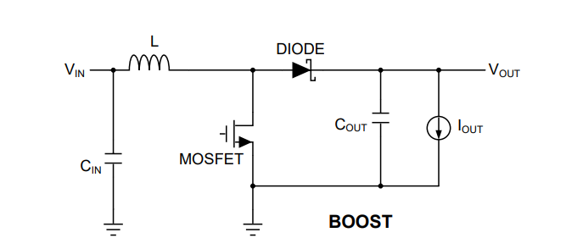

Figure 1 Basic Circuit of Boost Converter [1]

Diode can be replaced by a Mosfet and it is called synchronous boost converter. Diode on resistance is bigger than mosfets on resistance in general. Thus, the synchronous boost converter is more efficient.

## 3.1



Figure 2 Input and Output of the Boost Converter

Figure 2 illustrates the input and output relations of the converter.

The Power Designer gives some selection about design consideration. I chose the ‘high efficiency’ design because the efficiency affects the other parameters indirectly. For example, power loss is determined by efficiency and it affects thermal cooling.

For the advanced selection:

Regulator Type: Converter(Integrated Switch)

Design Attributes:

Efficiency: %90-98

BOM Cost: 3-5 Dollars

BOM Area : 191-578 (mm^2)

Switching Frequency : 300-500 (kHz)

Inductor Ripple current: 0-1.6 (A)

Crossover Frequency : 1-33 (kHz)

Phase Margin : 24-68 (°)

BOM Count: 16-44

Topology : Boost

IC Features: Frequency Synchronization

My design is based on high efficiency, low-power dissipation and high power density because that the features are figure of merit of any design. The cost can be added to them.

## 3.2

I chose TPS61088-Q1

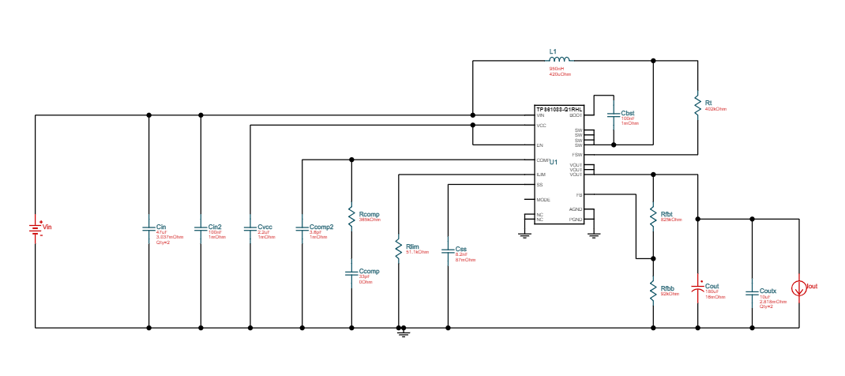

Figure 3 The Circuit Schematic of the Bus Converter

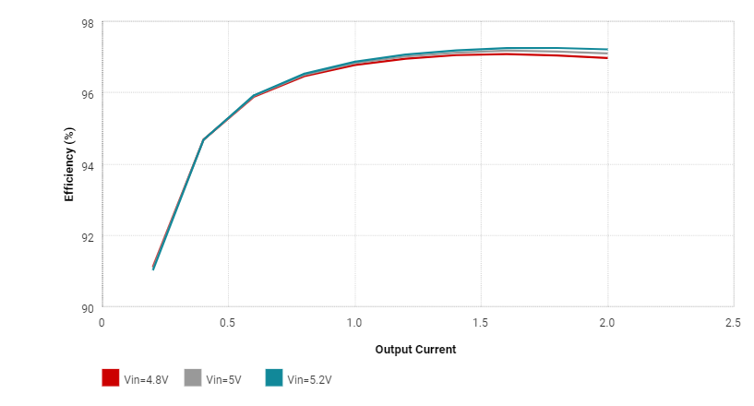

Figure 4 Efficiency vs Output Current Graph

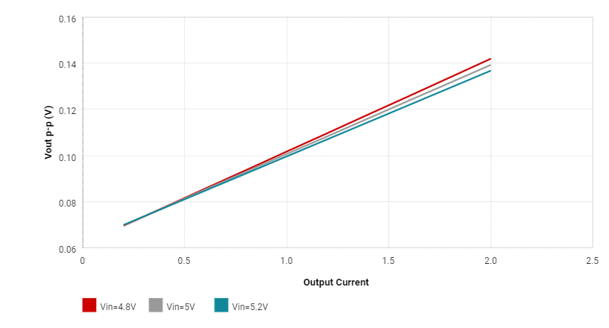

Figure 5 Output Voltage Ripple vs Output Current Graph

|  |  |
| --- | --- |
| Inductor Current Peak to Peak Value | 7.74 A |
| Output Voltage Peak to Peak Value | 141.96 mV |
| Efficiency | %97 |
| IC Junction Temperature | 49.43 |
| Mode | BOOST CCM |
| Footprint | 394 mm^2 |
| BOM Cost | 5.26 Dollars |

Table 1 : Table of Some Operation Properties

|  |  |  |  |
| --- | --- | --- | --- |
| Cin Pd | 7.59 mW | Power | Input capacitor power dissipation |
| Cout Pd | 56.66 mW | Power | Output capacitor power dissipation |
| L Pd | 13.03 mW | Power | Inductor power dissipation |  |
| IC Pd | 671.04 mW | Power | IC power dissipation |  |
| Coutx Pd | 1.38 mW | Power | Output capacitor_x power loss |  |
| Total Pd | 749.92 mW | Power | Total Power Dissipation |  |

Table 2 :  Power Loss of all Components

### Simulations :

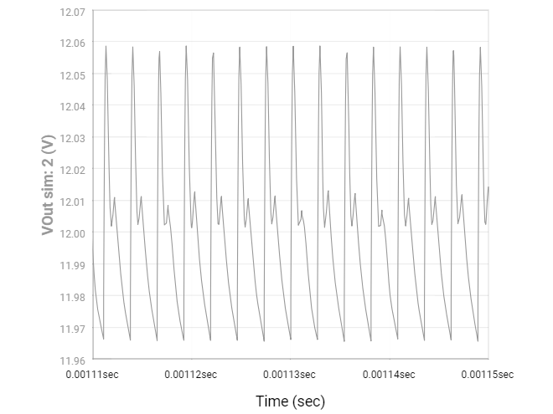

Figure 6 Output Voltage vs Time Graph for Steady-State

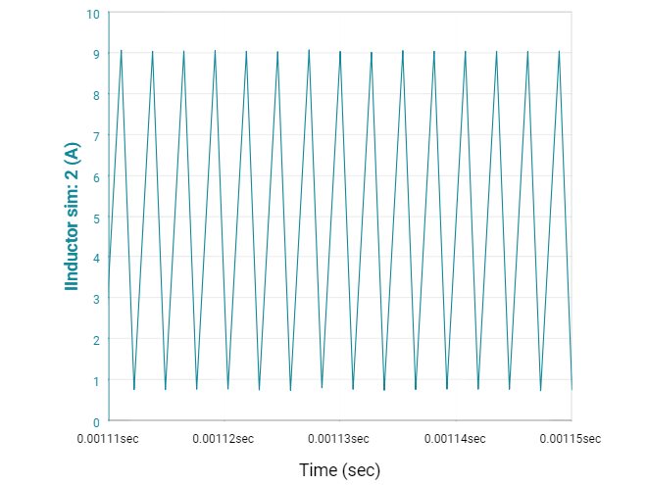

Figure 7 Inductor Current vs Time Graph for Steady-State

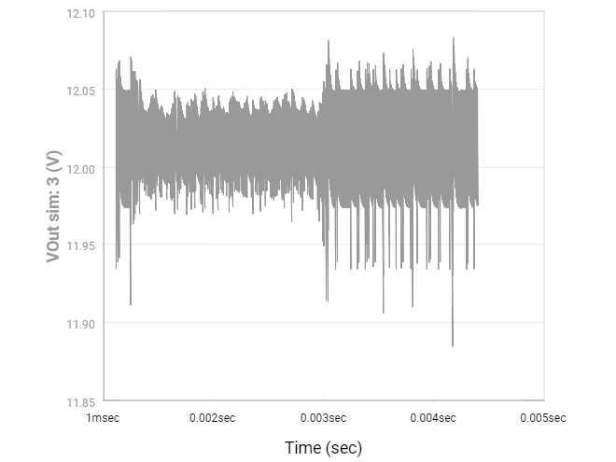

Figure 8 Output Voltage vs Time for Load Transient

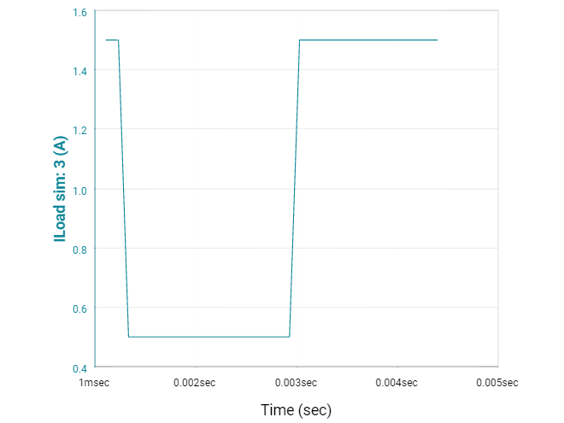

Figure 9 Load Current vs Time for Load Transient

### Comments:

Firstly, we examined the efficiency and output voltage ripple in respect to different output current at Figure X and X+1. It was observed that output ripple increases while the output current increases. However, the ripple is very small and negligible for all of current until 2 Amperes (Rated Power). The efficiency is low when the converter is at discontinues mode, the output current is low.

Secondly, Our design is based on low power loss, high efficiency. Table 1 and 2 shows that the design provides them. Efficiency is % 97.

Finally, there are 4 simulation results which are steady-state output voltage, steady state inductor current and transient load voltage and current.

Steady state output voltage is almost purely DC. It swings between 11.97 and 12.06. Voltage ripple is low and the converter works properly at steady state.

Steady state inductor current shows that the inductor charges for the time without connection of load. Then, the charges flow the load when connection of load starts and the inductor current decreases.

As thinking about the basic asynchronous boost converter:

DT:

(2)

(1-D)T :

(3)

For the transient of the load, the output voltage was increasing to 12 volt fastly and swings. The load current is smaller for the transient time

# Conclusion

.

References :

[1] <http://www.ti.com/lit/an/snva731/snva731.pdf>