

**MIDDLE EAST TECHNICAL UNIVERSITY**

ELECTRICAL & ELECTRONICS ENGINEERING

*EE463 – STATIC POWER CONVERSION 1*

*TERM PROJECT – COMPLETE SIMULATION REPORT*

Emin ÜN 2167476

Enes CANBOLAT 2231546

Berkay UZUN

**25.12.2020**

TABLE OF CONTENTS

1- INTRODUCTION 2

2- TOPOLOGY SELECTION 2

3- CIRCUIT ANALYSYS & SIMULATION RESULTS 3

3.1 Diode Rectifier and Buck Converter Block 3

3.2 Current Sense and Amplifier Block 5

3.3 DC Voltage Generator Block 6

3.4 Error Amplifier Block 7

3.5 PI Controller Block 8

3.6 PWM Generator Block 9

4- COMPONENT SELECTION 10

5- CONCLUSION 10

# INTRODUCTION

Renewable energy is defined as useful energy collected from renewable resources. Wind is one of the renewable resources. It is used to provide a mechanical power to the wind turbines to generate electricity. The wind power is widely used sustainable energy. However, there are some problems on using the electricity produced in the wind turbines. These turbines, generally, behaves as an electric generator with a continuously varying output voltage and output current. In this project, Kardesler Elektronik A.Ş. introduces AC to DC Converter project which regulate the output current. In the first part of this report, the topology of the converter will be discussed. The advantages and disadvantages of different topologies will be compared. Moreover, the reason for the topology selection will be given. In the second part, the circuit schematic and its simulation results with ideal cases will be provided. Moreover, the component selection and cost analysis will be provided in the second part. To conclude, our engineering skills on circuit design, simulations and our project management skills will improve. Additionally, this project will give us an opportunity to implement the theoretical knowledge of us on EE463 lecture.

# TOPOLOGY SELECTION

As mentioned in the ‘Introduction’ section, generated voltage needs to be rectified to feed the given battery. To do this rectification, there are some topologies that can be used. Using 3-phase thyristor rectifier and the diode rectifier with a buck converter are the most common ones. In this project we preferred the diode rectifier with a buck converter topology because of some reasons. Firstly, controlled the thyristors considering their phase difference is not an easy job; however, the diode rectifier does not need any gate voltage and operates without any external intervention. On the other hand, we need to control the gate voltage of the MOSFET and hence the duty cycle of the buck converter to keep the output current same. For this operation, again there is no one solution, using integrated circuits (IC) is one of the alternative solutions; however, the operating conditions are very important for these ICs. As shown in the ‘Simulation Results’ section, input voltage varies, and this high voltage can damage the selected IC. That’s why, we preferred to control the gate signal of the MOSFET with an analog circuit design. Moreover, we wanted to observe the feedback operation step by step. If we used an integrated circuit, we would not be able to observe the entire circuit. Due to missing IC models in MATLAB and modeling problem of input generator and battery in other simulation applications, we wouldn't be able to examine the performance of the design. Because of the pandemic conditions, we have also no chance to physically work on the designed circuit in the laboratory. Considering all these reasons, we decided to design an analog PI controller circuit. Last thing, we need to feed the gate of the MOSFET and hence we used one of the most common PWM generators called 555timer which can also be modelled in MATLAB Simulink. In short, we chose diode rectifiers with a buck converter topology and designed a closed loop PI feedback controller without using any integrated circuit. In the following section, circuit blocks will be examined in detailed and the simulation results will be shown.

# CIRCUIT ANALYSYS & SIMULATION RESULTS

As mentioned before, out circuit design includes some parts and in this section these blocks are examined in detailed. In Figure 1, block diagram of the circuit design is visualized.

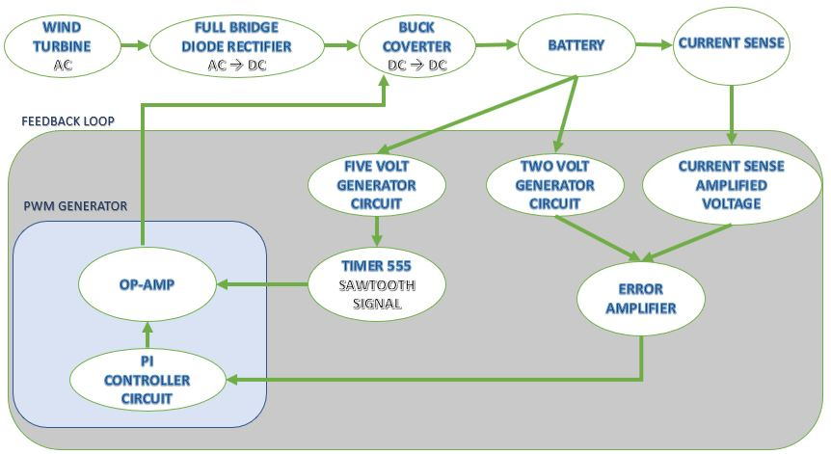

Figure 1 Block Diagram of the Circuit Design

## 3.1 Diode Rectifier and Buck Converter Block

As we learnt in our lectures, 3-phase diode rectifier is a good method to rectify the given AC signal; however, it is not enough to feed the battery without any external component since output of the rectifier depends on the input voltage and it is affected by the changes in the input voltages. In the following Figure 2, this input voltage waveforms of the rectifier are illustrated.

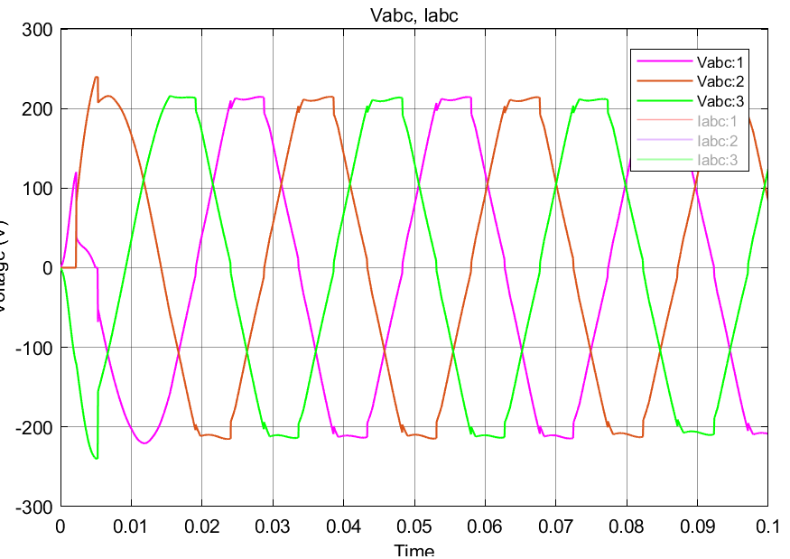

Figure 2 Input Voltage Waveforms of Diode Rectifier

The output voltage waveform is not a pure DC signal, in other words, voltage ripple is very high on this waveform. Therefore, we used a shunt capacitor (100µF) to filter this signal. Then, we connected this output to the MOSFET of the buck converter. For the buck converter design 15mH inductor and 100µF capacitor are used. In the following Figure 3, this block of the design is shown, also in the next figure the input currents of the diodes are shown. These current values are important while selecting the proper diode.

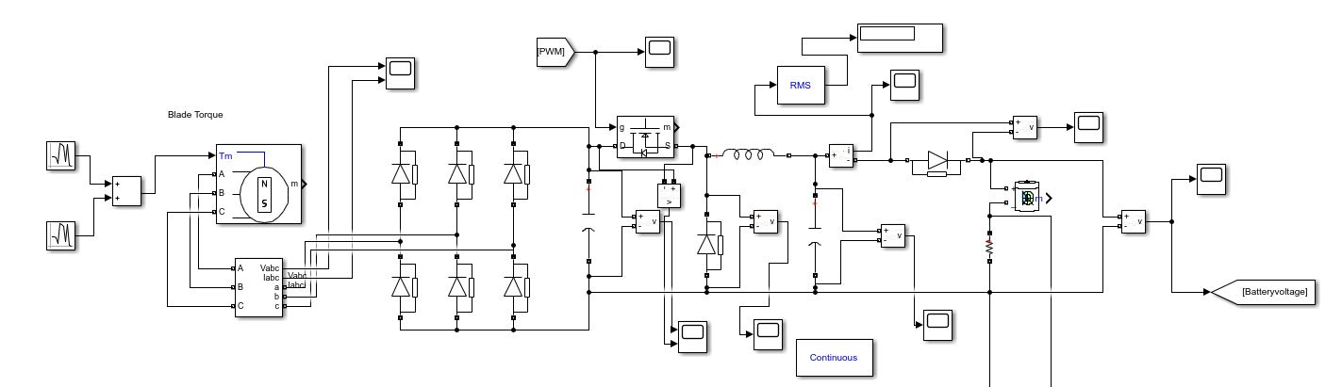

Figure 3 Diode Rectifier and Buck Converter Block

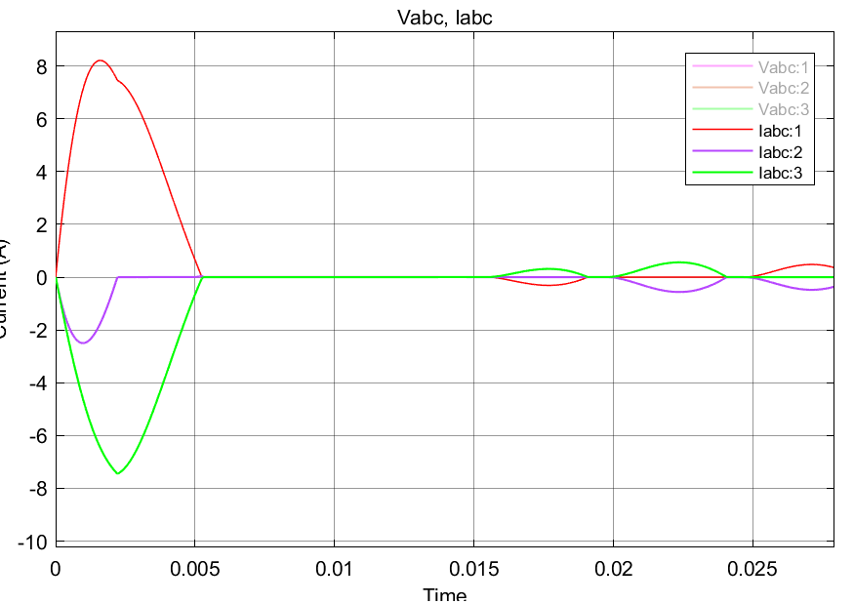

Figure 4 Input Current Waveforms of Diodes

## 3.2 Current Sense and Amplifier Block

In the project description, the input current value of the battery is given as a constant 2A and the ripple limit is 20% of the average current which is also specified in this description. Not to exceed this limit we connected a small resistor (250mΩ) to the negative leg of the battery. By checking the voltage on this resistor, we can understand the current flow through the resistor and hence the battery and using this knowledge we can start our feedback loop; however, the resistance and current values are not high enough to decide the error. Therefore, we amplified this voltage value up to 3V and this block and this amplified voltage are shown in Figure 5 and Figure 6, respectively.

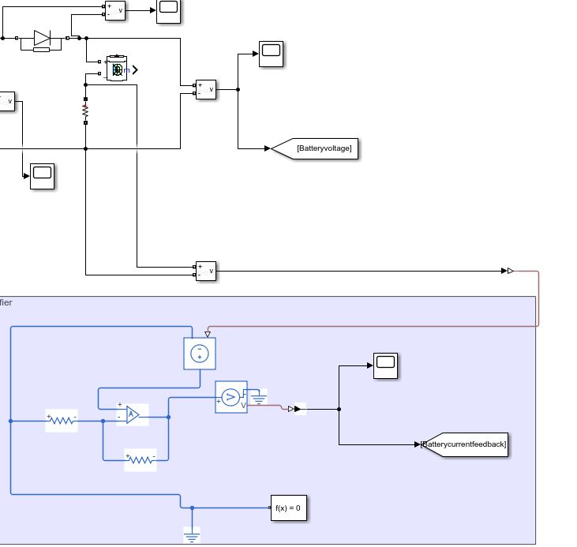

Figure 5 Current Sense and Amplifier Block

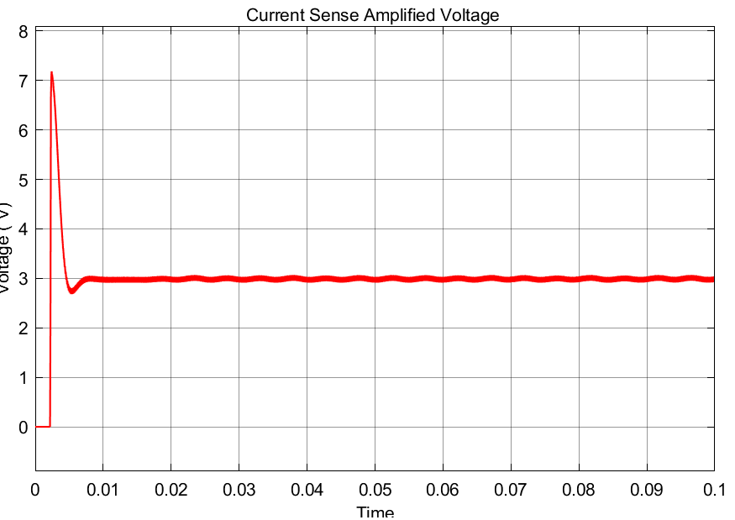

Figure 6 Waveform of Current Sense Amplified Voltage

## 3.3 DC Voltage Generator Block

In this design, we need to use DC voltages in some parts of the circuit such as feeding op-amps, input of error amplifier and input of 555timer component. Instead of using external DC supply voltage, we use the battery input voltage. In the following Figure 7, circuit schematic of this voltage generation block is shown. Note that, in this design we need 2 and 5V values and their circuit schematic consist of two inverting amplifiers with different resistive values. In Figure 8 both 2V and 5V blocks’ output values are shown.

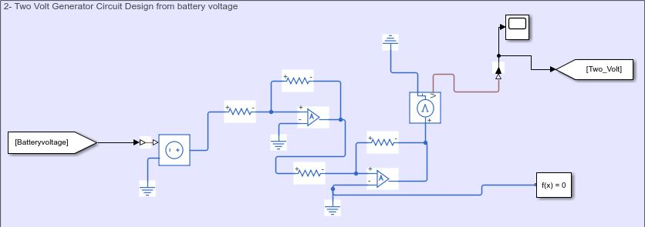

Figure 7 2 & 5V DC Generator Block

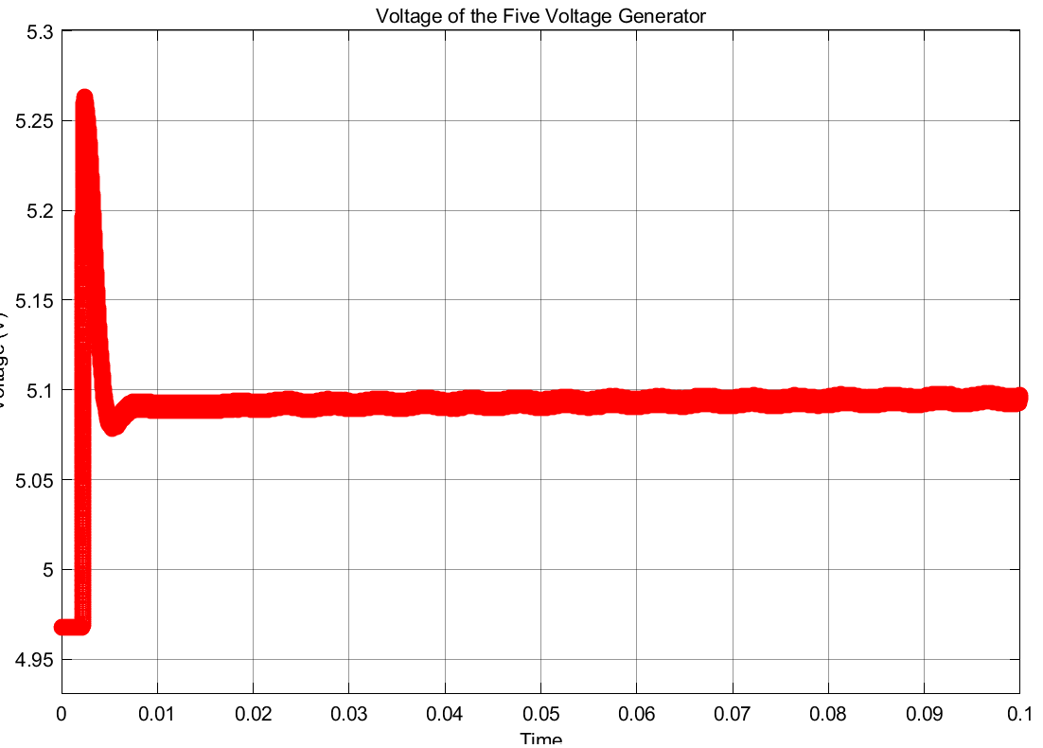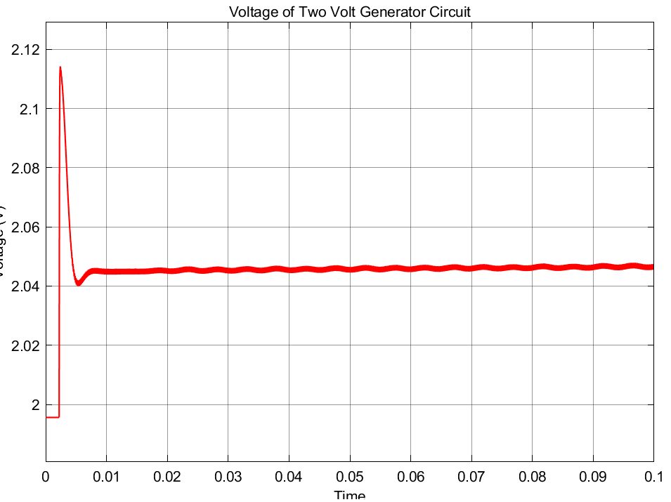

Figure 8 Output waveforms of 2- & 5-Volt Generation

## 3.4 Error Amplifier Block

In this part of the design, we found the error voltage using differentiator circuit design. Using the 2 Volt DC and amplified current sense values, difference between the (V+ & V-) input voltages of op-amp is given as the output of this differentiator. Then, using this knowledge we can arrange the duty cycle of the buck converter. The positive error means that the current is lower than 2A and the duty cycle needs to be increased and if the negative error is observed, this time the current passing through the battery is higher than 2A and the duty cycle needs to be decreased in order to decrease the current value. The error amplifier block and the error signal can be shown in the following Figure 9 & 10, respectively.

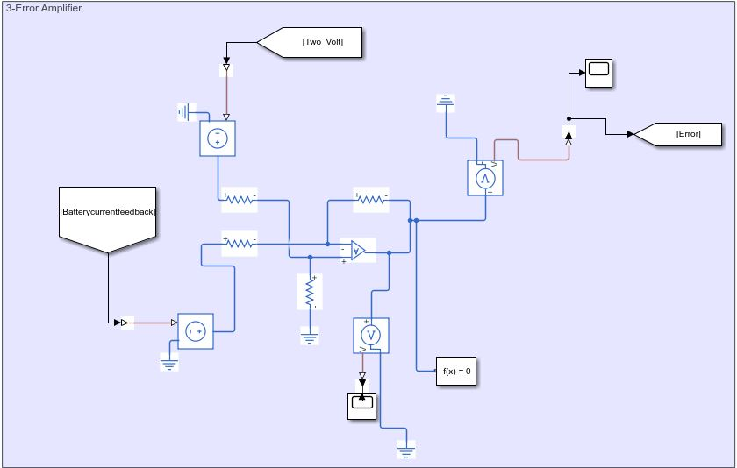

Figure 9 Error Amplifier Block

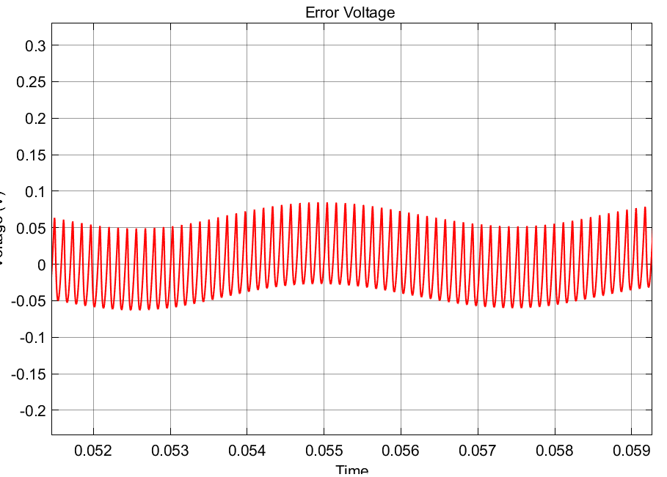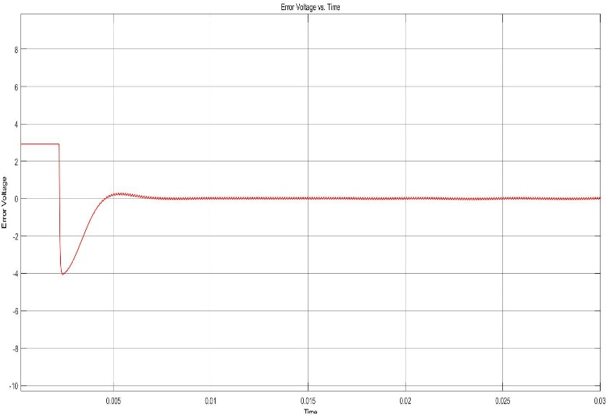

Figure 10 Error Voltage Waveform Before the Steady-State (Left Side) & Zoomed Version In the Steady-State (Right Side)

## 3.5 PI Controller Block

Aim of this block is control the battery current using the error voltage which is explained in the previous section. As known, the transfer function of PI Controller is and to create this transfer function we used 3 sub-circuits that are proportional, integrator and summer. If it is necessary to explain briefly, proportional part amplifies the error voltage and the ratio of two resistors in this part is the important parameter. The integrator block takes the integral of error voltage and multiplication of resistor and capacitor values are the important parameter for this block. Finally, the summer block sums these two values. The following Figure 11 shows the PI Controller block and the output waveform of this block can be seen in Figure 12.

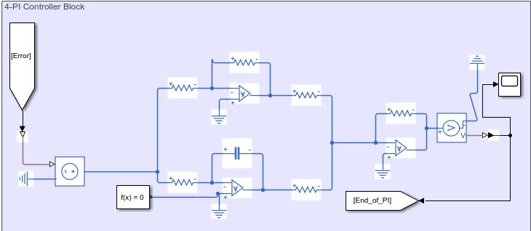

Figure 11 PI Controller Block

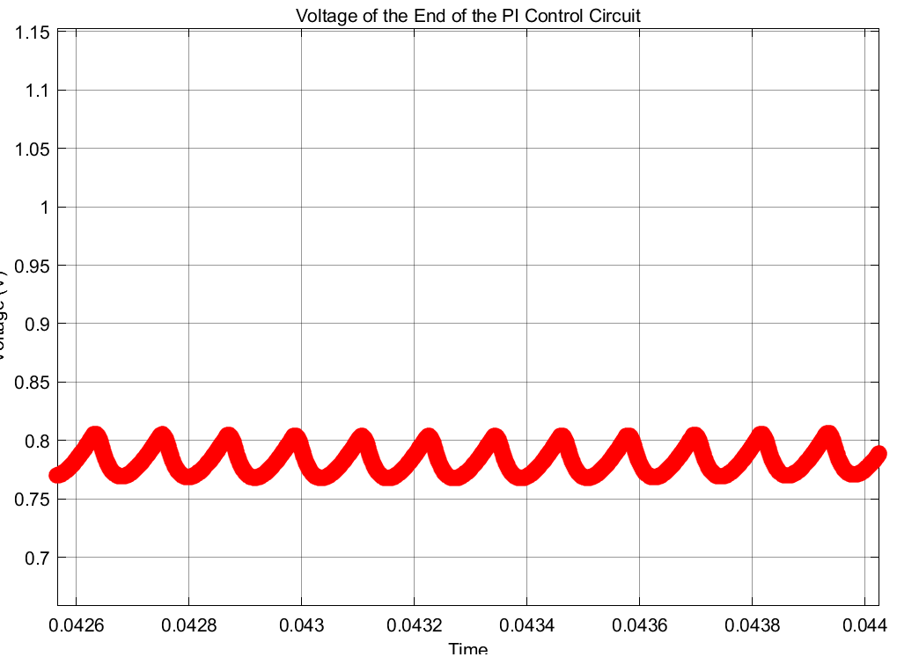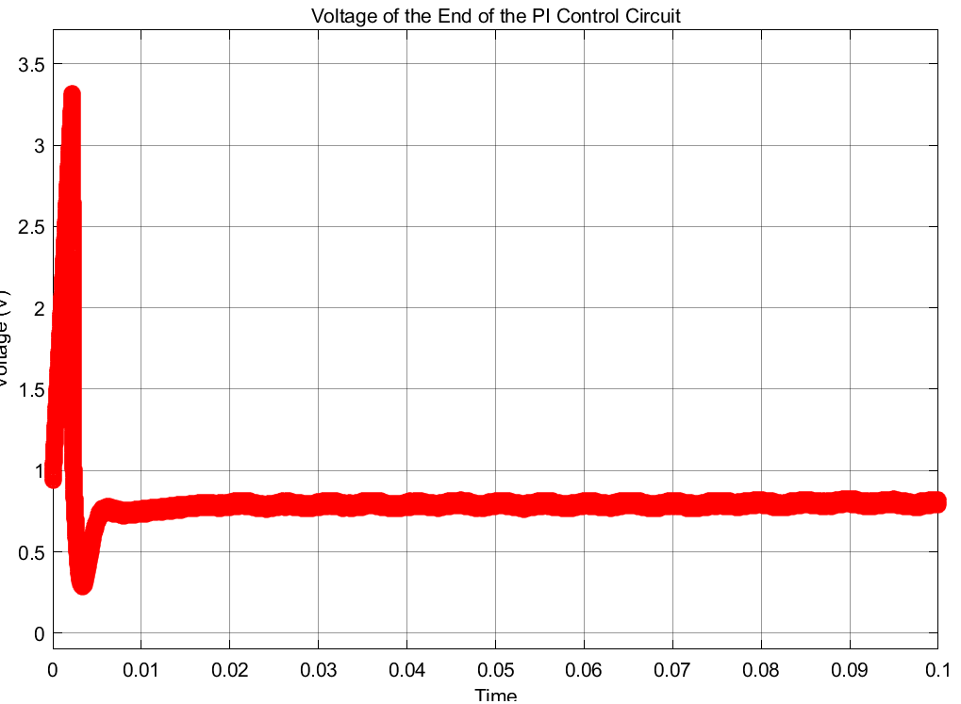

Figure 12 Output Voltage Waveform of the PI Controller Block (Zoomed Version is Shown in the Right Side)

## 3.6 PWM Generator Block

Last step of the feedback loop is generating the pulse voltage considering the output voltage of PI Controller block. In this part, we used a common component called 555Timer and this creates the sawtooth signal. In order to activate this 555Timer device, we feed it with 5V which is mentioned in the previous sections of the report. Then using an op-amp, we can compare the output of PI Controller and this generated sawtooth voltage. After this compare operation, output is a form of square wave, in other words, pulsating voltage waveform with changing duty cycle depending on the battery current. Both op-amp and Timer555 component creates the PWM Generator block which is shown in the following Figure 13. Moreover, the output of this PWM generator can be seen in Figure 14. Note that, this voltage directly connected with the gate of the MOSFET of the buck converter.

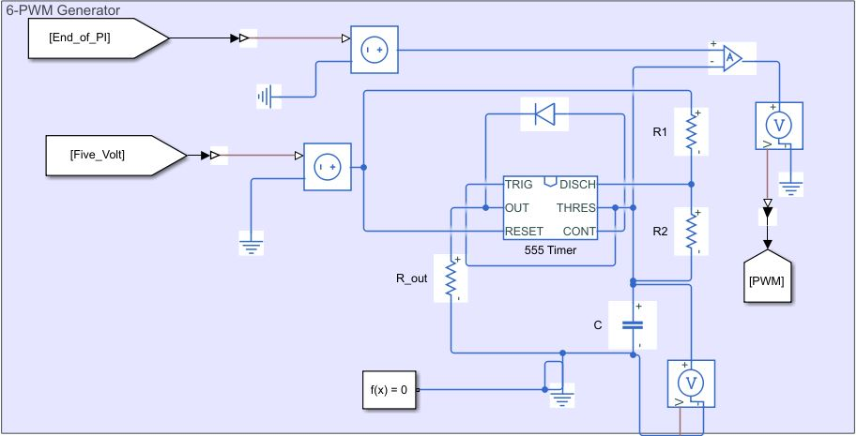

Figure 13 PWM Generator Block

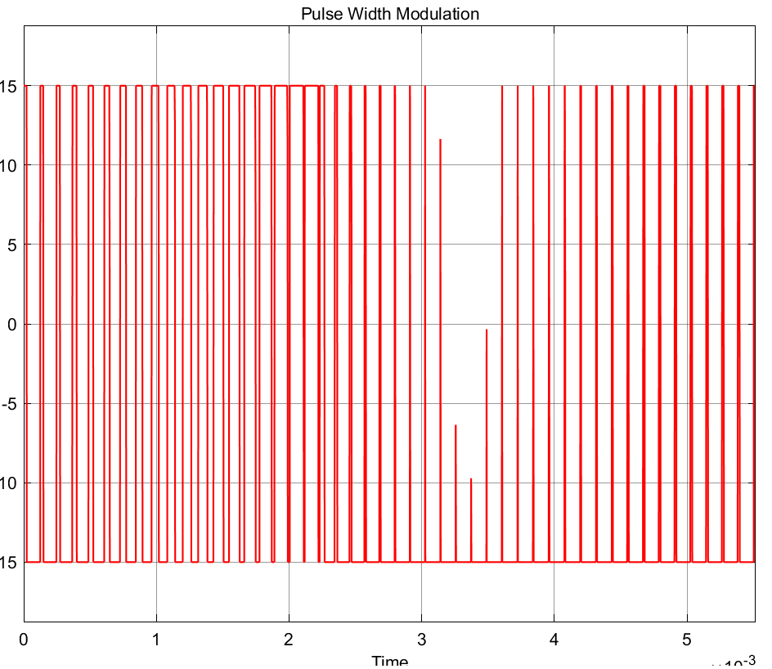

Figure 14 Input of the MOSFET's Gate

At the end of this feedback loop we can get 2.013 A average current which passing through the battery. The ripple on this current is about 5% of the average current. (It changes between 1.96 and 2.06A) In the following Figure 15, this battery current can be seen.

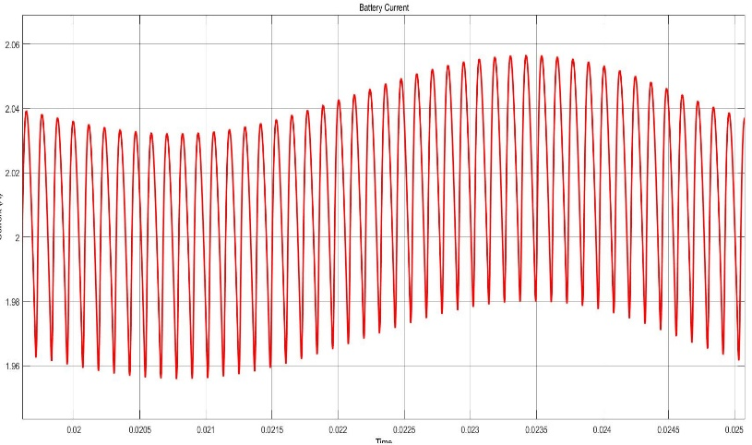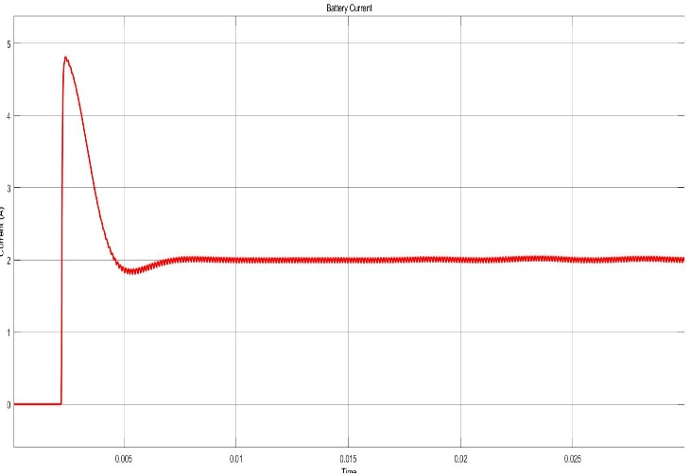

Figure 15 Waveform of the Battery Current (Zoomed Version is Shown in the Right Side)

# COMPONENT SELECTION

# CONCLUSION