

MIDDLE EAST TECHNICAL UNIVERSITY

ELECTRICAL & ELECTRONICS ENGINEERING DEPARTMENT

EE464

Static Power Conversion-II

TERM PROJECT

“DC/DC Converter Design for Tesla Model S”

**Student Names – Student ID’s**

Ceyhun Koç - 2166833

Enes Canbolat – 2231546

Eren Özkara - 2232551

Table of Contents

1. Introduction 2

2. Topology Selection 2

3. Operating Mode Selection 3

4. Analytical Calculations and Simulation 3

5. Magnetic Design 6

6. Component Selection and Controller 10

6.1. Controller 10

6.2 Discrete Component Selection 11

7. Detailed Simulation Results 13

8. Hardware Design 19

8.1. Schematic Design 19

8.2. Cost Analysis 22

9. Conclusion 23

References 24

# Introduction

Nowadays, electric vehicle technology is a rising trend and Tesla is leading this technological leap. In Tesla Model S, there are two batteries, high and low voltage ones, and there is a connection between them. The problem is that their voltage levels are so different, and it is needed to design a converter between them. At this point, Martian Power Solutions introduce a solution for this problem. Specs of the project are listed below, and the rest of the report contains the topology selection, some theoretical calculations, the component selection including the magnetic core design step and the realistic simulation results are mentioned in detail. Also, a schematic of the design is shown that will be used in the PCB design process.

* **Minimum Input Voltage:** 220 V
* **Maximum Input Voltage:** 400 V
* **Output Voltage:** 12 V
* **Output Power:** 100 W
* **Output Voltage Peak-to-Peak Ripple:** 4%
* **Line Regulation** (Deviation of percent output voltage when the input voltage is changed from its minimum to maximum or vice versa): 3%
* **Load Regulation** (Deviation of percent output voltage when the load current is changed from 10% to 100% or vice versa): 3%

Thanks to this project, we as engineers of Martian Power Solutions will improve our engineering skills. Moreover, we have a chance to use the theoretical knowledge that we have learned in the EE464 course.

# Topology Selection

In the scope of this project, there are three main topologies come forward that are Flyback Converter, Forward Converter, and Push-Pull Converter. All these topologies can be used between the high and low voltage batteries of Tesla Model S with an isolation mechanism. Also, all of these converter topologies give chance to adjust the output voltage with another parameter, the turns ratio. Flyback Converter topology is created from the buck-boost converter topology with a transformer that helps to store the energy. The Flyback is the most common and most studied on topology. Therefore, there are lots of source and application notes for this choice. Although it is preferable for low-power applications, the topology can supply the output current up to 10 A safely which is lower than the given specs of the project. The forward converter is created from the buck converter topology with a transformer. Like Flyback, Forward Converters are preferable for low-power applications. In the magnetic design, a gapless core can be used for the Forward Converter design and this increases the Lm value which means less ripple at the output; however, due to extra inductor and diode cost could be higher than the Flyback converter. Also, in DCM mode gain changes dramatically. Moreover, MOSFET should withstand higher voltages which increases the size of the design. Forward Converters works stable even the exceeding 15 Amperes limit. Due to these crucial disadvantages, Forward Converter is not the selected topology. Push-Pull Converter is a kind of Forward Converter with two primary windings to create a dual-drive winding. Utilization of the magnetic core is better compared to the two other topologies since in this topology the magnetic core can operate both the 1st and 3rd quadrants of the B-H curve. On the other hand, the switching control mechanism is harder than the other ones because as known both switches never should be activated at the same time. Moreover, Push-Pull Converters are a better choice for very high-power applications. Considering the above criteria Flyback Converter topology is the best choice for this project. Furthermore, the engineers of Martian Power Solutions had some experience in designing Flyback Converter circuits, and using these experiences results in a better solution for this project.

# Operating Mode Selection

There are both advantages and disadvantages of the two operating modes, CCM and DCM. CCM is preferable for high-power applications while DCM is preferable for low-power applications. The switching performance of DCM is better since the diode operates zero current just before the activating time. Also, transformer size in this mode is smaller; however, the peak and RMS value of the output current is higher than the CCM operation. This situation increases the stress level on the output capacitor and conduction losses on the MOSFET. Therefore, for the cases where the output has high voltage and low current DCM is a better option. On the other hand, CCM should be a better selection for the low output voltage and high output current. Furthermore, the controller is another important decision criterion of operating mode. Due to the specs of the project, there are no many suitable controllers or PWM generator selections in the market. LT8316 was chosen as a controller of this project and why this controller was selected is explained in the "Controller Selection" section in detail. In the description of the controller, it can be seen that the IC has a pin called the DCM pin. This pin detects the change of the voltage with respect to the time () of the switching waveform and controls the operating mode by adjusting the duty cycle of the system. The aim of this control mechanism called critical conduction mode is to operate the circuit almost in the boundary conditions since the controller improves load regulation without extra resistors and capacitors at the output side and reduces the transformer size with high efficiency at the boundary conditions. In short, the Flyback Controller with LT8316 operates at the boundary between the continuous and discontinuous conduction modes. To keep the operation at the boundary, the switching frequency of the system is variable. Thanks to the controller, the advantages of both continuous and discontinuous modes can be enjoyed in the design.

# Analytical Calculations and Simulation

This section contains analytical calculations and simulations for flyback converters. Since the controllers, whose details will be explained later, force the system to operate in boundary mode, calculations will be made according to the continuous current mode, and values of components will be taken in accordance with boundary mode.

Duty cycle values close to ideal conditions are calculated as in Equation 1. As a result of the research of the controller and transformer design, it was decided that the turn ratio value should be close to 4. Under normal conditions, considering the power loss and thermal conditions, the transformer ratio should be adjusted so that the duty cycle is optimally 0.5. However, due to the working mechanism of the controller selected in accordance with the project, the system will operate at a low duty cycle.

|  |  |
| --- | --- |
|  | (1) |
|  | (2) |

The minimum required inductance value for Continuous Current Mode depends on the frequency. The controller works with around 100kHz at input voltage values. The worst-case has been taken into consideration in the calculations.

|  |  |
| --- | --- |
|  | (3) |
|  | (4) |

When the switch is off, the voltage falling on the switch is calculated in equation 5.

|  |  |
| --- | --- |
|  | (5) |

|  |  |
| --- | --- |
|  | (7) |
|  | (8) |

The output voltage limit suitable for the project purpose is calculated according to the 7 and 8 equations. The worst-case has been taken into consideration in the calculations.

These calculated values are symbolic. It depends on the choice of components used and the mode in which the controller is operating. Therefore, after simulations with the controller, different calculations can be made using the same equations.

A converter diagram was created with MATLAB-SIMULINK to test analytical calculations the diagram can be seen in the following Figure 1. In the model, the circuit elements are taken as the values in the analytical calculation.

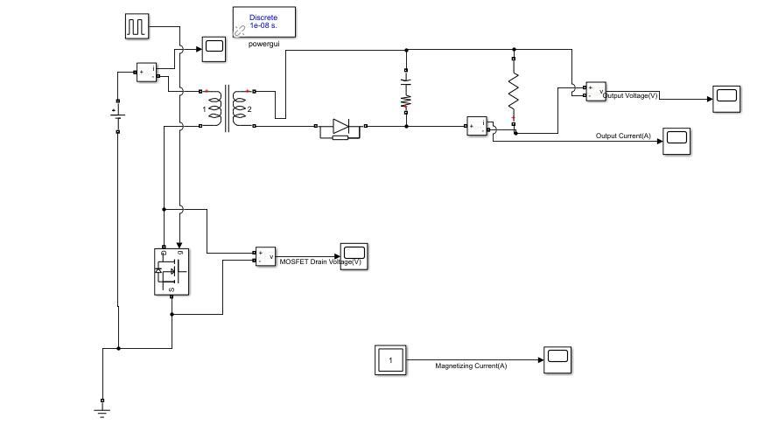

Figure Flyback Converter Simulink Model

While selecting the capacitor value, the ESR value of the capacitor was also considered. The output voltage ripple value is approximate to what was expected. The output voltage waveform can be seen in the following Figure 2.

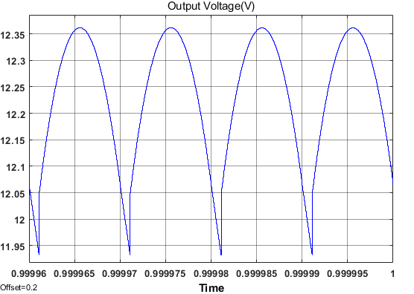

Figure Output Voltage Waveform

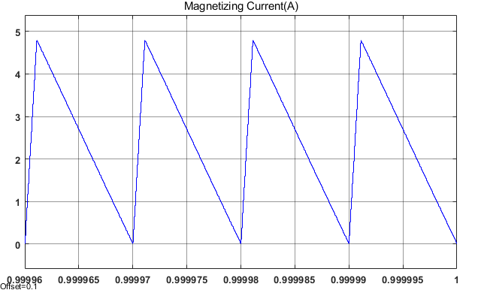

Figure Magnetizing Current Waveform

As can be realized that the converter works in boundary mode from the magnetizing current in Figure 3. Furthermore, the voltage waveform of the MOSFET is shown in the following Figure 4.

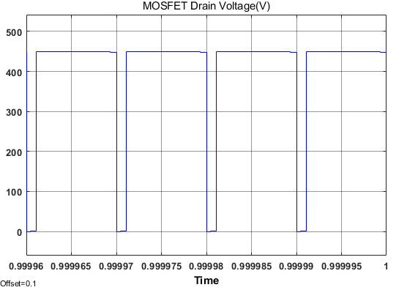

Figure MOSFET Drain Voltage

The breakdown voltage falling on the MOSFET while in off mode is also seen in Figure 4. The result is the same as the analytical model. This value should also be considered while choosing the MOSFET.

Analytical calculations and simulations made so far are the first steps of the project. In later stages, these analytical equations were used iteratively. However, the controller directly affects the converter's duty cycle and frequency. Therefore, it is compulsory to make a detailed simulation with the controller after the component selection. Components are selected iteratively according to the results of the simulations.

# Magnetic Design

Since the controller to be used will receive the power supply over transformer winding, a transformer with 3 windings will be designed. The transformer schematic can be seen in the following Figure 5.

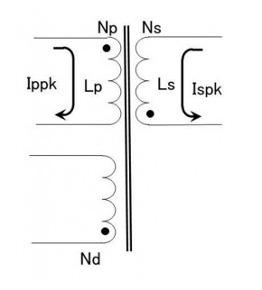

Figure Transformer schematic

Considering the size of the transformer to be designed, the duty cycle should be less than 0.5. As the duty cycle increases the size of the transformer should increase as the energy to be stored increases. The flyback reflected output voltage (VOR) is equal to the secondary output voltage plus the secondary diode on voltage (VO) multiplied by the transformer winding ratio (Np/Ns). Flyback reflected output voltage indicates the winding ratio and the duty cycle ratio (D). Diode forward voltage is assumed to be 1 V in calculations. Moreover, In the iterative calculations, it was decided that the winding ratio should be 26/6.

|  |  |
| --- | --- |
|  | (9) |
|  | (10) |
|  | (11) |

The minimum input voltage value to be used in the project is 220V, so the maximum duty cycle value has been calculated accordingly. Also, the sum of the input voltage value and the reflected output voltage value indicates the maximum breakdown voltage that will fall on the switch.

Then, the secondary winding inductance (Ls) value and the secondary-side peak current (Ispk) value are calculated. Since the controller tries to make the converter work in boundary mode, the calculations are made according to discontinuous mode (The worst case). The most critical point in this calculation is the point where the output current is maximum, so the calculations are made accordingly.

|  |  |
| --- | --- |
|  | (12) |
|  | (13) |
|  | (14) |

In simulations made with the controller, it was determined that the maximum frequency used by the controller was 100kHz, so the calculations were made by taking the maximum frequency of 100kHz. For the converter to work in boundary mode, the inductance value must be close to or smaller than the calculated value.

|  |  |
| --- | --- |
|  | (15) |
|  | (16) |

Primary winding inductance (Lp) and the primary peak current (Ippk) were calculated using the winding ratio from the calculations made for the secondary side.

After these calculations, the size of the transformer and the magnetic material to be used were decided. PC47EI25 was decided to be used as a result of the iterative calculations made by also looking at the fill factor. The size of the EI25 core is sufficient for the project and the magnetic properties of the PC47 ferrite core used are also suitable for the project purpose. The properties of the selected core are shown in the following Table 1.

Table Magnetic Properties of the PC47EI25

|  |  |  |  |
| --- | --- | --- | --- |
| Core Type | Effective Cross-Sectional Area Ae (mm2) | Maximum Magnetic Flux Density (T) | AL-Value with Air Gap (nH/N^2) |
| PC47EI25 | 41 | 0.42 | 125 |

By using an air-gapped ferrite core, the transformer cost was kept low, and it provided an advantage in size. Using these properties of the transformer, primary winding turns (Np) can be calculated. The primary winding turns must be adjusted so that the core cannot be in saturation during operation and the necessary calculations are shown in Equation 17. Lp value can be designed with AL-Value and Np which can also be seen in Equation 18. Also, the maximum MMF value in the core can be calculated with Equation 19. After calculating the primary winding turns, the secondary winding number can be calculated using the winding ratio which is shown in Equation 20. In addition, since the input voltage is equal to the output voltage in the controller, the number of winding turns must be equal as shown in Equation 21.

|  |  |
| --- | --- |
|  | (17) |
|  | (18) |
|  | (19) |
|  | (20) |
|  | (21) |

Finally, physical dimensions of the transformer core and cables to be used are needed to make fill factor calculations. Core dimension values are taken from the datasheet. It can be seen in Figure 6, Table 2, and Table 3. While choosing the cable, attention has been paid to ensure that the current value that the cable can carry is higher than the maximum current values.

Table Core Dimensions

|  |  |  |  |  |  |
| --- | --- | --- | --- | --- | --- |
| Core | A (mm) | C(mm) | D (mm) | E(mm) | F (mm) |
| EI25 | 25.3 | 5.75 | 6.5 | 19 | 12.35 |

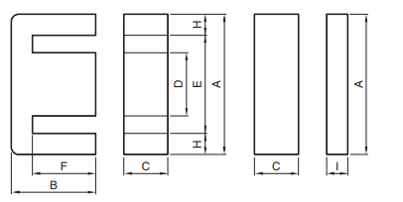

Figure Core Dimensions

Table Selected Cable Properties

|  |  |  |  |  |  |
| --- | --- | --- | --- | --- | --- |
| Wire | Area  (mm2) | Diameter(mm) | Ampacity  (75°C) | Resistivity (p) (10^-8 Ω.m) | Absolute magnetic permeability (u)  (10^-7 H/m) |
| AWG10 | 5.26 | 2.588 | 35 | 1.678 | 12.55 |
| AWG20 | 0.518 | 0.812 | 11 | 1.678 | 12.55 |
| AWG30 | 0.509 | 0.255 | 0.86 | 1.678 | 12.55 |

Using these dimensions, the fill factor is calculated as in Equation 22, 23 & 24.

|  |  |
| --- | --- |
|  | (22) |
|  | (23) |
|  | (24) |

Furthermore, the distribution of current in a conductor is almost uniform when the system is DC. However, the current in the transformer behaves as an AC current even though the converter is a DC/DC converter. Current flows in a transformer conductor are not uniform, therefore, skin effect should be taken into consideration while choosing cable. Since skin depth dictates effective cross-section area, it is significant while calculating the AC resistance of the cables. The resistance values are calculated according to the following equations and as it is seen that the cable used AWG20 reaches the highest AC resistance value, the values of the AWG20 cable are calculated as an example. While making these calculations, the values in Table 2 and Table 3 were used.

|  |  |
| --- | --- |
|  | (25) |
|  | (26) |
|  | (27) |
|  | (28) |

The resistance values of AWG 10, AWG 20, and AWG 30 cables are 2, 30, and 22 , respectively, so they can be neglected.

# Component Selection and Controller

In this part of the report, selected components, purposes and outcomes will be discussed. Basically, to design a system with an analog controller, we firstly selected the controller and then arranged other components, such as transformer design, output capacitor selection, output diode selection, switch selection, etc.

## Controller

While selecting the controller, the main aim was to have a wide input voltage range(220V-400V) and to operate at 100W operation. To simulate the closed-loop design easily, products of Analog Devices have been investigated. In these ranges, we have ended up with LT8316 and LT3752 controllers; however, LT3752 is an active clamp forward controller and accepts only 100V input maximum, however when LT8316 is examined, it has a wide operating input voltage range from 16V to 600V, and datasheet specifies that the controller can operate up to 100W. And when we investigate the configuration, the switch is connected externally, and the controller is operated by taking output voltage and current as feedback, which means if we arrange these external components for 100W operation, we could easily use that controller. So, we have decided to use LT8316 as the controller.

The main advantage of LT8316 is, the voltage feedback of the output voltage is taken from a tertiary winding, which means that in closed-loop control we do not need any optocoupler or other kind of isolation, which is a cost-effective solution. Moreover, we will only place the third winding into the transformer core with a very thin cable due to the high impedance of sense pins, so we will save space compared with the optocoupler isolation case. In addition, optocouplers are very sensitive components, and generally, they need a 3.3V or 5V supply; however, we do not need any power IC, thanks to tertiary winding. The feedback resistor selection will be discussed in the feedback resistor part. We are able to use the tertiary winding as a solution of LT8316, which is boundary mode operation. In this mode, the output voltage is sampled from the tertiary winding, when the secondary current is almost zero. The falling voltage is detected by DCM pin by sensing dV/dT and sampled from FB pin. With the boundary operation, the output diode voltage drops to zero in every cycle, so parasitic resistive voltage drops do not cause load regulation errors. Moreover, with the boundary operation, we can select a smaller transformer compared with CCM.

The other feature of the controller is current, so power limitation. The sense pin of the controller accepts 100mV maximum, and when the sense resistor voltage reaches that value, the controller limits the duty cycle to prevent the circuit. The sense resistor selection will be discussed in the "6.2. Discrete Component Selection" section.

In short, an example application of the selected controller LT8316 is shown in Figure 7, one can find the example application of LT8316. In this figure, all mentioned pin connections can also be seen, and this application example is a good guide for this project.

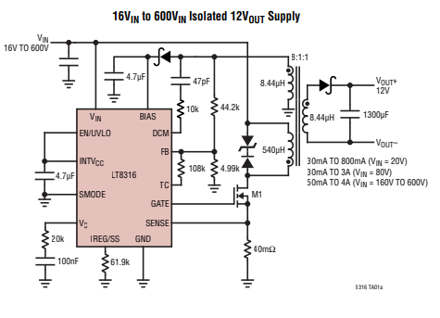

Figure Typical Application of LT8316

Another safety function of the LT8316, the EN/UVLO pin. This pin is compared with 1.22V internally, so if the voltage of this pin is lower than 1.22V, the converter will not operate for safety purposes. So, in this project, we have a 220V-400V input range, and we can arrange a high impedance voltage divider for that pin so that under a critical voltage, the controller does not operate. The protector resistor selection will be discussed in the UVLO Resistor part.

## Discrete Component Selection

1. **Feedback Resistor Selection:**

The feedback pin compares the output voltage with a 1.22V comparator, and to have a 12V output, we must divide the 12V into 1.22V; however, we have a small output, compared with the input voltage, so we need to consider the output diode forward voltage drop. The formulation in the datasheet is given as Equation 29.

|  |  |
| --- | --- |
|  | (29) |

In this case, the output diode has a 0.95V forward voltage drop, the output voltage is 12V, and , tertiary to secondary turns ratio, is 1. So that, the ratio between the feedback resistors becomes 9.6147. In this case, we can use as 48.1KΩ and as 5KΩ. However, when the detailed simulation is investigated, it is observed that with 47KΩ and 5KΩ resistors we obtain better output voltage. This may be a consequence of the inner reference voltage or the diode forward voltage drop. So, we will use 47KΩ and 5KΩ feedback resistors.

1. **Sense Resistor Selection:**

As discussed in the controller part, a proper sense resistor should be selected to set the maximum output current. LT8316 datasheet specifies the sense resistor formulation as Equation 30.

|  |  |
| --- | --- |
|  | (30) |

When we look at the detailed simulation part, the duty cycle changes between 0.1 and 0.2, and the primary to secondary turns ratio is detected as 26:6 in magnetic design part, so we find the maximum value of sense resistor as 17.5mΩ, however, to stay in the safe zone we will select a 10mΩ sense resistor. [1]

1. **UVLO Resistor:**

As specified in the controller part, the UVLO pin compares the pin voltage with 1.22V and cuts the operation below that value. The project specifies 220V-400V input voltage, so if 200V is selected as cut-off voltage, we need to divide that voltage to 1.22V. Equation 31 shows the UVLO voltage division.

|  |  |
| --- | --- |
|  | (31) |

In this equation, if we select as 1.5MΩ, we need to select as 9.2KΩ, so we will use these values in our circuit.

1. **MOSFET Selection:**

As seen in the detailed simulation part, MOSFET sees 450V and 6A maximum, so we are needed to select a MOSFET for that criteria. In this manner, N-Channel MOSFET with 550V and 7.6A ratings have been selected, because as the case temperature increases, the maximum drain current decreases. The MOSFET is Infineon Technologies IPD50R500CEAUMA1. [2]

1. **Output Diode Selection:**

As seen in the detailed simulation part, the output diode sees a maximum 110V reverse voltage and 22A peak forward current, so we have selected 170V, 30A STMicroelectronics STPS30170DJF-TR. [3] The power-flat packaging will help us to dissipate heat.

1. **Tertiary Diode Selection:**

The diode is placed before the BIAS pin of the controller, as can be seen in Figure 7. This diode sees the same reverse voltage as the output diode; however; the current does not exceed 100mA, so we have selected 150V, 1A STMicroelectronics STPS1150A. The main functionality of this diode is, it is a Schottky diode, so there is not a reverse recovery instance. [4]

1. **Output Capacitor Selection:**

As seen in the detailed simulation part, the output capacitor has nearly 20A current ripple, so in order to stay in %4 voltage ripple criteria, the equivalent ESR must be a maximum 24mΩ, and the ripple current of the capacitor, specified in the datasheet, should be minimum 20A. In this manner, we have used Aluminum-Polymer capacitors because this type has a higher ripple current, and connected four of them parallel, to achieve 20A ripple, because we have selected 330uF, 16V, ripple @100kHz: 5A, ESR: 14mΩ KEMET A750KK337M1CAAE014. [5] In this way, we have decreased the ESR, too.

1. **D-Z Snubber Selection:**

As seen in Figure 7, and as seen in the datasheet, the manufacturer proposes a D-Z snubber upper side of the switch, to prevent the switch and the circuit from voltage spikes. When we investigate the demo-board of the controller, the diode sees 400V maximum, and each of the Zener seed 90V, moreover both Zener diodes are the same and have a resistance of 60Ω. So, we have selected a 450V, fast recovery, ON Semiconductor ES1H [6] diode and 100V, 1W, Vishay SML4764A-E3/61 [7] Zener diode. While selecting these components, we are tried to stay similar to the demo board.

1. **Connector:**

In the project, we will use a two inputs screw terminal that is capable of up to 600V. For both input and output, we will use the same connector which is Phoenix Contact's 1714971 model. [8]

In this part of the report, we have discussed all of the critical components that are critical for our project to work in the desired requirements range. We have selected all of the components by considering the minimum and maximum requirements, inputs, and outputs. While designing our schematic, there will be some consumables, which are some capacitors, resistors, or diodes that the controller or other components are needed as by-pass, noise filtering, etc. These components are needed for the project to work correctly; however, they are not critical to discuss. The Bill of Materials will be taken from the Altium Designer, and the budget calculation is shown at the end of the "Hardware Design" section.

# Detailed Simulation Results

In this section, all the necessary realistic simulation results are shown with the selected components. The following Figure 8 shows the complete circuit diagram.

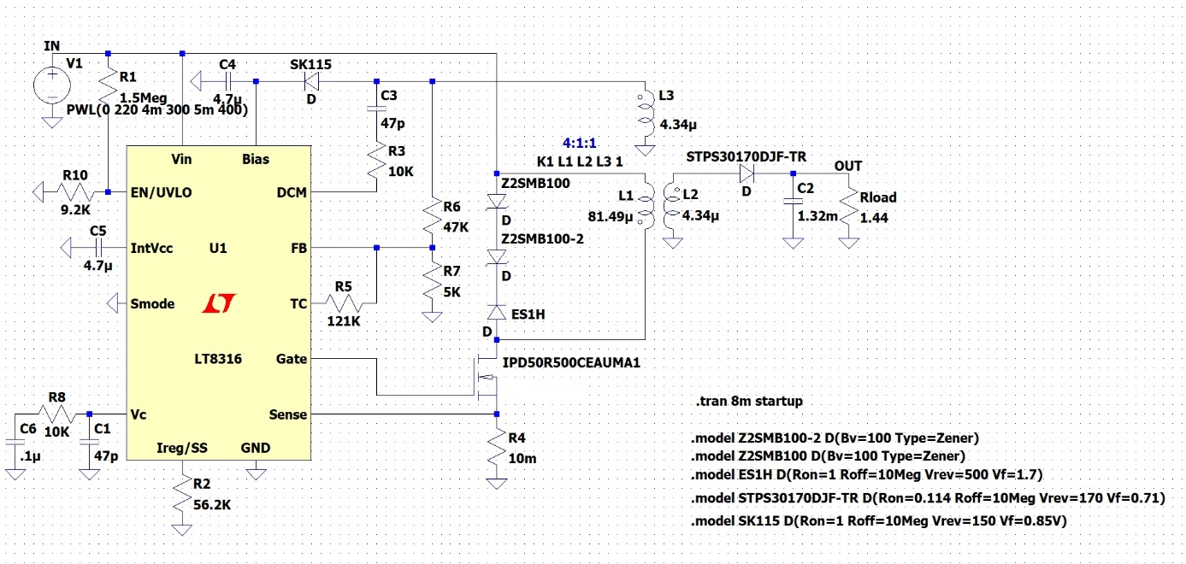

Figure Complete Circuit Diagram

As the project specs indicate that the input voltage can vary between 220V and 400V. The input voltage changing with respect to time is shown in Figure 9. Also, Figures 10 and 11 show that the performance of the output voltage and the output voltage ripple, respectively.

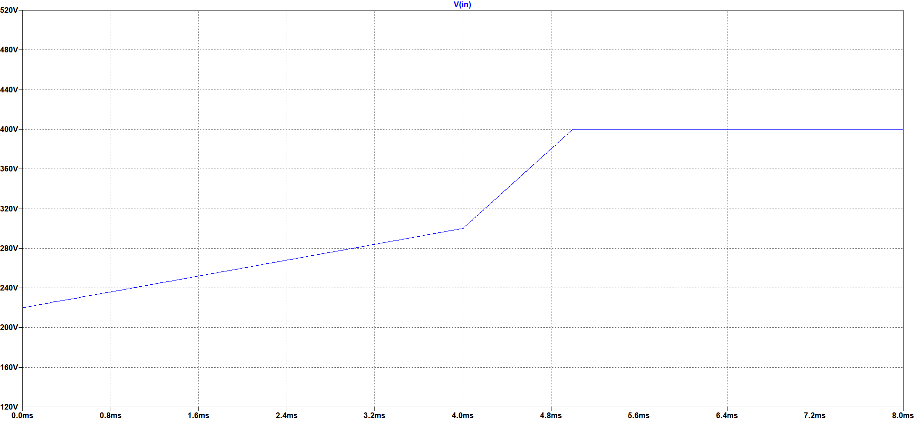

Figure Varying Input Voltage

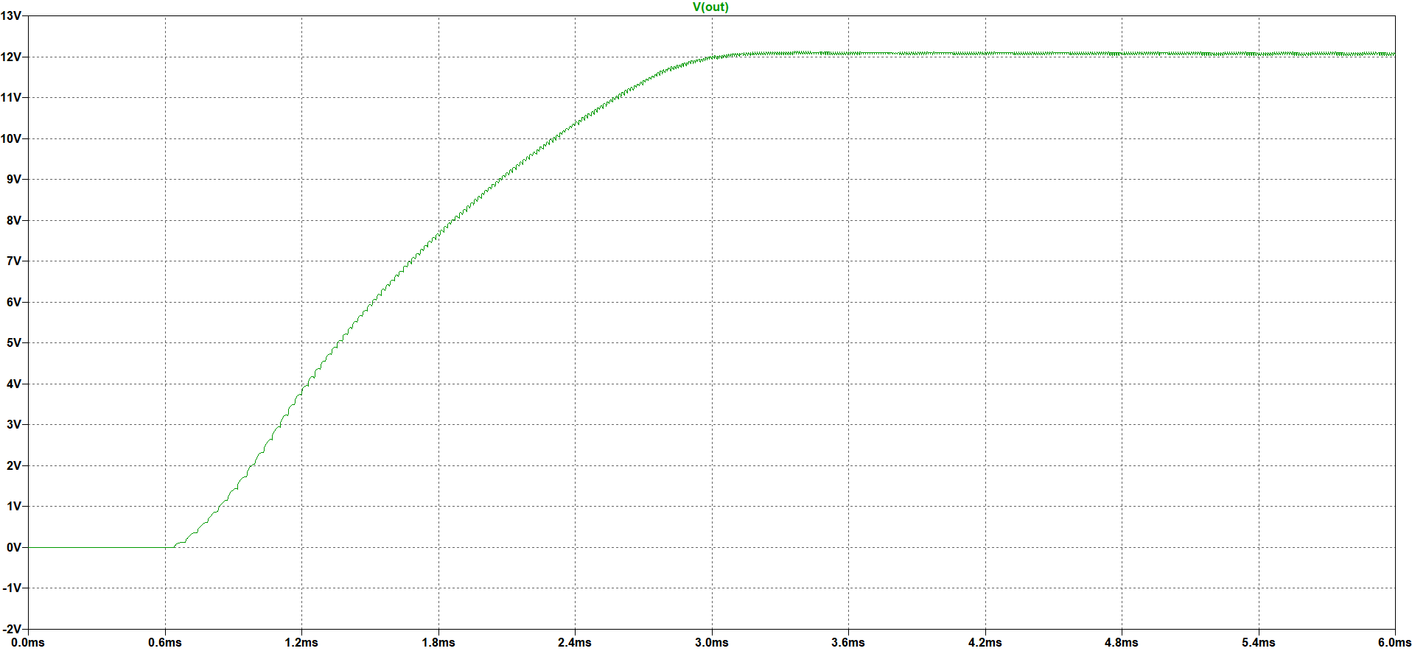

Figure Output Voltage Performance for Varying Input Voltage

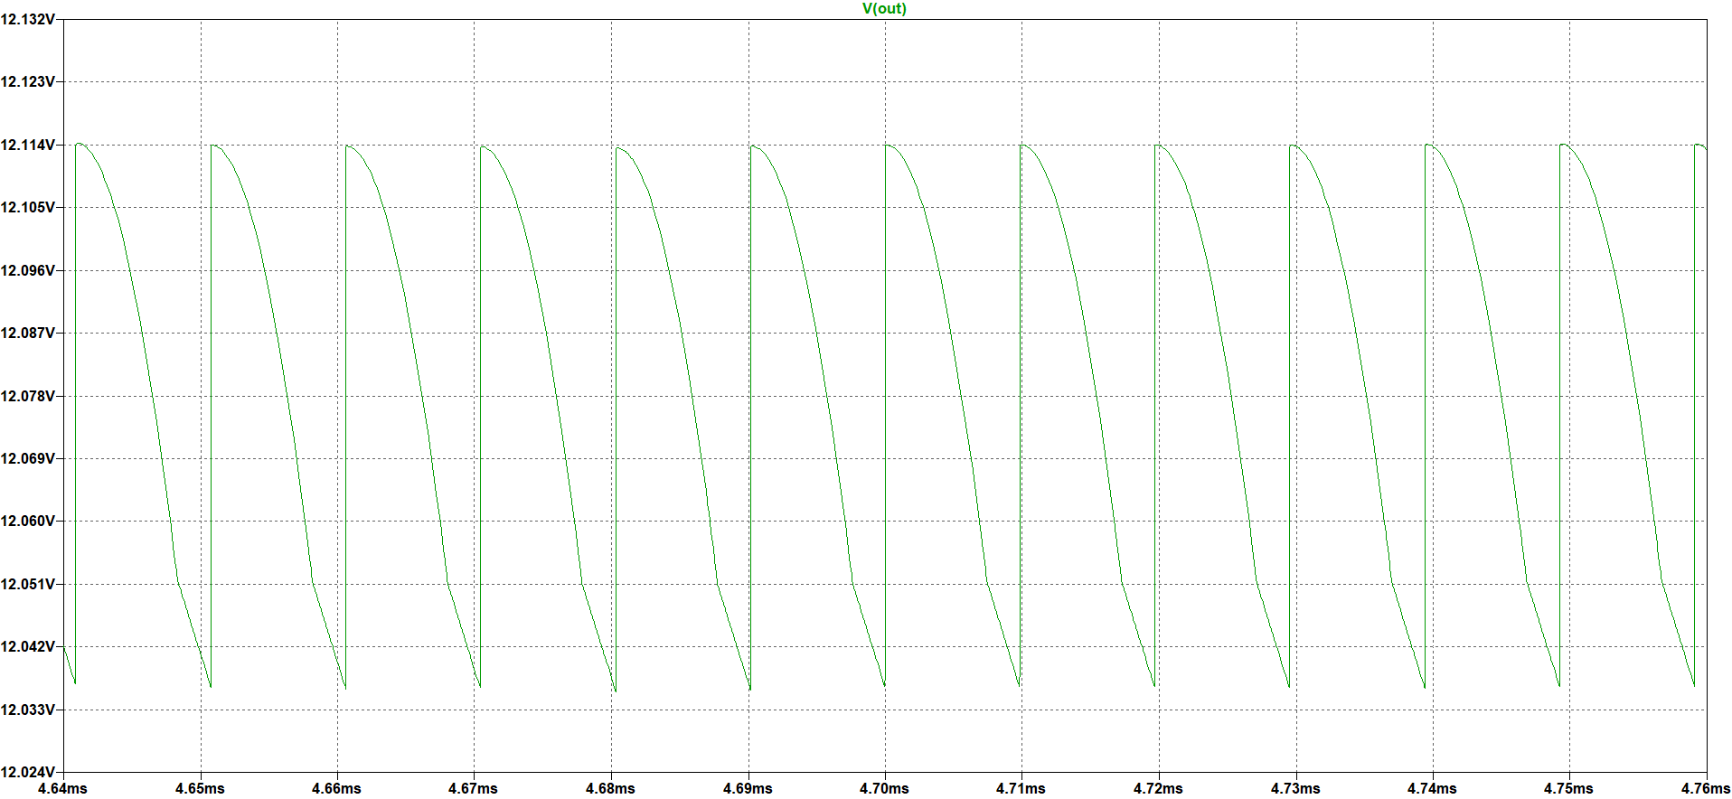

Figure Output Voltage Ripple for Varying Input Voltage

As can be seen in the above figures, the output voltage almost is not affected by the varying input voltage. It can give 12V with a small ripple which is in the specified ripple margin.

The following Figure 12 shows the output voltage performance. As can be seen in that figure, the controller has a soft start property, and the output voltage reaches 12V around 145ms. Since the output voltage reaches 12V almost the same time even for extreme cases, Figure 12 shows only a 220V input voltage situation.

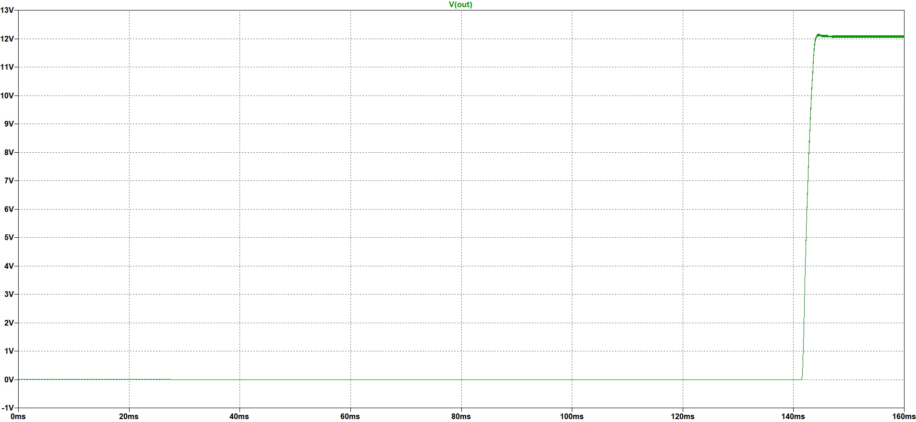

Figure Output Voltage Performance for 220V Input Voltage

After that point, all the voltage and current waveforms are shown for both 220V and 400V input voltage that are the extreme values of the input voltage. Figure 13 shows the output voltage waveform.

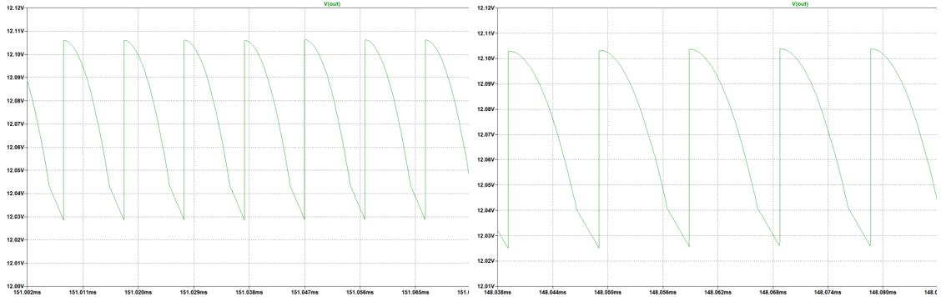

Figure Output Voltage Waveform for 220V (left) and 400V(right) Input Voltage

As can be seen in the above figures, the ripple is almost the same for extreme input voltage values and this voltage level is important for output capacitor selection. Also, the current passing through this capacitor which can be seen in the following Figure 14 is important for this selection.

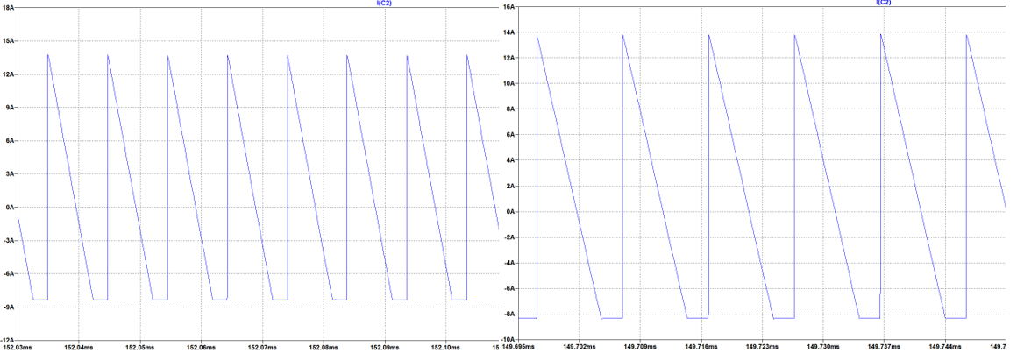

Figure Output Capacitor Current Waveform for 200V (left) and 400V (right) Input Voltage

As can be seen in the above figures, the current ripple on this capacitor is almost 20A. Therefore, the selected capacitor for the output side should filter this ripple. Furthermore, to obey the 4% voltage ripple criterion the ESR value of the selected capacitors must be very small.

The following Figure 15 and 16 shows the output diode current and voltage waveforms, respectively.

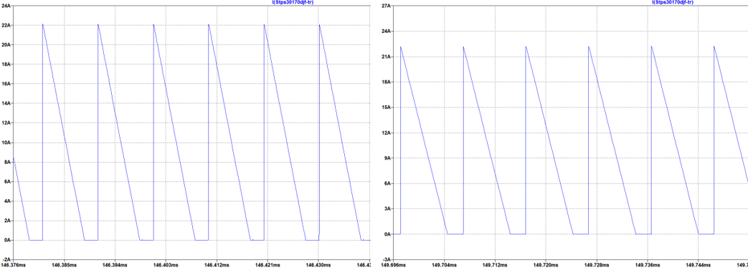

Figure Output Diode Current Waveform for 200V (left) and 400V (right) Input Voltage

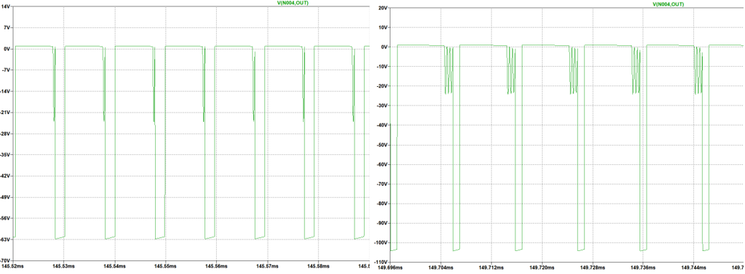

Figure Output Diode Voltage Waveform for 220V (left) and 400V (right) Input Voltage

As can be seen in the above figures, the diode current is almost the same for different input voltages and around 22A; however, the reverse voltages on this output diode are not the same. When the input voltage is 400V, the diode can withstand almost 110V. These values are important for suitable output diode selection.

The following Figure 17 and 18 shows the MOSFET gate voltage and current waveforms, respectively.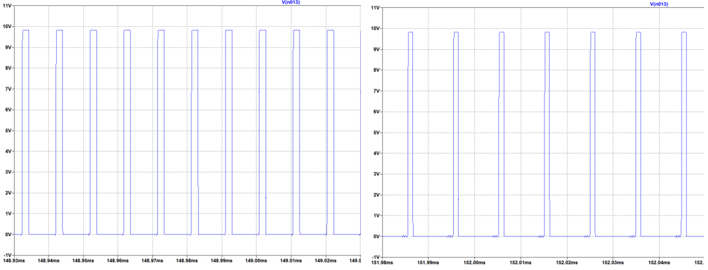

Figure MOSFET Gate Voltage Waveform for 220V (left) and 400V (right) Input Voltage

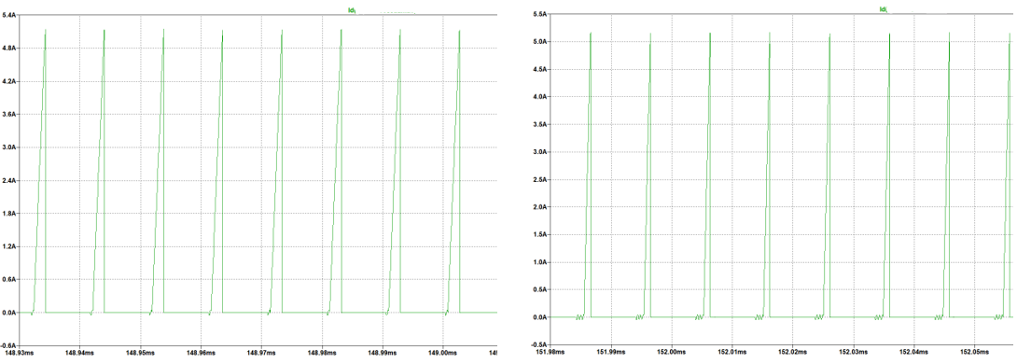

Figure MOSFET Current Waveform for 200V (left)and 400V (right) Input Voltage

As can be seen in the above figures, the gate voltage of the MOSFET is almost the same for both cases and around 10V. Moreover, the current waveforms are also similar, and it is around 5.1A. These values are important for suitable MOSFET selection.

In the following Figure 19 and 20, current and voltage waveforms of the tertiary diode can be seen, respectively.

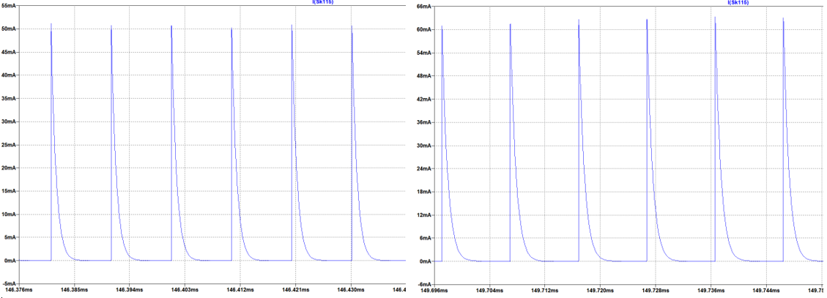

Figure Tertiary Diode Current Waveform for 200V (left) 400V (right) Input Voltage

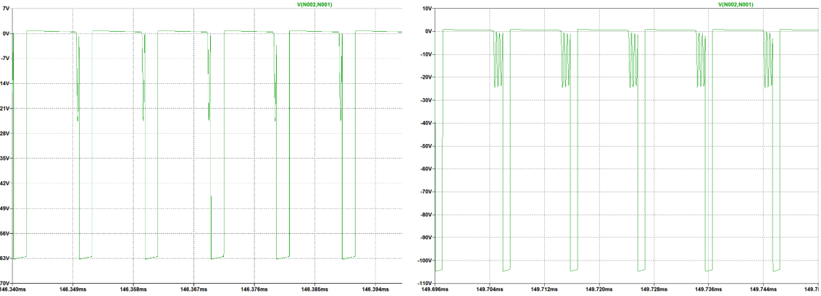

Figure Tertiary Diode Voltage Waveform for 200V (left) and 400V (right) Input Voltage

As can be seen in the above figures, the current varies between 50mA and 60mA; however, for voltage, this varying is more obvious. In short, the diode should withstand 110V. These values are important for suitable tertiary diode selection.

In the following Figure 21, voltage waveforms of the snubber diode can be seen.

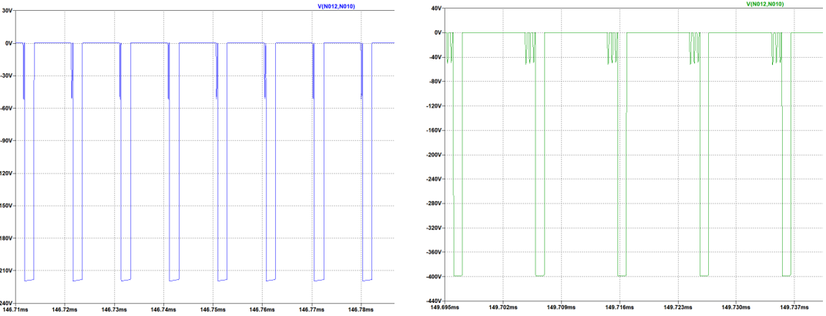

Figure Snubber Diode Voltage Waveform for 200V (left) and 400V (right) Input Voltage

In the following Figure 22, voltage waveforms of the snubber Zener diode can be seen.

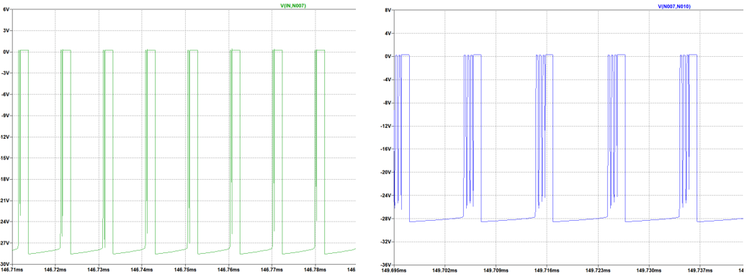

Figure Snubber Zener Diode Voltage Waveform for 200V (left) and 400V(right) Input Voltage

As can be seen in the above figures, while the snubber diode should withstand at least 400V, the Zener diodes should withstand the only 30V. These values are important for snubber diode selections.

# Hardware Design

## 8.1. Schematic Design

In this project, we have designed a schematic for the Flyback Converter hardware, by considering detailed simulation with LT8316 and DC2718A Demo Board Schematic, which is a 16V-600V input, 12V-3A output Flyback Converter demo board with LT8316. As a consequence of having a capable controller and tertiary winding transformer, we do not need any digital isolator (i.e. optocoupler) between two isolation boundaries. So, we have concluded our schematic with the controller, transformer, connectors, and some discrete components (discussed in the component selection part) such as resistors, capacitors, diodes. We have not needed any extra ICs.

In the component selection part, we have discussed feedback resistors, UVLO resistors, and sense resistors for the controller. However, there are some additional recommended components, that we placed in our schematic design. We can have a short discussion about these components:

**IntVcc Pin:** This pin is to maintain the internal supply voltage that is taken from the Bias pin. In order to do that, the datasheet recommends a minimum 2.2uF capacitor, in the schematic we have placed a 4.7uF capacitor.

**Bias Pin:** This pin takes the internal supply voltage from tertiary windings, so the datasheet recommends a bypass capacitor to the ground. We have placed a 4.7uF ceramic capacitor, again.

**Smode Pin:** This pin is used for stand-by operation. In order to avoid that we have connected it to the ground.

**Vc Pin:** This pin is the Loop Compensation pin, which determines the switching frequency from the feedback voltage. The datasheet recommends an R-C network to stabilize the regulation generally with a 20kohm resistor and 220nF capacitor. Normally decreasing R-value and increasing C value causes transient problems and increasing R-value and decreasing C value causes high-frequency problems. However, when we examine the demo board discussed above, the R-C network is constructed with a 10kohm resistor and 100nF capacitor. When comparing these values with the datasheet recommendation, we see that the demo board application gives better transient values, so 10kohm resistor and 100nF capacitor have been used in the hardware design.

**IREG/SS Pin:** This pin helps to regulate the output current. From this pin, 10uA current flows, and with the connected resistor, the voltage drop on the pin adjusts the current regulation. When we look datasheet, a formula is provided for this pin’s resistor, so when we calculate the needed resistor for 8.33A output current, we see that we need to connect a 50kohm resistor between this pin and ground.

**TC Pin:** This pin is used for Temperature Compensation, and from this pin to the feedback pin, a temperature compensation resistor is connected. Normally, there is a temperature coefficient that is found experimentally from the output diode voltage and temperature change, then the required resistance of this pin is calculated from this coefficient. However, in this project we are not able to implement that test, so we will use the demo board’s TC resistor which is 121kohm.

In addition to these recommended components by the datasheet, we have used some additional components, which are input ceramic capacitors to compensate high-frequency problems from input, and we have used a MOSFET gate resistor to limit the dI/dT ratio of gate current, and lastly, we have used a gate pull-down resistor to prevent any failure which may occur from the controller.

In Figure 23, we can see the input connector and the input bypass capacitors, in Figure 24, we can see the output connector, and finally, in Figure 25, we can see the schematic design of our Flyback Converter and controller.

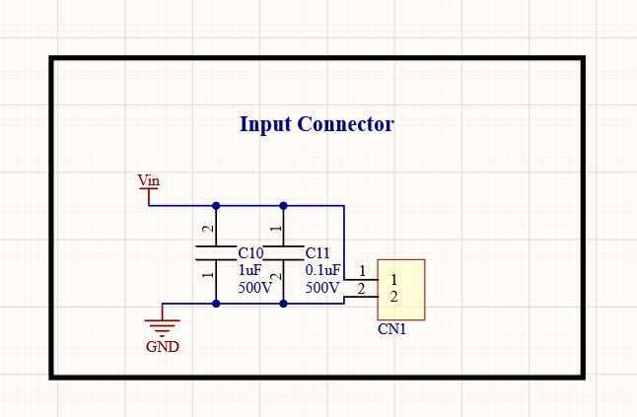

Figure Input Connector and Input Bypass Capacitors

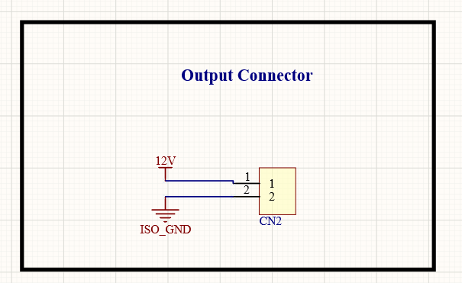

Figure Output Connector

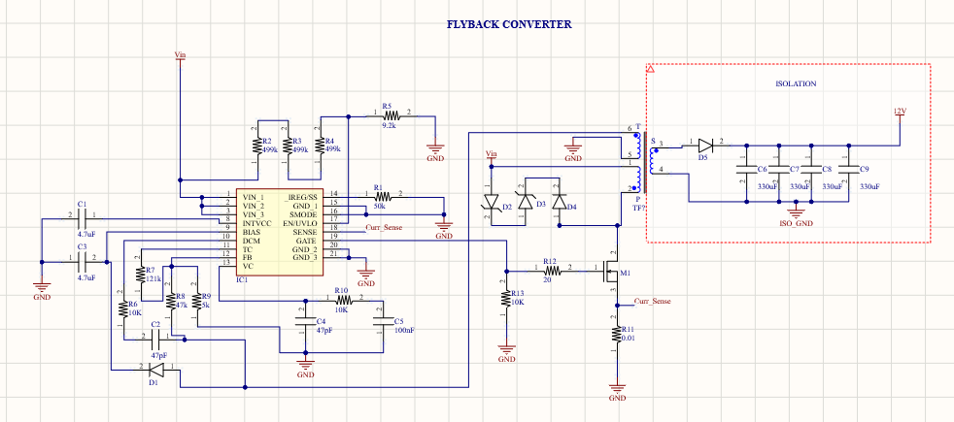

Figure Flyback Converter and Controller

## 8.2. Cost Analysis

When we take the bill of materials list from Altium Designer and select relevant components from Digikey, we have ended up with Table 4.

Table Cost Analysis of the Design

|  |  |  |  |
| --- | --- | --- | --- |
| **Manufacturer Part Number** | **Description** | **Unit Price**  **($)** | **Extended Price ($)** |
| CL31B475KOHNFNE | CAP CER 4.7UF 16V X7R 1206 | 0,0442 | 88,40 |
| 885012005023 | CAP CER 4.7PF 16V C0G/NP0 0402 | 0,01188 | 23,76 |
| 885012206046 | CAP CER 0.1UF 16V X7R 0603 | 0,028 | 28,00 |
| A750KK337M1CAAE014 | CAP ALUM POLY 330UF 20% 16V T/H | 0,18676 | 747,04 |
| CHV1210N500104KXT | CAP CER 0.1UF 500V X7R 1210 | 0,109 | 109,00 |
| CGA9P4X7T2W105K250KA | CAP CER 1UF 450V X7T 2220 | 1,3904 | 1.390,40 |
| 1714971 | TERM BLK 2P SIDE ENT 9.53MM PCB | 1,178 | 2.356,00 |
| STPS1150A | DIODE SCHOTTKY 150V 1A SMA | 0,12421 | 124,21 |
| SML4764A-E3/61 | DIODE ZENER 100V 1W DO214AC | 0,2057 | 370,26 |
| SML4764A-E3/61 | DIODE ZENER 100V 1W DO214AC | 0,3388 | 67,76 |
| ES1H | DIODE GEN PURP 500V 1A SMA | 0,10197 | 101,97 |
| STPS30170DJF-TR | DIODE SCHOTTKY 170V 30A POWRFLAT | 0,54198 | 541,98 |
| LT8316EFE#PBF | 600VIN MICROPOWER, ISOLATED NO-O | 3,105 | 3.105,00 |
| IPD50R500CEAUMA1 | MOSFET N-CH 550V 7.6A TO252 | 0,40554 | 405,54 |
| RT1206BRD0750KL | RES SMD 50K OHM 0.1% 1/4W 1206 | 0,11034 | 110,34 |
| RT0603FRE07499KL | RES SMD 499K OHM 1% 1/10W 0603 | 0,01104 | 33,12 |
| ESR03EZPJ912 | RES SMD 9.1K OHM 5% 1/4W 0603 | 0,01392 | 13,92 |
| SFR03EZPJ103 | RES 10 KOHM 5% 1/10W 0603 | 0,0124 | 37,19 |
| CRCW0603121KFKEAC | RES 121K OHM 1% 1/10W 0603 | 0,00652 | 6,52 |
| CRCW060347K0FKEAC | RES SMD 47K OHM 1% 1/10W 0603 | 0,00652 | 6,52 |
| CRCW08055K00JNTA | RES SMD 5K OHM 5% 1/8W 0805 | 0,02049 | 20,49 |
| CFG0612-FX-R010ELF | RES 0.01 OHM 1% 1W 1206 | 0,064 | 64,00 |
| CRCW120620R0FKEB | RES SMD 20 OHM 1% 1/4W 1206 | 0,01346 | 13,46 |
| PC47EI25-Z | EI CORE SMPS TRANSFORMER 1 SET | 1,022 | 1.022,00 |
| **TOTAL** | | | 10786,88 |

While constructing the BOM list, we have selected x1000 components, to prepare our budget for 1000 products. And as we see in Table 4, the total price of the components for one card is nearly $10.8. With transformer cable and PCB manufacturing costs, the budget max exceeds around $12.

# Conclusion

In this project, the topology selection is made considering the specs of the project. While analytical calculations and simulations were made as to the first step after topology selection, controllers which has suitable features for the project are investigated. However, there was limited controller choice due to project specs. Since the selected controller operates at variable frequencies, the project design has been made based on controller features. After the iterative transformer design that covers a small volume and meets the needs of the project, LTSpice was used with the controller block in detailed simulations. Due to the controller using variable frequency, simulations were considered together with analytical calculations in both component selection and optimum design stages. It has been observed that the needs of the project have been met in the design stages made so far. In the later stages of the project, power loss calculations and thermal calculations will be made and indirectly the heatsink requirement will be calculated. Finally, the project will be completed with a PCB design.

# References

[1] <https://www.digikey.com/en/products/detail/bourns-inc/CFG0612-FX-R010ELF/9924211>

[2] <https://www.digikey.com/en/products/detail/infineon-technologies/IPD50R500CEAUMA1/6599409>

[3] <https://www.digikey.com/en/products/detail/stmicroelectronics/STPS30170DJF-TR/2209783>

[4] <https://www.digikey.com/en/products/detail/stmicroelectronics/STPS1150A/1039597>

[5] <https://www.digikey.com/en/products/detail/kemet/A750KK337M1CAAE014/6196330>

[6] <https://www.digikey.com/en/products/detail/on-semiconductor/ES1H/1642578>

[7] <https://www.digikey.com/en/products/detail/vishay-general-semiconductor-diodes-division/SML4764A-E3-61/3104257>

[8] <https://www.digikey.com/en/products/detail/phoenix-contact/1714971/260639>