

MIDDLE EAST TECHNICAL UNIVERSITY

ELECTRICAL & ELECTRONICS ENGINEERING DEPARTMENT

EE472

Power System Analysis - II

Project II

LOAD FLOW ANALYSIS OF 380 KV

TURKISH ELECTRIC SYSTEM (YEAR 1990)

**Prepared by** Enes Canbolat (2231546)

Table of Contents

1. Executive Summary 2

2. System Description 3

3. Results & Discussions 8

4. Conclusion 13

Appendix 13

# Executive Summary

Nowadays, with the increasing electricity usage importance of operating the transmission line system has increased dramatically. There are lots of load and generation busses in the whole system and they should be controlled carefully. As known time affects the load profile of the system and the operator should be ready by estimating this profile using historical data; however, this project does not cover all day. In this project, we as an operator of the system need to handle only a moment of the time. Therefore, there is no variable load or generation profile but still, there are some problems waiting to be solved. In the scope of this project, each student has a different load profile and my load characteristic is maximum and $C_{load} (the load multiplier)$ is 1.1. All the details of the load profile are presented in the "System Description" section. Observing these characteristics, it can be said that the related time should be a noon moment due to the high load power profile.

The system is a simplified version of the 380 kV network in 1990. There are no transformers in the system and some short lines are omitted for this project. There are 35 busses and 15 generation points in the given system and the aim of the project is to operate this system according to some acceptable conditions. These conditions contain some strict rules to operate safely for this network which are listed below.

* All bus voltages should be within the range of 0.95 and 1.05.
* All lines should operate below 80% of their ratings.
* Total system losses should be as small as possible.

To start this project there are some milestones such as deciding the slack bus, distributing the generation units considering the load locations and required generation type shares. In other words, there are two types of generation that are hydro and thermal generations, and in my project, they should share the generation almost equally.

After implementing all the necessary information on the DIgSILENT, the possible improvements have been made in the network to obey all the criteria listed above. As mentioned before, there is a high load profile in my project, and it causes some high loss problems. To deal with this issue, some of the shunt reactors have been disconnected from the system and details of these tricks are mentioned in the "Results & Discussions" section.

In short, this project offers a chance to gain lots of experience in transmission system operation. We also have a chance to cover the network and operation synchronously with the help of this project. This report presents the solution to the mentioned problems and operation methods. In the first section ("System Description") of the report, the network is defined, and the single-line diagrams are shown in detail. Moreover, generation unit and slack bus selections before the load flow analysis are also mentioned in this section. In the "Results & Discussions" section, all the ratings and important results of the load flow analysis are discussed. Also, improvement techniques and contingency analysis are mentioned to obey the given criteria. The general concept of the project is concluded in the "Conclusion" section. Finally, the load flow analysis of the project is attached at the end of the report.

# System Description

As mentioned before, there are 35 busses in the all system. The load characteristics of the substations are different from each other and they have been calculated by multiplying a constant (1.1) with the maximum ratings of the given system. The following Table 1 shows these load characteristics for the given time.

Table Load Characteristics of the Given Substations

|  |  |  |  |  |  |
| --- | --- | --- | --- | --- | --- |
| **BUS NAME** | **Load Profile for Design** | | **BUS NAME** | **Load Profile for My Design** | |
| **MW** | **MVAR** | **MW** | **MVAR** |
| ALTINKAYA | 110 | 33 | ISIKLAR | 440 | 209 |
| ADAPAZARI | 264 | 71.5 | KANGAL | 0 | 0 |
| ALIAGA | 418 | 115.5 | KARAKAYA | 319 | 77 |
| ALIBEY | 308 | 137.5 | KAYABASI | 148.5 | 44 |
| AMBARLI | 0 | 0 | KAYSERI | 242 | 77 |
| AVANOS | 0 | 0 | KEBAN | 308 | 22 |
| BALIKESIR | 0 | 0 | OSMANCA | 231 | 99 |
| BURSA | 462 | 187 | OYMAPINAR | 77 | 22 |
| CANKIRI | 0 | 0 | SEYDISEHIR | 264 | 88 |
| CARSAMBA | 154 | 27.5 | SEYITOMER | 55 | 15.4 |
| CAYIRHAN | 0 | 0 | SINCAN | 352 | 93.5 |
| ELBISTAN | 231 | 38.5 | SIVAS | 27.5 | 16.5 |
| ERZIN | 418 | 121 | SOMA | 220 | 33 |
| GOKCEKAYA | 0 | 0 | TEPEOREN | 319 | 132 |
| GOLBASI | 286 | 77 | TUNCBILEK | 0 | 0 |
| HAMITABAD | 132 | 49.5 | UMRANIYE | 297 | 258.5 |
| HASAN U. | 0 | 0 | YATAGAN | 187 | 44 |
| IKITELLI | 330 | 66 | **TOTAL** | **6600** | **2154.9** |
| **TOTAL S (MVA)** | | | | | **6942.881** |

The following Figure 1 represents this single-line diagram and to make it look clear following Figure 2, 3, 4 & 5 shows the zoomed version of the system.

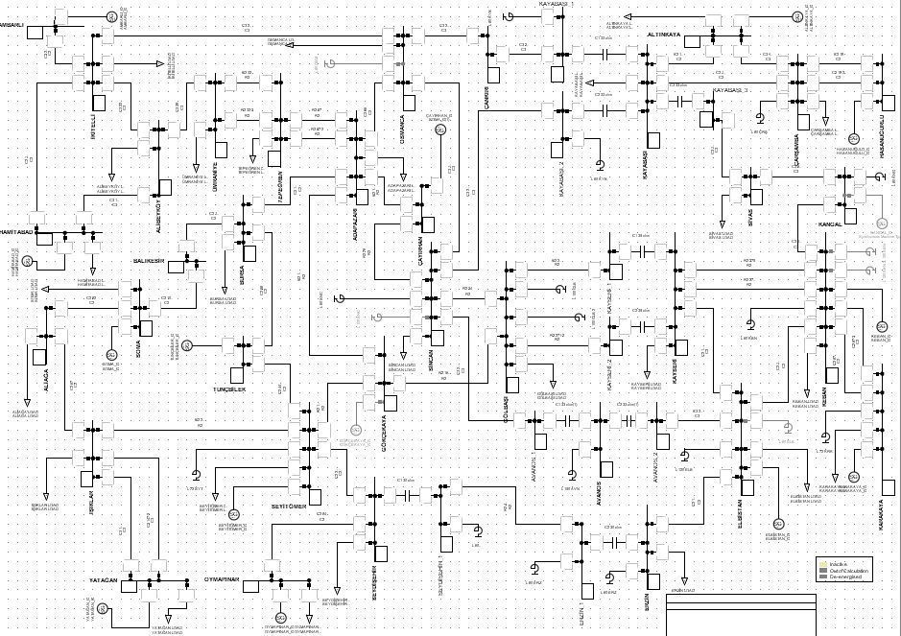

Figure Single-Line Diagram of the System

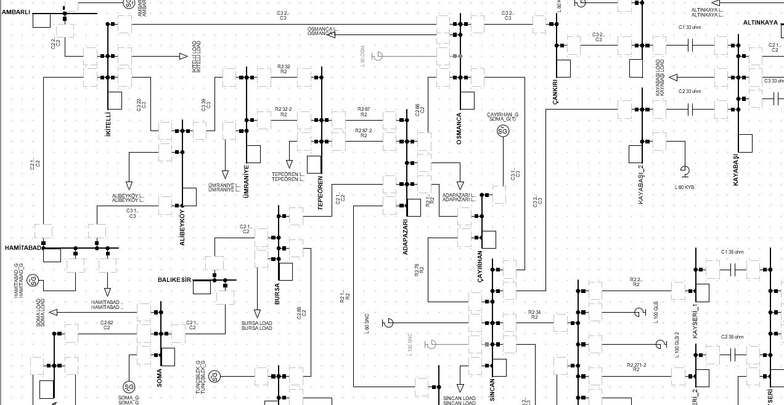

Figure Single-Line Diagram of the Left Upper Corner of the System

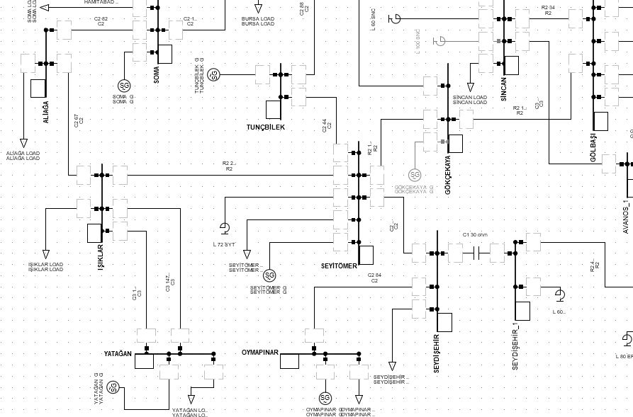

Figure Single-Line Diagram of the Left Bottom Corner of the System

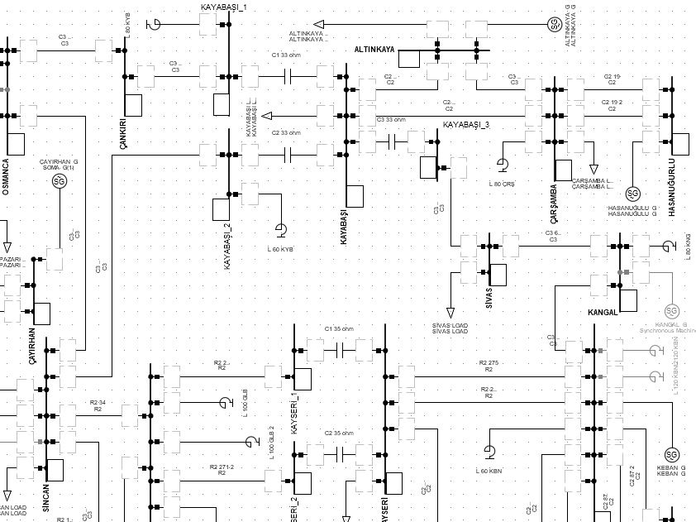

Figure Single-Line Diagram of the Right Upper Corner of the System

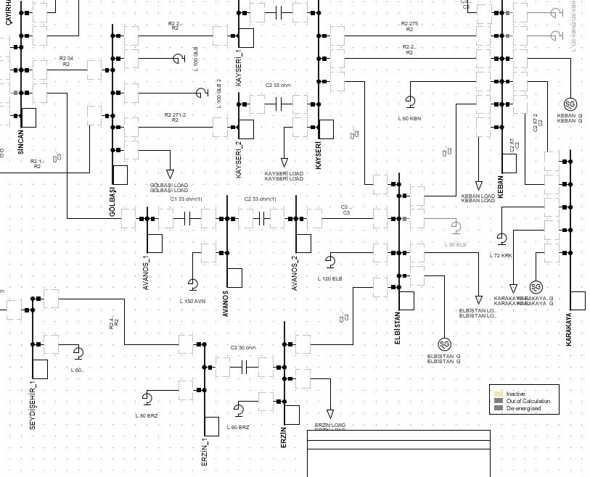

Figure Single-Line Diagram of the Right Bottom Corner of the System

As can be realized from the given Table 1 and the single-line diagrams, the total real power requirement of the 380kV network of Turkey is 6600MW. Note that this power is not equal to the whole load power of Turkey, this value represents only 380kV network and there are any other voltage levels such as 154kV etc. In short, there are 15 generation busses in the 380kV network. On the other hand, since all the substations do not have a generation unit, the supplied power should be well-distributed to the country. Considering the possible voltage drops and load locations a suitable system is designed and the details are shown in the following Table 2.

Table Details of Generating Stations

|  |  |  |  |  |  |  |  |
| --- | --- | --- | --- | --- | --- | --- | --- |
| **GENERATING STATION** | **# of Units** | **TYPE** | **RATED MW/UNIT** | **NO. OF UNITS ASSIGNED** | **TOTAL MW ASSIGNED** | **VOLTAGE ASSIGNED (PU)** | RATED MVA/UNIT |
|  |
|  |
| **ALTINKAYA** | **4** | **H** | **175** | **4** | **700** | **1.03** | 190 |  |
| **AMBARLI** | **2** | **T** | **150** | **3** | **450** | **1.01** | 170 |  |
| **CAYIRHAN** | **4** | **T** | **160** | **2** | **320** | **1.03** | **188** |  |
| **ELBISTAN** | **4** | **T** | **340** | **2** | **680** | **1.02** | **382** |  |
| **GOKCEKAYA** | **3** | **H** | **93** | **0** | **0** | **1.03** | **103** |  |
| **HAMITABAD** | **6** | **T** | **100** | **5** | **500** | **1.03** | **125** |  |
| **HASAN U.** | **4** | **H** | **130** | **3** | **390** | **1.03** | **145** |  |
| **KANGAL** | **1** | **T** | **150** | **0** | **0** | **1.01** | 188 |  |
| **KARAKAYA** | **6** | **H** | **300** | **3** | **900** | **1** | **315** |  |
| **KEBAN** | **8** | **H** | **165** | **5** | **825** | **1** | **187** |  |
| **OYMAPINAR** | **4** | **H** | **135** | **4** | **540** | **1.03** | **150** |  |
| **SEYITOMER** | **3** | **T** | **153** | **2** | **306** | **1.03** | 180 |  |
| **SOMA** | **4** | **T** | **165** | **3** | **495** | **1.02** | 194 |  |
| **TUNCBILEK** | **1** | **T** | **160** | **1** | **160** | **1.02** | 190 |  |
| **YATAGAN** | **3** | **T** | **210** | **2** | **420** | **1.03** | 247 |  |
| **TOTAL (MW)** | | | | | **6686** |  |  |  |

In the above table, while H represents the “hydro generation”, T represents the “thermal generation”. Also, as can be seen, that generators are not in the service with the full capacity, even the load is maximum installed power is much higher than the load. That’s why some of the units are out of service. Moreover, two of the generator substations (Gökçekaya & Kangal) are completely disconnected from the network. Finally, KEBAN is selected as a slack bus and it takes over the extra powers in the system. Therefore, some estimated power has been assigned in the above table to this slack bus. As can be realized from the above table, Keban has a capability to overcome these losses. After the load flow analysis, the supplied power by the slack bus is shown in the "Results & Discussions" section.

The distribution of H & T generations has been composed considering the given criterion. In the following Table 3, this distribution is shown in both percentage and numerical units.

Table Generation Power Distribution of the Network

|  |  |  |
| --- | --- | --- |
| **HYDRO (MW)** | **THERMAL (MW)** | **TOTAL (MW)** |
| **3355** | **3331** | **6686** |
| **50.17947951** | **49.82052049** | **100** |

As mentioned before the total load power is 6600 MW and in order to operate safely, the generation should be higher than this level at the rate of 10%. Furthermore, the required distribution of the network is the equal share of the generation between H & T. Clearly, thermal, and hydro generations are almost equal in the desired system. The "Results & Discussions" section contains the distribution of the generation network after the load flow analysis.

The system includes some shunt reactors and series capacitors to minimize losses on the lines. The following Table 4 & Table 5 show the existing capacitor and reactor values. Note that some of the shunt reactors are disconnected from the system that is explained in detail in the "Results & Discussion" section.

Table Existing Capacitors and Their Location & Ratings

|  |  |  |  |  |
| --- | --- | --- | --- | --- |
| **From** | **To** | **Capacitance (Ω)** | **Rating (%)** | **#of Capacitor** |
| Seydişehir | Erzin | 30 | 3.7 | 1 |
| Erzin | Seydişehir | 30 | 11.5 | 1 |
| Avanos | Elbistan | 33 | 21.9 | 1 |
| Avanos | Sincan | 33 | 23.7 | 1 |
| Kayseri | Gölbaşı | 35 | 29.4 | 2 |
| Kayabaşı | Sincan | 33 | 43.6 | 1 |
| Kayabaşı | Çankırı | 33 | 42.1 | 1 |
| Kayabaşı | Sivas | 33 | 17 | 1 |

Table Shunt Reactors and Their Location & Ratings

|  |  |
| --- | --- |
| **Bus Name** | **Existing (MVAR)** |
| AVANOS | 150 |
| CARSAMBA | 80 |
| ELBISTAN | 120 + 80 |
| ERZIN | 80 + 60 |
| GOLBASI | 100 + 100 |
| KANGAL | 80 |
| KARAKAYA | 72 |
| KAYABASI | 60 + 80 |
| KEBAN | 120+120+60 |
| OSMANCA | 80 |
| SEYDISEHIR | 60 |
| SEYITOMER | 120 |
| SINCAN | 100 + 50 |

Finally, in the given system 4 different types of cable are used and the following Table 6 expresses the properties of the used cables.

Table Used Cable Properties of the System

|  |  |  |  |  |  |
| --- | --- | --- | --- | --- | --- |
| **Conductor Type** | **MCM** | **R (ohm/km)** | **X (ohm/km)** | **Y (mho/km)** | **Rating (MVA)** |
| *3xPheasant* | *3x1272* | *0.0175* | *0.256* | *4.253* | *1000* |
| 3xCardinal | 3x954 | 0.0229 | 0.262 | 4.151 | 840 |
| 2xCardinal | 2x954 | 0.0351 | 0.317 | 3.436 | 620 |
| 2xRail | 2x954 | 0.035 | 0.319 | 3.412 | 62 |

# Results & Discussions

After implementing all the system information on the DIgSILENT, load flow has been analyzed. The program reached the results after 4 iterations by using the Newton-Raphson method. Although Table 2 indicates the final generation distributions, this is not the first version of the system. To compensate for all the loads in the network, some necessary changes have been made. Furthermore, as mentioned before, some of the shunt reactors are out of service to decrease losses. Because of the high loads, the system has inductive behavior and when all the shunt reactors are used in the system, losses in the system increase dramatically. The following Table 7 shows the details of the final shunt reactors.

Table Shunt Reactors and Their Location & Ratings

|  |  |  |  |
| --- | --- | --- | --- |
| **Bus Name** | **Existing (MVAR)** | **Out of Service** | **In Service** |
| AVANOS | 150 | 0 | 150 |
| CARSAMBA | 80 | 0 | 80 |
| ELBISTAN | 120 + 80 | 80+120 | 0 |
| ERZIN | 80 + 60 | 60 | 80 |
| GOLBASI | 100 + 100 | 100 | 100 |
| KANGAL | 80 | 0 | 80 |
| KARAKAYA | 72 | 72 | 0 |
| KAYABASI | 60 + 80 | 0 | 140 |
| KEBAN | 120+120+60 | 120+120 | 60 |
| OSMANCA | 80 | 80 | 0 |
| SEYDISEHIR | 60 | 60 | 0 |
| SEYITOMER | 120 | 0 | 120 |
| SINCAN | 100 + 50 | 100+50 | 0 |

As can be realized from the above table, some of the shunt reactors are completely disconnected from the network such as Elbistan, Osmanca, etc. substations. Moreover, some parts of the shunt reactors that are separately integrated into the system are also out of service such as Keban substations.

After the load flow analysis, Keban which is the slack bus of the system takes over some of the losses in the system. The following Table 8 shows the slack bus power generation.

Table Power Generation of the Slack Bus

|  |  |  |
| --- | --- | --- |
| **BUS NAME** | **POWER GENERATION** | |
| **MW** | **MVAR** |
| KEBAN | 843 | -62.68 |

The following Table 9 shows the losses and the real power distribution of the system considering the generation type (i.e. hydro or thermal generation). If Table 3 & Table 9 are compared, there is a slight difference in the power generation from the hydroelectric system. This difference is caused by the estimation of the slack bus before the analysis; however, it can be said that the estimation was successful, and the generation share is almost equal as the project specs indicate.

Table Final Power Generation & Losses of the Network

|  |  |  |
| --- | --- | --- |
|  | **MW** | **%** |
| **TOTAL GENERATION** | **6717** | **100** |
|  |
| **TOTAL HYDRO GENERATION** | **3373** | **50.3132** |  |
| **TOTAL THERMAL GENERATION** | **3331** | **49.6868** |  |
| **TOTAL SYSTEM LOSSES** | **104** | **1.55131** |  |
| **TOTAL SYSTEM LOAD** | **6600** |  |  |

As can be seen in the above table, total losses of the system are equal to 1.55131% of the total power generation of the network. This amount of loss is expected due to the high load power of the network and most of the possible improvements have been made in the network to decrease the losses and optimize the system. Also, the system required that 50% hydro generation; however, these hydro generations are not well-distributed on Turkey. Their locations are mostly in the east side of the country. Therefore, some losses on the lines are occurred. In short, high load profile and locations of hydro generations are the possible reasons of high losses. Moreover, the following Table 10 shows all the voltage values of the substations per unit. Also, this table is colored to make analysis easier.

Table Voltage Levels of the Substations

|  |  |  |  |
| --- | --- | --- | --- |
| **BUS NAME** | **Voltage (pu)** | **BUS NAME** | **Voltage (pu)** |
| IKITELLI | 1.01 |
| ALTINKAYA | 1.03 | ISIKLAR | 1.01 |
| ADAPAZARI | 1.01 | KANGAL | 1.01 |
| ALIAGA | 1.01 | KARAKAYA | 1 |
| ALIBEY | 1 | KAYABASI | 1.03 |
| AMBARLI | 1.01 | KAYSERI | 1.03 |
| AVANOS | 1.02 | KEBAN | 1 |
| BALIKESIR | 1.02 | OSMANCA | 1.02 |
| BURSA | 1 | OYMAPINAR | 1.03 |
| CANKIRI | 1.04 | SEYDISEHIR | 1.02 |
| CARSAMBA | 1.03 | SEYITOMER | 1.03 |
| CAYIRHAN | 1.02 | SINCAN | 1.02 |
| ELBISTAN | 1.02 | SIVAS | 1.02 |
| ERZIN | 0.98 | SOMA | 1.02 |
| GOKCEKAYA | 1.03 | TEPEOREN | 0.99 |
| GOLBASI | 1.02 | TUNCBILEK | 1.02 |
| HAMITABAD | 1.03 | UMRANIYE | 0.99 |
| HASAN U. | 1.03 | YATAGAN | 1.03 |

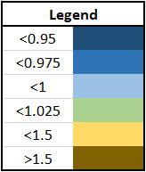

Figure Legend of Table 10

As can be seen in the above table, there is no substation out of the required voltage limits. The following Table 11 shows the load ratings of the generation busses. Also, this table is colored to make analysis easier.

Table Load Ratings of the Generation Busses

|  |  |  |  |
| --- | --- | --- | --- |
| **GENERATING STATION** | **TYPE** | **VOLTAGE ASSIGNED (PU)** | **Load Ratings (%)** |
|  |
|  |
| **ALTINKAYA** | **H** | **1.03** | **92.2** |  |
| **AMBARLI** | **T** | **1.01** | **88.3** |  |
| **CAYIRHAN** | **T** | **1.02** | **86.5** |  |
| **ELBISTAN** | **T** | **1.02** | **89** |  |
| **GOKCEKAYA** | **H** | **1.03** | **NA** |  |
| **HAMITABAD** | **T** | **1.03** | **82.8** |  |
| **HASAN U.** | **H** | **1.03** | **89.7** |  |
| **KANGAL** | **T** | **1.01** | **NA** |  |
| **KARAKAYA** | **H** | **1** | **95.2** |  |
| **KEBAN** | **H** | **1** | **90.4** |  |
| **OYMAPINAR** | **H** | **1.03** | **90** |  |
| **SEYITOMER** | **T** | **1.03** | **85.1** |  |
| **SOMA** | **T** | **1.02** | **86.1** |  |
| **TUNCBILEK** | **T** | **1.02** | **88.9** |  |
| **YATAGAN** | **T** | **1.03** | **85.9** |  |

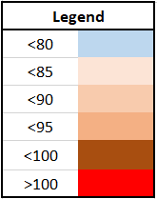

Figure Legend of Table 11

As can be seen in the above table, all the generation units are operating according to the given criteria. In other words, there is no generation whose rating is below 80% or higher than 100%. As mentioned before, generation units of Gökçekaya and Kangal are out of service, that's why NA representing "Not Applicable" is written in the above table.

Ratings of generation units are not the only point to check. Cable ratings also must be controlled, and all the cable ratings must be below 80% according to the project specs. The 380kV network of Turkey includes 46 different connections and some of the substations are connected to more than 1 cable. These cables have been assigned according to the given knowledge and meanings of the abbreviations that are used in the following Table 12 can be seen in Table 6. The following Table 12 shows the details of this information. Also, this table is colored to make analysis easier.

Table Connection and Ratings of the Cables

|  |  |  |  |  |  |
| --- | --- | --- | --- | --- | --- |
| **From** | **To** | **Type** | **Distance** | **Load Rating (%)** | **#of Cable** |
| Ambarlı | İkitelli | C2 | 23 | 71.9 | 1 |
| İkitelli | Hamitabad | C2 | 137 | 28.2 | 1 |
| İkitelli | Alibeyköy | C3 | 22 | 46.1 | 1 |
| İkitelli | Osmanca | C3 | 269 | 16.1 | 1 |
| Osmanca | Çankırı | C3 | 206 | 44.9 | 1 |
| Osmanca | Sincan | C3 | 174 | 27.6 | 1 |
| Osmanca | Adapazarı | C2 | 66 | 47.2 | 1 |
| Adapazarı | Çayırhan | R2 | 136 | 67.9 | 1 |
| Adapazarı | Gökçekaya | R2 | 100 | 35.3 | 1 |
| Adapazarı | Bursa | C2 | 156 | 30 | 1 |
| Adapazarı | Tepeören | R2 | 87 | 39.6 | 2 |
| Tepeören | Ümraniye | R2 | 32 | 10.1 | 2 |
| Ümraniye | Alibeyköy | C3 | 39 | 37.4 | 1 |
| Alibeyköy | Hamitabad | C3 | 150 | 30.1 | 1 |
| Bursa | Tunçbilek | C2 | 88 | 58.2 | 1 |
| Bursa | Balıkesir | C2 | 109 | 19.9 | 1 |
| Balıkesir | Soma | C2 | 65 | 14.1 | 1 |
| Soma | Aliağa | C2 | 82 | 56.9 | 1 |
| Aliağa | Işıklar | C2 | 67 | 14.8 | 1 |
| Işıklar | Yatağan | C3 | 147 | 17.8 | 2 |
| Işıklar | Seyitömer | R2 | 283 | 53.9 | 1 |
| Seyitömer | Tunçbilek | C2 | 44 | 34.8 | 1 |
| Seyitömer | Gökçekaya | R2 | 114 | 12.1 | 1 |
| Seyitömer | Seydişehir | C2 | 296 | 33.1 | 1 |
| Seydişehir | Oymapınar | C2 | 84 | 72.6 | 1 |
| Seydişehir | Erzin | R2 | 417 | 28 | 1 |
| Erzin | Elbistan | C2 | 178 | 67.8 | 1 |
| Elbistan | Keban | C2 | 170 | 59.4 | 1 |
| Elbistan | Kayseri | C2 | 146 | 26.4 | 1 |
| Elbistan | Avanos | C3 | 200 | 27.4 | 1 |
| Avanos | Sincan | C3 | 266 | 29.3 | 1 |
| Sincan | Kayabaşı | C3 | 292 | 49.4 | 1 |
| Sincan | Çayırhan | R2 | 78 | 9.9 | 1 |
| Sincan | Gölbaşı | R2 | 34 | 7.5 | 1 |
| Gölbaşı | Gökçekaya | R2 | 167 | 42.4 | 1 |
| Gölbaşı | Kayseri | R2 | 271 | 48 | 2 |
| Kayseri | Keban | R2 | 275 | 61.7 | 2 |
| Keban | Karakaya | C2 | 87 | 47.4 | 2 |
| Keban | Kangal | C3 | 140 | 23.3 | 1 |
| Kangal | Sivas | C3 | 61.5 | 23.3 | 1 |
| Sivas | Kayabaşı | C3 | 168 | 19.2 | 1 |
| Kayabaşı | Çankırı | C3 | 216 | 47.2 | 1 |
| Kayabaşı | Çarşamba | C2 | 125 | 52.4 | 1 |
| Kayabaşı | Altınkaya | C2 | 100 | 77.5 | 1 |
| Altınkaya | Çarşamba | C3 | 100 | 11.7 | 1 |
| Çarşamba | Hasanuğurlu | C2 | 19 | 30.6 | 2 |

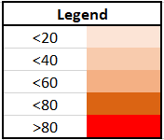

Figure Legend of Table 12

As can be seen in the above table, all the cable ratings are below 80% which satisfied the criterion.

While optimizing the network, the operation rating of the Gökçekaya substation was a problem. It operates very low ratings (between 20% and 40%). This could be caused by the no-load case at that substation. That's why while operating the system, generation units of Gökçekaya have been chosen completely out of service. Lack of generation in Gökçekaya created the need for more loading of the generators in Çayırhan. This situation also created some other problems such as overloading of the cable between Adapazarı which is directly connected to Gökçekaya and Çayırhan substations. The rating of the cable was observed higher than 85%. There were some losses due to the inductive effects of the network. To compensate for this situation, shunt reactors at Sincan which is directly connected to Çayırhan have been chosen out of service. Moreover, since the hydro generations are located to the east of the map, there are some loss problems in the west. Instead of transferring the power from east to west, that increases the losses in the system, taking Kangal out of the service and using one more generation unit in Ambarlı helps to decrease these losses. After implementing these kinds of improvements, the network can operate satisfying all the criteria that are mentioned in the "Executive Summary" section.

One other important thing is the contingency analysis. If a contingency analysis is made on the DIgSILENT, it can be realized that there is no overloading problem in the whole system. This means that if one of the lines somehow disconnected from the network, the designed system can handle this problem with a negligible voltage level and load ratings on the busses, generation units, or lines changings. This result is expected because all the generations are operating low than their rated values to compensate these kinds of problems. In other words, if somehow, a generator has to be out of the system unexpectedly, other generator units can supply the necessary amount of power instead of non-working generator unit without any problem. Moreover, all the line ratings are lower than 80% and hence the cables are prepared in the case of emergency. That’s why they can also transfer more power without any problem.

Finally, the load flow analysis of the project is attached at the end of this report. DIgSILENT version, some details and all the output analysis such as busbars/terminals, complete system report, grid & total system summary are shown in the GitHub page. This page’s link can be seen in “Appendix” section of the report.

# Conclusion

In the scope of this project, the 380 kV network of Turkey has been analyzed. While analyzing the system, there is a chance to observe lots of things about the transmission system. Load and generation power balance is one of the major problems in this system because, before the load flow analysis, generation units must be well-distributed. As known that slack bus takes over the losses in the system. That's why the power generation of the slack bus has to be estimated before the analysis. On the other hand, the assigned voltage values have also a crucial role since all the bus voltages should be between 0.95 & 1.05 pu. Moreover, the losses in the whole system should also be controlled and decreased as much as possible. To handle this issue, shunt reactors and line capacitors help the operator to control these voltage drops and losses. The operator can use these shunt reactors, especially for low load cases since when the loads and hence the power flow on the lines are low the system has a capacitive behavior. On the other hand, when the loads and hence the power flows on the lines is high, then the system has an inductive behavior. Therefore, according to the extra reactive power flows, the operator can disconnect some of the shunt reactors to compensate the system and decrease the losses. Furthermore, the contingency analysis also is considered since always there is a probability of disconnecting problems on the lines. That's why the system should handle these kinds of problems. To sum up, thanks to this project, there was a chance to gain lots of experience the operating the transmission system. In the following projects, maybe some of the missing parts can be observed such as cases with transformers or variable load & generation profiles.

# Appendix

GitHub link for the detailed simulation results and .pfd file: <https://github.com/EnesCanbolat/EE472_Project2.git>