***DETECTION AND COUNT OF CROPS WITH DRONE SIMULATION***

Üzeyir Enes GÜRDEN – Burak ÇINAR

AGU Electrical & Electronics Engineering Department

Asst. Prof. Samet GÜLER

AGU Electrical & Electronics Engineering Department

***Abstract: This paper mentions about one of the drones using area which is we think will be very helpful, agricultural field. With the increasing interest in unmanned aerial vehicles, drones have been utilized in many social, industrial, and military applications. This is one of the ideas and project could be developable. We did a simulation on v-rep by using matlab.***

***Keywords: aerial vehicle, drone, agriculture, V-rep, Matlab, Precision & Recall..***

# Introduction

First of all, we started this project according to the increasing interest in unmanned aerial vehicle, drones. Drones have been utilized in many social, industrial, and military applications. An interesting application area of drones is surveillance over agricultural fields to improve production quality and rate. The main purpose of this project is to design and test a drone system which improves the production rate and quality in agricultural fields. The system will comprise a drone equipped with camera and onboard computational units to constantly acquire aerial images of the fields. The system will be able to acquire high quality images of fields and further analyze this imagery data both onboard and offboard. The system will produce quantitative outputs which will help gain more healthy products and reduce the time and effort required in the production process. The general purpose of this project is to implement the knowledge that we gained in the previous years and our main purpose is to design a drone that provides to gain more yield from agricultural products and time in the agricultural lands [1].

# OBJECTIVE

## Problem in agricultural fields

This system will work on fields. So, there are some fundamental points we should mention. Firstly, farmers have always a problem about finding workers and time management for their products. If they can’t handle one of them, they will have a huge problem with their crops. Although there are machines which work instead of people there are still somethings that human beings should do. In this project we found out one problem about that and tried to find a solution. As you know there are so much agricultural field on earth and it can be like a hundred times bigger than a football field. After the crop time, farmers have to check their fields and crops if there is anything wrong and also before picking the crops, they want to see them if it is the right time or not. So, this system will save them time and have more healthier crops. Why we chose this sector? Turkey has really efficient agricultural territory on earth and since the past there have been so many people who earn their life in this sector so we wanted to do something beneficial for our country and for farmers in the world.

## Solution for the problem

## The purpose of our project is sending quadricopter to the set points which we certained specifically before and taking photos of the trees. Then detect the crops by training and decide how many of the crops are there and also how many of them are riped. This project will reduce the time for having better products by easily and more often checking up the field. A drone will be used to record the field’s video and provide farmers with a guide on the field’s situation. The drone will see and record a field even in the absence of farmers in the field. By processing the collected videos, farmers will obtain the field’s state such as which parts of the field have crops planted and which parts need a particular attention.

# APPROACH

## Mission planner

There will be objects which we used in positive instances. There are two types of images for detection. One of them is positive images which mean if there is an object that we are trying to detect in the photo. The other one is ‘negative images’ which mean the objects other than positives. There is an ‘image labeler’ property as in Figure 1. At first, we upload images from the load section. After we uploaded them, we create a new label named ‘object’. We label positive instances one by one; every single label represents one positive sample. We used Cascade Classifier Method to detect positive images. Our mission is complete the tasks step by step in the Figure 2. In Cascade Object Detector, firstly we upload thousands of positive and negative images. Then, we used train cascade object detector function as given in Figure 2.1. A false alarm rate is known as the probability of false detection. If it is been decreased, results are better. In Figure 2.2, under the training stage each point represents that machine scans all positive and negative images and detect positive images, when it goes next point, machine controls if detections are positive or negative. In every point the machine continues to do same progress until the best result and save as xml file. So, the greater the number of stages, the greater the amount of training data the classifier requires. If we didn’t choose feature type specially the system would choose HOG (Histogram of Oriented Gradients). Firstly, we tried HOG type but the results were a little false rated because we couldn’t adjust stage numbers as we wanted. The machine adjusts stages itself in this feature type [2]. In Haar type, it runs so slowly on stages and that takes so much time like hours or even days [3]. So, we decided to do in LBP (Local Binary Patterns) because we can adjust stages as we want. So, we increased stage number and decreased false alarm rate and had the best results [4]. Finally, in the vision.CascadeObjectDetector, system object detects objects in images by sliding a window over the image. The detector then uses a cascade classifier to decide whether the window contains the object of interest. As an example, we used 1130 positive samples for red tomatoes and 2112 negative samples [5].

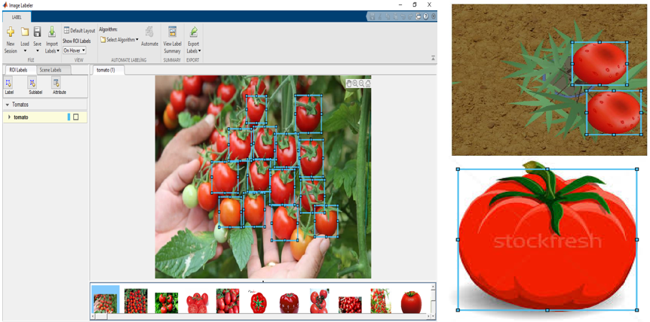Figure 1 Labeling Positive Samples

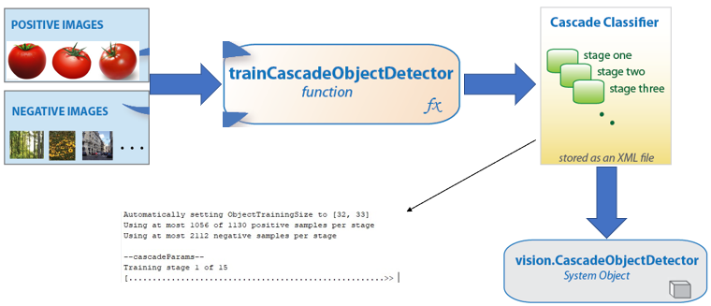  
Figure 2 Cascade Classifier Method

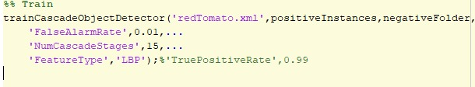Figure 2.1 Train Cascade Object Detector

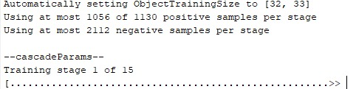Figure 2.2 Training Stages

## Motion planning

We command to the drone to go to certain coordinates, as in Figure 3, where crops are and drone goes to these points to take images from a certain height. Adjustments should be made so that the same objects don’t appear in different photos. These images are processed by the vision sensor and the methods we mentioned are applied. The results are given one by one and collectively [6].

Figure 3 Adjusting Set Points

## Vision based crop detection

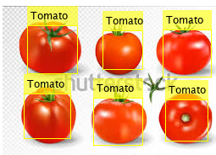Figure 4 Test Results of Ripe Tomatoes

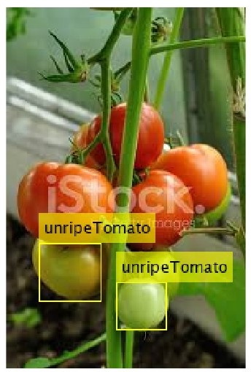  
Figure 5 Test Results of Unripe Tomatoes

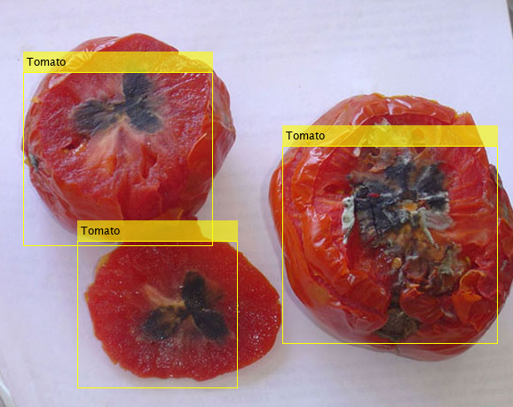  
Figure 6 Test Results of Rotten Tomatoes

As you see Figure 4,5 and 6, test results are like we expected.

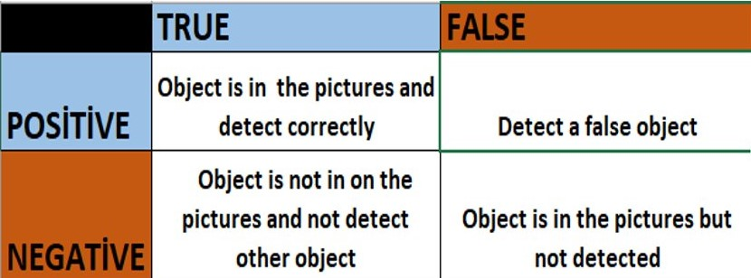  
Figure 7 Neural Network Parameters

For our project, true positive samples are red, unripe and rotten tomatoes (changeable according to object). False positive can be anything other than positive samples but detected by machine. True negatives can be anything other than positive samples but not detected by machine. False negative is that although there is an object, machine didn’t detect.

Precision, also called positive predictive value, is the fraction of relevant instances among the retrieved instances and is calculated by below equation:

*Precision = TruePositive/(TruePositive+FalsePositive) (1)*

Recall, also known as sensitivity, is the fraction of the total amount of relevant instances and is calculated by below equation [7]:

*Recall = TruePositive/(TruePositive + FalseNegative) (2)*

Figure 8 Cascade Parameters Analysis according to Test Results

# Algorıthm

- Uploading positive and negative images

- Labeling every single object in images

- Training stage by stage and saving as .xml file

- Drone goes to set point

- Get the image by camera

- Apply the detection

o Objects in the image are being compared with positive images from training .xml file

o If(objects are similar){

surrounds the object with bounding box}

o Else{ Don’t detect any object }

- Counting the crops

o If ( ripe object is detected){

increase ripe counter }

o Else if( unripe object is detected){

increase unripe counter }

o Else if( rotten object is detected){

increase rotten counter }

* Else{ Don’t change counter}

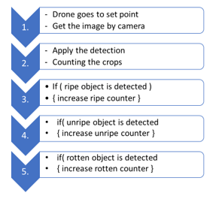  
Figure 9 Flow Chart

# Simulation

<https://www.youtube.com/watch?v=HtwfdUxCOLQ>

# Conclusion

In summary, large agricultural fields are controlled by farmers manually, e.g., without any technological aid, to observe and detect possible diseases and abnormalities in crops. This traditional method usually leads to waste of time and effort. By using our system, farmers will be able to observe their fields much easily and automatically, produce more healthy crops, and spend less energy and time to control their farms [8]. For our project, there were some unexpected results on simulation because of lack of simulation. However, in the real images we got results as much as we expected.

##### References

1. G G. Sylvester, “E-Agriculture in Action: Drones for Agriculture ”, Food and Agriculture Organization of the United Nations and International Telecommunication Union, Bangkok, 2018, pp.27-31
2. Dalal, N., and B. Triggs. “Histograms of Oriented Gradients for Human Detection.” IEEE Computer Society Conference on Computer Vision and Pattern Recognition. Volume 1, 2005, pp. 886–893
3. Viola, P., and M. J. Jones. "Rapid Object Detection using a Boosted Cascade of Simple Features." Proceedings of the 2001 IEEE Computer Society Conference. Volume 1, 15 April 2001, pp. I-511–I-518
4. Ojala, T., M. Pietikainen, and T. Maenpaa. “Multiresolution Gray-scale and Rotation Invariant Texture Classification With Local Binary Patterns.” IEEE Transactions on Pattern Analysis and Machine Intelligence. Volume 24, No. 7 July 2002, pp. 971–987.
5. MathWorks,” Train a Cascade Object Detector” , https://www.mathworks.com/help/vision/ug/train-a-cascade-object-detector.html.
6. ApiFunctions,“simSetObjectPosition”, https://www.coppeliarobotics.com/helpFiles/en/apiFunctions.htm#simSetObjectPosition
7. MathWorks,”bboxPrecisionRecall”,https://www.mathworks.com/help/vision/ref/bboxprecisionrecall.html
8. J. Jensen, “Agricultural Drones: How Drones Are Revolutionizing Agriculture and How to Break into this Booming Market”,Uav Coach, April 2019