High Precision Stepper Encoder Motor Position and Speed Control by using 2 stepper motors, motor driver, breadboard to see output of stepper motor on oscilloscope, power supply and Arduino as we see in the *Figure 12*. First, I wiring necessary connections, I could control speed of motor in microseconds domain and position of the motor. Then, I tested how many pulses are equal to 360 degrees. Normally, when 40600 pulses are applied, it is 360 degrees, but when the Arduino is only created a long int and multiplies with each other, there were very small negligible deviations. Normally this step motor’s 1.7 degree equals to 1 step. However, I could spin smaller steps by using this driver since we can adjust resolution. I wiring connections according to examining datasheet of the driver.

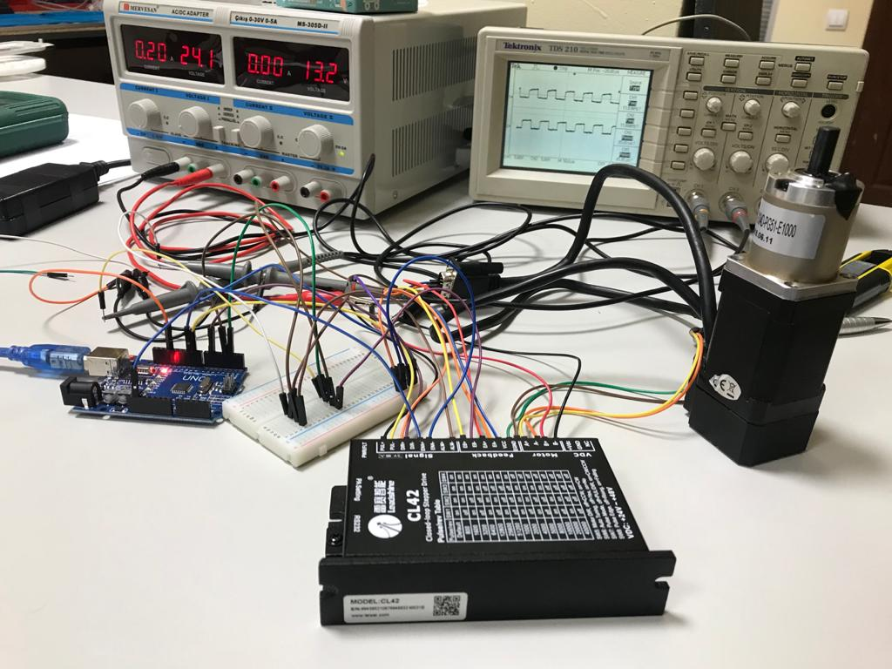

Figure 12

In the *Figure 13* we can see the system. Here we have a thing that we want to control, in this case we are controlling laser. Below motor controls laser’s x axis and above motor controls laser’s y axis.

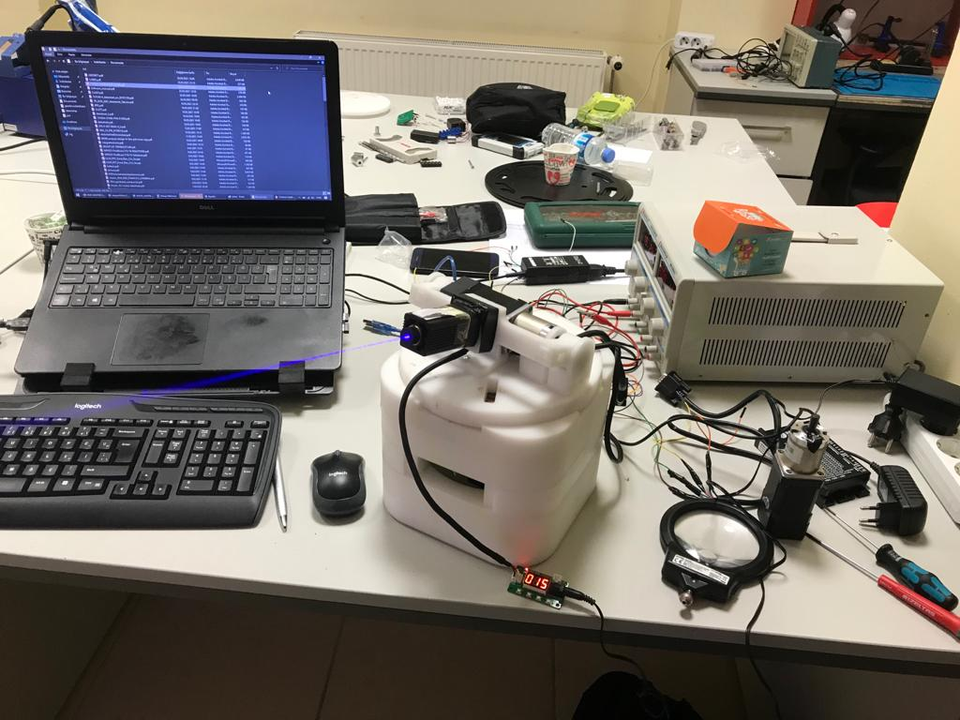

Figure 13

There was a lot of cable and I designed a PCB board that leads we get rid of cable (*Figure 14)*. This is actually just copper circles that provides electrical conductivity throughout 360 degrees.

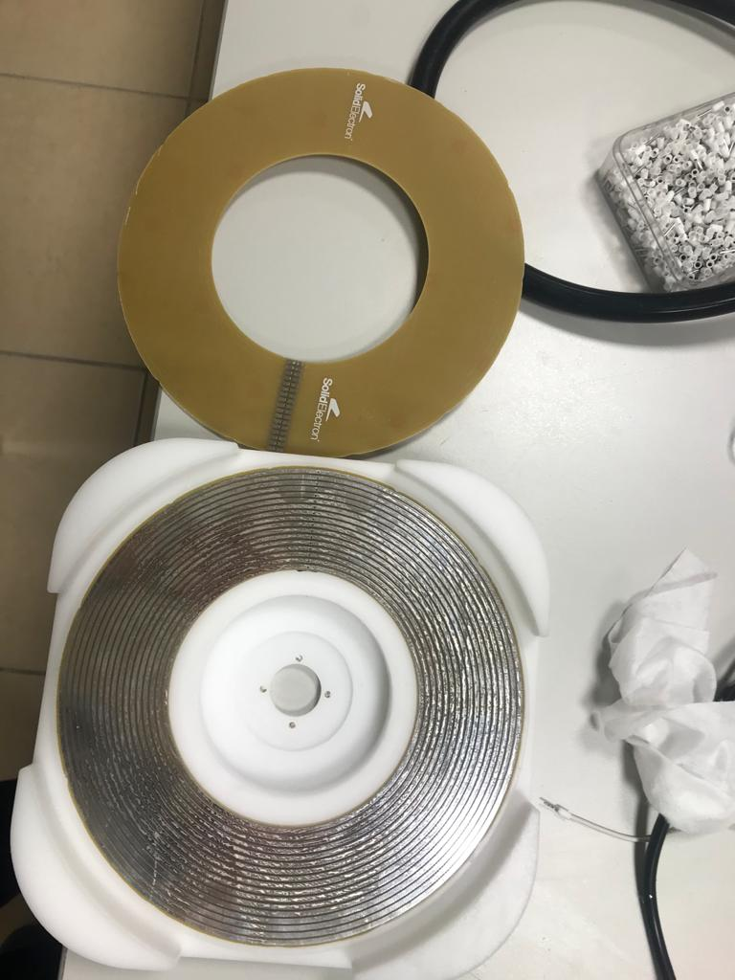

Figure 14

Motors spun one by one although I wanted to run motors at the same time. I created an algorithm that provides running at the same time. After I tested algorithm, I faced with a problem that there were some missing steps. Then, I fixed step missing (*Figure 15*).

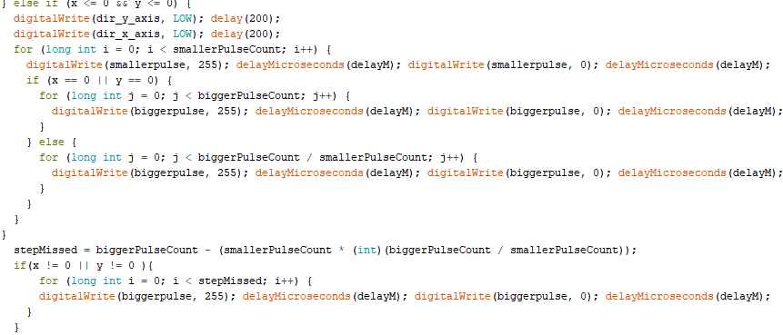

Figure 15

I provided communication between 2 Arduinos and understood communication principles.

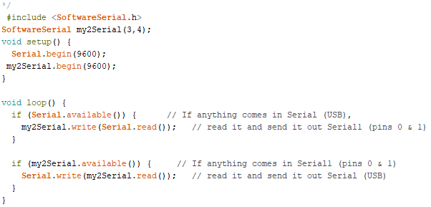

Figure 16

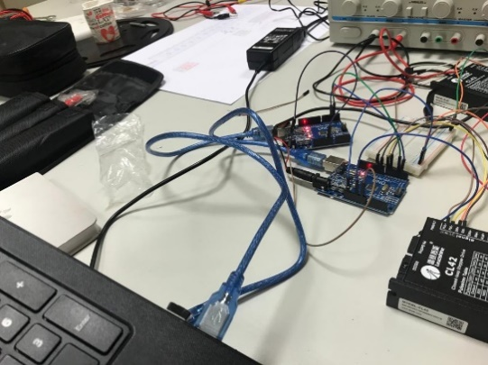

Figure 17

After I learned communication principles, I literature reviewing about Qt Framework serial communication and I provided communication Arduino by coding Qt framework as we see below.

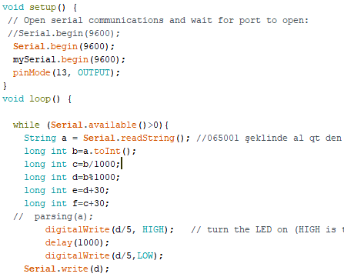

Arduino Serial Communication Code Reading-Writing

QT Creator Serial Communication Code

Reading-Writing

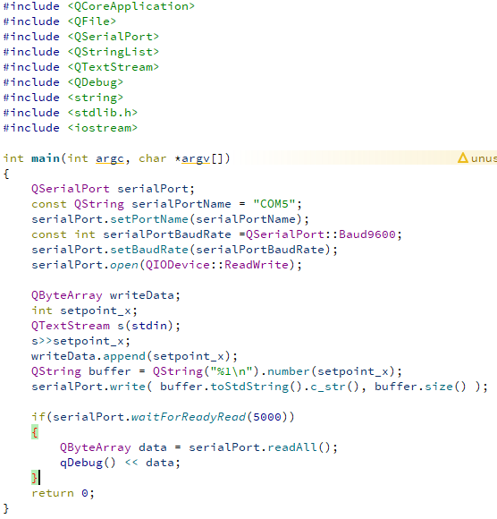

Then, company wanted me to build an interface on Qt to control laser easily. First, I created the necessary environment and determined the boundaries use mouse press event function on Qt which is used for showing x and y coordinates of mouse when we pressed any points in the window. I designed a dynamic interface on Qt (*Figure 18*). I used mousePressEvent function to get x and y axis value from widget and send these values to Arduino.

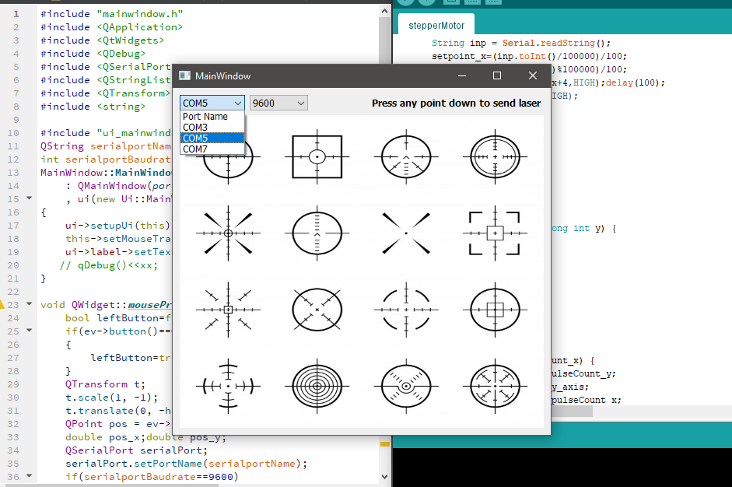

Figure 18

However, I faced with another problem which we couldn’t send String data or 2 double data separately from Qt to Arduino. So, I solved this problem by sending merged data. As you see in the algorithm (*Figure 19*), we multiply x with 10 million and sum a hundred times of y on qt. So, we have a data whose first 5 digits represent x, and last 5 digits represent y. Then, we divided data in middle and then divided by 100 to get x axis and y axis separately.

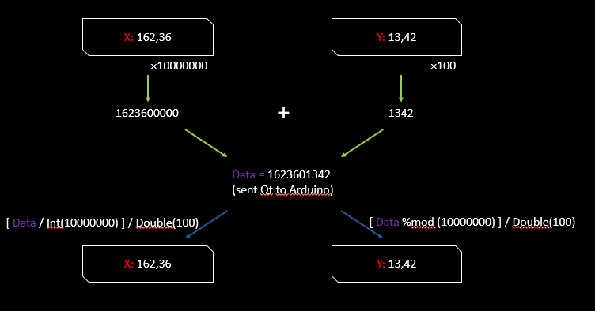

Figure 19

Then, I faced with another problem that was when user pressing map on qt in succession, x axis motor spins forever. Solution of this problem creating object that we assign minus operator between setpoint and temporary axis value (*Figure 20*). I had to change some part of code most of the time because we are dealing with microseconds on Arduino and I should be careful when I use some functions for example println, minus operator or Serial.write since Arduino processor is not so fast.

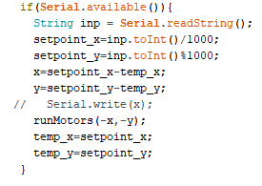

Figure 20

Then, company wanted me to design a new Windows desktop application that sending 2 lasers to at the same point while we know only location of lasers and target object. First, I designed a dynamic interface (*Figure 21*).

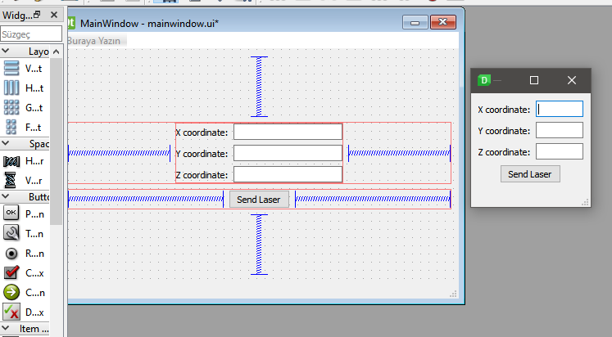

Figure 21

Then, I focus on a math calculation which provides us which angles between laser and target object and I created algorithm according to some math calculations as in the below:

After that, I calibrated system by putting a target object over the wall and measured x, y and z axis distance between laser and target object by using meter and I faced with a problem that when x and y location on laser is both 0; x, y and z are all 0; motors spin constantly. This problem is because of tan-1(0/0) is undefined, actually 0/0 is undefined. Using if conditions for these 2 possibilities and inside of if doing nothing. Another problem is that when I sent 215 and bigger degree of x position motor, output was different from what I expected. Normally integers are 32 bits in Qt platform. When I sent 214 degrees for x axis motor, merged data would be 2140000000 and if I sent bigger than 214 degrees for instance 215.01 for x and 35.26 for y axis motor, merged data would be bigger than 32 bits (*Figure 22*). So, I solved this problem by raising the bit to 64 (*Figure 23*).

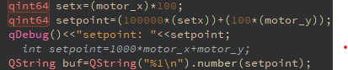

Figure 22

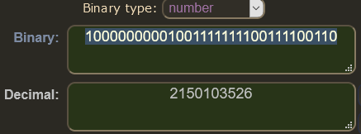

Figure 23

Then, I focus on setting coordinate system. First, I send inputs according to below table respectively.

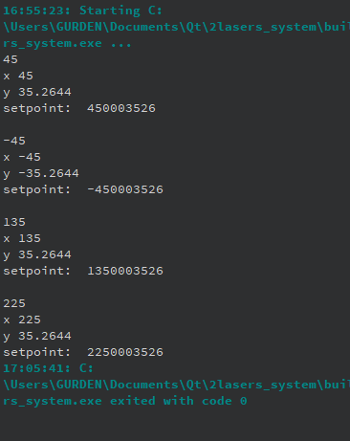

Figure 24

|  |  |  |
| --- | --- | --- |
| Area (at order in code) | X | Y |
| 1st | + | + |
| 4th | + | - |
| 2nd | - | + |
| 3rd | - | - |

And output of the system was as in the *Figure 24*.

I have to detect if z axis is negative, do nothing because we can’t send laser under the system according to design. There was a problem only 4th area of coordinate system. I solve this problem by detecting if x axis positive and y axis negative, sign of motor y must be changed because we had to send coordinates properly.

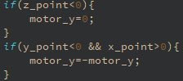

Figure 25

I changed the sign of motor y on Arduino part (*Figure 26)*. So, if I would like to send laser 4th area of coordinate system, laser goes properly.

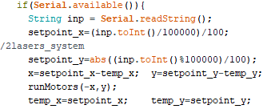

Figure 26