My purpose was that designing high precision temperature balancing and control system by using RTD (Resistance Temperature Detector which is also known Pt100), Peltier, computer fan, CPU cooler and Arduino. RTD which is shown in the *Figure 1*has platin resistor inside of itself. First, I connected a resistor (330 ohm) as series to measure voltage on RTD’s resistor by “analogRead” on Arduino and then I calculated resistance value of RTD by using voltage divider and finally transform to temperature by using this formula:

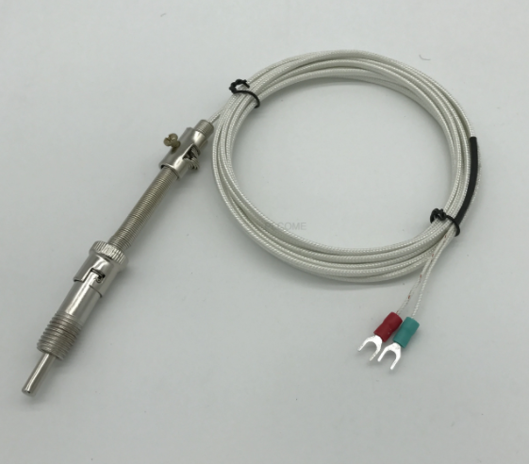

Figure 1

When I examined output of temperature values, I recognize there is an offset value. So, I calibrated RTD to find offset value by measuring ice and room temperature by comparing with a temperature sensor (thermocouple probe with adaptor). Offset value was equal to 5.85 degree. So, I added offset value to formula as:

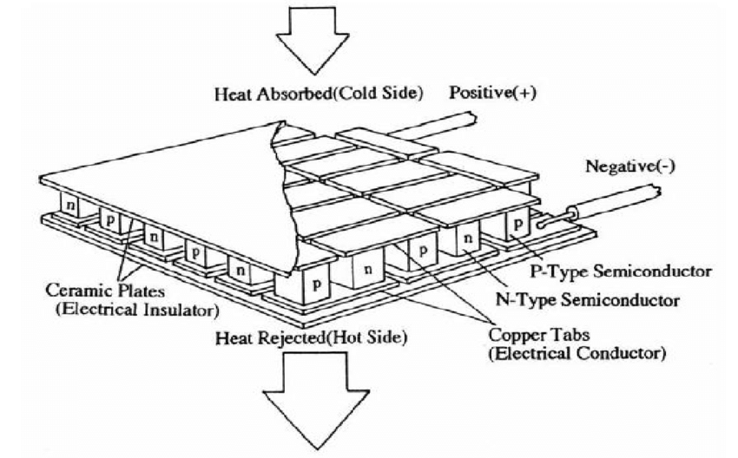

Figure 2

Peltier which is shown in the *Figure 2*is used for heat sink; it has 2 sides, while one side is getting hot, other side is getting cold. If we wanted to cool down excessively, we should get Peltier’s hot side to cold. Otherwise, Peltier would burn.

So, I used computer fan to get Peltier’s hot side for cooling. Finally, I designed the system as in the *Figure 3*.

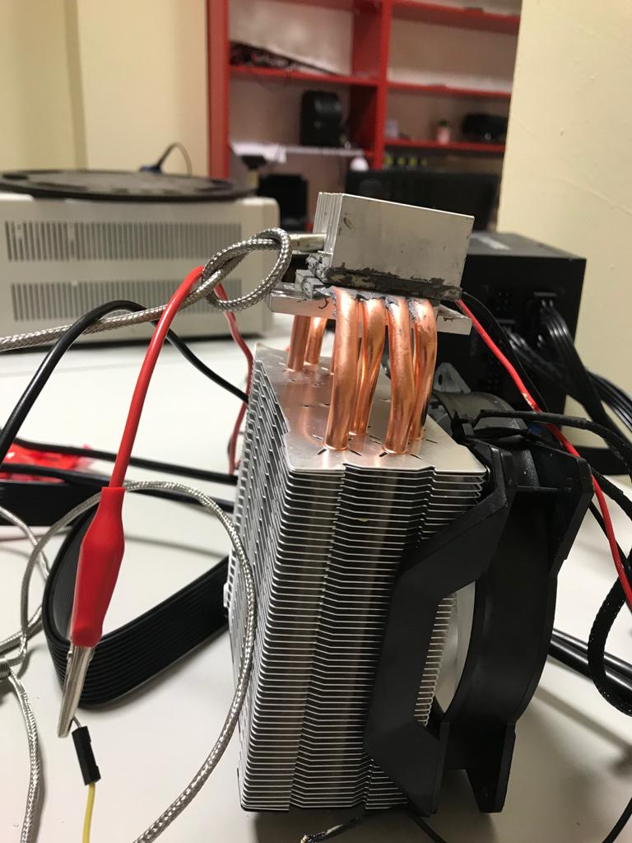

Figure 3

I needed a driver to control which condition I want to Peltier on and off. I used BTS7960 which is a motor driver that control system by receiving PWM signals and making some functions to component that we can used i.e., h bridge function. I used BTS7960 to get analog output from digital input of Arduino and control giving power to Peltier while comparing process temperature and setpoint on software and wiring battery +/- to power supply and motor +/- to Peltier. I provided wiring connections between driver and Arduino according to *Figure 4*.

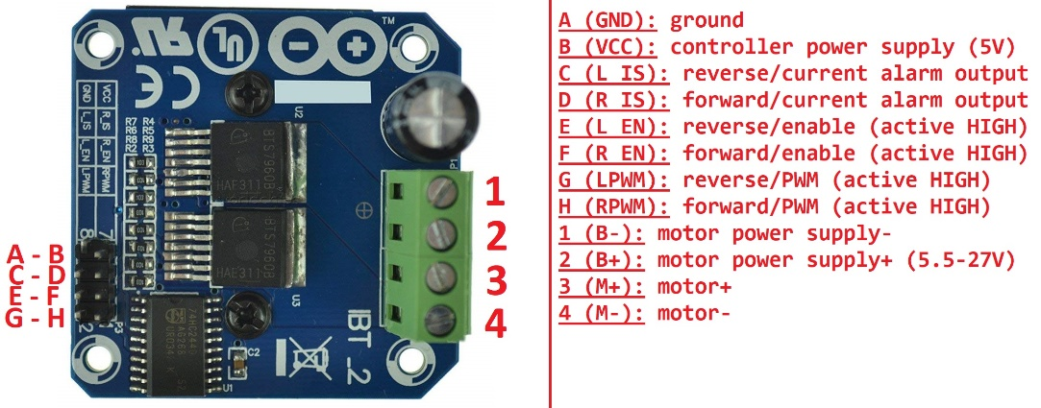

Figure 4

There were noises on plot and not stable. I applied Kalman filter to reduce noise on plot and to make more stable. I used samples array as 10 dimensions, and my purpose was receiving 10 samples and calculate median of these samples and to give median as output. I burned Peltier because of overloading power while receiving data with high frequency and heat sink side became very hot and burned suddenly. There were 2 assumptions the reason why Peltier burned: I didn’t change delay which was 20 milliseconds and this causes higher frequency or other assumption that in test process, I gave energy and take energy many times. It may lead Peltier to burn.