CmpE 352 Spring 2020 Group 6 – Milestone 1

Group Members

* [Ahmet Berat Can](https://github.com/bounswe/bounswe2020group6/wiki/Ahmet-Berat-Can)
* [Doğukan Kalkan](https://github.com/bounswe/bounswe2020group6/wiki/Do%C4%9Fukan-Kalkan)
* [Emilcan Arıcan](https://github.com/bounswe/bounswe2020group6/wiki/Emilcan-Ar%C4%B1can)
* [Muhammed Enes Toptaş](https://github.com/bounswe/bounswe2020group6/wiki/Muhammed-Enes-Topta%C5%9F)
* [Ezgi Gülperi Er](https://github.com/bounswe/bounswe2020group6/wiki/Ezgi-G%C3%BClperi-Er)
* [Tuba Çibuk](https://github.com/bounswe/bounswe2020group6/wiki/G%C3%BCls%C3%BCm-Tuba-%C3%87ibuk)
* [Hamza Işıktaş](https://github.com/bounswe/bounswe2020group6/wiki/Hamza-I%C5%9EIKTA%C5%9E)
* [Hazer Babur](https://github.com/bounswe/bounswe2020group6/wiki/Hazer-Babur)
* [Ömer Faruk Özdemir](https://github.com/bounswe/bounswe2020group6/wiki/%C3%96mer-Faruk-%C3%96zdemir)
* [Salih Can Özçelik](https://github.com/bounswe/bounswe2020group6/wiki/Salih-Can-%C3%96z%C3%A7elik)
* [Cemre Efe Karakaş](https://github.com/bounswe/bounswe2020group6/wiki/Cemre-Efe-Karaka%C5%9F)

**Contents**

**1. Executive Summary** 3

**1.1 Summary of Project Status** 3

**1.2 Planned for Moving Forward** 3

**2. List and status of deliverables** 3

**2.1 Communication plan** 3

**2.2 Requirements** 4

• 1.1 User Requirements 4

• 1.2 System Requirements 7

• 2.1 Activity Streams 9

• 2.2 Availability & Accessibility 9

• 2.3 Perfomance & Scalability 9

• 2.4 Security 9

**2.3 Scenarios and Mockups** 10

GUEST USER / Scenario 1 10

Persona (Ertugrul Düldül) 10

Goals 10

Preconditions 10

User story 10

Scenario 10

Action List 11

Acceptance criteria 11

Mockup 11

Registered User / Scenario 2 16

Persona (Friedrich Nietzsche) 16

Goals 16

Preconditions 17

User story 17

Scenario 17

Action List 17

Acceptance criteria 17

Mockup 18

Registered User / Scenario 3 20

Persona (Atakan Kayalar) 20

Goals 20

Preconditions 20

User story 20

Scenario 21

Action List 21

Acceptance criteria 21

Mockup 21

**2.4 UML Software Designs** 28

**2.5 Project plan & RAM** 28

**3. Evaluation of the status of deliverables and its impact on your project plan** 28

**4. Evaluation of tools and processes you have used to manage your team Project** 28

**5. Summary of work done** 28

# **1. Executive Summary**

## **1.1 Summary of Project Status**

## **1.2 Planned for Moving Forward**

# **2. List and status of deliverables**

## **2.1 Communication plan**

|  |  |  |  |  |
| --- | --- | --- | --- | --- |
| **Where** | **Purpose** | **Frequency** | **Audience** | **Channel** |
| Slack | Keeping each other informed about progress | Anytime | All members | Online |
| Github | Following Overall Work / Issue Management | Every Thursday @ 12 PM | All members | Face-to-face |
| Bogazici University, Cmpe Building, BM A5 | Weekly Review | Every Thursday @ 12 PM | All members | Face-to-face |
| Bogazici University, Cmpe Building, BM Classes | Customer Meeting | When Needed | Some members | Face-to-face |
| Whatsapp | Urgent Communication | Anytime | All members | Online |
| Piazza | Communication With The Customer | Anytime | All members | Online |
| Zoom | Weekly Review | Every Thursday @ 12 PM | All members | Online |

## 

## **2.2 Requirements**

#### **1. Functional Requirements**

### ****1.1 User Requirements****

* + **1.1.1** Users shall be able to search and view users, public papers and projects
  + **1.1.2** Users shall be able to view profile pages of authors, and collaborators of papers and projects
  + **1.1.3** Users shall be able to search related information about the upcoming conferences or journal special issues

#### **1.1.4 Guests**

* + - **1.1.4.1** Guests shall not be able to view private papers or projects.
    - **1.1.4.2** Guests shall not be able to join papers/projects, comment to papers/projects or post new papers/projects.

#### **1.1.5 Registration**

* + - **1.1.5.1** Users shall be able to register by providing name, surname, unique email address and password
    - **1.1.5.2** Users shall validate the e-mail address for completing the registration phase
    - **1.1.5.3** Users shall be able to specify the research interests
    - **1.1.5.4** Users shall provide the information about affiliation
    - **1.1.5.5** Users shall be able to identify themselves as student or academician

#### **1.1.6 Registered Users**

* + - **1.1.6.1** Users shall login by email and password provided
    - **1.1.6.2** Users shall be able to state whether s/he is looking for a project to collaborate
    - **1.1.6.3** Users shall be able to send request to join the team
    - **1.1.6.4** Users, as the owner of the projects, shall be able to accept or reject requests to join the team
    - **1.1.6.5** Users shall be able to invite any user to participate
    - **1.1.6.6** Users shall be able to accept or reject invitations
    - **1.1.6.7** Users shall be able to rate and comment other users that s/he collaborated with during the collaboration and after the project is completed
    - **1.1.6.8** Users shall be able to collaborate on more than one paper/project
    - **1.1.6.9** User shall be able to disable join requests to end call for collaboration phase
    - **1.1.6.10** Users shall be able to have more than one paper/project topic posted
    - **1.1.6.11** Users shall be able to specify a deadline for the paper/project
    - **1.1.6.12** Users shall not be able to delete a paper/project that is in progress
    - **1.1.6.13** Users shall be able to file complaints
      * **1.1.6.13.1** Users shall be able to report another user, a project or a paper for unwanted/inappropriate behavior
      * **1.1.6.13.2** Users shall be able to mark a publication as unrelated
    - **1.1.6.14** Users shall be able to follow other users on the platform.
      * **1.1.6.14.1** Users shall be able to approve/reject follow requests.
      * **1.1.6.14.2** Users shall be able to set visibility of their projects/papers for the users not following them.
      * **1.1.6.14.3** Users shall be able to request to join a project/paper if they can see it.
      * **1.1.6.14.4** Users shall be able to invite other uses to collaborate, without following them.
    - **1.1.6.15** Users shall be able to set their profiles to public or private.
    - **1.1.6.16** Users shall be able to log out from his account.
    - **1.1.6.17** Users shall be able to delete his account.
    - **1.1.6.18** Users shall be able to delete or update a comment s/he made before.
    - **1.1.6.19** Users shall be able to delete or update a rate s/he gave before.
    - **1.1.6.20** Users shall be able to add additional files to the collaborated projects/papers.
    - **1.1.6.21** Users shall be able to add additional files to their projects/papers in progress.

#### **1.1.7 Registered Users Requirements**

#### **1.1.7.1 Profile Page**

* + - * **1.1.7.1.1** Users shall be able to provide information about the research area, recent publications and affiliation.
      * **1.1.7.1.2** Users shall be able to link their Google Scholar or ResearchGate accounts.
      * **1.1.7.1.3** Users shall be able to edit their own profile page.
      * **1.1.7.1.4** Users shall be able to see invitations that are sent from the other users.
      * **1.1.7.1.5** Users shall be able to see messages that are sent from the other users.
      * **1.1.7.1.6** Users shall be able to see ratings and comments that are made by other users.
      * **1.1.7.1.7** Users shall be able to see their followers.
      * **1.1.7.1.8** Users shall be able to see people who they follow.

#### **1.1.7.2 Creating / Editing Page**

* + - * **1.1.7.2.1** Users shall be able to provide information about: topic of the research, deadline of submission, milestones, codes, documents, result plots / figures, required skills in order to apply and if the the project is funded or not.
      * **1.1.7.2.2** Users shall be able to add a summary(abstract) part.
      * **1.1.7.2.3** Users shall be able to state the type of the content (Paper or Project).
      * **1.1.7.2.4** Users shall be able to state whether project/paper is private or public.
      * **1.1.7.2.5** Users shall be able to add co-authors and collaborators during creation of a project.
      * **1.1.7.2.6** Users shall be able to add tags related to project/paper.
      * **1.1.7.2.7** Collaborators shall be able to track the information shared by corresponding users.
      * **1.1.7.2.8** Collaborators shall be able to prepare document or article for submission simultaneously.

#### **1.1.7.3 Paper/Project Page**

* + - * **1.1.7.3.1** Users shall be able to create a new paper.
      * **1.1.7.3.2** Users shall be able to create a new project.
      * **1.1.7.3.3** Users shall be able to see the status of his/her paper(s).
      * **1.1.7.3.4** Users shall be able to see the status of his/her project(s).
      * **1.1.7.3.5** Users shall be able to edit the specifications of his/her paper(s).
      * **1.1.7.3.6** Users shall be able to edit the specifications of his/her project(s).
      * **1.1.7.3.7** Users shall be able to see his/her paper(s) in progress.
      * **1.1.7.3.8** Users shall be able to see his/her project(s) in progress.
      * **1.1.7.3.9** Users shall be able to edit the specifications of his/her paper(s) in progress.
      * **1.1.7.3.10** Users shall be able to edit the specifications of his/her project(s) in progress.
      * **1.1.7.3.11** Users shall be able to invite another user to collaborate on his/her paper(s) in progress.
      * **1.1.7.3.12** Users shall be able to invite another user to collaborate on his/her project(s) in progress.
      * **1.1.7.3.13** Users shall be able to accept or reject another users invitation to collaborate on his/her paper or project

#### **1.1.8 Search Page**

* + - **1.1.8.1** Users shall be able to search; other users, papers, projects, conferences and journals within the system.
    - **1.1.8.2** Users shall be able to filter search results with regards to the research area, topic, scope and difficulty.
    - **1.1.8.3** Users shall be able to find related posts searching related keywords.
    - **1.1.8.4** Users shall be able to view previews of papers/journals/projects/conferences related to their activities, profile and interests.

#### **1.1.9 Events Page**

* + - **1.1.9.1** Users shall be able to see about upcoming conferences related to joined projects/papers.
    - **1.1.9.2** Users shall be able to see closing deadlines of joined projects/papers.
    - **1.1.9.3** Users shall be able to travel in the timeline to see past events.
    - **1.1.9.4** Users shall be able to travel in the timeline to see far future events.
    - **1.1.9.5** Users shall be able to synchronize this calendar with other calendar applications.
    - **1.1.9.6** Users shall be able to view particular event more detailed when clicked/tapped.

### ****1.2 System Requirements****

#### **1.2.1 Search & Recommendation**

* + - **1.2.1.1** System shall support basic search of the available content.
    - **1.2.1.2** System shall support semantic search.
    - **1.2.1.3** System shall provide a tagging system.
    - **1.2.1.4** System shall provide a filtering system. This system filters the content such as projects/papers/profiles showed to the registered user.
    - **1.2.1.5** System shall provide a recommendation mechanism that recommends papers/journals/projects/conferences to the registered user based on the user activities and profile.
    - **1.2.1.6** System shall provide a recommendation mechanism for project owners, to recommend possible collaborators based on their research interests, or previous works in that area.

#### **1.2.2 Homepage**

* + - **1.2.2.1** System shall provide a homepage for each registered user, showcasing recent sharings.

#### **1.2.3 Profile Page**

* + - **1.2.3.1** System shall provide a profile page for each registered user, showcasing their interests, past contributions to projects and papers, their contacts and their related links (example: Google Scholar).
    - **1.2.3.2** System shall retrieve information (example: citations, h-index) of a user from their Google Scholar/ResearchGate pages.

#### **1.2.4 Notifications**

* + - **1.2.4.1** System shall provide a notification mechanism for informing users about the incoming invitations
    - **1.2.4.2** System shall provide a notification mechanism for informing users about whether their request to join a team accepted or rejected
    - **1.2.4.3** System shall provide a notification mechanism for informing users about whether someone accepted or rejected their invitations
    - **1.2.4.4** System shall provide a notification mechanism for informing users about whether someone has commented on their profile
    - **1.2.4.5** System shall provide a notification mechanism for warning users if they perform an unauthorized activity

#### **1.2.5 Events**

* + - **1.2.5.1** System shall provide a page of Events for every registered user.
    - **1.2.5.2** System shall fill this page with the events related to registered user.

#### **2. Nonfunctional Requirements**

### ****2.1 Activity Streams****

* + **2.1.1** System shall obey [W3C Standards](https://www.w3.org/standards/)
  + **2.1.2** System shall follow [W3C Activity Streams Model](https://www.w3.org/TR/activitystreams-core/)

### ****2.2 Availability & Accessibility****

* + **2.2.1** The system shall be available as a website and as an Android application.
  + **2.2.2** The website and the application shall be available in English.
  + **2.2.3** The system shall notify users in case of a failure.
  + **2.2.4** Any failure in the system shall be handled in at most half an hour.

### ****2.3 Perfomance & Scalability****

* + **2.3.1** The system shall use queuing algorithms and caching mechanism to reduce response time.
  + **2.3.2** The system shall respond to a request at most 5 seconds.
  + **2.3.3** The system shall be able to respond up to 1000 requests per second.

### ****2.4 Security****

* + **2.4.1** The system shall be protected from unauthorized accesses and attacks to the system and its stored data according to [KVKK](https://www.mevzuat.gov.tr/MevzuatMetin/1.5.6698.pdf)
  + **2.4.2** The system shall force users to use strong passwords that contain a lowercase letter, an uppercase letter, a number and a special character and contain 6-24 characters in total.
  + **2.4.3** The system shall store only the hashed version of passwords.
  + **2.4.4** The system shall force users to change their passwords once a year.
  + **2.4.5** The system shall deny all the access attempts to an account after three failed access attempts until user re-validates his/her account via a link sent in an email.
  + **2.4.6** The system shall provide a validation code for users during registration.
  + **2.4.7** The system shall be protected against SQL injection and DDOS attacks.

## **2.3 Scenarios and Mockups**

## GUEST USER / Scenario 1

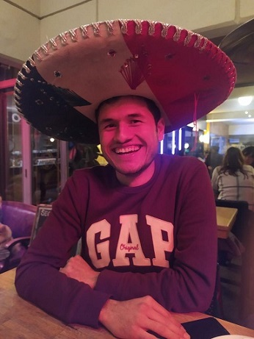

### Persona (Ertugrul Düldül)

* 23 years old
* Student
* Currently pursuing bachelor’s degree
* Enthusiastic about basketball
* Playing, watching, and thinking about basketball

### Goals

* Being an academic basketball researcher
* Learning physics such that he can nail basketball
* Learning mathematics like his mother tongue to be a gambler

### Preconditions

* Ertugrul is not a member of the platform.
* He visits the platform as a guest.

### User story

* Ertugrul is a junior computer engineering student at Bogazici University. He wants to combine his computing and scientific skills with basketball and be the one who rules the whole game. He has been into basketball for as long as he can remember.

### Scenario

* Ertugrul first visits the web page as a guest. Then he looks for some mechanical physics papers to learn more about the movement of a basketball. He finds a paper and starts reading it. When he wants to comment, he isn't able to do it since he is not registered. After that he decides to be a registered user so that he can comment to posts, see what he has read up to now, publish papers and projects through his profile page, invite people to contribute to them and join academic collaborations; he provides his full name, password, and an e-mail address to register and validate his account. Since he is not an academician, he does not have to provide university-specific information or his social security number.

### Action List

* 1 . Ertugrul visits the web page as a guest.
* 2 . He searches for "mechanical physic".
* 3 . He finds a paper related to it.
* 4 . He opens the document.
* 5 . He wants to write a comment after reading.
* 6 . He decides to register since writing a comment requires to be a registered user.
* 7 . He fills the registration form.

### Acceptance criteria

* 1.1.1 Users shall be able to search and see public papers or projects
* 1.1.2 Guests should be able to see profile pages of authors, contributors and collaborators of papers and projects
* 1.1.3 Guests shall be able to search related information about the upcoming conferences or journal special issues
* 1.1.11 Registration
* 1.1.11.1 Users shall be able to register by providing name, surname, unique email address and password
* 1.1.11.2 Users shall validate the e-mail address for completing the registration phase
* 1.1.11.3 Users shall be able to specify the research interests
* 1.1.11.4 Users shall provide the information about affiliation
* 1.1.11.5 Users shall be able to idendify themselves as student or academician

### Mockup

* Ertugrul wants to learn about mechanical physic in basketball. He visits the web page as a guest.
* Then search for "mechanical physic".

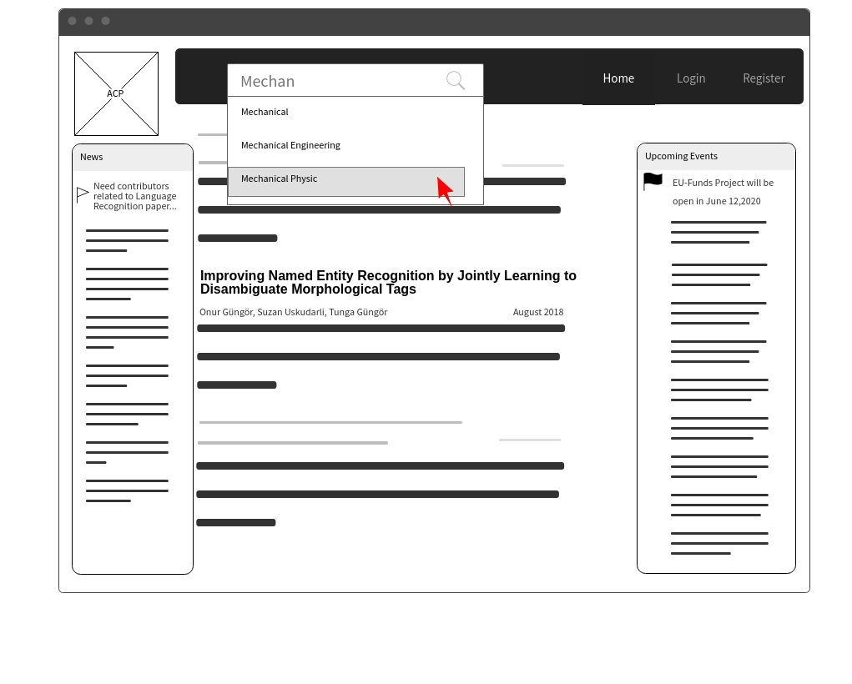

* Find a paper related to it.

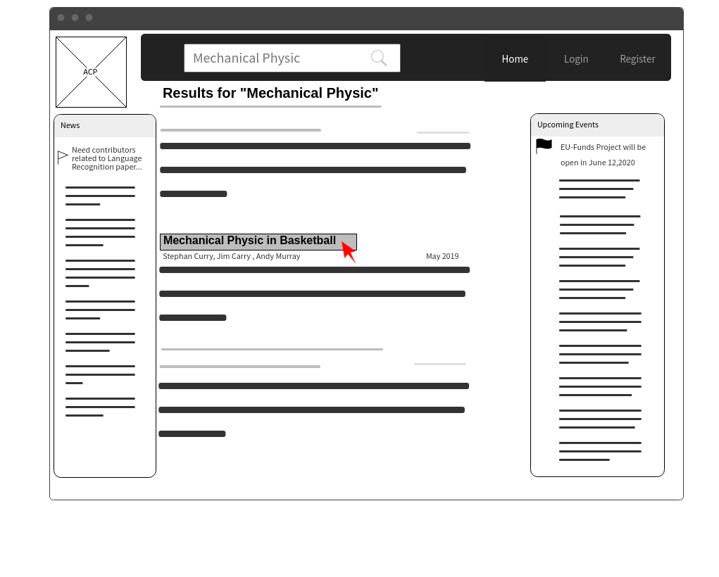

* After reading he wants to write comment 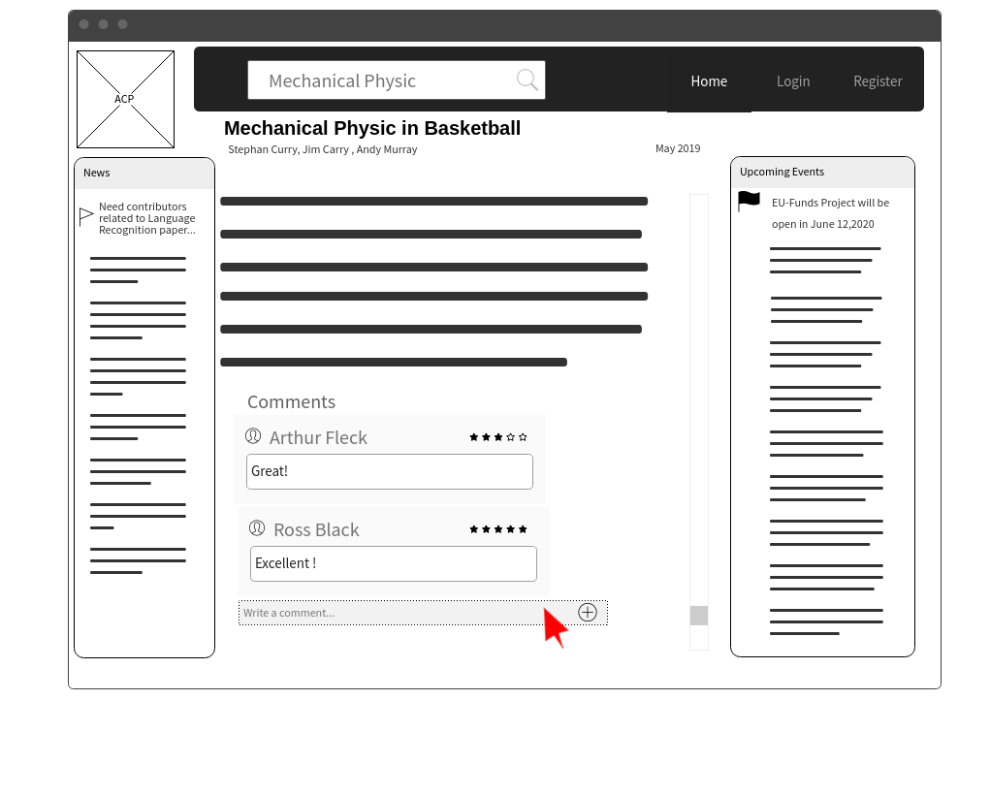
* Writing a comment requires to be login.
* In order to write a comment he decides to be a registered user. 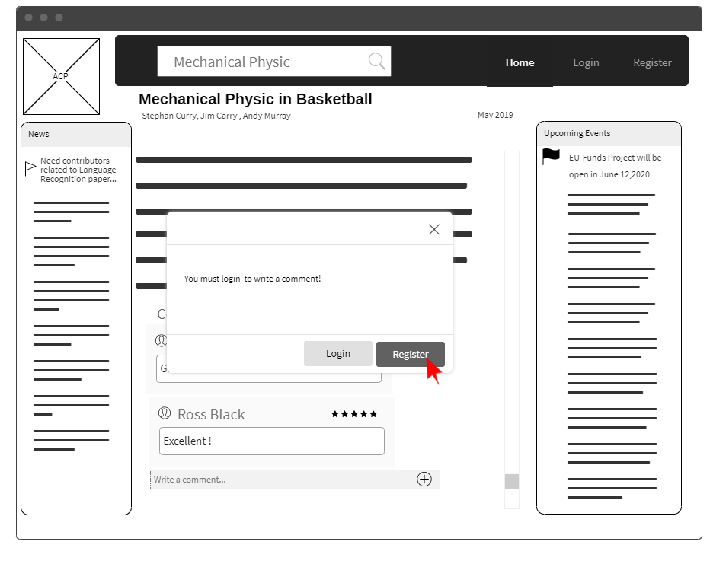 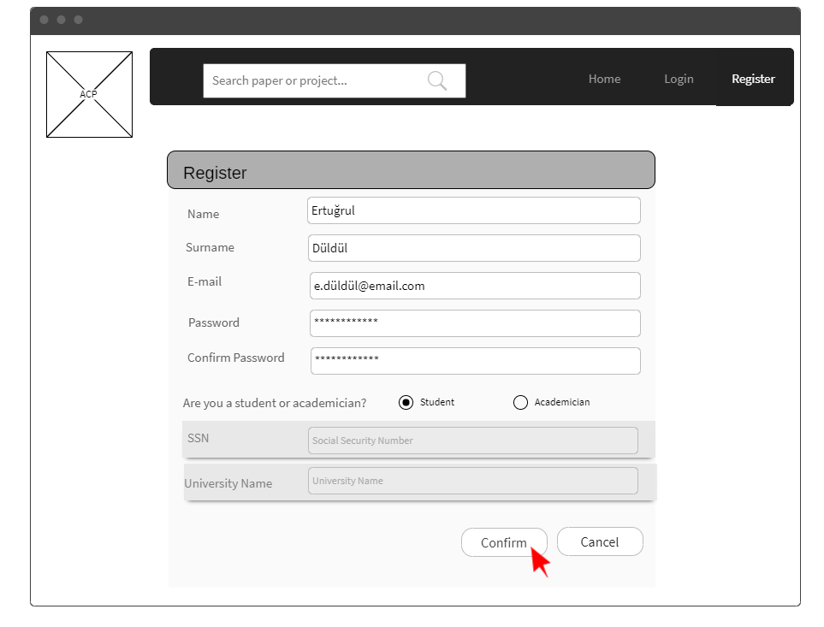
* After filling the registration form validation e-mail is sent.

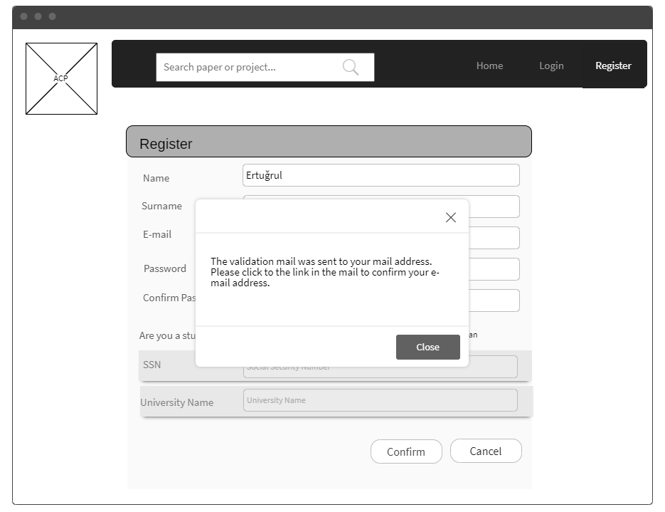

## Registered User / Scenario 2

### Persona (Friedrich Nietzsche)

* 34 years old
* Nihilist.
* German philosopher, cultural critic, composer, poet, philologist, and scholar of Latin and Ancient Greek whose work has exerted a profound influence on modern intellectual history.
* Übermensch
* Loves horses

### Goals

* Help other people comprehend the world around them
* Publish papers, create projects, and invite people to his research
* Paying respect to and supporting an independent academic platform

### Preconditions

* The user has already logged in
* Friedrich Nietzsche is an old member of the platform
* He already has a great portfolio beforehand

### User story

* Friedrich Nietzsche is a man who supports the independent academy. He wants to publish ideas/projects/papers on this free platform. He also stands up for every individual's right to feel free in academy and not hesitate to reveal their ideas.

### Scenario

* Friedrich Nietzsche is a spirited member of academy but sick of people not appreciating good work. Since he believes his ideas are thrilling and paradigm-shifting, he applies to our platform using the web page to be a registered user so that he can freely publish his ideas/papers/projects. While publishing his new work he sets a topic of research, a deadline and some requirements. He creates a fund request and attaches some documents. He adds a summary part to his work that explains what the work is about and what type of publication it is (paper, project). He states that the project public and clicks publish. He can now see his paper is "in progress" (progress) and "awaiting funding" (status).

### Action List

* 1 . Nietzsche is logged in and is looking at his profile page.
* 2 . He realizes it is a good time for creating a new publication and clicks "add" under publications.
* 3 . He fills out the new publication form according to his needs.
  + He sets a topic.
  + He writes a summary that explains what the work is/will be about.
  + He selects the type of publication to be "paper".
  + He skips the add files part.
  + He writes out some requirements.
  + He toggles the switch to apply for a funding.
* 4 . He clicks publish to finish creating the publication.
* 5 . Now back at his profile, he checks the info for the paper.
* 6 . He sees that the paper is in progress and is awaiting for funding.

### Acceptance criteria

* 1.1.9.1 Users shall be able to create a new paper.
* 1.1.9.2 Users shall be able to create a new project.
* 1.1.9.3 Users shall be able to see the status of his/her paper(s).
* 1.1.9.4 Users shall be able to see the status of his/her project(s).
* 1.1.9.5 Users shall be able to edit the specifications of his/her paper(s).
* 1.1.9.6 Users shall be able to edit the specifications of his/her project(s).
* 1.1.9.7 Users shall be able to see his/her paper(s) in progress.
* 1.1.9.8 Users shall be able to see his/her project(s) in progress.

### Mockup

* Nietzsche is logged in and is looking at his profile page.
* He realizes it is a good time for creating a new publication and clicks "add" under publications.

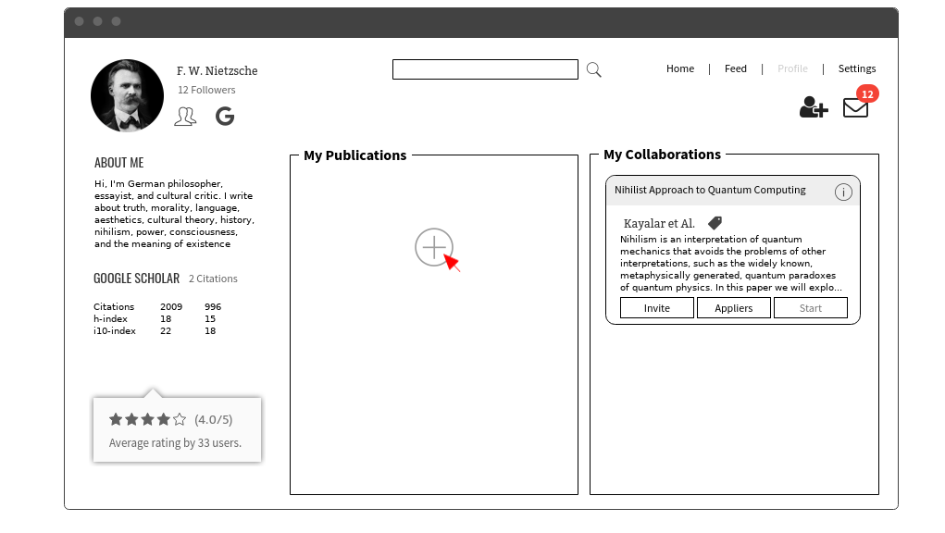

* He fills out the new publication form according to his needs.
  + He sets a topic.
  + He writes a summary that explains what the work is/will be about.
  + He selects the type of publication to be "paper".
  + He skips the add files part.
  + He writes out some requirements.
  + He toggles the switch to apply for a funding.
* He clicks publish to finish creating the publication.

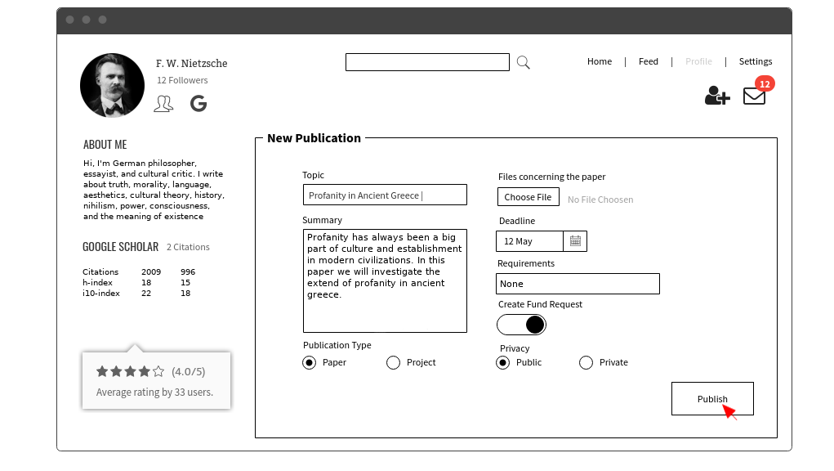

* Now back at his profile, he checks the info for the paper.
* He sees that the paper is in progress and is awaiting for funding.

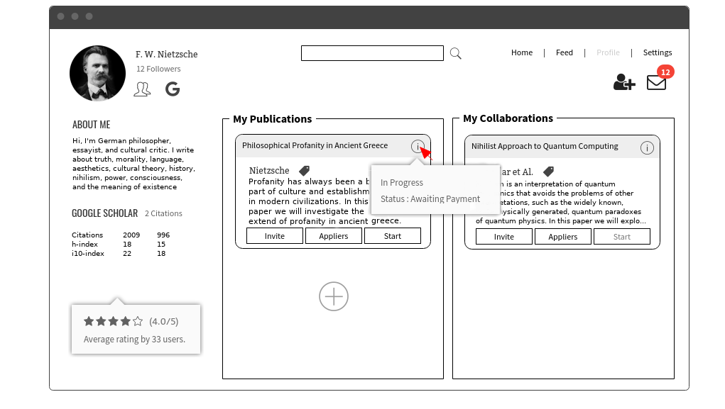

## Registered User / Scenario 3

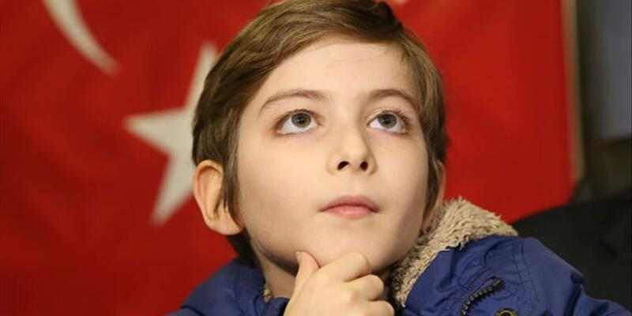

### Persona (Atakan Kayalar)

* 10 years old
* Kid
* Primary school student
* Part time philosopher
* Enthusiastic about all kinds of books, papers, and projects
* Currently holding the Guinness Record for most books read in 5 months (250)

### Goals

* Wants to expand his knowledge about academic philosophy
* Wants to publish papers, create projects, and invite people to his research
* Wants to join other academicians’ research

### Preconditions

* The user has already logged in
* Atakan is a new member of the platform
* He has a great portfolio beforehand
* He has many followers who are interested in his research and quotas.
* He linked his Google Scholar account to his profile page.

### User story

* Atakan is a primary school student who wants to broaden his academic skills. His main goal is to share his knowledge with the world so that a better world could be established with academy.

### Scenario

* The little philosopher visits his profile page using his android phone. He sees that he has 150k followers and by clicking his google scholar page link he sees that he has 98724 citations. There is an invite button that he can invite someone to his papers/projects. He also has an invitation box wherein he can see all invitations for him. He can accept or reject the invitations.

### Action List

* 1 . The little philosopher logs in using his android phone.
* 2 . The little philosopher visits his profile page. He sees that he has 150k followers and he sees that he has 98724 citations.
* 3 . He looks at his pending paper and sees who is invited.
* 4 . He searches for one specific user and invites him.
* 5 . He checks the appliers for his paper.

### Acceptance criteria

* 1.1.5.1 Users shall login by email and password provided
* 1.1.5.2 Users shall be able to send request to join the team of authors
* 1.1.5.3 Users shall be able to accept or reject requests to join the team of authors
* 1.1.5.4 Users shall be able to invite any academicians to participate
* 1.1.5.5 Users shall be able to search related information about the upcoming conferences or journal special issues
* 1.1.5.6 Users shall be able to rate and comment other users that s/he collaborated with
* 1.1.5.7 Users shall be able to collaborate on more than one paper/project
* 1.1.5.8 Users shall be able to have more than one paper/project topic posted
* 1.1.5.9 Users shall be able to specify a deadline or make the deadline open for the paper/project
* 1.1.5.10 Users shall not be able to delete a paper/project that is in progress
* 1.1.6.2 Users shall be able to link their Google Scholar or ResearchGate accounts.
* 1.1.6.4 Users shall be able to see invitations that are sent from the other users

### Mockup

* Atakan first logs in with his e-mail and password.

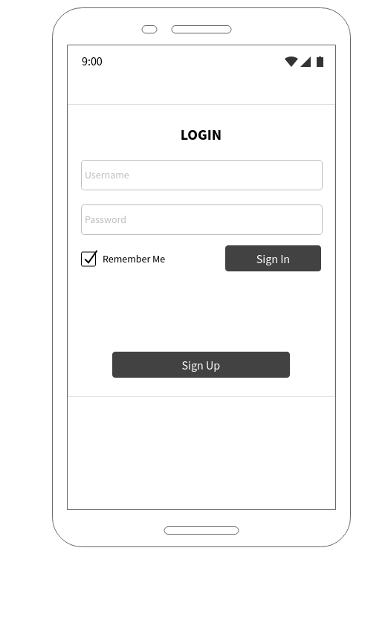

* Then home page is opened.
* He goes to his profile page by clicking his own profile photo. (After closing the document)

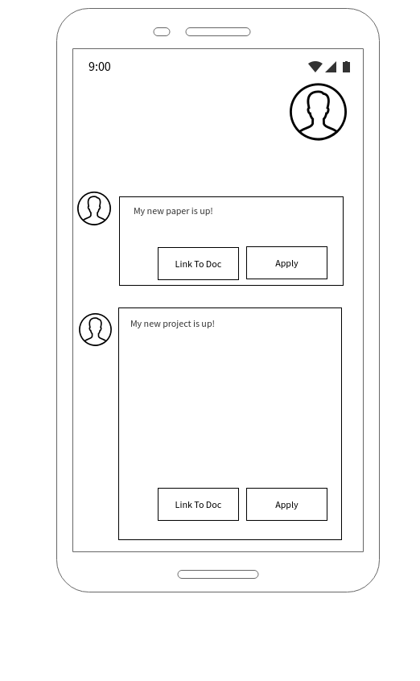

* When he clicks on his own profile photo, his profile page is opened.
* He sees his followers, buttons for linking Google Scholar or ResearchGate Accounts, and information about himself he wrote.
* He looks at his pending papers.
* He invites users by invite button, looks at applicants by appliers button.

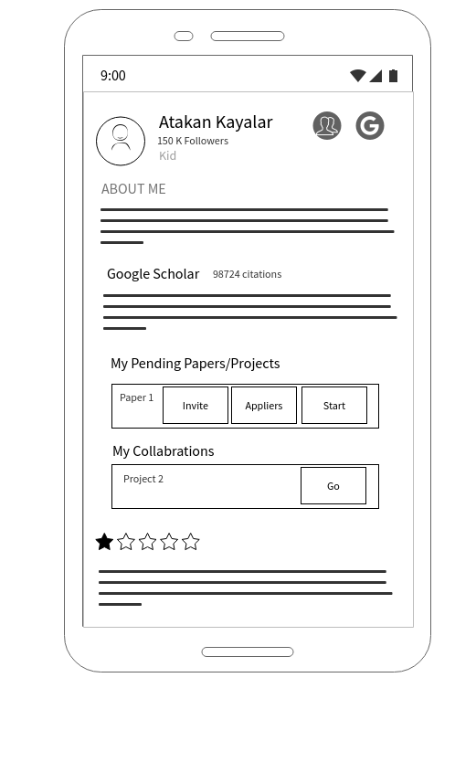

* When he clicks invite button, this menu is opened.
* He searches users to invite them.
* He sees who is invited before.
* He invites a user by clicking buttons.

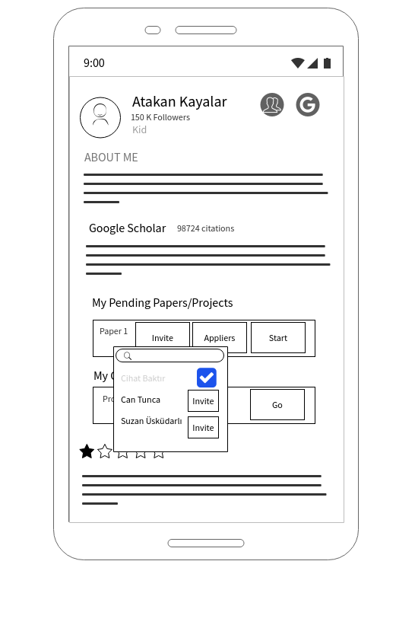

* When he clicks Appliers button, this menu is opened.
* He closes the menu touching the screen. (not on the menu but anywhere else)

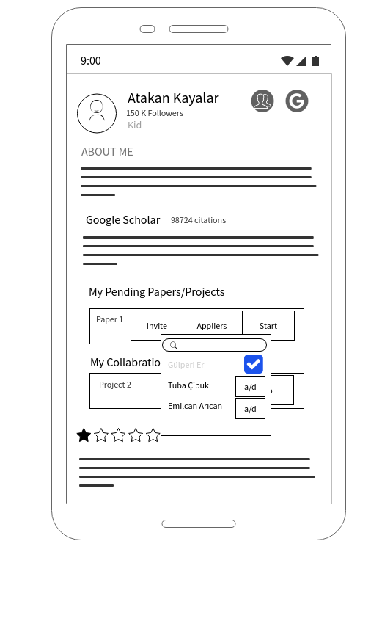

## **2.4 UML Software Designs**

## **2.5 Project plan & RAM**

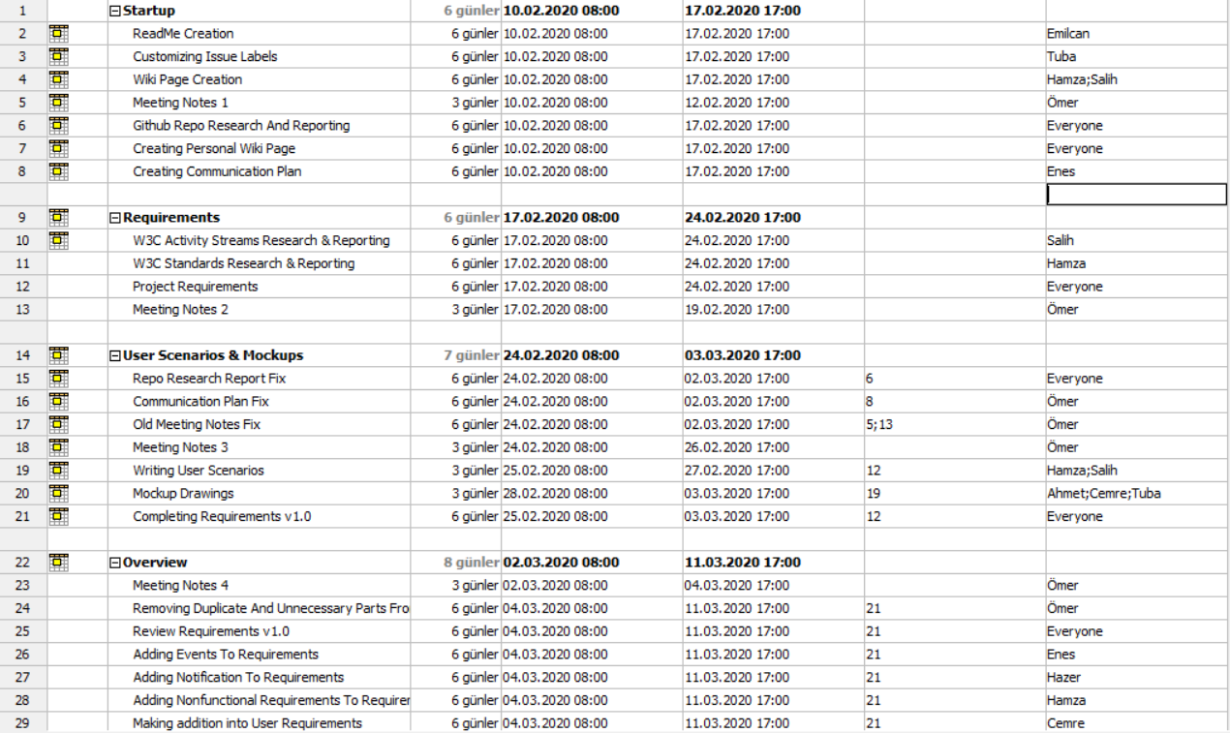

# **3. Evaluation of the status of deliverables and its impact on your project plan**

# **4. Evaluation of tools and processes you have used to manage your team Project**

Github – Doğu

-ProjectLibre is an old fashinoned Project Management software. It is hard to use and not very intuitive. Printing or saving as pdf is also very problematic. Learning and using is hard as well.  
But since ProjectLibre is an open source, freely available project management software it is a great oppurtunity for people since it is one of the first freely available Project Management softwares.

MockFlow - Tuba

LucidChart - Cemre

Slack - Gülperi

Zoom - Enes

# **5. Summary of work done**

|  |  |
| --- | --- |
| Group Member | Contribution |
| Ahmet Berat Can |  |
| Doğukan Kalkan |  |
| Emilcan Arıcan |  |
| Muhammed Enes Toptaş |  |
| Ezgi Gülperi Er |  |
| Tuba Çibuk |  |
| Hamza Işıktaş |  |
| Hazer Babur |  |
| Ömer Faruk Özdemir | Managed Meetings, created Meeting Notes and created issues weekly.  Arranged meeting topics and agendas.  Contributed in creating communication plan.  Contributed in user requirements.  Kept track of Diagrams progress and  compatibility.  Created issues with distributable tasks for feedbacks.  Kept track of general progress and deadlines.  Created most of the Project Plan.  Created backend template in flask. |
| Salih Can Özçelik | Researched and created wiki page, wiki sidebar page. Researched and shared informations about W3C Activity Streams Research. Contributed in user requirements. Created user scenarios. Created use-case diagrams. Created template for milestone 1. |
| Cemre Efe Karakaş |  |