**\*\* PROJECT – 1 \*\***

The main purpose of Project-1 is to be familiar with bash script. There are 5 different questions for that project. There are solutions and explanations :

**Menu :**

All questions are combined in just 1 file which is menu.sh. There is the interface of the menu :

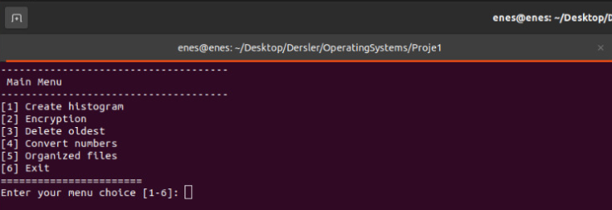

**Question 1 >>**

In that question , we are expected to find all the occurances of the number in the txt file and create a histogram by using that information.

Firstly, file is entirely read to catch any wrong format like -5 , a5 i, 5b ,a and so on. If there is , then it just simply prints the error on the screen. Then , file is read 10 times. In each iteration, current value is incremented as the number of that value.According to these values, program starts to print the “*” as times as current number’s value.

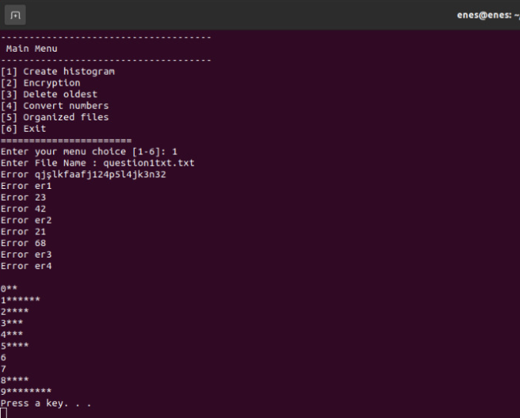

**Question 2 >>**

This is a simple cryptology program which runs at 2 different modes. In the first mode, the program takes string value and numeric value that has length 1 as inputs. Then, it increments all chars’ ascii codes of the string by the value of our second input. In the second mode, the program takes string and numeric value that has length as same as length of the string. Then, it increments all char’s ascii codes of the string by the value corresponding index of numerical value.

“ printf -v num %d "'${fName:i:1}" ” is used to get the ascii value of the char. Its ascii value is loaded into the “num” variable. That is the hardest part of that question. All algorithms are created by using that information.

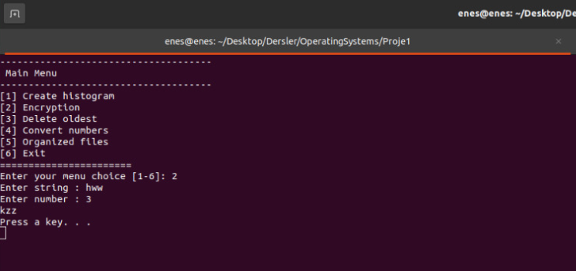

< Mode 1

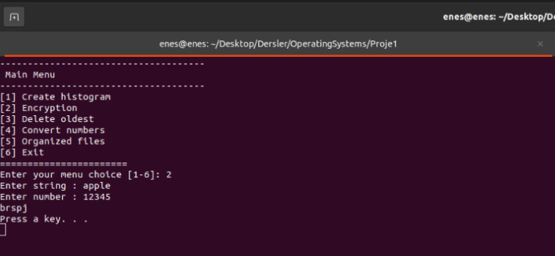

< Mode 2

**Question 3 >>**

This question is aimed to find the oldest file in the current directory or the given path. So, there is 2 different modes for that program.

“ stat -c %Y $file “ gives us the information about when the file is created . This is the milestone for that question. All files in the directory are traversed and the oldest file is found by using this creating information.

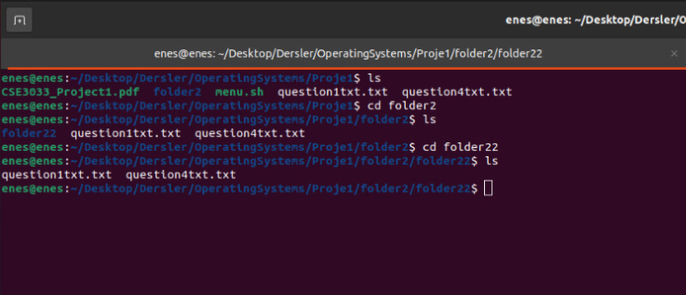< Current file where the program is working

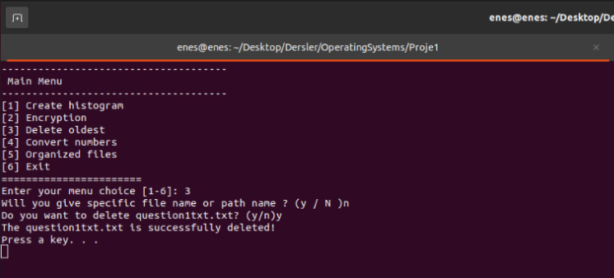 < Mode 1

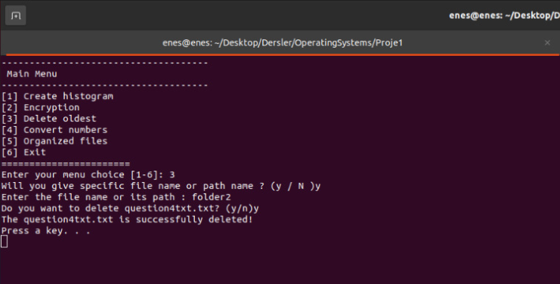 < Mode 2

Note : You can give the pathname as “folder2” or “folder2/” or “folder2/folder22”. All of these will be accepted.

**Question 4 >>**

Finding all numbers and converting them into text files is the purpose of that question.

“awk” command is used to convert numbers to text. This command turns specific number to text and write it to the new txt file . Firstly, text file is searched for finding “0” and convert all 0’s to “zero” and write it to the new txt file. Then, new txt file is searched for finding “1” and convert all 1’s to “one” and write it to the new txt file. And so on. All old txt files are deleted. This is the algorithm to overcome question 4.

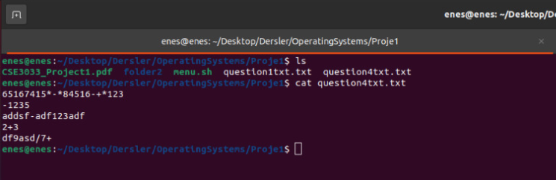

<Before execution

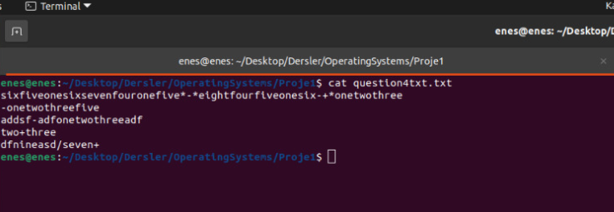

< After execution

**Question 5 >>**

In that question , we need to find the all files which obeys the string format that is given as parameter when the program is executed and copy them into the file named as “copied”. There are 2 different modes. They are recursive and non-recursive modes. In the non-recursive mode program just looks the current directory whereas in the recursive mode, program looks all the sub directories to find the txt files we are looking for.

In both cases , program checks that either there is any file named as “copied” or there is any file that obeys our string format. According to the that information, “copied” file is created and required files are copied into that file.

To traverse all files recursively, for loop is used. “cd” command is used to enter the file and then , required files are copied into the “copied” file.

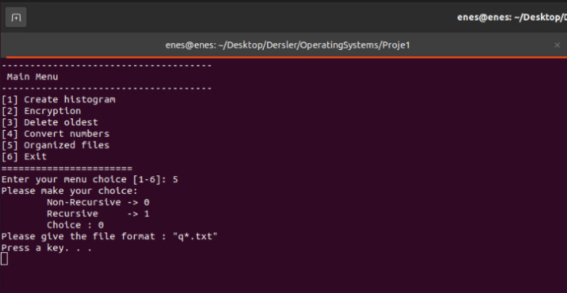

< Mode 1

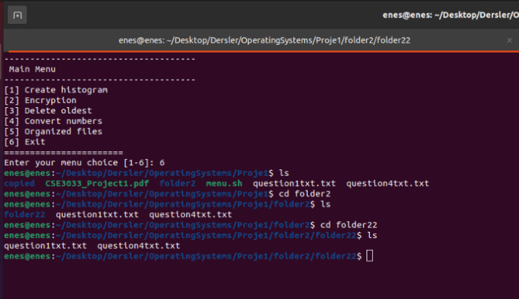< After execution mode 1

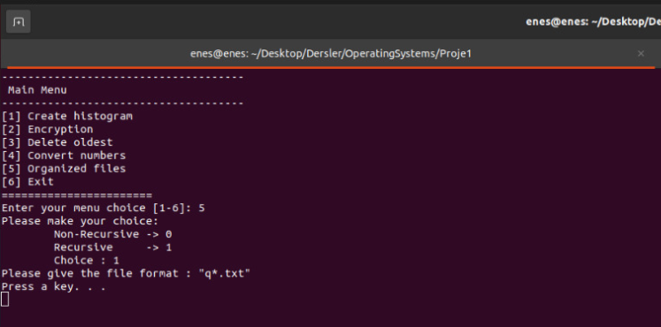

< Mode 2

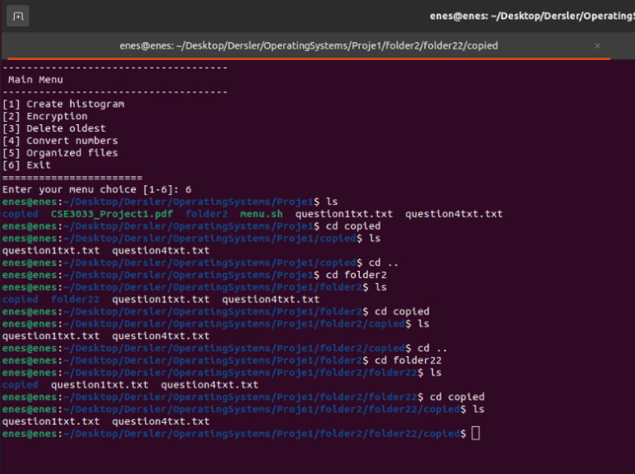< After execution mode 2

**Yunus Emre Ertunç / 150117064**

**Muhammed Enes Aktürk / 150117036**