PROGRAMMING PATTERNS
420-301-VA
ASSIGNMENT-4-

MVC Individual and Team work
Modify the given JavaFX application in Lea “SAMPLE MVC APP” to add the below functionality.
Individual work
- Connect the application to the HR database so that the employees data is retrieved from the database.
- Add a filter text box that allows the user to specify an employee first name and a search button, when clicked the window will only display the employees with the specified first name.
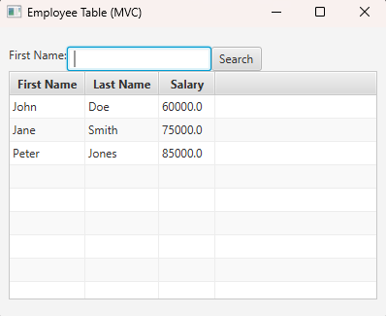
- Add an additional window
  - Team member 1: add another window that displays departments
  - Team member 2: add another window that displays projects
  - Team member 3: add a window that displays projects and the employees working on the projects
Group Work
- Create a Github repository
- Integrate the work from 1,2, and 3 into one program.

