Bank Customer Activity & Financial Analysis
Snapshot: 26 September 2026 | Currency: EUR
Source: Synthetic_Bank_Customers_300(1).xlsx

Executive Summary
The workbook contains 300 fictional bank customers in a single EUR snapshot. 267 customers (89.0%) are classified as active and 33 (11.0%) as dormant. There are 161 active subscriptions (53.7% of customers), generating €2,305.39 in monthly subscription fees. Customer account balances total €2,944,351.22, while reported monthly income and spending total €700,371.14 and €424,444.06, respectively. The dataset records 4,354 transactions in the last 30 days (average 14.5 per customer) and 110 customers with loan balances totaling €2,347,434.91.
Key review points are the 15 dormant customers who still have active subscriptions and the presence of statistical outliers in transaction counts, balances, and loan balances. These are investigation flags, not evidence of misconduct. The workbook does not contain transaction amounts or a historical financial time series, so transaction value and period-over-period financial growth cannot be calculated.

Dataset Overview
Item | Result
Customer records | 300
Worksheets | Customers; Field guide
Customer ID duplicates | 0
Subscription fields missing | 78 customers; consistent with no subscription record
Snapshot date | 26 Sep 2026
Currency | EUR
Financial time series | Not provided

Key Performance Indicators
Indicator | Value
Active customers | 267 (89.0%)
Dormant customers | 33 (11.0%)
Active subscriptions | 161 (53.7%)
Cancelled subscriptions | 61
Monthly subscription fees | €2,305.39
Total account balances | €2,944,351.22
Average account balance | €9,814.50
Total monthly income | €700,371.14
Total monthly spending | €424,444.06
Spending / income ratio | 60.6%
30-day transactions | 4,354
Average 30-day transactions/customer | 14.51
Customers with loans | 110 (36.7%)
Total loan balances | €2,347,434.91

Customer Activity Analysis
Active customers represent 89.0% of the population. All 33 dormant customers show zero transactions in the 30-day transaction-count field, which is internally consistent with the activity classification. However, 15 dormant customers (45.5% of dormant customers) retain an active subscription, representing a retention, servicing, or billing-review opportunity.
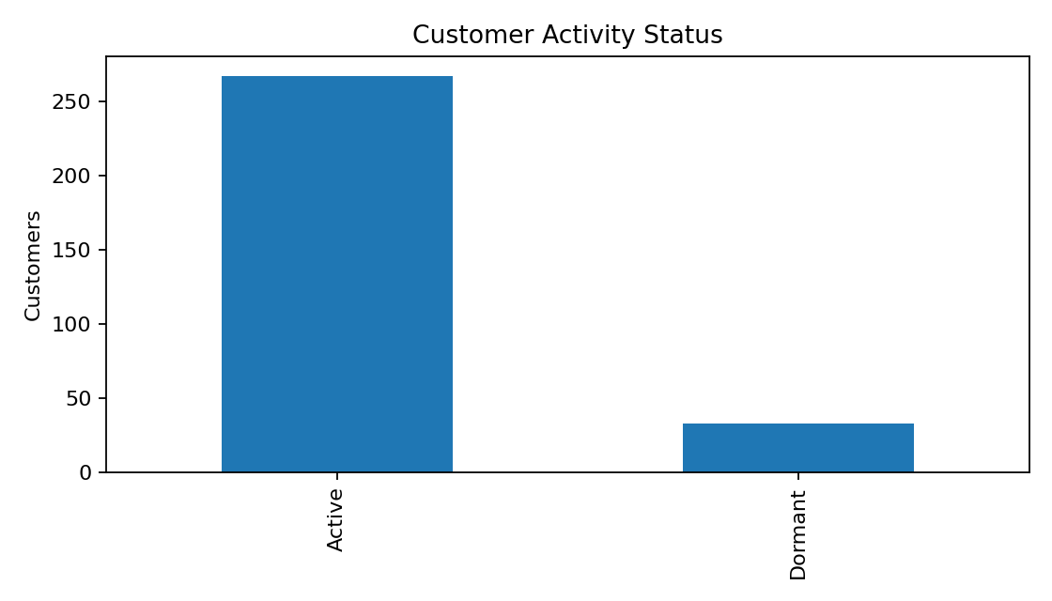

Subscription Analysis
Of 300 customers, 161 have active subscriptions, 61 have cancelled subscription records, and 78 have no subscription details. Among active subscriptions, Business is the largest plan by count and fee contribution.
Plan | Active subscriptions | Monthly fees
Business | 55 | €1,374.45
Essential | 45 | €179.55
Plus | 32 | €287.68
Premium | 29 | €463.71
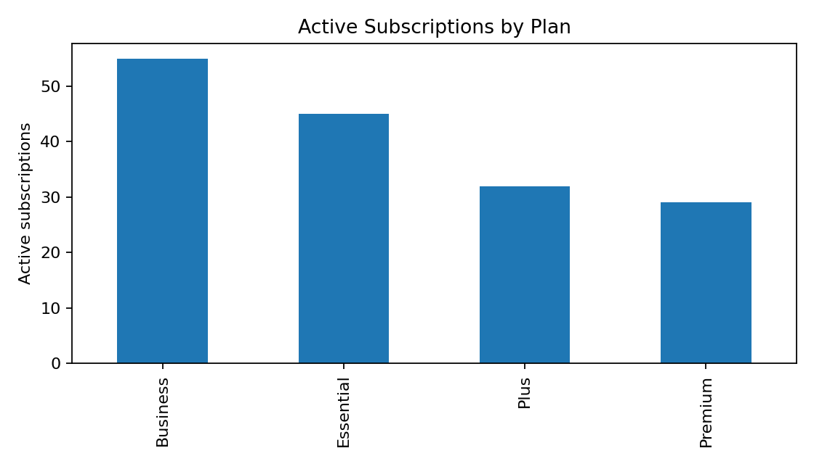

Transaction & Financial Analysis
The workbook records 4,354 transaction events over the last 30 days, but no transaction-value field is supplied; therefore total or average transaction value cannot be determined. Account balances total €2,944,351.22 (median €8,408.60). Reported monthly spending equals 60.6% of reported monthly income in aggregate. No customer has monthly spending above monthly income in this synthetic snapshot.
Loan exposure is concentrated among 110 customers, with €2,347,434.91 outstanding and an average of €21,340.32 among borrowers.

Segment Analysis
Segment | Customers | Active | Active subs | Balances | Monthly income | Monthly spend | 30d tx
Business | 45 | 39 (86.7%) | 23 | €735,195.01 | €167,877.82 | €104,088.23 | 991
Premium | 46 | 43 (93.5%) | 28 | €455,080.58 | €108,356.64 | €63,910.87 | 768
Retail | 178 | 156 (87.6%) | 95 | €1,663,959.94 | €407,360.87 | €246,408.95 | 2,442
Student | 31 | 29 (93.5%) | 15 | €90,115.69 | €16,775.81 | €10,036.01 | 153
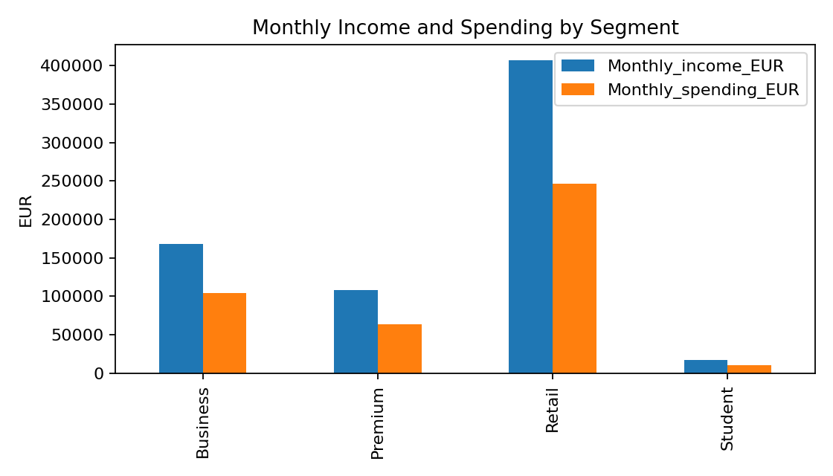

Trend Analysis
A true monthly, quarterly, or yearly financial trend cannot be calculated because the workbook contains one snapshot rather than repeated period observations. Last activity dates range from December 2025 to September 2026, but grouping current balances, income, or spending by last-activity month would not measure historical financial performance. Likewise, account-opened and subscription-start dates describe customer tenure/acquisition timing, not historical revenue. A time-stamped transaction or monthly account-history table is required for growth rates and period comparisons.

Anomalies and Data Quality
No duplicate customer IDs or negative financial values were found. The 78 missing subscription-plan/start/end/status values occur on customers without a current subscription record and should be interpreted as structural absence rather than automatically treated as erroneous missing data.
Observation | Count | Interpretation
Dormant customers with active subscriptions | 15 | Requires review for billing/retention appropriateness
Transaction-count IQR outliers | 13 | Unusually high/low relative to distribution; investigate context
Account-balance IQR outliers | 6 | High balances relative to distribution; not inherently problematic
Loan-balance IQR outliers | 32 | Higher exposures warrant normal credit/risk review
Negative numeric financial values | 0 | None detected
Customers spending above monthly income | 0 | None detected

Highest Observed Values
Customer ID | 30-day transactions
CUST-00222 | 77
CUST-00290 | 77
CUST-00051 | 55
CUST-00225 | 50
CUST-00255 | 49
Customer ID | Loan balance
CUST-00192 | €44,674.26
CUST-00059 | €44,315.06
CUST-00086 | €43,368.93
CUST-00265 | €41,933.77
CUST-00243 | €41,526.30

Key Findings
- Customer engagement is high in the snapshot: 89.0% are classified as active.
- Subscription penetration is 53.7%; active subscriptions produce €2,305.39 in monthly fees.
- Aggregate monthly spending is 60.6% of aggregate monthly income.
- 36.7% of customers carry loan balances, totaling €2,347,434.91.
- 15 dormant customers retain active subscriptions and merit operational review.
- The data supports snapshot analysis but not historical financial growth or transaction-value analysis.

Recommendations
- Review the 15 dormant customers with active subscriptions to confirm billing status, service usage, and retention/contact actions.
- Investigate high transaction-count and high loan-balance outliers using underlying account and transaction records before drawing risk conclusions.
- Add transaction amount, transaction date, transaction type, and debit/credit fields to enable transaction-value, cash-flow, and anomaly analysis.
- Maintain monthly snapshots or a dated balance/revenue history to support month-over-month and year-over-year trend analysis.
- Continue validating subscription nulls against a formal 'never subscribed/no plan' category to make downstream reporting unambiguous.

Conclusion
The dataset presents a generally consistent synthetic customer snapshot with strong recorded activity, meaningful subscription participation, and material loan exposure. The most actionable operational observation is the overlap between dormant status and active subscriptions. Statistical outliers should be reviewed in context, while stronger trend and transaction-value conclusions require longitudinal and transaction-level monetary data.

