  Checkpoint IV | Checkpoint IV: First Prototype
 | Group: | <23>
 | Date: | <2023/10/16>

Layout
For this checkpoint we defined the layout for our visualization which is shown in figure 1.
Location | Idiom | Representation
Upper part | All our data | 2D choropleth map
Bottom Left | All our data | Line Chart
Bottom Right | HDI, life expectancy and fertility rate | Sankey Plot
Our initial idea of the layout (Figure 2) had 4 boxes: 3 idioms and one box for the filters. We haven’t implemented the Sankey diagram yet as you can see from our currently layout. We had a little problem about HDI our dataset begins in 1990 but all the others begin in 1960. We thought to have a large interval of years is more relevant so to resolve this issue, we will have to fix the slider of the timeline in 1990 when you click on the HDI box in filters (to be done after).
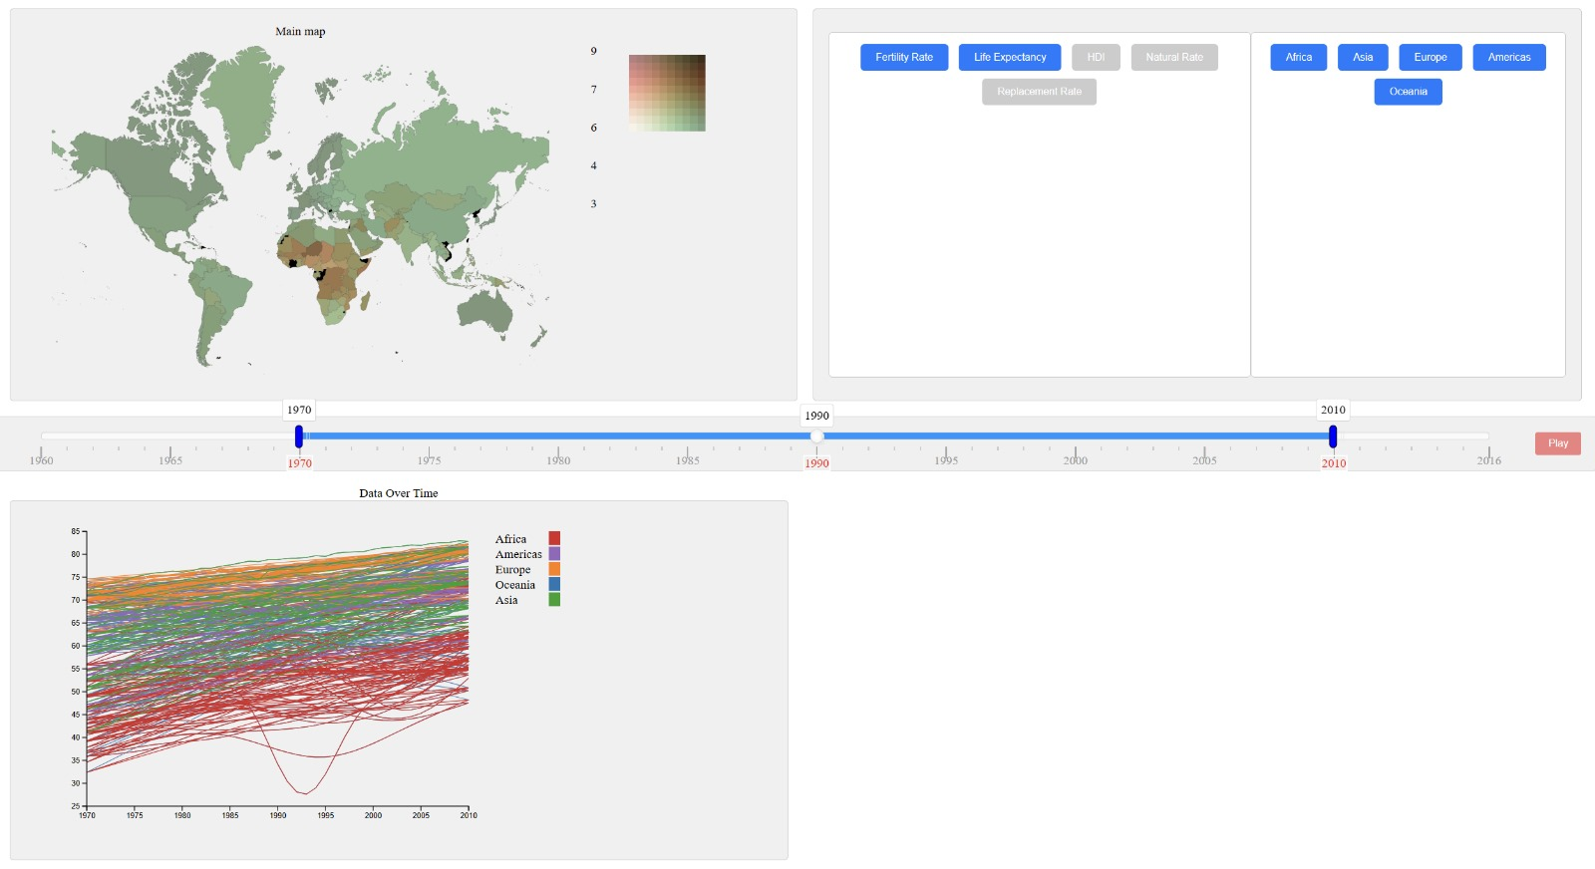
Figure 1 – Main layout
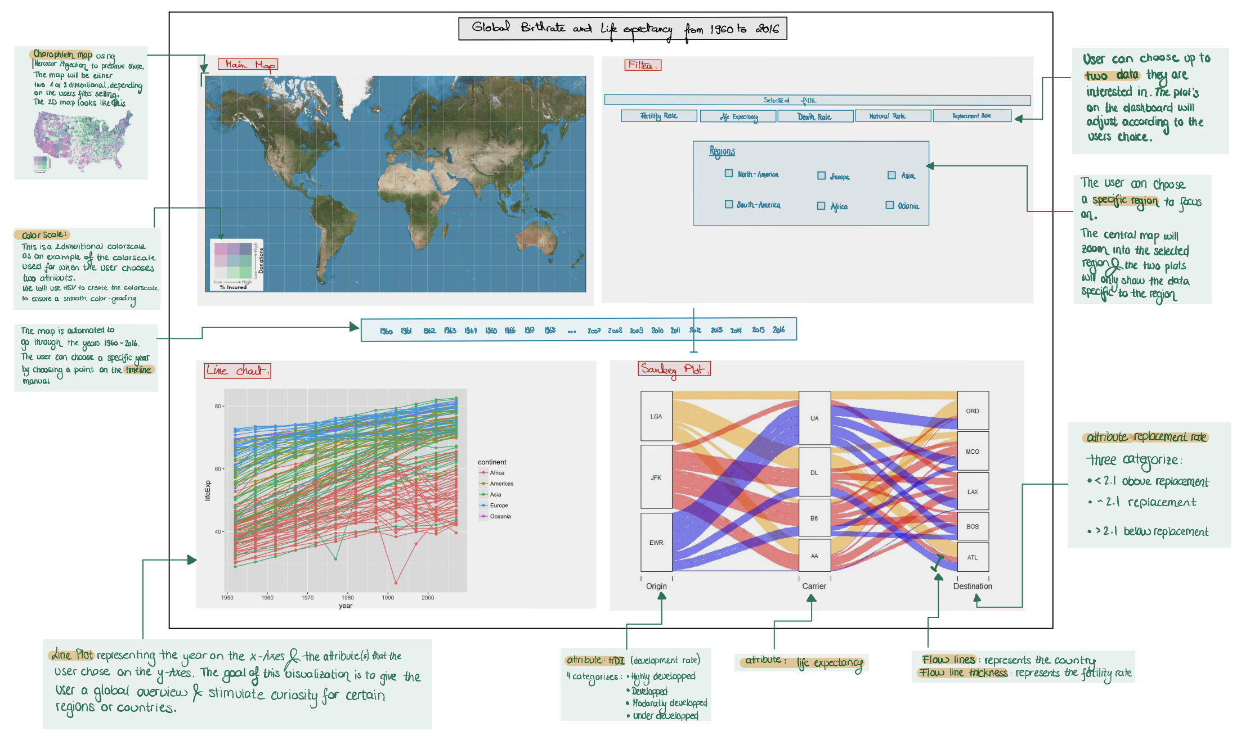
Figure 2- Initial Layout

Visual Encoding and Interactivity
We have two of the three idioms where the base structure is fully implemented, which are the 2D choropleth map (Figure 3) and the line chart (Figure 4).
The 2D choropleth map (Main map): this map holds all the information about our data. At first, the user will have to select two filters: life expectancy and fertility rate for example and he’s free to select the interval of time that he wants using the slider just below the choropleth map. Also, he can choose to display certain continents in order to focus on some countries and take conclusions. For the implementation, we have only the HDI missing.
The line chart: From the filter box, the user can choose one specific demographic metric to show for example life expectancy. The line chart will display the evolution of life expectancy over time (also you’re free to choose the time interval you want by using the slider: from 1970 to 2003 for example). Besides, we did some clustering between countries from the same continent (it will be useful to see the evolution of the continent and respond to our questions). For the legend, it’s not completely implemented because it’s fixed not linked with all the interaction: when you want to display the data for only Africa for example the legend should contain only the continent Africa. We will correct this later.
We also implemented a functionality called ‘play’ on the slider: it’s when you want to see the evolution of the choropleth map over all the years one by one.
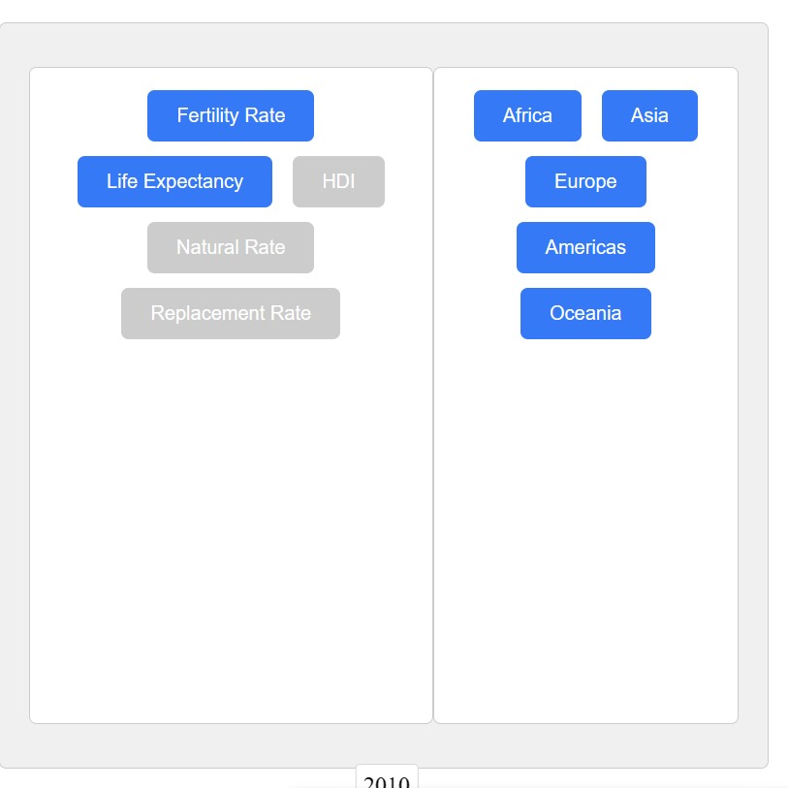

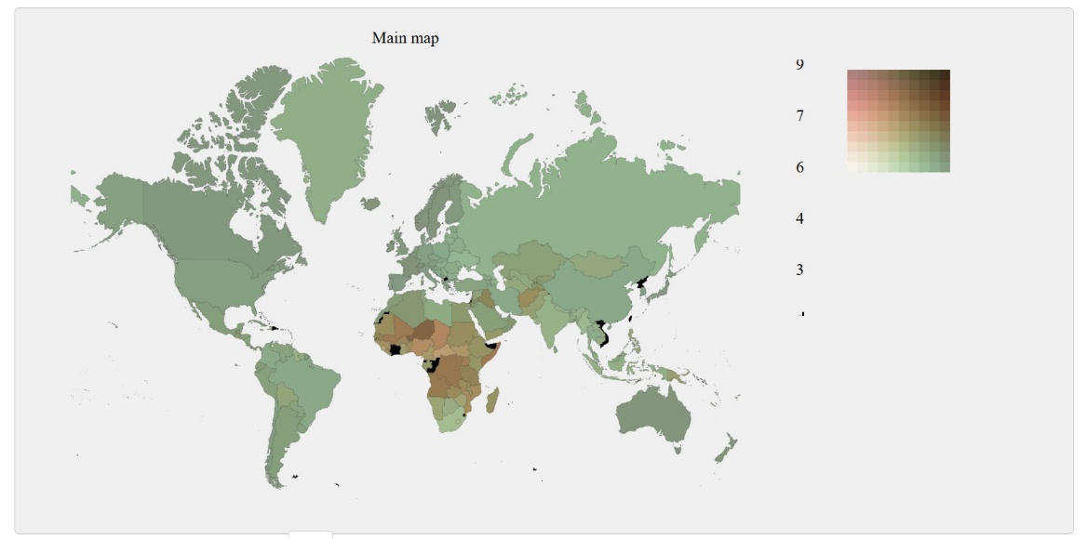
Figure 3 – 2D choropleth map
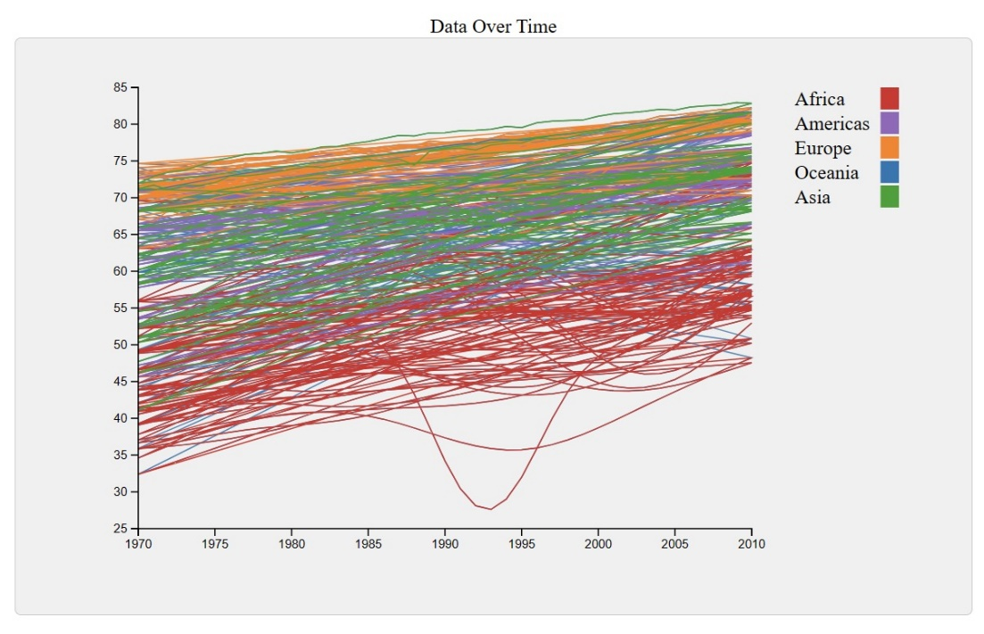
Figure 4 – Line Chart

Implementation of Linking Mechanism
The connection between the different views will mainly work through the selection of the filters which the user wants to compare, then the views are filtered according to that selection. Also, the timeline chosen by the user in the slider will give you the information on that specific period. All the views will have a transition when the selection is made: (Imagine we selected two continents to compare)
- 2D choropleth map: all the countries will be filled according to the colour scale in the legend and will only display the data in the selected period for the selected continents (all the other countries will be coloured in grey)
- Line chart: It will display all the lines for the selected continents (with one colour for each continent). For sure, it will show only the selected data for example replacement rate and for the selected period of time.
For the line chart, we thought of some interactivity that it will be implemented after: a vertical line that slides over the time when you move the slider. This bar will have some a circle for each line of the continent then it will be easier to compare between countries and to see the exact evolution of a particular country.

