  Checkpoint III | Checkpoint III: Visualization Sketch
 | Group: | 23
 | Date: | 2023/11/03

Overview

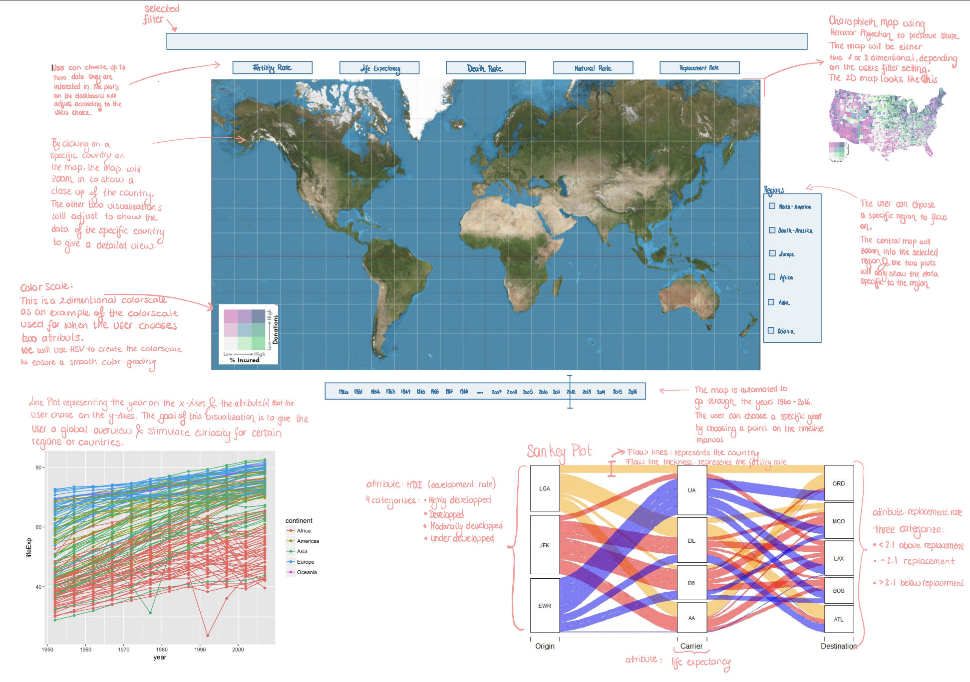 Visual Encoding
Choropleth Map in 2 dimensions: We chose a Mercator projection because we need to make each country easly visible, and this projection permits to show the European countries, which are smaller, bigger than they are supposed to be.
We will use this map to reprensent each time 2 attributes (at maximum) with the color scaling of 2 dimensions. The user has the possibility to choose 2 attributes between the 5 available. We will use HSV as color scaling to better emphasize the gradually evolution of the values.
The thing that makes this chart the most customized one is that in addition we represent the different years we will use a timeline cursor under the map that do like an animation automatically until you interact with her, then you can choose the years that you want to display in particular.
Line chart: For this chart we will use the 2 attributes chose by the user for the map. We will represent on the x-axis the years and on the Y axis the value of the two attributes. We will differentiate between them by color.
Sankey Diagram: A Sankey diagram is a flow diagram that represents the magnitude of flows between nodes.
Initial Nodes: These are the nodes representing the countries we are analyzing. We choose to divide the countries into 4 categories of development range.
The second level nodes: will represent different ranges of life expectancies.
The final level nodes: will represent different categories of replacement rate. Above 2.1 children per women, around 2.1 children per women, under 2.1 children per women.
Flow lines: Flow lines connect the country nodes to the corresponding life expectancy nodes and then to the corresponding replacement rate node. The thickness of the lines represents the magnitude of fertility rate changes for each country in each year.
The year will be represented similarly to the one in the map (timeline cursor).

Answering the Questions
- Is there a discernible relationship between the upward trend in life expectancy at birth and the concurrent decline in fertility rates across countries from 1960 to 2016?
  - By the map and by sliding the years we can very quickly see a changing of the patern the countries. In addition the line chart provides directly a comparaison between the fertility rate and life expectancy. Use line chart
- Are there countries where the fertility rate has consistently exceeded the replacement rate throughout this timeframe?
  - We can answear to this quesiton by using the Choropleth Map with these two attributes and also the Sankey Diagram will help us to see flow between the thickness of flow lines and categories of replacement rate.
- What are the demographic implications of countries with declining fertility rates, particularly in terms of population aging?
  - The same as for the first question but we will focus on countries with declining fertility rate.
- Can you predict future population growth and life expectancy trends based on historical data?
  - By choosing the attributes life expectancy and natural rate we can see by the Choropleth Map and the line chart a trend between these two. Use line chart maybe remove
- How do fertility rates and life expectancy trends differ between developed and developing countries?
  - By choosing the attributes the HDI and the life expectancy or the fertility rates we will be able to spot by the Choropleth Map the trends. In addition Sankey Diagram will permit us to compare directly the life expectancy with the fertility rate by categorising between the level of development of countries using color channel to differentiate them.
- Can you detect any significant anomalies or outliers in the dataset that require further investigation, such as countries with exceptionally low fertility rates or life expectancies?
  - With the Choropleth Map and the line chart we can inspect for outliers or another anomalie.
The Storyboard:
The question that we chose is the first one focused on North America. This question depends on the attributes of the ferility rate and the life expectancy.
The user will se by the animation of the timeline spot that on the map there is a trend where all countries tends to the same color which indicated a trend between the life expectancy at birth and the fertility rates.
Then he will read the line chart to see if there is in fact two lines that are crossing one for declining fertility rate and the upward life expectancy.
Also the Sankey Diagram we will notice that it exist a thick flow line connected to low life expectancy at first will evolve to being thin and switching to be connected to higher life expectancy.
