OverTheWire: Bandit
Capture the Flag walkthrough
Author: Rina Enea
LinkedIn: linkedin.com/in/enea-rina

Contents
- Project objective
- Methodology
- Level walkthroughs (0 → 33)
- Lessons learned

1. Project objective
This is my documented walkthrough of the OverTheWire Bandit wargame, which I completed to practise and demonstrate my Linux command-line and security fundamentals. For every level I recorded the goal, the commands I used, the password I found and an explanation of why the approach works.

2. Methodology
Each level hides the password for the next one somewhere on the Bandit server, which I reach over SSH with the credentials from the previous level. My approach for every level:
- Read the objective carefully and look for hints.
- Use standard Linux command-line tools to explore and test.
- Work methodically, adjusting the approach after each result.
- Record every step, command and result.
Skills practised: SSH and key-based login, file system navigation, find, grep, sort, uniq, strings, encoding and decoding (base64, ROT13, hexdump), compressed archives, ports and services (nc, ncat, nmap), SSL/TLS, setuid binaries, cron jobs, Bash scripting, brute-forcing, git history and branches, and escaping restricted shells.

3. Level walkthroughs

Level 0 → 1
Goal: Log into the game using SSH. The host is bandit.labs.overthewire.org on port 2220, with username bandit0 and password bandit0.
Commands used:
ssh bandit0@bandit.labs.overthewire.org -p 2220
ls
cat readme
Password found: ZjLjTmM6FvvyRnrb2rfNWOZOTa6ip5If
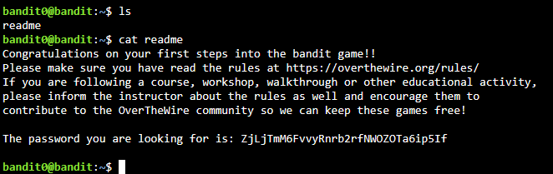
Explanation: I connected with SSH, listed the files in the home directory with ls and read the readme file with cat.

Level 1 → 2
Goal: The password is stored in a file called - in the home directory.
Commands used:
ssh bandit1@bandit.labs.overthewire.org -p 2220
ls
cat ./-
Password found: 263JGJPfgU6LtdEvgfWU1XP5yac29mFx
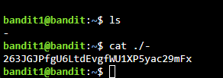
Explanation: Most commands treat - as a special argument (standard input), so cat - doesn't read the file. Writing ./- gives the full path to the file, so cat reads it as a normal filename.

Level 2 → 3
Goal: The password is stored in a file called spaces in this filename in the home directory.
Commands used:
ssh bandit2@bandit.labs.overthewire.org -p 2220
ls
cat ./"--spaces in this filename--"
Password found: MNk8KNH3Usiio41PRUEoDFPqfxLPlSmx
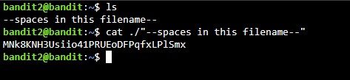
Explanation: ls showed the real filename is --spaces in this filename--. The quotes keep the spaces as part of one filename, and the ./ prefix stops the leading -- from being read as an option.

Level 3 → 4
Goal: The password is stored in a hidden file in the inhere directory.
Commands used:
ssh bandit3@bandit.labs.overthewire.org -p 2220
ls
cd inhere
ls -a
cat ./...Hiding-From-You
Password found: 2WmrDFRmJIq3IPxneAaMGhap0pFhF3NJ
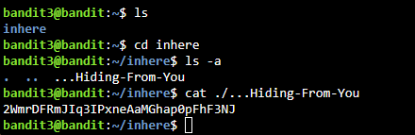
Explanation: Files starting with a dot are hidden from a plain ls. ls -a lists all files, including hidden ones, which revealed ...Hiding-From-You.

Level 4 → 5
Goal: The password is stored in the only human-readable file in the inhere directory. Tip: if your terminal is messed up, try the reset command.
Commands used:
ssh bandit4@bandit.labs.overthewire.org -p 2220
ls
cd inhere
file ./*
cat ./-file07
Password found: 4oQYVPkxZOOEOO5pTW81FB8j8lxXGUQw
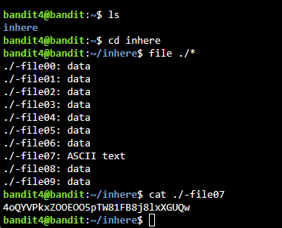
Explanation: file ./* reports the type of every file in the directory. Only -file07 was ASCII text, so that was the one to read.

Level 5 → 6
Goal: The password is stored in a file somewhere under the inhere directory that is human-readable, 1033 bytes in size and not executable.
Commands used:
ssh bandit5@bandit.labs.overthewire.org -p 2220
ls
cd inhere
ls
find -type f -size 1033c
cat ./maybehere07/.file2
Password found: HWasnPhtq9AVKe0dmk45nxy20cvUa6EG
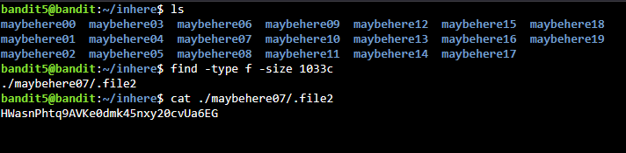
Explanation: There were 20 folders to search, so I used find. -type f limits the search to files and -size 1033c matches exactly 1033 bytes (c means bytes). Only one file matched, so the other properties didn't need checking.

Level 6 → 7
Goal: The password is stored somewhere on the server in a file that is owned by user bandit7, owned by group bandit6 and 33 bytes in size.
Commands used:
ssh bandit6@bandit.labs.overthewire.org -p 2220
ls -a
find / -type f -user bandit7 -group bandit6 -size 33c 2>/dev/null
cat /var/lib/dpkg/info/bandit7.password
Password found: morbNTDkSW6jIlUc0ymOdMaLnOlFVAaj
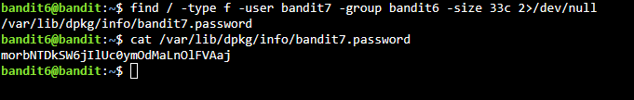
Explanation: This time the file could be anywhere, so I searched from the root directory / and combined three filters: -user bandit7, -group bandit6 and -size 33c. Searching the whole system produces many "Permission denied" errors, so 2>/dev/null discards the error output and leaves only the match.

Level 7 → 8
Goal: The password is stored in the file data.txt, next to the word millionth.
Commands used:
ssh bandit7@bandit.labs.overthewire.org -p 2220
ls
grep millionth data.txt
Password found: dfwvzFQi4mU0wfNbFOe9RoWskMLg7eEc
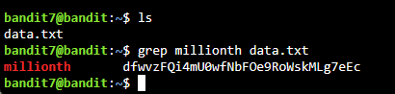
Explanation: grep searches a file for a word and prints every line that contains it. The only line containing millionth also contained the password.

Level 8 → 9
Goal: The password is stored in the file data.txt and is the only line of text that occurs only once.
Commands used:
ssh bandit8@bandit.labs.overthewire.org -p 2220
ls
sort data.txt | uniq -u
Password found: 4CKMh1JI91bUIZZPXDqGanal4xvAg0JM
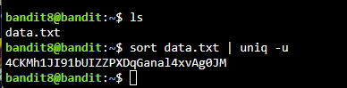
Explanation: uniq -u prints only the lines that are not repeated, but it only compares lines that are next to each other. Piping the file through sort first puts identical lines together, so the one unique line is the only output.

Level 9 → 10
Goal: The password is stored in the file data.txt in one of the few human-readable strings, preceded by several = characters.
Commands used:
ssh bandit9@bandit.labs.overthewire.org -p 2220
ls
strings data.txt | grep "=.*"
Password found: FGUW5ilLVJrxX9kMYMmlN4MgbpfMiqey
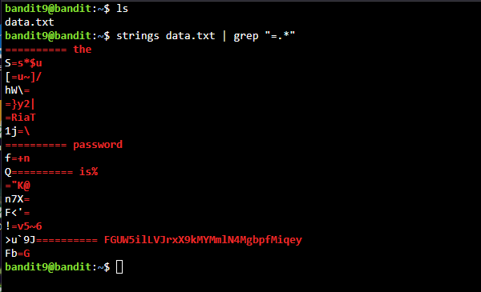
Explanation: data.txt is mostly binary data. strings extracts only the human-readable text from it, and grep "=.*" keeps the lines that contain =. The password appeared on a line after several = characters.

Level 10 → 11
Goal: The password is stored in the file data.txt, which contains base64-encoded data.
Commands used:
ssh bandit10@bandit.labs.overthewire.org -p 2220
ls
cat data.txt | base64 --decode
Password found: dtR173fZKb0RRsDFSGsg2RWnpNVj3qRr
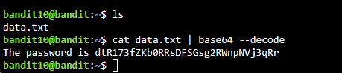
Explanation: I piped the file into base64 --decode, which turns the encoded text back into the original message containing the password.

Level 11 → 12
Goal: The password is stored in the file data.txt, where all lowercase (a-z) and uppercase (A-Z) letters have been rotated by 13 positions.
Commands used:
ssh bandit11@bandit.labs.overthewire.org -p 2220
ls
cat data.txt | tr 'A-Za-z' 'N-ZA-Mn-za-m'
Password found: 7x16WNeHIi5YkIhWsfFIqoognUTyj9Q4
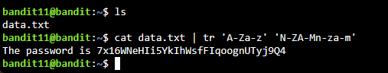
Explanation: The file was encoded with ROT13, which shifts each letter 13 places in the alphabet. tr maps each character in the first range to the matching character in the second, so A-Za-z → N-ZA-Mn-za-m shifts every letter back by 13 and reveals the password.

Level 12 → 13
Goal: The password is stored in the file data.txt, which is a hexdump of a file that has been repeatedly compressed. It helps to create a working directory under /tmp with mktemp -d, then copy the file there with cp and rename it with mv.
Commands used:
ssh bandit12@bandit.labs.overthewire.org -p 2220
ls
mktemp -d
cp data.txt /tmp/tmp.aWNpYEUEkA
cd /tmp/tmp.aWNpYEUEkA
ls
cat data.txt
xxd -r data.txt password.gz
gunzip password.gz
ls
cat password
xxd -p password
mv password password.bz2
bunzip2 password.bz2
file password
mv password password.gz
gunzip password.gz
ls
file password
mv password password.tar
tar -xf password.tar
ls
file data5.bin
mv data5.bin data5.bin.tar
tar -xf data5.bin.tar
ls
file data6.bin
mv data6.bin data6.bin.bz2
bunzip2 data6.bin.bz2
ls
file data6.bin
mv data6.bin data6.bin.tar
tar -xf data6.bin.tar
ls
file data8.bin
mv data8.bin data8.bin.gz
gunzip data8.bin.gz
ls
file data8.bin
cat data8.bin
The /tmp/tmp.… folder name is the random one printed by mktemp -d, so it is different on every run.
Password found: FO5dwFsc0cbaIiH0h8J2eUks2vdTDwAn
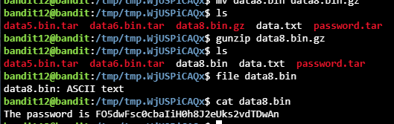
Explanation: The file was a hexdump, so I used xxd -r to turn it back into binary. From there I repeated the same loop until I reached plain text:
- Run file to find out the format of the current layer (gzip, bzip2 or tar).
- Rename the file with the matching extension using mv, because the decompression tools expect it.
- Unpack it with the right tool: gunzip for gzip, bunzip2 for bzip2 and tar -xf for tar.
I used cat along the way to check whether a file had become readable. The final file, data8.bin, was ASCII text containing the password.

Level 13 → 14
Goal: The password is stored in /etc/bandit_pass/bandit14 and can only be read by user bandit14. Instead of a password, this level provides a private SSH key that can be used to log into the next level. Note: localhost is a hostname that refers to the machine you are working on.
Commands used:
ssh bandit13@bandit.labs.overthewire.org -p 2220
ls
ssh -i sshkey.private bandit14@bandit.labs.overthewire.org -p 2220
cd /etc/bandit_pass
ls
cat bandit14
Password found: MU4VWeTyJk8ROof1qqmcBPaLh7lDCPvS
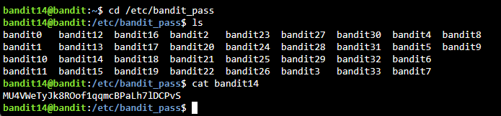
Explanation: The home directory of bandit13 contained a private SSH key. ssh -i tells SSH to use that identity file instead of a password, which logged me in as bandit14. As bandit14, I could read its password file in /etc/bandit_pass.

Level 14 → 15
Goal: The password for the next level can be retrieved by submitting the password of the current level to port 30000 on localhost.
Commands used:
ssh bandit14@bandit.labs.overthewire.org -p 2220
echo MU4VWeTyJk8ROof1qqmcBPaLh7lDCPvS | nc localhost 30000
Password found: 8xCjnmgoKbGLhHFAZlGE5Tmu4M2tKJQo
Explanation: echo prints the current password and the pipe sends it into nc (netcat), which opens a connection to port 30000 and delivers the input. The service replied with the next password.

Level 15 → 16
Goal: The password for the next level can be retrieved by submitting the password of the current level to port 30001 on localhost using SSL/TLS encryption.
Commands used:
ssh bandit15@bandit.labs.overthewire.org -p 2220
echo "8xCjnmgoKbGLhHFAZlGE5Tmu4M2tKJQo" | ncat --ssl localhost 30001
Password found: kSkvUpMQ7lBYyCM4GBPvCvT1BfWRy0Dx
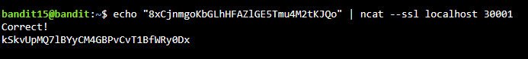
Explanation: This is the same idea as the previous level, but the service only accepts encrypted connections. ncat --ssl wraps the connection in SSL/TLS, so the password is sent securely and the server replies with the next one.

Level 16 → 17
Goal: The credentials for the next level can be retrieved by submitting the password of the current level to a port on localhost between 31000 and 32000. First find which ports have a server listening, then which of those speak SSL/TLS. Only one server gives the next credentials; the others send back whatever you send them.
Commands used:
ssh bandit16@bandit.labs.overthewire.org -p 2220
nmap localhost -p31000-32000
echo "kSkvUpMQ7lBYyCM4GBPvCvT1BfWRy0Dx" | ncat --ssl localhost 31790
exit
nano password17
chmod 400 password17
Result: an RSA private key for bandit17, which I saved on my own machine as password17.
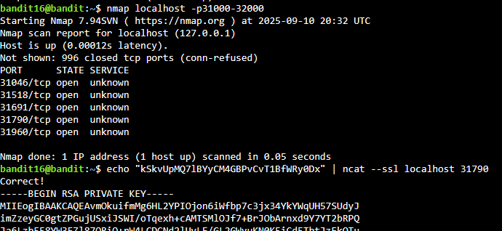
Explanation:
- nmap scanned the port range and found five open ports.
- I sent the current password with ncat --ssl to each port. Most echoed my input back; port 31790 replied "Correct!" followed by an RSA private key.
- I logged out, pasted the key into a local file with nano, and ran chmod 400 so only I can read it. SSH refuses to use a private key that other users can read.
- I used this key to log in as bandit17 in the next level.

Level 17 → 18
Goal: There are two files in the home directory: passwords.old and passwords.new. The password is in passwords.new and is the only line that has changed between the two files.
Commands used:
ssh -i password17 bandit17@bandit.labs.overthewire.org -p 2220
ls
diff passwords.old passwords.new
Password found: x2gLTTjFwMOhQ8oWNbMN362QKxfRqGlO
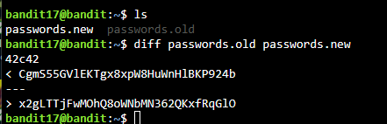
Explanation: diff compares two files and prints only the lines that differ. The line marked > comes from passwords.new, so that is the new password.

Level 18 → 19
Goal: The password is stored in a file readme in the home directory. Unfortunately, someone has modified .bashrc to log you out when you log in with SSH.
Commands used:
ssh bandit18@bandit.labs.overthewire.org -p 2220 "cat readme"
Password found: cGWpMaKXVwDUNgPAVJbWYuGHVn9zl3j8
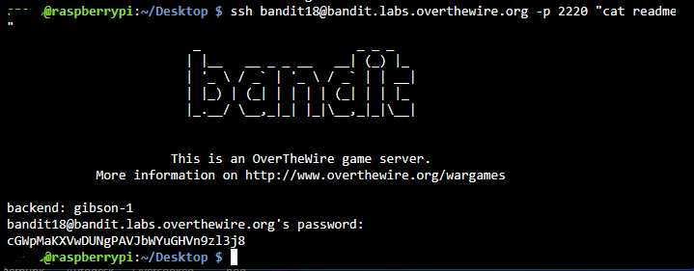
Explanation: .bashrc only runs when an interactive shell starts. Adding a command at the end of the ssh command runs it directly on the server without opening an interactive shell, so cat readme printed the password before the logout could happen.

Level 19 → 20
Goal: To gain access to the next level, use the setuid binary in the home directory. Run it without arguments to find out how to use it. The password is in the usual place (/etc/bandit_pass) after you have used the setuid binary.
Commands used:
ssh bandit19@bandit.labs.overthewire.org -p 2220
ls
ls -l /etc/bandit_pass
ls -la
./bandit20-do cat /etc/bandit_pass/bandit20
Password found: 0qXahG8ZjOVMN9Ghs7iOWsCfZyXOUbYO
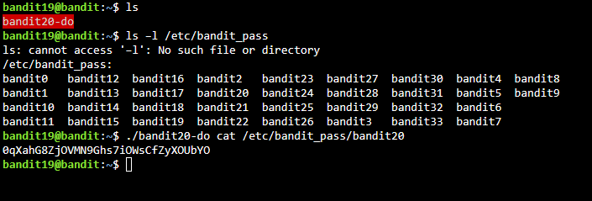
Explanation: The home directory contained bandit20-do, which has the setuid bit set: it runs with the permissions of its owner, bandit20, rather than the user who runs it. Running it without arguments showed a usage message: it executes any command as bandit20. So I used it to run cat /etc/bandit_pass/bandit20, a file only bandit20 can read.

Level 20 → 21
Goal: A setuid binary in the home directory connects to localhost on the port you give it as an argument. It reads a line of text from the connection and compares it to the password of the previous level (bandit20). If the password is correct, it sends back the password for the next level (bandit21).
Commands used (two SSH sessions open at the same time):
Terminal 1, to start a listener:
ssh bandit20@bandit.labs.overthewire.org -p 2220
nc -l -p 50002
0qXahG8ZjOVMN9Ghs7iOWsCfZyXOUbYO
Terminal 2, to run the binary:
ssh bandit20@bandit.labs.overthewire.org -p 2220
ls
./suconnect
./suconnect 50002
Password found: EeoULMCra2q0dSkYj561DX7s1CpBuOBt
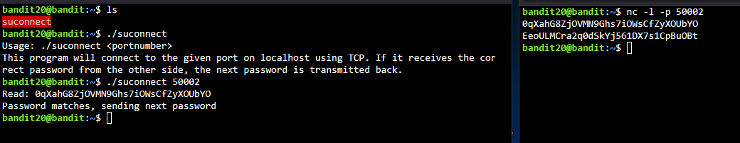
Explanation: The binary needs a server to connect to, so I opened a second SSH session and used nc -l -p 50002 to listen on port 50002, ready to send the current password. Running ./suconnect without arguments showed its usage. Then ./suconnect 50002 connected to my listener, received the correct password, and sent the next password back to the listener.

Level 21 → 22
Goal: A program is running automatically at regular intervals from cron, the time-based job scheduler. Look in /etc/cron.d/ for the configuration and see what command is being executed.
Commands used:
ssh bandit21@bandit.labs.overthewire.org -p 2220
ls -l /etc/cron.d/
file /etc/cron.d/cronjob_bandit22
cat /etc/cron.d/cronjob_bandit22
cat /usr/bin/cronjob_bandit22.sh
cat /tmp/t7O6lds9S0RqQh9aMcz6ShpAoZKF7fgv
Password found: tRae0UfB9v0UzbCdn9cY0gQnds9GF58Q
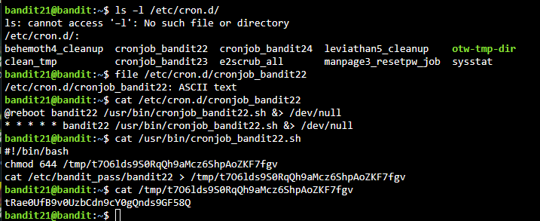
Explanation: The cron configuration cronjob_bandit22 runs the script /usr/bin/cronjob_bandit22.sh every minute as bandit22. Reading the script showed that it copies the bandit22 password into a file in /tmp and makes it readable by everyone, so I read that file.

Level 22 → 23
Goal: A program is running automatically at regular intervals from cron, the time-based job scheduler. Look in /etc/cron.d/ for the configuration and see what command is being executed.
Commands used:
ssh bandit22@bandit.labs.overthewire.org -p 2220
ls -l /etc/cron.d/
cat /etc/cron.d/cronjob_bandit23
cat /usr/bin/cronjob_bandit23.sh
echo I am user bandit23 | md5sum | cut -d ' ' -f 1
cat /tmp/8ca319486bfbbc3663ea0fbe81326349
Password found: 0Zf11ioIjMVN551jX3CmStKLYqjk54Ga
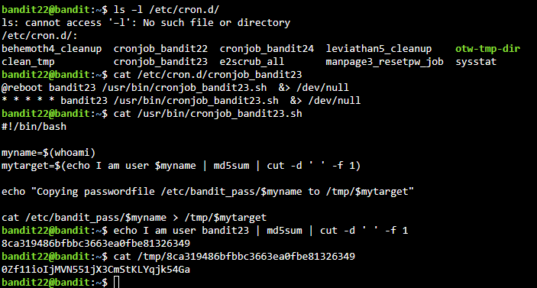
Explanation: The script cronjob_bandit23.sh takes the text "I am user" plus the username, hashes it with md5sum, and saves the user's password to /tmp/<hash>. Running the same command with bandit23 as the username gave me the filename, and reading that file gave the password.

Level 23 → 24
Goal: A program is running automatically at regular intervals from cron, the time-based job scheduler. Look in /etc/cron.d/ for the configuration and see what command is being executed.
Commands used:
ssh bandit23@bandit.labs.overthewire.org -p 2220
ls -l /etc/cron.d/
cat /etc/cron.d/cronjob_bandit24
cat /usr/bin/cronjob_bandit24.sh
mkdir /tmp/bandittest24
cd /tmp/bandittest24
nano bandit24_password.sh
Contents of bandit24_password.sh:
#!/bin/bash
cat /etc/bandit_pass/bandit24 > /tmp/bandittest24/output.txt
Then:
chmod -R 777 /tmp/bandittest24
cp bandit24_password.sh /var/spool/bandit24/foo
ls
cat output.txt
Password found: gb8KRRCsshuZXI0tUuR6ypOFjiZbf3G8
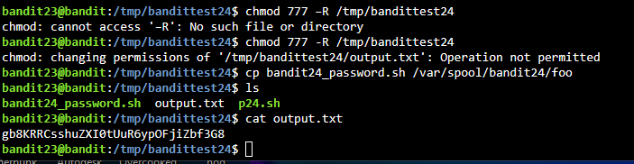
Explanation: The cron script runs every minute as bandit24. It executes any script placed in /var/spool/bandit24/foo, then deletes it. So I wrote my own script that copies the bandit24 password into a file in my own folder.
- chmod -R 777 made my folder and script writable and executable by everyone, so bandit24 could run the script and write the output file.
- I copied the script into the folder the cron job watches.
- After about a minute, output.txt appeared with the password.

Level 24 → 25
Goal: A daemon is listening on port 30002 and gives the password for bandit25 if given the password for bandit24 and a secret 4-digit PIN. The only way to find the PIN is to try all 10,000 combinations (brute-forcing). You do not need to create a new connection each time.
Commands used:
ssh bandit24@bandit.labs.overthewire.org -p 2220
mkdir /tmp/bandittest25
cd /tmp/bandittest25
nano password25.sh
Contents of password25.sh:
#!/bin/bash
p="gb8KRRCsshuZXI0tUuR6ypOFjiZbf3G8"
for i in {0000..9999};
do
echo "$p $i"
done | nc localhost 30002
Then:
chmod +x password25.sh
./password25.sh
Password found: iCi86ttT4KSNe1armKiwbQNmB3YJP3q4
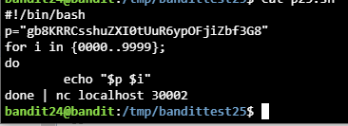
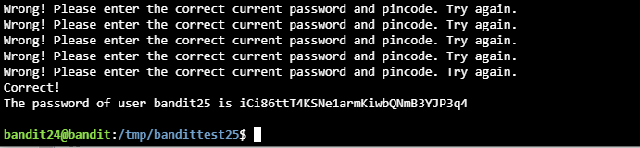
Explanation: The script loops through every PIN from 0000 to 9999 and prints each one after the password. Piping the whole loop into a single nc connection sends all 10,000 attempts over one connection, which is much faster than reconnecting each time. The service replied "Wrong!" until it reached the correct PIN, then printed the password.

Level 25 → 26
Goal: Logging in to bandit26 from bandit25 should be fairly easy. The shell for user bandit26 is not /bin/bash, but something else. Find out what it is, how it works and how to break out of it.
Commands used:
ssh bandit25@bandit.labs.overthewire.org -p 2220
ls
cat /etc/passwd | grep bandit26
cat /usr/bin/showtext
ssh -i bandit26.sshkey -p 2220 bandit26@bandit.labs.overthewire.org
With the terminal window made as small as possible, so more pauses, I pressed v to open vim, then ran:
:e /etc/bandit_pass/bandit26
:set shell=/bin/bash
:shell
Password found: s0773xxkk0MXfdqOfPRVr9L3jJBUOgCZ
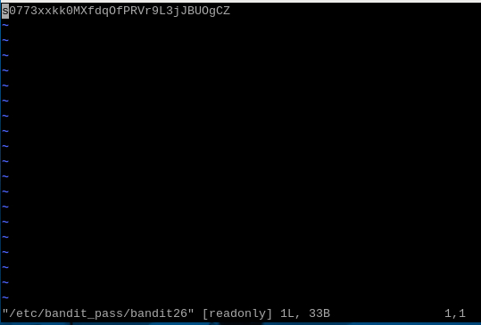
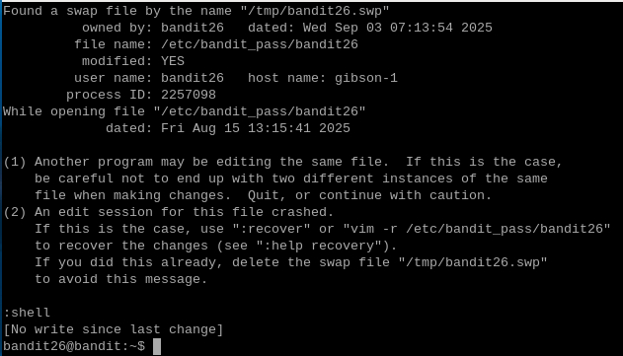
Explanation:
- /etc/passwd showed that the shell for bandit26 is /usr/bin/showtext. Reading that script showed it displays a text file with more and then exits, so a normal login closes immediately.
- more only pauses when the text doesn't fit on the screen. Making the terminal very small kept it paused, and pressing v in more opens the file in vim.
- In vim, :e /etc/bandit_pass/bandit26 opened the password file.
- :set shell=/bin/bash followed by :shell started a real bash shell as bandit26, which I needed for the next level.

Level 26 → 27
Goal: Good job getting a shell! Now hurry and grab the password for bandit27!
Commands used:
ls
ls /etc/bandit_pass
./bandit27-do cat /etc/bandit_pass/bandit27
Password found: upsNCc7vzaRDx6oZC6GiR6ERwe1MowGB
Explanation: I continued in the bash shell from the previous level. As in level 19, the home directory contained a setuid binary, bandit27-do, which runs commands as bandit27. I used it to read /etc/bandit_pass/bandit27.

Level 27 → 28
Goal: There is a git repository at ssh://bandit27-git@localhost/home/bandit27-git/repo via port 2220. The password for the user bandit27-git is the same as for bandit27. Clone the repository and find the password for the next level.
Commands used:
ssh bandit27@bandit.labs.overthewire.org -p 2220
mkdir /tmp/bandittest27
cd /tmp/bandittest27
git clone ssh://bandit27-git@localhost:2220/home/bandit27-git/repo
ls
cd repo
ls
cat README
Password found: Yz9IpL0sBcCeuG7m9uQFt8ZNpS4HZRcN
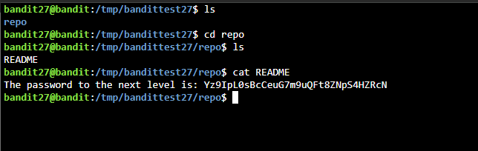
Explanation: I cloned the repository into a working folder in /tmp. The password was in the README file.

Level 28 → 29
Goal: There is a git repository at ssh://bandit28-git@localhost/home/bandit28-git/repo via port 2220. The password for the user bandit28-git is the same as for bandit28. Clone the repository and find the password for the next level.
Commands used:
ssh bandit28@bandit.labs.overthewire.org -p 2220
mkdir /tmp/bandittest28
cd /tmp/bandittest28
git clone ssh://bandit28-git@localhost:2220/home/bandit28-git/repo
ls
cd repo
ls
cat README.md
git log
git show 710c14a2e43cfd97041924403e00efb00b3a956e
Password found: 4pT1t5DENaYuqnqvadYs1oE4QLCdjmJ7
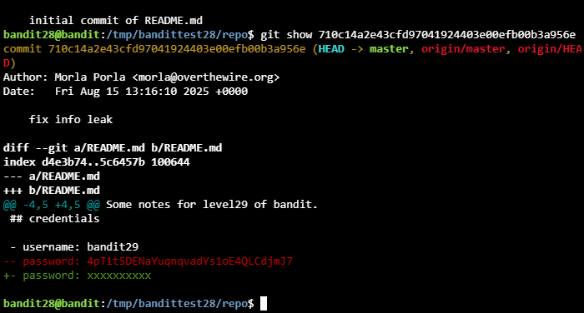
Explanation: The current README.md showed the password as xxxxxxxxxx. git log listed a commit called "fix info leak", and git show on that commit displayed its changes: the line removed (shown in red) still contained the real password. Deleting a secret in a new commit doesn't remove it from the history.

Level 29 → 30
Goal: There is a git repository at ssh://bandit29-git@localhost/home/bandit29-git/repo via port 2220. The password for the user bandit29-git is the same as for bandit29. Clone the repository and find the password for the next level.
Commands used:
ssh bandit29@bandit.labs.overthewire.org -p 2220
mkdir /tmp/bandittest29
cd /tmp/bandittest29
git clone ssh://bandit29-git@localhost:2220/home/bandit29-git/repo
ls
cd repo
ls
cat README.md
git branch -a
git checkout dev
ls -la
cat README.md
Password found: qp30ex3VLz5MDG1n91YowTv4Q8l7CDZL
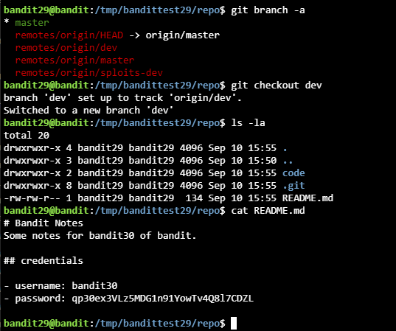
Explanation: The README.md on the main branch didn't contain the password. git branch -a listed all branches, including remote ones, and showed a dev branch. After switching to it with git checkout dev, the README.md there contained the password.

Level 30 → 31
Goal: There is a git repository at ssh://bandit30-git@localhost/home/bandit30-git/repo via port 2220. The password for the user bandit30-git is the same as for bandit30. Clone the repository and find the password for the next level.
Commands used:
ssh bandit30@bandit.labs.overthewire.org -p 2220
mkdir /tmp/bandittest30
cd /tmp/bandittest30
git clone ssh://bandit30-git@localhost:2220/home/bandit30-git/repo
ls
cd repo
ls
cat README.md
git tag
git show secret
Password found: fb5S2xb7bRyFmAvQYQGEqsbhVyJqhnDy
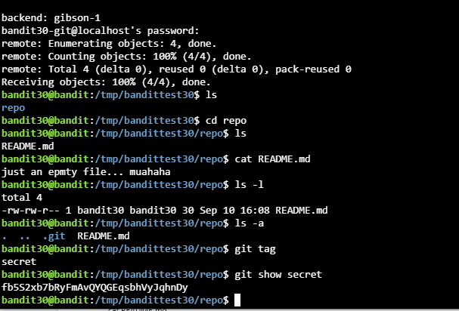
Explanation: The README.md only said it was an empty file. git tag listed a tag called secret, and git show secret displayed its content: the password.

Level 31 → 32
Goal: There is a git repository at ssh://bandit31-git@localhost/home/bandit31-git/repo via port 2220. The password for the user bandit31-git is the same as for bandit31. Clone the repository and find the password for the next level.
Commands used:
ssh bandit31@bandit.labs.overthewire.org -p 2220
mkdir /tmp/bandittest31
cd /tmp/bandittest31
git clone ssh://bandit31-git@localhost:2220/home/bandit31-git/repo
ls
cd repo
ls
cat README.md
echo 'May I come in?' > key.txt
git add -f key.txt
git commit -a
git push -u origin master
git commit -a opens an editor for the commit message.
Password found: 3O9RfhqyAlVBEZpVb6LYStshZoqoSx5K
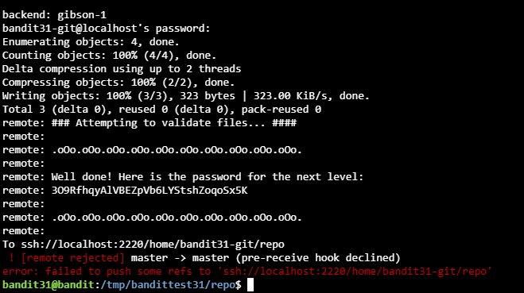
Explanation: The README.md asked for a file called key.txt containing "May I come in?" to be pushed to the master branch. The repository's .gitignore ignores .txt files, so git add -f was needed to force the file in. When I pushed, a server-side hook checked the file and printed the password. The push itself was then rejected, which is expected: the level only needs the hook to check the file.

Level 32 → 33
Goal: After all this git stuff, it's time for another escape. Good luck!
Commands used:
ssh bandit32@bandit.labs.overthewire.org -p 2220
>> $0
$ whoami
$ cat /etc/bandit_pass/bandit33
Password found: tQdtbs5D5i2vJwkO8mEyYEyTL8izoeJ0
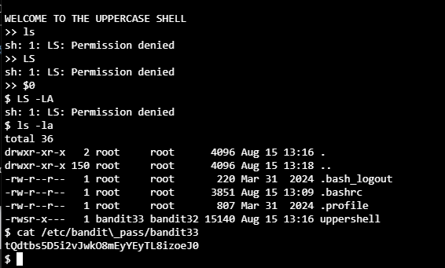
Explanation: The login shell was an "uppercase shell": it converts everything I type to uppercase, so ls becomes LS, which doesn't exist. $0 is a variable that holds the name of the current shell (sh), and uppercasing doesn't change it. Typing $0 started a normal sh shell, which still runs with the bandit33 permissions of the uppercase shell. whoami confirmed the user, and I read the password file.

Final level check
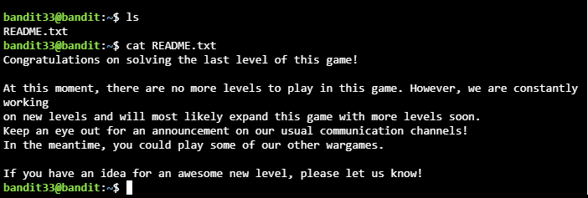
Logging in as bandit33 shows the message that this is the last level of the game.

4. Lessons learned
Completing the whole Bandit wargame was a hands-on tour of Linux, networking and security fundamentals. Across the levels I built practical skills in using the command line efficiently, exploring the file system and working with files and permissions. Each challenge pushed me to solve problems creatively, from decoding ciphers and unpacking unusual file formats to talking to remote services over network sockets.
I learned how cron jobs and setuid binaries work, which showed how much permissions matter and how a misconfigured system can be abused. The git challenges showed version control from a security angle: a repository can hide secrets in its history, branches and tags, even after they look deleted.
Beyond the technical skills, the CTF strengthened my persistence and attention to detail. Many levels needed careful reading of the instructions, noticing small hints and testing commands step by step. It also reinforced a mindset that matters in cybersecurity: consider several approaches, anticipate how the system will respond, and stay curious.
Overall, it wasn't just about finding passwords. It gave me a deeper intuition for how Linux systems work, how network services can be explored safely in a controlled environment, and how to approach complex problems methodically. It's a foundation I'll keep building on in system administration, ethical hacking and cybersecurity.
Thank you to the OverTheWire team for a fun and valuable experience.

