**Evaluation Only. Created with Aspose.Words. Copyright 2003-2022 Aspose Pty Ltd.**

**LECTURE NOTES**

For Health Extension Trainees in Ethiopia

**Introduction to Health Education**

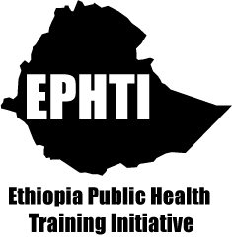

Meseret Yazachew Yihenew Alem

Jimma University

In collaboration with the Ethiopia Public Health Training Initiative, The Carter Center, the Ethiopia Ministry of Health, and the Ethiopia Ministry of Education

November 2004



Funded under USAID Cooperative Agreement No. 663-A-00-00-0358-00.

Produced in collaboration with the Ethiopia Public Health Training Initiative, The Carter Center, the Ethiopia Ministry of Health, and the Ethiopia Ministry of Education.

**Important Guidelines for Printing and Photocopying**

Limited permission is granted free of charge to print or photocopy all pages of this publication for educational, not-for-profit use by health care workers, students or faculty. All copies must retain all author credits and copyright notices included in the original document. Under no circumstances is it permissible to sell or distribute on a commercial basis, or to claim authorship of, copies of material reproduced from this publication.

**©2004 by Meseret Yazachew Yihenew Alem**

All rights reserved. Except as expressly provided above, no part of this publication may be reproduced or transmitted in any form or by any means, electronic or mechanical, including photocopying, recording, or by any information storage and retrieval system, without written permission of the author or authors.

*This material is intended for educational use only by practicing health care workers or students and faculty in a health care field.*

**Acknowledgment**

The development of this lecture note for training Health Extension workers is an arduous assignment for Dr. Meseret Yazachew and Dr. Yihenew Alem at Jimma University.

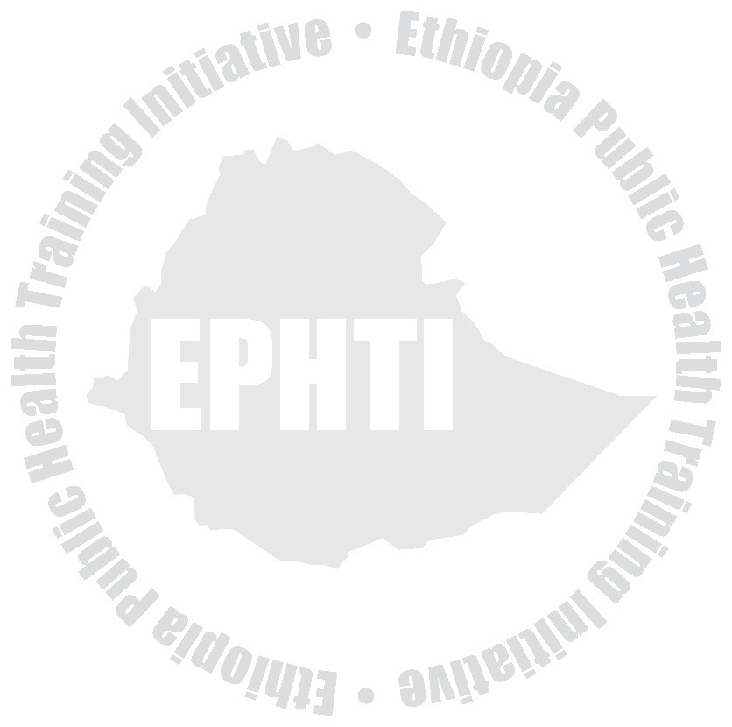

Essentially, it required the consolidation and merging of existing in depth training materials, examination of Health Extension Package manuals and the Curriculum.

Recognizing the importance of and the need for the preparation of the lecture note for the Training of Health Extension workers THE CARTER CENTER (TCC) ETHIOPIA PUBLIC HEALTH TRAINING INITIATIVE (EPHTI) facilitated the task for Jimma University to write the lecture note in consultation with the Health Extension Coordinating Office of the Federal Ministry of Health.

Finally the Federal Ministry of Health would like to express special words of gratitude for those who contributed and endeavored to the development of this lecture note and to TCC/USAID for the technical and financial support.

i

**Table of Contents**

**Content**

Acknowledgement ........................................................................... i Table of content .............................................................................. ii



List of abbreviations ...................................................................... vi

List of tables ................................................................................. vii

List of figures ................................................................................ vii Introduction ................................................................................... ix

**UNIT ONE: Introduction To Health Education**

Objectives ......................................................................................1 Health Education ...........................................................................3

* Historical development ................................................3
* Definitions ....................................................................4
* Aims and Basic principles of Health Education ............7
* Approaches to Health Education ................................10
* Targets for Health Education ......................................10
* Health Education settings ...........................................11
* Who is responsible for Health Education? ..................11
* Role of Health Educator ..............................................12

Exercises ......................................................................................13

ii

**UNIT TWO: Health And Human Behavior**

Objectives .....................................................................................14 Introduction ...................................................................................14



Definition of behavior and other related terms .............................15 Factors affecting human behavior ................................................17 The role of human behavior for prevention of disease .................22

Exercise ........................................................................................25

**UNIT THREE**: **Working With Communities**

Objectives .....................................................................................26 Introduction ...................................................................................26 Definition of community ................................................................27 Concept of community participation .............................................27 Benefit of community participation ...............................................30 Helping people to organize: The role of Health Extension

Workers ...........................................................................31

**UNIT FOUR: Health Communication**

Objectives .....................................................................................35 Introduction ...................................................................................35

What is communication? ..............................................................36

Why communication? ...................................................................36 Types of communication ..............................................................37

iii

Components of communication ....................................................38 Communication stages .................................................................41 Common communication approaches ..........................................49 Methods of communication ..........................................................49 Barriers to effective communication .............................................51 Characteristics of effective communication ..................................55



**UNIT FIVE: Educational Methods And Materials**

Objectives .....................................................................................57 Introduction ...................................................................................57 Educational methods ....................................................................58

* Individual ............................................................58
* Group .................................................................63

Teaching materials .......................................................................77

* Audios ............................................................77
* Visual aids .......................................................79

Mass media ..................................................................................84

Exercise ........................................................................................87

**UNIT SIX: Training**

Objectives .....................................................................................88 Introduction ...................................................................................88 What is training? ..........................................................................89 Types of training ...........................................................................89 Phases of training .........................................................................89

iv

Exercise ........................................................................................94

**UNIT SEVEN: Planning, Implementation and Evaluation Of Health Education Programs**

Objectives .....................................................................................95 Introduction ...................................................................................95 Planning process ..........................................................................95



* Information gathering ..................................................97
* Defining and prioritizing problems ............................101
* Setting goals and objectives .....................................103
* Identifying and obtaining resources ..........................105
* Selecting appropriate methods .................................107

Carry out and evaluate the project .............................................110

* Development and implementing a project plan .........110
* Evaluating the project ...............................................111

Exercise ......................................................................................113

**UNIT EIGHT: Ethical Issues in Health Education**

Objectives ...................................................................................114 Introduction .................................................................................114

Definition ....................................................................................114

Basic Principles of Ethics ...........................................................115 Health extension workers responsibilities as a health educator .117

Exercise ......................................................................................119

v

**Reference:** .................................................................................120



vi

**List of abbreviations**

**AIDS**  Acquired Immuno-Deficiency Syndrome **HE**  Health Education

**HEWs** Health Extension Workers



**BCC**  Behavioral Change Communication **FGM**  Female Genital Mutilation

**FP**  Family Planning

**HIV**  Human Immunodeficiency Virus

**HSDP**  Health Sector Development Program **IEC**  Information Education Communication **MOH**  Ministry of Health

**PHC**  Primary Health Care

**WHO**  World Health Organization

**UNICEF**  United Nation Children’s Fund

vii

**List of tables**

Table 4.1 Examples of failure at different communication

* stages .........................................................................47

Table 5.1.Main characteristics of mass media and face-to-face



communication .........................................................85

**List of figures**

Fig.2.1. Levels of prevention of disease .......................................22 Fig.4.1. Complete communication model .....................................38 Fig.4.2. Communication stages ....................................................42 Fig. 6.1 Project planning cycle .....................................................96

viii

**Introduction**

The impetus for writing this lecture note arose from two but interrelated pressing demands. The primary reason is the identification of community based health care approach, as a strategy, by the MOH of Ethiopia which intern required the training of Health Extension Workers (HEWs). In addition to the eight components of HSDP identified during the 1st phase, HSDP II included the training and deployment of HEWs who will be delivering essential health care services at the grass root level. Reference materials on health communication both as an aid for the training of these groups of development workers as well as for future utilization at the work places are scarce or absent so far.



Appreciating the critical necessity of this material, the Carter Center/ Ethiopian Public Health Training Initiative, requested Jimma University to prepare and make it ready for the purpose.

Accordingly, the Department of Health Education & Behavioral Sciences made utmost effort to produce the material within the shortest time possible. We tried to include major topics on health education and promotion taking into account the scope of the beneficiaries and the essentiality of some titles. The first two chapters deal with the concept and principles of health education and issues related to health and human behavior. With the assumption that the health extension workers are closely working with and for the community, the general concept and ways of community participation

ix

is described in the 3rd chapter. The fourth chapter discusses on health communication.

Educational methods and materials are purposely discussed relatively in a more detail in chapter five to provide adequate alternatives for the HEW in their effort of communicating issues on disease prevention and health promotion to individuals and families at household level. The 6th and 7th chapter addresses planning process of health education programs and designing training sessions, respectively. Working with the community is something to be carried out with caution. Therefore, ethical issues and standards are discussed in the last chapter.



The authors believe that, though this lecture note is primarily prepared for HEWs as a reference material, other paramedical and related health educators can find it useful.

During the writing, we have tried our best to utilize simple and understandable terms so as to make its consumption easier at all levels. Examples and illustrations from personal experiences and the work of other colleagues were used to make the material more palatable. Objectives of each topic in every chapter are outlined to help readers anticipate some knowledge before going through the section. Study questions are also forwarded at the end of every chapter to serve as a self-test. Lastly, we would be grateful and enthusiastic to receive any sort of feedbacks and comments on the writing.

x

**UNIT ONE Introduction To Health Education**

**Objectives**



At the end of this chapter, the trainees will be able to:

* Explain the concept of Health.
* Define Health Education.
* State historical development of Health Education.
* Describe objectives of Health Education.
* State basic principles of Health Education.

Before discussing about health education, it is imperative to conceptualize what health itself means. Health is a highly subjective concept. Good health means different things to different people, and its meaning varies according to individual and community expectations and context. Many people consider themselves healthy if they are free of disease or disability. However, people who have a disease or disability may also see themselves as being in good health if they are able to manage their condition so that it does not impact greatly on their quality of life.

**WHO** defined health as “a state of complete physical, mental, and

social well being and not the mere absence of disease or infirmity.”

1

**Physical health** – refers to anatomical integrity and physiological functioning of the body. To say a person is physically healthy:

* All the body parts should be there.
* All of them are in their natural place and position.
* None of them has any pathology.



* All of them are doing their physiological functions properly.
* And they work with each other harmoniously.

**Mental health** - ability to learn and think clearly. A person with good mental health is able to handle day-to-day events and obstacles, work towards important goals, and function effectively in society.

**Social health** – ability to make and maintain acceptable interactions with other people. E.g. To feel sad when somebody close to you passes away.

The absence of health is denoted by such terms as disease, illness and sickness, which usually mean the same thing though social scientists give them different meaning to each.

**Disease** is the existence of some pathology or abnormality of the body, which is capable of detection using, accepted investigation methods.

2

**Illness** is the subjective state of a person who feels aware of not being well.

**Sickness** is a state of social dysfunction: a role that an individual assumes when ill



**Health Education Historical development**

While the history of health education as an emerging profession is only a little over one hundred years old, the concept of educating about health has been around since the dawn of humans. It does not stretch the imagination too far to begin to see how health education first took place during pre-historic era. Some one may have eaten a particular plant or herb and become ill. That person would then warn (educate) others against eating the same substance. Conversely, someone may have ingested a plant or herb that produced a desired effect. That person would then encourage (educate) others to use this substance.

At the time of Alma Ata declaration of Primary Health Care in 1978, health education was put as one of the components of PHC and it was recognized as a fundamental tool to the attainment of health for all. Adopting this declaration, Ethiopia utilizes health education as a primary means of prevention of diseases and promotion of health. In

3

view of this, the national health policy and Health Sector Development Program of Ethiopia have identified health education as a major component of program services.

**Definition**



Health education has been defined in many ways by different authors and experts. Lawrence Green defined it as “a combination of learning experiences designed to facilitate voluntary actions conducive to health.”

The terms **“combination, designed, facilitate and voluntary action”** have significant implications in this definition.

**Combination**: emphasizes the importance of matching the multiple determinants of behavior with multiple learning experiences or educational interventions.

**Designed**: distinguishes health education from incidental learning experiences as systematically planned activity.

**Facilitate** means create favorable conditions for action.

**Voluntary action** means behavioral measures are undertaken by an individual, group or community to achieve an intended health effect with out the use of force, i.e., with full understanding and acceptance of purposes.

4

Most people use the term health education and health promotion interchangeably. However,  **health promotion** is defined as a combination of educational and environmental supports for actions and conditions of living conducive to health.

**Various terms used for communication and health education activities**



**Information, Education and Communication** (IEC) is a term originally from family planning and more recently HIV/AIDS control program in developing countries. It is increasingly being used as a general term for communication activities to promote health.

* **Information:** A collection of useful briefs or detailed ideas, processes, data and theories that can be used for a certain period of time.
* **Education:** A complex and planned learning experiences that aims to bring about changes in cognitive (knowledge), affective (attitude, belief, value) and psychomotor (skill) domains of behavior.
* **Communication:** the process of sharing ideas, information, knowledge, and experience among people using different channels.

**Social mobilization** is a term used todescribe a campaign approach combining mass media and working with community groups and organizations.

5

**Health extension**  is an approach of promoting change through demonstration, working with opinion leaders and community based educational activities.

**Nutrition education** is education directed at the promotion of nutrition and covers choice of food, food-preparation and storage of food.



**Family Life Education** refers to education of young people in a range of topics that include family planning, child rearing and childcare and responsible parenthood**.**

**Patient education** is a term for education in hospital and clinic settings linked to following of treatment procedures, medication, and home care and rehabilitation procedures.

**Behavior Change Communication (BCC)**: Is an interactive process aimed at changing individual and social behavior, using targeted, specific messages and different communication approaches, which are linked to services for effective outcomes.

**Advocacy**: refers to communication strategies focusing on policy makers, community leaders and opinion leaders to gain commitment and support. It is an appeal for a higher-level commitment, involvement and participation in fulfilling a set program agenda.

6

**Aims and principles of health education Aims**

* Motivating people to adopt health-promoting behaviors by providing appropriate knowledge and helping to develop positive attitude.



* Helping people to make decisions about their health and acquire the necessary confidence and skills to put their decisions into practice.

**Basic Principles**

* All health education should be need based. Therefore before involving any individual, group or the community in health education with a particular purpose or for a program the need should be ascertained. It has to be also specific and relevant to the problems and available solutions.
* Health education aims at change of behavior. Therefore multidisciplinary approach is necessary for understanding of human behavior as well as for effective teaching process.
* It is necessary to have a free flow of communication. The two- way communication is particularly of importance in health

7

education to help in getting proper feedback and get doubt cleared.

* The health educator has to adjust his talk and action to suit the group for whom he has to give health education. E.g. when the health educator has to deal with illiterates and poor people, he has to get down to their level of conversation and human relationships so as to reduce any social distance.



* Health Education should provide an opportunity for the clients to go through the stages of identification of problems, planning, implementation and evaluation. This is of special importance in the health education of the community where the identification of problems and planning, implementing and evaluating are to be done with full involvement of the community to make it the community’s own program.
* Health Education is based on scientific findings and current knowledge. Therefore a health educator should have recent scientific knowledge to provide health education.
* The health educators have to make themselves acceptable. They should realize that they are enablers and not teachers. They have to win the confidence of clients.

8

* The health educators should not only have correct information with them on all matters that they have to discuss but also should themselves practice what they profess. Otherwise, they will not enjoy credibility.
* It must be remembered that people are not absolutely without any information or ideas. The health educators are not merely passing information but also give an opportunity for the clients to analyze fresh ideas with old ideas, compare with past experience and take decisions that are found favorable and beneficial.



* The grave danger with health education programs is the pumping of all bulk of information in one exposure or enthusiasm to give all possible information. Since it is essentially a learning process, the process of education should be done step-by-step and with due attention to the different principles of communication.
* The health educator should use terms that can be immediately understood. Highly scientific jargon should be avoided.
* Health Education should start from the existing indigenous knowledge and efforts should aim at small changes in a graded fashion and not be too ambitious. People will learn step by step and not everything together. For every change of behavior, a

9

personal trail is required and therefore the health education should provide opportunities for trying out changed practices.

**Approaches to health education**

* **The persuasion approach –**deliberate attempt to influence the other persons to do what we want them to do (DIRECTIVE APPROACH)



* **The informed decision making approach-**giving people information, problem solving and decision making skills to make decisions but leaving the actual choice to the people.

E.g. family planning methods

Many health educators feel that instead of using persuasion it is better to work with communities to develop their problem solving skills and provide the information to help them make informed choices. However in situations where there is serious threat such as an epidemic, and the actions needed are clear cut, it might be considered justified to persuade people to adopt specific behavior changes.

**Targets for health education**

* Individuals such as clients of services, patients, healthy individuals
* Groups E.g. groups of students in a class, youth club

**This document was truncated here because it was created in the Evaluation Mode.**