LECTURE NOTES
For Health Extension Trainees in Ethiopia
Introduction to Health Education
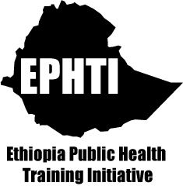
Meseret Yazachew
Yihenew Alem
Jimma University
In collaboration with the Ethiopia Public Health Training Initiative, The Carter Center, the Ethiopia Ministry of Health, and the Ethiopia Ministry of Education
November 2004


Funded under USAID Cooperative Agreement No. 663-A-00-00-0358-00.
Produced in collaboration with the Ethiopia Public Health Training Initiative, The Carter Center, the Ethiopia Ministry of Health, and the Ethiopia Ministry of Education.
Important Guidelines for Printing and Photocopying
Limited permission is granted free of charge to print or photocopy all pages of this publication for educational, not-for-profit use by health care workers, students or faculty. All copies must retain all author credits and copyright notices included in the original document. Under no circumstances is it permissible to sell or distribute on a commercial basis, or to claim authorship of, copies of material reproduced from this publication.
©2004 by Meseret Yazachew Yihenew Alem
All rights reserved. Except as expressly provided above, no part of this publication may be reproduced or transmitted in any form or by any means, electronic or mechanical, including photocopying, recording, or by any information storage and retrieval system, without written permission of the author or authors.
This material is intended for educational use only by practicing health care workers or students and faculty in a health care field.

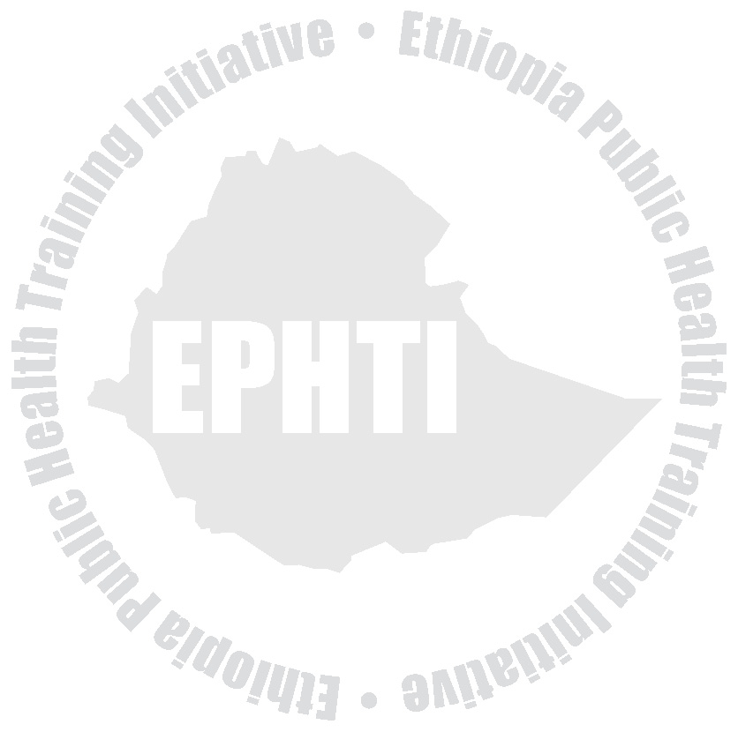
Acknowledgment
The development of this lecture note for training Health Extension workers is an arduous assignment for Dr. Meseret Yazachew and Dr. Yihenew Alemat Jimma University.
Essentially, it required the consolidation and merging of existing in depth training materials, examination of Health Extension Package manuals and the Curriculum.
Recognizing the importance of and the need for the preparation of the lecture note for the Training of Health Extension workers THE CARTER CENTER (TCC) ETHIOPIA PUBLIC HEALTH TRAINING INITIATIVE (EPHTI) facilitated the task for Jimma University to write the lecture note in consultation with the Health Extension Coordinating Office of the Federal Ministry of Health.
Finally the Federal Ministry of Health would like to express special words of gratitude for those who contributed and endeavored to the development of this lecture note and to TCC/USAID for the technical and financial support.
i

Table of Contents
Content
Acknowledgement ........................................................................... i Table of content .............................................................................. ii List of abbreviations ...................................................................... vi List of tables ................................................................................. vii List of figures ................................................................................ vii Introduction ................................................................................... ix
UNIT ONE: Introduction To Health Education
Objectives ......................................................................................1 Health Education ...........................................................................3 • Historical development ................................................3 • Definitions ....................................................................4 • Aims and Basic principles of Health Education ............7 • Approaches to Health Education ................................10 • Targets for Health Education ......................................10 • Health Education settings ...........................................11 • Who is responsible for Health Education? ..................11 • Role of Health Educator ..............................................12 Exercises ......................................................................................13
ii

UNIT TWO: Health And Human Behavior
Objectives .....................................................................................14 Introduction ...................................................................................14 Definition of behavior and other related terms .............................15 Factors affecting human behavior ................................................17 The role of human behavior for prevention of disease .................22 Exercise ........................................................................................25
UNIT THREE: Working With Communities
Objectives .....................................................................................26 Introduction ...................................................................................26 Definition of community ................................................................27 Concept of community participation .............................................27 Benefit of community participation ...............................................30 Helping people to organize: The role of Health Extension
Workers ...........................................................................31
UNIT FOUR: Health Communication
Objectives .....................................................................................35 Introduction ...................................................................................35 What is communication? ..............................................................36 Why communication? ...................................................................36 Types of communication ..............................................................37
iii

Components of communication ....................................................38 Communication stages .................................................................41 Common communication approaches ..........................................49 Methods of communication ..........................................................49 Barriers to effective communication .............................................51 Characteristics of effective communication ..................................55
UNIT FIVE: Educational Methods And Materials
Objectives .....................................................................................57 Introduction ...................................................................................57 Educational methods ....................................................................58
• Individual ............................................................58
• Group .................................................................63 Teaching materials .......................................................................77
• Audios ............................................................77
• Visual aids .......................................................79 Mass media ..................................................................................84 Exercise ........................................................................................87
UNIT SIX: Training
Objectives .....................................................................................88 Introduction ...................................................................................88 What is training? ..........................................................................89 Types of training ...........................................................................89 Phases of training .........................................................................89
iv

Exercise ........................................................................................94
UNIT SEVEN: Planning, Implementation and Evaluation Of Health Education Programs
Objectives .....................................................................................95 Introduction ...................................................................................95 Planning process ..........................................................................95 • Information gathering ..................................................97 • Defining and prioritizing problems ............................101 •
Setting goals and objectives .....................................103 • Identifying and obtaining resources ..........................105 • Selecting appropriate methods .................................107 Carry out and evaluate the project .............................................110 • Development and implementing a project plan .........110 • Evaluating the project ...............................................111 Exercise ......................................................................................113
UNIT EIGHT: Ethical Issues in Health Education
Objectives ...................................................................................114 Introduction .................................................................................114 Definition ....................................................................................114 Basic Principles of Ethics ...........................................................115 Health extension workers responsibilities as a health educator .117 Exercise ......................................................................................119
v

Reference: .................................................................................120
vi

List of abbreviations
AIDS Acquired Immuno-Deficiency Syndrome
HE Health Education
HEWs Health Extension Workers
BCC Behavioral Change Communication
FGM Female Genital Mutilation
FP Family Planning
HIV Human Immunodeficiency Virus
HSDP Health Sector Development Program
IEC Information Education Communication
MOH Ministry of Health
PHC Primary Health Care
WHO World Health Organization
UNICEF United Nation Children’s Fund
vii

List of tables
Table 4.1 Examples of failure at different communication
• stages .........................................................................47 Table 5.1.Main characteristics of mass media and face-to-face communication .........................................................85
List of figures
Fig.2.1. Levels of prevention of disease .......................................22 Fig.4.1. Complete communication model .....................................38 Fig.4.2. Communication stages ....................................................42 Fig. 6.1 Project planning cycle .....................................................96
viii

Introduction
The impetus for writing this lecture note arose from two but
interrelated | pressing | demands. | The | primary | reason | is | the
identification of community based health care approach, as a strategy, by the MOH of Ethiopia which intern required the training of Health Extension Workers (HEWs). In addition to the eight components of HSDP identified during the 1st phase, HSDP II included the training and deployment of HEWs who will be delivering essential health care services at the grass root level. Reference materials on health communication both as an aid for the training of these groups of development workers as well as for future utilization at the work places are scarce or absent so far.
Appreciating the critical necessity of this material, the Carter Center/ Ethiopian Public Health Training Initiative, requested Jimma University to prepare and make it ready for the purpose.
Accordingly, the Department of Health Education & Behavioral Sciences made utmost effort to produce the material within the shortest time possible. We tried to include major topics on health education and promotion taking into account the scope of the beneficiaries and the essentiality of some titles. The first two chapters deal with the concept and principles of health education and issues related to health and human behavior. With the assumption that the health extension workers are closely working with and for the community, the general concept and ways of community participation
ix

is described in the 3rd chapter. The fourth chapter discusses on health communication.
Educational methods and materials are purposely discussed relatively in a more detail in chapter five to provide adequate alternatives for the HEW in their effort of communicating issues on disease prevention and health promotion to individuals and families at household level. The 6th and 7th chapter addresses planning process of health education programs and designing training sessions, respectively. Working with the community is something to be carried out with caution. Therefore, ethical issues and standards are discussed in the last chapter.
The authors believe that, though this lecture note is primarily prepared for HEWs as a reference material, other paramedical and related health educators can find it useful.
During the writing, we have tried our best to utilize simple and understandable terms so as to make its consumption easier at all levels. Examples and illustrations from personal experiences and the work of other colleagues were used to make the material more palatable. Objectives of each topic in every chapter are outlined to help readers anticipate some knowledge before going through the section. Study questions are also forwarded at the end of every chapter to serve as a self-test. Lastly, we would be grateful and enthusiastic to receive any sort of feedbacks and comments on the writing.
x

UNIT ONE
Introduction To Health Education
Objectives
At the end of this chapter, the trainees will be able to:
• Explain the concept of Health.
• Define Health Education.
• State historical development of Health Education.
• Describe objectives of Health Education.
• State basic principles of Health Education.
Before discussing about health education, it is imperative to conceptualize what health itself means. Health is a highly subjective concept. Good health means different things to different people, and
its | meaning | varies | according | to | individual | and | community
expectations and context. Many people consider themselves healthy if they are free of disease or disability. However, people who have a disease or disability may also see themselves as being in good health if they are able to manage their condition so that it does not impact greatly on their quality of life.
WHO defined health as “a state of complete physical, mental, and social well being and not the mere absence of disease or infirmity.”
1

Physical health – refers to anatomical integrity and physiological functioning of the body. To say a person is physically healthy:
• All the body parts should be there.
• All of them are in their natural place and position.
• None of them has any pathology.
• All of them are doing their physiological functions properly.
• And they work with each other harmoniously.
Mental health - ability to learn and think clearly. A person with good mental health is able to handle day-to-day events and obstacles, work towards important goals, and function effectively in society.
Social health – ability to make and maintain acceptable interactions with other people. E.g. To feel sad when somebody close to you passes away.
The absence of health is denoted by such terms as disease, illness and sickness, which usually mean the same thing though social scientists give them different meaning to each.
Disease is the existence of some pathology or abnormality of the body, which is capable of detection using, accepted investigation methods.
2

Illness is the subjective state of a person who feels aware of not being well.
Sickness is a state of social dysfunction: a role that an individual assumes when ill
Health Education
Historical development
While the history of health education as an emerging profession is only a little over one hundred years old, the concept of educating about health has been around since the dawn of humans. It does not stretch the imagination too far to begin to see how health education first took place during pre-historic era. Some one may have eaten a particular plant or herb and become ill. That person would then warn (educate) others against eating the same substance. Conversely, someone may have ingested a plant or herb that produced a desired effect. That person would then encourage (educate) others to use this substance.
At the time of Alma Ata declaration of Primary Health Care in 1978, health education was put as one of the components of PHC and it was recognized as a fundamental tool to the attainment of health for all. Adopting this declaration, Ethiopia utilizes health education as a primary means of prevention of diseases and promotion of health. In
3

view of this, the national health policy and Health Sector Development Program of Ethiopia have identified health education as a major component of program services.
Definition
Health education has been defined in many ways by different authors and experts. Lawrence Green defined it as “a combination of learning experiences designed to facilitate voluntary actions conducive to health.”
The terms “combination, designed, facilitate and voluntary action” have significant implications in this definition.
Combination: emphasizes the importance of matching the multiple determinants of behavior with multiple learning experiences or educational interventions.
Designed: distinguishes health education from incidental learning experiences as systematically planned activity.
Facilitate means create favorable conditions for action.
Voluntary action means behavioral measures are undertaken by an individual, group or community to achieve an intended health effect with out the use of force, i.e., with full understanding and acceptance of purposes.
4

Most people use the term health education and health promotion interchangeably. However, health promotion is defined as a combination of educational and environmental supports for actions and conditions of living conducive to health.
Various terms used for communication and health education activities
Information, Education and Communication (IEC) is a term originally from family planning and more recently HIV/AIDS control program in developing countries. It is increasingly being used as a general term for communication activities to promote health.
• Information: A collection of useful briefs or detailed ideas, processes, data and theories that can be used for a certain period of time.
• | Education: | A | complex | and | planned | learning
experiences that aims to bring about changes in cognitive (knowledge), affective (attitude, belief, value) and psychomotor (skill) domains of behavior.
• Communication: the process of sharing ideas, information, knowledge, and experience among people using different channels.
Social mobilization is a term used todescribe a campaign approach combining mass media and working with community groups and organizations.
5

Health extension is anapproach of promoting change through demonstration, working with opinion leaders and community based educational activities.
Nutrition education is education directed at the promotion of nutrition and covers choice of food, food-preparation and storage of food.
Family Life Education refers to education of young people in a range of topics that include family planning, child rearing and childcare and responsible parenthood.
Patient education is a term for education in hospital and clinic settings linked to following of treatment procedures, medication, and home care and rehabilitation procedures.
Behavior Change Communication (BCC):Is an interactive process aimed at changing individual and social behavior, using targeted, specific messages and different communication approaches, which are linked to services for effective outcomes.
Advocacy: refers to communication strategies focusing on policy makers, community leaders and opinion leaders to gain commitment and support. It is an appeal for a higher-level commitment, involvement and participation in fulfilling a set program agenda.
6

Aims and principles of health education
Aims
• Motivating people to adopt health-promoting behaviors by providing appropriate knowledge and helping to develop positive attitude.
• Helping people to make decisions about their health and acquire the necessary confidence and skills to put their decisions into practice.
Basic Principles
• All health education should be need based. Therefore before involving any individual, group or the community in health education with a particular purpose or for a program the need should be ascertained. It has to be also specific and relevant to the problems and available solutions.
• Health education aims at change of behavior. Therefore multidisciplinary approach is necessary for understanding of human behavior as well as for effective teaching process.
• It is necessary to have a free flow of communication. The two- way communication is particularly of importance in health
7

education to help in getting proper feedback and get doubt cleared.
• The health educator has to adjust his talk and action to suit the group for whom he has to give health education. E.g. when the health educator has to deal with illiterates and poor people, he has to get down to their level of conversation and human relationships so as to reduce any social distance.
• Health Education should provide an opportunity for the clients to go through the stages of identification of problems, planning, implementation and evaluation. This is of special importance in the health education of the community where the identification of problems and planning, implementing and evaluating are to be done with full involvement of the community to make it the community’s own program.
• Health Education is based on scientific findings and current knowledge. Therefore a health educator should have recent scientific knowledge to provide health education.
• The health educators have to make themselves acceptable. They should realize that they are enablers and not teachers. They have to win the confidence of clients.
8

• The health educators should not only have correct information with them on all matters that they have to discuss but also should themselves practice what they profess. Otherwise, they will not enjoy credibility.
• It must be remembered that people are not absolutely without any information or ideas. The health educators are not merely passing information but also give an opportunity for the clients to analyze fresh ideas with old ideas, compare with past experience and take decisions that are found favorable and beneficial.
• The grave danger with health education programs is the pumping of all bulk of information in one exposure or enthusiasm to give all possible information. Since it is essentially a learning process, the process of education should be done step-by-step and with due attention to the different principles of communication.
• The health educator should use terms that can be immediately understood. Highly scientific jargon should be avoided.
• Health Education should start from the existing indigenous knowledge and efforts should aim at small changes in a graded fashion and not be too ambitious. People will learn step by step and not everything together. For every change of behavior, a
9

personal trail is required and therefore the health education should provide opportunities for trying out changed practices.
Approaches to health education
• The persuasion approach –deliberate attempt to influence the other persons to do what we want them to do (DIRECTIVE APPROACH)
• The informed decision making approach-giving people information, problem solving and decision making skills to make decisions but leaving the actual choice to the people.
E.g. family planning methods
Many health educators feel that instead of using persuasion it is better to work with communities to develop their problem solving skills and provide the information to help them make informed choices. However in situations where there is serious threat such as an epidemic, and the actions needed are clear cut, it might be considered justified to persuade people to adopt specific behavior changes.
Targets for health education
• Individuals such as clients of services, patients, healthy individuals
• Groups E.g. groups of students in a class, youth club
• Community E.g. people living in a village
10

Health education settings
When considering the range of health education interventions, they are usually described in relation to different settings. Settings are used because interventions need to be planned in the light of the resources and organizational structures peculiar to each. Thus, health education and promotion takes place, amongst other locations, in:
• Communities
• Health care facilities
• Work sites
• Schools
• Prisons
• Refugee camps …etc
Who is responsible for health education?
Health education is the duty of everyone engaged in health and community development activities. Health Extension Workers are primarily responsible in working with the families and community at a grass root level to promote health and prevent disease through provision of health education. If health and other workers are not practicing health education in their daily work, they are not doing their job correctly. When treating someone with skin infection or malaria, a health worker should also educate the patient about the cause of the illness and teach preventive skills. Drugs alone will not solve the
11

problems. Without Health Education, the patient may fall sick again from the same disease. Health workers must also realize that their own personal example serves to educate others.
Role of health educator
• Talking to the people and listening of their problems
• Thinking of the behavior or action that could cause, cure and prevent these problems.
• Finding reasons for people’s behaviors
• Helping people to see the reasons for their actions and health problems.
• Asking people to give their own ideas for solving the problems.
• Helping people to look as their ideas so that they could see which were the most useful and the simplest to put into practice.
• Encouraging people to choose the idea best suited to their circumstances.
12

Exercise
1. Define health and health education?
2. Explain why voluntary actions are so important in health education programs.
3. List health education settings found in your locality.
4. Mention five basic principles of health education.
13

UNIT TWO
Health And Human Behaviour
Objectives
At the end of this chapter, the trainees are expected to:
• Define behavior and related terms
• Describe the factors which affect human behavior
• Discuss on the role of human behavior in prevention of disease and promotion of health.
Introduction
In the previous section, we have tried to discuss the concept of health and health education. Human behaviour is among the major determinants of the health of individuals, families or communities. Healthy behaviours contribute to the overall health of individuals and communities and unhealthy behaviours adversely affect the quality of life people at different levels. Most health issues cannot be dealt with by treatment alone. The promotion of health and prevention of diseases will usually involve some changes in life styles or human behaviour.
14

Definitions of behaviour and other related terms
Behaviour is an action that has a specific frequency, duration and purpose whether conscious or unconscious. It is what we “do” and how we “act”. People stay healthy or become ill, often as a result of their own action or behaviour. The following are examples of how people’s actions can affect their health:
• Using mosquito nets and insect sprays helps to keep mosquito away.
• Feeding children with bottle put them at risk of diarrhoea.
• Defecating in an open field will lead to parasitic infection.
• Unsafe sex predisposes people to unwanted pregnancy, HIV/AIDS and other STDs
In health education it is very important to be able to identify the practices that cause, cure, or prevent a problem.
The words actions,practices and behaviours are different words of the same thing.
Life style: refers to the collection of behaviours that make up a person’s way of life-including diet, clothing, family life, housing and work.
Customs: It represents the group behaviour. It is the pattern of action shared by some or all members of the society.
Traditions: are behaviours that have been carried out for a long time and handed down from parents to children.
15

Culture: is the whole complex of knowledge, attitude, norms, beliefs, values, habits, customs, traditions and any other capabilities and skills acquired by man as a member of society.
Distinguishing characteristics of culture
• Culture is symbolic. It is an abstract way of referring to, and understanding ideas, objects, feelings or behavior – the ability to communicate with symbols using language. To convey new ideas people may invent single words to represent many different ideas, feelings or values.
• Culture is shared. People in the same society share common behavior patterns and ways of thinking through culture. For example people living in a society share the same language, dress in similar styles, eat much of the same food and celebrate many of the same holidays.
• Culture is learned. A person must learn culture from other people in a society. For instance, people must learn to speak and understand a language and to abide by the rules of a society.
• Culture is adaptive. People use culture to adjust flexibly and quickly to changes in the world around them. For instance a person can adjust his diet when he changes an area of residence.
16

Examples of behaviours promoting health and preventing diseases
Healthy behaviours: - actions that healthy people undertake to keep themselves or others healthy and prevent disease. Good nutrition, breast feeding, reduction of health damaging behaviours like smoking are examples of healthy behaviours
Utilization behaviour: - utilization of health services such as antenatal care, child health, immunization, family planning…etc Illness behaviour: - recognition of early symptoms and prompt self-referral for treatment.
Compliance behaviours: - following a course of prescribed drugs such as for tuberculosis.
Rehabilitation behaviours: - what people need to do after a serious illness to prevent further disability.
Community action: - actions by individuals and groups to change and improve their surroundings to meet special needs.
Factors affecting human behaviour
1. Predisposing factors: provide the rationale or motivation for the behavior to occur. Some of these are:
• | Knowledge | 17
• | Belief | 17
• | Attitudes | 17
• | Attitudes | 17
• | Values | 17

E.g. For an individual to use condom, he has to have knowledge about condom and develop positive attitude towards utilization of condom.
• Knowledge is knowing things, objects, events, persons, situations and everything in the universe. Itis the collection and storage of information or experience. It often comes from experience. We also gain knowledge through information provided by teachers, parents, friends, books, newspapers, etc…
E.g. knowledge about methods of prevention of HIV
• Belief is a conviction that a phenomenon or object is true or real. Beliefs deal with people’s understanding of themselves and their environment. People usually do not know whether what they believe is true or false. They are usually derived from our parents, grandparents, and other people we respect. Beliefs may be helpful, harmful or neutral. If it is not certain that a belief is harmful, it is better to leave it alone.
For example, a certain society may have the following beliefs:
• Holding materials made of iron by mothers during postpartum (Neutral)
• Diarrhea may end up with death (helpful)
• Measles can not be prevented by immunization (harmful)
18

• Attitudes are relatively constant feelings, predispositions or set of beliefs directed towards an object, person or situation.
They are evaluative feelings and reflect our likes and dislikes.
They often come from our experiences or from those of people close to us. They either attract us to things, or make wary of them.
E.g. w/o Almaz had fever and visited the nearby health center. The staff on duty that day was very busy and shouted at her, “Do you want us to waste our time for a mild fever? Come back when we are less busy.” She did not like being shouted at. This experience gave her bad attitude toward the health staff. This bad attitude could discourage her from attending the health center next time she is sick.
• Values are broad ideas and widely held assumptions regarding what are desirable, correct and good that most members of a society share. Values are so general and abstract that they do not explicitly specify which behaviors are acceptable and which are not. Instead, values provide us with criteria and conceptions by which we evaluate people, objects and events as their relative worth, merit, beauty or morality. E.g. being married and having many children are highly valued in most Ethiopian community.
19

• Norms are social rules that specify appropriate and
inappropriate behavior in given situations. They tell us what
we should and must do as well as what we should not and
must not do.
For Example,
• We often regard greeting as a social norm to be
conformed among members who know each other.
• Murder, theft and rape often bring strong disapproval.
2. Enabling factors: these are characteristics of the environment
that
facilitates healthy behavior and any skill or resource required
to attain the behavior. Enabling factors are required for a
motivation to be realized.
Examples of enabling factors include:
• Availability and or accessibility of health resources
• Government laws, priority and commitment to health
• Presence of health related skills
E.g. Enabling factors for a mother to give oral rehydration solution to
her child with diarrhea would be:
• Time, container, salt, sugar
• Knowledge on how to prepare and administer it
20

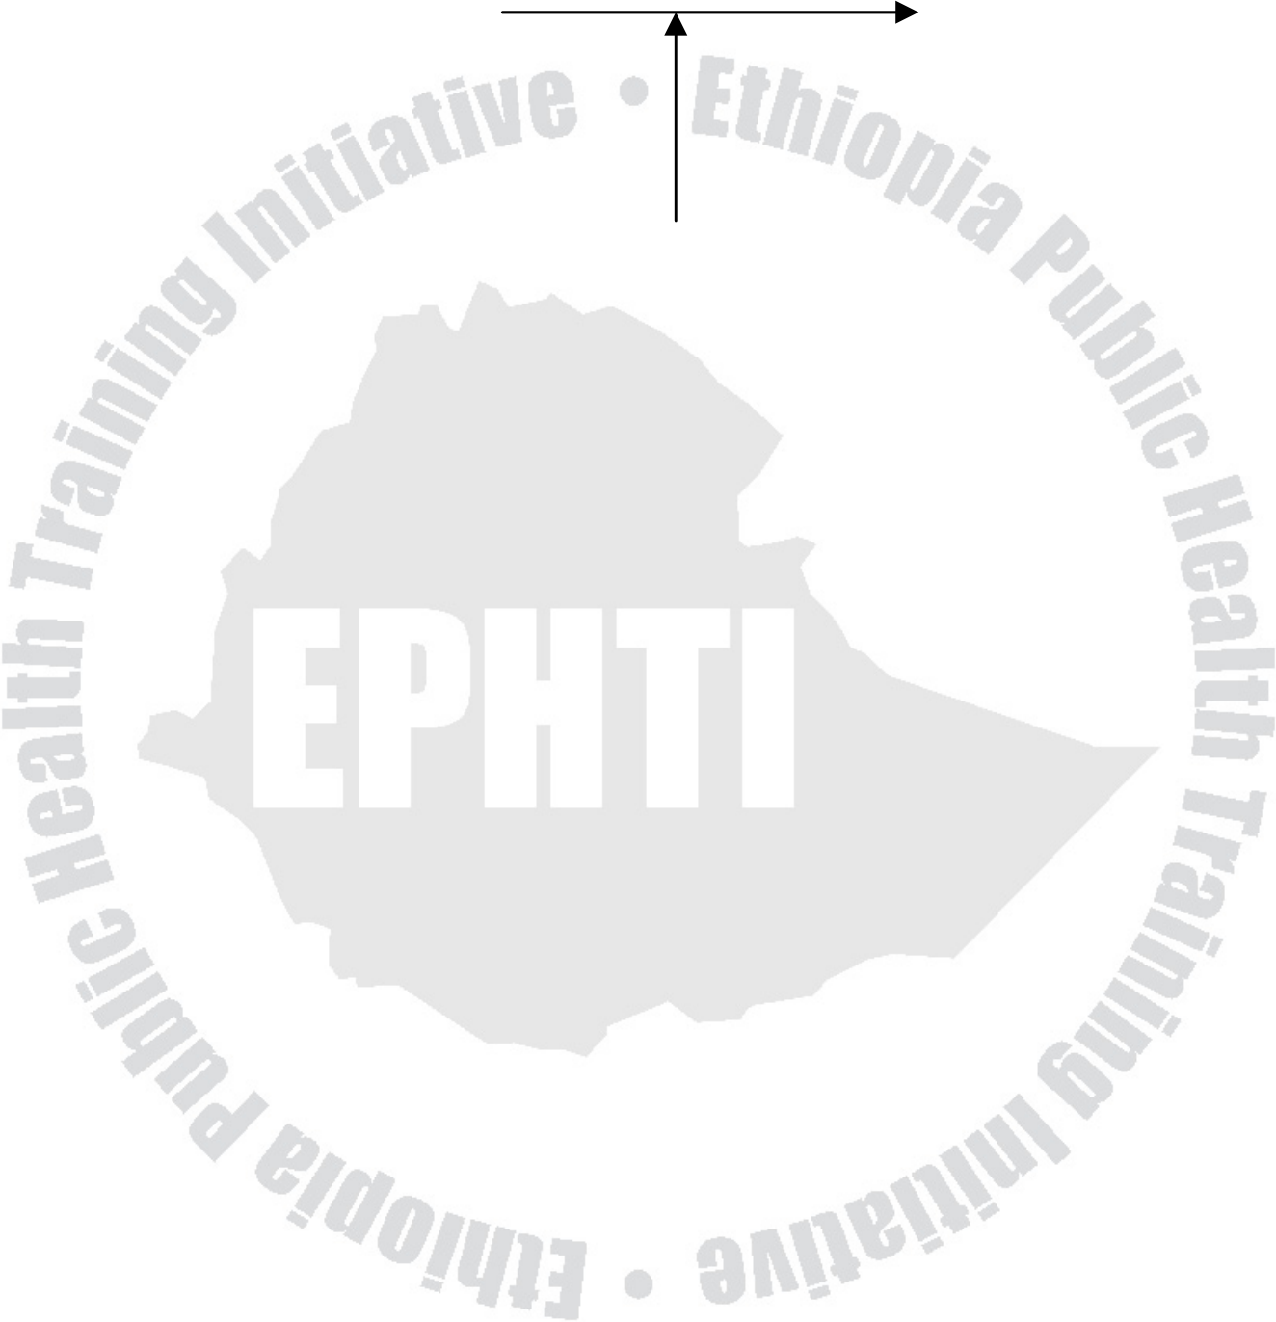
In general, it is believed that enabling factors should be available for an individual or community to perform intended behavior.
Behavioral intention Behavioral change
Enabling factors
(Time, money and materials, skills, accessibility to health services)
Behavioral intention is willingness/ readiness to perform a certain behavior provided that enabling factors are readily available.
3. Reinforcing factors: these factors come subsequent to the behavior. They are important for persistence or repetition of the behavior. The most important reinforcing factors for a behavior to occur or avoid include:
• Family
• Peers, teachers
• Employers, health providers
• Community leaders
• Decision makers
We are all influenced by the various persons in social network. Pressure from others can be a positive influence to adopt health promoting practices as well as an obstacle. Influential people
21

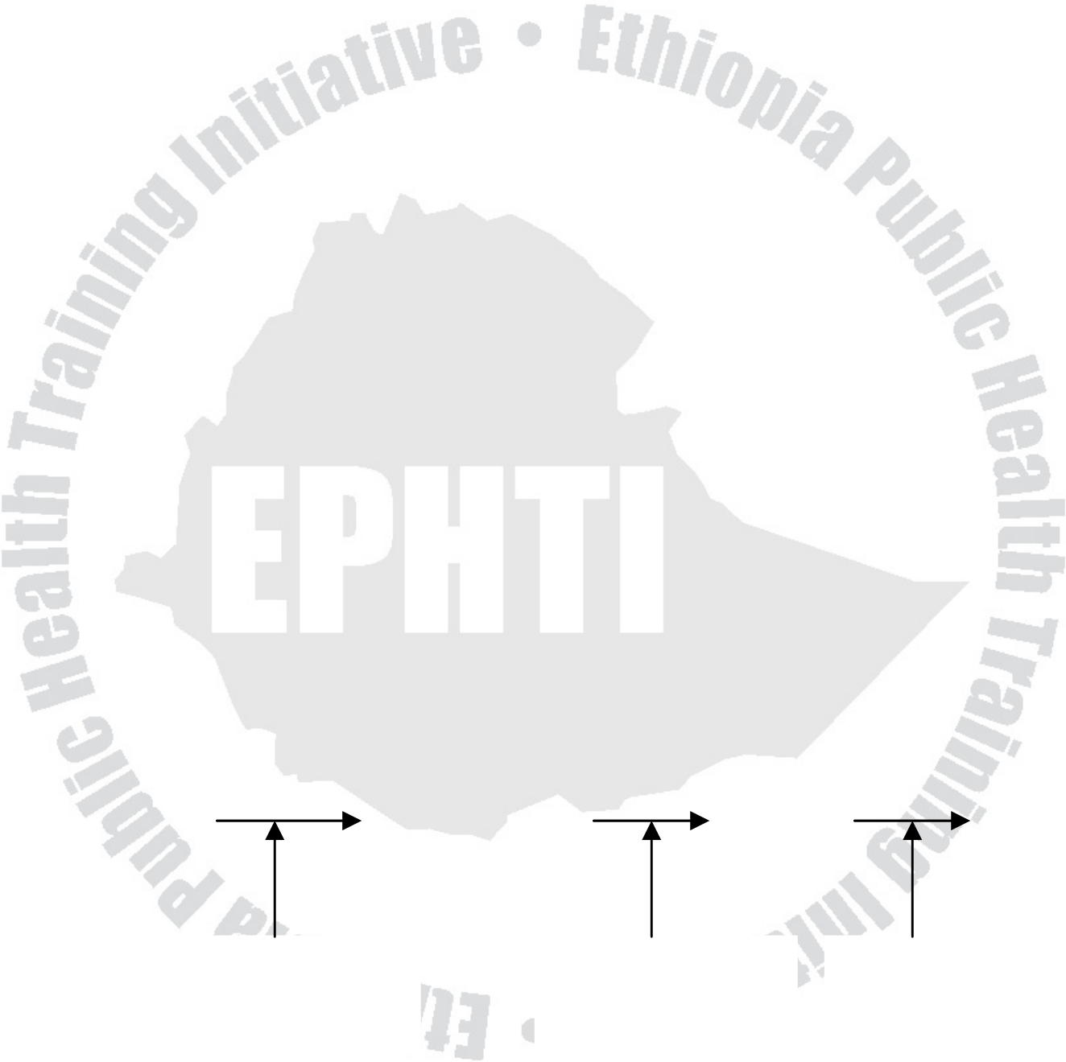
significant influence to change others. In the case of a young child, it is usually the parents who have the most influence. As a child grows older, friends become important and a young person can feel a powerful pressure to conform to the peer group.
E.g. a young man starts smoking because his friends encouraged him to do so.
The role of human behavior in prevention of disease and promotion of health
What is prevention?
Prevention is defined as the planning for and the measures taken to forestall the onset of a disease or other health problem before the occurrence of undesirable health events. There are three distinct levels of prevention: primary, secondary, tertiary prevention.
Healthy person Early signs Disease |  | Death  Tertiary  prevention
Primary  prevention | Secondary  prevention | Death  Tertiary  prevention
Fig. 2.1Levels of prevention of disease
22

Primary prevention
Primary prevention is comprised of those activities carried out to keep people healthy and prevent them from getting disease. Examples of important behaviors for primary prevention includes using rubber gloves when there is a potential for the spread of disease, immunizing against specific diseases, exercise, and brushing teeth. And any health education or promotion program aimed specifically at prevention of the onset of illness or health problems is also an example of primary prevention.
Secondary prevention
Secondary prevention includes preventive measures that lead to an early diagnosis and prompt treatment of a problem before it becomes serious. It is important to ensure that the community can recognize early signs of disease and go for treatment before the disease become serious. Health problems like tuberculosis can be cured if the diseases is detected at an early stage. The actions people take before consulting a health worker, including recognition of symptoms, taking home remedies (‘self-medication’), consulting family and healers are called illness behaviors. Illness behaviors are important examples of behaviors for secondary prevention.
23

Tertiary prevention
Tertiary prevention seeks to limit disability or complication arising from an irreversible condition. Even at this stage actions and behaviors of the patient are essential. The use of disability aids and rehabilitation services help people from further deterioration and loss of function. For example, a diabetic patient should take strictly his/her daily insulin injection to prevent complications.
24

Exercise
1. Identify helpful, neutral and harmful beliefs in your locality. 2. Discuss the enabling factors for latrine construction by a family, and contraception use by a woman.
3. Give examples of important human behaviors, which contribute to primary, secondary and tertiary prevention of diseases.
25

UNIT THREE
Working With Communities
Objectives
At the end of this chapter, the trainees will be able to;
• Explain the concept of community and community participation, in public health in general and health education and promotion in particular.
• Describe the benefits of community participation in the achievement of health education programs.
• | Explore | the | mechanisms | of | achieving | community
mobilization for common goal and the role of community leaders towards such an endeavor.
Introduction
In the past, health education follows persuasion approach to force behavior change among individuals. However, contemporary health education program underscores an informed decision-making approach emphasizing community participation and empowerment. When the idea of primary health care was launched, community participation was one of the important principles identified for its implementation. Although everyone talks about it, real community participation is rarely practiced.
26

What is community?
Community could be defined as organized groups of people who share a sense of belonging, beliefs, norms, and leadership and who usually interact within a defined geographical area.
E.g. People living in a “Kebele” or Woreda”
People organized under one religion etc.
The concept of community participation
The health of the community will improve only if the people themselves become involved in planning, implementing, and having a say about their own health and health care. Nevertheless, involvement will not just happen.
Many people emphasize the importance of community participation for any development issues, including health promotion, to become a success. However, the question is how serious are we about involving individuals, families, and communities? Are we prepared - mentally and professionally – to listen to their concerns, to learn from them what they feel is important, to share with them appropriate information, to encourage and support them? Are we ready to assist them in choosing from alternative solutions, in setting their own targets and evaluating their own efforts? In many cases, so far, the answer is “NO”.
27

In health education, we are concerned about how people actually feel, not how we think they should feel. We are interested in how people look at their own problems, not only in the problems we see ourselves. We want people to develop the confidence and skills to help themselves.
The traditional approach in planning health care or health education program involves the decision to be made by experts. This approach is sometimes called the ‘top-down’ approach and contrasted with the ‘bottom-up’ approach where members of the community make the decisions. In this model people are just told what to do. We make decisions and expect them to follow.
The concept of community participation or involvement encompasses the process by which individuals and families assume responsibility for the community and develop the capacity to contribute to their health and the community’s development. It is a means by which the emphasis is on strengthening the capacity of communities to determine their own needs and take appropriate action. Communities should not be passive recipients of services.
The following are examples of actions that does not indicate genuine participation
• Involvement of individuals from the community in responding to health assessment survey questionnaires,
28

• Requesting the community members to contribute labor to dig a
latrine for the school in its village,
• Holding a meeting to ask people’s opinions on the issue of
uncontrolled population growth,
• Requesting mothers to bring their children to a clinic for
vaccination
We may say communities are participating when they are actively
involved in:
• The assessment of the situation/needs
• Problem identification
• Priority setting and making decisions
• Sharing responsibility in the planning, implementing, monitoring
and evaluation
The role of experts should be limited to helping them identify their
problems and to point out methods for dealing with the problems.
Checklist for identifying the degree of participation in a
program:
• Is the community involved in planning, management, control and
evaluation of the health program at community level?
• Were the felt needs of the community well entertained in the
planning?
29

• Is there a mechanism for dialogue between health system personnel and community leaders?
• Are community representatives nominated in decision-making at higher levels?
• Is there any evidence of the external agents changing their plans as a result of criticism from the community?
• Are deprived groups, such as poor, landless, unemployed, and women, adequately represented in the decision making process?
• Are local resources such as labour, buildings, money etc… exhaustively used?
Benefits of community participation
• It leads development endeavors to success.
• Shifts the emphasis from the individual to the community e.g. If all members of a community are convinced of the benefits of cleanliness, they will help each other to find pure water sources and keep such sources clean. They will build and use latrines everywhere in the community and keep them clean as well.
• As communities often have detailed knowledge about their surroundings, their participation makes programs relevant to local situation.
• Ensures community motivation and support. If the community is involved in choosing priorities and deciding on plans it is much more likely to become involved in program implementation and
30

take up of the services because they are seen to be meeting their needs.
• Promotes self-help and self-reliance. If community members do their own development work, they learn and become more conscious of their needs and potentials for solving their own problems, they make use of local skills, they learn to be responsible for projects and their maintenance, and they gain the necessary self-confidence to tackle further and perhaps more complicated development projects.
• Improves trust and partnership between the community and health workers.
• Enhances the implementation of the health extension package program.
Helping people to organize: The Role of Health Extension Workers
Success in community participation involves a series of overlapping stages.
They include:
• Knowing the community
• Learning about the community (its structure and pattern) • Contacting with families, leaders and community groups. • Discussing on concerns and felt needs.
31

• Taking some actions:
• Actions on achievable, short-term aims based on felt
needs which bring the community together and build
confidence.
• Further activities and organization building
• Build up-on existing community organization or
associations.
• Formation of committee e.g. Health committee
• Educational in-puts
• Select and train volunteers
• Decision making on priorities
• Further actions by the community themselves
In the process of promotion of community participation, community
leaders are very essential.
Who are the leaders?
A leader is a person whose ideas or actions influence others to get
things done that the people want done.
• Could be a person of wisdom and sound judgment
• Might be one whose advice has been valuable in the past.
• Might be wealthy and powerful
• Is known to be religious
32

Why are leaders important?
• Usually make decisions that result in success or failure of a project
• They are trusted and the community members are ready to work with them.
• Help people in the community know you and gain confidence in you.
• Serve as an officer in an organization or chairperson of a committee.
In summary, the most important resources for the promotion of health are the people themselves. Through community participation, you can use that resource to improve the health of the people. However, successful community participation is not as simple as people may think. It requires a demanding task of working with the local communities, holding dialogue, initial teaching and awareness–raising activities, supporting community organization, and being able to convince and work with community leaders. However, overcoming all the challenges and achieving community participation require systematic and careful planning. Obviously, this is the usual challenge for the community health educators.
33

Exercise
1. From your own local experience, describe how the ‘kebele’ heath committee functions and the role they have ever played in the improvement of the health of their people.
2. Out line, the procedures you may follow to mobilize the local community for the development of spring in their village.
List down the perceived advantages of involving the 3.
community in every health education programs.
34

UNIT FOUR
Health Communication
Objectives
At the end of this chapter, the trainees will be able to:
• Define communication
• Discuss the components of communication
• Explore methods of communication
• Explain stages of communication
• Identify barriers to effective communication and how to overcome them
Introduction
Communication is the core of health education and promotion programs. In human society communication can play an important part in daily life. We have the advantage of language, spoken words, songs, and written scripts and so on. It is by communication that an individual makes himself/herself to understood by others. This act requires an appropriate design so as transmit an effective message.
35

What is communication?
Communication is the process of sharing of ideas, information,
knowledge, | and | experience | among | people | to | take | action.
Communication may take place between one person and another, between an individual and a group or between two groups. Communication facilitates creation of awareness, acceptance and action at individual, group and inter-group level. The process always involves a sender and a receiver regardless of the number of people concerned.
Why communication?
• To have dialogue with communities.
• Influence decision makers to adopt health promoting policies and laws.
• Raise awareness among decision makers on issues regarding poverty, human rights, equity, environmental issues, etc...
• Ensure that the public gives support to government health promoting activities.
• Communicate new laws and policies to the public
• Raise public awareness in order to mobilize community participation.
• Develop community action on health issues.
36

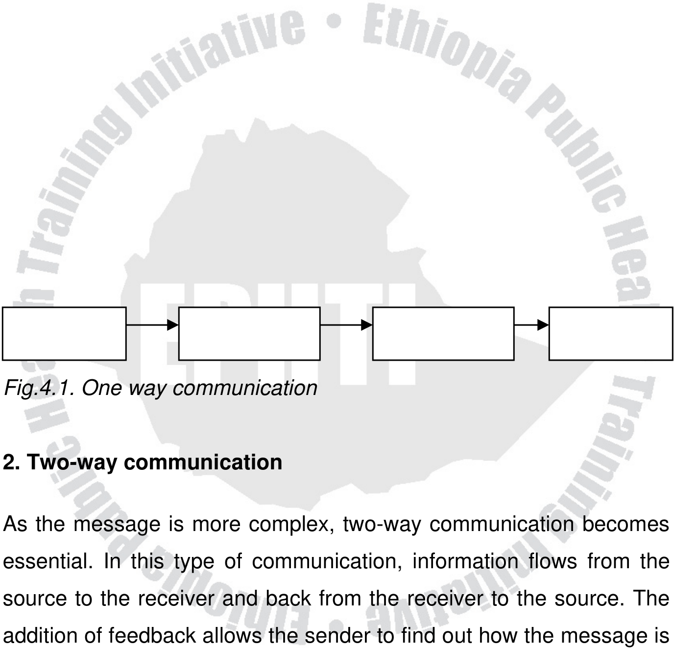
Types of Communication
1.One-way communication
This is a linear type of communication in which information flows from the source to the receiver. There is no input (feed back) from the receiver. It is commonly used in advertising; the message is designed to persuade the receiver to take action prescribed by the sender. The model is best used by organizations when the message is simple and needs to be communicated quickly, for example, the date and time of
a | public | meeting. | There | is | no | opportunity | to | clear | up
misunderstanding and meaning is controlled by the receiver.
→  Sender | message | Channel | Receiver
Fig.4.1. One way communication
2. Two-way communication
As the message is more complex, two-way communication becomes essential. In this type of communication, information flows from the source to the receiver and back from the receiver to the source. The addition of feedback allows the sender to find out how the message is being received and so it can be monitored and adapted to better suit the receiver’s needs.
37

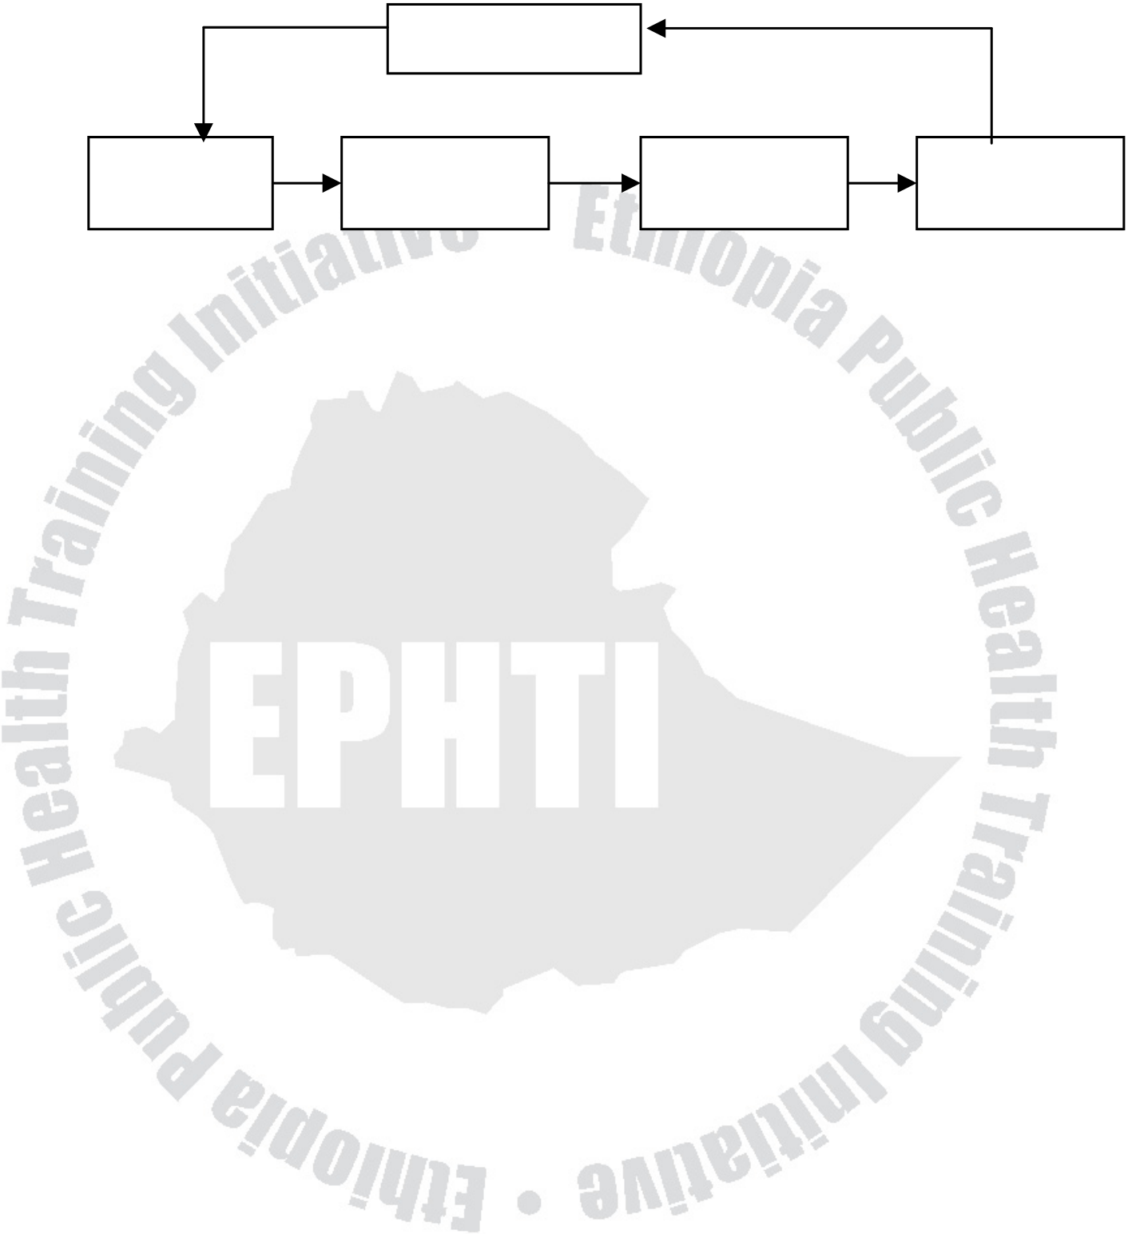
FFeeeeeedddbbbaaaccckkk
SSeeen nndddeeerrr | Meeessssssaaagggeee | CCh hhaaan nnn nneeelll | RReeeccceeeiiivvveeerrr
Fig. 4.2Complete Communication Model
Two way communication
Components of communication
1) Source (sender)
• Originator of message
• Can be from an individual or groups, an institution or organization.
• People are exposed to communication from different source but most likely to accept a communication from a person or organization that they trust i.e. has high source credibility.
• Depending on the community, trust and source credibility may come from:
� Personal qualities or actions e.g. a health worker who always comes out to help people at night.
� Qualification and training
� A person’s natural position in the family or community, e.g. village chief or elder.
� The extent to which the source shares characteristics such as culture, education, experiences with the
38

receiver. A person from a similar background to the community is more likely to share the same language, ideas and motivations and thus be a more effective
communicator. | One | of | the | main | reasons | for
communication failure is when the source comes from a different background from the receiver and uses inappropriate message content and appeals. This principle–that people who share similar backgrounds communicate better with each other–has important implications for health education. It explains why health workers who are strangers to the local community are not always effective in their health education work. Because of this, the health extension package program emphasizes recruitment of health extension workers from the local community. This is particularly relevant in our country where there is a huge diversified culture.
2) Message
It consists of what is actually communicated including the actual appeals, words, and pictures and sounds that you use to get the ideas across.
A message will only be effective if the advice presented is relevant, appropriate, and acceptable and put across in an understandable way.
39

A message is said to be good if it:
• Is Epidemiologically correct (evidence based)
• Is affordable (feasible)
• Requires minimum time/effort
• Is realistic
• Is culturally acceptable
• Meets a felt need
• Is easy to understand
3) Channel
A Channel is a physical means by which message travels from a
source to a receiver. The commonest types of channels are verbal,
visual, printed materials or combined audio visual and printed
materials. Your choice of channel will depend on what you are trying
to achieve, the nature of your audience and what resources are at
your disposal.
4) Receiver (Audience)
• The person or a group for whom the communication is
intended
• The first step in planning any communication is to consider the
intended audience.
40

• Before communication, the following characteristics of audiences should be analyzed.
• Educational factors: can they read? What type of appeals might convince them?
• Sociocultural factors: What do they already believe and feel about the topic of communication?
• Patterns of communication: how people show respect when talking to another person? What time of the day and which programs do they listen? Which places do they pass that might be good places to put up posters?
5) Effect and feedback
• Effect is the change in receiver’s knowledge, attitude and practice or behavior.
• Feedback is the mechanism of assessing what has happened on the receiver after communication has occurred.
Communication stages
In health education and health promotion we communicate for a special purpose – to promote improvements in health through the modification of the human, social and political factors that influence
41

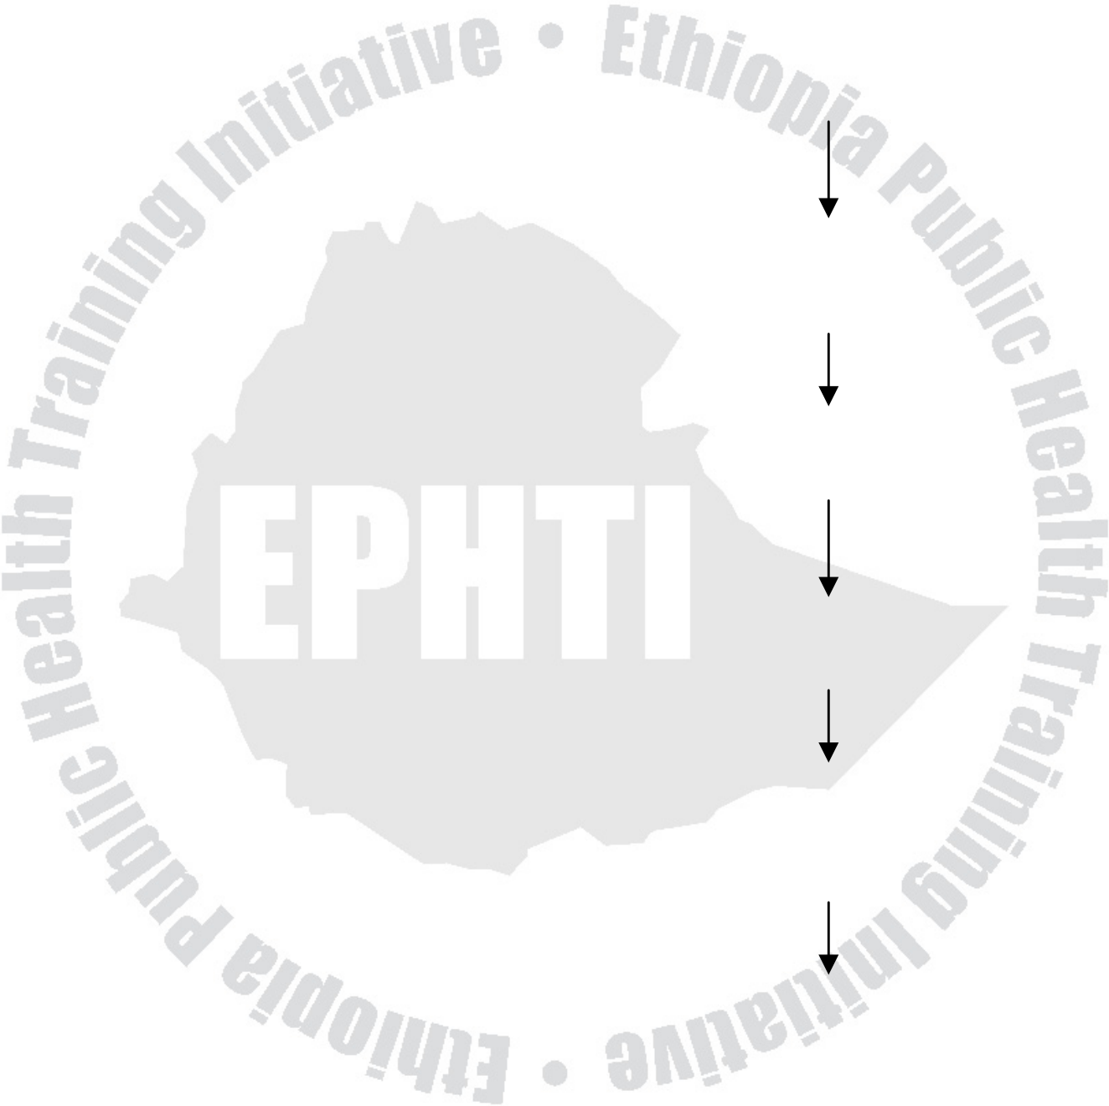
behaviors. To achieve these objectives, a successful communication
must past through several stages:
SENDER RECEIVER
Reaches senses
Gain attention
Message understood
Acceptance /change
Behavior change
Change in health
Fig. 4.2 Communication Stages
42

Stage 1: Reaching the intended audience
Communication cannot be effective unless it is seen or heard by its intended audience. A common cause of failure is preaching to the converted.
E.g. Posters placed at the health post or talks given at the antenatal clinics. These only reach the people who attend the services and are already motivated. But the groups you are trying to reach may not attend clinics, nor have radios or newspapers. Communications should be directed where people are going to see them or hear them. This requires studying your intended audience to find out where they might see posters, what their listening and reading habits are.
Stage 2: Attracting the audience’s attention
Any communication must attract attention so that people will make the effort to listen/read it. At any one time we receive a wide range of information from each of our five senses – touch, smell, vision, hearing and taste. It is impossible to concentrate on all these at the same time. Attention is the process by which a person selects part of this complex mixture to focus on (i.e. to pay attention to) while ignoring others for the time being.
Examples of communication failures at this stage are:
• Walking past the poster without bothering to look at it,
43

• Not paying attention to the health talk or demonstration at the
clinic,
• Turning off the radio program or switching over.
Factors that make communications attract attention
1. Physical characteristics
• Sizee.g. size of the whole poster
• Intensity – bold reading in a sentence
• High pitched sounds e.g. police sirens
• Color-primary colors such as red and yellow
• Pictures-photographs and drawing
2. Motivational characteristics
• Novelty - an unusual features, unfamiliar and surprising
objects
• Interest - felt needs of audience
• Entertainment and humor
In general for successful communication, a health extension worker
should:
• Consider the design of the poster, including colour, size,
lettering and use of pictures which increase the likelihood of
gaining attention and being noticed.
44

• Deal with subjects that the target group wants to know something about i.e. which fit with their felt needs and interests.
• Arouse interest by including something unusual in the communication.
• Explore ways of making educational works interesting and fun.
Stage 3: Understanding the message (perception)
Once a person pays attention he/she then tries to understand it. It is a highly subjective process i.e. two people may hear the same radio programme and interpret the message quite differently from each
other | and | from | the | meaning | intended | by | the | sender.
Misunderstandings can easily take place when complex language, unfamiliar technical words are used and when too much information is presented.
Stage 4: Promoting change (acceptance)
A communication should not only be received and understood; it should be believed and accepted. It is easier to change beliefs when they have been acquired only recently and when its effects can be easily demonstrated.
45

Stage 5: Producing a change in behavior
A communication may result in a change in beliefs and attitudes but still may not influence behavior. This can happen when the communication has not been targeted at the belief that has the most influence on the person’s attitude to the behavior, pressure from other people in the family or community and lack of enabling factors.
Stage 6: Improvement in health
Improvements in health will only take place if the behaviors have been carefully selected so that they really do influence health. If your messages are based on outdated and incorrect ideas, people could follow your advice but their health would not improve – need accurate advice.
46

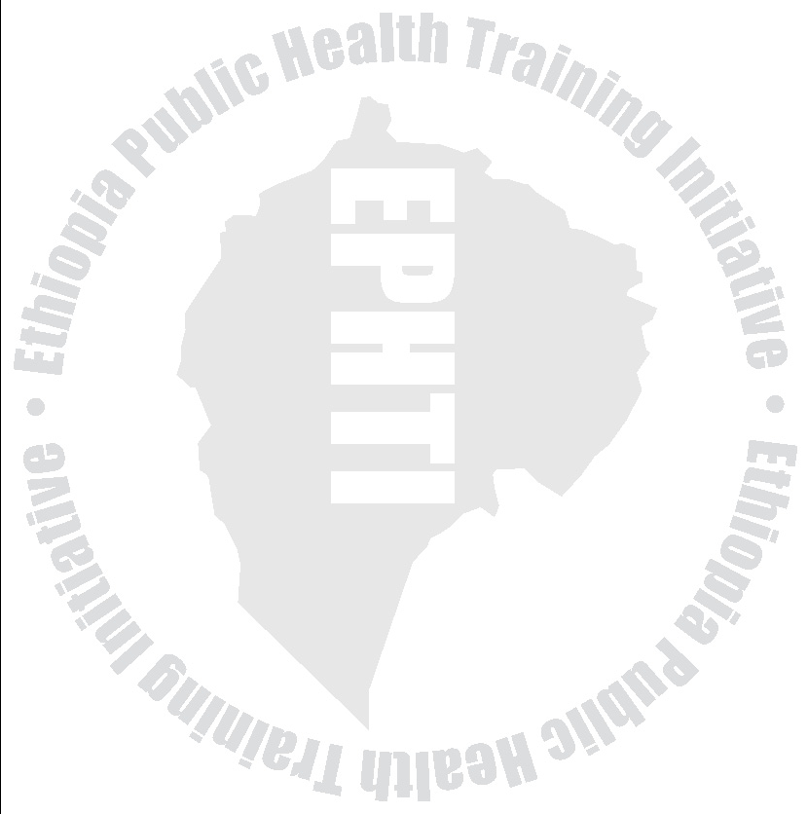
The poster is lacking striking features  and doesn’t stand out compared with  attractive commercial advertisements  Poster showing large hypodermic  syringe held by smiling doctor was  thought by the community to be a  47  Table 4.1 Examples of failure at different communication stages  Immunization poster  Poster is placed at the health center  and only seen by mothers who have | How to ensure success  Research target group to find out where they go and may see the poster.  Find out interests of target group
   | Sta | es
   | 1. Reaches is seen or h  2. Gains att  holds interest, noticed  3. Is unders correctly int | senses;  eard  im ention;  st,  tood;  erpreted. | munized their ch
   |  | dev | devil with a knife.
 | and | make | it | interesting,
attractive and unusual.
Test it out
Make it simple; avoid confusing
 | words | and | pictures. |  | Pretest
 | words and pictures with sample of target group.

 | People believe that measles is caused | Base message on what people
   | 4. Is accepted, believed, le  takes place | ed,  arning
   | 5. Changes in behavior  6. Improves | in  health
 | by witchcraft and do not believe the | already | believe. |  |  | Pretest
 | poster even though they understand | messages for acceptability.
 | the message. | Target the influential people and
 | The mother accepted the message
 | and wished to take the child for | ensure | enabling | factors |  |  | are
 | immunization but the grand mother | available. Pretest for feasibility.
 | didn’t allow it. | Choose | most |  | important
 | The vaccine was destroyed by a | Choose
 | break in the cold chain and the child | behaviors. Make sure support
 | became sick with measles. | services are functioning.
 | 48

Common communication approaches
Informing - The new idea is introduced and made familiar to the target audience.
Educating - The new idea is explained including its strengths and weaknesses.
Persuading- The audience is given convincing argument that motivates them to take an action or accept a new idea.
Entertaining - The attention of the audience is drawn to the new idea by stimulating the audience’s emotions
Methods of Communication
1. Intra - Personal communication
2. Inter - Personal communication
2. Mass communication
Intra-Personal communication
It takes place inside a person. It includes the beliefs, feelings, thoughts and justification we make for our actions. E.g. a person may look at an object and develop a certain understanding. However, this
49

could be affected by a number of factors including previous
experience, language, culture, personal needs, etc.
Interpersonal Communication
It means interaction between two or more people who are together at
the same time and place. E.g. between health extension worker and
community member, a teacher and students in a class. The decisive
criterion for personal communication is that communication happens
at the same time and place.
Advantages
• Two way communication
• The communication could utilize multi-channels (both verbal
and non verbal) i.e. far more channels are involved than is
possible in mass communication.
• Useful when the topic is a taboo or sensitive.
Limitations
• Requires language ability of the source.
• Requires personal status.
• Needs professional knowledge and preparation.
50

Mass communication
It is a means of transmitting messages to a large audience that usually reaches a large segment of the population. It uses mass media. Mass media includes broadcast media (radio and television) as well as print media (newspapers, books, leaflets and posters)
Advantage:
• Reach many people quickly
• They are believable specially when the source is a credible one
Limitation:
• One sided (linear)
• Doesn’t differentiate the target
Barriers to Effective Communication
A breakdown can occur at any point in the communication process.
Barriers | (obstacles) | can | inhibit | communication, | resulting | in
misunderstanding, lack of response or motivation and distortion of the message. This can lead to conflicting of views, insecurity and the inability to make effective decisions. Barriers can also prevent the achievement of project or program goals if we are not aware of them or not prepared for them.
51

Common barriers to effective communication
• Competition for attention (noise)
• Language difference and vocabulary use
• Age difference
• Attitudes and Beliefs
We cannot avoid or overcome all these barriers but we have to find
ways of minimizing them.
52

Competition for attention (noise)
Noise is a major distraction during communication. It could be:
• Physical noise – avoidable
• Internal noise - any physiological or psychological state that could undermine a person’s ability to communicate effectively such as being ill or beset by personal problems. We may or may not be able to do anything to help in this kind of situation.
Language difference and vocabulary use
This includes whether there is language difference, vocabulary use, different meaning of the same word or sentence.
Age difference
Age difference between the sender and receiver is a barrier to effective communication. For example, if the sender is young, inexperienced and not knowledgeable the audience may not give proper attention resulting in a communication barrier.
Attitudes and Beliefs
The community may be misguided by expectation on the role of health extension workers. They either think that health extension
53

workers are supposed to do every thing for them or that they know too much or do not require services,
Cultural beliefs of a people influence the rate at which they accept and adopt new ideas and skills. Normally the beliefs of a community may dictate what foods should be given to children and also their related taboos. In such circumstances it will be very difficult for a health worker to convince the mothers to feed their children on certain food despite their nutritional values. For this reason it is necessary for the health extension workers to be aware of the attitudes and beliefs of the communities they are working with.
How to overcome barriers of communication
• The sender must know his/her audience’s:
• Background
• Age and sex
• Social status
• Education
• Job/work
• Interests/problems/needs
• Language
• The messages must be:
• Timely
• Meaningful/relevant
• Applicable to the situation
54

• The audience must remove their own barriers. Members of the
audience could be:
• The non-listener type – who refuse to listen.
• The know-it-all type – who thinks he/she knows the
answer to everything.
• The impatient type – who is reluctant to sit and jumps to
conclusion.
• The negative personality – who enjoys saying ‘no’ to
everyone.
• Even if all the barriers have been removed, communication could
still be a failure without good presentation. Good presentation
requires complete understanding of the subject establishing good
relationship with the audience, choosing the right channels or
media, proper utilization of the chosen media and using the
multimedia approach.
Characteristics of effective communication
• All barriers have been removed.
• The proper media has been chosen.
• A good presentation has been made.
• Two – way communication has been established.
55

Exercise
1. Discuss the difference between one-way communication and two-way communications.
2. Discuss the possible causes of failure for a radio program given on nutrition.
3. Identify the possible barriers in your locality that you think could affect effective communication in the process of promotion of family planning services.
56

UNIT FIVE
Educational Methods And Materials
Objectives
At the end of this chapter, the trainees are expected to:
• | Explain | the | common | methods | of | transmitting | health
information
• Describe the advantages and disadvantages of interpersonal and mass media communication means
• Explores the role of counseling at the grass root level
• List major traditional as well as modern methods for group communications
• | Explain | common | teaching | aids | used | for | effective
communication
Introduction
Basically health education helps people to make wise choices about their health and the quality of life of their community. To do this, accurate information must be presented in an understandable way using different methods.
57

Ways to put across health messages:
1. Direct – Interpersonal (Individual and groups) 2. Indirect – Mass media and visual aids.
To transmit information effectively, you have to choose appropriate educational tools. For example, where resistance is anticipated because the changes recommended are contrary to deeply held traditions, intensive interpersonal educational efforts may be necessary. Where the benefits of a recommended change are so great that resistance is low, mass media can be used.
The | important | thing | to | remember | is | that | effective | health
communication is seldom achieved through the use of one method alone. Nearly always, a combination of techniques is needed to achieve behavior changes. Both effectiveness and costs must be considered in choosing a combination of techniques. Besides, selection of local media is appreciably useful.
I. Educational methods
1. Individual educational methods - Counseling
Counseling is one of the approaches most frequently used in health education to help individuals and families. It is a person-to-person communication in which one person is helped by another to increase
58

in understanding, ability and confidence to find solutions to own problems.
This service could be given to patients at the health center, to pupils at school, to families during a home visit or during casual visits to community (e.g. Market place, at water well etc).
Home Visits
Advantages
• When people are in their home, they usually feel happier and more secure. You may find that people are more willing to talk in their own homes than when they are at the clinic.
• It also gives an opportunity to see how the environment and the family situation might affect a person’s behavior; thus, making observations and any necessary suggestions for change right there.
• Keeps a good relationship with people and families
• Encourages the prevention of common diseases.
• Enables detecting and improving troublesome situations early, before they become big problems.
• Enhances checking on the progress of a sick person, or on progress towards solving other problems.
• Motivate the family on how to help a sick person in which their participation is needed.
59

• Therefore, health extension workers should visit all homes in their
communities regularly. Home visits become convenient if we
design our own family health education folder for use.
What information should be in the folder and kept up to date?
• The family name.
• The address and location of the house
• The date of the visit.
• The name and ages of all members of the house hold. (Be
sensitive to local customs about collecting such information)
• Health problems
• Information discussed
• Ideas offered
• Agreements reached
• What you agreed to do
• Date of next visit
Purposes of counseling
• To help individuals increase knowledge of self
• To encourage individuals or families to think about their problems
and understand the causes.
• Help people commit themselves to take action on their own will to
solve the problems.
• Help individuals to choose, but not forcing them to do so.
60

Principles in counseling
• Counseling requires establishing good relationship between the counselor and the client
• Counselors should assist people identify their own problems.
• Counselors develop empathy (understanding and acceptance) for person’s feelings. It is thinking by putting self on the shoe of the others.
• Counselors should never try to persuade people to accept their advice. Rather help people to think about all the factors involved in their problems and encourage them to choose the solutions that are best in their particular situation.
• Counselors should always respect the privacy of the people they are helping. They never reveal information without specific permission.
• Counselors should share information and ideas on resources, which the client needs in order to make a sound decision. For example, many people do not realize the connection between their behavior and their health.
61

Below is an example of the problems that arise when a person is advised and forced:
During a home visit one health extension worker (HEW) saw a mother with a marasmic child. The child was so thin and very small for age.
The HEW worried the child would die in a near future. She scolded the mother for not taking to the clinic. The HEW persuaded the mother to take the child to a hospital where nutrition rehabilitation is given and stay there until the child would regain weight.
The mother nodded her head in agreement. While she was packing her things she began to cry.
A brother of the women’s husband came to see what she was crying about. The HEW explained, but the man become angry. He said there were many good reasons why the woman was crying. She was worried because, if she stayed in hospital, there would be no one to care for her other two older children. She had recently moved to another village with her husband. She felt that there would be no one whom her children knew and trusted enough to stay with.
62

Also the mother was crying for fear that the HEW might refuse to help her in the future, if she did not agree to go to hospital now.
This health worker had obviously not learned the techniques of counseling; otherwise, she would have followed the simple rules listed above.
2. Group Educational Methods
It is needless to mention that much of the problem solving in the community has to be done by group work and cannot be attempted at individual level alone. Specifically, working with groups is a major activity in health education. When people get together to identify, define, and solve a problem, they have many more resources than when they work individually.
What is a Group?
A group could be defined as a gathering of two or more people who have a common interest.
Example of groups often found in a community:
• A family
• A health committee
• People working at the same factory, business, or agency
• A class of school children
• A farmers’ cooperative
63

• A youth club
• People attending a religious ceremony together
• Some friends getting together to relax
• A gathering of patients at a clinic
• People riding together on a bus
Types of Groups - There are two main kinds of group
1. Formal groups
• Groups that are well organized with some rules and
regulations
E.g. Farmer’s – cooperative, Women’s Associations
2. Informal groups
• Groups that are not well organized
E.g. People attending market on a particular day
People attending funereal ceremony
Characteristics of formal group
• Has a purpose or goal that everyone strives to achieve together.
• There is a set membership, so people know who is a member and
who is not.
• There are recognized leaders who have the responsibility of
guiding the group to wards achievement of its goals.
64

• There are organized activities such as regular meetings and
project.
• The group has rules that members agree to follow and works
towards the welfare of the members.
Characteristics of informal gatherings
• May have some features in common, but no special goal that they
are trying to achieve together E.g. People riding together on a bus
• No special membership or feeling of belonging
• People come and go at will
• No special leader selected, no special rules apply
• Usually no special activity is planned by the people themselves
E.g. People coming to watch a football match
• There is usually more concern for self, and less for the welfare of
the other people.
Group Dynamics
Group dynamics is a field of study concerned with scientific methods
to determine why groups behave the way they do. Group dynamics is
of immediate importance to the health educator (including HEWs)
who is interested in helping groups to get together, discuss, take
decisions and implement their programs to solve the problems. In a
positive dynamism, it is necessary that the commonness of purpose,
65

a sense of belonging and an attitude of selflessness be developed amongst the individuals. Otherwise it will be difficult for the group to stay as a cohesive unity and turn out useful work or achieve its objectives.
Some of the important qualities and behavior patterns for a group to function harmoniously and effectively are listed below.
• They have to be group conscious. In other words, they should understand that they are an integral part of a group with certain objectives.
• There should be a sense of shared purpose /goal.
• A spirit of interdependence and helpfulness and selflessness is very essential
• There should be frankness and sincerity of opinion and purpose
• There should be a sense of freedom among the members to discuss matters without any fear or complex
• Responding politely to the suggestions of others
• Attending meetings regularly and on time.
• Thanking each other for suggestions given.
66

The Value of Group Education
• In a group, one can find the support and encouragement needed to promote and maintain healthy practices.
• It permits sharing of experience and skills.
• Working in groups makes it possible to pool the resources of all members.
E.g. to dig a well, group of families can contribute enough money
Common Methods Used for Group Education
a) Group discussions
Health education has been quick to recognize that groups provide an ideal set-up for learning in a way that leads to change and action. Discussion in a group allows people to say what is in their minds. They can talk about their problems, share ideas, support and encourage each other to solve problems and change their behavior.
Size of a group
For sharing of ideas an ideal group is the one with 5-10 members. If the members are large every one may not have a chance to speak.
67

Planning a discussion
Planning a discussion involves:
• Identification of the discussants that do have a common interest
E.g. mothers whose child suffers from diarrhea.
• Getting a group together
• Identification of a comfortable place and time:
Conducting the discussion
• Introduction of group members to each other
• Allow group discussion to begin with general knowledge
E.g. any health problems they have ever faced
• Encourage everyone to participate.
- Have a group act out some activity (drama, role play)
- Have a villager report on a successful experience
- Limit those who talk repeatedly and encourage the quiet to
contribute.
• Limit the duration of discussion to the shortest possible, usually 1-
2 hrs.
• Check for satisfaction before concluding the session.
E.g. Do they think that they are learning?
Do they think the group should continue?
68

b) Meetings
Meetings are good for teaching something of importance to a large
group of people. They are held to gather information, share ideas,
take decisions, and make plans to solve problems. Meetings are
different from group discussions. A group discussion is free and
informal, while meetings are more organized. Meetings are an
important part of successful self-help projects.
Planning a meeting
• It should be need based
• Determine the time and place
• Announce the meeting through village criers or word of mouth.
• Prepare relevant and limited number of agendas.
Conducting the meeting
• Should be led by a leader
• Encourage participation as much as possible
• Try to reach at consensus based decisions
• Use some visual aids to clarify things
• Finally, get ready to take actions to solve problems.
69

c) Clubs
There are many kinds of organizations to which women, men and young people belong. Clubs are becoming popular in many areas. They provide an opportunity for a systematic way of teaching over an extended period of time. E.g. a group of citizens could form an association to deal with problems related to a major local disease or to protect the environment.
d) Demonstrations
A demonstration is a step-by step procedure that is performed before a group. They involve a mixture of theoretical teaching and of practical work, which makes them lively. It is used to show how to do something. The main purpose of demonstrations is helping people learn new skills. The size of the group should be small to let members get the chance to practice. It is particularly useful when combined with a home visit. This allows people to work with familiar materials available in the locality.
Planning the Demonstration
• Identify the needs of the group to learn
• Collect the necessary materials such as models and real objects or posters and photographs.
70

• Make sure that it fits with the local culture. E.g. for nutrition
demonstration you have to use the common food items and local
cooking methods.
• Prepare adequate space so that everyone could see and practice
the skill.
• Choose the time that is convenient for everyone.
Procedures
• Introduction: Explain the ideas and skills that you will
demonstrate and the need for it
• Do the demonstrations: Do one step at a time, slowly. Make
sure everyone can see what you are doing. Give explanations
as you go along.
• Questions: Encourage discussion either during or at the end
of the demonstration. Ask them to demonstrate back to you or
to explain the steps.
• Summarize:Review the important steps and key points
briefly.
Checklist to evaluate a demonstration
• Did the audience learn how to do what was demonstrated?
• What evidence was given that the audience plans to carry out this
practice on their own?
71

• Visit members of the audience to see if they are using the new methods demonstrated.
• How could your demonstration be improved?
e) ‘Village’ criers
They spread information in the community in the past eras & even today in remote areas where modern mass media are scarce. When they have some thing to say, ordered by village leaders, they may use a bell or drum to attract attention. Drum beats and other sounds can be a special code or signal that people understand. The significance about these people is that the villagers know who is the real village crier and may only respect information coming from him or her.
The following messages could be passed on:
• A reminder to mothers to immunize their children
• A request that people participate in a village sanitation campaign
• A call for people to work in a community project such as digging a well
• A warning about dirty water during cholera outbreak
72

f) Songs
People sing to express ideas and feelings, such as love and sadness, to tell story of a famous person, commemorate religious days etc. Particularly village people like to sing and dance and almost every village have someone who can sing and put works to music. In addition to expression of feelings, songs can also be used to give ideas about health. You can give topics that you want to make popular to those persons for synthesis and dissemination. For instance, the following issues could be entertained:
• The village with out safe water
• The malnourished child who got well with the proper food to eat
• The village girl who went to school to become a health extension worker
• The house where no flies and mosquitoes breed
g) Stories
Stories often tell about the deeds of famous heroes or of people who lived in the village long ago. Story telling is highly effective, can be developed in any situation or culture, and requires no money or equipment. It should include some strong emotions like sadness, anger; humor, or happiness as well as some tension and surprise. An older person, instead of directly criticizing the behavior of youth, may
73

tell stories to make his/her points. He/She may start by saying,“I remember some years ago there were young people just about your age…” and then continue to describe what these young people did that caused trouble. Stories may also be a way of re-telling interesting events that happened in a village. So stories can entertain, spread news and information so that people are encouraged to look at their attitudes and values, and to help people decide how to solve their problems.
h) Proverbs
They are short common-sense sayings that are handed down from generation to generation. They are like advice on how best to behave. Some proverbs are straight for ward- others are more complicated.
Examples
• One does not go in search of a cure for ringworm while leaving leprosy unattended. This is to mean: �try to solve the most serious problem first.
• A young man may have as many new clothes, but not as many worn-out clothes, as an old man. This is to mean: �An old man has more experience than a young one
• Prevention is better than cure.
74

The first proverb could be useful during a talk to mothers that emphasizes the importance of bringing their children to the clinic when they are sick, instead of going about some other business. The second proverb could encourage young people to respect and care for their elderly parents.
i) Drama
Drama is less common in villages, but it is a good means to entertain people in a message. Their preparation, practice and others may incur time and money. This means that it is somehow difficult to prepare repeatedly. Yet, they are extremely useful for conferences, workshops and refresher courses.
Ask members of the community to help write the script (e.g. teachers or individuals who enjoy and are capable of writing such scripts.) or to play a drama someone else has played earlier. Dramas should have one main learning objective but can often include 2 or 3 other less important objectives as well. Alike stories, dramas make us look at our own behavior, attitudes, beliefs and values in the light of what we are told or shown. Plays are interesting because you can both see and hear them.
75

General principles
• Keep the script simple and clear
• Identify an appropriate site
• Say a few words at the beginning of the play to introduce the subject and give the reasons for the drama
• Encourage questions and discussions at the end
j) Role - playing
Role-playing consists of the acting out of real-life situations and problems. The player tries to behave in a way that the character might behave when faced with a given situation or problem. It is used to show different people feel about a problem and what they should do about it.
Role-playing can be used to start off a discussion, to see what possible consequences of a certain action are, and to develop a better understanding of why people feel as they do. We learn about our own behavior during a role-play, we can discover how our attitudes and values encourage cooperation and problem solving or, how our attitude and values create problems.
76

II. Teaching materials (aids)
Teaching materials include all materials that are used as teaching aids to support the communication process and bring desired effect on the audience. The following are some selected teaching aids that are commonly used in health education programs.
1. Audios
Audios include anything heard such as spoken-word (talk), music or any other sounds. Talks are the most commonly used audio teaching methods.
Characteristics of audios:
- Effective when based on similar or known experience - Could be distorted or misunderstood when translated - Easily forgotten
1.1 Health talks
The most natural way of communicating with people is to talk with them. In health education, this could be done with one person, a family, or with groups (small or large). Health talks have been, and remain, the most common way to share health knowledge and facts. However, we need to make it more than advice and make effective by
77

combining it with other methods, especially visual aids, such as
posters, slides, demonstrations, video show etc.
In principle, it should be given to smaller group (5 to 10 people)
though it could be given for larger group like radio talk. In health talks,
unclear points could be asked and discussed.
In preparing a talk, consider the following points:
� Know the group: their interests and needs
� Select single and simple topic: e.g. Nutrition is too big as
a topic. Thus, select subtopic such as breast-feeding,
weaning diet etc.
� Have correct and up-to- date information.
� Limit the points to only main once.
� Write down what you will say, use examples, proverbs
and stories to help emphasize points.
� Make use of visual aids.
� Practice your whole talk
� Make the talk as short as possible - usually 15-20
minutes talk and 15 minutes discussion.
78

2. Visual aids
Visuals are objects that are seen. They are one of the strongest
methods | of | communicating | messages; | particularly | when
accompanied with interactive methods.
Advantages
• They can easily arouse interest
• Provide a clear mental picture of the message • Speed up and enhance understanding
•
Can stimulate active thinking • Create opportunities for active learning
• Help memory and provide shared experience.
Visuals are more effective than words alone, and it will be rather more effective when extended to practice (action).
The Chinese proverb goes for this:
• If I hear, I forget
• If I see, I remember
• If I do, I know
Like wise, it is a common understanding that you remember 20% of what you hear, 50% of what you hear and see, and 90% of what you hear, see and do. With repetition close to 100% is remembered.
79

2.1. Non-projected materials (aids) or graphics
They are shown or displayed and do not necessarily depend on any projected equipment.
a. Leaflets
Leaflets are unfolded sheet of printed material. Leaflets can be very appealing if their message is simple and clear, and if the language is understood by the reader. In preparing them, short sentences and paragraphs should be used, illustrated with simple drawings or pictures that are easily understood. They need to be pre-tested before distributed to the villagers.
b. Newspapers/Newsletters
Newspapers might be of some help in reaching the villagers. Very often, though, the national or regional newspapers do not reach smaller communities, or the people are unable to read them. In this case, newsletters, written by the villagers themselves, teachers and extension workers can become the communities’ newspaper. Place copies on a bulletin board or wall in a public meeting places (market, well, bar).
80

c. Photographs
Photographs can be used to show people new ideas or new skills being practiced. They can also be used to support and encourage new behavior. They are best used with individuals and small groups. People can compare photos taken of malnourished children in the village before and after receiving treatment.
Advantages
• They can be photographed in the town where you work thus assuring familiarity and recognition by the people.
• They are relatively inexpensive and reproducible for different uses (posters, flipcharts)
• You can make them your self.
d. Posters
A poster is a large sheet of paper, often about 60 cm wide by 90cm high with words and pictures or symbols that put across a message. It is widely used by commercial firms for advertising products, but can also be used for preventive purposes.
Advantages
• Give information and advice, e.g. beware of HIV/AIDS!
81

• Give directions and instructions, e.g. how to prevent HIV / AIDS
• Announce important events and programmers, e.g. World AIDS
day
Standard rules in making posters:
• All words should be in the local language
• Words should be limited and simple
• Symbols that illiterate people will also understand should be used
• Mix of colors should be used to attract attention
• Only put one idea on a poster.
General principles:
• They should contain the name of the event, date, time, and place
• They should be large enough to be seen from some distance;
• They could be used for small or larger groups
• Should be placed where many people are likely to pass
• Do not leave them up for more than one month, to avoid boredom
• Never use them before pre-testing.
e. Flipchart
A flipchart is made up of a number of posters that are meant to be
shown one after the other. In this way, several steps or aspects of a
central topic can be presented such as about family planning. Their
82

purpose is to give information and instructions, or record information when prepared with blank pieces of paper.
f. Flannel graphs
A flannel graph is a board covered with flannel cloth. The flannel graph is one of the most effective and easily used teaching aids because it is cheap and portable. Pictures and words can be placed on the board to reinforce or illustrate your message. It is very useful with people who do not read and in groups of less 30 people.
g. Displays
A display is an arrangement of real objects, models, pictures, poster, and other items, which people can look at and learn from. Like a poster, it provides ideas and information but where as a poster contains only one idea, a display has many. E.g. how a child develops and grows.
2.2. Projected aids
Projected materials are simply educational materials that are shown to people using a projector. They are used to facilitate lectures or seminars/trainings. The group should not be more than 30.
83

The commonly utilized once are slide projectors (color pictures on a transparent object), overhead projectors (display written or drawn materials on a transparency), and power point projectors. They are expensive, requires expertise and electric power. They are useful to underline the most important points in a talk or lecture.
Mass Media
It is one way of giving health education. The communication that is aimed to reach the masses or the people at large is called mass communication. The media that are generally used for mass communication go by the name of mass media. The commonly used mass media are microphones or public address system, radio, television, cinema, newsprints, posters, exhibitions.
Mass media are the best methods for rapid spread of simple information and facts to a large population at low cost. However, the major concerns with this method of communication are availability, accessibility and popularity in a given community.
84

 | Spee  Accur  Ability  Ability  Direct | d to  acy  to s  to f  ion  bac  effe | Charact cover lar  and lack elect pa  it to loca | eristics ge popu  of disto rticular  l needs | latio  rtion audi | n  ence | Rapid  One-way
 | Feed  Main | d to  acy  to s  to f  ion  bac  effe | k  ct |  |  |  | Rapid  One-way
Provides non-specific information
Only indirect feedback from surveys
Increase knowledge/awareness
85
Can fit to local need
Two-way
Direct feedback possible
Change in attitudes and
behavior; problem solving.
Table 5.1.Main characteristics of mass media and face- to- face channels
Mass media Face-to-face
Slow
Highly accurate Easily distorted
Difficult to select audience Can be highly selective

Selection of Teaching Methods and Materials
The selection of the teaching methods and aids depends on 1. The type of the message
2. The purpose
3. The people addressed
4. Availability of resources
5. Availability of skills.
86

Exercise
1. List formal and informal groups found in your community. 2. Mention the advantages and disadvantages of face-to-face and mass media communication channels.
3. Identify traditional communication methods used in your locality and describe their strong aspects.
87

UNIT SIX
Training
Objectives
At the end of this chapter, the trainees will be able to:
• Describe what training is
• Discuss types and phases of training
• Explore the methods of training
• Discuss evaluation of training process
Introduction
In the previous chapters, we have tried to see some basic principles and components of communication and teaching methods and materials. In this chapter, we will see training approaches that are relevant to health educator roles and activities. In the context of the professional role of health educator, training is of vital importance. The health educator has to play the role of trainer for training various categories of health personnel and other development workers.
88

What is Training?
Training is the process of education in which both the mind and body are brought under exercise and discipline. It is the act of acquiring necessary qualification or occupation or feat of physical skill or endurance.
Types of training
• Pre-service: involves the preparation in general of any trainee for qualifying for a certain set of professional or specific job oriented roles.
• Orientation training: refers to a preparation for the specific job to be performed in a particular position.
• In service training: It is a refresher course given with a view of updating knowledge and skills of the workers in any department or organization.
Phases of Training
• Preparation (pre-training) phase
• Training phase
• Post-training (follow-up component)
89

a. Preparation phase
This phase involves several activities to be carried out.
• Conducting training need assessment. This is to ask whether there is a need gap for a certain kind of health workers to carry out some work
• Identify aims of the training program.
• State needs or problems that are expected to be solved
• Identification of the trainees. Recruiting and selecting learners is the single most important step in any training program. This is because the problems to be solved primarily rests on their attitude and behavior when they are deployed for services. Quite often recruitment of community health workers is effected through political leaders. However, most of the time this results in failure because it is absolutely necessary for community members to be able to trust and have confidence in the people who are responsible for their health. This is particularly true for traditional birth attendants. Therefore, the community members must have an important part in choosing who is going to be trained.
• Know who the learners are. Their educational and training background experiences they have with this problem, topic or subject, their interests, and their social and cultural background.
90

• Identify resources available- time, equipment, space, trainers and written materials including books, handouts…
• Determine the four important areas (domains) of learning going to be changed (knowledge, belief, attitude and skill) • Determine the teaching methods to be used depending on the targeted domain of learning.
• Arrange living condition of the trainees and facilitators (food, lodging, transportation, recreation, financial support).
• Determine how the learners and the program be evaluated.
This may include pre-test and post test, feedback from the trainees at the end, follow-up for the graduates.
Choosing Training Methods
Some of the important questions to ask our selves to determine the type of methods to use are:
• What are the learning objectives? Is it to influence or change thinking, believing, feeling or doing?
• Who are the learners? Educational, cultural, motivational, future role, experience status.
• How much time do we have?
• What other resources are available?
• How can active involvement by the participants be made certain?
91

Based on these curies, the following methods or combinations of them can be used.
• Lecturing- the most common and easiest method but the least efficient especially in addressing how to do a job.
• | Lecture | and | discussion-asking | questions | encourage
participation. It gives more opportunity to learn.
• Provision of textbooks /handouts.
• Learner presentations
• Demonstrations-essential tools of training in task learning
• Audiovisual support- flipcharts, posters, slides, models.
• Popular art forms-they are one of the most effective training methods for many resources. These include dramas, role- plays, poems, sings, games, puppets…
b. Training Phase
In the actual training phase training curriculum is to be followed and the necessary arrangements has to be made for concurrent monitoring and evaluation. The training curriculum should be modified now and then by making mid course correction and change to suit the objectives and needs. The training phase must insure the opportunities for learning by doing and also creating necessary climate or environment in which learning can take place effectively.
92

c. Evaluation of Training
Evaluation is a process of determining the degree or amount of success with pre-determined objective.
Steps for evaluation
• Input evaluation- examines what resources were used based on which we can calculate the cost per graduate-efficiency.
• Process evaluation- looks at what methods are used; see how trainees are progressing, training run as per the schedule…
• Output evaluation- reviews the quality and numbers of people trained to see if they meet standards and the targets or objectives set during the planning process. This includes the knowledge and skill tests.
• Outcome/Impact evaluation- examines what the results or effects the graduates have achieved in the work they are trained for. This is performed using field assessment through observations and surveys.
93

Exercise
1. List down the types and phases of training.
2. What are the steps to follow in the evaluation of training?
94

UNIT SEVEN
Planning, Implementation And Evaluation Of Health Education Programs
Objectives
At the end of this chapter, the trainees are expected to:
• Discuss on the planning process
• Describe how to carry out and evaluate health education programs
Introduction
So far, we have gone through important points related to knowing how human behavior influences health, relevance of participation of beneficiaries in every steps of health education programs, communication channels and teaching methods and materials.
A. The planning Process
Planning a health education program is like planning a journey. In planning a journey, you know where you are and have to decide where to go. Then you must decide the best way of getting to your destination. If you do not arrive at the place you wanted to go, you
95

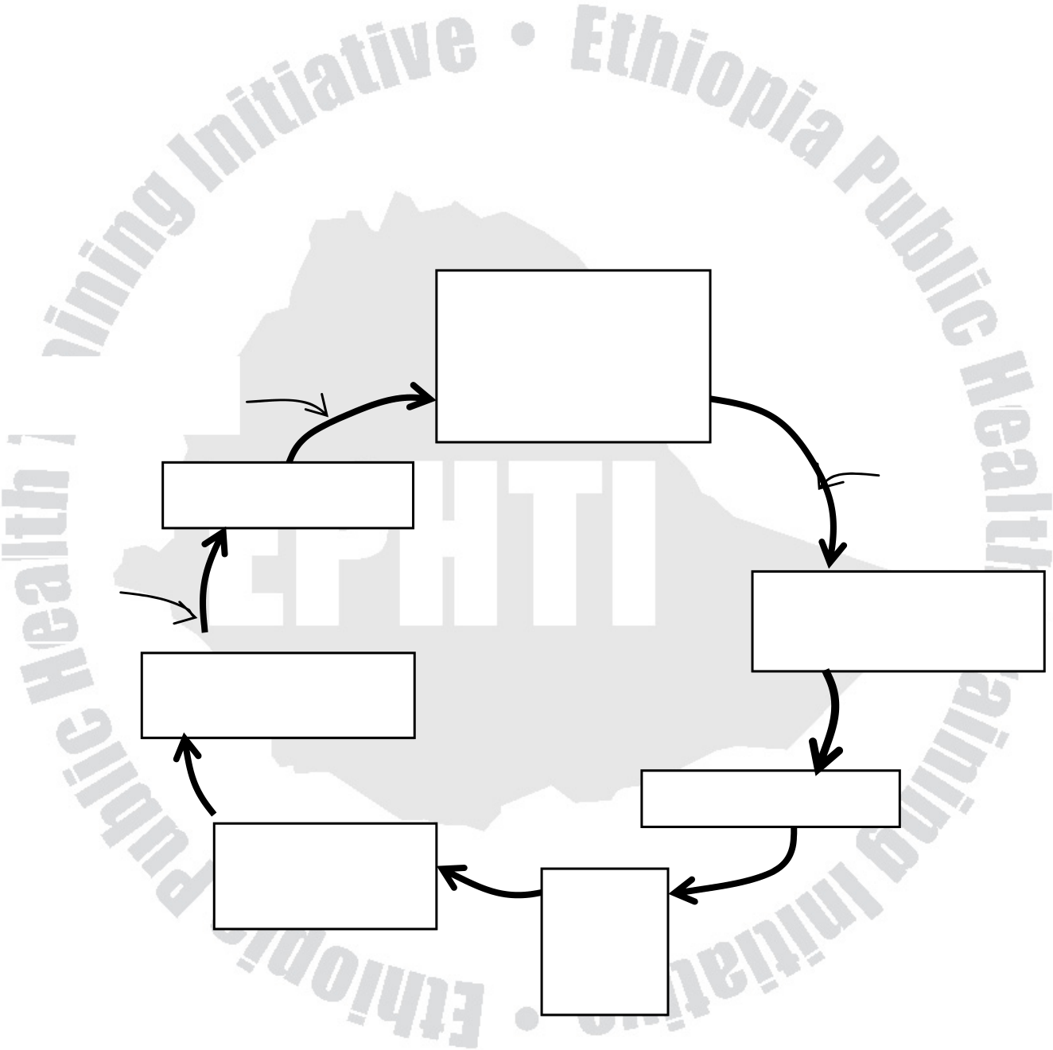
realize that you are lost. Likewise, the starting point for health education program is the present health situation, e.g. level of immunization, family Planning coverage, malnutrition status, or sanitation, that you would like to improve to a better level, which is your destination. To do this, you must decide on a strategy - the methods you must use to improve the situation. At the end, you evaluate your program to find out if you have reached your target - or have got lost!
Assessresource | Selecting  appropriate methods | Develop
Set Objectives | Selecting  appropriate methods | Develop
Set Objectives | Selecting  appropriate methods | indicators
Prioritize | Selecting  appropriate methods | Carry out the  project
Define problems | Selecting  appropriate methods | Carry out the  project
Evaluate
Information  gathering | Re-  plan
Fig. 6.1 Project Planning Cycle
96

Steps in Planning
1. Information gathering
A good way of finding out the present situation is to carry out a community profile or diagnosis. Following are some types of information, which may be helpful in understanding the community and its health problems.
1.1. The community and its general physical characteristics
Efforts in health education must be based on a clear understanding of the community and its problems. These include:
• The size of the community
• The kind of crops, food, natural resources existing
• The transportation routes
• Localization of existing schools, religious institutions, market places, recreational facilities, health facilities and other public and private services.
1.2. Information on the number of people and their characteristics - may be from available records.
• Number of people who live in the area
• Their sex and age group
• Average size of a household
97

• Average number of pregnancies, children alive, and children
died in the last one year.
• Literacy status of the adults
1.2. Community groups and their impact on the health care system
• Learn the existence of various social groups and the nature of
relationships both within and between those groups. E.g. Ethnic
class, religious groups etc.
1.3. The communication network
To reach the people in the community, it is necessary for you to know
how information and rumors spread within the community.
• What the formal and informal channels are
• Who the participants in those channels are
• Who the communicators are and how effective they are
• Learn how various leaders communicate their ideas and
opinions and note to what extent their messages are accepted.
A good way to gather this information is to observe where people
gather and listen to the types of information that is spread. You can
also attend meetings, festivals, and religious gatherings. You can
spend time socializing with women in the market or at village wells, or
you can ask people to whom they would go for advice on health
98

matters and to whom they feel comfortable giving advice or forwarding news.
1.5. The family structure
As we look about a society, we encounters good many differences in the ways in which families are organized. Families vary in their composition and in their descent, residence and authority patterns An understanding of the family structure, the status of various members of the family and who is involved in the decision-making process within the family on all major decisions as well as those related to health is valuable to work with community.
Without this knowledge, you may direct your educational activities toward the wrong member of the family.
1.6. The political structure in the community
• Explore the basis for leadership and power within the community.
1.7. The economy and its impact on health
• Know about businesses, industries, agricultural conditions, unemployment, family debts, and how the land is distributed. This information will increase your knowledge of what is important to the people and what resources are available to them.
99

1.8. Religion and its impact on health
Religion may have a great influence on the lifestyle of the community including the health practices and beliefs of individuals. A mother may believe that her child is sick because it is GOD’S desire. It is important, therefore, to know:
• Who the major religious groups in the community, their leaders & their roles in the community life
• Whether there is any conflict between them
• The attitude of the government and the community to wards religious affiliated programs.
1.9. Health beliefs and practices
• How people define good health and disease
• Some people may believe that prevention of illness is impossible, or very difficult
• | Others may value only a particular method. |  |  |  |  |  |  | as
• |  |  |  |  |  |  |  | as
• | What methods are used to help maintain their health? |  |  |  |  |  |  | as
• | What | are | people’s | attitudes | towards | such | services | as
vaccinations, Family Planning, insecticide spray etc.
• What are local attitudes and practices regarding personal hygiene?
• Are there special beliefs concerning food? When child is ill, for pregnant ladies etc.
100

• Breast feeding and weaning practice for infants
• Where do most women give birth? Who assists in delivery?
• What methods are used to cut the umbilical cord?
• Are mothers confined in darkroom after delivery?
• Sources of water, excreta disposal, do they know that certain diseases may be contracted through human feces?
All the above information could be gathered using formal and informal ways of obtaining information. Informal ways include, observing and talking to people, and reading reports, official documents and newspapers. Common example for formal method is conducting surveys using structured questionnaires.
2. Defining and prioritizing problems
The first requirement in bringing about change is to agree that there is a problem and that something should be done about it. Defining of specific health problems must involve the community members. Ask questions in an attempt to find out how they view the health situations. Start from the general and work down to the specific problems you have in mind. For example, if you found a very unsanitary environment in your survey of the community you might contact the leaders and proceed as follows:
• What needs to be done in this village to improve their life?
• What are the illnesses most common in this village?
101

• What is the extent of the problem? How bad is the situation?
• What do people die of? Which groups or individuals are most affected?
• Do they have diarrhea, febrile illnesses, or worms in this village? What causes these illnesses?
• Are there any latrines in the village? What do people use?
• Has any thought been given to building latrines?
• Why some people refuse to use them?
• Do people in the village plan together to get rid of these problems?
At times, your priority problem may not coincide with the felt need of the community. For example, your own analysis may indicate that improved sanitation is most needed but the community may feel that they should first improve their road so that they can market what their produce. In such cases, you cannot neglect the need of the community if you anticipate good community participation and establish sustainable project. In the above case you need to talk to the concerned offices and community leaders and convince that helping to meet the community’s goals will make it easier for them to try to improve their environment. Perhaps the community will agree to get aside money generated from their marketing for sanitation.
102

Generally, whenever people come up with multiple needs, the following four questions can help them see their problems more clearly and make their choice of priorities easier.
• Which is the most serious problem?
E.g. Lack of food to eat by a family.
• Where does the greatest future benefit lie?
E.g. skills training for unemployed.
• What needs can be met with the resource available? E.g. purchasing inexpensive, yet nutritious foods available at the local market.
• Which are the problems of greatest concern to the people? E.g. A health post compared to a school.
3. Setting goals and Objectives
For a program to succeed, we must know clearly what we want to do and how we are going to do it. After people have decided upon their priority needs, they must spell out exactly what they want, i.e. their objectives.
An Objective is a statement of proposed change over a fixed time period. It should be measurable, relevant and possible to achieve. It has to describe:
• What you want to change?
103

• How much change you want?
• For whom or for what you want the change?
• When? By what time or date?
Types of objectives in health education
1. Health Objectives
If measles is a serious problem in a community, a primary health care
program to solve the problem might have the following as its health
objective.
• Fewer children will get measles
• Those who do get measles will recover quickly and suffer no
disabilities
• No children will die from measles.
2. Educational Objectives
Since people’s behavior affects their health, there will be certain
actions that people must carry out to solve their health problems.
Such are educational objectives of a program. Some examples of
educational objectives for a program against measles include:
• Mothers will bring their children for immunization
• Mothers whose children get measles will bring them quickly to the
health worker for care.
104

• Children who get measles will be fed as well as possible to help them recover more quickly.
4. Identifying and Obtaining Resources
4.1. Resources inside the community
It is best to find resources inside your community for two reasons: For one thing, it saves money. More importantly, people are proud to be able to help themselves, which in turn encourage people to try to solve more problems by their own efforts. Some of them include: • Places to hold meetings, discussions, and trainings, such as schools, and halls
• Some people may be able to donate money to buy materials. • Some have skills to contribute, e.g. carpenters, teachers, masons, artists, traditional healers, weavers and potters
• Many can provide labour.
Some may support transport: bicycle, motor cycle or vehicle •
4.2. Resources outside the community
If resources within are not adequate one may seek from outside: • Some agencies and ministries can donate funds
• People with special skills, such as finding under ground water for wells, may come from outside.
105

• Educational materials such as films and posters could be given from outside agencies.
Health education Resources
Local Media
One should be able to identify local and traditional means of communication such as proverbs, stories, and fables, which elders use to pass traditional values on to the young.
• Local leaders may use village criers or bell-ringers to announce upcoming events.
• Traditional songs or plays may communicate important ideas and values.
• Local artists, printers, and photographers can be involved in designing, and producing educational materials.
Outside sources
• These may include mass media such as newspapers and radio.
• Ministries of health and information could supply or loan films, posters, and vans with loudspeakers.
• A local school teacher who is a subscriber of newspaper can use to teach pupils and inform parents.
106

5. Selecting appropriate Methods
It is not enough to decide what will be done, by whom and when, we
also need to decide how it will be done.
Once a health worker understands the reason behind behavior that is
causing a health problem, he or she can use many different methods
to encourage a change in that behavior. Generally, there are some
basic issues to consider before choosing health education methods:
• How fast do people change?
• How many people are involved?
• Is the method appropriate to the local culture?
• What resources are available?
• What combined methods are needed?
• What methods fit the characteristics (age, sex, religion etc) of the
target group?
5.1. How fast do people change?
• Some people are ready for change and are economically able to
do the advice easily. For such people provision of information
107

through posters, radio, songs, plays, stories or displays could suffice.
• Some are ready but influence from others could hinder. Direct contact with such people is the preferred method. E.g. convincing grandmother for immunization.
• For those who are economically unable, linking them with sectors that help them earn money is a remedy
5.2. How many people involved
Providing good ideas quickly to a large number of people is a very helpful step in health education. It creates awareness of a problem or idea. But it may not be enough to change health behavior. Posters, lectures, display, plays, newspapers, radio, films and village criers are appropriate for large groups.
Activities such as practicing new skills, discussing personal feelings, values and money matters, and sharing difficult experiences are best done person-to-person, or in small groups using story-telling,
demonstrations, | role-playing, | case | studies, | discussions | and
educational games.
5.3. Is the method appropriate for the local culture?
From the Previous sections, we know that culture is the way of life of people in a community. Culture will determine the educational 108

methods that will be acceptable and understandable to people. Some methods may not be accepted in one culture while it may be effective in the others. For example Role-playing, photographs, or films may not be adaptive to illiterate community. In such communities we can use the most natural way of communication such as proverbs, village criers, plays, songs and so on.
Practical demonstrations are good ways of teaching skills. For example, instead of just talking about hygiene, a health worker can show mothers how to bath their babies. This would motivate and enable them practice in the future.
5.4. What resources are needed?
Some methods require the use of machines: tape recorders, films or slide projectors, which at the same time require electricity. Other methods require the use of teaching aids such as posters, flannel graphs, demonstrations, models, flip charts and the like. On the other hand, some methods require only yourself and the people around you; these include the use of stories and songs, role-plays, group discussions, and community meetings.
Therefore, try to look for methods that are inexpensive, culturally acceptable, understandable, and at the same time effective.
5.5. What combined methods are needed?
109

Ideally, use of mix of methods and repetition improves understanding and people are more likely to remember them. The following combinations may be used:
• Story telling and asking the audience to role-play in which they act out the story for all to see.
• Lecture assisted with posters, films or demonstrations.
• Community meeting with displays or short play.
5.6. Which methods fit the group best?
Health education could be designed for various groups of people: old, young, women groups, children and so on. Select and adapt your methods to fit the type of people you meet.
Fables using animals might be better for children than for adults. Lectures are more applied for educated. If the people belong to one religion, select proverbs from the scriptures on books of that religion.
B. Carry out and Evaluate the Program
1. Development and implementing a program
After having analyzed the situation, define problems, prioritize and set objectives, identify resources, and design strategy, the health extension workers and health committee should be able to develop an action plan. A plan of work is a picture or “map” of what to do, when to do it, who will do it, and at what cost each step of activities 110

be accomplished. It will serve as a guide and will help in implementing and evaluating the project and planning another one.
The Plan of Action should include:
• Goal and objectives
• What steps are to be taken - list of activities
• Who will be responsible for each step - person in charge
• What materials, equipment, people, funds will be necessary for each step - resources
• When each step is to be completed - target date.
2. Evaluating the program
Evaluation is the process of looking back over what has been done to be sure that things were done the way they should. Evaluation is not a one-time event. It is a continuous process how the program is progressing according to a set time table in the action plan. Information for evaluation program would be obtained from observations, interviews, and records.
Following each step or activity, ask questions such as:
• How well did we do?
• Did the plans work?
111

• Why did we succeed? Or fail?
• What do we do next?
• Did we learn from our mistakes or successes?
By the end of the educational activities, you should be able to
measure their successes by counting how many people are behaving
according to the original objectives: is this number more than before
the program started?
At the end of the program, a final meeting can be held to discuss how
far the program succeeded.
Changes in attitude may be assessed by answering the following
questions:
• Did people participate in the project as expected?
• Did people gain new skills and learn from the program?
• Was there less opposition by groups in the village who had
previously been against the program?
Changes in behavior:
• People disposing of feces and urine in latrines
• People using clean bucket for gathering water
• Increased in visits to the health post.
• Increased in the number of children immunized
• Increased number of pregnant women seeking early prenatal
care.
• Increased in the number of births that occur in the health facilities.
112

Exercise
1. Explain how to define and prioritize problems
2. If malaria is a problem of the area you are working, what will be your educational objectives as part of the control program? 3. How do you get information to evaluate a certain health education program?
113

UNIT EIGHT
Ethical Issues In Health Education
Objectives
At the end of this chapter, the trainees will be able to:
• Define ethics
• State basic principles of ethics
• Describe the responsibilities of health extension workers to
community.
• Describe the responsibilities of health extension workers to the
health extension package.
Introduction
From a profession point of view, ethical behavior is expected from
professionals. Ethical conduct is particularly important for health
educators, since they are working with a mission to serve the
individual. This chapter will try to address:
Definition
114

Ethics is the philosophical study of the moral value of human conduct and the rules that govern it. It is the right thing to do for society and self. Moral refers to those beliefs about how people ought to behave.
Basic ethical principles
1. The principle of autonomy
This principle means that people, being individuals with individual differences must have a freedom to choose their own ways and means of being moral with the framework of the other four principles.
Respect for autonomy involves respecting another persons rights and dignity such that a person reaches a maximum level of fulfillment as a human being. In the context of health promotion and health care this means that the relationship between health extension worker and community member is based on a respect for him or her as a person and with individual rights.
Rights in relation to health care are usually taken to include:
• The right to information
• The right to privacy and confidentiality
• The right to appropriate care and treatment
2. Beneficence (doing good)
115

Beneficence means doing or promoting good as well as preventing, removing and avoiding evil or harm.
E.g. provide information about emergency first aid to reduce the risks of HIV infection or accident.
3. Non-maleficence (doing no harm)
Non-maleficence holds a central position in the tradition of medical ethics and guards against avoidable harm to subjects. In short, it refers to non-infliction of harm to others. E.g. use of sterile needles.
4. Justice (fairness)
This principle states that human being should treat other human being fairly and justly in distributing goodness and badness among them. In other words justice should include:
• Fair distribution of scarce resources
• Respect for individual and group rights
• Following morally acceptable laws
5. The principle of truth telling (honesty)
116

At the heart of any moral relationship, there is communication. A necessary component of any meaningful communication is telling the truth, being honest.
Ethics for the performance of health extension workers as health educators
Health extension workers as health educators assume profound responsibility in using educational processes to promote health and influence human well-being. They are also responsible for the implementation of health extension package program. Ethical precepts that guide these processes must reflect the right of individuals and communities to make decisions affecting their lives.
Health extension workers responsibilities as a health educator
• Affirm an equal right, believing that health is a basic human right for all.
• Provide people with relevant and accurate information and resources to make their choices freely and intelligently.
• Support change by freedom of choice and self-determination, as long as these decisions pose no threat to the health of others.
• Be advocates for healthful change and legislation, and speak out on issues deleterious to public health.
117

• Avoid and take appropriate action against unethical practices and conflict of interest situations
• Respect the privacy, dignity and culture of the individual and community and use skills with these values.
• Share their skills, experience and vision with their clients and colleagues.
• Observe principles of informed consent and confidentiality of individuals.
• Maintain their highest levels of competence through continued study, training and research.
• Accurately represent their capabilities and education as well as training and experience and act within the boundaries of their professional competence;
• Ensure that no exclusionary practices be enacted against individuals on the bases of sex, marital status, color, age, social class, religion, ethnic background, national origin, or other nonprofessional attributes in rendering service, employing, training, or promoting others.
118

Exercise
1. Mention basic principles of ethics
2. What are your responsibilities to the community as a health educator?
119

References
1. John Hubley. Communicating Health, An action guide Health Education and Health promotion, 2002.
2. WHO, Education for Health. A manual on Health Education in Primary Health Care, 1988, Geneva, WHO.
3. Jannie N., Jane W. Health Promotion Foundations for Practice, 2nd edition, UK, 1995.
4. LRamachandran, TDharmalingam. Health Education, A new approach, New Delhi 1998.
5. EPHA. Public Health Code of Ethics for Ethiopia, July 2003. 6. Ayele F., Argaw H., G/Mariam A., Kaba M., T/Mariam S.
Training of Trainers Guide on Communication and Social Mobilization for Health Communicators, Jimma Institute of Health Sciences, Department of community, Jimma, Ethiopia, 1997.
7. Reidulf k.Molvaer. Education for Better Health: A manual for senior Health Educators, UNICEF/MOH Addis Ababa, Ethiopia, 1989.
8. Peace corps Information collection and Exchange manual M-8, 1978. Community Health Education in developing countries; prepared by American public Health Association, September 1981.
9. Urban Jonsson. Human rights Approach to development programming, published by UNICEF, 2003.
120

10. Getnet Mitike. Health Education for Health Science students, Addis Ababa University, Department of Community Health, January2003.
11. Challi Jira, Amsalu Feleke, Getnet Mitike. Health service management for Health science students, Jimma University, Faculty of public Health, 2003 January.
12. Randall R. Cottrell, James T. Girvan and James F. McKenzie.
Principles | and | foundations | of | Health | Promotion | and
Education. Publishers: Allyn and Bacon, 1999.
121

