MSE800 Professional Software Engineering
Ako: UI design document
Low-fidelity wireframes, visual style and screen notes for all 17 user stories
Status: draft for team review, 19 October 2026. Based on the user stories of 19 October (17 stories, 61 story points, owners and sprints as in the Scrum Plan) and the requirements specification. Screens for stories planned for later are marked "Later". Wireframes show layout and content, not final colours or graphics. Names and dates in the examples are made up.

1. Purpose and scope
This document shows what Ako looks like and how people use it. Developers use it to build screens that match, and testers use it to check the acceptance criteria on each user story.
- In scope: every screen needed by the 17 user stories (US-001 to US-017), with wireframes, numbered parts, messages and states.
- MVP: US-001, 002, 003, 004, 005, 006, 008, 014 and 015 (Sprints 1 to 3, 31 points). Screens for US-007, 009, 010, 011, 012, 013, 016 and 017 are designed now and built later if time allows.
- Not in scope: a mobile app, learner accounts, advance enrolment, class groups, a learner timetable, exams and pronunciation scoring. Photos of learners are never shown.

2. Users and devices
User | Device | What they need from the screens
Volunteer teacher | Laptop or desktop browser at the library. Some have no smartphone and some are older | Large text, few steps, everything visible without hidden menus, printable pages
Coordinator (club lead) | Laptop or desktop browser | The teacher screens plus accounts, reports, learner import, correction of past attendance and review of Māori content
Newcomer (public page) | Phone, 360 px wide or more | Simple English, class time, place and contact in one look. No login
Learner (later) | Own phone camera and browser | Scan a code, type a name, see the day's files. No app and no account. Learners walk in and are ticked by a teacher until QR sign-in exists
Visitor (public page) | Phone | Same as the newcomer above. Visitors never log in

Roles and permissions
Only coordinators and teachers log in. The table is taken from the roles page of the user stories. A "-" means the person cannot use the screen.
Feature (story) | Coordinator | Teacher | Learner | Visitor
Log in and out (US-001) | Yes | Yes | - | -
Manage teacher accounts (US-002) | Yes | - | - | -
Add and update learners (US-003) | Yes | Yes | - | -
Import learners from CSV (US-017) | Yes | - | - | -
Create class sessions (US-014) | Yes | Yes | - | -
Record attendance by hand (US-004) | Yes | Yes | - | -
Correct past attendance (US-015) | Yes | View only | - | -
View a learner's attendance history (US-016) | Yes | View only | - | -
Print or export attendance (US-005) | Yes | - | - | -
Create and edit lessons (US-006) | Any lesson | Own lessons | - | -
Search and copy lessons (US-007) | Yes | Yes | - | -
Flag Māori content (US-008) | Flags and records the review | Flags | - | -
Open check-in with a QR code (US-011) | Yes | Yes | - | -
Sign in by scanning the QR code (US-012) | - | - | Yes | -
See lesson materials (US-013) | Lesson library | Lesson library | After sign-in | -
View club information (US-009) | Yes | Yes | Yes | Yes
Register interest in classes (US-010) | - | - | - | Yes
View enquiries (US-010) | Yes | - | - | -

A teacher edits only their own lessons. A coordinator can edit any lesson, as the team confirmed on 19 October 2026.

3. Design principles
These come from the requirements specification (NFR-01, NFR-02, NFR-05, NFR-06 and NFR-10) and from what Julie told the team about her volunteers.
Principle | What it means on screen
Plain and large | Body text at least 18 px. Short sentences, no more than 15 words on public pages. One main action per screen
Works on paper too | Attendance lists, reports and the check-in code print on A4 in black and white
No smartphone needed for volunteers | Every volunteer screen works in a desktop browser. Learners without a phone are ticked by the teacher
Little personal data | Forms ask only for what the club needs. No date of birth, address, ID number, photo or ethnicity
Safe by default | Role menus show only what a role may use. Destructive actions ask for confirmation. Sessions with attendance are never deleted. Past attendance can be changed only by a coordinator, and every change is logged
Respect for te reo Māori | Macrons are shown exactly as typed. Māori content has a clear review label. Wording is agreed with a Kaiārahi

4. Site map and navigation
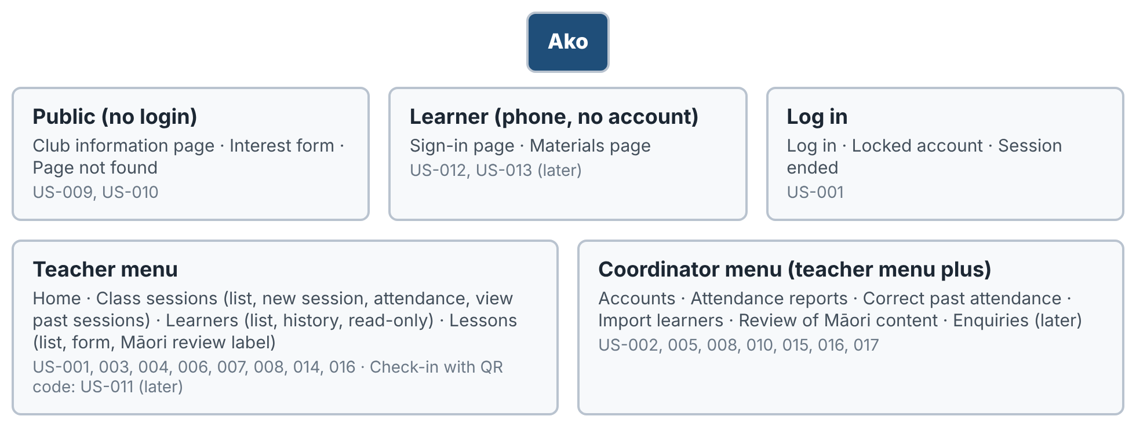
Figure 1. Site map by user group
Menu item | Teacher | Coordinator | Stories
Home | Yes | Yes | US-001
Class sessions (list, new session, attendance) | Yes (past sessions view only) | Yes (and corrects past sessions) | US-014, US-004, US-015
Learners (list, history, import) | Yes (history view only, no import) | Yes (and imports from CSV) | US-003, US-016, US-017
Lessons (list, form, review label) | Yes (own lessons) | Yes (any lesson, and records reviews) | US-006, 007, 008
Attendance reports | No | Yes | US-005
Accounts | No | Yes | US-002
Enquiries (later) | No | Yes | US-010

The menu bar is on every logged-in page. The current item is underlined and bold. A teacher who types the address of a coordinator page sees "You do not have permission" and no data.

Main flow
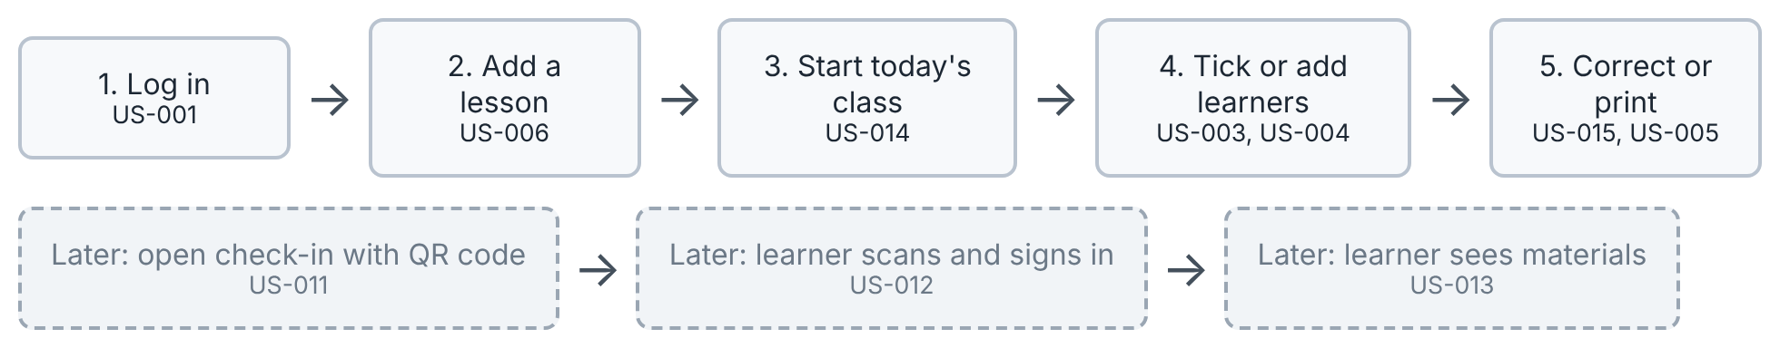
Figure 2. The main workflow. Grey dashed boxes are planned for later. Steps 1 to 5 are the first release

5. Visual style

Colours
Colour | Swatch | Used for | Contrast (needs 4.5:1)
Navy (main) | #1F4E79 | Menu bar, main buttons, headings | White text on navy 8.7:1
Ink (text) | #1C2733 | Body text | On white 15.1:1
Slate (secondary text) | #4A5A6B | Hints and captions | On white 7.1:1
Error | #FDE8E8 | Error messages, red border C0392B, text 7B1D14 | Text on pink 8.8:1
Success | #E4F4E8 | Saved and reviewed, green border 2E8B57, text 1B5A37 | Text on green 7.2:1
Warning | #FFF4D6 | Warnings and "not yet reviewed", border D79A00, text 6A4A00 | Text on cream 7.4:1
Information | #E8F0FA | Neutral notes, border 2F6EA5, text 173F66 | Text on blue 9.4:1

Colour is never the only signal. Messages also carry words, and the review label has text as well as colour.

Type, spacing and controls
Part | Rule
Font | Inter, or the system sans-serif font. Supports macrons (ā, ē, ī, ō, ū)
Sizes | Body 18 px. Page title 28 px. Section heading 21 px. Hints and table notes not below 14 px
Buttons | At least 44 px tall. Main action: navy fill, white text. Second action: white fill, navy border. Dangerous action: white fill, red border and text. A later feature is shown dashed and grey
Form fields | Label above the field, 44 px high, 2 px border. Required fields end with *. Hints go under the field
Tables | Header row shaded light blue-grey, rows at least 44 px high, text 16 px
Messages | Box under the field or button it belongs to: error (red), warning (amber), success (green), information (blue)
Labels and chips | Topic tags are blue outlined chips. Review status is a pill: amber "not yet reviewed", green "reviewed"
Layout | Desktop pages up to 980 px wide with a navy menu bar. Phone pages one column, 360 px wide, with no sideways scrolling
Print | White background, black text, no menu bar. Tables must fit A4 portrait without cut-off names

6. Screens
Each screen below shows the story it serves, a wireframe with numbered parts, and the messages the acceptance criteria require. Message text in quotation marks is shown exactly as written because the system is in English.

6.1 Log in
Stories: US-001 | MVP, Sprint 1
The first screen for volunteers. There is no sign-up link because coordinators create accounts.
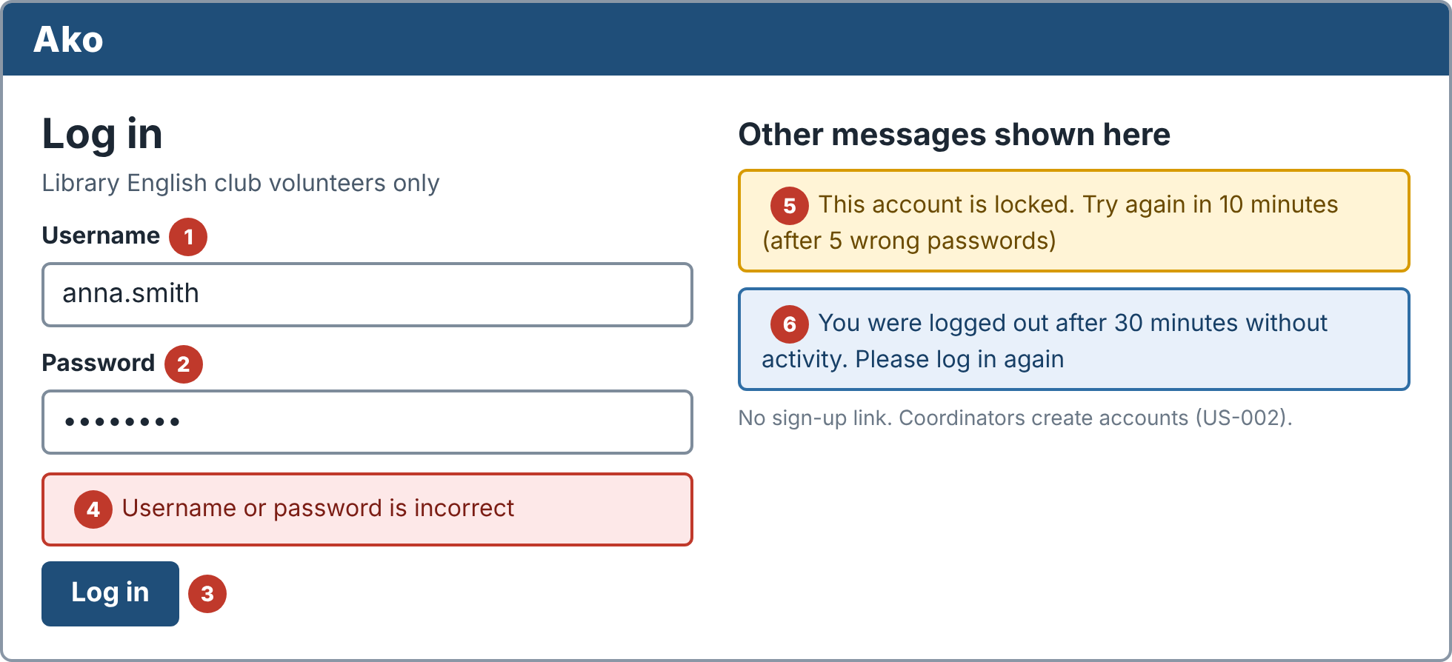
Wireframe 6.1
No. | Part | What it does
1 | Username | Text field, required
2 | Password | Hidden characters, required
3 | Log in | Opens the home page for the person's role within 3 seconds
4 | Wrong password message | "Username or password is incorrect". The person stays on this page. The message never says which part was wrong
5 | Locked account message | After 5 wrong passwords in a row the account is locked for 10 minutes. The message says when to try again
6 | Session ended message | Shown after Log out or after 30 minutes without activity

6.2 Home
Stories: US-001 (menus), US-014 (Start today's class) | MVP, Sprint 1
A starting page with one big action. It shows only what the person's role may use.
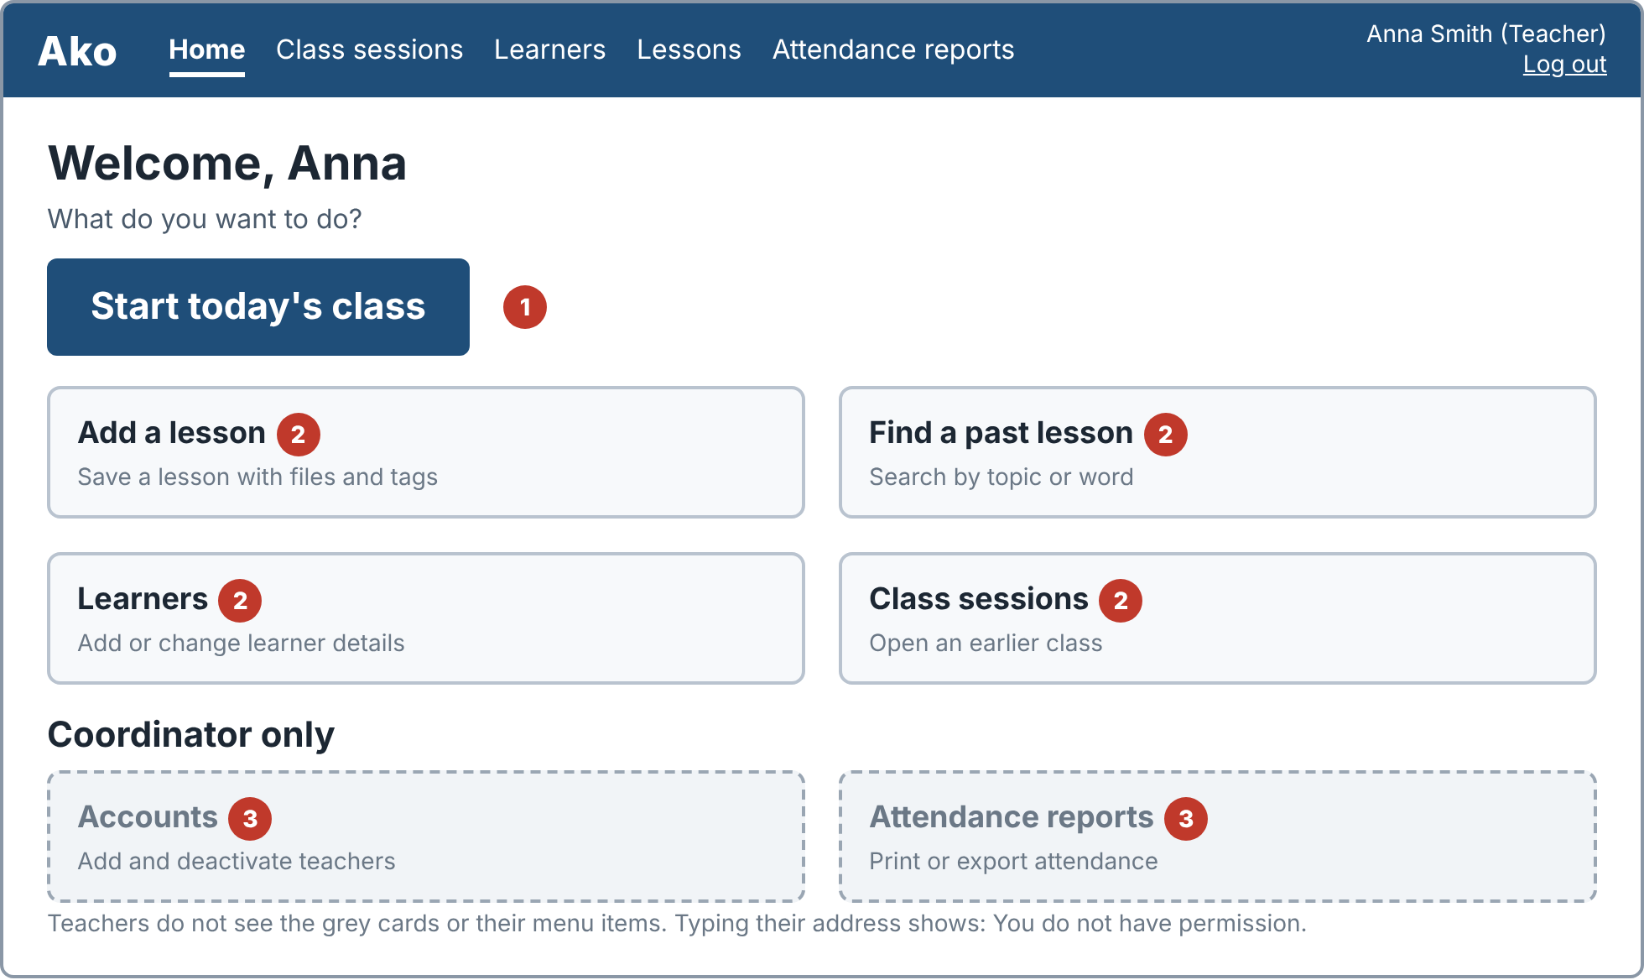
Wireframe 6.2
No. | Part | What it does
1 | Start today's class | The main action. Creates or opens today's session (see 6.5)
2 | Shortcuts | Add a lesson, find a past lesson, learners and class sessions
3 | Coordinator-only cards | Accounts and attendance reports. Teachers do not see these cards or the menu items

6.3 Teacher accounts
Stories: US-002 | MVP, Sprint 3
The coordinator adds, edits and deactivates teacher accounts. Accounts are never deleted, so past lessons keep their author.
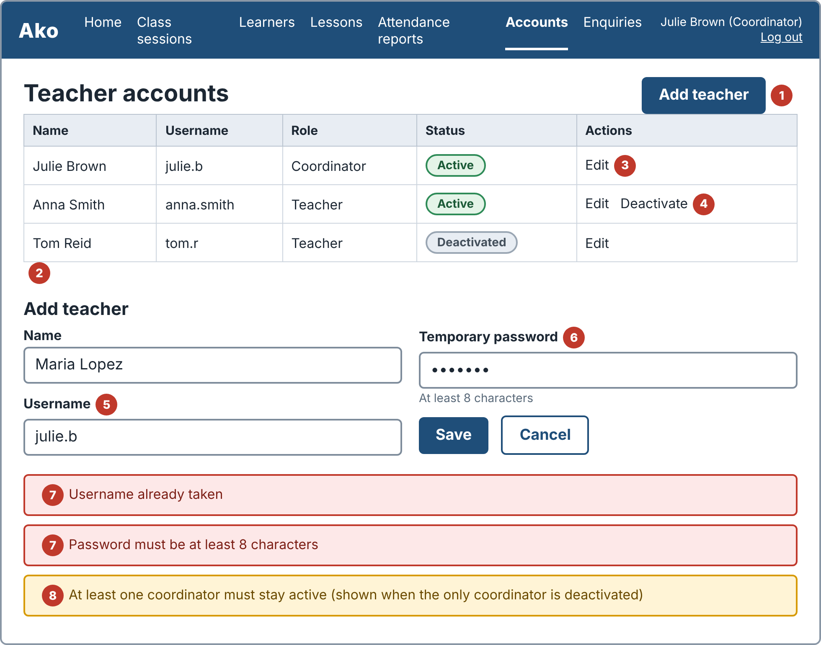
Wireframe 6.3
No. | Part | What it does
1 | Add teacher | Opens the form below the table
2 | Staff table | Name, username, role and status. Deactivated accounts are greyed with a grey pill
3 | Edit | Changes the teacher's name. The new name shows in the list after saving
4 | Deactivate | The teacher can no longer log in. Their lessons and attendance stay visible
5 | Username | Must be unique
6 | Temporary password | At least 8 characters
7 | Error messages | "Username already taken" and "Password must be at least 8 characters". No account is created
8 | Last coordinator message | Blocks deactivating the only active coordinator. At least one must stay active

6.4 Learners
Stories: US-003 | MVP, Sprint 1
Coordinators and teachers keep a minimal class list. Learners are added by hand, because the team uses made-up learners only. Only what the club needs is collected.
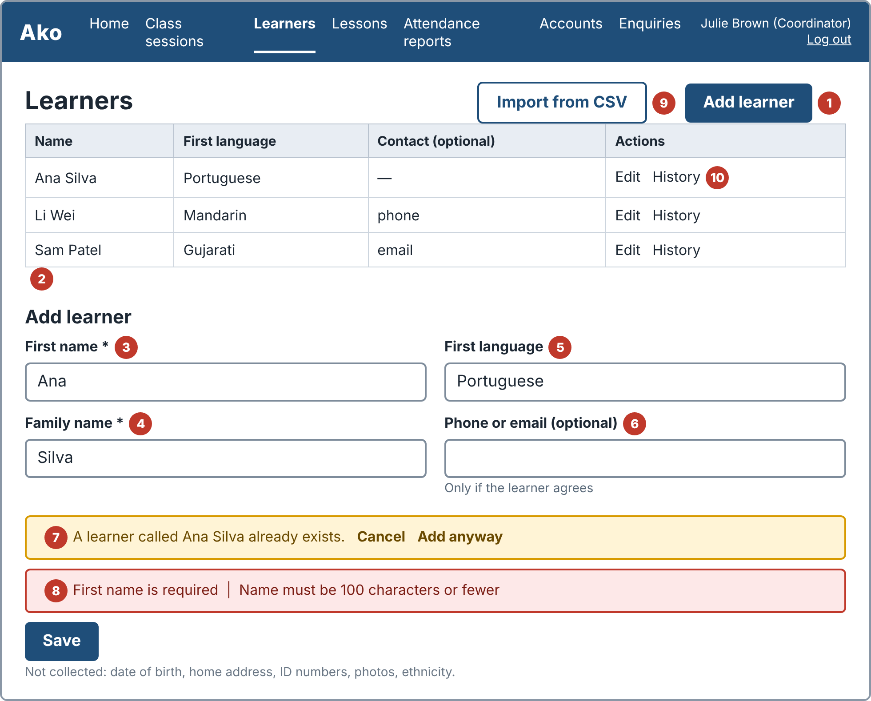
Wireframe 6.4
No. | Part | What it does
1 | Add learner | Opens the form below the table
2 | Learner table | Name, first language and optional contact, with an Edit action
3 | First name | Required
4 | Family name | Required
5 | First language | Free text
6 | Phone or email | Optional. The hint says it is only needed if the learner agrees
7 | Duplicate warning | Shown when a learner with the same first and family name exists. The teacher can Cancel or Add anyway, because two people can share a name
8 | Validation messages | "First name is required" and "Name must be 100 characters or fewer"
9 | Import from CSV | Coordinators only. Opens the import screen (6.18, later). Teachers do not see this button
10 | History | Opens the learner's attendance history (6.17, later). Teachers can open it but cannot change anything

6.5 Class sessions
Stories: US-014 | MVP, Sprint 2
A class session is one meeting on one date. Attendance is recorded against it.
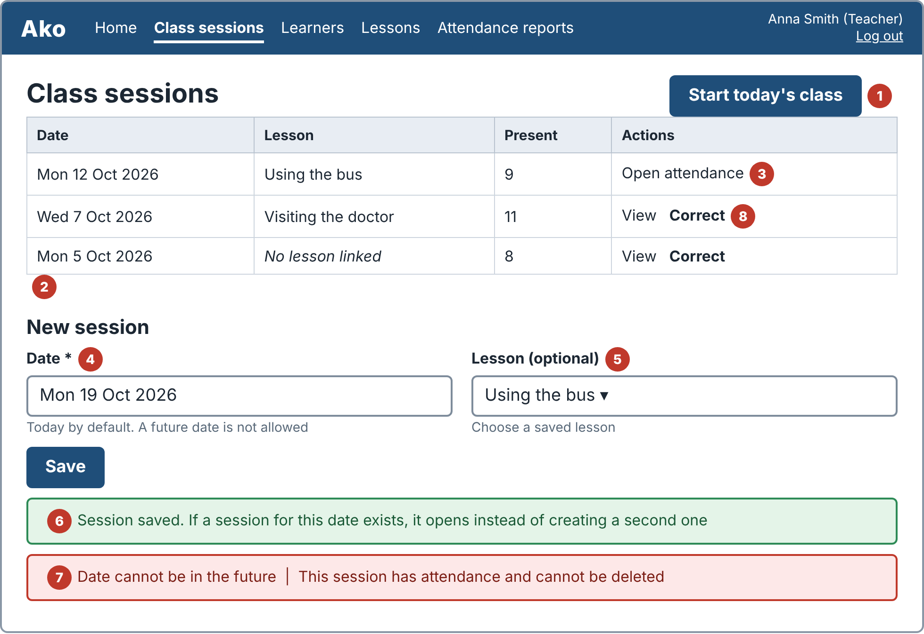
Wireframe 6.5
No. | Part | What it does
1 | Start today's class | Creates a session for today and opens it within 2 seconds. If today's session already exists, it opens that one
2 | Session table | Newest first, with date, linked lesson, present count and an action
3 | Open attendance | Goes to the attendance screen (6.6)
4 | Date | Today by default. A future date is not allowed
5 | Lesson | Optional drop-down of saved lessons. The session shows the lesson's title and the lesson itself does not change
6 | Success message | Confirms the session is saved
7 | Error messages | "Date cannot be in the future" and "This session has attendance and cannot be deleted"
8 | Past sessions | Teachers can only View a finished session. The coordinator also sees Correct, which opens 6.16. There is one session per class date and no class groups

6.6 Attendance
Stories: US-004 | MVP, Sprint 2
The teacher ticks who is here. This is also the way to record learners who have no phone once QR sign-in exists.
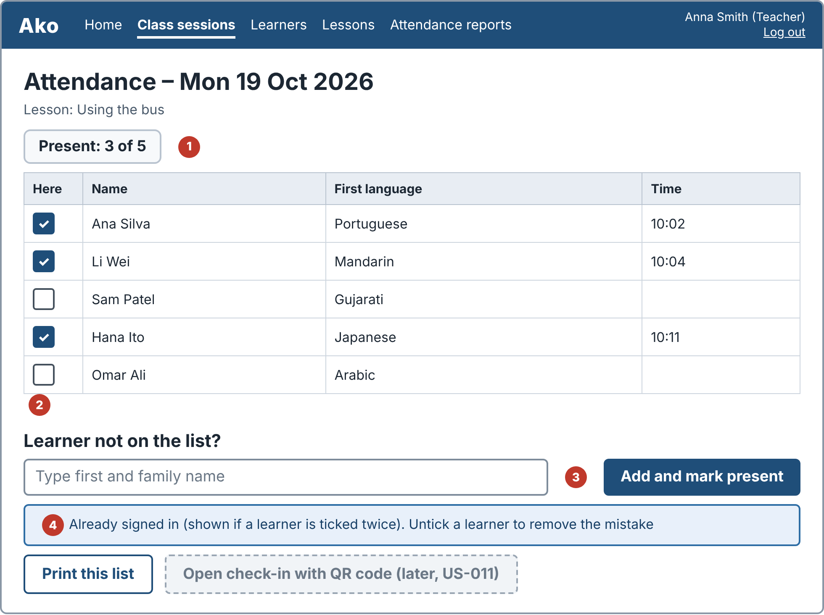
Wireframe 6.6
No. | Part | What it does
1 | Present count | Updates by 1 each time a learner is ticked or unticked
2 | Class list | Tick box, name, first language and time. Unticking removes the present record. A list of 50 learners shows within 3 seconds
3 | Add learner not on the list | Typing a name and choosing "Add and mark present" adds the learner to the class list and marks them present in one step
4 | Already signed in message | Shown if the same learner is ticked twice. No duplicate record is made

- This screen is for the class that is running. After the class ends, only a coordinator can change it (6.16).
- "Print this list" gives a printable A4 page.
- The dashed button for QR check-in is a later feature (US-011) and is not active in the MVP.

6.7 Attendance reports
Stories: US-005 | MVP, Sprint 3
The coordinator prints or saves attendance for a range of dates, so the club still has a paper record.
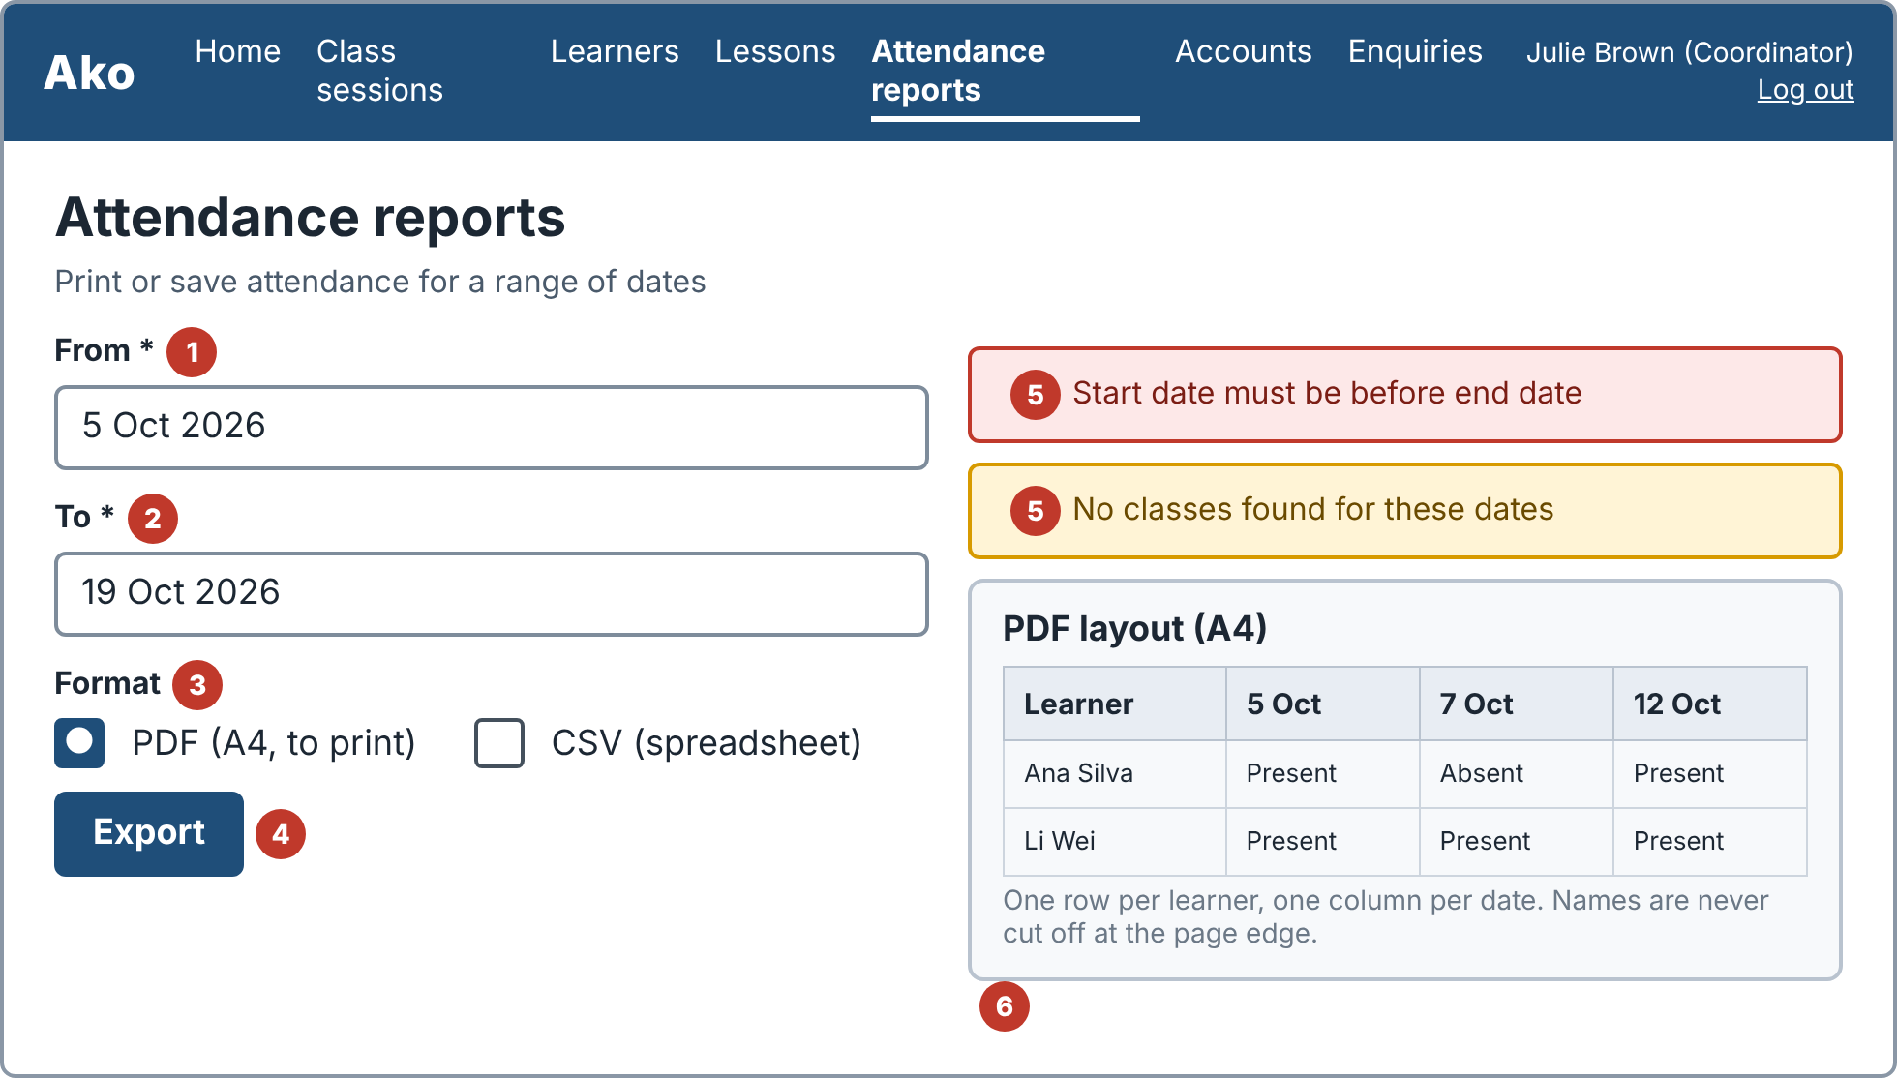
Wireframe 6.7
No. | Part | What it does
1 | From | Start date, required
2 | To | End date, required
3 | Format | PDF (A4, to print) or CSV (opens in a spreadsheet)
4 | Export | The PDF downloads within 10 seconds for 12 classes and 50 learners
5 | Messages | "Start date must be before end date" and "No classes found for these dates". No file is made
6 | PDF layout | One row per learner and one column per date, showing Present or Absent. No name is cut off at the page edge

6.8 Add or edit a lesson
Stories: US-006 (also US-008 and US-013 ticks) | MVP, Sprint 1
Teachers keep each lesson, its topic tags and its files in one place.
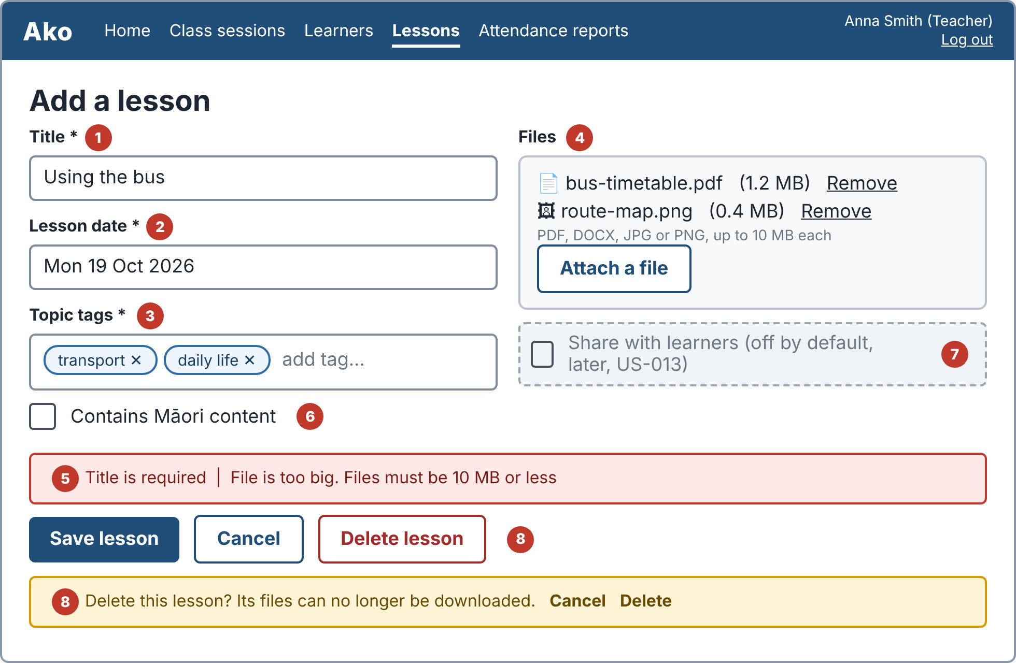
Wireframe 6.8
No. | Part | What it does
1 | Title | Required
2 | Lesson date | Required
3 | Topic tags | At least one, such as transport, health or shopping. The tag list is still to be confirmed
4 | Files | PDF, DOCX, JPG or PNG, up to 10 MB each. The file name stays the same when downloaded again
5 | Validation messages | "Title is required". A file that is too big or the wrong type is rejected with a message that states the rule, and the other details are kept
6 | Contains Māori content | Tick box. Adds the review label (6.10)
7 | Share with learners | Later (US-013). Off by default, so nothing is shared until a teacher ticks it
8 | Delete lesson | Asks for confirmation. After deleting, the lesson leaves the list and its files cannot be downloaded

6.9 Lesson library
Stories: US-007 | Later
Teachers find a past lesson and copy it as the start of a new one. This saves preparation time.
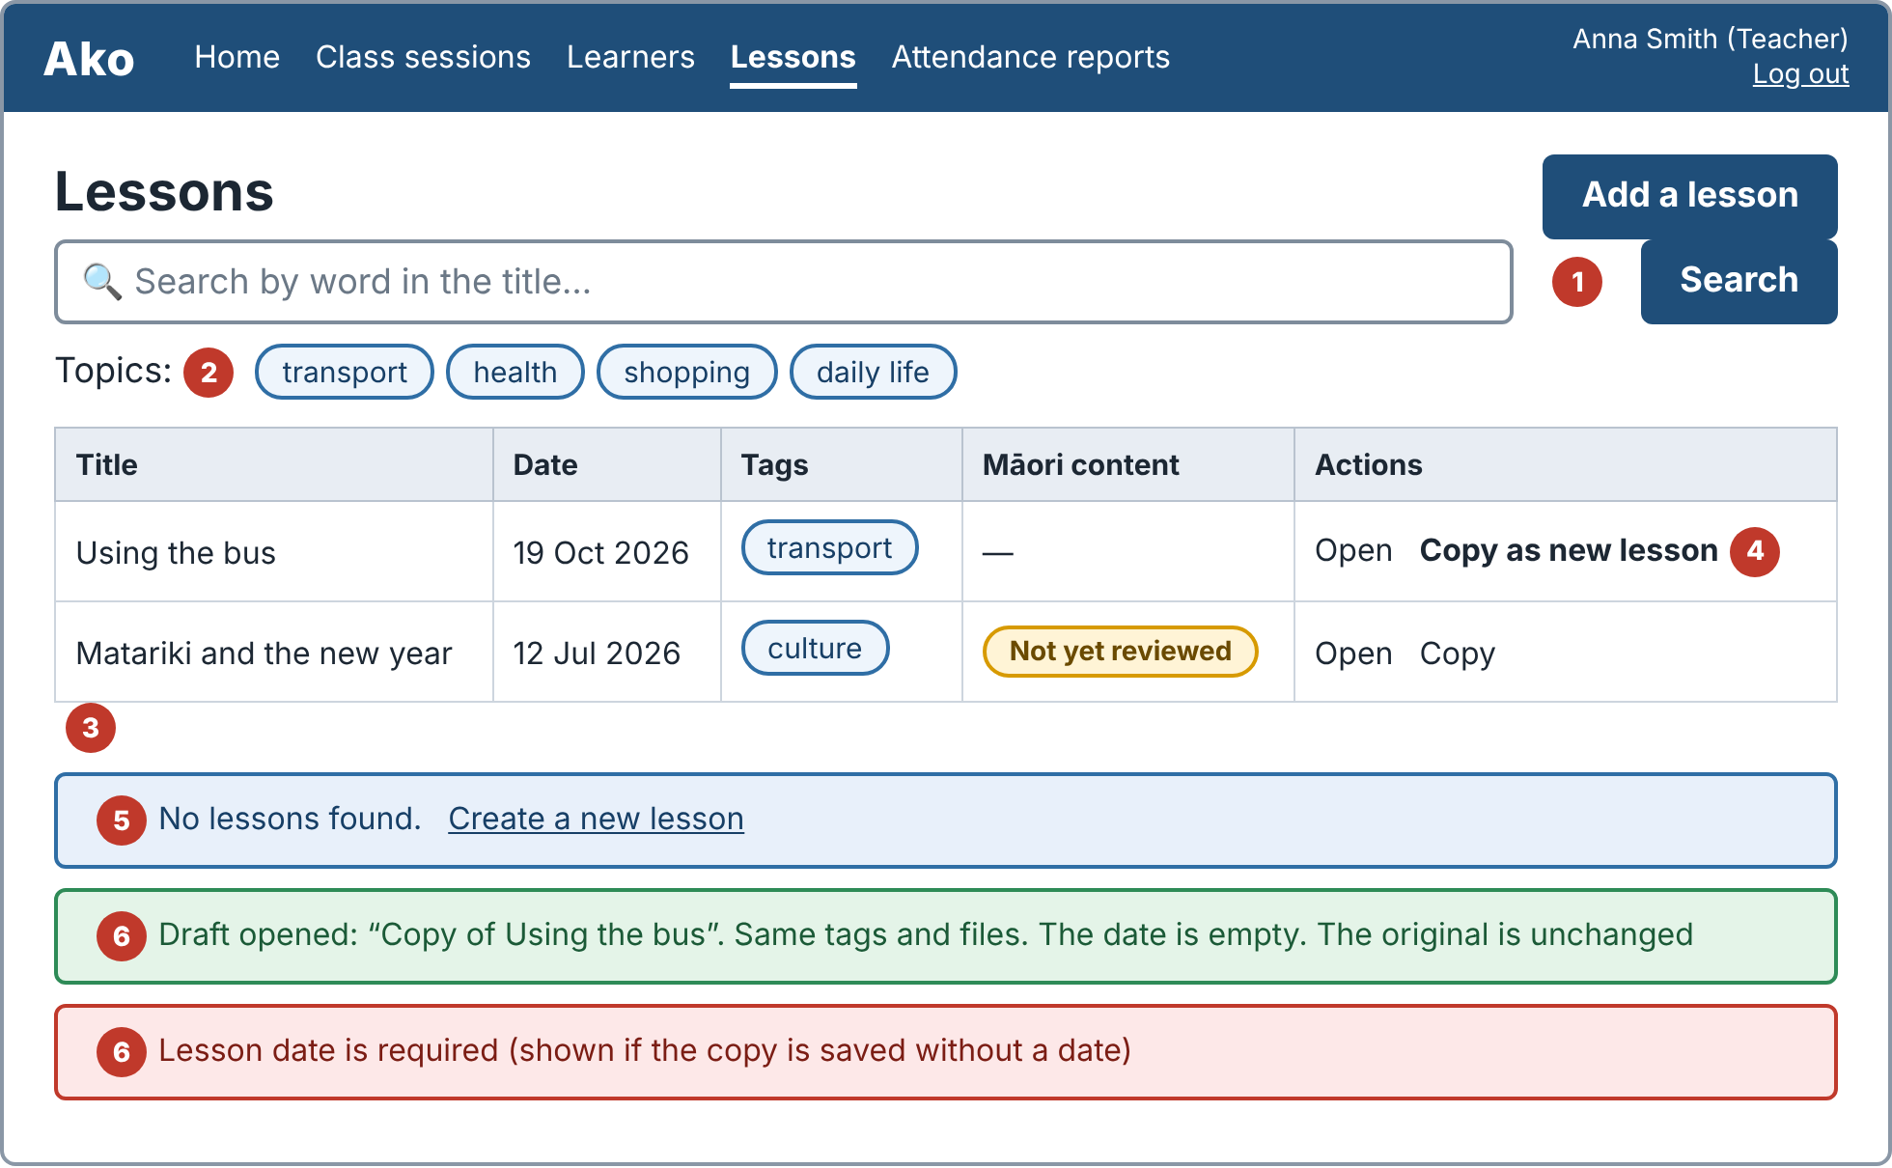
Wireframe 6.9
No. | Part | What it does
1 | Search | Matches words in the title, in any letter case, and shows results within 2 seconds
2 | Topic filter | Shows only lessons with the chosen tag
3 | Results table | Title, date, tags, Māori content label and actions
4 | Copy as new lesson | Opens a draft titled "Copy of ..." with the same tags and files, an empty date, and the original unchanged
5 | No results | "No lessons found" with a link to create a new lesson
6 | Copy messages | The draft needs a date. "Lesson date is required" is shown if it is saved without one

6.10 Māori content review label
Stories: US-008 | MVP, Sprint 2
Supports the Protection principle of Te Tiriti o Waitangi. The label and review step must be agreed with a Kaiārahi before they are final.
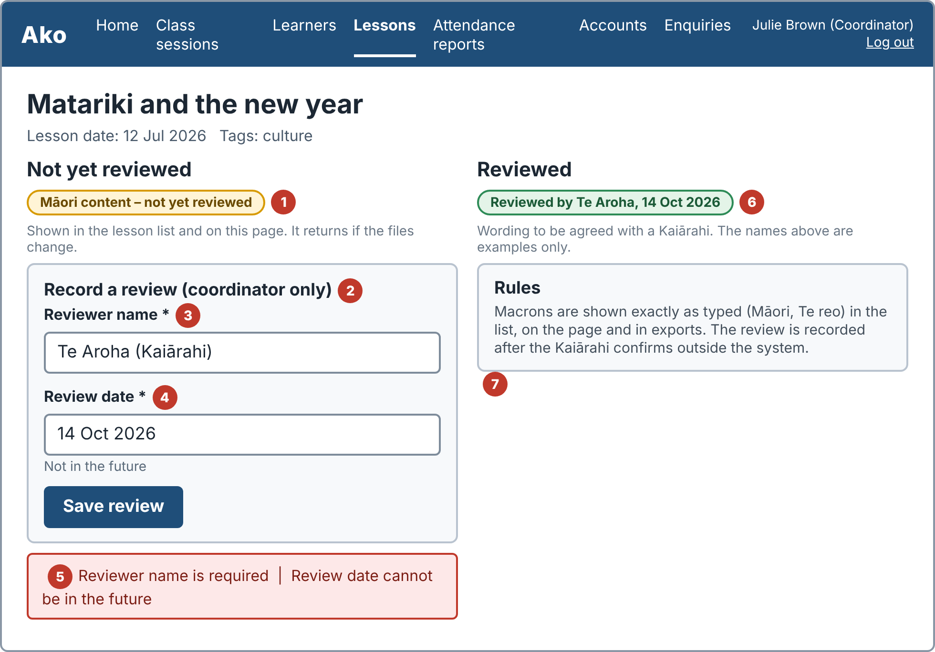
Wireframe 6.10
No. | Part | What it does
1 | Not yet reviewed pill | "Māori content – not yet reviewed". Shown in the lesson list and on the lesson page. It returns if the lesson's files change
2 | Record a review | Coordinators only. The review is recorded after the Kaiārahi confirms outside the system
3 | Reviewer name | Required
4 | Review date | Required and not in the future
5 | Review messages | A message is shown and the label does not change if the name is empty or the date is in the future
6 | Reviewed pill | "Reviewed by [name], [date]". The wording is a draft
7 | Rules | Macrons are shown exactly as typed in the list, the lesson page and exports

- The Kaiārahi consultation is still to be arranged. This document does not claim any endorsement.

6.11 Public page (phone)
Stories: US-009 | Later
A newcomer sees when and where the club meets and how to contact it. Day, time and place are sample text until the club confirms them.
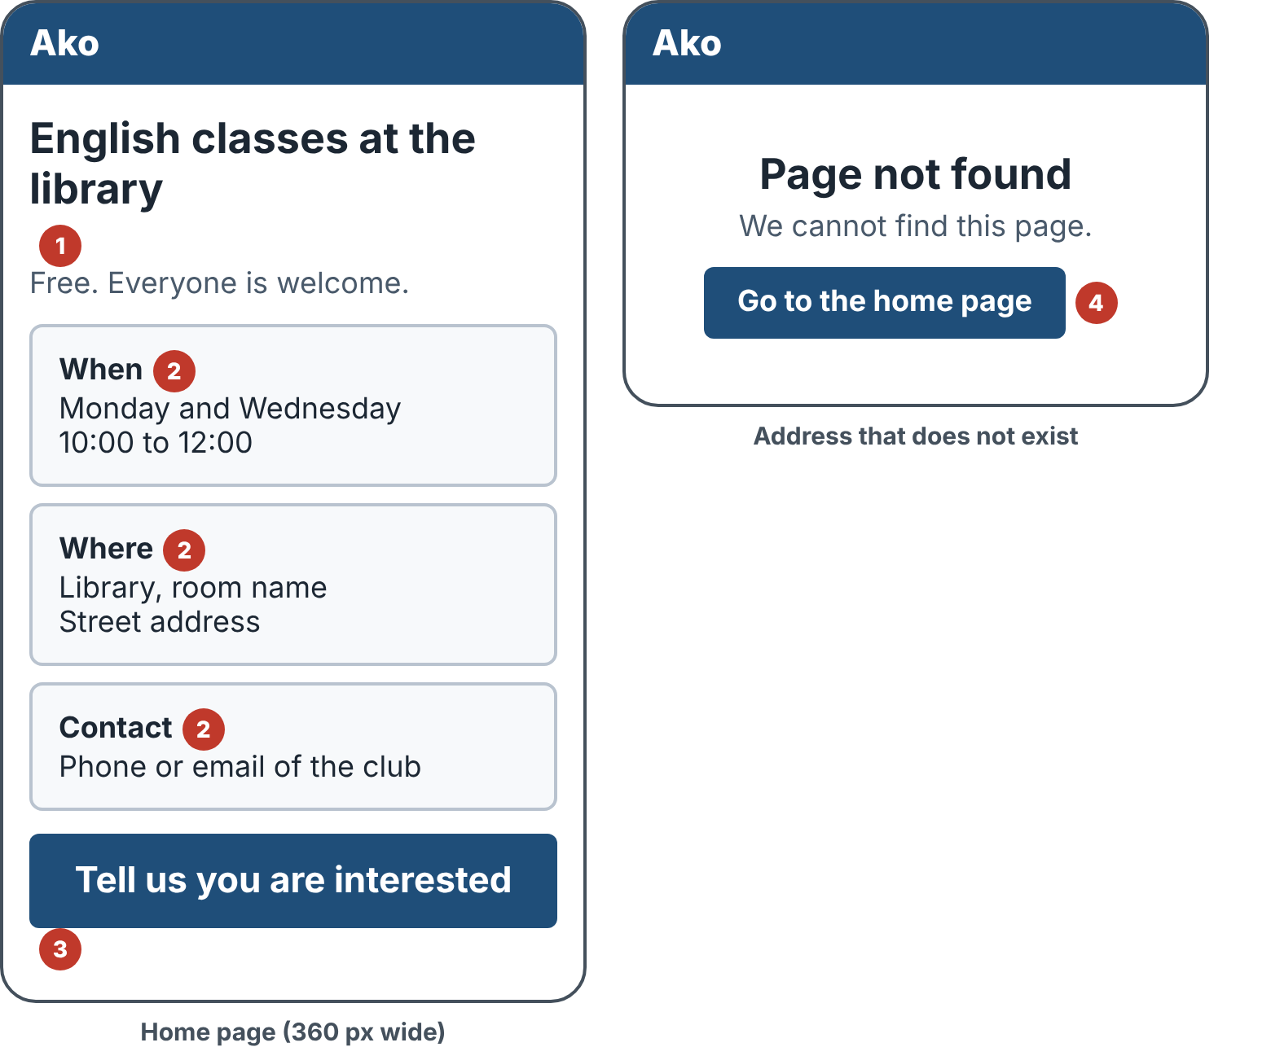
Wireframe 6.11
No. | Part | What it does
1 | Heading | Simple English. No sentence longer than 15 words
2 | Information cards | When, where and contact at the top of the page
3 | Interest button | Opens the interest form (6.12)
4 | Page not found | "Page not found" with a link to the home page

- No sideways scrolling at 360 px. Text at least 18 px, contrast at least 4.5:1, accessibility audit score at least 90.
- No photos of learners. Club contact details are shown only with the club's permission. Any "Kia ora" or te reo wording is checked by a Kaiārahi first.

6.12 Interest form and enquiries
Stories: US-010 | Later
A newcomer leaves a name and one way to be contacted. Only the coordinator can read enquiries.
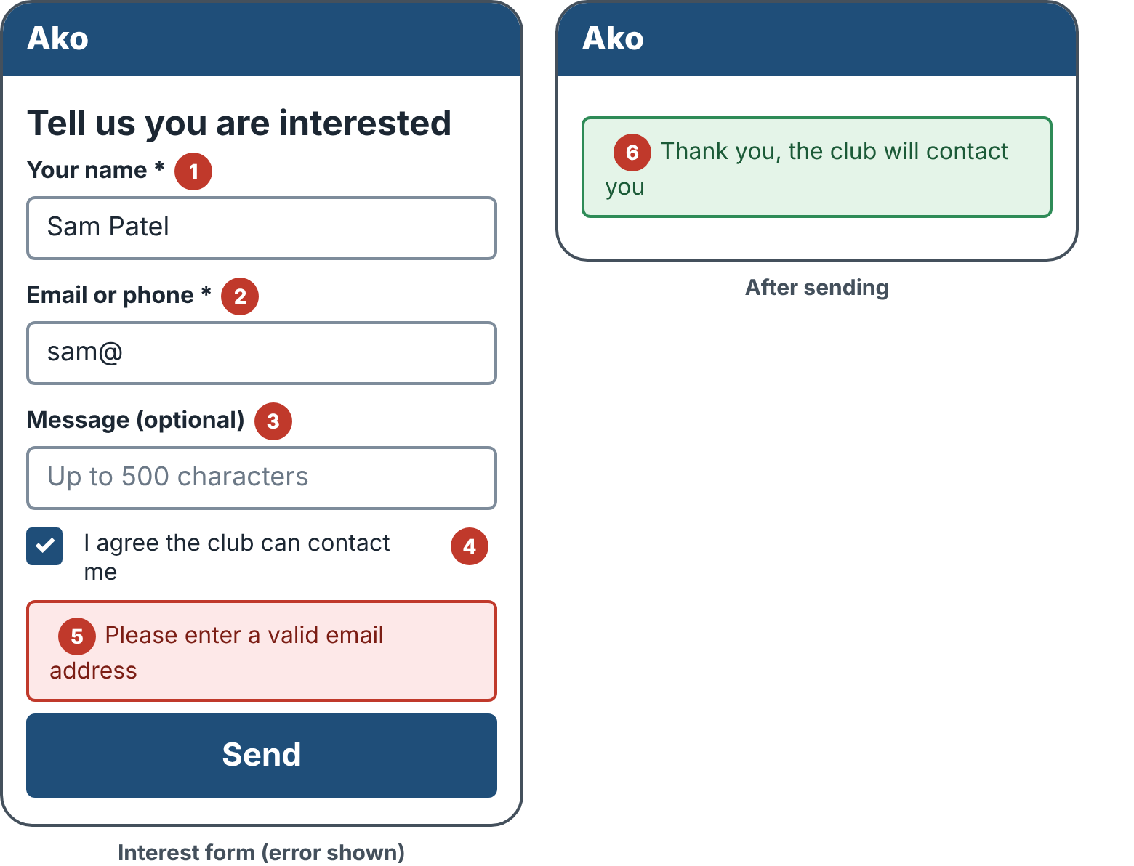
Wireframe 6.12
No. | Part | What it does
1 | Your name | Required
2 | Email or phone | Required. A bad email such as "sam@" is rejected
3 | Message | Optional, up to 500 characters
4 | Consent | Must be ticked before sending
5 | Invalid email message | "Please enter a valid email address". Nothing is saved
6 | Thank-you message | "Thank you, the club will contact you"

- Over 500 characters shows "Message must be 500 characters or fewer". An unticked consent box stops sending and the message explains why.
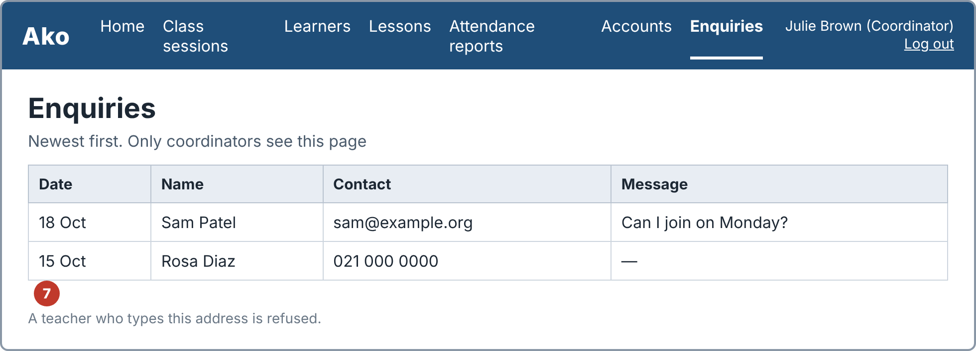
Wireframe 6.12 (coordinator view)
Enquiries page: the coordinator sees name, contact, message and date, newest first. A teacher who opens the address is refused.

6.13 Check-in with QR code (teacher)
Stories: US-011 | Later
The teacher opens check-in for a session and shows the code on a phone or screen, or prints it.
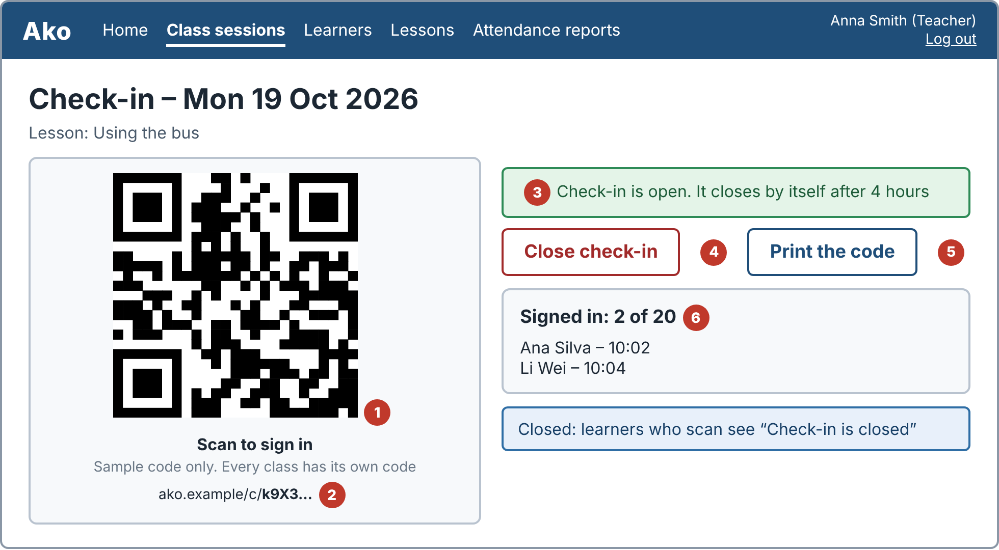
Wireframe 6.13
No. | Part | What it does
1 | QR code | Different for every session. Appears within 2 seconds
2 | Sign-in link | Holds a long random token, not the date, so it cannot be guessed
3 | Status | Open, with a note that it closes by itself after 4 hours
4 | Close check-in | The code stops working at once. Learners who scan see "Check-in is closed"
5 | Print the code | Opens the printable page below
6 | Signed-in list | A learner who signs in shows as Present with the time within 10 seconds, without the teacher typing

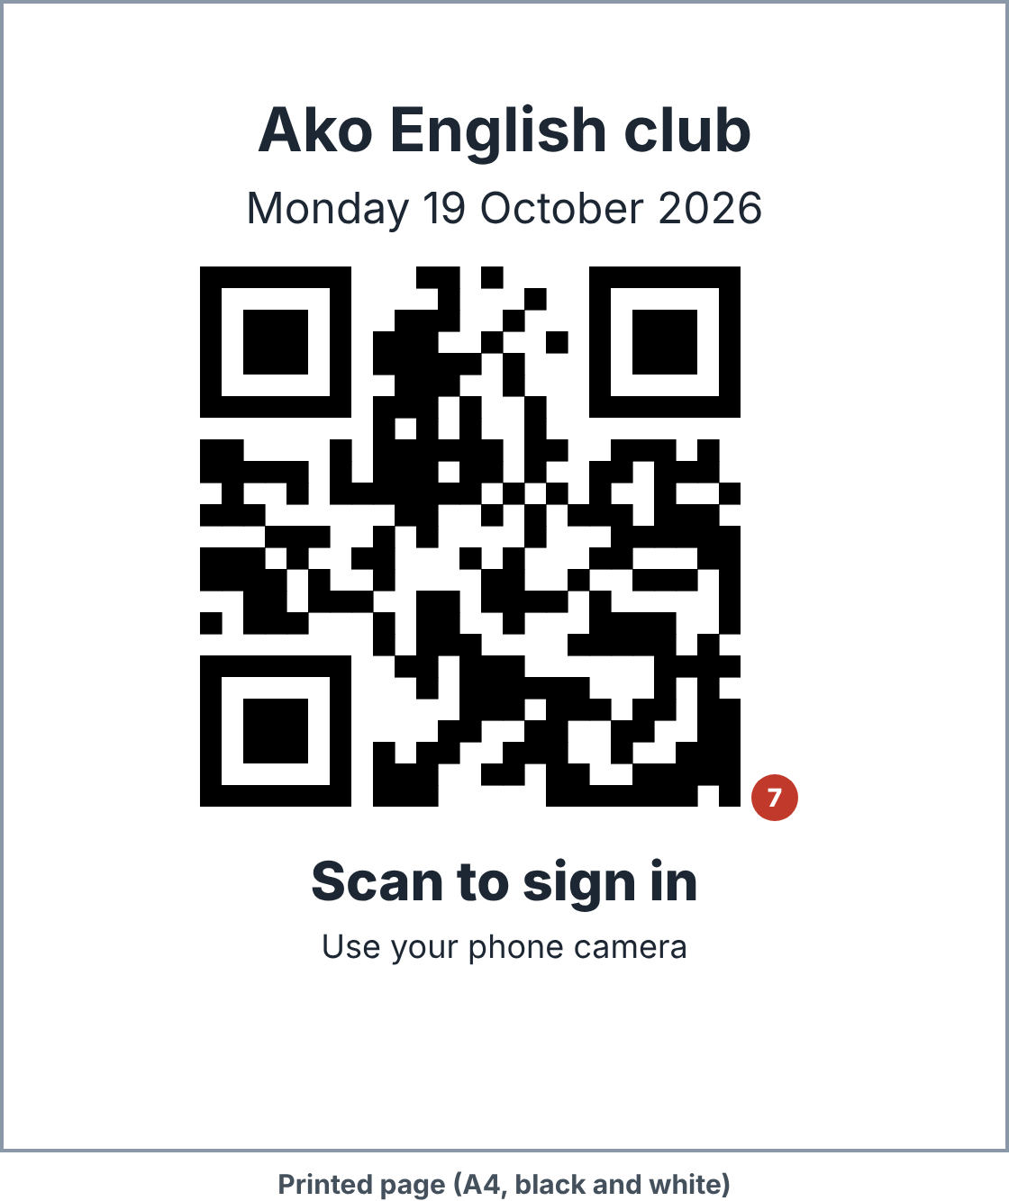
Wireframe 6.13 (printed page)
Printed page: the code is at least 8 cm wide, with the class date and the words "Scan to sign in". It reads well in black and white.

6.14 Learner sign-in (phone)
Stories: US-012 | Later
The phone camera opens this page. There is no app and no login. The learner types a name that matches the class list, so the list of names is never shown.
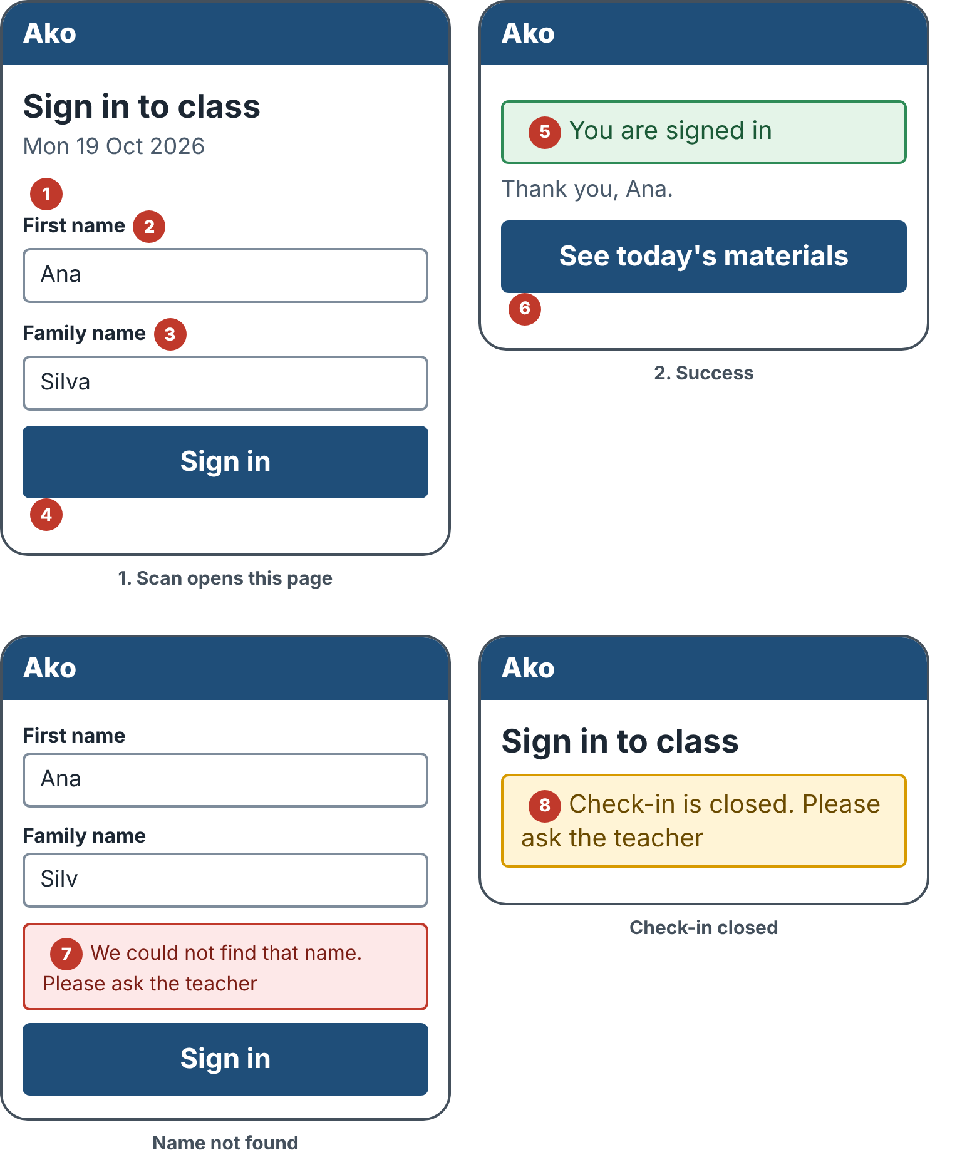
Wireframe 6.14
No. | Part | What it does
1 | Class date | Shows which class this is
2 | First name | Typed by the learner
3 | Family name | Typed by the learner
4 | Sign in | Big button, at least 44 px tall
5 | Success | "You are signed in". The learner shows as Present on the teacher's list
6 | Materials link | Opens the materials page (6.15)
7 | Name not found | "We could not find that name. Please ask the teacher". No record is made
8 | Check-in closed | "Check-in is closed. Please ask the teacher". No sign-in is recorded

- A learner who signs in twice sees "Already signed in" and no duplicate is made.
- The page stores only name and time. It stores no location or device details.

6.15 Lesson materials (phone)
Stories: US-013 | Later
After signing in, the learner sees and downloads the files the teacher chose to share.
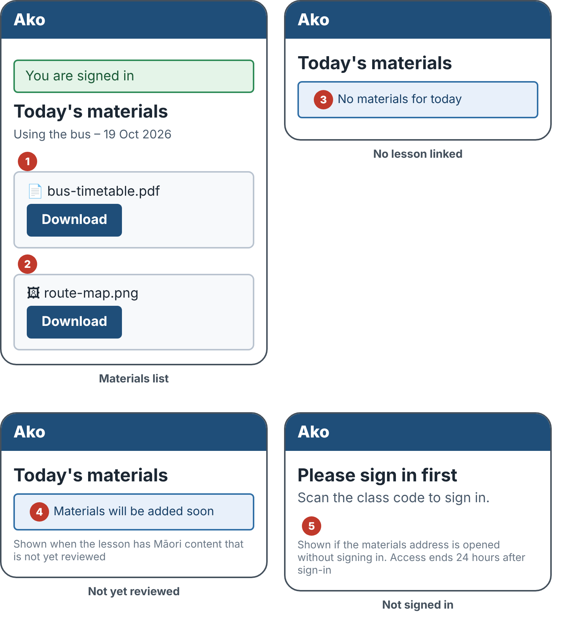
Wireframe 6.15
No. | Part | What it does
1 | Heading | Today's lesson and date
2 | Download buttons | Only files the teacher ticked "Share with learners" are listed. Each file downloads with its original name
3 | No materials | "No materials for today". The sign-in is still recorded
4 | Not yet reviewed | "Materials will be added soon" when the lesson has Māori content that is not yet reviewed. This rule is to be agreed with a Kaiārahi
5 | Not signed in | The page asks the person to sign in first and shows no file names

- The page keeps working for 24 hours after sign-in on the same phone, then asks the learner to scan a code again.

6.16 Correct past attendance
Stories: US-015 | MVP, Sprint 3
The coordinator fixes a mistake found after the class. Teachers can still tick and untick during the class itself (6.6) and only view afterwards.
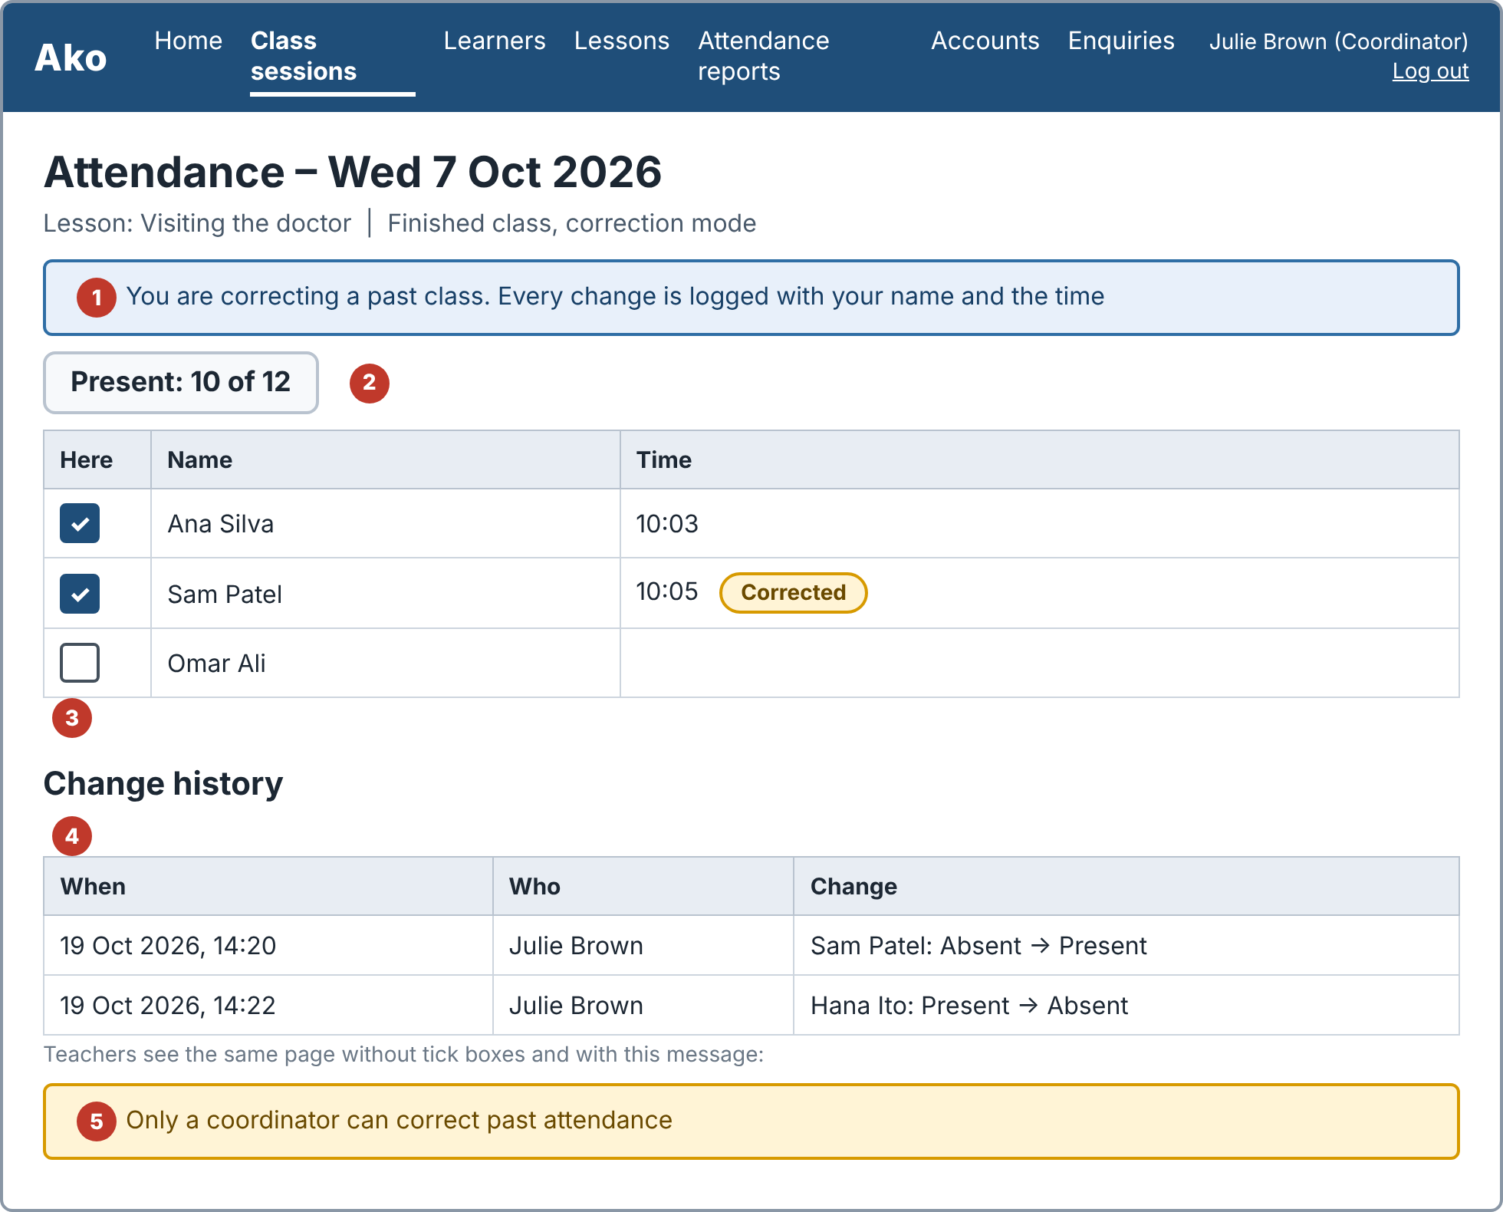
Wireframe 6.16
No. | Part | What it does
1 | Correction notice | Tells the coordinator that every change is logged with their name and the time
2 | Present count | Rises or falls by 1 each time a learner is changed
3 | Class list | Tick boxes work for the coordinator. A learner changed later shows a "Corrected" pill
4 | Change history | Each change shows who made it, what changed and when
5 | Teacher view | The same list without tick boxes. "Only a coordinator can correct past attendance" is shown

6.17 Learner attendance history
Stories: US-016 | Later
One learner across all class sessions, so the coordinator can follow up when someone stops coming. Learners do not log in, so they never see this page.
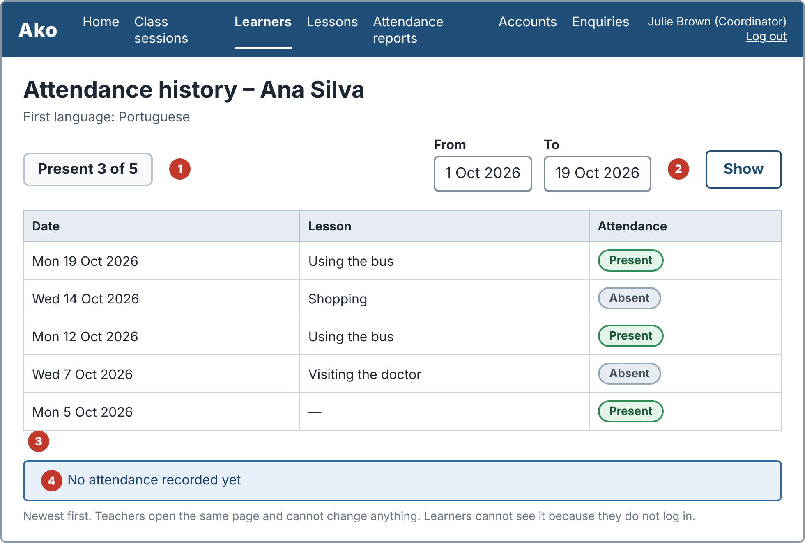
Wireframe 6.17
No. | Part | What it does
1 | Summary | For example "Present 3 of 5"
2 | Date range | Only sessions in the range are listed and the summary matches
3 | Session list | Newest first, each with its date, lesson and Present or Absent
4 | Empty state | "No attendance recorded yet" when the learner has no records

- Teachers open the same page read-only. Nothing on it can be changed by a teacher.

6.18 Import learners from CSV
Stories: US-017 | Later
The coordinator loads a list of learners from a file instead of typing each one. During the course project the file contains made-up learners only, never a real list.
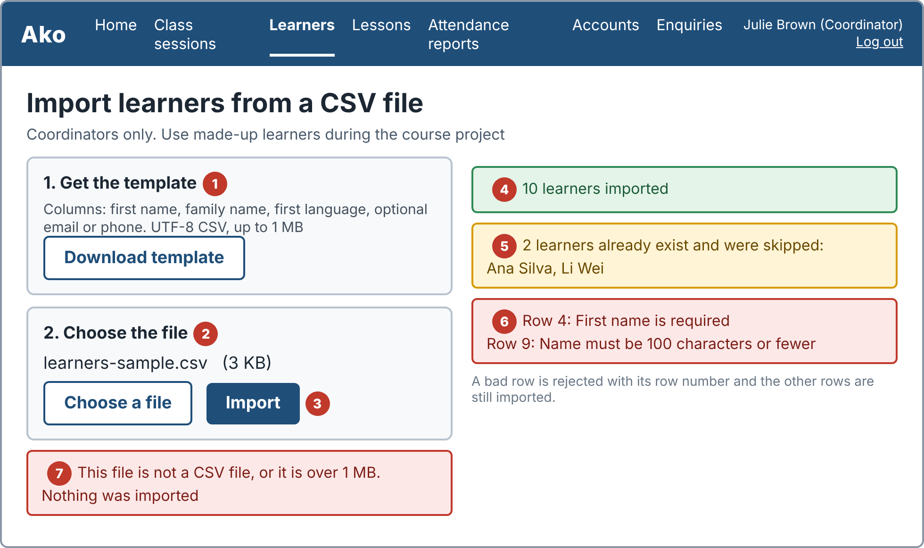
Wireframe 6.18
No. | Part | What it does
1 | Template | A template file shows the columns: first name, family name, first language, and optional email or phone
2 | Choose the file | UTF-8 CSV, up to 1 MB
3 | Import | Adds the learners and shows the result
4 | Success message | "10 learners imported" (the number is the number of rows added)
5 | Skipped duplicates | Learners with the same first and family name are skipped and listed. The others are imported
6 | Rejected rows | A row with an empty first name, or a name over 100 characters, is rejected with its row number. The other rows are imported
7 | Wrong file | A file that is not CSV, or is over 1 MB, is rejected with a message that states the rule. Nothing is imported

7. Message catalogue
All user-visible messages from the acceptance criteria, so wording stays the same across screens and tests.
Screen | Message | Type
Log in | Username or password is incorrect | Error
Teacher accounts | Username already taken | Error
Teacher accounts | Password must be at least 8 characters | Error
Any page | You do not have permission | Error
Learners | First name is required | Error
Learners | Name must be 100 characters or fewer | Error
Class sessions | Date cannot be in the future | Error
Class sessions | This session has attendance and cannot be deleted | Error
Attendance | Already signed in | Information
Correct past attendance | Only a coordinator can correct past attendance | Warning
Import learners | 10 learners imported (number varies) | Success
Import learners | Row [n]: First name is required | Error
Import learners | Row [n]: Name must be 100 characters or fewer | Error
Learner history | No attendance recorded yet | Information
Attendance reports | No classes found for these dates | Warning
Attendance reports | Start date must be before end date | Error
Lesson form | Title is required | Error
Lesson library | No lessons found | Information
Lesson library | Lesson date is required | Error
Māori review | Māori content – not yet reviewed | Label (amber)
Māori review | Reviewed by [name], [date] | Label (green)
Public page | Page not found | Information
Interest form | Please enter a valid email address | Error
Interest form | Message must be 500 characters or fewer | Error
Interest form | Thank you, the club will contact you | Success
Learner sign-in | You are signed in | Success
Learner sign-in | We could not find that name. Please ask the teacher | Error
Learner sign-in | Check-in is closed. Please ask the teacher | Warning
Learner materials | No materials for today | Information
Learner materials | Materials will be added soon | Information

8. Accessibility, print and phone rules
- Keyboard: every action can be done with the keyboard, in a sensible order, and the focus outline is visible.
- Text and contrast: body text at least 18 px, contrast at least 4.5:1, and no information shown only by colour.
- Errors: messages sit next to the field they belong to and say how to fix the problem.
- Phone pages: one column, no sideways scrolling at 360 px, buttons at least 44 px tall.
- Print: attendance lists, reports and the check-in code print on A4 in black and white and fit the page.
- Language: plain English. Te reo Māori words keep their macrons in the list, on the page and in exports.

9. Traceability: stories to screens
Story | Title | Screens | Sprint
US-001 | Log in by role | 6.1 Log in, 6.2 Home | Sprint 1
US-002 | Manage staff accounts | 6.3 Teacher accounts | Sprint 3
US-003 | Keep learner records | 6.4 Learners | Sprint 1
US-004 | Record attendance by hand | 6.6 Attendance | Sprint 2
US-005 | Print attendance record | 6.7 Attendance reports | Sprint 3
US-006 | Create a lesson | 6.8 Add or edit a lesson | Sprint 1
US-007 | Find and copy lessons | 6.9 Lesson library | Later
US-008 | Flag Māori content for review | 6.10 Review label, 6.8 tick box | Sprint 2
US-009 | View club information | 6.11 Public page | Later
US-010 | Register interest in classes | 6.12 Interest form and enquiries | Later
US-011 | Open check-in with a QR code | 6.13 Check-in with QR code | Later
US-012 | Sign in by scanning the QR code | 6.14 Learner sign-in | Later
US-013 | See lesson materials after signing in | 6.15 Lesson materials | Later
US-014 | Manage class sessions | 6.5 Class sessions, 6.2 Home button | Sprint 2
US-015 | Correct a past attendance record | 6.16 Correct past attendance | Sprint 3
US-016 | View a learner's attendance history | 6.17 Learner attendance history | Later
US-017 | Import learners from a CSV file | 6.18 Import learners from CSV | Later

10. Open points
- Confirm the topic tag list with the teachers (US-006).
- Agree the wording of the Māori review label and the rule that hides unreviewed materials from learners, with a Kaiārahi. The consultation has not happened yet.
- Class day, time, venue and club contact details are sample text until the club confirms them.
- Decide whether a short code read out in class is also needed for QR sign-in, in case a photo of the code is shared (US-012).
- Wireframes are low fidelity. Final colours, fonts and spacing are set while building and checked against section 5.

