Ako Project – Group Meeting 6 Agenda
Date | Tuesday, 20 October 2026
Meeting Chair | Leon Wu
Project | MSE800 – Group Assessment 2

1. Progress Updates
Each team member briefly reports the work completed since the previous meeting, including progress, outstanding tasks, and any difficulties encountered.
- Leon: Updated Jira based on the finalised requirements, including 4 Epics, 17 User Stories, 6 Tasks, and 3 Sprints. Reviewed the requirements prepared by Pei and provided 12 comments.
- Pei: Report on requirements updates and other completed work.
- Michael: Report on technical preparation and development progress.
- Sandhya: Updated her assigned User Stories in Jira.

2. Sprint Progress Review and Planning
Review the current Sprint 2 and planned Sprint 3, clarify individual responsibilities, and agree on the work to be completed before the next meeting.

Sprint 2 (20–23 October)
- US-001 – Log in by role
- US-002 – Manage staff accounts
- US-003 – Keep learner records
- US-004 – Record attendance by hand
- US-014 – Manage class sessions
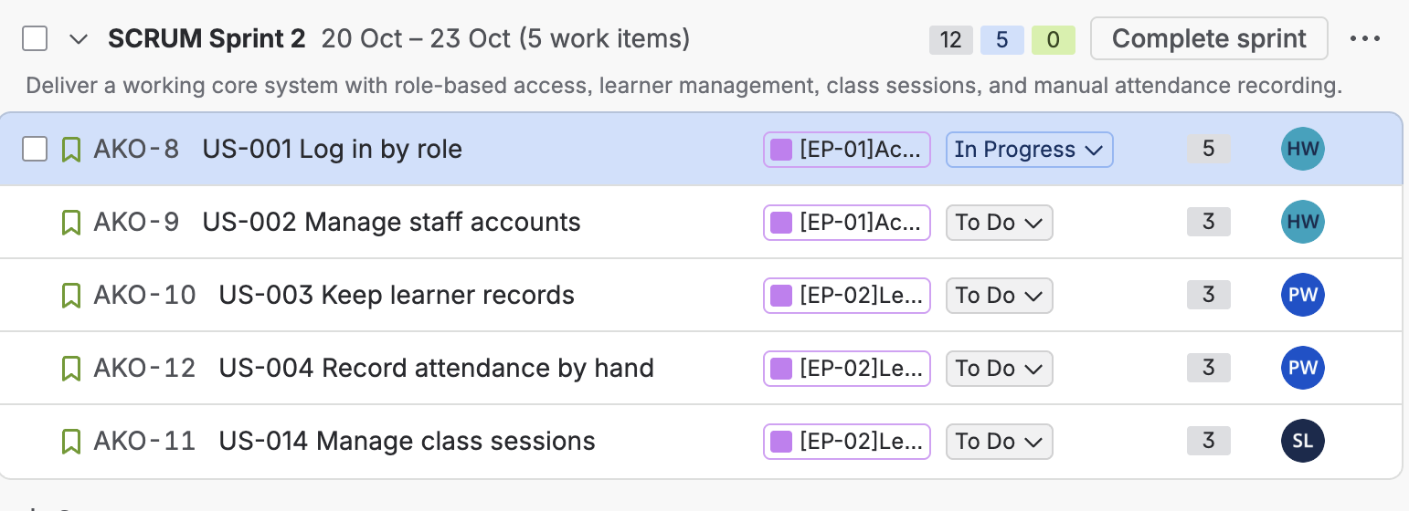

Sprint 3 (24–28 October)
- US-005 – Print attendance record
- US-006 – Create a lesson
- US-008 – Flag Māori content for review
- US-013 – Access shared lesson materials
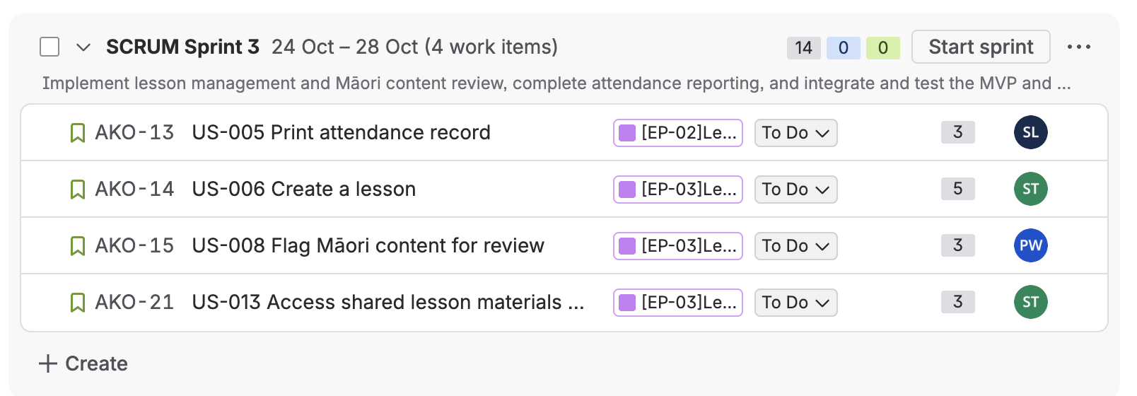

Individual Responsibilities
Each team member is responsible for managing their assigned User Stories in Jira, including:
- Reviewing and updating Story details where necessary.
- Moving relevant Stories from the Backlog into the appropriate Sprint.
- Breaking down Stories into Subtasks.
- Updating task status and recording progress regularly.
- Carrying out the necessary design and development work.
Leon will monitor overall progress through Jira and provide assistance with Jira-related issues when needed.

3. Issues and Team Discussion
Discuss any issues that require team input or joint decisions, including technical challenges, unclear requirements, dependencies, and potential risks to Sprint delivery.
Agree on solutions and assign follow-up actions where necessary.

4. Next Meeting
Proposed date: Friday, 23 October 2026
Time: To be confirmed
Team members should update their Jira tasks and prepare a brief progress report before the next meeting.

