Ako Project – Group Meeting 7 Agenda
Date | Friday, 23 October 2026
Meeting Chair | Leon Wu
Project | MSE800 – Group Assessment 2
Platform | Microsoft Teams (proposed)
Time | To be confirmed

1. Sprint Progress Review and Planning
Leon will first review the team's overall progress using Jira, summarising the work completed since the previous meeting, outstanding tasks and current Sprint status.
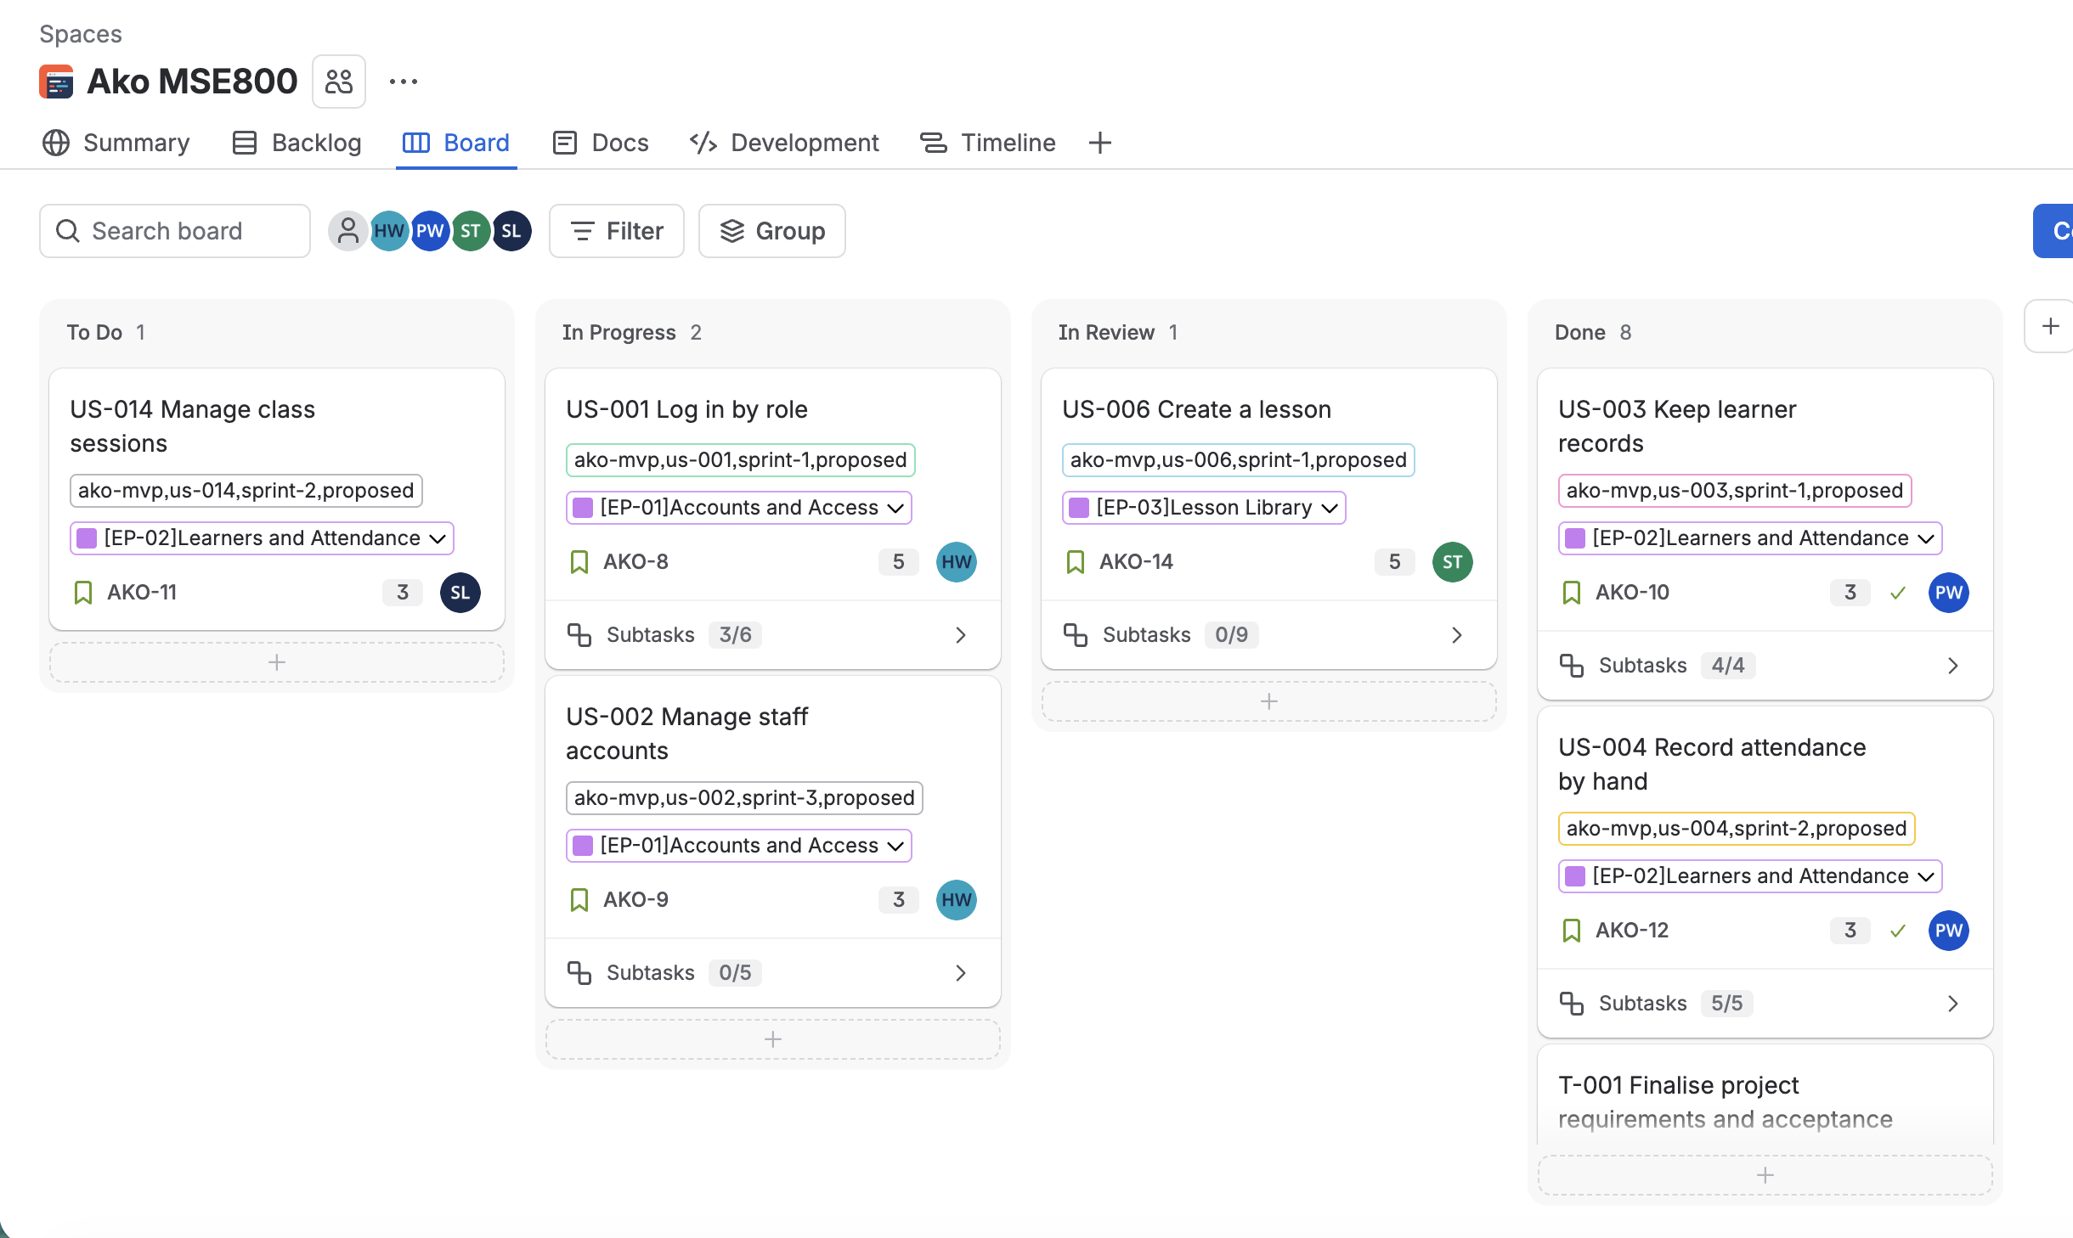

Sprint 2 Review (20–23 October)
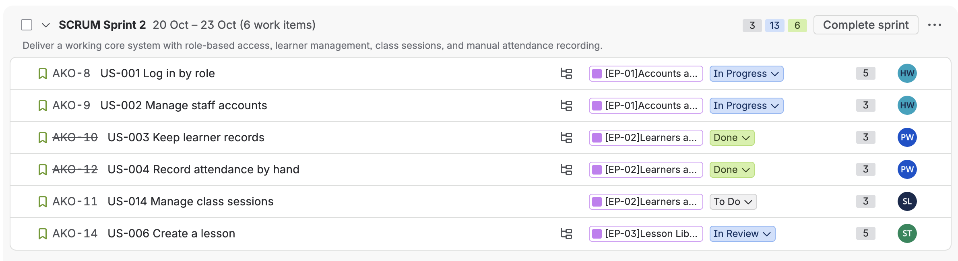
Review the completion status of the following User Stories:
- US-001 – Log in by role
- US-002 – Manage staff accounts
- US-003 – Keep learner records
- US-004 – Record attendance by hand
- US-014 – Manage class sessions
Identify completed and incomplete Stories, review outstanding Subtasks and discuss any blockers. Confirm how unfinished work will be handled and update Jira accordingly.

Sprint 3 Planning (24–28 October)
Review the following User Stories:
- US-005 – Print attendance record
- US-006 – Create a lesson
- US-008 – Flag Māori content for review
- US-013 – Access shared lesson materials
Confirm individual responsibilities, development priorities, dependencies and expected deliverables.

2. Individual Progress Updates
Following the Jira review, each team member reports their individual progress, outstanding work, difficulties encountered and next steps.
- Leon: Report on assigned User Story development, Jira management and outstanding issues.
- Pei: Report on assigned User Stories, UI design integration, testing preparation and documentation updates.
- Micheal: Report on technical development, database design, Git branching, baseline code integration and technical documentation.
- Sandhya: Report on assigned User Stories, development progress and any issues requiring team support.

3. Issues and Team Discussion
Briefly discuss only key issues that may affect overall project progress, Sprint delivery or team coordination.
Detailed technical and requirements-related issues will be discussed at tomorrow's face-to-face meeting.

4. Next Meeting
Date: Saturday, 24 October 2026
Time: After class
Location / Platform: Face-to-face (Yoobee College)
Main Purpose: Discuss and resolve technical and requirements-related issues encountered during development.
Team members should prepare specific questions or issues in advance to facilitate discussion and agree on practical solutions.

