|  |  |
| --- | --- |
|  | ***TM358*: Machine learning and *artificial intelligence***  Tutor-Marked Assignment (TMA) Spring 23/24 |

**Cut-Off Date:** Based on the Published Deadline. **Total Marks:** …. marks turned to 15 marks **Contents**

Warnings and Declaration…………………………………….………………………………......1

Question 1 ……………….…………………………………. ………………………………...…..2

Question 2 ………………………………………………………………………………….…..…..3

Question 3 ………………………………………………………………………………….…..…..4

Marking Criteria ...…………..………………………………………………………….………..…5

**Plagiarism Warning:**

As per AOU rules and regulations, all students are required to submit their own TMA work and avoid plagiarism. The AOU has implemented sophisticated techniques for plagiarism detection. You must provide all references in case you use and quote another person's work in your TMA. You will be penalized for any act of plagiarism as per the AOU's rules and regulations.

**Declaration of No Plagiarism by Student (to be signed and submitted by student with TMA work):**

I hereby declare that this submitted TMA work is a result of my own efforts and I have not plagiarized any other person's work. I have provided all references of information that I have used and quoted in my TMA work.

Name of Student:…………………………….. Signature:…………………………………………... Date:…………………………………………………

**Question 1, [20 marks]**

Having the following goal state for the XO game:

|  |  |  |  |  |  |  |  |  |  |  |  |  |  |  |  |  |  |  |  |  |  |  |  |  |  |  |  |  |  |  |  |  |  |  |  |  |  |  |  |
| --- | --- | --- | --- | --- | --- | --- | --- | --- | --- | --- | --- | --- | --- | --- | --- | --- | --- | --- | --- | --- | --- | --- | --- | --- | --- | --- | --- | --- | --- | --- | --- | --- | --- | --- | --- | --- | --- | --- | --- |
| |  |  |  | | --- | --- | --- | | X | X | X | | E | E | E | | E | E | E | | |  |  |  | | --- | --- | --- | | E | E | E | | X | X | X | | E | E | E | | |  |  |  | | --- | --- | --- | | E | E | E | | E | E | E | | X | X | X | | |  |  |  | | --- | --- | --- | | X | E | E | | X | E | E | | X | E | E | |
| |  |  |  | | --- | --- | --- | | E | X | E | | E | X | E | | E | X | E | | |  |  |  | | --- | --- | --- | | E | E | X | | E | E | X | | E | E | X | | |  |  |  | | --- | --- | --- | | X | E | E | | E | X | E | | E | E | X | | |  |  |  | | --- | --- | --- | | E | E | X | | E | X | E | | X | E | E | |

and having the following current state s=

|  |  |  |
| --- | --- | --- |
| X | O | E |
| O | O | X |
| X | E | E |

1. Generate the game tree until reaching the leaf nodes.
2. Using mini-max algorithm, set the value for each node.
3. Decide the winner for the game if any.
4. If the branching factor for a similar game is very huge and the steps required to reach the leaf nodes are very deep, propose a solution to such task so that we can adopt mini-max for this case.

**Question 2, [20 marks]**

Given the following search graph, write the sequence of node numbers in the search agenda across the search life-time and using *A* search*.  
Assume the following heuristic value per node:

|  |  |
| --- | --- |
| **Node ID** | **Node Heuristic value** |
| 1 | 541 |
| 2 | 0 |
| 3 | 380 |
| 4 | 381 |
| 5 | 161 |
| 6 | 198 |

Assume distance between cities are as mentioned on the links  
Apply A* algorithm showing intermediate values for the Agenda, g(n), h(n)  
Source city is :C6  
Destination city:C2

**Question 3, [20 marks]**

1. Given the following search graph and adopting *depth-first search*:
2. Trace the states inside the search agenda until reaching the goal state.
3. How many states will be visited until reaching the goal state?
4. Mention the solution path if exist to the goal state.

Assume that the goal state is 14.

1. Replace the algorithm in a) with BFS then solve again 1,2,3
2. Compare the methods in a) and b)  
   **Question 4, [20 marks]**

• In a TSP problem with 4 cities, cities are connected as shown in the figure:  
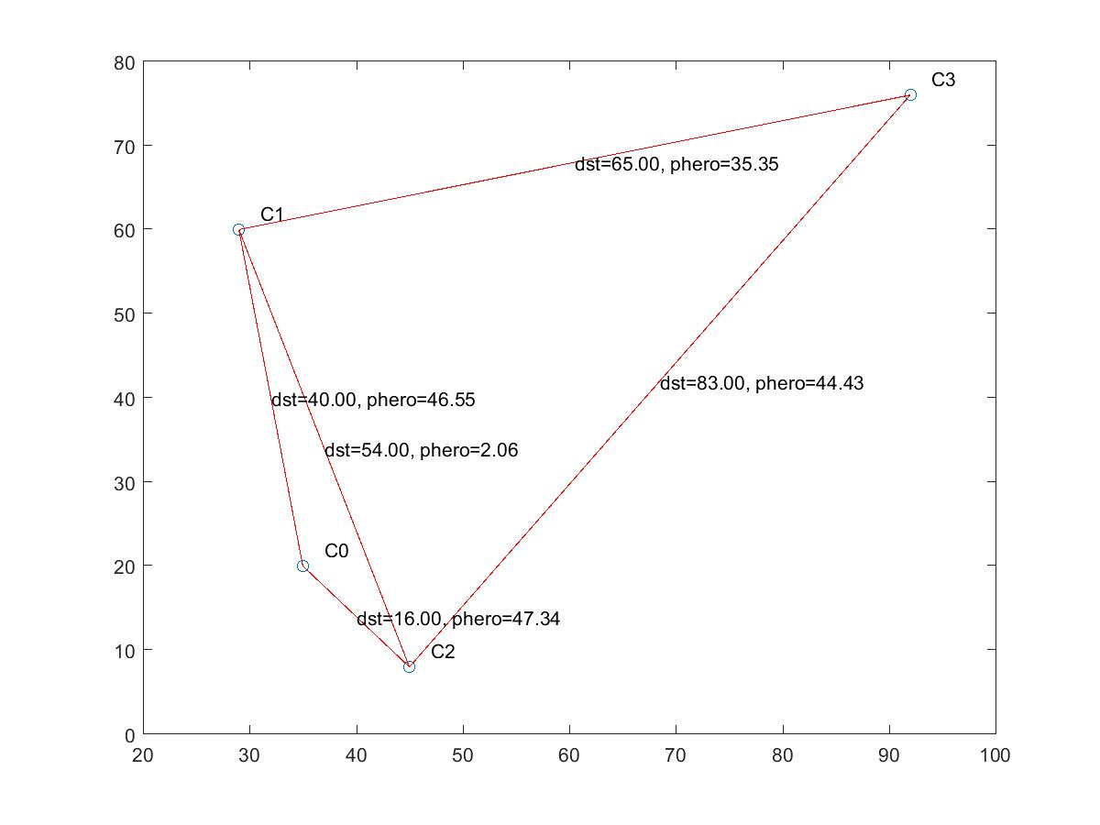  
the following table shows the distances between different cities

|  |  |  |  |  |
| --- | --- | --- | --- | --- |
|  | **C0** | **C1** | **C2** | **C3** |
| C0 | 0.00 | 40.00 | 16.00 | 80.00 |
| C1 | 40.00 | 0.00 | 54.00 | 65.00 |
| C2 | 16.00 | 54.00 | 0.00 | 83.00 |
| C3 | 80.00 | 65.00 | 83.00 | 0.00 |

[Distance of 0 means distance is not applicable.  
]The following table shows the pheromone in units between different cities

|  |  |  |  |  |
| --- | --- | --- | --- | --- |
|  | **C0** | **C1** | **C2** | **C3** |
| C0 | 0.00 | 46.55 | 47.34 | 0.00 |
| C1 | 46.55 | 0.00 | 2.06 | 35.35 |
| C2 | 47.34 | 2.06 | 0.00 | 44.43 |
| C3 | 0.00 | 35.35 | 44.43 | 0.00 |

• Assume that an ant has followed the following route:[3,2,0,1,] and back to source

1. Calculate the total cost of the above route.
2. Calculate the ant's switching probabilities for the first 3 steps in the above route assuming pheromone exponent parameter α=0.56 and heuristic exponent parameter β=0.09.
3. Calculate the updated pheromone amounts after applying the ACO evaporation step assuming ρ=0.25.
4. Calculate the updated pheromone amounts after applying the ACO depositing step assuming Q=13.91.
5. Comment on the update with regard to the optimization task convergence

**Question 5, [20 marks]**

Given the following particle positions in a PSO minimization optimization process:

|  |  |  |  |  |  |
| --- | --- | --- | --- | --- | --- |
| **X1** | **X2** | **X3** | **X4** | **X5** | **X6** |
| 0 | 1 | -1 | 2 | 1 | 1 |
| 1 | -2 | -2 | 1 | 2 | 0 |
| 0 | 1 | 1 | 2 | 0 | 1 |
| 2 | -1 | 0 | 1 | 2 | 1 |
| 1 | -2 | 0 | 1 | 1 | -1 |

and given that each particle's attached velocity is:

|  |  |  |  |  |  |
| --- | --- | --- | --- | --- | --- |
| **V1** | **V2** | **V3** | **V4** | **V5** | **V6** |
| 1.0 | 1.6 | 1.3 | 0.9 | -0.6 | 0.1 |
| 0.5 | 0.1 | 1.4 | -1.2 | 0.2 | -0.8 |
| 0.0 | -0.0 | 0.6 | -0.5 | -1.8 | -0.8 |
| -1.5 | -0.5 | 1.3 | 0.6 | -0.2 | 2.1 |
| -1.0 | -0.4 | 1.9 | 0.0 | 0.5 | 1.1 |

and given each particle's local best as:

|  |  |  |  |  |  |
| --- | --- | --- | --- | --- | --- |
| **P1** | **P2** | **P3** | **P4** | **P5** | **P6** |
| 1 | 1 | 2 | -1 | 2 | -1 |
| 0 | -1 | 0 | -2 | -1 | 0 |
| 1 | 2 | 0 | -1 | 1 | -1 |
| 0 | -2 | -2 | -1 | -1 | 0 |
| 1 | 1 | -1 | 0 | 1 | -2 |

assuming the global best is:[2,0,0,-2,-1,]  
a) Calculate the updated positions and velocities for the next 3 iterations  
Assume Φ1=0.9 and Φ2=0.3  
The function to be minimized is:5x11+2x22+6x33+9x45+1x57

b) what do you think about the convergence PSO in this case?