CHAPTER III
SYSTEM METHODOLOGY AND DESIGN
3.1 Introduction
This chapter presents the methodology and technical design of the proposed system developed in this study. The chapter provides a detailed explanation of the system description, its main features, architecture, development approach, and the technical environment required to build and run the application. The purpose of this chapter is to provide a structured understanding of how the proposed system addresses the research problem and how the system components interact to achieve the intended objectives.
The chapter begins by presenting an overview of the proposed application and explaining the overall purpose of the system. It then describes the key features of the system and explains how these features support users in ordering fuel, LPG cylinders, and automotive spare parts. The system architecture is also presented to illustrate how different components of the application interact with each other.
In addition, the chapter outlines the system requirements including both hardware and software requirements necessary for developing and running the application. Functional and non-functional requirements are also described to explain what the system must do and the quality standards it must meet.
Furthermore, the chapter presents a feasibility study to evaluate whether the proposed system is practical in terms of technology, cost, operations, and time constraints. Finally, the chapter describes the UML diagrams and database design used to structure the system and manage application data effectively.

3.2 System Overview
The proposed system is an online fuel, gas, and spare parts delivery application designed to simplify and modernize the process of ordering essential automotive and household energy products. The system provides a digital platform where customers can easily order petrol, diesel, LPG cylinders, and automotive spare parts using a mobile application. The objective of the system is to reduce the inconvenience associated with traditional purchasing methods where customers are required to physically travel to fuel stations, gas suppliers, or spare parts shops.
Currently, many fuel stations and gas suppliers operate through manual systems where customers must visit service locations to obtain products. This approach often results in delays, transportation challenges, and inefficiencies in service delivery. In addition, communication between customers and vendors is often informal and unstructured, which makes it difficult to coordinate deliveries or manage product availability effectively.
The proposed system addresses these challenges by introducing a centralized digital platform that connects customers, fuel suppliers, gas providers, and spare parts vendors within a single application. Through the mobile application interface, users can browse available products, view prices, and place orders directly from their smartphones. This improves accessibility and reduces the time required for customers to obtain essential services.
The system also provides functionality that allows vendors to manage their product listings and respond to customer orders efficiently. Vendors can update product availability, confirm orders, and coordinate deliveries through the backend system. This helps improve operational efficiency and ensures that businesses can respond to customer demands more effectively.
From a technical perspective, the system is composed of three main components: the frontend mobile application, the backend server, and the database management system. The frontend is developed using Flutter, which provides a responsive and user-friendly interface for mobile users. The backend server is built using Node.js with the Express framework, which handles application logic, processes requests, and manages communication between the mobile application and the database. The system database is implemented using MySQL, which stores all application data including user accounts, product information, and order records.
Overall, the proposed system provides an integrated solution that improves service efficiency, enhances customer convenience, and supports the development of organized delivery services for fuel, gas, and automotive spare parts.
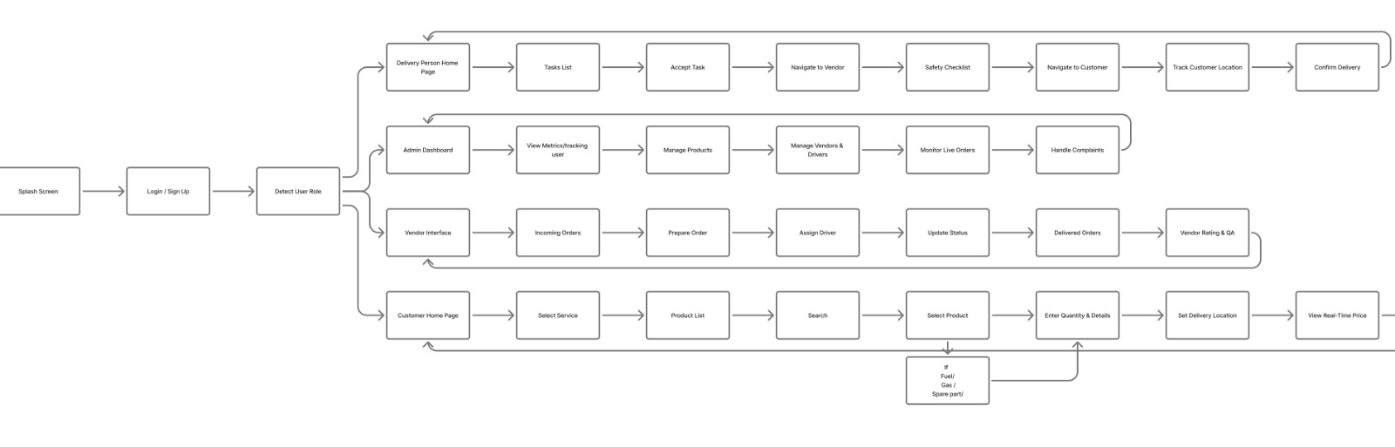
3.3 System Features
The proposed system includes several important features designed to improve the process of ordering fuel, LPG cylinders, and automotive spare parts. These features aim to enhance efficiency, accessibility, and user experience by providing a structured digital platform for both customers and vendors. Each feature supports specific system functions that contribute to achieving the overall objectives of the application.
User Registration and Authentication
One of the fundamental features of the system is user registration and authentication. This feature allows new users to create accounts by providing basic personal information such as name, contact information, and login credentials. Once registered, users can securely log into the application using their credentials.
Authentication plays an important role in protecting user data and ensuring that only authorized users can access the system. It also allows the system to maintain personalized user profiles and track user activity such as orders and account history.
Product Browsing and Listing
The system provides a product browsing feature that allows users to explore available products offered by vendors. These products include petrol, diesel, LPG cylinders, and automotive spare parts. Each product listing contains detailed information such as the product name, description, price, and availability.
This feature helps customers make informed decisions when selecting products and simplifies the process of searching for required items. It also enables vendors to display their available products through the system.
Order Placement
The order placement feature allows customers to submit requests for fuel, gas cylinders, or spare parts directly through the mobile application. Once a customer selects the desired product, the system records the order details and sends the request to the relevant vendor.
This feature eliminates the need for customers to physically visit service providers and allows them to place orders from any location using their smartphones. The order placement system improves convenience and reduces time spent searching for products.
Order Management
Order management is another essential feature of the system. This feature enables vendors to view and manage incoming orders from customers. Vendors can confirm orders, update order status, and prepare products for delivery or pickup.
Through this feature, the system helps businesses organize their operations more efficiently and respond to customer requests in a structured manner.
Real-Time Order Tracking
The system also includes a real-time order tracking feature that allows customers to monitor the progress of their orders. Once an order is submitted, the customer can view updates regarding the order status, such as confirmation, preparation, and delivery stages.
This feature improves transparency and helps customers stay informed about their orders. It also increases trust between customers and vendors by providing clear communication regarding service progress.
Vendor Management
Vendor management allows fuel suppliers, gas providers, and spare parts vendors to manage their business activities within the system. Vendors can add products, update prices, manage inventory availability, and respond to customer orders.
This feature ensures that vendors have control over the products and services they offer through the platform, making the system useful for both customers and service providers.
Notification System
The notification system informs users about important updates within the application. Customers receive notifications when their orders are confirmed, processed, or delivered. Vendors also receive notifications when new orders are placed.
This feature improves communication between users and ensures that both customers and vendors remain informed about system activities.
Secure Data Management
Security is an essential feature of the system. The application ensures that user information and transaction data are securely stored in the database. Authentication and secure communication mechanisms help protect sensitive data from unauthorized access.
Secure data management increases user trust and ensures that the system operates safely and reliably.
3.4 System Architecture
System architecture refers to the structural design of a software system that defines how different components interact with each other to achieve the overall objectives of the application. It provides a blueprint that explains the organization of system components, the communication mechanisms between those components, and the flow of data within the system.
The proposed online fuel, gas, and spare parts delivery application follows a three-tier architecture, which separates the system into three main layers: the presentation layer, the application layer, and the data layer. This architecture is widely used in modern software development because it improves system scalability, maintainability, and security.
By separating system components into different layers, the architecture ensures that each layer performs a specific function while communicating efficiently with other layers. This layered structure allows developers to modify or upgrade one component without affecting the entire system.
Presentation Layer (Frontend)
The presentation layer represents the user interface of the system and serves as the point of interaction between users and the application. In this proposed system, the presentation layer is implemented using Flutter, a cross-platform mobile development framework that allows developers to build high-performance mobile applications for Android and iOS platforms.
The Flutter-based mobile application provides users with an intuitive and responsive interface that enables them to perform various actions such as creating accounts, browsing available products, placing orders, and tracking order status. The interface is designed to be user-friendly so that customers can easily navigate through the application without requiring technical knowledge.
Through this layer, user inputs such as login credentials, product selections, and order requests are captured and transmitted to the backend server through Application Programming Interfaces (APIs). The presentation layer also displays system responses received from the backend server, such as order confirmations, product listings, and notification messages.
Application Layer (Backend)
The application layer, also known as the backend layer, is responsible for processing system logic and managing communication between the frontend and the database. In the proposed system, the backend server is developed using Node.js with the Express.js framework.
Node.js provides a powerful runtime environment that enables efficient server-side execution of JavaScript code, while Express.js simplifies the development of RESTful APIs used for communication between the mobile application and the server.
The backend server performs several critical tasks, including user authentication, order processing, vendor management, and data validation. When a user submits a request through the mobile application, the request is sent to the backend server where it is processed according to the system's business logic.
For example, when a user places an order for fuel or a gas cylinder, the backend server verifies the request, stores the order information in the database, and sends a confirmation response back to the mobile application. The backend server also handles communication between vendors and customers by managing order updates and notifications.
This layer ensures that system operations are executed efficiently while maintaining data integrity and security.
Data Layer (Database)
The data layer is responsible for storing and managing all information required by the system. In this proposed system, the data layer is implemented using MySQL, which is a widely used relational database management system known for its reliability, efficiency, and scalability.
The database stores various types of data including user account information, product details, vendor information, order records, and system logs. Each type of data is organized into structured tables with defined relationships that ensure data consistency and integrity.
Primary keys are used to uniquely identify records within tables, while foreign keys establish relationships between related tables. For example, an order record may include a foreign key referencing the user who placed the order and the product that was ordered.
The MySQL database enables efficient data retrieval and storage, allowing the system to quickly access information whenever users interact with the application.
Data Flow Between System Components
The interaction between the three layers ensures that the system operates smoothly and efficiently. When a user interacts with the mobile application, the request is sent from the presentation layer to the backend server through API endpoints. The backend server processes the request and communicates with the MySQL database to retrieve or store the required data.
Once the backend completes the requested operation, it sends a response back to the mobile application, which then displays the results to the user. This continuous exchange of information between system components enables real-time system functionality and ensures that users receive timely responses to their actions.
Architectural Benefits
The three-tier architecture used in this system provides several advantages. First, it improves system scalability by allowing each layer to be expanded independently as the number of users grows. Second, it enhances system maintainability because developers can modify one layer without affecting the others. Third, it improves security by isolating sensitive data within the database layer and controlling access through the backend server.
These architectural advantages make the proposed system suitable for handling real-world operations involving fuel, gas, and spare parts ordering and delivery services

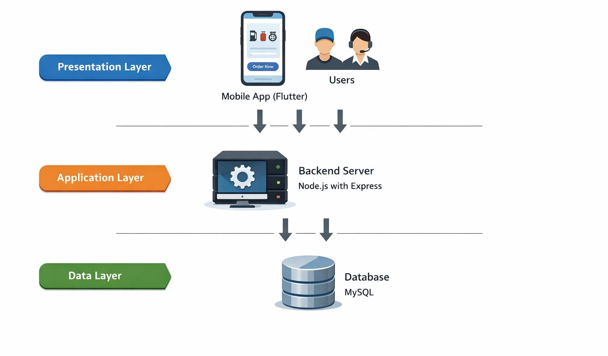

3.5 System Requirements
The system requirements define the technical and operational specifications necessary for the successful development, deployment, and operation of the proposed application. These requirements describe the hardware and software resources needed to ensure that the system functions efficiently and reliably. Clearly identifying system requirements is essential for establishing the technical environment required for building, testing, and running the application.
For the proposed online fuel, gas, and spare parts delivery application, the system requirements are divided into two main categories: hardware requirements and software requirements. These requirements ensure that the application can be developed and operated under appropriate technical conditions while maintaining system performance and reliability.
3.5.1 Hardware Requirements
Hardware requirements refer to the physical computing resources necessary to support the development, testing, and execution of the proposed system. These components ensure that the development environment can efficiently handle the tools and technologies required to build the application.
For this project, the recommended hardware specifications include a computer or laptop equipped with a modern processor capable of supporting software development tools. A processor equivalent to Intel Core i5 or higher is recommended to ensure adequate performance during development and testing.
In addition to processing capability, sufficient memory is required to run multiple development tools simultaneously. A minimum of 8 GB RAM is recommended to support the Flutter development environment, Node.js runtime, and database operations without performance issues.
Adequate storage capacity is also necessary to store source code, libraries, frameworks, and project resources. A minimum storage capacity of 256 GB is recommended to accommodate development tools and project files.
A mobile device or smartphone is also required to test the Flutter mobile application on a real device environment. This enables developers to verify the usability and performance of the application in conditions similar to those experienced by actual users.
Furthermore, a stable internet connection is required for downloading development dependencies, accessing online libraries, testing API communication, and managing cloud-based development resources.
These hardware components collectively provide a suitable development environment for building and testing the proposed application.

3.5.2 Software Requirements
Software requirements refer to the development tools, programming languages, frameworks, and platforms required to design, implement, and execute the proposed system. These software components provide the necessary environment for coding, testing, debugging, and deploying the application.
One of the primary software requirements for this project is the use of a suitable Integrated Development Environment (IDE). In this study, Visual Studio Code is used as the main development environment due to its flexibility, lightweight structure, and extensive support for modern development frameworks such as Flutter and Node.js.
The proposed system utilizes two primary programming languages to implement different parts of the application. The Dart programming language is used to develop the mobile application using the Flutter framework. Dart provides efficient performance and strong support for building cross-platform mobile applications. For the backend system, JavaScript is used within the Node.js runtime environment, allowing developers to build scalable and efficient server-side applications.
The system also requires a reliable database management system to store and manage application data. In this project, MySQL is used as the relational database management system. MySQL provides efficient data storage and retrieval capabilities and ensures the integrity of stored information such as user accounts, product listings, vendor details, and order records.
Several frameworks and supporting libraries are also used to facilitate the development process. The Flutter framework is used for building the mobile application interface, enabling the creation of responsive and visually consistent user interfaces across multiple platforms. The Node.js runtime environment provides server-side execution capabilities for backend operations, while the Express.js framework simplifies the creation of RESTful APIs used for communication between the mobile application and the backend server.
Finally, the application is designed to operate on multiple operating systems. The development environment primarily runs on Windows, while the mobile application targets Android devices and can also support iOS devices due to Flutter’s cross-platform capabilities.
Together, these software components create a complete development environment that supports the design, implementation, and deployment of the proposed online fuel, gas, and spare parts delivery application.
3.6 Requirements
System requirements describe the expected behavior and operational capabilities of the proposed system. They define what the system must accomplish in order to meet the needs of users and support the objectives of the application. Requirements are typically categorized into functional requirements and non-functional requirements. Functional requirements focus on the core operations the system must perform, while non-functional requirements define the quality attributes and constraints under which the system operates.
3.6.1 Functional Requirements
Functional requirements describe the specific tasks and services that the proposed system must perform. These requirements define how users interact with the system and how the system responds to those interactions. Each functional requirement represents a system capability that contributes to the overall functionality of the application.
For the proposed online fuel, gas, and spare parts delivery application, the following functional requirements are identified:
R1: The system shall allow users to create a new account by registering their personal information.
R2: The system shall allow registered users to securely log into the mobile application using authentication credentials.
R3: The system shall allow users to view and browse available products including petrol, diesel, LPG cylinders, and automotive spare parts.
R4: The system shall display detailed product information such as product name, description, price, and availability.
R5: The system shall allow users to place orders for selected products through the mobile application.
R6: The system shall record all order information and store it in the system database.
R7: The system shall allow vendors to add, update, or remove product listings within the system.
R8: The system shall allow vendors to receive and manage incoming customer orders.
R9: The system shall allow the system to update the order status (e.g., pending, confirmed, delivered).
R10: The system shall allow users to track the status of their orders.
R11: The system shall allow the system to send notifications to users regarding order confirmations or updates.
R12: The system shall allow vendors to manage inventory availability of fuel, gas cylinders, and spare parts.
R13: The system shall maintain a secure database that stores user accounts, product information, and order records.
R14: The system shall allow administrators to manage system users and monitor system operations.
R15: The system shall allow users to log out securely from the application when their session is complete.
R16: The system shall support five distinct user roles, namely administrator, vendor, customer, driver, and car services worker, each with role-based access to functions and data.
R17: The system shall allow customers to browse and order across four service domains: fuel (petrol and diesel), LPG gas cylinders, automotive spare parts, and car services.
R18: The system shall allow customers to book car services by selecting a service, a vehicle type, optional add-ons, and a scheduled time slot, and shall support express (immediate) booking.
R19: The system shall calculate the delivery fee on the server based on distance and vendor delivery zones, and shall not rely on client-supplied fees.
R20: The system shall process payments through the Waafi/EVC mobile-money gateway and shall prevent duplicate charges through idempotent checkout keyed on a unique request identifier.
R21: The system shall enforce an order status workflow (pending, accepted, preparing, pending driver assignment, driver assigned, on the way, arrived, delivered, completed, cancelled, failed) with validated transitions.
R22: The system shall allow vendors to assign orders to drivers and shall filter driver assignment by online/offline availability.
R23: The system shall provide real-time GPS tracking of active deliveries and shall require one-time-password verification and photographic proof before an order is marked delivered.
R24: The system shall require a monthly vendor subscription, processed by mobile-money payment, to grant vendors access to the vendor portal and its modules.
R25: The system shall allow a vendor to purchase (unlock) additional service modules through a paid module-upgrade request that is validated by payment and approved by an administrator.
R26: The system shall require administrator verification and approval of vendors before they can operate on the platform.
R27: The system shall compute platform commission at a centrally configured rate and shall generate vendor settlements and settlement items automatically.
R28: The system shall allow vendors to manage inventory for fuel, gas, and spare parts, to manage suppliers, and to record purchases.
R29: The system shall allow customers to submit ratings and reviews, and shall allow vendors to create offers and promotions.
R30: The system shall provide dashboards, reports, and analytics for administrators and vendors, with export to PDF and Excel, and shall deliver real-time and push notifications for key events.
3.6.2 Non-Functional Requirements (NFR)
The non-functional requirements describe the quality standards and operational constraints that determine how the proposed system should perform. These requirements are essential in ensuring that the online fuel, gas, and spare parts delivery application operates efficiently, securely, and reliably while meeting the expectations of customers, vendors, and delivery personnel.
NFR1: Real-Time Performance
The system shall provide real-time response during fuel, gas, and spare parts ordering processes. Customer requests, order confirmations, and delivery tracking updates should be processed and displayed within 3 to 5 seconds. This is important to ensure that users receive timely information about product availability and delivery status.
NFR2: Security and Data Protection
The system shall ensure that all customer information, vendor data, payment details, and order records are securely stored and protected from unauthorized access. User passwords must be encrypted, and secure authentication mechanisms shall be implemented to protect system access.
NFR3: Usability
The mobile application shall provide a simple, clear, and user-friendly interface that allows customers to easily browse fuel products, LPG cylinders, and automotive spare parts, place orders, make payments, and track deliveries. The interface should support ease of navigation for customers, vendors, and administrators.
NFR4: Reliability
The system shall remain available and functional whenever users need to access fuel, gas, or spare parts delivery services. The application should maintain stable performance with minimal downtime to ensure uninterrupted service.
NFR5: Scalability
The system shall be capable of handling an increasing number of customers, vendors, products, and delivery transactions as the service expands to different locations and user groups.
NFR6: Delivery Tracking Accuracy
The system shall provide accurate real-time location updates for ongoing deliveries. GPS-based tracking should display the current location of delivery personnel and estimated delivery progress to the customer
NFR7: Authentication and Access Security
The system shall authenticate all users through JSON Web Tokens and shall enforce role-based access control and object-level ownership checks so that each user can access only the resources permitted to their role.
NFR8: Data Integrity and Consistency
The system shall maintain relational integrity through primary and foreign keys, shall validate all input on the server, and shall keep financial and inventory state consistent by cancelling orders and releasing stock when payment fails.
NFR9: Maintainability
The system shall follow a modular Model-View-Controller structure that separates routes, controllers, and data-access models, enabling components to be modified independently.
NFR10: Portability and Compatibility
The mobile application shall run on common Android devices, and the web portal shall operate on modern web browsers across desktop and mobile screen sizes.
NFR11: Responsiveness and Real-Time Updates
The web and mobile interfaces shall be responsive, and the system shall deliver real-time updates for order status, driver assignment, and live tracking through a persistent socket connection.
NFR12: Auditability
The system shall record key events, including notifications, booking status history, and settlement history, to support traceability and accountability.
3.7 Feasibility Study
The feasibility study is an essential component of this research project as it evaluates the practicality and viability of the proposed system in relation to the available resources, time, and financial capacity. It aims to determine whether the project can be successfully developed and implemented within the existing academic and operational constraints. In the context of this study, the proposed system entitled Design and Development of an Online Fuel, Gas & Spare Parts Delivery App for Real-Time Petrol, Diesel, LPG Cylinder, and Automotive Parts Ordering is assessed from technical, economic, operational, and schedule perspectives.
This analysis is necessary to ensure that the proposed system is realistic, sustainable, and capable of addressing the identified problem within the scope of the study. Given the growing need for digital solutions in service delivery and logistics management, the proposed application is considered feasible for development and deployment.

3.7.1 Technical Feasibility
Technical feasibility examines whether the required technologies, development tools, hardware, software platforms, and technical expertise are available to support the successful implementation of the proposed system.
The proposed project is technically feasible because all the technologies required for its development are readily available and widely adopted in modern software engineering practices. The mobile application will be developed using Flutter, a cross-platform mobile development framework that supports both Android and iOS operating systems through a single codebase. This technology is highly suitable for the study because it reduces development time, minimizes maintenance complexity, and ensures consistency across different mobile platforms.
The backend services of the application will be implemented using Node.js in conjunction with Express.js, which provide a robust and scalable environment for developing RESTful APIs. These technologies are capable of handling user authentication, order processing, delivery management, and communication between the mobile application and the database.
Furthermore, the system database will be managed using MySQL, which is a reliable relational database management system suitable for storing structured data such as customer profiles, product details, order records, payment information, and delivery tracking data.
The integration of GPS and real-time location tracking services further strengthens the technical feasibility of the project, as these technologies are already supported within the selected development environment.
Therefore, based on the availability of the required tools, platforms, and technical knowledge, the project is technically feasible.
3.7.2 Economic Feasibility
Economic feasibility assesses whether the project can be implemented within the available financial resources and whether the expected benefits justify the development cost.
The proposed system is economically feasible because the majority of the technologies selected for development are open-source and freely available. Tools such as Flutter, Node.js, Express.js, and MySQL significantly reduce software acquisition costs.
The primary costs associated with the project include internet connectivity, electricity, testing devices, optional cloud hosting services, and the time required for development and testing. These costs are relatively affordable within the scope of an academic research project.
In terms of benefits, the proposed system is expected to improve service efficiency, reduce customer waiting time, minimize transportation costs, and increase operational effectiveness for vendors and delivery personnel. The system also has the potential to improve customer satisfaction and enhance business productivity.
Given that the anticipated benefits outweigh the estimated costs, the project is considered economically viable.
3.7.3 Operational Feasibility
Operational feasibility focuses on the practicality of the system in the real-world environment and the extent to which intended users can effectively utilize the application.
The proposed system is operationally feasible because it directly addresses existing challenges in the current delivery process of fuel, LPG cylinders, and automotive spare parts. At present, customers are often required to physically visit suppliers, which results in delays, inconvenience, and inefficiency.
The introduction of a centralized mobile application enables customers to place orders remotely, make payments, and track deliveries in real time. This significantly improves convenience and accessibility.
Moreover, the system is designed with a simple and user-friendly interface to ensure ease of use for customers, vendors, delivery personnel, and administrators. Considering the increasing use of smartphones and internet-based services in Somalia, the likelihood of user acceptance and adoption is high.
Therefore, the proposed system is operationally practical and suitable for implementation within the intended environment.
3.7.4 Schedule Feasibility
Schedule feasibility evaluates whether the project can be completed within the allocated academic timeframe and project deadlines.
The proposed project is schedule feasible because the available time within the academic semester is sufficient to complete all required phases of the study. These phases include requirement analysis, system design, implementation, testing, documentation, and final presentation.
The use of modern development frameworks such as Flutter and Node.js facilitates rapid development and reduces the overall implementation period.
In addition, the researcher has prior knowledge and practical experience with the selected technologies, which further supports timely completion of the project.
3.8 UML Diagrams
The UML diagram of the proposed system is presented using both the use case diagram and the application screen flow diagram. These diagrams illustrate how customers, vendors, administrators, and delivery personnel interact with the system and how users navigate through different application screens. The diagrams help to provide a clear understanding of user interaction and the workflow of the proposed fuel, gas, and spare parts delivery application
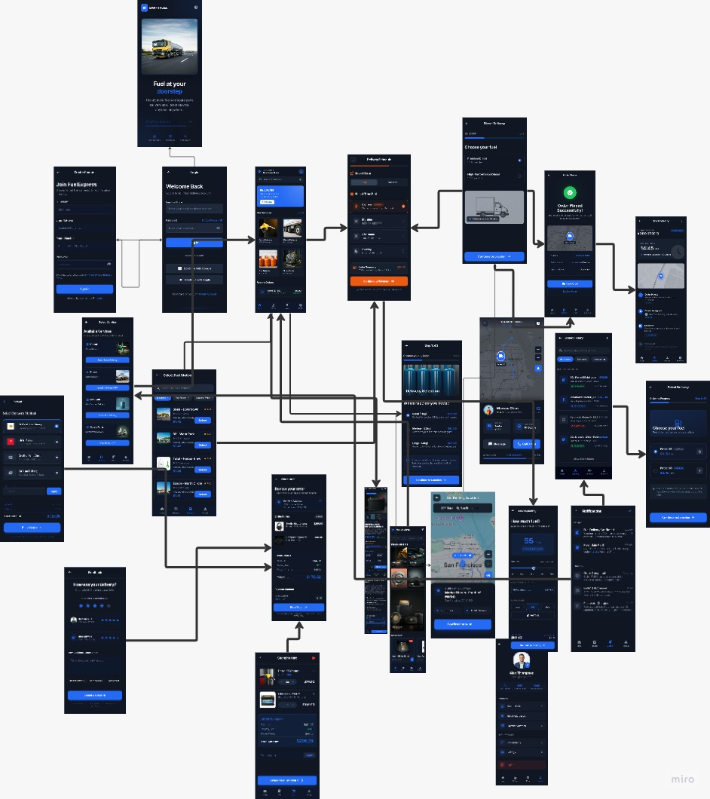

3.9 Database Design
The database design of the proposed system is represented using an Entity Relationship Diagram (ERD), which illustrates the structure of the database tables and the relationships among the main entities of the application.
The main tables in the proposed system include Customers, Vendors, Drivers, Products, Orders, Payments, Delivery Tracking, and Inventory.
The Customers table stores customer information such as customer ID, full name, phone number, and address.
The Products table stores information related to petrol, diesel, LPG cylinders, and automotive spare parts including product name, category, price, and vendor details.
The Orders table records customer transactions, order status, quantity, and total payment amount.
The Delivery Tracking table stores GPS location coordinates and delivery status updates to support real-time order tracking.
This database structure ensures data consistency, integrity, and efficient retrieval of information within the proposed application.

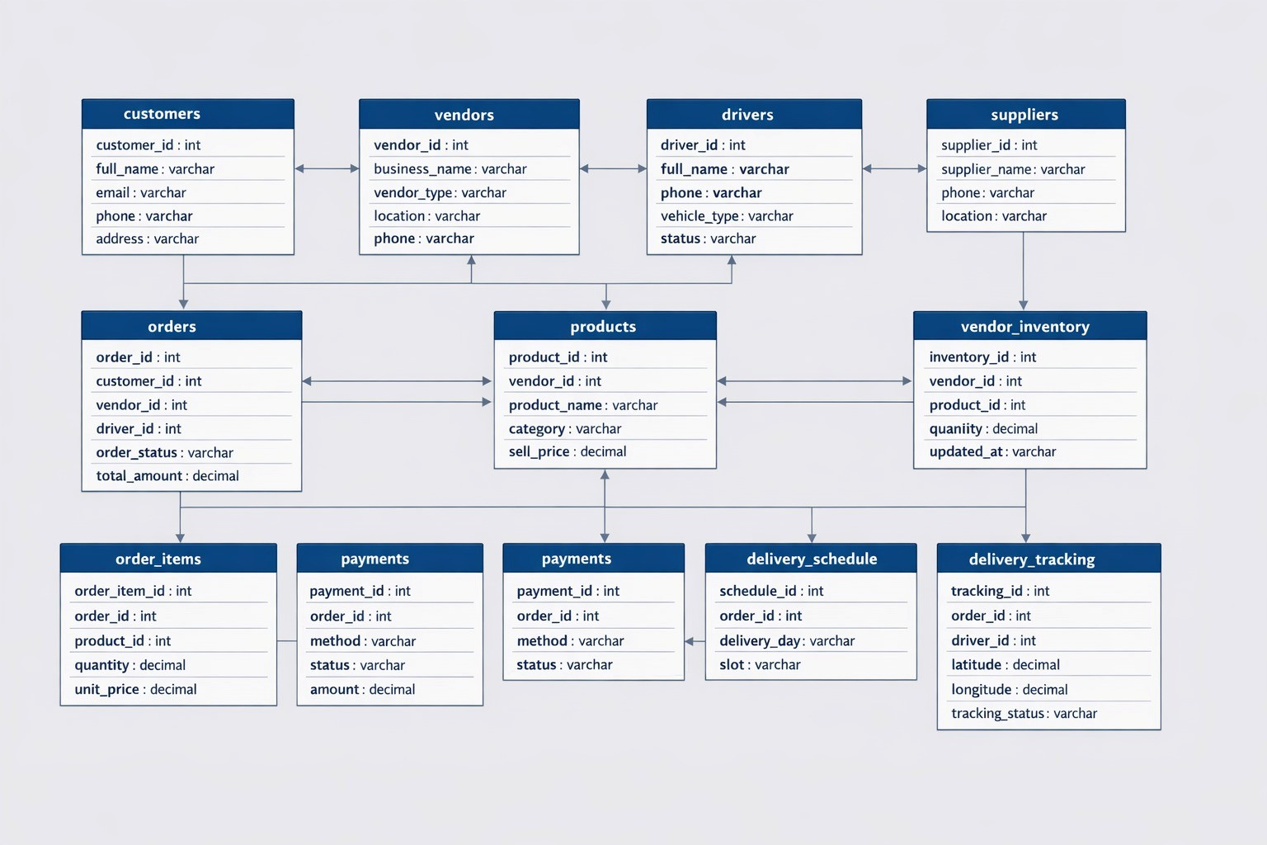

3.10 Updated System Overview (Current Implementation)
During development the system evolved from an ordering application for fuel, gas, and spare parts into a unified, multi-vendor, multi-service delivery management platform. In its current implementation the system supports four service domains, namely fuel (petrol and diesel), LPG gas cylinders, automotive spare parts, and car services, and it serves five user roles, namely administrator, vendor, customer, driver, and car services worker. The platform is delivered through two clients: a React-based web portal that serves administrators, vendors, and car services workers, and a Flutter mobile application that serves customers, drivers, and car services workers. The backend, implemented in Node.js with the Express framework and a MySQL database, additionally provides real-time communication through Socket.IO, mobile-money payment through the Waafi/EVC gateway, push notifications through Firebase Cloud Messaging, a monthly vendor subscription model, a paid module-purchase mechanism, and automated commission and settlement processing. The following sections document these additions in detail and reflect the current state of the implementation. They complement, and where indicated supersede, the earlier summary sections of this chapter.
3.11 System User Roles and Multi-Role Architecture
The system implements a multi-role architecture governed by role-based access control. Identity is centralised in a users table linked to a roles table, and each user is associated with a role-specific profile. The five roles and their responsibilities are summarised below.
Table 3.10: System User Roles
Role | Primary Responsibilities | Access Channel
Administrator | Governs the marketplace: approves and verifies vendors, manages users and roles, configures commission and categories, approves subscriptions and module-purchase requests, oversees settlements, payments, delivery zones, and reports. | Web portal
Vendor | Manages products, inventory, suppliers, purchases, orders, drivers, delivery zones, offers, reviews, car services, subscriptions, module purchases, settlements, and reports. | Web portal
Customer | Registers, browses vendors and products across all domains, places orders and car-service bookings, pays, tracks deliveries, confirms delivery by OTP, and rates services. | Mobile app
Driver | Manages availability (online/offline), accepts or rejects delivery offers, updates delivery status, streams GPS location, verifies OTP, uploads proof of delivery, and views earnings. | Mobile app
Car Services Worker | Receives and manages assigned car-service jobs, progressing them through accept, start, ready, and complete, and views job history and notifications. | Mobile app / Web portal

Each role is authenticated separately and issued a JSON Web Token carrying its role and identity. Middleware verifies the token on every request and authorises access according to the role, while ownership checks ensure that vendors, drivers, and workers can access only their own records. This multi-role design replaces the earlier single customer-vendor-admin model described in the initial sections of this chapter.
3.12 Updated System Architecture
The current architecture retains the layered, three-tier foundation described in Section 3.4 but extends it into a multi-client, service-oriented design with real-time communication and external integrations. The presentation tier now comprises two clients rather than one; the application tier exposes a role-structured REST API and a real-time socket layer; and the data tier is a MySQL relational database of more than forty tables.
3.12.1 Multi-Client Presentation Tier
• Web portal: A React (Vite) web portal, styled with Tailwind CSS, serves administrators, vendors, and workers through role-based routing, and uses Leaflet maps for delivery zones and tracking and Recharts for analytics.
• Mobile app: A Flutter (Dart) mobile application serves customers, drivers, and workers from a single codebase, communicating with the backend over REST and Socket.IO.
3.12.2 Application Tier (Backend)
The backend follows a modular Model-View-Controller structure. Route modules (admin, vendor, customer, driver, worker, auth, payment, and notification) map endpoints to controllers; controllers enforce business logic and authorisation; and model modules encapsulate all database access through a mysql2 connection pool. Cross-cutting concerns are implemented as middleware, including JWT authentication, role-based authorisation, request rate limiting, secure HTTP headers, cross-origin resource sharing control, and secured file uploads. A dedicated service layer handles the more complex operations, including checkout orchestration, payment provider integration, and notifications.
3.12.3 Real-Time Communication Layer
A Socket.IO layer, authenticated with the same JSON Web Tokens as the REST API, provides real-time features. Drivers join private rooms to receive new delivery assignments instantly, and live GPS coordinates are streamed during active deliveries so that customers can track their orders on a map. Stale socket sessions are periodically cleaned to prevent resource leaks, and expired driver tokens automatically mark the driver offline.
3.12.4 External Integrations
• Payment: Mobile-money payments are processed through the Waafi/EVC gateway, with an additional Hurmood payment path, using server-initiated payment requests and callback confirmation.
• Notifications: Push notifications are delivered to mobile devices through Firebase Cloud Messaging.
The complete technology stack of the current implementation is presented in Table 3.11. This table extends the software requirements given in Section 3.5.2.
Table 3.11: Technology Stack of the Current Implementation
Layer / Concern | Technology | Role in the System
Backend runtime and framework | Node.js, Express.js | REST API server and application logic.
Database | MySQL (mysql2 pool) | Persistent relational data storage.
Web portal | React, Vite, Tailwind CSS | Administrator, vendor, and worker web interface.
Mobile application | Flutter (Dart) | Customer, driver, and worker mobile interface.
Real-time | Socket.IO | Live driver assignment and GPS tracking.
Authentication and security | jsonwebtoken (JWT), bcryptjs, Helmet, CORS | Auth, password hashing, secure headers, origin control.
Payment | Waafi/EVC gateway, Hurmood | Mobile-money payment processing.
Notifications | Firebase Cloud Messaging | Push notifications to mobile clients.
File uploads | Multer with content verification | Secure image and document handling.
Mapping and analytics | Leaflet, Recharts | Maps and dashboard charts in the web portal.
Reporting and export | jsPDF, xlsx | PDF and Excel report generation.

3.13 Detailed System Modules
The functionality of the current system is organised into role-based modules. Each module is described below together with the principal web pages or mobile screens through which it is delivered.
3.13.1 Administrator Module
The administrator module provides central governance of the platform through the web portal. It comprises a dashboard with marketplace-wide analytics; vendor management with document preview, verification, activation, password reset, and Waafi settings; user and role management; driver oversight and live driver locations; product, category, and delivery-zone governance; commission configuration and commission reports; subscription and module-request approval; settlement review, approval, confirmation, and rejection; payment oversight and reconciliation; system settings; and reporting. The corresponding web pages include Dashboard, Vendors, Users, Drivers, Products, Inventory, Categories, Delivery Zones, Commission Reports, Settlements, Module Requests, Payments, Operations, Reports, and Settings.
3.13.2 Vendor Module
The vendor module enables service providers to operate their business through the web portal. It comprises a dashboard overview; product and inventory management; order management with acceptance, status updates, driver assignment, and delivery-proof viewing; supplier directory and purchase history; delivery-zone configuration with per-zone fees; offers and promotions; customer reviews; delivery tracking; sales, commission, and report generation with export; subscription status and payment; module listing, upgrade requests, and payment; settlement balance and requests; and the complete car services management set. The corresponding web pages include Dashboard Overview, Products Management, Inventory Management, Orders List, Order Detail, Delivery Tracking, Delivery Zones, Drivers Fleet Management, Suppliers Directory, Purchases History, Offers and Promotions, Customer Reviews, Reports and Analytics, Report Generator, Settlements, Settings, Car Wash Services, Car Wash Vehicle Pricing, Car Wash Add-ons, Car Wash Bookings, and Car Wash Booking Detail.
3.13.3 Customer Module
The customer module is delivered through the Flutter mobile application. It provides registration and login; profile and multiple saved-address management; browsing of vendors and products across fuel, gas, spare parts, and car services; product and quantity selection; a shopping cart; delivery location and time-slot selection; payment-method selection and mobile-money payment; order confirmation, order history, and order status; live driver tracking; ratings and reviews; offers; and notifications. Representative mobile screens include the home dashboard, fuel and gas selection, spare parts shop, car services booking, shopping cart, price summary, payment method selection, order status, live driver tracking, order history, saved addresses, offers, and rating and review.
3.13.4 Driver Module
The driver module, also delivered through the mobile application, provides driver login; an online/offline availability toggle; a dashboard of assigned deliveries; delivery details; acceptance or rejection of delivery offers; a delivery workflow of pickup, on-the-way, arrived, and delivered; live GPS location streaming; one-time-password verification and proof-of-delivery upload; and earnings, wallet, transactions, history, and notifications. Representative screens include the driver dashboard, assigned deliveries, delivery details, driver wallet, driver history, and driver notifications.
3.13.5 Car Services Worker Module
The car services worker module supports the staff who perform car services, formerly referred to as car wash. It provides worker login and profile management; an availability toggle; a list of assigned jobs and job details; a job workflow of accept, start, ready, and complete; job history; statistics; and notifications. It is delivered through dedicated worker screens in the mobile application and corresponding worker pages in the web portal (Worker Home, Worker Jobs, Worker Job Detail, Worker History, Worker Notifications, and Worker Profile).
3.14 Business Workflows and Process Design
This section documents the principal business processes implemented in the current system. Each workflow reflects the actual behaviour of the backend controllers, services, and models.
3.14.1 Order Lifecycle and Status Workflow
Orders progress through a validated state machine enforced by the backend. A newly placed order begins in the pending state and may move to accepted or processing, then preparing, then pending driver assignment. Once a driver is assigned the order becomes driver assigned, then on the way, then arrived, and finally delivered, after which it is marked completed. Orders may also be cancelled, or marked failed and returned for reassignment. Transitions are checked against an allowed-transition map so that invalid status changes are rejected, ensuring a consistent and auditable order history.
3.14.2 Checkout and Payment Workflow
Checkout is asynchronous and idempotent. The customer submits a checkout request bearing a client-generated request identifier; the server acknowledges immediately and processes the order in the background, validating the vendor and stock, computing a server-authoritative delivery fee from distance and vendor delivery zones, applying any offer, and creating the order. Payment is initiated through the Waafi/EVC mobile-money gateway using the customer's paying phone number, and the application polls a status endpoint until a terminal result is reached. Because the request identifier is reused on retries, a repeated or double-tapped submission resolves to the same transaction rather than charging the customer twice. On successful payment the order is confirmed and commission is deducted; on failure the pending order is cancelled and reserved stock is released, keeping financial and inventory state consistent.
3.14.3 Driver Assignment, Availability Filtering, and GPS Tracking
When an order is ready for delivery, the vendor assigns it to a driver, or a delivery offer is broadcast to available drivers. Driver assignment is filtered by online/offline availability so that only drivers who are currently online and available are offered deliveries. The accepting driver progresses through the delivery workflow while streaming GPS coordinates, which are stored as the latest known location and as a location history and relayed to the customer in real time through the socket layer. Delivery is completed only after the customer provides the one-time password and the driver verifies it and uploads photographic proof.
3.14.4 Commission and Settlement Workflow
The platform earns commission on transactions at a rate configured centrally by the administrator and stored in the settings table. Commission is recorded per transaction, and vendor settlements are generated automatically together with their constituent settlement items. Vendors can view their settlement balance and request settlement; administrators review, approve, confirm, or reject settlements; and a settlement history is retained for auditability.
3.14.5 Vendor Subscription Workflow
Vendors operate under a monthly subscription model. Subscription pricing is defined and maintained centrally by the administrator, with a pricing history. A vendor subscribes or renews by making a mobile-money payment, which is recorded as a subscription payment; an active subscription grants access to the vendor portal and its modules, while expiry restricts access until renewal. Administrators can view a subscription overview and approve or reject subscription records.
3.14.6 Module Purchase (Upgrade) and Vendor Approval Workflow
By default a vendor is enabled for a base service domain. To offer an additional domain, for example a gas vendor adding car services or spare parts, the vendor submits a paid module-upgrade request. The request is validated by a mobile-money payment and then reviewed by an administrator, who may approve or reject both the request and its payment. Upon approval the corresponding vendor business type is activated, unlocking the new module for that vendor. Vendor participation itself is also gated by an administrator approval and verification step, during which the vendor's business and identity documents are reviewed before the vendor is activated.
3.14.7 Car Services Booking Workflow
The car services module allows customers to book services rather than order physical goods. A customer selects a vendor, a service, and a vehicle type, chooses optional add-ons, and either schedules a time slot or requests an express (immediate) booking; the system checks availability before confirming. Pricing is derived from the service, the vehicle type, and the selected add-ons. The booking is paid through mobile money and assigned to a car services worker, who progresses it through accept, start, ready, and complete. A booking status history is maintained, and the customer may rate the completed service. This module is supported by dedicated tables for services, vehicle types, add-ons, bookings, booking add-ons, and booking status history.
3.14.8 Inventory, Supplier, and Purchase Management
Vendors manage inventory for fuel, gas cylinders, and spare parts, with stock levels maintained and safeguarded against invalid values. Vendors also maintain a directory of suppliers and record purchases, providing the basis for stock replenishment and cost tracking. Inventory is decremented when orders are placed and is protected by server-side validation and stock-floor checks.
3.15 API Design and Endpoint Structure
The backend exposes a RESTful application programming interface over HTTP, communicating in JavaScript Object Notation and secured by bearer JSON Web Tokens. Endpoints are grouped by role under versioned prefixes, and standard HTTP verbs and status codes are used, including the 202 Accepted response used by the asynchronous checkout process and the 409 Conflict and 429 Too Many Requests responses used for stale data and rate limiting respectively. The principal endpoint groups are summarised in Table 3.12.
Table 3.12: Principal API Endpoint Groups
Endpoint Group | Representative Operations
/api/auth | Login, staff login, Google sign-in, logout, change password, heartbeat.
/api/admin | Vendors, users, drivers, orders, products, inventory, payments, categories, commissions, settlements, subscriptions, module requests, delivery zones, settings, reports.
/api/vendor | Products, orders, inventory, suppliers, purchases, drivers, delivery zones, offers, reviews, reports, subscriptions, modules, settlements, car-wash services, add-ons, and bookings.
/api/customer | Registration, login, vendors and products, addresses, offers, orders, checkout, tracking, reviews, car-wash catalogue and bookings, notifications.
/api/driver | Login, profile, deliveries and status transitions, accept/reject, pickup, on-the-way, arrived, delivered, location, verify code, upload proof, offers, online-status, earnings.
/api/worker | Login, profile, availability, jobs and job transitions (accept, decline, start, ready, complete), notifications, statistics.
/api/payment | Payment providers, transaction creation, callbacks, and status.
/api/notifications | List notifications, unread count, mark read, register push token.

3.16 Security Design
Security is enforced across the request pipeline through multiple complementary controls.
3.16.1 Authentication
All users authenticate through stateless JSON Web Tokens issued at login and verified on every request by middleware. Passwords are hashed using bcrypt and are never stored in plain text. Login attempts are rate-limited per client and account, and a global rate limiter mitigates abuse; expired driver tokens automatically mark the driver offline to keep availability accurate.
3.16.2 Authorization and Role-Based Access Control
Authorization is enforced by role-based access control middleware that checks the token's role against each route, and by object-level ownership checks that prevent insecure direct object references, ensuring that a vendor, driver, or worker can access only their own records. Vendor module restrictions further ensure that a vendor can use only the service modules that have been activated for their account.
3.16.3 Input Validation and API Validation
All input is validated on the server, independently of client-side checks, so that malformed or malicious payloads are rejected before reaching the database. Database access uses parameterised prepared statements throughout, preventing structured-query-language injection. Business rules, including order contents, payment method, addresses, phone numbers, pricing, stock levels, and status transitions, are validated server-side.
3.16.4 File Upload and Payment-Number Validation
Uploaded files are content-verified so that only genuine image and document bytes are accepted; they are stored under random, non-executable names and served with strict security headers, and sensitive vendor documents are served only through an authenticated, ownership-checked endpoint. Payment phone numbers are validated for the mobile-money gateway before a payment request is initiated.
3.16.5 Error Handling
The backend applies centralised error handling that returns clean, meaningful status codes and messages for client errors while withholding internal details for server errors, and dedicated handlers translate upload and validation failures into clear responses. This protects the system from information disclosure while giving clients actionable feedback.
3.17 Updated Database Design
The database has grown substantially beyond the tables summarised in Section 3.9. The current schema is a normalised relational design implemented in MySQL and comprising more than forty inter-related tables, organised into functional groups. Primary keys are auto-incremented integers, foreign keys enforce referential integrity, and indexes are applied to frequently queried columns such as driver and delivery identifiers. Table 3.13 documents the principal tables of the current implementation. This updated documentation supersedes the earlier summary in Section 3.9, which remains for reference.
Table 3.13: Principal Database Tables of the Current Implementation
Functional Group | Tables | Purpose
Identity and access | users, roles | Central authentication and role-based access control.
Role profiles | customers, vendors, drivers, car_wash_workers | Role-specific profile records linked to users.
Catalogue and stock | products, categories, inventory, suppliers, purchases | Vendor catalogue, classification, stock, supply, and purchases.
Ordering | orders, order_items, order_destinations | Customer orders, line items, and multiple delivery points.
Delivery | deliveries, delivery_offers, driver_locations, driver_location_history | Delivery fulfilment, driver offers, and live and historical GPS.
Payments | payments, hurmood_payments | Payment records and mobile-money transaction data.
Commission and settlement | commissions, vendor_settlements, vendor_settlement_items, vendor_settlement_history | Commission and automated vendor settlement with history.
Subscription and modules | vendor_subscription_payments, subscription_pricing, module_upgrade_requests, business_types, vendor_business_types | Monthly subscription, pricing, and paid module purchase.
Car services | car_wash_bookings, car_wash_services, car_wash_vehicle_types, car_wash_addons, car_wash_booking_addons, car_wash_booking_status_history | Car-service catalogue, bookings, add-ons, and status history.
Location and zones | addresses, customer_locations, vendor_delivery_zones | Customer addresses, locations, and vendor delivery zones with fees.
Engagement | offers, offer_products, offer_analytics, reviews, customer_vendor_favorites | Promotions, ratings, and customer preferences.
Notifications and settings | notifications, admin_notifications, vendor_notifications, notification_logs, settings | Multi-channel notifications and system configuration.

Key relationships include the following: a user has exactly one role and one role-specific profile; a vendor owns many products, drivers, delivery zones, offers, and car services; a customer places many orders and car-service bookings; an order contains many order items and destinations and is fulfilled by one delivery; a delivery is performed by one driver and produces location history; a car-service booking references one service and one vehicle type and may include several add-ons; and commissions and settlements are derived from completed orders. An updated Entity Relationship Diagram reflecting this schema should be placed in the appendix.
3.18 User Interface and Responsive Design Improvements
The current interfaces apply consistent visual design, clear navigation, and role-appropriate dashboards across both clients. The React web portal is responsive across desktop and mobile screen sizes and presents each role with only the functions relevant to it, while the Flutter mobile application follows platform conventions and provides guided, step-by-step ordering and booking flows. Real-time visual feedback is provided for order status and live delivery tracking, and map-based interfaces are used for delivery zones and driver tracking. These improvements reduce the effort required of non-technical users and increase transparency and trust.
3.19 Deployment Architecture
In deployment, the system is organised as a set of cooperating components. The Node.js and Express backend runs as an application server that exposes the REST API and the Socket.IO endpoint and connects to a MySQL database server through a connection pool. Uploaded media are stored on the server file system, with public media served statically under controlled options and sensitive documents served only through authenticated endpoints. The React web portal is built into static assets served to administrators, vendors, and workers, while the Flutter application is distributed to customers, drivers, and workers as an Android mobile application. External services, namely the Waafi/EVC mobile-money gateway and Firebase Cloud Messaging, are integrated over the network. Security controls, including secure headers, cross-origin resource sharing restrictions, and rate limiting, are applied at the application boundary. A deployment diagram illustrating these components should be placed in the appendix.
3.20 Updated UML Design Models
To reflect the current implementation, the UML models of Section 3.8 are extended with the following diagrams, which should be prepared and placed in the appendix with appropriate figure numbering.
• Use case diagram: An updated use case diagram showing the five actors (administrator, vendor, customer, driver, and car services worker) and their use cases, including subscription, module purchase, car-service booking, driver assignment, settlement, and reporting.
• Class diagram: A class diagram of the core domain model, including User, Role, Customer, Vendor, Driver, Worker, Product, Category, Inventory, Supplier, Order, OrderItem, OrderDestination, Delivery, Payment, Commission, Settlement, Subscription, ModuleUpgradeRequest, Offer, Review, CarWashBooking, CarWashService, and CarWashVehicleType, with their associations.
• Sequence diagram: A sequence diagram of the customer order-and-delivery flow, covering idempotent checkout, payment confirmation, driver assignment over the socket layer, GPS tracking, and OTP-verified completion.
• Activity diagram: An activity diagram of the end-to-end order lifecycle, including the payment-success decision, stock release on failure, driver fulfilment, and settlement.
• Car-service activity diagram: An activity diagram of the car-service booking workflow, covering service and vehicle selection, add-ons, time-slot or express scheduling, availability checking, worker job progression, and rating.

