# Lesson 1

1. **Which of the following properties of water makes it essential for life on Earth?**

**A-Increased density when frozen B-Ability to dissolve many substances C-Decreased density in the liquid state D-Lower boiling point**

1. **Which of the following represents the largest source of water on the Earth's surface? A-Oceans. B-Fresh lakes. C-Groundwater. D-Glaciated rivers**
2. **What is the percentage that oceans, seas and salty lakes represent from the total area of liquid water covering the Earth's surface?**

A-70% B- 97% C- 3% D- 30%

1. **What are the two essential elements that make up a water molecule**

**A-Carbon and hydrogen B-Nitrogen and oxygen**

**C-Hydrogen and oxygen D-Chlorine and sodium**

1. **Which element represents the largest volumetric ratio in the chemical composition of water?**

**A-Hydrogen B-Oxygen C-Both are equal D-Cannot be determined**

1. **Which element represents the largest proportion of the mass of a water molecule?**

**A-Hydrogen B-Oxygen C-Both are equal D-Cannot be determined**

1. **What type of chemical bonds connect the hydrogen and oxygen atoms in a watermolecule?**

**A-Ionic bonds B-Covalent bonds C-Metallic bonds D-Hydrogen bonds**

1. **What is the approximate value of the angle between the covalent bonds in a watermolecule? A-90° B-104° C-120° D-180°**
2. **Which of the following correctly describes the hydrogen and hydroxide ions in purewater? A-They are present in equal amounts B-They are present in very large amounts**

**C-They are present in very small amounts D-Cannot be determined**

1. **What happens when salt dissolves in water?**

**A-The concentration of hydrogen ions always increases**

**B-The concentration of hydroxide ions always increases**

**C-The concentration of either hydrogen or hydroxide ions may increase dependingon the type of salt**

**D-There is no change in the concentration of ions**

1. **what determines the acidity or alkalinity of water?**

**A-Concentration of sodium ions B-Concentration of chloride ions C-Concentration of hydrogen and hydroxide ions D-Temperature of the water**

1. 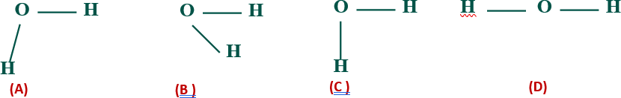**Which of the following diagrams correctly represents the structure of a watermolecule and the angle between the two covalent bonds in it**
2. **In the opposite figure what is the type of bond?**

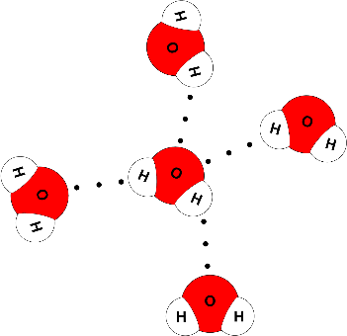

|  |  |  |
| --- | --- | --- |
|  | **In the water molecule** | **between water molecules** |
| **A** | **Covalent** | **Hydrogen** |
| **B** | **Covalent** | **Covalent** |
| **C** | **Hydrogen** | **Covalent** |
| **D** | **Hydrogen** | **Hydrogen** |

1. **The plant gets rid of water through the stomata, a process known as……..**

A-Transpiration B-Breathing C-digestion D-Absorption

1. What is the process in which the plant loses a part of its water content to the atmosphere?
   1. Photosynthesis b) Transpiration c) Diffusion d) Osmosis
2. What is the biological process that the animals perform and share through it in the water cycle in nature? A-Respiration B-Transpiration C-Photosynthesis D-Growth
3. The water cycle in nature is known as... cycle.

A-hydrogen b-biogeochemical c-hydro-electric d-hydrologic

1. How does water return from land to oceans?

A-By evaporation B-By flowing C-By condensation D- By volatility

1. Which of the following processes may be a direct source of groundwater?
   1. Water evaporation. c) Transpiration in plants.
   2. Water infiltration (leakage) d) Respiration in humans.
2. **Transpiration and respiration are vital processes that exist in the hydrological cycle. These vital processes occur as follows: Management of the development of thematerial**

|  |  |  |
| --- | --- | --- |
| **choice** | **Transpiration occurs in** | **Breathing occurs in** |
| **A** | **Plant without animal** | **Plants and animals** |
| **B** | **Plant without animal** | **Animal without plant** |
| **C** | **Plants and animals** | **Plants and animals** |
| **D** | **Plant and animal** | **Plants and animals** |

1. **Read statements carefully, then choose: When table salt dissolves in water, thesodium and chloride ions are surrounded by water molecules,**

Statement (1): The sodium ions are surrounded by water molecules, and the water isattracted from the oxygen side.

Statement (2): The chloride ions are surrounded by water molecules, and the water isattracted from the oxygen side

|  |  |  |
| --- | --- | --- |
|  | **statement (1)** | **statement (2)** |
| **A** | **right** | **right** |
| **B** | **false** | **right** |
| **C** | **right** | **false** |
| **D** | **false** | **false** |

1. **Water is a polar compound because:**

A-Oxygen carries a positive charge; hydrogen carries a negative charge

B-The electronegativity of hydrogen is greater than the electronegativity of oxygen

C-Oxygen carries a partial positive charge; hydrogen carries a partial negative charge D-Oxygen carries a partial negative charge; hydrogen carries a partial positive charge

1. **The polarity of the water molecule is due to:**

A-Oxygen carries a positive charge; hydrogen carries a negative charge

B-The electronegativity of hydrogen is greater than the electronegativity of oxygen

C-Oxygen carries a partial positive charge; hydrogen carries a partial negative charge D-Oxygen carries a partial negative charge; hydrogen carries a partial positivecharge

1. **When comparing the boiling point of water with the boiling point of a compoundsimilar in composition, such as hydrogen sulfide, we notice:**

A-The boiling point of water is high, due to the presence of hydrogen bonds betweenits molecules

B-The boiling point of water decreases due to the presence of hydrogen bondsbetween its molecules

C-The boiling point of hydrogen sulfide is high, due to the presence of hydrogenbonds between its molecules

D-The boiling point of hydrogen sulfide is low, due to the presence of hydrogenbonds between its molecules

1. **All of the following are consequences of the polarity of the water molecule except:**

A-Water molecules are linked together by hydrogen bonds

B-The ability to dissolve many mineral salts

C-The boiling point of water rises to 100

D-The ability to dissolve a non-polar organic compound

1. **Four students measured the pH value of four water samples and recorded the valuein the table in the designated place:**

|  |  |  |  |  |
| --- | --- | --- | --- | --- |
| **Student** | **a** | **b** | **c** | **d** |
| **Water** | **Sea water** | **Fresh water** | **Distilled water** | **Clouds** |
| **PH** | **7** | **5.5** | **5** | **4.5** |

Which student's measurement was correct?

A-a B-b C-c D-d

1. **Four students measured the pH value of four water samples and recorded the valuein the table in the designated place**

|  |  |  |  |  |
| --- | --- | --- | --- | --- |
| **STUDENT** | **a** | **b** | **c** | **d** |
| **WATER** | **cloud** | **Ground water** | **sea water fresh** | **SEA WATER** |
| **PH** | **6** | **7** | **7** | **8** |

Which student was measured wrong? A-a B-b C-c D-d

1. **Which of the following graphs expresses the percentage of water and the percentageof land on the surface of the Earth?**

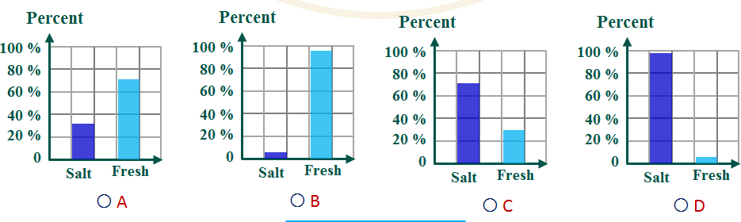

1. **Which of the following graphs expresses the ratio of salt water to fresh water on thesurface of the Earth?**

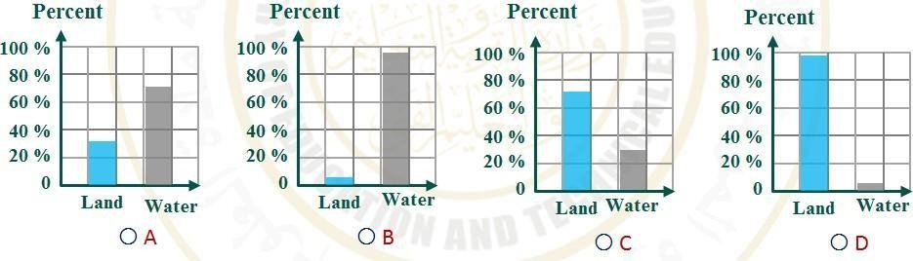

1. **Which of the following graphs represents the pH of a sample of seawater (X) andanother sample of clouds?**

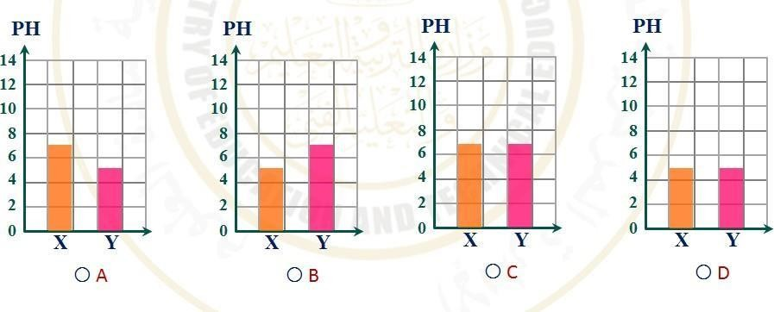

1. **Which of the following graphs represents the pH of a sample of table salt solution (X)and another sample of Ammonium chloride (Y) ?**

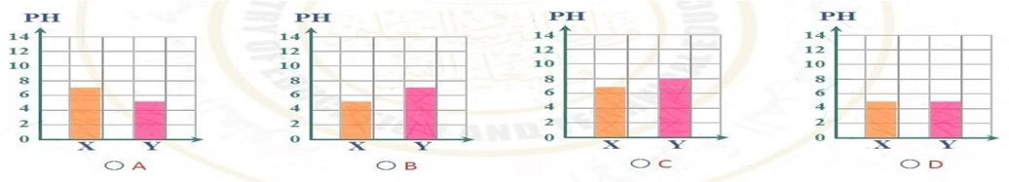

1. **Which of the following graphs represents the pH of a sample of table salt solution (X)and another sample of Sodium bicarbonate (Y) ?**



1. **When electrolysis was performed on a quantity of water and the resulting hydrogengas and oxygen gas were collected separately, the total volume is equal to 60 cm3. Then**

|  |  |  |
| --- | --- | --- |
|  | **Hydrogen gas volume** | **Oxygen gas volume** |
| **A** | **60 cm³** | **60 cm³** |
| **B** | **30 cm³** | **30 cm³** |
| **C** | **20 cm³** | **40 cm³** |
| **D** | **40 cm³** | **20 cm³** |

1. **When sodium chloride is dissolved in water, then**

|  |  |  |
| --- | --- | --- |
|  | **hydrogen ion concentration** | **hydroxyl ion concentration** |
| **A** | **It decreases** | **It decreases** |
| **B** | **Doesn't change** | **Doesn't change** |
| **C** | **It increases** | **It decreases** |
| **D** | **It decreases** | **It increases** |

1. **When sodium bicarbonate dissolves in water, then**

|  |  |  |
| --- | --- | --- |
|  | **hydrogen ion concentration H+** | **OH--** |
| **A** | **It decreases** | **It decreases** |
| **B** | **Doesn't change** | **Doesn't change** |
| **C** | **It decreases** | **It decreases** |
| **D** | **It decreases** | **It decreases** |

1. **When ammonium chloride salt is added to water, then**

|  |  |  |
| --- | --- | --- |
|  | **hydrogen ion concentration** | **hydroxyl ion**  **concentration** |
| **A** | **It decreases** | **It decreases** |
| **B** | **Doesn't change** | **Doesn't change** |
| **C** | **It increases** | **It decreases** |
| **D** | **It decreases** | **It increases** |

1. **The solution resulting from dissolving table salt in water is neutral because**

A-The salt ions remain in the solution due to their association with water ions

B-The association of all salt ions in the solution with water ions

C-Sodium ions in solution bind to water ions

D-The association of chloride ions in solution with water ions

1. **The solution resulting from dissolving sodium bicarbonate in water is basic because?**

A-The concentration of [H] ions equals the concentration of |OH ions

B-The concentration of [H] ions decreases and the concentration of |OH ionsincreases

C-Increase in [H] ion concentration and decrease in |OH| ion concentration

D-Low concentration of [H] ions and low concentration of 1-OH ions

1. **The solution resulting from dissolving ammonium chloride salt in water is acidicbecause**

A-The concentration of [H] ions is equal to the concentration of [OH] ions

B-Low concentration of [H] ions and high concentration of [OH] ions

C-Increase the concentration of [H] ions and low concentration of [OH] ions

D-Low ion concentration of [H] ions and a decrease in the concentration of OH ions

1. **Table salt solution**

|  |  |  |  |
| --- | --- | --- | --- |
|  | **Solution type** | **lationship [H] andOH** | **PH value** |
| **A** | **Neutral** | **[OH = [H+]** | **Equals 7** |
| **B** | **Acidic** | **[OH]<[H]** | **Less than 7** |
| **C** | **Neutral** | **[OH]<[H]** | **Equals 7** |
| **D** | **Basic** | **[OH]>[H+]** | **Greater than 7** |

1. **Sodium bicarbonate solution**

|  |  |  |  |
| --- | --- | --- | --- |
|  | **Solution type** | **relationship[H]andOH** | **PH value** |
| **A** | **Neutral** | **[OH = [H+]** | **Equals 7** |
| **B** | **Acidic** | **[OH]<[H]** | **Less than 7** |
| **C** | **Neutral** | **[OH]<[H]** | **Equals 7** |
| **D** | **Basic** | **[OH]>[H+]** | **Greater than 7** |

1. **ammonium Chloride solution**

|  |  |  |  |
| --- | --- | --- | --- |
|  | **Solution type** | **The relationship[H]andOH** | **PH value** |
| **A** | **Neutral** | **[OH = [H+]** | **Equals 7** |
| **B** | **Acidic** | **[OH]<[H]** | **Less than 7** |
| **C** | **Neutral** | **[OH]<[H]** | **Equals 7** |
| **D** | **Basic** | **[OH]>[H+]** | **Greater than 7** |

1. **Which of the following salts dissolves in water and produces an acidic solution? A-Sodium chloride B-Ammonium chloride**

C-Sodium bicarbonate D-Ammonium acetate

1. **Which of the following salts, when dissolved in water, produces a basic solution? A-Sodium chloride B-Ammonium chloride**

C-Sodium bicarbonate D-Ammonium acetate

1. **Which of the following values expresses the pH when some carbon oxides or sulfuroxides are dissolved in distilled water?**

A-5 B-7 C-7.5 D-8.4

1. **Which of the following values expresses the pH of salt water in seas and oceans? A-4.5:5 B-7.5:8.4 C-6.5:8.5 D-7**
2. **Which of the following values expresses the pH of the clouds?**

A-4.5:5 B-7.5:8.4 C-6.5:8.5 D-7

1. **Which of the following values expresses the pH of distilled water?**

A-4.5:5 B-7.5:8.4 C-6.5:8.5 D-7

1. **Which of the following values expresses the pH of fresh water in rivers and lakes? A-4.5:5 B-7.5:8.4 C-6.5:8.5 D-7**
2. **Which of the following types of water can be acidic, neutral, or basic? A-Salt water B-Fresh water C-Groundwater D-Clouds**
3. **Which of the following types of water can be acidic?**

A-Salt water B-Fresh water C-Groundwater D-Distilled water

1. **All of the following types of water can be basic except**

A-Salt water B-Fresh water C-Groundwater D-Clouds

1. **Read each of the two sentences carefully, then choose:**

Statement (1): Water reacts with carbon oxides and sulfur oxides in the air, forming acid rain.

Statement (2): Acid rain causes the dissolution of rocks.

|  |  |  |
| --- | --- | --- |
| **choice** | **Statement (1):** | **Statement (2)** |
| **A** | **Right** | **Right** |
| **B** | **False** | **Right** |
| **C** | **Right** | **False** |
| **D** | **False** | **False** |

|  |  |  |
| --- | --- | --- |
| **54.Groundwater…..**  **A-Acidic, neutral or basic** | **B-Neutral or acidic C-Neutral or basic** | **D-Acidic or basic** |
| **55.Fresh water…..**  **A-Acidic, neutral or basic** | **B-Neutral or acidic C-Neutral or basic** | **D-Acidic or basic** |
| **56.Sea water is** |  |  |

A-Acidic B-Neutral or acidic C- basic D-Acidic or basic

1. **Distilled water**

A-Acidic, neutral or basic B-Neutral C-Neutral or basic D-Acidic or basic

1. **Distilled water to which another type of water was added, so the water becameacidic. The type of water added is:**

A-Sea water B-Groundwater C-Clouds D-Distilled water

1. **A continuous change between the three states of water on the Earth’s surface withina closed system called the cycle.**

A-nitrogenous B-Carbonaceous C-Oxygenation D-Hydrology

# Lesson 2

1. **The density of water is equal to 1g/ cm3 at a temperature of 4℃, when thetemperature is raised to 8℃ the:**

|  |  |  |
| --- | --- | --- |
| **Choice** | **Water Volume** | **Water Density** |
| **A** | **Increases** | **Increases** |
| **B** | **Increases** | **Decreases** |
| **C** | **Decreases** | **Increases** |
| **D** | **Decreases** | **Decreases** |

1. **The density of water is equal to 1g/ cm3 at a temperature of 4℃, then the mass of 4m3 of water is equal to**

A-0.004 Kg B-4000 Kg C-4 Kg D-1 Kg

1. **From the graph shown, it can be concluded that**

A-The density of water increases by raising the temperature above 4℃

B-The density of water increases by lowering the temperature below 4℃

C-The volume of water increases by lowering the temperature below 4℃

D-The volume of water decreases as the temperature decreases below 4℃

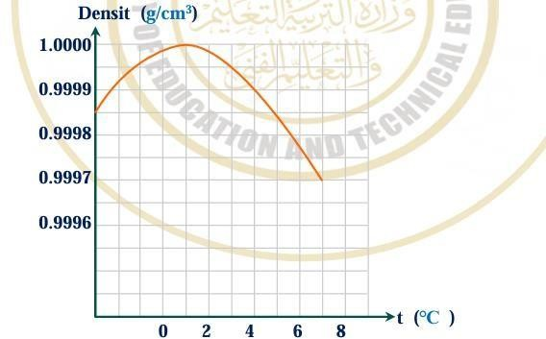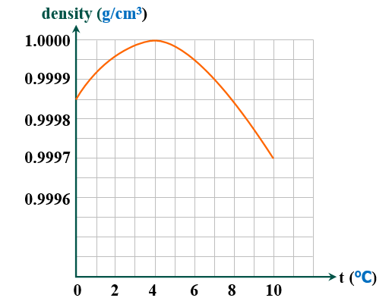

1. **Both the volume of water and the density of water change with temperature Whathappens during the procedure described?**

|  |  |  |
| --- | --- | --- |
| **Choice** | **Water Volume** | **Water Density** |
| **A** | **Increases** | **Increases** |
| **B** | **Increases** | **Decreases** |
| **C** | **Decreases** | **Increases** |
| **D** | **Decreases** | **Decreases** |



1. **Both the volume of water and the density of water change with temperature Whathappens during the procedure described?**

|  |  |  |
| --- | --- | --- |
| **Choice** | **Water Volume** | **Water Density** |
| **A** | **Increases** | **Increases** |
| **B** | **Increases** | **Decreases** |
| **C** | **Decreases** | **Increases** |
| **D** | **Decreases** | **Decreases** |



1. **Calculate the salinity of the solution resulting from dissolving 70 g of table salt, in acup of pure water and increase the volume of the solution to 2 L.**

A-70 g/L B-140 g/L C-35 g/L D-17.5 g/L

1. **An ocean water salinity of 35g/L means**

A-Each 1 L of solution contains 35 g of salt B-Every 1 g of solution contains 35 L of salt C-Every 35 g of solution contains 1 L of salt D-Every 35 L of solution contains 1 g of salt.

1. **All of the following are sources of water-soluble carbon dioxide except**

A-Atmosphere B-Sea creatures C-Decomposition of organic matter D-Photosynthesis

1. **Analyze the graph shown**

From the figure, it is clear that by raising thetemperature the:

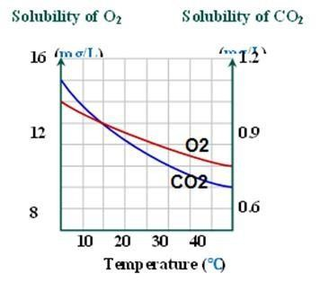a- N2 solubility decreases at a greater rate thanCO2 solubility

B-The solubility of CO2 decreases at a greater ratethan the solubility of O2

C-The solubility of both O2, CO2 decreases at thesame rate

D-The solubility of O2, CO2 is increasing at thesame rate

1. **Increasing the percentage of CO2 gas in the water works**

A-Increase acidification, increase calcification

B-Increase acidification, reduce calcification

C-Reduce acidification, increase calcification

D-Reduce acidification, reduce calcification

1. **Which of the following causes a low Ph**

A-Increased O2 B-Increased CO2 C-Decreased O2 D-Decreased CO2

1. **Four samples of water each have a mass of 1 Kg, which one has a larger volume: A-Salt water at 4℃ B-Fresh water at 4℃**

C-Salt water at 8℃ D-Fresh water at 8℃

1. **Which of the following changes causes the density of 2℃ water to decrease A-Reduce its temperature by 4℃ B-Reduce its temperature by 1℃**

C-Dissolve table salt in it D-Exposing it to very high pressure with a constant temperature

1. **When the temperature of pure water is increased from 0℃ to 8℃. its density**

A-Increases B-Decreases C-Decreases then increases D-Increases then Decreases

1. 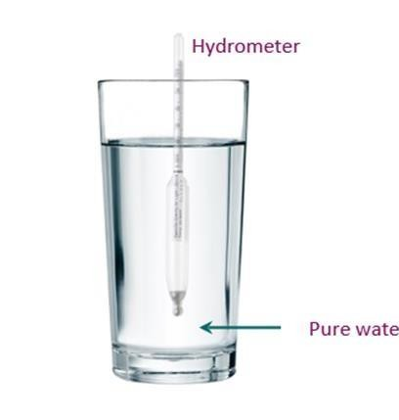**In the diagram shown, when a large amount of salt is dissolved in pure water. the volume of the fraction of a hydrometer in the water**

A-Increases B- Decrease

C-Doesn’t change D-Cannot be determined

1. **The density of water is 1g/cm3 at a temperature of 40C. This means that: A-The mass of 1 cm3 of water is 1 Kg B-The mass of 1cm3 of water is 1 g C-The mass of 1 m3 of water is 1 g D-The mass of 1 cm3 of water is 1 L**
2. **The density of water is 1g/cm3 at a temperature of 4C. It is equivalent to A-0.001 Kg/m3 B-1 Kg/m3 C-1000 Kg/m3 D-4 Kg/m3**
3. **The density of water is equal to 1g/cm3 at a temperature of 4C. When thetemperature is decreased to 0 C, then**

|  |  |  |
| --- | --- | --- |
|  | **The volume of water** | **The density of water** |
| **A** | **Increases** | **Increases** |
| **B** | **Increases** | **Decreases** |
| **C** | **Decreases** | **Increases** |
| **D** | **Decreases** | **Decreases** |

1. **When the water temperature is increased from 0 C to 4 C, then:**

|  |  |  |
| --- | --- | --- |
|  | **The volume of water** | **The density of water** |
| **A** | **Increases** | **Increases** |
| **B** | **Increases** | **Decreases** |
| **C** | **Decreases** | **Increases** |
| **D** | **Decreases** | **Decreases** |

1. **The maximum value of water density is at a temperature equal A-0 C B-2 C C-4 C D-6 C**
2. **The anomalous expansion of water occurs when:**

A-Its temperature is increased from 0 C to 4 C

B-Its temperature is increased from 4 C to room temperature

C-Its temperature is decreased from 4 C to 0 C

D-Its temperature is increased from room temperature to 4 C

1. **The relative density of seawater is 1.025. This means that the density ofseawater is equal to:**

|  |  |  |
| --- | --- | --- |
|  | **g/cm3** | **Kg/m3** |
| **A** | **1.025** | **1.025** |
| **B** | **1025** | **1025** |
| **C** | **1.025** | **1025** |
| **D** | **1025** | **1.025** |

1. 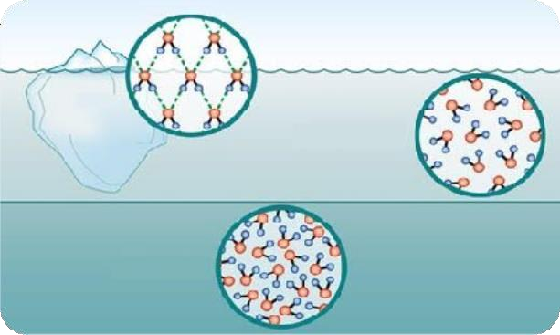**From the figure shown, the reason for the difference in density between water1 andwater 2 is due to the difference in**

A - Molecular mass

B-Temperature

C-Molecular volume

D-Bonds between atoms

1. **The density of water is 1g/cm3 at a temperature of 4C, so the volume of 4 kgof water is equal to**

A-0.004 m3 B-4000 m3 C-4 m3 D-1 m3

1. **When the melted glacier water enters the ocean, they**

**(2)**

**(1)**

A-Mix because both of them are liquid water with the same density

B-Don’t mix and the salt water floats on the surface of the fresh water

C-Don’t mix and the fresh water floats on the surface of the salt water

D-Don’t mix and floats either of them according to its temperature 85-From the graph shown.

The volume of a quantity of water with a mass of 2 kg at a temperature of 4 C isequal to A-0.002 m3 B-2000 m3 C-2 m3 D-4 m3

1. **From the graph shown, we can conclude that: A-The density of water increases when the temperature is raised above 4 ℃**

B-The density of water increases when the temperature is lowered below 4 ℃

C-The volume of water increases when the temperature is lowered below 4 ℃

D-The volume of water decreases when the temperature is lowered below 4 ℃

1. **Both the volume and density of water change with temperature.**

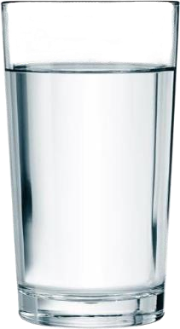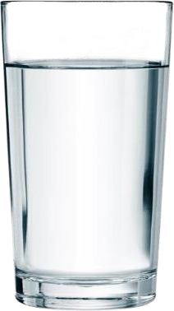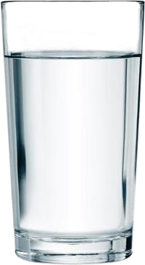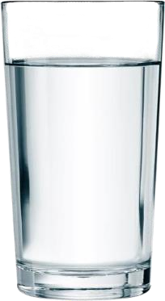

What happens during the process shown? 4°C 23°C

|  |  |  |
| --- | --- | --- |
|  | **The volume of water** | **The density of water** |
| **A** | **Increases** | **Increases** |
| **B** | **Increases** | **Decreases** |
| **C** | **Decreases** | **Increases** |
| **D** | **Decreases** | **Decreases** |

1. 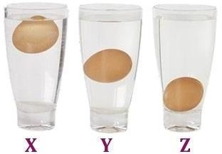**The figure shows three cups of water of different salinities, at the same temperature. An egg is placedin each of them (and the eggs are completely identical). The arrangement of the water according to density is:**

A-X=Y=Z B- X>Y>Z C-Z>Y>X D-Z>Y=X

89-A sample of water has a density of 1 g/cm3. This sample is:

A-Distilled water at 4 C B-Distilled water at 0C-Distilled water at 8 CD-Distilled water at 23 C

90-Which of the following devices is used to measure the density of liquids?

A-Hydrometer B-Barometer C-Manometer D-Thermometer 91-Hydrometer scale:

A-The lower scale indicates zero B-The upper scale indicates zero

C-The lower scale indicates the lowest density D-The upper scale indicates the lowestdensity

1. **In the hydrometer:**

|  |  |  |
| --- | --- | --- |
|  | **The function of wide**  **cavity** | **The function of**  **mercury** |
| **A** | **Floating** | **Vertical balance** |
| **B** | **Floating** | **Floating** |
| **C** | **Vertical balance** | **Floating** |
| **D** | **Vertical balance** | **Vertical balance** |

1. **In a hydrometer, the density of the liquid is maximum when**

A-The volume of the immersed part of hydrometer in the liquid increases

B-The volume of the immersed part of hydrometer in the liquid decreases

C-The coefficient of adhesion of the liquid to the glass decreases

1. **In a hydrometer, which of the following materials can be used to help balance:**

A-Mercury or lead B-Nickel or chromium

C-Platinum or iridium D-Bronze or phosphorus

1. **Calculate the mass of table salt that must be added to a cup of pure water and complete the volume of the solution to 0.25 L so that the salinity of the solution is 35 g/L**

A-8.75 g B-17.5 g C-35 g D-70 g

1. **Which of the following cups shown contains the maximum density of water? A-a**

B-b

C-c

D-d

1. 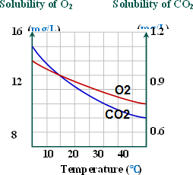**Which of the following relationships can be used to calculate the salinity of anaqueous solution:**

A-(salt mass)/(salt volume) = salinity

B-(mass of salt dissolved in water)/(solution volume) = salinity C-solution volume × mass of dissolved salt in water= salinity D-(solution volume)/(water in solute salt mass) = salinity

1. **Ocean currents transport**

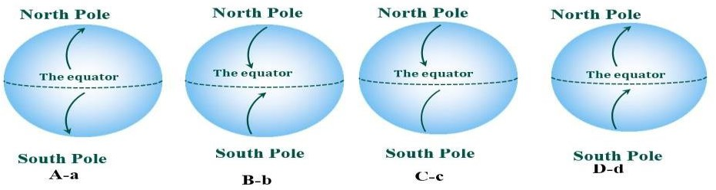A-Heat from the poles to the tropics B-Nutrients from the ocean surface to the bottom C-Nutrients from the ocean bottom to the surface D-Salt from the poles to the tropics

1. **Which of the following diagrams has arrows drawn correctly to show the direction ofheat and salt transfer by air currents?**
2. **The direction in which ocean currents move**

|  |  |  |
| --- | --- | --- |
|  | **Heat and salts** | **Nutrients** |
| **A** | **From the poles to the**  **equator** | **From the ocean surface to the bottom** |
| **B** | **From the poles to the equator** | **From the bottom of the ocean to the surface** |
| **C** | **From the equator to the**  **poles** | **From the bottom of the ocean to the**  **surface** |
| **D** | **From the equator to the**  **poles** | **From the ocean surface to the bottom** |

1. **Which of the following diagrams correctly shows the temperatures of a lake in apolar region?**



A-a B-b C-c D-d

# Lesson 3

1. **The main source of both oxygen and carbon dioxide dissolved in water**

A-Photosynthesis B-Respiration C-Atmosphere D-Hydrosphere

1. **The concentration of oxygen in the atmosphere is...than the concentration of carbondioxide in it.**

A-About 500 times more. B-About 50 times more. C-About 500 times less. D-About 50 times less

1. **Solubility of oxygen gas in water…..than carbon dioxide gas in A-About 500 times more. B-About 50 times more.**

C-About 500 times less. D-About 50 times less

1. **From the opposite figure:when increasing the temperature,**

|  |  |  |
| --- | --- | --- |
|  | **Solubility of O2** | **Solubility of CO2** |
| **A** | **Decreases** | **Increases** |
| **B** | **Increases** | **Decreases** |
| **C** | **Decreases** | **Decreases** |
| **D** | **Increases** | **Increases** |

1. **During hydrolysis of water on adding to its ammoniumchloride, the salt solution will be A-Alkaline due to increase of H+ B-Alkaline due to decrease of OH-**

C-Acidic due to increase of OH- D-Acidic due to decrease of OH-

1. **When the percentage of CO2 gas increases in the water, the pH value**

A-Increases B-Decreases C-Remains constant D-Vanishes

1. **Increasing the percentage of CO2 gas in water works to convert**

A-Calcium carbonate insoluble in water to calcium bicarbonate soluble in water

B-Calcium carbonate soluble in water to calcium bicarbonate insoluble in water

C-Calcium bicarbonate insoluble in water to calcium carbonate soluble in water

D-Calcium bicarbonate soluble in water to calcium carbonate insoluble in water

1. **Increasing the percentage of CO2 gas in the water leads to**

A-decreases the pH of the wat B-Enhance respiration for marine organisms C---Reduce the process of photosynthesis D-Improve metabolism

1. **What happens to the pH value when:**

|  |  |  |  |  |
| --- | --- | --- | --- | --- |
|  | **increasing O2 in water** | **increasing CO2 in water** | **Decreasing O2 in water** | **creasing CO2 in water** |
| **A** | **Doesn’t change** | **Increase** | **Doesn’t change** | **Decrease** |
| **B** | **Doesn’t change** | **Decrease** | **Doesn’t change** | **Increase** |
| **C** | **Increase** | **Doesn’t change** | **Increase** | **Doesn’t change** |
| **D** | **Decrease** | **Doesn’t change** | **Decrease** | **Doesn’t change** |

1. **Which of the following causes decalcification?**

A-Increased O2 B-Increased CO2 C-Decreased O2 D-Decreased CO2 112- Which of the following choices affects the shown food

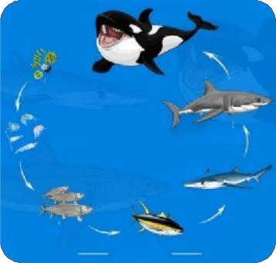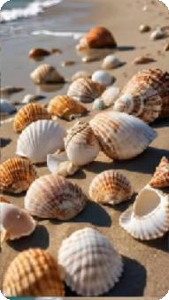

chain?A-Increased O2 B-Increased CO2

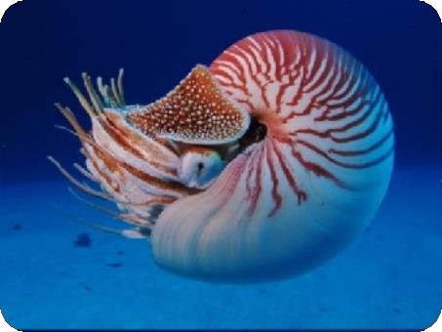C-Decreased O2 D-Decreased CO2 113- Which of the following affects the ability of the shown marinecreatures to form their shells:

A-Increased O2 B-Increased CO2 C-Decreased O2

D-Decreased CO2

1. **When studying an aquatic environment, an increase in swimming, hunting and reproduction activity was observed. Which of the following factors could be thecause of this?**

A-Increased O2 B-Increased CO2 C-Decrease in O2 D-Decrease in CO2

1. **The ratio between the concentrations of carbon dioxide and oxygen gases in the atmospheric air respectively is approximately:**

a)500 b) 0.05 c) 0.03 d) 0.002

1. **If the amount of oxygen dissolved in 1 L of river water at a temperature of 20°C is approximately 10 mg what is its probable amount in one liter of ocean water at the same temperature? a)12 mg b) 7.5 mg c) 5 mg d) 10 mg**
2. **All of the following are considered a source of dissolved oxygen in water, except:**

a)Algae b) Phytoplankton c) Atmospheric air d) Zooplankton

1. **Which of the following does its increase lead to the increase of the percentage of dissolved oxygen in water?**

a)The temperature of water b) The concentration of salts in water

c) Air pollutants d)Photosynthesis process

# Lesson 4

1. 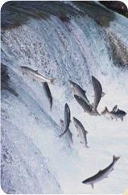**Deep-sea fish have arteries and veins that are:**

|  |  |  |
| --- | --- | --- |
|  | **Strength and durability** | **Diameter** |
| **A** | **Strong and durable** | **Thin** |
| **B** | **Small** | **Thin** |
| **C** | **Strong and durable** | **Thick** |
| **D** | **Small** | **Thick** |

1. **The figure shows the migration of salmon, which is adaptation: A-Behavioral adaptation B-Functional adaptation**

C-Structural adaptation D-Functional Structural adaptation 121- If the concentration of saline solution (X) is greater than

solution(Y), the membrane becomes semi-permeable, meaning that the salt move from:

A-The saline solution (X) to solution (Y) B-Solution (Y) to solution (X)

C- Water move From solution (X) to solution (Y) D- Water moves from solution (Y) to solution (X) What is the environment in which each of the following occurs for salmon?

|  |  |  |  |
| --- | --- | --- | --- |
| Choice | Environment in which it lives until  Maturity sexual | Environment where it  born | Reproduction  environment |
| A | Sea | River | River |
| B | River | Sea | River |
| C | River | River | Sea |
| D | Sea | Sea | River |

1. 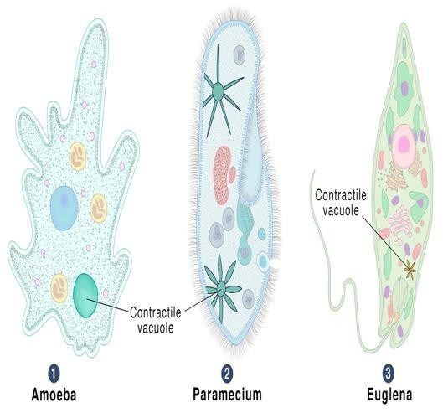**The solution with the higher concentration has an osmotic pressure: A-Higher, and draws water from the less concentrated solution**

B-Higher, and pushes water towards the less concentrated solutionC- Less, and pulls water from the less concentrated solution

D-Less, and pushes water toward the less concentrated solution

1. **The importance of contractile vacuoles in single-celledorganisms living in freshwater is to:**

A-Get rid of excess water B-Maintain balance by absorbing water C-Increase osmotic pressure D-Improve oxygen extraction

1. **Which of the following best represents the correctorder of osmotic pressure?**

A-Fresh Water < Plant cells in fresh water< Fresh water fish< Saline water fish < Seawater

B- Freshwater < Plant cells in saline water < Freshwaterfish < Saline water fish < Seawater

C-Seawater < Plant cells in freshwater < Freshwater fish < Saline water fish < Freshwater

D-Seawater < Plant cells in saline water < Freshwater fish < Saline water fish < Freshwater 125- Osmotic pressure in freshwater fish is:

A-Low, causing water to move into their bodies B-High, causing water to leave their bodies

C-Low, causing water to leave their bodies D-High, causing water to enter their bodies 126- Osmotic pressure in saline water fish is:

A-Low, causing water to leave their bodies B-High, causing water to enter their bodies C-Low, causing water to enter their bodies D-High, causing water to leave their bodies

* 1. **The streamlined body, mucus and scales help fish to reduce water resistance formoving in water and this is considered as… adaptation**

A-Behavioral B-Functional C-Structural D-Osmotic

* 1. **What is the environment in which salmon fish live during the stages of their lifecycle?**

|  |  |  |  |
| --- | --- | --- | --- |
| **choice** | **The environment in which it is born** | **The environment in which it lives until the sexual**  **maturity stage** | **Breeding environment** |
| **A** | **River** | **Sea** | **River** |
| **B** | **Sea** | **River** | **River** |
| **C** | **River** | **River** | **Sea** |
| **D** | **Sea** | **Sea** | **River** |

* 1. **The importance of the swim bladder (or air sac) in bony fish.**

A-Helps them float B-Improves their ability to extract oxygen C-Reduces water resistance to their movement D-Allows them to withstand high pressure

130- A salt solution with a concentration of 10% and a sugar solution with a concentration of 15%. These solutions are separated by a semi permeablemembrane. What will happen?

A-Water will move from the salt solution to the sugar solution

B-Water will move from the sugar solution to the salt solution

C-Undissolved salt will move from the salt solution to the sugar solution D-Undissolved sugar will move from the sugar solution to the salt solution

1. **How deep-sea fish adapt to the following conditions and what type of adaptation itis in each case: A-Lack of oxygen B-Increased pressure C-Lack of light**
2. **Which of the following fish used to live in deep depths and their body densities are high to bear high pressure?**
   1. **Sardine fish. b)Tilapia fish. c) Ray fish. d) Salmon fish.**

## Lesson 5

1. **Which of the following physical quantities is considered as a measure ofaverage kinetic energy of particles in a body?**
   1. **The amount of heat gained or lost b) Body temperature**

c)Work done on the object d) Mass of the body molecules

1. **The thermal energy that is transferred from hot bodies to cold bodies is called:**
   1. **Temperature b) specific heat c) amount of heat d)internal energy**
2. **Which pair of the following physical quantities have the same unit of measurement?**
   1. **Amount of heat and temperature c) Amount of heat and internal energy.**
   2. **Internal energy and temperature. d) Specific heat and temperature**
3. **The internal energy of a water quantity of mass 1 kg is higher at a temperature of**
   1. **4°C b) 340K c) 40°C d) 300k**
4. The following data table shows the change in temperature of equal masses ofdifferent materials (Δt) at each one gains the same amount of heat.

|  |  |
| --- | --- |
| Substance | Change in temperature (Δt°C) |
| W | 5 |
| X | 10 |
| Y | 15 |
| Z | 20 |

Which substance W, X, Y or Z has the largest specific heat?

a. Substance W b. Substance X c. Substance Y d. Substance Z

1. Which of the following values on the kelvin scale is equivalent to -10°C?

a) 263 k b) 273 k c) 283 k d) 303 k

1. A certain amount of a substance whose temperature rises from 30 °C to 310 k.then the change in temperature is………
   1. **7 k b) 37°C c) 280 k d) 280°C**
2. 200 g of water at 50°C is added to 450 g of boiling water. Then the final temperature of the mixture is a) 48.62°C b) 84.62°C c) 14.82°C d) 100°C
3. If the temperature of an object is 283 K, then its equivalent temperature on the Fahrenheit scale is

a)10 °F b) 30 °F c) 50 °F d) 70 °F

1. The following table data shows the specific heat of a group of differentsubstances W,X,Y,Z

|  |  |
| --- | --- |
| Substance | The specific heat(J/KG.°C) |
| W | 450 |
| X | 385 |
| Y | 897 |
| Z | 130 |

When equal masses of these materials are given the same amount of heat,Which material W,X,Y or Z have a higher temperature?

* 1. Substance W b) Substance X c) Substance Y d) Substance Z

1. Which of the following graphs represents the relation between the specific heat (c) of a certain metal and the mass (m) of several bodies of that metal?

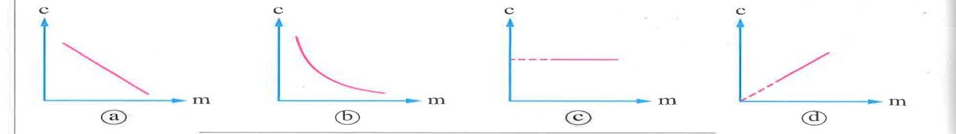

1. The amount of heat required to raise the temperature of 0.9 kg of Copper by 70°C

equal (The specific heat of copper equal 385 J/Kg.K)

a) 2.43 x 104 J b) 1.19 x 105 J c) 4.14 x 104 J d) 2.03 x 105 J

1. The absolute zero is equivalent to……………
   1. **0°C b) 273°C c) 0 k d) 273k**
2. If you know that the normal human temperature is 37.°C, then on the Kelvin scale it is equivalent to ........... **a) 37k b)273 k c) 300 k d)310 k**
3. If you know that the specific heat of glass is 840J/ Kg.°C, it is equivalent to…

a) 3.08 J/Kg.K b) 567 J/Kg.K c) 840 J/Kg.K d) 1113 J/Kg.k

1. **The temperature of a piece of aluminum of mass 0.3 kg has changed from 20°C to 253 K, given that the specific heat of aluminum is 897 J/kg.K, the piece of aluminum has:**

a)absorbed an amount of heat of 10764 J b) absorbed an amount of heat of 62700.3 J

c) lost an amount of heat of 10764 J d) lost an amount of heat of 62700.3 J

1. When the same amount of heat was given to four samples of equal mass but ofdifferent materials, the following was observed: Which material has the highest specific heat?
   1. The temperature of the sample W of material increases by20° C
   2. The temperature of the sample X of material increases by 40° C
   3. The temperature of the sample W of material increases by 60K
   4. The temperature of the sample W of material increases by 80k
2. What is meant by a substance of 2kg gains an amount of heat of 10000J andits temperature rises by 10.°C ?

**…………………………………………………………………………………………………………**

1. What are the factors affecting the amount of heat gained or lost by a substance for changing its temperature?

**…………………………………………………………………………………………………………**

## Lesson 6

1. The deeper the water, the more intense the light below the water surface

a)Gradually increases b) Gradually decreases

c) Decreases then increases d) Increases then decreases

1. Which of the following statements represents the correct arrangement ofthe luminous zones in water according to their depth from top to bottom?

(a)Twilight zone-Aphotic zone-Euphotic zone (b)Aphotic zone-Euphotic zone-Twilight (c)Euphotic zone–twilight zone-Aphotic zone (d) twilight zone-Euphotic zone-Aphotic

1. **The greatest amount of light that penetrates the water surface when theangle between the falling sunlight and the water surface is equal to ……….**

a) 0°C b) 45°C c) 90°C d) 120°C

1. **Which of the following electromagnetic rays completely absorbs its energy after about 10 cm of penetration to the ocean surface?**

a) Violet rays b) Ultra violet rays c) Red rays d) Infrared

1. **Which of the following statements is true?**

a)Water depth affects only light absorption. b)Water depth affects only light intensity.

1. **Water depth affects both light absorption and intensity.**
2. **The depth of water doesn’t affect either absorption or light intensity.**
3. **When the light reaches a depth of about 10 m below the ocean surface, the water absorbs more than** **of visible light energy**

a) 20% b) 30% c) 40% d) 50%

1. **In the clear tropical water, only about…** **of visible light reaches**

at adepth 100 m mostly in the color range.

a)1% - blue b) 1% - red c) 10% - blue d)10%- red

1. **In the process of photosynthesis, ……… energy is converted into** **energy.**
   1. **Chemical – Solar b) Solar – chemical c) Electrical – Solar d) Solar – Electrical 160- In which of the following electromagnetic spectrum regions, the waves have the**

shortest

1. **Radio waves. b) Visible light. c) X-rays d) Gamma rays. 161- The process of photosynthesis occurs mainly in the** **layers of water**
2. **Epipelagic b) mesopelagic c) bathypelagic d) abyssopelagic**
   1. **From the marine organisms that live(s) in the cold regions is/are**
      1. Coral reefs b)Cod fish c)Tuna fish d)Barracuda fish
   2. 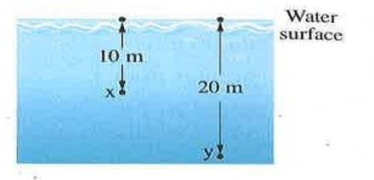**The opposite figure shows two points (x) and (y) at different depths inside the ocean water. If the energy of visible light at point (x) is E, the energy of visible light at point (y) is approximately**

equal to

* + 1. **E b)** 𝟏 𝑬 **c)** 𝟏 𝑬

𝒅)

𝟏 𝑬

𝟐 𝟑 𝟒

* 1. The opposite diagram shows four regions in the electromagnetic spectrum, which of the following choices represents regions (A) and (B),

|  |  |  |  |
| --- | --- | --- | --- |
| Region (A) | Visible light | Ultraviolet rays | Region (B) |

respectively?

a) X-rays, Gamma rays b) Infrared rays, Microwaves

c) X-rays, Infrared rays d) Infrared rays, X-rays

# Lesson 7

* 1. **Fluids include….substances.**

a- Solid and liquid b- Solid and gaseous c- liquid and gaseous d- solid, liquid and gaseous 166- All the following properties are of the gaseous substance except….

A-The ability to flow B-Has definite volume

C-To compress easily D-Takes the shape of the container 167- All the following properties of the liquids except ………

A-No ability to flow B-Has almost definite volume

C-Resists compression D-Takes the shape of the container

1. **The pressure at any point inside the liquid equal to the…of the liquid column above that point acting on the unit area of that point.**

A-Density B-Volume C-Weight D-Mass

1. **Which of the following doesn't affect the pressure at a point inside a liquid?**

A- The area of liquid surface. B-The depth of the point inside the liquid. C- The temperature of the liquid. D-The type of the liquid.

1. **When salmon fish migrates from ocean to river, the pressure on its body at the same depth**

A- Decreases B- increases C- Doesn’t Change D- cant be determined 171- Which of the following is not a measuring unit of the pressure?

A-N/m2 B-Bar C-Joule D-Pascal

1. **1 Pascal =…..Bar**

A-104 B-10-4 C-105 D-10-5

1. **If the pressure at a point inside liquid equal to 2 bar, then it is equivalent to …….**

A-2 x104 Pascal B-2x10– 4 Pascal C-2x10-5 Pascal D-2x105 Pascal 174- Water pressure increases by approximately…….for every 10 m below the surface

A-1 Pascal B-10 Pascal C-1 Atm D-10 Atm 175- What is the main advantage of the cartilaginous skeleton in fish like sharks?

a) It provides greater strength b) It provides greater flexibility

c) it makes the fish heavier d) it provides no special advantage

1. **Some animals can dive to a depth of 1 km. What is the total pressure they can withstand at this depth? (1 atm = 105 N/m2, g = 10 m/s2, ρwater =1000 kg/m3).A- 9 Atm B-90 Atm C-101 Atm D-111 Atm**
2. **Which of the following choices has the greatest effect on increasing the pressure ata point inside a static fluid?**

A-Increasing the surface area of the fluid B-Increasing the density of the fluid

C-Increasing the viscosity of the fluid D-Increasing the temperature of the fluid 178- If a set of containers are filled with water as shown in the figure, the correct

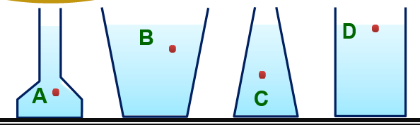orderof points A, B, C, D according to pressure is?

A-A > B > C > D B-D > C > B > A C-A > C > B > D D-D > B > C > A

179- What is the main function of the swim bladder in fish that live at intermediate depths? A-Produces heat to maintain body temperature B-Helps in digestion

C-Controls buoyancy D-Stores oxygen for respiration 180- How do fish living at great depths adapt to high pressure?

A-By increasing the size of their swim bladder B-By reducing the density of their bodies C-By increasing their heart rate D-By increasing the size of their gills

181- What is the importance of lipoproteins in the cell membranes of deep-sea marine organisms?

A-Increases the rigidity of the membranes B-Increases the flexibility of the membranes

C-Increases the permeability of the membranes D-Reduces the surface area of the membranes 182- What does the term "the concentration of solution" express?

A-Total volume of solution B- Type of solute and solvent C- Amount of solute in a given volume of solvent

1. **Which of the following graphs represents correctly the relation between the pressure (P) at multiple points of the same depth inside different liquids that are not exposed to the atmospheric pressure and the density of these liquids (p) ?**
2. **Mariana Trench is the deepest trench in the world which is located in the Western Pacific Ocean at depth of 11 km, if the average density of the ocean's water is 1020 kg/m3, then the pressure of water at this depth is nearly equal to……… (g = 9.8 m/s2)**

A- 1.8 x 105 pascal B- 2.2 x 106 pascal C- 2.9 x 109pascal D- 1.1 x 108pascal

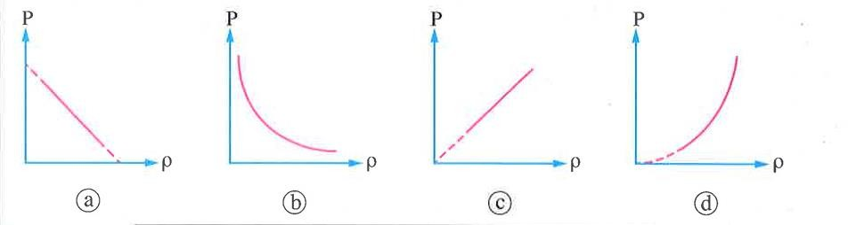

1. **A bowl of bottom area 1000 cm2 is placed horizontally while it contains salty water of density 1030 kg/m3. If the height of water inside the bowl is 1 m and the bowl surface is (Take: P2 = 1.013 × 105 N/m2, g = 10 m/s2)**
2. **The total pressure on the bottom of the bowl equals**

A- 2 × 103 N/m2 B- 2 × 104 N/m2 C- 9.1 × 104 N/m2 D- 1.116 × 105 N/m2

1. **The total force that causes pressure on the bottom of the bowl equals**

A- 2 × 105 N B- 105 N C- 2 × 104 N D- 1.116 × 104 N

1. 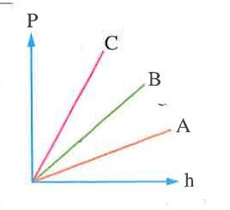**The opposite graph shows the relation between the pressure (P) at a point inside a liquid in a closed container and the vertical distance (h) between this point and the surface of the liquid for three liquids A, B and C, so the correct order of densities of the three liquids is…**

**A-PC< Pb < PA C- PC > PB > PA B- PC< PA < Pb D- PA = PB = PC**

# Lesson 8

1. **Which of the following is from the colligative properties of solutions?**
   1. **Elevation of vapor pressure. b) Depression of boiling point.**

c) Elevation of freezing point. d) Osmotic pressure.

1. **Which of the following is not an example of an aqueous solution?**

A) solution of table salt in water B-Lemon juice C-Tea D-A mixture of sand and water

1. What does the term "the concentration of solution" express?
   1. **Total volume of solution c) Amount of solute in a given volume of solvent**
   2. **Type of solute and solvent d) Temperature of the solution**
2. **What is the effect of increasing the concentration of dissolved substances in water on its density?**

A-Decreases. B-Increases. C-Does not change. D-Changes randomly 191- What is the main effect of adding solute to water; on its vapor pressure?

A-The vapor pressure decreases B-The vapor pressure increases

C-The vapor pressure is not affected D-The vapor pressure increases then decreases 192- The boiling point of a solution at a mountain top is 108°C, therefore the boiling point of

the same solution on the Earth's surface is

A- 106°C B- 104°C C- 108°C D-110°C

1. **Why are water molecules less likely to evaporate in solutions than in pure water?**

A-Because of the attractive forces between water molecules increases

B-Because of the attractive forces between water molecules decreases

C-Because of the attractive forces between water molecules and the solute increases

D-Because of the attractive forces between water molecules and the solute decreases

1. **What is the relationship between the number of solute molecules in a solution andits vapor pressure?**

A-Inverse relationship B-Direct relationship.

C-No relationship D-Variable relationship 195-Liquid starts to boil when its vapor pressure:

a) is less than pressure exerted on it b) is greater than pressure exerted on it

c) is equal to pressure exerted on it d) is double the pressure exerted on it

1. **By increasing the concentration of solutes in water, all of the following is correct except: a)decreasing the vapor pressure b) decreasing the freezing point**

c) decreasing the density d) increasing the boiling point

**Lesson 9**

1. **Which of the following doesn't achieve the ecological balance in the aquatic ecosystems?**

A- Expanding human activities B-Variation of living organisms types.

C- Nutrients balance. D-Energy flow through living organisms.

1. **The role of predatory fish in maintaining ecological balance in aquatic ecosystems leads to A-Increasing the number of small fish B-Controlling the number of prey fish**

C-Reducing the nutrient levels D-Enhancing algal growth 199- When nutrient levels in an aquatic system are excessive, that leads to …….

A-Decrease in plant growth B-Increase in biodiversity

C-Abnormal algal blooms D-Stabilization of the ecosystem

1. **Which of the following is an example of overfishing impact on ecological balance? A-Increase in water quality B-Decline in predator fish populations**

C-Rise in biodiversity D-Stability in prey populations

1. **The primary cause of biodiversity loss in aquatic ecosystems is ……… A-Sustainable fishing B-Habitat destruction**

C-Natural predation D-Balanced nutrient levels

1. **Which of the following is the correct sequence of an aquatic food chain according to the direction of energy flow?**

A-Phytoplankton  Zooplankton  Fish  Bird B-Phytoplankton  Fish  Zooplankton  Bird C-Zooplankton  Phytoplankton  Eagle  Fish D-Zooplankton  Fish  Phytoplankton  Bird

1. **The role that humans play in maintaining ecological balance is ……… A-Ignoring resource management B-Preserving natural resources C-Increasing pollution levels D-Overusing water resources**
2. **What is a key strategy in protecting aquatic ecosystems?**

A-Ignoring climate change B-Developing comprehensive protection plans C-Enhancing industrial pollution D-Overexploiting natural resources

1. **Which of the following is NOT a role human can play to help maintain ecological balance?**

A-Preserving natural resources B-Reducing environmental awareness programs C-Promoting sustainable development D-Avoiding pollution and overuse of resources 206- Sustainable development contributes to ecological balance, through

A-By increasing pollution B-By meeting current needs responsibly C-By ignoring future generations' needs D-By promoting unsustainable agriculture

207- Which of the following human activities contributes positively to maintainingecological balance?

A-Overharvesting marine species C-Increasing fertilizer use in aquatic regions

B-Using clean and sustainable technologies D-Overfishing to control fish populations 208- What is one of the most effective ways to raise awareness about ecological balance?

A-Reducing educational programs

B-Implementing environmental awareness campaigns in schools and media

C-Decreasing the study of ecosystems in schools D-Encouraging the overuse of natural resources 209- Which of the following is NOT a negative impact of human activities on aquatic

ecosystems?

A-Pollution from pesticides and heavy metals B-Sustainable development programs

C-Overfishing D-Destruction of natural habitats like coral reefs 210- How can humans contribute to preserving natural resources?

A-By promoting pollution B-By using resources sustainably and avoiding overuse

C-By destroying coral reefs for economic purposes

D-By reducing the number of environmental awareness programs

1. **From the significant consequence of failing to protect aquatic ecosystems is…….. A-Improved ecological balance B-Loss of biodiversity and ecosystem services**

C-Enhanced water quality D-Increased species diversity

1. 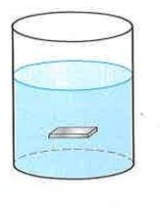**What is the main purpose of maintaining ecological balance in aquatic systems?**

A-To increase the population of all organisms

B-To ensure the continuous flow of energy through the food web

C-To maximize the production of fish and other seafood

D-To maintain the dynamic stability of the ecosystem

1. **Which of the following human activities can lead to the disruption of the ecologicalbalance in aquatic systems?**

A-Pollution B-Overfishing C-Environmental destruction D-All of the above 214- Which of the following is NOT a strategy for humans to maintain ecological balance in

aquatic systems? A-Preserving natural resources B-Promoting unsustainable development C-Increasing environmental awareness and education D-Participating in environmental policies

215- How does energy flow in an aquatic food web?

A-From producers like algae to consumers like herbivores and predatory fish

B-From predators directly to plants C-From nitrogen to phosphorus D-From deep-sea organisms to surface-dwelling organisms

Essay

1. **What is meant by:**

The pressure at a point inside the liquid equal to 5000 N/m2?

**……………………………………………………………………….**

1. **The diagram shows the apparatus ofthe connecting vessels. Why does the liquid in vessels reaches the same height regardless of their shape or section?**

**……………………………………………………………………….**

1. **What are the factors affecting on the liquid pressure at a point inside it?**

**……………………………………………………………………….**

1. **What are the factors affecting on the total pressure at a point insideliquid?**

**……………………………………………………………………….**

1. **The base area of a fish tank equals 640 cm2 and the tank contains 1280 N ofwater, Calculate the pressure of the water on the bottom of the tank**

First: in Pascal Second: in bar

**……………………………………………………………………….**

1. **Calculate the total pressure at a point 30 meters below the surface of the sea. Given that the density of seawater is 1025 kg/m3, the acceleration due to gravity is 9.8 m/s2, and the**

atmospheric pressure at the sea surface is 1.013 x 105 Pa.

**……………………………………………………………………….**

1. **The opposite figure shows a slide of surface area 20 cm2 located inside a liquid and being subjected to a pressure of 1.028 x 105 N/m2. Calculate the total force acting on the slide.**

………………………………………………………………………. 8-Give reasons for :

* 1. **Sea level is the same in all open seas and oceans.**

**………………………………………………………………………**

1. **What happens When vapor pressure of a pure liquid equals vapor pressure exerted on its surface**

**………………………………………………………………………**

1. **Calculate the depth of a point below the surface of a lake, given that the pressureof the water on this point is 5 bar.**

Knowing that: the density of the water in the lake is 1000 kg/m3 and theacceleration due to gravity is 10 m/s2

**……………………………………………………………………….**

1. 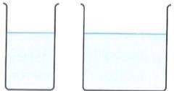**The diagram shows two containers with different liquids. If we know that the density of liquid X is greater than that of liquid Y. When the height of the two liquids is held constant asshown,**

Which of the tow liquids exerts on the base of its containerwith more pressure? Why?

**……………………………………………………………………….**

1. 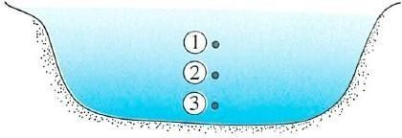**The diagram shows three points (1), (2), and (3) at different depths below the surface of the water.**

Rank the pressure exerted at each point from lowestpressure to highest pressure

**……………………………………………………………………….**

1. 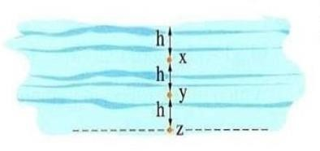**The figure shows three points (X), (Y), and (Z) at different depths below the surface of a lake as shown. Ifyou know that**

the effective water pressure at point X is1 bar, what is the total pressure at each of:

Knowing that: The atmospheric pressure at the surfaceof the lake is approximately 1 bar

First: Point Y Second: Point Z

**……………………………………………………………………….**

1. **Compare between: Bony fish (Osteichthyes) and Cartilaginous fish (Chondrichthyes) Concerning to**

The type of its skeleton Its weight Its flexibility

**……………………………………………………………………….**

1. **What is the effect of the increase in the concentration of the dissolved substances in the pure water on each of the following:**
   1. **Its density…………………….…………………………**
   2. **Its boiling point………………...……………………….**
   3. **Its freezing point……………………………………….. 16-Correct the underlined word(s):**
2. **The colligative properties of a solution depend on the type of the solute particles (…………**

**)**

1. **The liquid vapor exerts a pressure on the surface of its liquidcalled the osmotic pressureof the**

liquid. (… )

1. **The decrease in the liquid vapor pressure of a solution is inversely proportional to thenumber of solute molecules or ionsin. (** **)**
2. **The freezing point of a solution is always equal to that of the pure water at normal atmospheric pressure. (…** **)**
3. **The boiling point of a solution is equal to that of the pure water at normal atmospheric pressure. (…** **)**
4. **A liquid boils when its vapor pressure is less than that of atmospheric air pressure at the surface of the liquid. (…** **)**
5. **The following data table shows: Three samples of equal masses ofimpure water (X, Y, and Z) and the boiling point of each sample under the normal atmospheric pressure.**

|  |  |
| --- | --- |
| **The sample** | **Its boiling point** |
| **Sample X** | **101.5 °C** |
| **Sample Y** | **100.5 °C** |
| **Sample Z** | **102.5 °C** |

Arrange the three samples in ascending order by the number ofmolecules dissolved in the water……………………………………………………………………….

1. **The following data table shows: Three samples of equal masses of impure water(X, Y, and Z) and the boiling point of each sample under a different atmospheric pressure.**

|  |  |
| --- | --- |
| **The sample** | **Its boiling point** |
| **Sample X** | **103 °C** |
| **Sample Y** | **98 °C** |
| **Sample Z** | **101 °C** |

Arrange the three samples in ascending order by the value of theacting atmospheric pressure

**……………………………………………………………………….**

# Problems

1. A piece of aluminum with a mass of 200g and a temperature of 80°C is dropped into a quantity of water at room temperature. If the final temperature of the system is 40°C, calculate the amount of heat gained by the amount of water. The specific heat of aluminum is 897 J/kg.K.

**…………………………………………………………………………………………………………**

1. A 300 g piece of aluminum at 90°C is placed into 25°C water. If the final temperature of the system is 50°C, calculate the heat lost by the aluminum. (Specific heat capacity of aluminum: 897 J/kg·K)

**…………………………………………………………………………………………………………** 3- A 250 g aluminum block is heated to 100°C and dropped into a container of water at 30°C. If the final temperature of the aluminum is 60°C, calculate the amount of heat transferred from the

aluminum to the water. (Specific heat capacity of aluminum: 897 J/kg·K)

**…………………………………………………………………………………………………………**

1. If a 0.5 kg block of aluminum cools from 75°C to 25°C, how much heat does it release? (Specific heat capacity of aluminum: 897 J/kg·K)
2. An aluminum block of mass 200 g cools from 85°C to 35°C. Calculate the heat lost by the aluminum and explain what happens to this heat if the block is placed in an insulated container of water.

**…………………………………………………………………………………………………………**

1. **A 2 kg block of iron cools from 150°C to 50°C. If the specific heat capacity of iron is 450 J/kg·K, how much heat is released?**

**……………………………………………………………………………………………………….**

1. **A 1.2 kg block of silver heats up from 25°C to 100°C. If the specific heat capacity of silver is 235 J/kg·K, how much heat is absorbed?**

**…………………………………………………………………………………………………………**

1. **A 0.8 kg block of gold is cooled from 90°C to 30°C. Given that the specific heat capacity of gold is 129 J/kg·K, how much heat is released?**

**…………………………………………………………………………………………………………**

1. **How much heat is released by a 1.5 kg block of water cooling from 80°C to 20°C? (Specific heat capacity of water: 4,186 J/kg·K).**

**…………………………………………………………………………………………………………**

1. **3.0 kg block of lead is cooled from 200°C to 50°C. If the specific heat capacity of lead is 128 J/kg·K, how much heat is released?**

**………………………………………………………………………………………………………….**

1. A copper block with a mass of 0.5 kg is heated from 25°C to a final temperature of 75°C. Calculate the amount of heat absorbed by the copper. (Specific heat of copper: 385 J/kg·K)

**…………………………………………………………………………………………………………**

1. A copper plate absorbs 9,625 J of heat. Its mass is 0.4 kg, and its initial temperature is 30°C. What is its final temperature? (Specific heat of copper: 385 J/kg·K)

**…………………………………………………………………………………………………………**

1. A copper piece of mass 0.3 kg had a temperature of 20°C. If it absorbed an amount of heat of 5775 J, calculate its final temperature. (Given that: the specific heat of copper is 385 J/kg.K)

**…………………………………………………………………………………………………………**

1. A surface with an area of 0.25 m² is subjected to a pressure of 1.5 × 10⁵ N/m². What is the total force acting on the surface?

**…………………………………………………………………………………………………………**

1. A plate with an area of 35 cm² is exposed to a pressure of 2.8 × 10⁴ N/m². Calculate the force acting on the plate.

**…………………………………………………………………………………………………………**

1. An object with a surface area of 0.12 m² is under a pressure of 9.0 × 10⁴ N/m². Determine the total force on the object.

**…………………………………………………………………………………………………………**

1. A slide with an area of 50 cm² experiences a pressure of 3.2 × 10⁵ N/m². Find the total force acting on it.

**…………………………………………………………………………………………………………** 18- A rectangular surface of area 0.08 m² is subjected to a pressure of 7.0 × 10⁴ N/m². Calculate the force acting on the surface…………………………………………………………………………

1. A plate with a surface area of 20 cm² is under a pressure of 1.2 × 10⁵ N/m². What is the total force acting on the plate?.............................................................................................................
2. An object with an area of 0.03 m² is exposed to a pressure of 5.0 × 10³ N/m². Calculate the total force acting on the object.

**…………………………………………………………………………………………………………**

1. A surface with an area of 10 cm² experiences a pressure of 2.4 × 10⁵ N/m². What is the force exerted on the surface?

**…………………………………………………………………………………………………………**

1. A plate with an area of 0.15 m² experiences a total force of 450 N. What is the pressure acting on the plate?

**…………………………………………………………………………………………………………**

1. A rectangular surface of area 30 cm² is subjected to a total force of 3.6 N. Calculate the pressure acting on the surface.

**…………………………………………………………………………………………………………**

1. A slide with an area of 0.05 m² is subjected to a total force of 1,250 N. Determine the pressure applied to the slide.

**…………………………………………………………………………………………………………**

1. An object with a surface area of 75 cm² is under a total force of 18.75 N. What is the pressure acting on the object?

**…………………………………………………………………………………………………………**

1. A surface with an area of 0.2 m² is exposed to a total force of 9,000 N. Calculate the pressure exerted on the surface.

**…………………………………………………………………………………………………………** 27- Calculate the total pressure at a point 30 meters below the surface of the sea. Given that the density of seawater is 1025 kg/m³, the acceleration due to gravity is 9.8 m/s², and the

atmospheric pressure at the sea surface is 1.013 x 105 Pa.

**…………………………………………………………………………………………………………**

1. Calculate the total pressure at a point 50 meters below the surface of the sea. Assume the density of seawater is 1025 kg/m³, g = 9.8 m/s², and the atmospheric pressure at the surface is 1.013 × 10⁵ N/m².

**…………………………………………………………………………………………………………**

1. A diver is 20 meters below the surface of a freshwater lake. If the density of water is 1000 kg/m³, g = 9.8 m/s², and atmospheric pressure is 1.013 × 10⁵ N/m², calculate the total pressure experienced by the diver.

**…………………………………………………………………………………………………………**

1. At what depth below the surface of seawater (ρ = 1025 kg/m³) will the total pressure be 5 × 10⁵ N/m²? Assume atmospheric pressure is 1.013 × 10⁵ N/m² and g = 9.8 m/s².

**………………………………………………………………………………………………………………………………**

1. An underwater vehicle is operating at a depth of 80 meters in seawater (ρ = 1025 kg/m³). Find the total pressure acting on it. Take g = 9.8 m/s² and atmospheric pressure as 1.013 × 10⁵ N/m².

……………………………………………………………………………………………………. 32- A point lies 15 meters below the surface of an oil tank. If the oil’s density is 850 kg/m³, g = 9.8

m/s², and atmospheric pressure is 1.013 × 10⁵ N/m², calculate the total pressure at this point.

**…………………………………………………………………………………………………………**

1. If the atmospheric pressure at the sea surface is 1.01 × 10⁵ N/m², calculate the total pressure at a depth of 40 meters in seawater (ρ = 1025 kg/m³) assuming g = 9.8 m/s².

**…………………………………………………………………………………………………………**

1. A pressure gauge at the bottom of a water tank reads 245,000 N/m². If the density of water is 1000 kg/m³ and g = 9.8 m/s², find the depth of the water in the tank.

**…………………………………………………………………………………………………………**

1. A scuba diver experiences a pressure of 300,000 N/m² at a certain depth in seawater (ρ = 1025 kg/m³). If atmospheric pressure is 1.013 × 10⁵ N/m², calculate the diver's depth. Use g = 9.8 m/s².

**…………………………………………………………………………………………………………**

1. A submarine is at a depth of 60 meters below the surface of the sea. If the density of seawater is 1025 kg/m³, g = 9.8 m/s², and the atmospheric pressure is 1.013 × 10⁵ Pa, calculate the total pressure acting on the submarine.

**…………………………………………………………………………………………………………**

1. The pressure at a point in a fluid is measured to be 400,000 Pa. If the fluid is seawater (ρ = 1025 kg/m³) and g = 9.8 m/s², find the depth of the point below the surface assuming atmospheric pressure is 1.013 × 10⁵ Pa.

**…………………………………………………………………………………………………………**

1. A point at the bottom of a freshwater reservoir has a total pressure of 3.013 × 10⁵ Pa. If atmospheric pressure is 1.013 × 10⁵ Pa, calculate the depth of the water. Assume the density of water is 1000 kg/m³ and g = 9.8 m/s².

**…………………………………………………………………………………………………………**

1. A diver descends to a depth of 25 meters below the sea surface. If the density of seawater is 1025 kg/m³, g = 9.8 m/s², and the atmospheric pressure is 1.013 × 10⁵ N/m², calculate the total pressure at this depth in **atm**. (Given: 1 atm = 10⁵ N/m²)

**…………………………………………………………………………………………………………**

1. A tank filled with oil (ρ = 900 kg/m³) has a depth of 10 meters. If the atmospheric pressure at the surface is 1.01 × 10⁵ N/m², calculate the total pressure at the bottom of the tank in **atm**. (Given: 1 atm = 10⁵ N/m²)

**…………………………………………………………………………………………………………**

1. A submarine is operating at a depth of 70 meters in seawater (ρ = 1025 kg/m³). Calculate the total pressure acting on the submarine in **atm**. Assume g = 9.8 m/s² and atmospheric pressure is

1.013 × 10⁵ N/m². (Given: 1 atm = 10⁵ N/m²)

1. A scuba diver at a depth of 50 meters in freshwater (ρ = 1000 kg/m³) experiences a total pressure.

Calculate this pressure in **atm** if the atmospheric pressure is 1.013 × 10⁵ N/m². (Given: 1 atm = 10⁵ N/m²)

**………………………………………………………………………………………………………**

1. What is the effect of the increase in the concentration of the dissolved substances in the pure water on each of the following:a) its density b) its boiling point c) its freezing point

**…………………………………………………………………………………………………………**

1. A homogeneous mixture of solvent and solute.

**…………………………………………………………………………………………………………**

1. What is the advantage of the presence of a cartilaginous skeleton in sharks that live in deep

depths?

**…………………………………………………………………………………………………………**