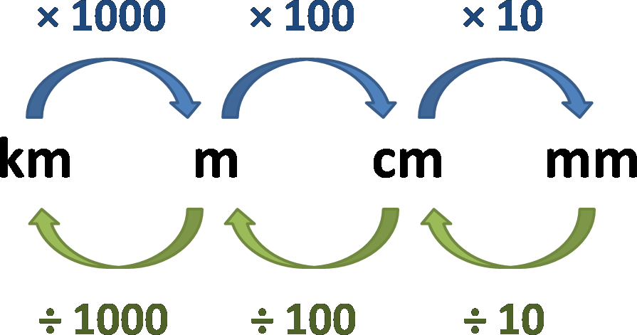

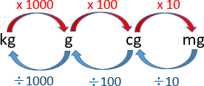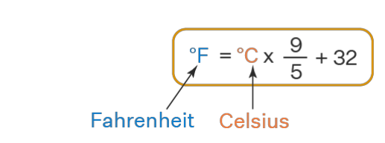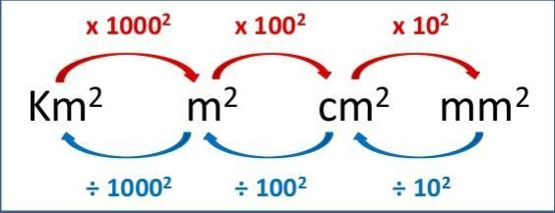

**. 101300 N/M2 =101300 Pascal = 1013 Milli Bar = 1 atm = 760 mmhg**

. 1 Bar=1000millibar = 105 Pascal = 105 N/m2

𝐐𝐭𝐡 = 𝐦 𝐜 ∆𝐭

Qth

m C ∆𝐭

F = P × A. F P A

Ptotal = Pa + Pliquid = Pa + ρ g h

Pliquid = ρ g h

Pliquid

ρ g h

1 Bar= 1 atm = 105 Pascal = 105 N/m2

**Devices**

1. **Barometer: used to measure atmospheric pressure**
2. **pH meter: used to measure of how acidic/basic water is.**
3. **Joule calorimeter: used to determine the specific heat of water.**
4. **Moisture meter: to detect moisture content in soil.**
5. **hygrometer: to measure the humidity, or amount of water vapor in the air.**
6. **Gas Chromatography: It is used to analyze volatile organic compounds such as benzene, and formaldehyde**
7. **UV spectroscopy :Used to measure oxides of nitrogen and ozone in the air.**



