“In this milestone, I successfully connected my local Git repository to GitHub, verified the remote configuration, pushed local commits, and practiced repository synchronization using git pull and git fetch. This milestone strengthened my understanding of remote repositories and version control workflows.”

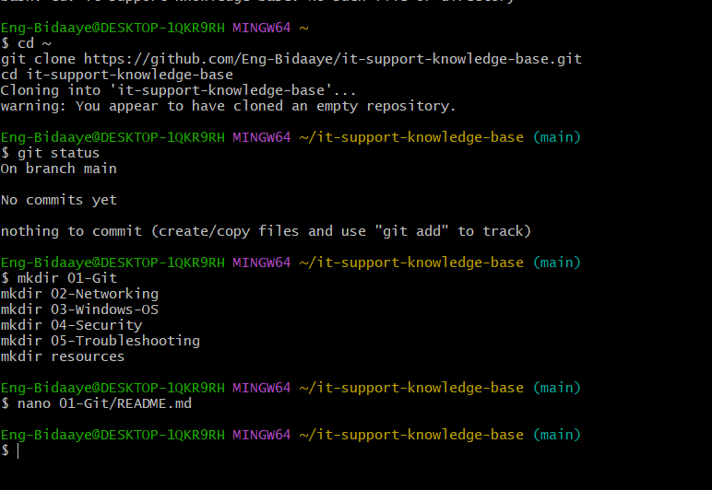

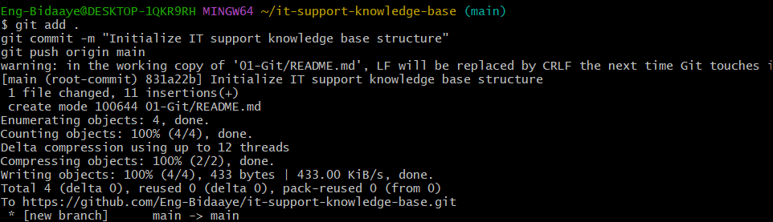
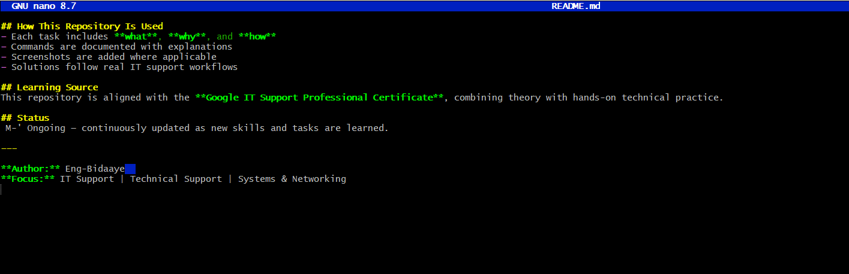
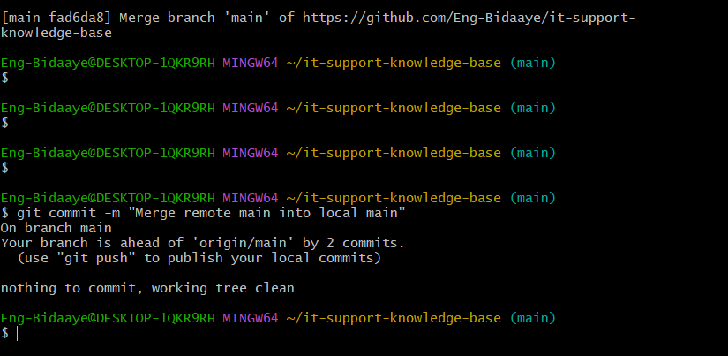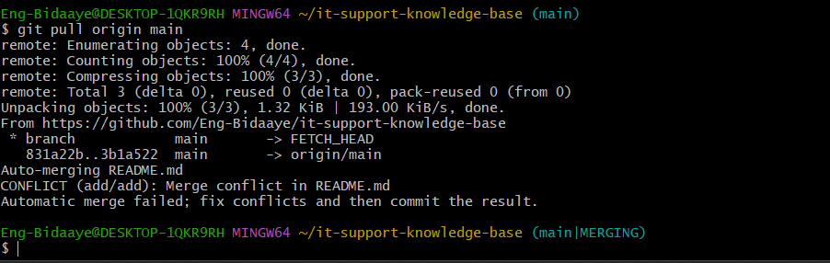
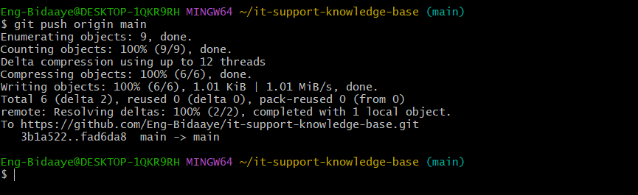
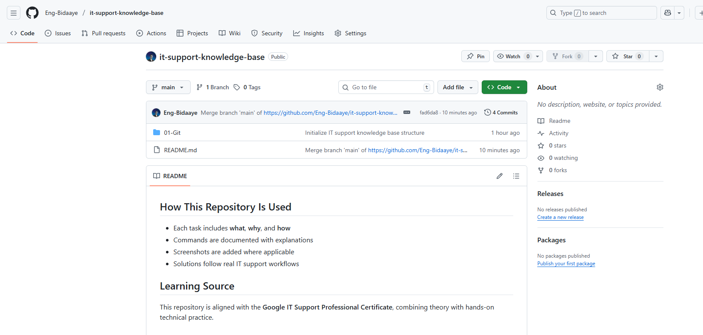
Here is my link https://github.com/Eng-Bidaaye/it-support-knowledge-base

