  Faculty of Computer & Information Sciences  Ain Shams University  Subject: CSW150  Fundamentals of Structured  Programming | Examiners: Prof. Zaki Taha  Dr. Yasmine Afify  Dr. Salsabil Amin  Academic year: 2nd term 2019-2020  Year: 1st undergraduate
Research Topic Version (D)
Title: Traffic Control System.
تحذير هام: علي الطالب عدم كتابة اسمه أو كتابة اي شيء يدل علي شخصيته

- Data Model
- const int ownedcar = 3, constant because it does not change in program, global to see in the whole code as struct and function, use type int because it is short and not need float. use 3 because its maximum owned of car.
- int counter = 1; bool check = false; bool check2 = false; bool check1 = false; bool ok = false; int pay
(use type int : it short not long or not float , use type Boolean: to check the variable true or false.
string username, passward, string yourchoose (use type string : to need write word from many character)
global to Avoid repetition ,to see in whole code, and used in code many times structs and function.
- struct fines_info, struct list_of_ownedcars , struct drivers_info, struct traffic_man
use type struct to include many different types of data and every data (structure member) has own independent memory that means we can access any member anytime.
- drivers[100], trafficman[100];
use struct of array to store the same type of data to many variables, size 100 to store many drivers and traffic man.
- Then use functions to make code easier
- string type; string ch; string cont;
use them local because of used in function main only.
- In sign in when user register ,the code compares the entered information with information in struct if it’s valid it continues their tasks else display invalid account.
- Also when the driver pays fined the struct information update the value become zero, the statue become paid and when traffic_man register fines the struct (fines_info) update with date fines , street name ,statue fines , value fines and when driver use function (regestire_new_car) the struct (drivers_info) update with new information entered ,if the new car increase on 3 car it display invalid

start

- Logical Model (Algorithm)
regestire_fines(float speed, float road_max_speed, int drivers_no, int owned_car_no)

Speed > road_max_speed

false true

Write
“Enter street name”
Write
"no fined"

Read
drivers[drivers_no].
ownedcar_no[owned_car_no].fines.street_name

End

A
Write
"the value fines = "
Read
drivers[drivers_no].ownedcar_no[owned_car_no].fines.statue_fines
Write
"Enter statue fines(paid or not)"
Read
drivers[drivers_no].ownedcar_no[owned_car_no].fines.date_fines

Write
"Enter date fines"
drivers[drivers_no].ownedcar_no[owned_car_no].fines.value_fines = 2 * (speed - road_max_speed);
A

End
End
Write
drivers[drivers_no].ownedcar_no[owned_car_no].fines.value_fines

FUNCTION regestire_fines(float speed, float road_max_speed, int drivers_no, int owned_car_no)
IF speed > road_max_speed THEN
PRINT "Enter street name"
READ drivers[drivers_no].ownedcar_no[owned_car_no].fines.street_name;
PRINT "Enter date fines"
READ drivers[drivers_no].ownedcar_no[owned_car_no].fines.date_fines
PRINT "Enter statue fines(paid or not)"
READ drivers[drivers_no].ownedcar_no[owned_car_no].fines.statue_fines
PRINT "the value fines = "
READ "the value fines = "
drivers[drivers_no].ownedcar_no[owned_car_no].fines.value_fines = 2 * (speed - road_max_speed);
PRINT drivers[drivers_no].ownedcar_no[owned_car_no].fines.value_fines
ELSE
PRINT "no fined"
END IF
END

- Process Model (Functions)
- void total_fines (int no ,int driver_no)
no: number of cars the driver has , driver_no: array number.
parameter (int no , int driver_no) , don’t return thing , the output in the body of the function is total fines, it calculates total fines.
- void regestire_fines (float speed, float road_max_speed, int drivers_no, int owned_car_no)
float speed: car speed , road_max_speed: max speed of road , drivers_no: array number , owned_car_no: number car owned.
Parameter (float speed, float road_max_speed, int drivers_no, int owned_car_no) , don’t return thing, not found output, this function calculates the fines value if there.
- void pay_fines(int driver_no, int no)
no: number of cars the driver has , driver_no: array number.
Parameter(int driver_no, int no) , don’t return thing ,not found output, this function to pay fines.
- void regestire_new_car (int driver_no , int no)
no: number of cars the driver has , driver_no: array number.
Parameter (int driver_no , int no), don’t return thing , not found output, this function, if drivers want to register a new car.
- void drivers_info()
don’t take thing and don’t return thing , it makes sure from information of drivers, then display total fines, paid fines or register the new car.
- void traffic_man_info()
don’t take thing and don’t return thing , it makes sure from information about the traffic man then traffic_man register fines if the car speed exceeds the road maximum speed.
- void search()
doesn’t take thing and don’t return thing, the output in the body of the function is information about the car and information about fines, this function search about car and fines function by plate car or owner name.
- void sign_up(string type)
type : to know if he driver or traffic man.
Parameter (string type) , don’t return thing , this function to make an account.
9. void sign_in (string type) type: to know if his driver, traffic man or researcher.
Parameter (string type), don’t return thing, it to sign in and do tasks.
• Why use void in my function?
Because I do display in the body of the function.

- Coding Style
- Use comments (reference[1]) lines (15,22,30,39,45,54,71,86,100,143,146,193,204,217,240,244,247,269,280,314)
- Good naming (reference[2]) lines (11,12,13,16:20,23:27,31:36,40:43, 46,55, 72,87, 101,194, 152,153,283,247,294,295)
- Functions (reference[3]) lines (46,72, 55, 87, 101 ,147,194, 245,283)
- Global variable (reference[4]) lines (5:13)
- Keep it Simple (reference[5]) show in the code.
- Include statements must be located at the top of file only. Lines(1:4)
- 7 The presumed case should be included in the if part and the exception in the other part of an if statement. lines(56/67 , 75/81 , 89/91 , 122/142 , 303/308)
- Take advantage of white space to improve readability (56/67 , 75/81 , 89/91 , 122/142 , 303/308)
- We should avoid abbreviations in names. Lines(12, 13, 16:20 , 23:27, 31:37, 40:44, 46, 55, ….)
- In the top, Declare state constants and types (reference[4]) lines (5)

- Implementation
[Copy the code from IDE, make sure to choose ‘keep the source formatting’ when you paste it here]
#include <iostream>
#include <string>

using namespace std;
const int ownedcar = 3;
int counter = 1;
bool check = false;
bool check2 = false;
bool check1 = false;
bool ok = false;
int pay;
string yourchoose;
string username, passward;

// information about fines
struct fines_info {
int value_fines=0;
string street_name;
string date_fines;
string statue_fines;
};
//information about owned car
struct list_of_ownedcars {
string car_plate_no;
string model;
fines_info fines;
int production_year;
};

//information about driver
struct drivers_info {
int license_no;
string driver_name;
string driver_birthday;
string driver_passward;
list_of_ownedcars ownedcar_no[ownedcar];
} drivers[100];

//information about traffic_man
struct traffic_man {
string traffic_name;
string traffic_birthday;
string traffic_passward;
}trafficman[100];
//function to calculates total fines
void total_fines(int no ,int driver_no){
int sum=0;
for (int i = 1; i <= no; i++) {
sum += drivers[driver_no].ownedcar_no[i].fines.value_fines;
}
cout << "total fines : " << sum << endl;
}

// function to calculates fines value
void regestire_fines(float speed, float road_max_speed, int drivers_no, int owned_car_no) {
if (speed > road_max_speed) {
cout << "Enter street name" << endl;
cin >> drivers[drivers_no].ownedcar_no[owned_car_no].fines.street_name;
cout << "Enter date fines" << endl;
cin >> drivers[drivers_no].ownedcar_no[owned_car_no].fines.date_fines;
cout << "Enter statue fines(paid or not)" << endl;
cin >> drivers[drivers_no].ownedcar_no[owned_car_no].fines.statue_fines;
cout << "the value fines = ";
drivers[drivers_no].ownedcar_no[owned_car_no].fines.value_fines = 2 * (speed - road_max_speed);
cout << drivers[drivers_no].ownedcar_no[owned_car_no].fines.value_fines << endl;
}
else
cout << "no fined";
}

// function to pay fines
void pay_fines(int driver_no, int no) {
cout << "you have to pay: " << drivers[driver_no].ownedcar_no[no].fines.value_fines << endl;
cin >> pay;
if (drivers[driver_no].ownedcar_no[no].fines.value_fines == pay) {
drivers[driver_no].ownedcar_no[no].fines.statue_fines = "pay";
drivers[driver_no].ownedcar_no[no].fines.value_fines = 0;
cout << "successful" << endl;
}

else if (drivers[driver_no].ownedcar_no[no].fines.value_fines > pay) {
cout << "it is not enough" << endl;
drivers[driver_no].ownedcar_no[no].fines.statue_fines = "not_pay";
}
}
//function to register new car
void regestire_new_car(int driver_no , int no) {
no++;
if (no > 3)
cout << "it is not available" << endl;
else {
cout << "register new car (plate number)" << endl;
cin >> drivers[driver_no].ownedcar_no[no].car_plate_no;
cout << "register new car (model)" << endl;
cin >> drivers[driver_no].ownedcar_no[no].model;
cout << "register new car (production year)" << endl;
cin >> drivers[driver_no].ownedcar_no[no].production_year;
}
}
//to display total fines, paid fines or register new car
void drivers_info() {
int driver_no;
int no;
char chick;
int num;
int number;
cout << "Enter your username" << endl; cin.ignore();
getline(cin, username);
cout << "Enter your passward" << endl;
cin >> passward;
for (int i = 1; i <= 100; i++) {
if (username == drivers[i].driver_name && passward == drivers[i].driver_passward) {
check = true;
driver_no = i;
}
}
if (check == true) {
cout << "if you want show total fines enter(t)" << endl;
cout << " if you want pay fines enter(p)" << endl;
cout << " if you want register new car enter(r)" << endl;
cin >> chick;
if (chick == 't') {
cout << "how many cars you have" << endl;
cin >> num;
for (int i = 1; i <= num; i++) {
cout << "the fine on the car " << i << endl;
cout << drivers[driver_no].ownedcar_no[i].fines.value_fines << endl;
}
total_fines(num, driver_no);
}
if (chick == 'p') {
cout << "Enter owned car number you want pay to it" << endl;
cin >> no;
pay_fines(driver_no, no);
}
if (chick == 'r') {
cout << "Enter how many cars you have"<<endl;
cin >> number;
regestire_new_car(driver_no, number);
}
}
else
cout << "invalid account" << endl; //if username and passward invalid
check = false;
}
//to traffic_man register fines if the car speed exceeds the road maximum speed.
void traffic_man_info(){
int trafficman_no;
int no;
string platecar;
int driver;
float speed;
float road_max_speed;
cout << "Enter your username" << endl; cin.ignore();
getline(cin, username);
cout << "Enter your passward" << endl;
cin >> passward;
for (int i = 1; i <= 100; i++) {
if (username == trafficman[i].traffic_name && passward == trafficman[i].traffic_passward) {
check1 = true;
trafficman_no = i;
}
}
if (check1 == true) {
cout << "Enter driver username" << endl; cin.ignore();
getline(cin, username);
cout << "Enter owned car number" << endl;
cin >> no;
cout << "Enter driver plate car number" << endl;
cin >> platecar;
for (int i = 1; i <= 100; i++) {
if (username == drivers[i].driver_name && platecar == drivers[i].ownedcar_no[no].car_plate_no) {
check2 = true;
driver = i;
}
}
if (check2 == true) {
cout << "Enter the speed of car" << endl;
cin >> speed;
cout << "Enter road_max_speed" << endl;
cin >> road_max_speed;

regestire_fines(speed, road_max_speed, driver, no);
}
else
cout << "invalid account" << endl;
}
else
cout << "invalid account" << endl;
check = false;
check2 = false;
}
//to search about car and fines by plate car or owner name
void search() {
int driver_no;
int no;
int num;
char cho;
string plate;
string name;
cout << "if you want research by plate car enter (1)" << endl;
cout << "if you want research by car owner name enter (2)" << endl;
cin >> cho;
//to research by plate car
if (cho == '1') {
cout << "Enter plate car" << endl;
cin >> plate;
cout << "Enter number of cars owned" << endl;
cin >> no;
for (int i = 1; i <= 100; i++) {
if (plate == drivers[i].ownedcar_no[no].car_plate_no) {
ok = true;
driver_no = i;
}
}
}
//to research by owner name
if (cho == '2') {
cout << "Enter car owner name" << endl; cin.ignore();
getline(cin, name);
cout << "Enter number of cars owned" << endl;
cin >> no;
for (int i = 1; i <= 100; i++) {
if (name == drivers[i].driver_name) {
ok = true;
driver_no = i;
}
}
}
if (ok == true) {
cout << "car model : " << drivers[driver_no].ownedcar_no[no].model << endl;
cout << "car production year : " << drivers[driver_no].ownedcar_no[no].production_year << endl;
cout << "fines value : " << drivers[driver_no].ownedcar_no[no].fines.value_fines << endl;
cout << "fines statue : " << drivers[driver_no].ownedcar_no[no].fines.statue_fines << endl;
cout << "fines date : " << drivers[driver_no].ownedcar_no[no].fines.date_fines << endl;
cout << "fines street : " << drivers[driver_no].ownedcar_no[no].fines.street_name << endl;

}
else
cout << "invalid account" << endl; //this account didn’t find
ok = false;
}

// to make account
void sign_up(string type) {
int owncarno;
if (type == "driver") { //register information about drivers and their cars
cout << "username" << endl; cin.ignore();
getline(cin, drivers[counter].driver_name);
cout << "passward" << endl;
cin >> drivers[counter].driver_passward;
cout << "what is your birthday" << endl;
cin >> drivers[counter].driver_birthday;
cout << "Enter your license number" << endl;
cin >> drivers[counter].license_no;
cout << "how many cars you have?" << endl;
cin >> owncarno;
for (int i = 1; i <= owncarno; i++) {
cout << "Enter information about car" << i << endl;
cout << "Enter your car plate number" << endl;
cin >> drivers[counter].ownedcar_no[i].car_plate_no;
cout << "Enter your car model" << endl;
cin >> drivers[counter].ownedcar_no[i].model;
cout << "Enter your car production year" << endl;
cin >> drivers[counter].ownedcar_no[i].production_year;
}
counter++;
}
else if (type == "traffic_man") { //register information about traffic_man
cout << "username" << endl; cin.ignore();
getline(cin, trafficman[counter].traffic_name);
cout << "passward" << endl;
cin >> trafficman[counter].traffic_passward;
cout << "what is your birthday" << endl;
cin >> trafficman[counter].traffic_birthday;
counter++;
}
}

//to sign in and do tasks
void sign_in(string type) {
char chick;

if (type == "driver") {
drivers_info();
}

if (type == "traffic_man") {
traffic_man_info();
}
else if (type == "researcher") {
search();
}
}
int main() {
system("COLOR f0");
string type;
string ch;
string cont;
do {
cout << "you have account" << endl;
cin >> ch;
if (ch == "yes") {
cout << "are you driver , traffic_man or researcher??" << endl;
cin >> type;
sign_in(type);
}
else if(ch=="no") {
cout << "are you driver or traffic_man??" << endl;
cin >> type;
sign_up(type);
}
cout << "are you want to continue??" << endl;
cin >> cont;
} while (cont == "yes"); //ask you if you want to continue the program

system("pause");
return 0;
}
- Testing
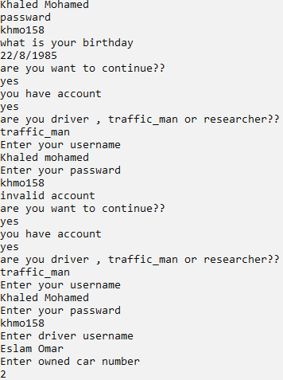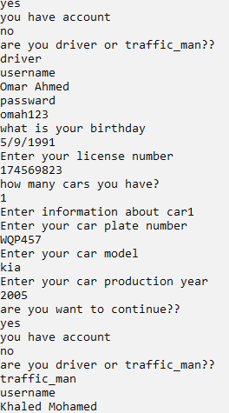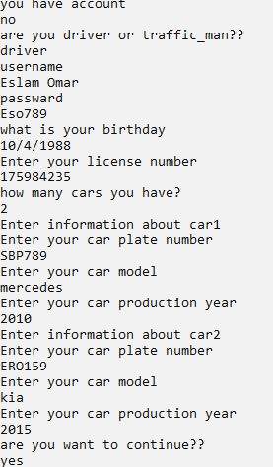
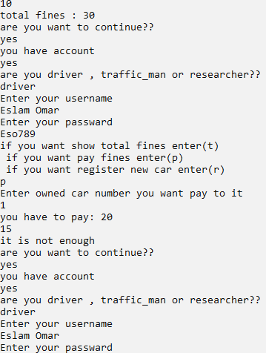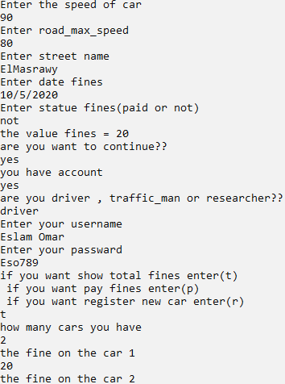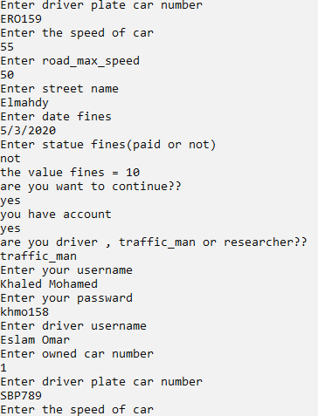

References:
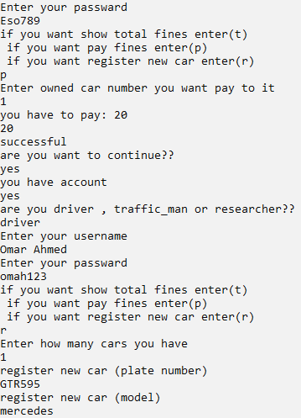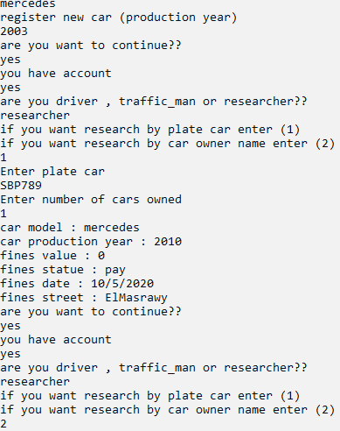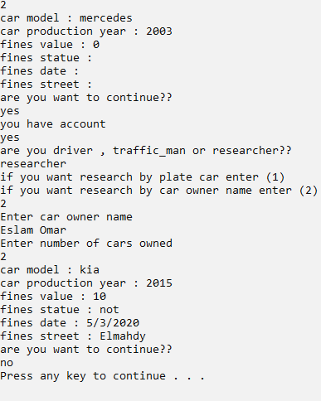
[1] https://www.embedded.com/six-rules-for-writing-clean-code/
datePublished:"2009-06-08"
date I copied : "2020-05-15"
[2] https://bulldogjob.com/articles/469-3-basic-rules-of-clean-code
Date Published:"2017-05-25"
Date I copied : "2020-05-15"
[3] https://hackernoon.com/how-to-write-clean-code-d557d998bb08
[4] https://www.freecodecamp.org/news/how-to-write-clean-code--c/
Date Published: "2020-01-02",dateModified: "2020-04-30".
Date I copied : "2020-05-15"
[5] https://www.planetgeek.ch/wp-content/uploads/2013/06/Clean-Code-V2.2.pdf
[at least 5 references]
With My Best Regards,
your signature

