

Cairo University

Faculty of Computers and Artificial Intelligence

**Structured Programing**

**CS112**

**Assignment 2: Github account and operations**

**Submitted to: Dr. Mohammad El-Ramly**

|  |  |  |  |
| --- | --- | --- | --- |
| **Name** | **Email** | **ID** | **Sec** |
| جمال مجاهد سيد محمد | [Eng.gamalmegahed@gmail](mailto:Eng.gamalmegahed@gmail).com | 20231039 | 12 |

**My Github acconnt**

My profile

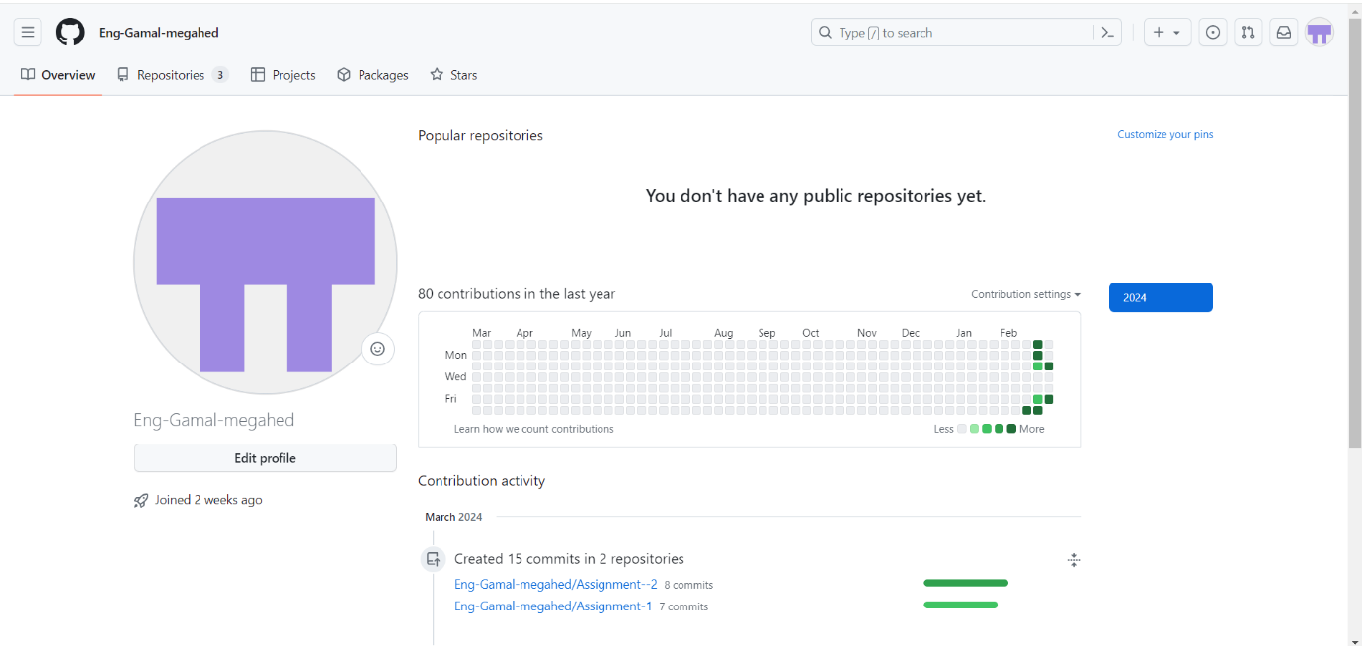

My Project

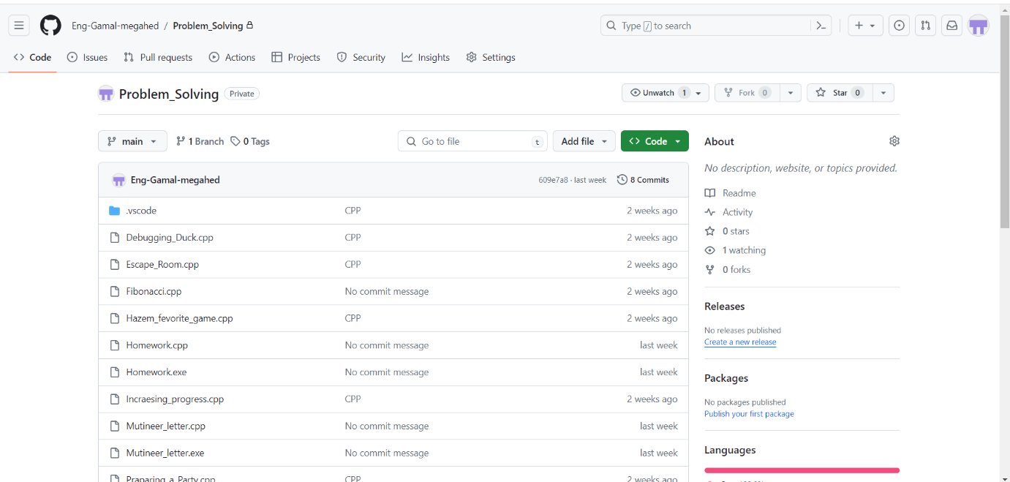

**basic operations that can be done on GitHub**

1. **Creating a new repository**

* From your profile click on your repositories
* Chose “New”
* Setup your repository setting
* Click create repository

1. **Cloning a repository**

* Open the repository you want to clone
* Click on “Code”
* Chose the link type from (https,shh)
* Copy this link
* Open the Git Bash
* Open your directory
* Write this command on the Git Bash: git clone “Link you have copyed”

1. **Add and Commit changes**

* Open the Git Bash
* Open your directory
* To Add a specified files write : git add “file1name” “file2name” ……..
* To Add all files in the directory : git add .
* To Commit all changes : git commit -m “message”

1. **Show your directory informations**

* Open the Git Bash
* Open your directory
* Write this command : git status

1. **Add my team members to my repository**

* **Open the repository**
* **Click on settings**
* **Chose collaborators**
* **Click on Add people**
* **Write your team member username in GitHub**

1. **Pushing my local commits**

* **Open Git Bash and open your directory**
* **To push all commits write : git push “Remote” “Branch”**

1. **Pulling the changes my friends do**

* **Open Git Bash and open your directory**
* **To pull the new changes write : git pull “Remote” “Branch”**