## A computer and a computer Description automatically generated with medium confidenceA logo of a person sitting in a chair Description automatically generatedCairo University

## Faculty of Computers & Artificial Intelligence

# Structured Programing

# CS112

## Assignment 2: GitHub account and My steps

## To: Mohammed El-Ramly

|  |  |
| --- | --- |
| MY Data |  |
|  |  |
| NAME | Walid Adel Mordy Rohaim |
| ID | 20231200 |
| EMAIL Sec | [Khattabadel112005@gmail.com](mailto:Khattabadel112005@gmail.com)  S11 |
|  |  |

## My account on GitHub

## My profile

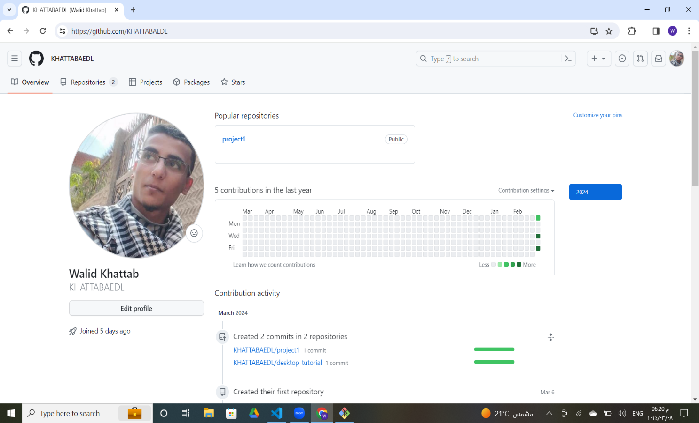

* My project

## My steps to prepare GitHub Environment

1. Create a git hub account:
   1. You can sign up on the GitHub desktop or the website.
2. Create a new Repository:
   1. Select " new repository".
3. Give it a name.
   1. Choose if you want to make it (Public or Private)
   2. It will be better if select "README".
   3. And click create repository.
   4. Clone Repository:
   5. Clone Repository at the first stage it will be at your local machine by this command on git brash" git clone <repository URL>".
4. Add your files to your local repository by using "git add file name".
5. Commit changes.
   1. Commit your changes by using "git commit -m"your message".
6. Push Changes to GitHub.
   1. Push your changes by using "git push origin master".
7. To see your changes and directory info.
   1. Type "git status " on git bash.
8. To connect your local version with git version.
   1. Take a copy of git repository link.
   2. Type this command on git bash "git remote add origin <paste link>"
9. To See the remote type this command "git remote -v".
10. Add a member to work with you on the same project.
    1. At the repository go to settings.
    2. Choose collaborators.
    3. Choose add people.
    4. Enter the participants username.