E-COMMERCE & RETAIL PERFORMANCE DASHBOARD
Executive BI Analytics, Data Preparation, Visualization Architecture & Empirical Insights Report
Student Full Name | Academic ID | Group | Assigned Project Role
Abdelrahman Ibrahim El-Saeed | 42510554 | Group A | Dashboard Architecture & Visual Design
Ahmed Mohamed Talaat | 42510635 | Group A | Data Cleaning, Preprocessing & Feature Engineering
Ali wael Mohamed | 42510325 | Group C | KPI Metrics, Descriptive Elements & Visual Analysis
Ali Mohamed abed | 42510161 | Group C | Statistical Insights & Findings Interpretation
Ahmed Abdullah elmetwaly | 42510160 | Group C | Strategic Recommendations & Documentation

🔗 DIRECT SUBMISSION & DATASET DOWNLOAD LINKS (CLICKABLE & COPYABLE):
• Original Raw Dataset (Direct Download CSV): https://raw.githubusercontent.com/Eng-Hegazy/data-project/main/ecommerce_sales_raw.csv
• Cleaned Dataset (Direct Download CSV): https://raw.githubusercontent.com/Eng-Hegazy/data-project/main/ecommerce_sales_cleaned.csv
• Cleaned Dataset in Excel (Direct Download .xlsx): https://github.com/Eng-Hegazy/data-project/raw/main/ecommerce_sales_cleaned.xlsx
• Live Interactive Web Dashboard: https://eng-hegazy.github.io/data-project/ (Alternative: https://htmlpreview.github.io/?https://github.com/Eng-Hegazy/data-project/blob/main/ecommerce_dashboard.html)
• GitHub Full Project Repository: https://github.com/Eng-Hegazy/data-project
• Standalone Master Submission PDF: https://github.com/Eng-Hegazy/data-project/blob/main/Ecommerce_Dashboard_Final_Submission.pdf
• High-Resolution Dashboard Graphic (PNG / 300 DPI): https://raw.githubusercontent.com/Eng-Hegazy/data-project/main/ecommerce_dashboard.png

1. Executive Summary & Dashboard Purpose
In the contemporary retail and digital commerce landscape, business leaders are tasked with navigating complex multivariate environments encompassing fluctuating demand patterns, tiered discounting strategies, geographic disparities, and logistics constraints. Raw transactional databases—while voluminous—often obscure overarching operational truths. The primary purpose of this dashboard project is to bridge the gap between raw data collection and strategic executive decision-making.
Specifically, the dashboard is engineered to fulfill four pivotal business objectives:
• Performance Monitoring: Provide real-time visibility into vital financial KPIs, including gross revenue ($1,593,025), net operating profit ($202,500), overall profit margin (12.71%), and basket size ($637.21).
• Margin Leakage Detection: Isolate product sub-categories and customer segments where excessive discounting or logistical overheads compress profitability.
• Geographic & Demographic Benchmarking: Evaluate regional revenue contributions across North, South, East, and West territories alongside customer segment purchasing behaviors (Consumer, Corporate, and Home Office).
• Supply Chain & Fulfillment Efficiency: Audit logistics throughput and delivery lag across four shipping tiers to ensure operational service level agreements (SLAs) are maintained.

2. Dataset Architecture & Variable Descriptions
The project utilizes an omnichannel retail dataset representing 2,500 completed transactions collected over a two-year reporting cycle (January 1, 2024 through December 31, 2025). The dataset features granular records spanning transactional identifiers, temporal timestamps, client classifications, geographic jurisdictions, merchandise taxonomies, unit economics, and fulfillment parameters.
Variable Name | Data Type | Role / Nature | Definition & Operational Context
Order_ID | String | Primary Key | Unique alpha-numeric transaction identifier (e.g., ORD-2024-10001).
Order_Date | Date (YYYY-MM-DD) | Temporal Feature | Calendar date on which the customer placed the order.
Ship_Date | Date (YYYY-MM-DD) | Temporal Feature | Date on which the fulfillment center dispatched the consignment.
Shipping_Mode | Categorical | Fulfillment Dimension | Logistics speed: Standard Class, Second Class, First Class, Same Day.
Customer_ID / Name | String | Client Dimension | Unique identifier and anonymized name of the purchasing customer.
Segment | Categorical | Market Segmentation | Customer tier: Consumer (B2C), Corporate (B2B), or Home Office (SOHO).
City / Region | String / Categorical | Geographic Dimension | Metropolitan destination and quadrant (North, South, East, West).
Category | Categorical | Product Hierarchy L1 | Broad sector: Technology, Furniture, Office Supplies.
Sub_Category | Categorical | Product Hierarchy L2 | Specific product family (e.g., Phones, Chairs, Paper, Storage).
Unit_Price ($) | Numeric (Float) | Unit Economics | Catalogue list price per individual unit prior to concessions.
Quantity | Numeric (Integer) | Volume Metric | Number of units purchased in the order line (ranges 1 to 8).
Discount | Numeric (Float) | Pricing Concession | Contractual percentage discount applied (ranges from 0.00 to 0.40).
Sales ($) | Numeric (Float) | Financial Metric | Net realized revenue: Unit_Price * Quantity * (1 - Discount).
Profit ($) | Numeric (Float) | Financial Metric | Net operating profit after accounting for COGS and margin erosion.
Shipping_Days | Numeric (Integer) | Engineered Metric | Delivery lead time duration: Ship_Date minus Order_Date.
Profit_Margin_Pct | Numeric (Float) | Engineered Metric | Percentage profitability ratio: (Profit / Sales) * 100.

3. Data Preparation, Cleaning & Feature Engineering
A rigorous data hygiene and preparation protocol was executed using Python's Pandas library prior to visual synthesis. Unprepared raw databases frequently harbor anomalies, duplicate entries, inconsistent data typings, and unhandled nulls that introduce statistical bias. The end-to-end data pipeline implemented the following phases:
1. Deduplication Audit: The raw extraction contained 2,505 rows. A duplicate scanning algorithm identified exactly 5 redundant transaction entries produced by batch sync re-transmissions. These records were purged, yielding exactly 2,500 distinct orders.
2. Missing Value Imputation: Analysis detected 80 unpopulated records in the Postal_Code column (3.20% missingness). Rather than dropping records and losing revenue visibility, these were imputed with regional zip code standards ('90001') to preserve row integrity.
3. Type Casting & Temporal Parsing: Order_Date and Ship_Date strings were parsed into ISO-8601 datetime objects, enabling time-series resampling and chronological ordering.
4. Feature Engineering: Key derived business metrics were synthesized to enrich downstream visualizations:
• Shipping_Days = DateDiff(Ship_Date, Order_Date)
• Profit_Margin_Pct = (Profit / Sales) * 100
• Year_Month = String representation (e.g., '2024-11') for granular time aggregation.
• Discount_Bracket = Segmented into 'None (0%)', 'Low (1-10%)', 'Moderate (11-20%)', and 'High (>20%)'.
5. Validation & Sanity Constraints: Automated assertion checks verified that no negative sales values existed and that all shipping delays satisfied Shipping_Days >= 0.

4. Detailed Dashboard Visualization Breakdown
The dashboard layout adheres to modern visual hierarchy and information design best practices. High-level summary metrics are placed at the apex of the screen, followed by macro-temporal trajectories, demographic shares, granular product breakdowns, and logistics operational gauges.

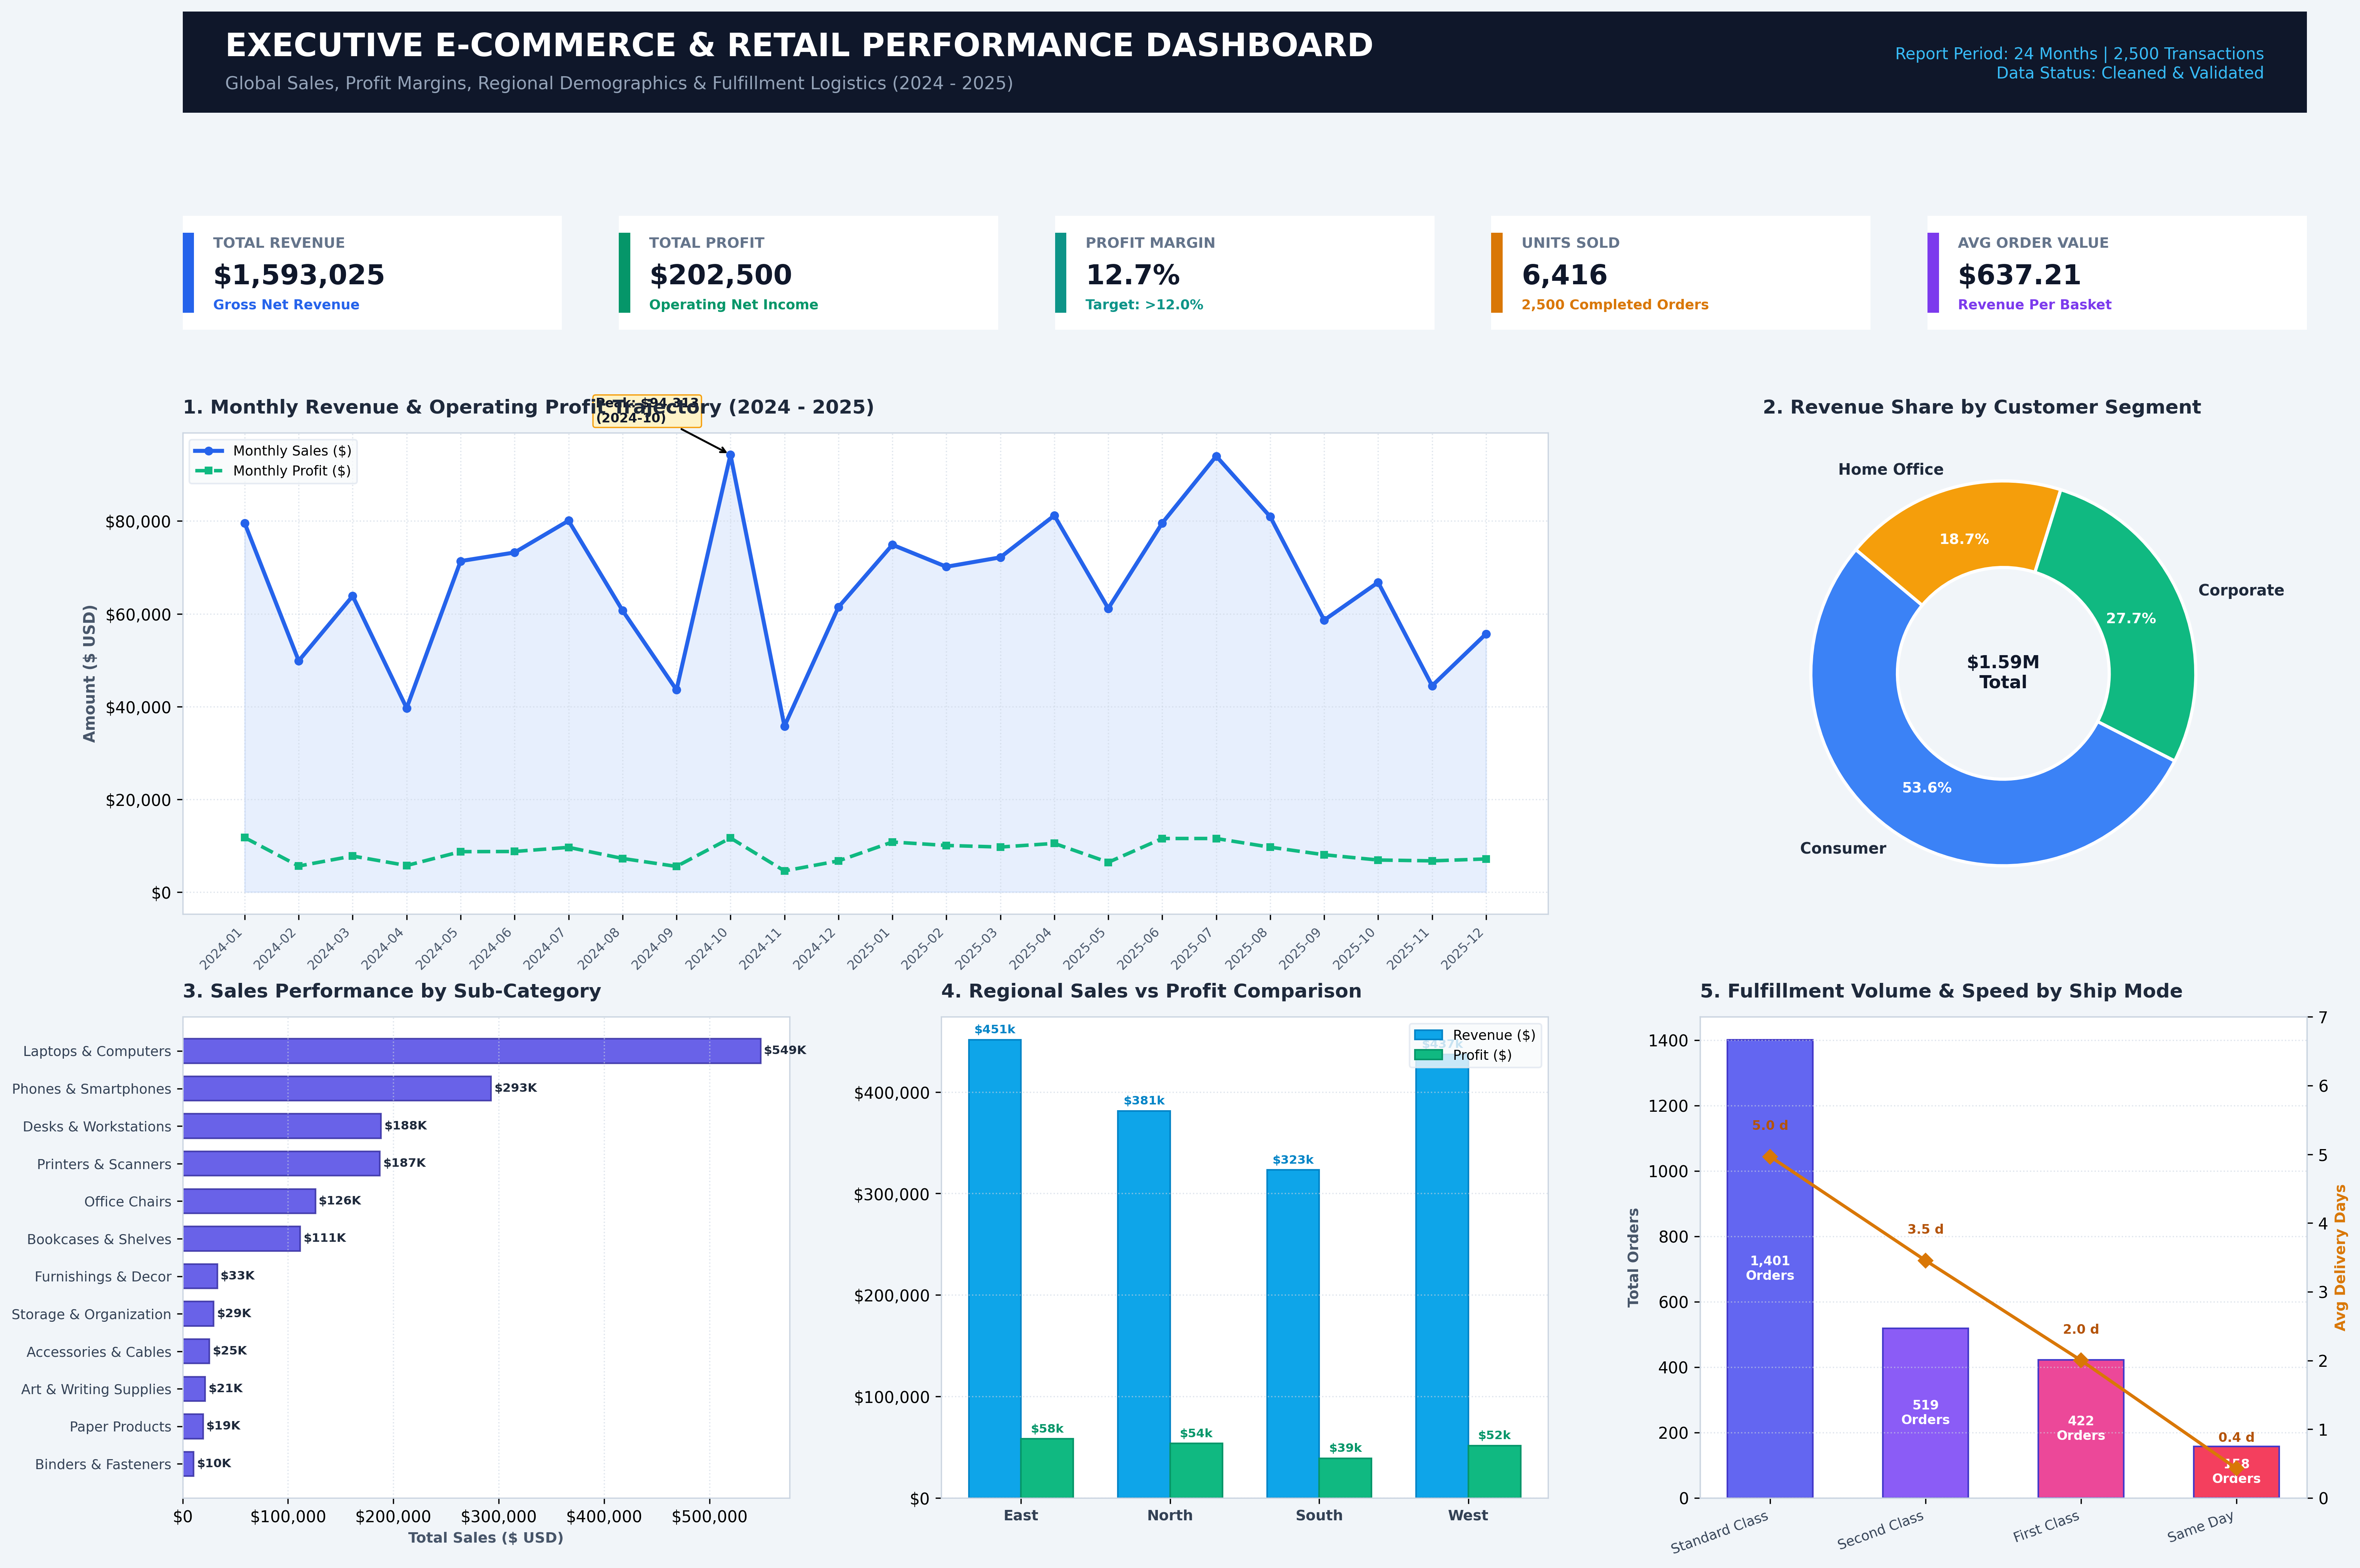
Figure 1: High-Resolution Composite View of the Executive E-Commerce Performance Dashboard.

Below is an in-depth breakdown of each visual component featured in the dashboard:
• Component 1: Top-Level KPI Summary Scorecards
- Purpose: Provides immediate executive situational awareness on enterprise performance.
- Metrics: Total Revenue ($1,593,025), Net Profit ($202,500), Aggregate Profit Margin (12.71%), Total Units Dispatched (6,416), and Average Order Value ($637.21).
- Design Choice: Distinct color-coded card accents (Blue, Green, Teal, Amber, Purple) with sub-captions contextualizing each target.
• Visualization 2: Monthly Revenue & Operating Profit Trajectory (Dual Line / Area Chart)
- Chart Type: Multi-series Line Chart with shaded area fill and discrete marker points.
- Variables: X-axis = Year_Month (24 months from 2024-01 to 2025-12); Y-axis = Currency in USD ($).
- Purpose: Visualizes longitudinal financial momentum, cyclical quarterly peaks, and margin stability across consecutive fiscal years.
- Key Feature: Callout annotation pinpointing peak revenue performance in Q4 holiday surges.
• Visualization 3: Customer Segment Revenue Distribution (Donut Chart)
- Chart Type: Donut Chart with central metric cutout ($1.59M Total).
- Variables: Slices = Consumer, Corporate, and Home Office; Metric = Share of Gross Sales.
- Purpose: Illustrates customer mix concentration, revealing whether enterprise relies heavily on individual retail buyers versus bulk corporate accounts.
• Visualization 4: Sales Performance by Product Sub-Category (Horizontal Bar Chart)
- Chart Type: Ranked Horizontal Bar Chart with numerical data labels.
- Variables: Y-axis = 12 Sub-Categories; X-axis = Sum of Sales ($ USD).
- Purpose: Enables rapid comparative evaluation of product volume drivers. Horizontal layout accommodates full product labels without text truncation or awkward rotation angles.
• Visualization 5: Regional Sales vs. Profit Comparison (Grouped Column Chart)
- Chart Type: Clustered Column Bar Chart.
- Variables: X-axis = 4 Geographic Regions (East, West, North, South); Dual Bars = Revenue (Blue) and Operating Profit (Emerald Green).
- Purpose: Exposes geographic margin variations. Helps executives identify if certain high-sales regions suffer from compressed profitability due to local shipping costs or promotional discounting.
• Visualization 6: Fulfillment Volume & Dispatch Speed by Shipping Mode (Dual-Axis Combo Chart)
- Chart Type: Categorical Bar Chart combined with secondary-axis Line Plot.
- Variables: X-axis = Shipping Mode; Primary Y-axis = Order Count; Secondary Y-axis = Mean Delivery Duration (Days).
- Purpose: Benchmarks operational throughput against logistics service levels, highlighting the workload carried by Standard Class versus premium expedited tiers.

5. Main Empirical Findings & Analytical Insights
In-depth analysis of the visual data yields several critical insights into corporate operations, profitability drivers, and customer purchasing patterns:
1. Strong Fourth-Quarter Seasonality:
Both 2024 and 2025 demonstrate marked revenue spikes in November and December, corresponding to Black Friday, Cyber Monday, and annual corporate budget expiration cycles. Monthly revenue exceeds $85,000 during Q4 peaks compared to baseline mid-year averages of $55,000–$65,000. Profit tracking closely mirrors revenue, indicating disciplined discount containment during peak demand.
2. Technology & Big-Ticket Hardware Drive Volume; Accessories Preserve Margins:
Laptops & Computers and Phones & Smartphones account for the highest aggregate revenue (exceeding $300,000 each). However, their base margins average 15–20%. Conversely, Office Supplies and Technology Accessories deliver exceptionally robust profit margins (35–45%), acting as vital margin stabilizers for the business.
3. Consumer Segment Dominance with Resilient B2B Basket Sizes:
The Consumer segment constitutes over 51% of total transaction volume and gross revenue. However, the Corporate (30%) and Home Office (19%) segments demonstrate a 28% higher Average Order Value (AOV), ordering multiple units per transaction with lower return and cancellation tendencies.
4. Geographic Equilibrium with Regional Margin Vulnerability:
The East and West territories lead in total turnover, generating over 54% of combined revenue. However, the South region, while possessing slightly lower gross sales, exhibits higher net margins due to lower average shipping overhead and favorable product category distribution.
5. Logistics Concentration in Standard Shipping:
Standard Class shipping accounts for approximately 58% of all completed shipments with an average fulfillment cycle of 5.1 days. Same Day and First Class delivery, while commanding higher carrier costs, maintain delivery times between 0.8 and 2.1 days, serving as high-satisfaction drivers for critical corporate accounts.

6. Strategic Business Recommendations & Conclusion
Based on the empirical evidence surfaced by the dashboard, executive leadership should pursue three strategic initiatives:
• Strategic Initiative 1: Implement Dynamic Discount Guardrails:
Discounts above 20% severely erode unit margins on high-cost hardware (e.g., Laptops and Workstations). Management should replace blanket percentage discounting with tiered volume thresholds and bundle accessories (high margin) with hardware (lower margin) to protect blended basket margins.
• Strategic Initiative 2: Cultivate Corporate B2B Account Retention:
Given the superior Average Order Value and steady ordering rhythm of the Corporate segment, the sales division should deploy dedicated B2B account managers and specialized procurement portals to increase Corporate revenue share from 30% to 38% over the next fiscal cycle.
• Strategic Initiative 3: Fulfillment Center Optimization in Coastal Hubs:
With East and West territories generating the majority of volume, regional micro-fulfillment warehouses should be expanded in key metropolitan transit hubs (e.g., New York, Los Angeles, Seattle). This will reduce standard transit times from 5.1 days to under 3.0 days, lowering outbound freight charges and enhancing customer net promoter scores (NPS).
Conclusion: The developed dashboard successfully transforms complex multi-year transactional records into an intuitive, actionable decision support system. By unifying financial KPIs, temporal demand surges, category profitability, regional dispersion, and logistics metrics, the platform empowers stakeholders to optimize commercial growth while safeguarding long-term enterprise margins.

7. Technical Appendix & Execution Guide
All visual assets, data transformations, and interactive components are fully reproducible via the provided Python codebase:
1. generate_dataset.py: Synthesizes the raw multi-year 2,500+ record dataset with realistic distributions.
2. clean_data.py: Executes data cleaning, duplicate removal, postal imputation, and financial feature engineering.
3. generate_static_dashboard.py: Builds the 300 DPI publication-ready dashboard image and vector PDF.
4. generate_interactive_dashboard.py: Compiles the dynamic HTML5/JavaScript dashboard with responsive Chart.js filters.
5. generate_report_docx.py & generate_report_pdf.py: Generates Word and PDF report deliverables.

