ET-A: QUIZ

Question 1:

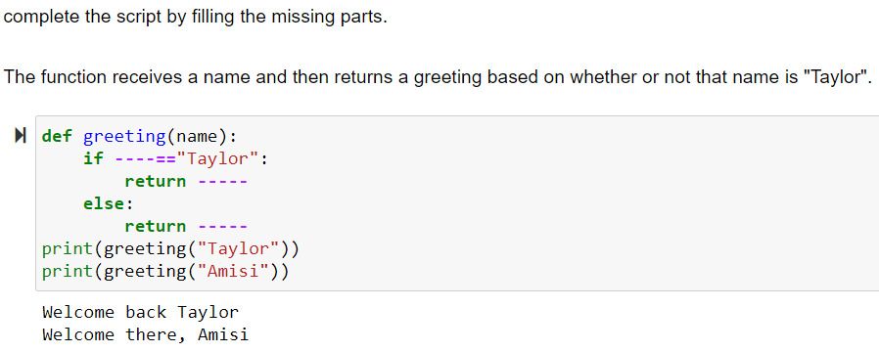

ANSWER:

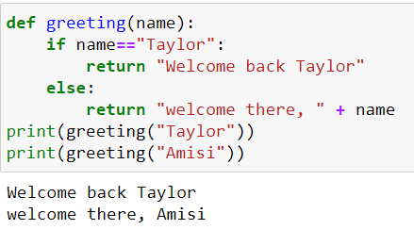

xxxxxxxxxxxxxxxxxxxxxxxxxxxxxxxxxxxxxxxxxxxxxxxxxxxxxxxxxxxxxxxxxxxxxxxxxx

Question 2:

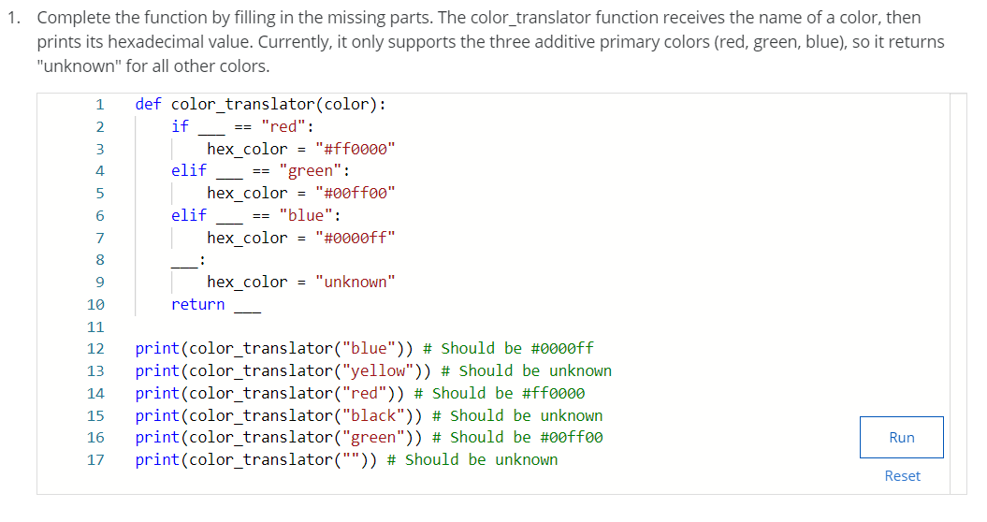

ANSWER:

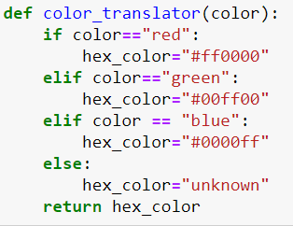

xxxxxxxxxxxxxxxxxxxxxxxxxxxxxxxxxxxxxxxxxxxxxxxxxxxxxxxxxxxxxxxxxxxxxxxxxx

Question 3:

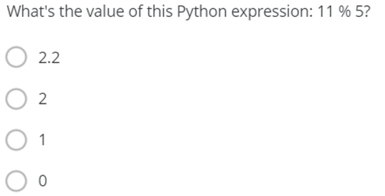

ANSWER: 1

Question 4:

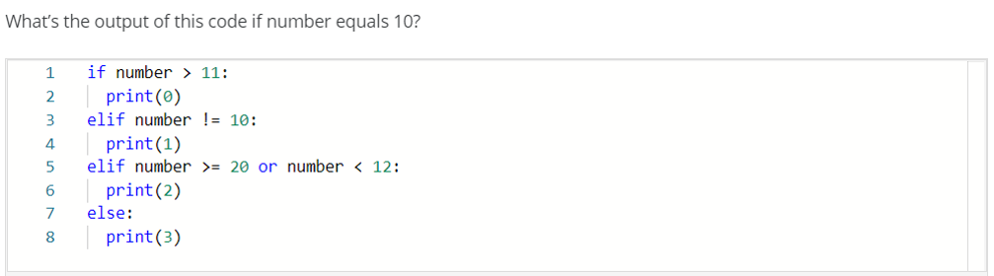

ANSWER: 2