
Faculty of Engineering & Technology
Department of Electrical & Computer Engineering
Wireless and Mobile Networks
Project – Live Wi-Fi Channel Occupancy Sensing and Dynamic Channel-Hopping Interference Generation with SDR
ENCS5323

Prepared by:
Ellen Izz 1220806
Nawras Yaccob 1221904
Mohammad Abutteen 1221573

Instructor: Dr. Mohammad K. Jubran
Section: 1
Date: 20 September 2026

Part 1: Live Wi-Fi Channel Occupancy Sensing

Methodology
The goal of this part was to monitor activity in the 2.4 GHz Wi-Fi band using the ADALM-PLUTO SDR.
The 2.4 GHz band used in this experiment covers approximately 2400-2500 MHz. The PlutoSDR cannot capture this whole frequency range at once, so the program divides the band into smaller sections and scans them one after another.
The receiver uses a sample rate and RF bandwidth of 30 MHz. For each frequency section, the PlutoSDR collects $2^{16}$ IQ samples. The collected samples are then processed using Welch's method to estimate the power at each frequency.
Only the middle 80% of every capture is used. The edges are ignored because the receiver filter can make the measurements near the edges less accurate. After this, the useful parts from the different captures are combined to create one spectrum covering the complete 2400-2500 MHz range.
A small unwanted spike can also appear at the exact center frequency of each PlutoSDR capture because of the SDR hardware. The program removes this spike before combining the measurements.
The program repeats this process for 40 complete sweeps, with approximately 3 seconds between sweeps.
For every sweep, the program calculates the average received power for Wi-Fi channels 1 through 13 A channel is considered occupied when its measured power is more than 6 dB above the estimated noise floor.
The measurements are then displayed using two plots:
- A power spectrum showing activity across the complete 2.4 GHz band.
- A heatmap showing how the measured power of each Wi-Fi channel changes over time.

1.2 Power Spectrum
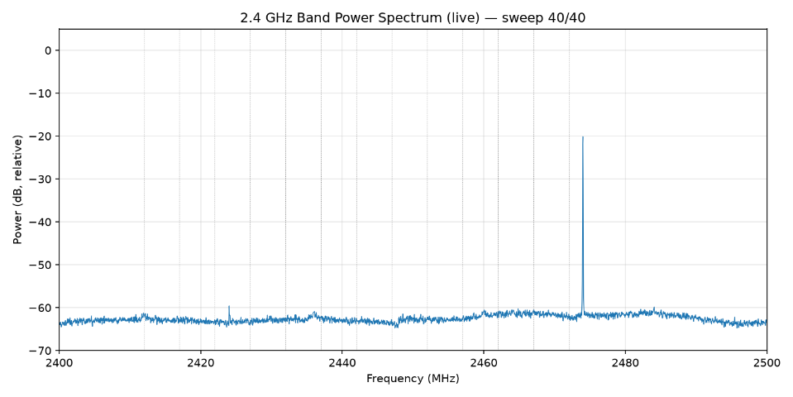
Figure 1: Measured power spectrum across the 2.4 GHz band during the final sweep.
Figure 1 shows the measured power across the full 2.4 GHz band from 2400 MHz to 2500 MHz during the final sweep. Most of the spectrum stays around −62 to −64 dB, which represents the background noise level measured by the SDR. The strongest signal appears near 2474 MHz, where the power rises to about −20 dB, showing strong RF activity in that part of the band. A few smaller variations can also be seen at other frequencies, but most of the band remains close to the noise level during this sweep. Since the system only measures received RF power, the plot shows where wireless activity is present but does not determine exactly which device or wireless technology produced the signal.

1.3 Channel Occupancy Over Time
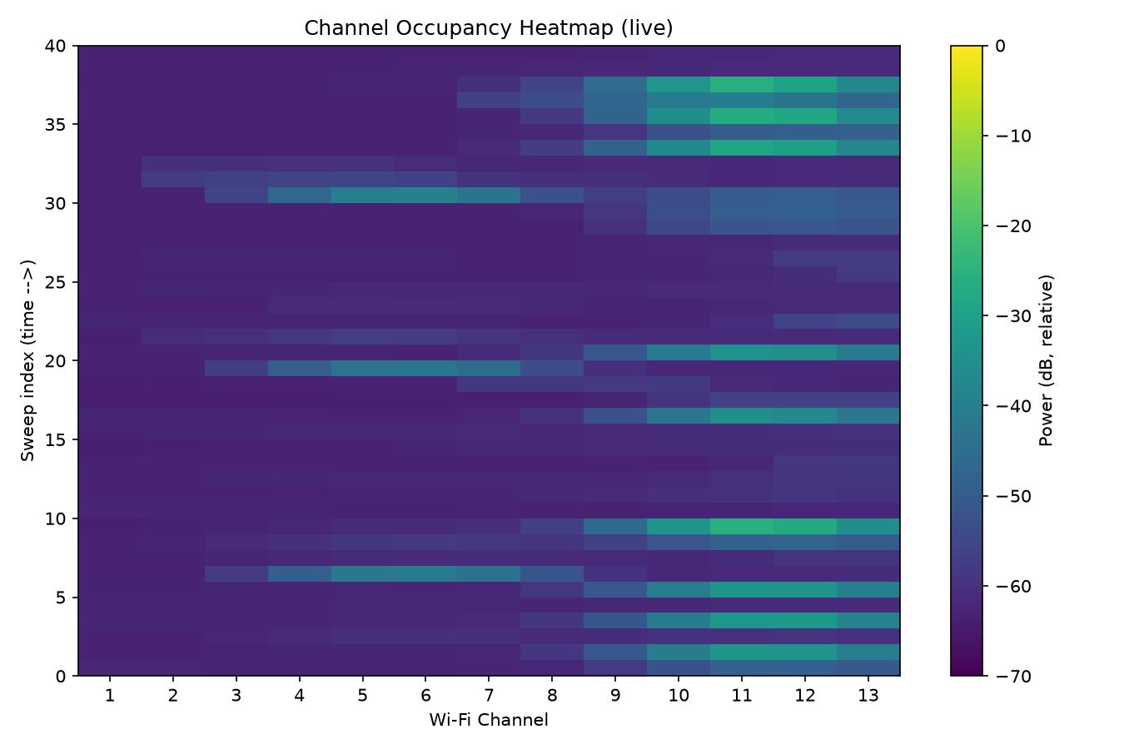
Figure 2: Measured power for Wi-Fi channels 1–13 over 40 consecutive sweeps, approximately 3 seconds apart.
Figure 2 shows how the measured power in each Wi-Fi channel changes over 40 sweeps. Darker areas represent lower received power, while brighter areas represent stronger RF activity. The results show that the activity is not constant and changes from one sweep to another.
Several periods of stronger activity can be seen, especially around channels 9–13. Some activity also appears around channels 3–7 during other sweeps. Many sweeps remain close to the background noise level, showing that large parts of the band were quiet during those measurements.
This changing pattern is expected because wireless devices usually transmit data for short periods rather than continuously. The heatmap therefore makes it easy to see which parts of the 2.4 GHz band are active and how that activity changes over time.

1.4 Discussion and Limitations
The system detects RF power in each Wi-Fi channel, but it cannot identify the exact type of signal or device causing the activity. A channel is considered occupied when its power is above the estimated noise floor.
One limitation is that the noise floor is calculated for each sweep. If many channels are active at the same time, weaker signals may be missed. Using a more stable or calibrated noise-floor value could improve the detection accuracy.

