

|  |
| --- |
| **THERMAID** |
| User Quick Start Guide v.1.0 |

|  |
| --- |
|  |

Table of contents

Acknowledgements 3

Copyright 3

License 3

Introduction 4

Theory of the embedded discrete fracture model 5

Quick Start 6

Running the Code 7

Elements of the Code 7

Input File 10

Boundary Conditions 15

Examples 16

Example 1: Crossed fractures 16

Example 2: Crossed Fractures with Heat Transport 16

Example 3: Complex fracture network with 13 Fractures 16

Example 4: Load a FracSim3D fracture network 16

Example 5: Load a FracMan fracture network 16

Visualization with Thermaid 17

Understanding efficient runtime visualization 17

### Acknowledgements

THERMAID is based on Maflot, developed by Rouven Künze and Ivan Lunati at the University of Lausanne, 2012. The initial code basis was provided through their code available at www.maflot.com.

I thank Prof. Stephen. A. Miller for his support and for sharing his pearls of wisdom with me during the creation of the Thermaid code. I would also like to show my gratitude to Reza Sohrabi without whom the code and documentation would not exist in this form.

This project was supported by the Swiss National Fond (SNF) through grant ‘NFP70:Energy Turnaround (153971)’.

### Copyright

Thermaid Quick Start Guide v.1.0 is Copyright ©2017 Gunnar Jansen. All rights reserved.

For queries related to this document contact us through the projects repository form at github.com

### License

Along with this user manual a MATLAB code, called Thermaid, for the solution of flow and heat transport with additional capabilities to determine fracture stability in fractured porous media using the embedded discrete fracture model is distributed.

Thermaid is free software: you can redistribute it and/or modify it under the terms of the GNU General Public License as published by the Free Software Foundation, either version 3 of the License, or (at your option) any later version.

Thermaid is distributed in the hope that it will be useful, but WITHOUT ANY WARRANTY; without even the implied warranty of MERCHANTABILITY or FITNESS FOR A PARTICULAR PURPOSE. See the GNU General Public License for more details.

You should have received a copy of the GNU General Public License along with Thermaid.  
If not, see <http://www.gnu.org/licenses/>.

# Introduction

A large fraction of the world’s water and energy resources are located in naturally fractured reservoirs within the earth’s crust. Understanding the dynamics of such reservoirs in terms of flow, heat transport and fracture stability is crucial to successful application of engineered geothermal systems (also known as enhanced geothermal systems, EGS) for geothermal energy production in the future.

Fractured reservoirs can be considered to consist of two distinct separate media, namely the fracture and matrix space respectively. Depending on the properties of matrix and fracture, different types of reservoirs can be defined. In case of enhanced geothermal systems, typically two cases may prevail: 1) reservoirs with low porosity matrix for which both the permeability and the storage capacity of the rock mass are controlled by the fractures and 2) reservoir with sufficient matrix porosity such that fluid storage is dominated by the matrix while the fractures contain only a small fraction of the fluid but control the permeability.

Simulation of flow and transport through fractured porous media is challenging due to the high permeability contrast between the fractures and the surrounding rock matrix. However, accurate and efficient simulation of flow through a fracture network is crucial in order to understand, optimize and engineer reservoirs. It has been a research topic for several decades and is still under active research. Additionally accurate estimations of the fracture stability are necessary in order to predict permeability evolution and forecast induced seismicity. Discrete fracture models (DFM) have been developed to address the computational problem of scales for fluid flow and heat transport. Yet traditional conforming DFM where the fractures are explicitly resolved by the numerical grid, suffer from computationally expensive pre-processing in the numerical grid generation and can encounter severe time step restrictions during the simulation if explicit time-stepping and small cells around the fractures are used.

An alternative approach is used by the embedded discrete fracture models (EDFM), which treat fracture and matrix in two separate computational domains. The embedded fracture model was first introduced by Lee et al. for single phase problems and later extended to twophase flow. The embedded discrete fracture model is a promising technique in modelling the behavior of enhanced geothermal systems.

Slip tendency analysis is used in order to estimate fault reactivation potential in earthquake prone areas as well as fracture stability in geothermal reservoirs. Slip tendency is the ratio of shear stress to effective normal stress on a surface. Fracture or fault reactivation is likely to occur if the shear stress to effective normal stress ratio equals or exceeds the frictional sliding resistance. In general, the stress field is heterogeneous due to the contrast of mechanical properties and past rock mass rupture. Moreover, the stability of the fractures is controlled by the local stress field. However, assessing this local stress field is not trivial. On the other hand it may not be necessary to determine the local stress field and resolve the complex deformation process during fault slip in order to obtain an indicator for the likelihood of slip. Using slip tendency, predictions on fracture instabilities during the hydraulic stimulation of a fractured reservoir are feasible without solving for the typically non-linear evolution of the stress equilibrium equation.

Thermaid is an open source implementation of an embedded discrete fracture model for single phase flow and heat transport with additional capabilities to determine fracture stability in fractured reservoirs. Thermaid, is a fractured reservoir modelling framework implemented in MATLAB which can be used as a standalone simulation package for TH(m) cases in geothermal reservoirs or as a blue print for the re-implementation of the method e.g. in a high performance computing (HPC) framework. Of course, additional model capabilities can be implemented by new users directly in the Thermaid package.

# Theory of the embedded discrete fracture model

The conceptual idea of the EDFM is the distinct separation of a fractured reservoir into a fracture and a matrix domain. We introduce a transfer function to account for coupling effects between the two domains (cf. Figure 1), so the fracture and matrix domains are computationally independent except for the transfer function. As the fractures are generally very thin and highly permeable compared to the surrounding matrix rock, the gradient of fracture pressure normal to the fracture is negligible. This allows for a lower dimensional representation of fractures (i.e. 1D objects within a 2D reservoir).

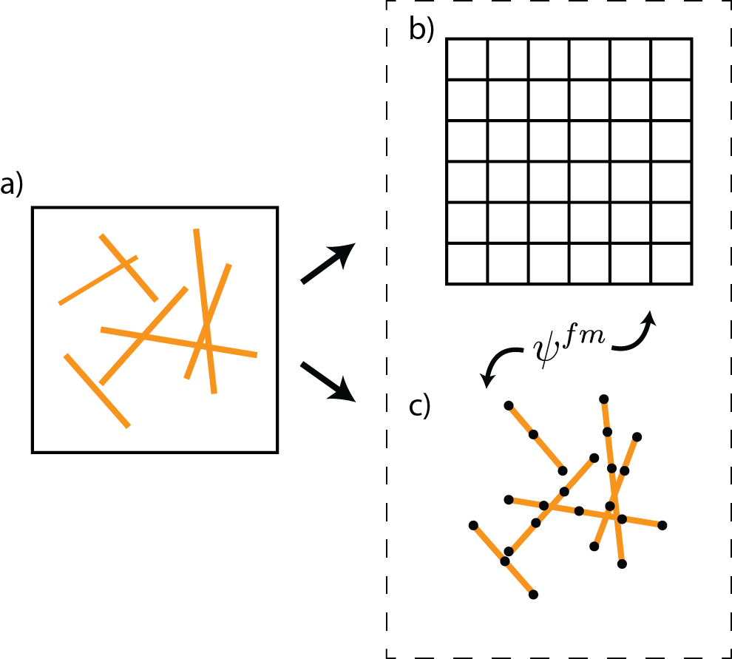For more detail on the underlying theory implemented in Thermaid please refer to Thermaid’s scientific publication.

Figure 1: A fractured domain a) is separated in a uniform grid b) and a fracture grid c). The two resulting domains are coupled using the transfer function $Ψ_{fm}$.

# Quick Start

You can get started running the Thermaid code right away. Open MATLAB, change into the Thermaid directory and run the startup script:

>> cd PATH_TO_/Thermaid  
>> startup

The startup script will add the necessary directories to the search path and execute a small sanity test. If your MATLAB version gives you an error message at this point, please note that Thermaid has been developed and tested with MATLAB R2015b. Please contact the authors for support.

After the startup script has successfully finished, you can run any of the provided examples by typing the following into your command window:

>> ex1

This will run the first of the examples and show the results in a plot. Please see the detailed examples description section for more information on what problems the examples solve and how to visualize your results.

Beware, that this code is scientific software that should not be used for mindless simulations. Always look at your simulations results critically and evaluate if the computed results are physically making sense.

We encourage you to take the time to carefully read through this manual after you played around a little with the examples, so that you can understand more in depth, how the code and its underlying physical model works.

With this being said, let’s get started. In the following sections the basic elements of the code are outlined. Then, the usage of the input file, the conventions of the boundary conditions are explained. Finally we provide some tips on visualizing your results and provide more details on the examples.

# Running the Code

Thermaid can be run from its directory by entering the command

>> THERMAID(‘InputFile’)

Alternatively, you can access Thermaid form any directory by adding the Thermaid directory to your current path:

>> addpath(genpath(‘/path/to/THERMAID’)) TODO??

When calling Thermaid an input file must be given. You can edit the existing input file, or (preferably) copy and edit it according to your needs. Afterwards you can execute it by calling

>> THERMAID(‘My_InputFile’)

The input file is more or less self-explanatory and can be modified according to your needs. Nevertheless, the contents of the input file are explained throughout this guide.

As an additional option to the Thermaid call, the default graphical output of the results can be suppressed. In order to do this the call has to be modified to

>> THERMAID(‘My_InputFile’,0)

This might be useful, if timed simulations are desired as the graphical output takes a big part of the simulation time. You can still plot the final results afterwards as the data is written to the workspace.

# Elements of the Code

Thermaid consists of multiple functions. THERMAID.m itself is the main function that controls the simulation and calls most of the sub functions. The sub functions deal with specific parts of the program, such as initialization, discretization and solution of the flow and transport equations. The individual functions are introduced briefly here while the underlying theory is further explained throughout the scientific publication.

#### THERMAID.m

The main function. All sub functions are called out of this main function. It contains the time loop and is responsible for general functionalities of the code. More insight to the main functions structure is given in the scientific publication.

#### InputFile.m

This is the user’s control file for the simulation. It describes to discrete fracture network as well as the problems parameters and boundary conditions. The input file is self-explanatory but a short explanation is given in section Input File.

#### startup.m

The startup routine of Thermaid. During the execution the Thermaid directories are added to the MATLAB environment path and a simple example to verify the build.

#### initialize.m

Initializes the interface based values such as permeability and porosity as well the gravity contributions to the pressure system.

#### calc_density.m

The density is temperature and pressure dependent. An equation of state is implemented in this function to calculate the correct value.

#### intersectionsGrid.m

Finds the intersections of the discrete fracture network with the matrix grid and calculates the connectivity index.

#### calc_d_mean.m

Calculates the mean distance of the fracture to the cell. See the scientific publication for more detail.

#### intersectionsSegments.m

Finds intersections between individual fractures and computes the corresponding transmissivities.

#### calc_frac_flux_mat.m

Calculate the matrix operator for flux extraction on the fractures. This enhances the computational performance of Thermaid.

#### calc_frac_grad_expand_mat.m

Calculate the matrix operator for expanded gradient operations on the fractures. This is used in the velocity calculations for instance.

#### calc_frac_grad_mat.m

Calculate the matrix operator for expanded gradient operations on the fractures.

#### calc_frac_mean_mat.m

Calculate the matrix operator for the mean on the fractures.

#### calc_interface_values.m

Calculate interface values for the matrix interfaces.

#### calc_interface_values_fracture.m

Calculate harmonic mean interface values for the fracture interfaces.

#### pressureSystem.m

Constructs the mass balance matrix and right hand side vector for the pressure system. The linear algebraic system is solver outside in the main function.

#### calcVelocity.m

Calculates the velocity field from the pressure using Darcy’s law.

#### transport_heat_System.m

Solves the transport problem based on the mass continuity equation of the solvent. The system is solved within the function.

#### transport_heat_Advection.m

Constructs the advection matrix using a first order upwind approximation.

#### transport_heat_Diffusion.m

Constructs the diffusion operator for the transport equation.

#### calc_frac_stability.m

Calculate fracture stability based on slip tendency. Refer to the scientific publication for more detailed background information.

#### attach_pre_timestep.m

This function allows user-defined code to be executed before each time step. This can be used to load external data into the simulation or to interface with other software.

#### attach_post_timestep.m

This function allows user-defined code to be execute after each time step. This can be used for visualization for instance.

# Input File

The input file is more or less self-explanatory and can be modified according to your needs. It is recommended that you create a renamed copy of the input file before you modify it.

All user input data is saved in a structure called udata which is used to facilitate data transfer within Thermaid to all the relevant positions. Units are always given in brackets. The form of the Input file respectively all variables shown here must be preserved to avoid errors.

The first section of the input file defines the global dimensions of the domain and its discretization:

%% GRID PARAMETERS ------------------------------------------------------------%

udata.len = [500 500]; % physical length of the domain in x and y direction [m]

udata.Nf = [51 51]; % number of cells in x and y direction

udata.dx = udata.len./udata.Nf; % cell length [m]

Next, the simulation parameters corresponding to the time of the simulation are set.

%% SIMULATION PARAMETER FOR TRANSIENT SIMULATIONS------------------------------%

udata.timeSim = 86400; % total simulation time [s]

udata.dt = 3600; % time step length [s]

udata.tol = 1.e-4; % tolerance in pressure-heat loop [-]

udata.maxit = 100; % maximum number of pressure-heat loops to converge

The fracture network is set by calling one of the existing DFN or load a DFN from file. Please look at examples 4 and 5 to learn more about reading DFNs from file.

%% FRACTURE NETWORK -----------------------------------------------------------%

% Thirteen 'random' fractures

frac_complex_n13;

if (udata.dxf < min(udata.dx))

error('dxf < dx')

end

Note that an error check is included in the input file to make sure that the discretization length of the fracture is bigger than the minimum cell spacing. Now, that the fracture network and the most general parameters for the simulation have been defined, we define the initial conditions:

Setting boundary conditions is fairly simple in Thermaid, however it might take some time to get used to it. Following this section there is a section to clarify the conventions used in boundary conditions. The general structure looks like this:

%% BC FLUID -------------------------------------------------------------------%

udata.ibcs = zeros(2*sum(udata.Nf),1); % type 0:Neumann(N); 1:Dirichlet(D)

udata.Fix = zeros(2*sum(udata.Nf),1); % value N [m2/s] (inflow>0); D [Pa]

udata.ibcs(1:udata.Nf(2)) = 1;

udata.ibcs(udata.Nf(2)+1:2*udata.Nf(2))=1;

udata.Fix(1:udata.Nf(2)) = 5e6;

udata.Fix(udata.Nf(2)+1:2*udata.Nf(2))=0;

%% BC TRANSPORT ---------------------------------------------------------------%

udata.flagHeatTransport = 0;

udata.FixT = zeros(2*sum(udata.Nf),1);%normalized concentration of boundary flow [-]

%% INITIAL CONDITIONS----------------------------------------------------------%

udata.T0 = zeros(udata.Nf(1),udata.Nf(2)); % Initial matrix temperature [°C]

udata.T0f = zeros(udata.Nf_f,1); % Initial fracture temperature [°C]

udata.tmax = 0; % maximum temperature [°C] for plotting

udata.p0 = zeros(udata.Nf(1),udata.Nf(2)); % Initial matrix pressure [Pa]

udata.p0f = zeros(udata.Nf_f,1); % Initial fracture pressure [Pa]

Note that heat transport can be turned on and off using the user data flag udata.flagHeatTransport. If the value is set to 0, then a pressure-only simulation is executed.

You can add internal sources by using the source terms:

%% SOURCE TERMS ---------------------------------------------------------------%

Q = zeros(udata.Nf); % source term [m2/s]; inflow positive

QT = zeros(udata.Nf); % normalized concentration for source term [-]

Next, the hydraulic parameters of the matrix and fractures have to be defined. Note that we define also whether or not to account for gravity here:

Fluid density and viscosity can either be calculated using an equation of state, or held constant at a value specified in the input file:

%% Fluid density --------------------------------------------------------------%

udata.const_density = 1;

if(udata.const_density)

udata.density_l = 1000*ones(udata.Nf); % density of the rock [kg/m3]

udata.density_lf = 1000*ones(udata.Nf_f,1); % density of the rock [kg/m3]

end

%% Fluid viscosity ------------------------------------------------------------%

udata.const_viscosity = 1;

if(udata.const_viscosity)

udata.viscosity = 1e-3*ones(udata.Nf); % density of the rock [kg/m3]

udata.viscosity_f = 1e-3*ones(udata.Nf_f,1); % density of the rock [kg/m3]

end

%% GRAVITY---------------------------------------------------------------------%

udata.gravity = 0; % gravity acceleration in y [m/s2]

%% PERMEABILITY ---------------------------------------------------------------%

udata.K = ones(udata.Nf(1),udata.Nf(2))*1e-9; % permeability field [m2]

udata.K_f = ones(udata.Nf_f,1)*1e-5; % fracture permeability field [m2]

%% Fracture aperture ----------------------------------------------------------%

udata.b0 = sqrt(12.*udata.K_f).*ones(udata.Nf_f,1); % fracture aperture field [m]

%% Porosity -------------------------------------------------------------------%

udata.phi = ones(udata.Nf(1),udata.Nf(2))*0.3; % porosity field

udata.phi_f = ones(udata.Nf_f,1)*0.3; % fracture porosity field

The following parameters are related to mechanic capabilities of Thermaid:

%% MECHANIC PROPERTIES---------------------------------------------------------%

udata.flagIncompressible = 0; % If 1 - incompressible fluids are used

udata.compressibility_l = 5e-10; % Bulk Modulus of the fluid [Pa]

udata.compressibility_s = 5e-10; % Bulk Modulus of the rock [Pa]

udata.shear_modulus = 29e9; % Shear modulus of the rock [Pa]

udata.poisson_ratio = 0.25; % Poisson ratio of the rock [-]

udata.friction_coeff = 0.6; % Friction coefficient (shear failure) [-]

udata.K_enh = 1e2; % Permeability enhancement factor [-]

udata.therm_exp_coeff = 7.9e-6;%Thermal expansion coefficient of the rock matrix [-]

udata.flagFracStability = 0; % If 0 the remaining parameters in this section are not used

udata.sigma_1 = 20e6*ones(udata.Nf_f,1); % Maximum principal stress [Pa]

udata.sigma_1 = 20e6*ones(udata.Nf_f,1); % Maximum principal stress [Pa]

udata.sigma_1 = 20e6*ones(udata.Nf_f,1); % Maximum principal stress [Pa]

udata.stress_trend = [0 90]; % [TR(S1) TR(S3)]

udata.stress_plunge = 90; % PL(S1)

udata.frac_az = 90*ones(size(udata.frac_angle)); % Fracture dip [°]

udata.frac_dip = min(abs(udata.frac_angle),180-abs(udata.frac_angle)); % Fracture azimuth (from N) [°]

udata.use_thermal_stress = 0; % Boolean for thermal stress in calculations

Finally we have to define the rock density and thermal properties:

%% ROCK DENSITY ---------------------------------------------------------------%

udata.density_s = 2500*ones(udata.Nf); % density of the rock [kg/m3]

udata.density_sf = 2500*ones(udata.Nf_f,1); % density of the rock [kg/m3]

%% THERMAL DIFFUSION ----------------------------------------------------------%

udata.lambda_l = 0.5; % Thermal conductivity of the fluid [W/(m*K)]

udata.lambda_s = 2.0; % Thermal conductivity of the rock [W/(m*K)]

udata.cp_l = 4000; % Specific heat capacity of the fluid [J/(kg*K)]

udata.cp_s = 1000; % Specific heat capacity of the rock [J/(kg*K)]

udata.ibcD = zeros(2*sum(udata.Nf),1); % 1 -> Diffusion on boundary cells

With this, all necessary input parameters are defined and can be used in a Thermaid simulation.

# Boundary Conditions

The boundary conditions follow a convention that is explained here in detail. Note, that for the pressure equation two types of boundary conditions (Dirichlet and Neumann) can be used. The transport equation can only be constrained by Dirichlet boundary conditions as the flux is prescribed by the pressure equation.

**Dirichlet**: The value at the boundary should fixed. I.e. on the left side boundary 1MPa pressure is applied. Another example would be the tracer amount at the top is 1kg/m3.

**Neumann**: The flux at the boundary is fixed. I.e a constant flux of 10m3/s enters at the bottom of the domain.

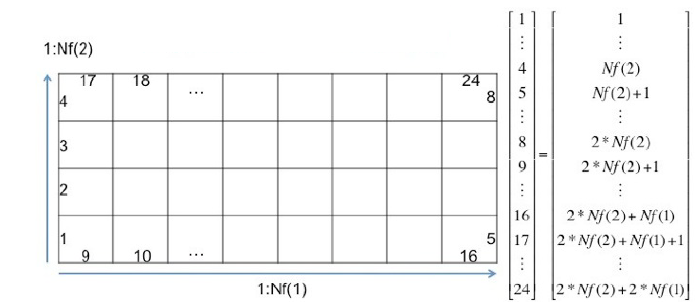The input file uses a vector formulation to assign the boundary condition type and value. Thus, two vectors $ibcs$ and $Fix$ with dimensions $2⋅[Nf(2)+Nf(1)]$ where $Nf(1)$ and $Nf(2)$ are the cells in $x$ and $y$ directions respectively, are used.

Figure 2: Visualization of the boundary condition conventions used in Thermaid. This image is directly taken from the Maflot manual.

The ordering of the vector entries is shown in the example in Figure 2. For convenience the index sets for the four boundaries are:

Left: 1 : Nf(2)

Right: Nf(2)+1 : 2*Nf(2)

Bottom: 2*Nf(2)+1 : 2*Nf(2)+Nf(1)

Top: 2*Nf(2)+Nf(1)+1 : 2*Nf(2)+2*Nf(1)

The vector $ibcs$ defines the type of the boundary:

Neumann: 0

Dirichlet: 1

The vector $Fix$ (or $FixC$ for the transport solution) defines the value to the defined type.

# Examples

Thermaid is distributed with five examples that can directly be used to understand the method and used as a basis for new simulations. The scripts to run all examples are provided with the Thermaid source code. They can be found in the /examples subdirectory and can be used directly from within MATLAB by the following commands

>> ex1

The above command runs the first of five examples. The other examples can be called in the same fashion. The following examples are included:

* Example 1 : Crossed fractures  
  A simple test case of two perpendicular fractures interacting in an external pressure field
* Example 2: Crossed fractures with heat transport   
  A simple test case of two perpendicular fractures interacting to an external pressure field including heat transport
* Example 3 : Complex fracture network with 13 fractures  
  A complex fracture network test case on a larger scale
* Example 4 : Load a FracSim3D fracture network  
  Load and use a DFN loaded from a FracSim3D file
* Example 5 : Load a FracMan fracture network  
  Load and use a DFN loaded from a FracMan file

## Example 1: Crossed fractures

More information will follow.

## Example 2: Crossed Fractures with Heat Transport

More information will follow.

## Example 3: Complex fracture network with 13 Fractures

More information will follow.

## Example 4: Load a FracSim3D fracture network

More information will follow.

## Example 5: Load a FracMan fracture network

More information will follow.

# Visualization with Thermaid

Visualization with Thermaid is simple due to MATLAB’s visualization features. After Thermaid simulations have finished, the results and all other relevant Thermaid variables are written into the MATLAB workspace. From here you can continue to use any visualization routine that you are familiar with in MATLAB. We have found the plot and pcolor functions to be especially useful. Examples of this can be found in the ex1.m and ex2.m scripts.

Thermaid can also produce visualization at runtime. This is enabled through the attach_post_timestep.m function. The standard attach_post_timestep.m function includes optional visualization that are turned on by the showPlot flag that is an input parameter to the Thermaid function as discussed in section Running the Code. By default a pressure solution plot is generated. If the udata.flagHeatTransport is set in the input file, an additional plot of the temperature solution is produced.

## Understanding efficient runtime visualization

More information will follow.