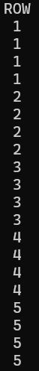
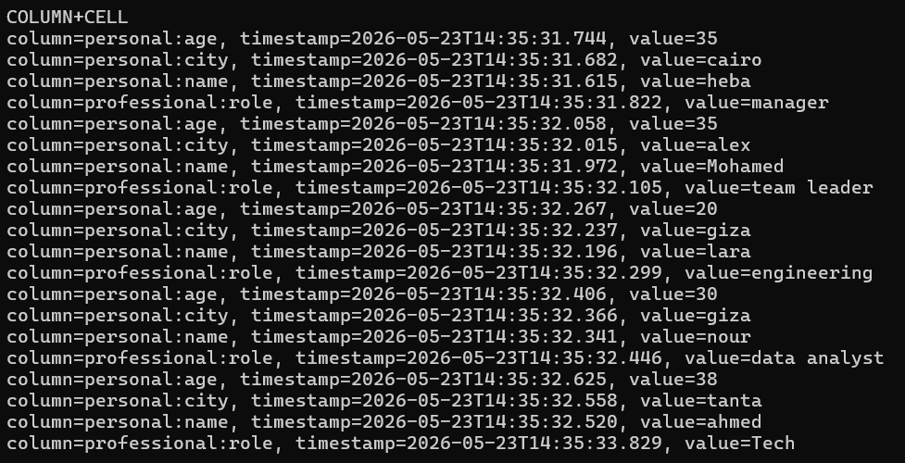

HBase Commands
Start Hbase process :
(base) [bigdata@localhost Desktop]$ start-hbase.sh

base) [bigdata@localhost Desktop]$ jps
3979 HMaster
(base) [bigdata@localhost Desktop]$

Start Hbase shell :
(base) [bigdata@localhost Desktop]$ hbase shell

(base) [bigdata@localhost Desktop]$
(base) [bigdata@localhost Desktop]$ jps
4837 Main
3979 HMaster
(base) [bigdata@localhost Desktop]$

Start Hbase web interface :
http://localhost:16010

Display HBase Shell Help Text:
hbase(main):001:0> help
exit from error / Shell Help Text
hbase(main):004:0* end
Ctrl+D

exit the shell

hbase(main):021:0> exit

Example
Given below is a sample schema of a table named emp. It has two column families: “personal data” and “professional data”.

hbase(main):004:0> create 'emp', 'personal data', 'professional data'
Created table emp
Took 1.0314 seconds
=> Hbase::Table - emp
hbase(main):005:0>
Row key | personal data | professional data

 | personal data
Rowkey | Name | City | age
1 | heba | cairo | 35
2 | Mohamed | alex | 35
3 | lara | giza | 20
4 | nour | giza | 30
5 | ahmed | tanta | 38

professional data
Rowkey | manger
1 | Team leader
2

put <'tablename'>,<'rowname'>,<'columnvalue'>,<'value'>

hbase(main):019:0> put 'emp', 1 ,'personal data:name' , 'heba'
hbase(main):019:0> put 'emp', 2 ,'personal data:name' , 'mohamed'
hbase(main):019:0> put 'emp','3 ,'personal data:name' , 'lara'
hbase(main):019:0> put 'emp', 4 ,'personal data:name' , 'nour'
hbase(main):019:0> put 'emp', 5 ,'personal data:name' , 'ahmed'

hbase(main):005:0> put 'emp', 1 ,'personal data:city' , 'cairo'
hbase(main):006:0> put 'emp', 2 ,'personal data:city' , 'alex'
hbase(main):007:0> put 'emp', 3 ,'personal data:city' , 'giza'
hbase(main):008:0> put 'emp', 4 ,'personal data:city' , 'giza'
hbase(main):009:0> put 'emp', 5 ,'personal data:city' , 'tanta'

hbase(main):014:0> scan 'emp'
ROW COLUMN+CELL
1 column=personal data:city, timestamp=2022-02-03T21:50:06.289, value=cairo
1 column=personal data:name, timestamp=2022-02-03T21:41:49.484, value=heba
2 column=personal data:city, timestamp=2022-02-03T21:52:08.480, value=alex
2 column=personal data:name, timestamp=2022-02-03T21:44:36.040, value=mohamed
3 column=personal data:city, timestamp=2022-02-03T21:52:31.450, value=giza
3 column=personal data:name, timestamp=2022-02-03T21:44:50.010, value=lara
4 column=personal data:city, timestamp=2022-02-03T21:52:39.037, value=giza
4 column=personal data:name, timestamp=2022-02-03T21:45:03.956, value=nour
5 column=personal data:city, timestamp=2022-02-03T21:53:21.800, value=tanta
5 column=personal data:name, timestamp=2022-02-03T21:46:07.856, value=ahmed
5 row(s)

hbase(main):015:0> put 'emp', 1 ,'personal data:age' , '35'
hbase(main):016:0> put 'emp', 2 ,'personal data:age' , '35'
hbase(main):017:0> put 'emp', 3 ,'personal data:age' , '20'
hbase(main):018:0> put 'emp', 4 ,'personal data:age' , '20'
hbase(main):019:0> put 'emp', 5 ,'personal data:age' , '38'

hbase(main):020:0> scan 'emp'
ROW COLUMN+CELL
1 column=personal data:age, timestamp=2022-02-03T21:54:25.887, value=35
1 column=personal data:city, timestamp=2022-02-03T21:50:06.289, value=cairo
1 column=personal data:name, timestamp=2022-02-03T21:41:49.484, value=heba
2 column=personal data:age, timestamp=2022-02-03T21:54:49.382, value=35
2 column=personal data:city, timestamp=2022-02-03T21:52:08.480, value=alex
2 column=personal data:name, timestamp=2022-02-03T21:44:36.040, value=mohamed
3 column=personal data:age, timestamp=2022-02-03T21:54:59.830, value=20
3 column=personal data:city, timestamp=2022-02-03T21:52:31.450, value=giza
3 column=personal data:name, timestamp=2022-02-03T21:44:50.010, value=lara
4 column=personal data:age, timestamp=2022-02-03T21:55:08.603, value=20
4 column=personal data:city, timestamp=2022-02-03T21:52:39.037, value=giza
4 column=personal data:name, timestamp=2022-02-03T21:45:03.956, value=nour
5 column=personal data:age, timestamp=2022-02-03T21:55:18.761, value=38
5 column=personal data:city, timestamp=2022-02-03T21:53:21.800, value=tanta
5 column=personal data:name, timestamp=2022-02-03T21:46:07.856, value=ahmed
5 row(s)
Took 0.0205 seconds

hbase(main):021:0> put 'emp', 1 , 'professional data:position' , 'manager'
hbase(main):022:0> put 'emp', 2 , 'professional data:position' , 'team leader'

hbase(main):023:0> scan 'emp' ,{COLUMNS => 'personal data:name', LIMIT => 2, STARTROW => '3'}

ROW COLUMN+CELL
3 column=personal data:name, timestamp=2022-02-03T21:44:50.010, value=lara
4 column=personal data:name, timestamp=2022-02-03T21:45:03.956, value=nour
2 row(s)
Took 0.0090 seconds

hbase(main):009:0> get 'emp' , '1'
COLUMN CELL
personal data:age timestamp=2022-02-03T21:54:25.887, value=35
personal data:city timestamp=2022-02-03T21:50:06.289, value=cairo
personal data:name timestamp=2022-02-03T21:41:49.484, value=heba
professional data:position timestamp=2022-02-03T22:03:24.316, value=manager
1 row(s)

hbase(main):020:0> get 'emp', '1', {COLUMN => 'personal data:name'}
COLUMN CELL
personal data:name timestamp=2022-02-03T21:41:49.484, value=heba
1 row(s)
Took 0.0067 seconds

base(main):042:0> scan 'emp',{ COLUMNS => 'personal data:name' , FILTER => "ValueFilter(=,'binary:heba')" }
ROW COLUMN+CELL
1 column=personal data:name, timestamp=2022-02-03T21:41:49.484, value=heba
1 row(s)
Took 0.0429 seconds

