**Report about best devices in PC, best operating system and suitable programming languages.**

**System Name:**

* **Best Devices**
* Lab Top oR Pc has at least 8 G RAM and 265 GB Core i5 6th gen
* Server has 521 GB SSD M.2 To Download Database on it on to store the important data of the users
* **Best Operating System**

**Windows : flexability and integration with WPF Application**

**Kali : Scalability and easy to use and good for server side**

* **Suitable Programming Languages**

**C# (dot Net Core) : .Net and Entity frame work core the best integration with WPF apps and strong library support it**

**C++ (Windows Api) : The Completely usage for the hardware which make the app very stable and fast good integration with the operating system**

**Design of an integrated system (Class diagram)**

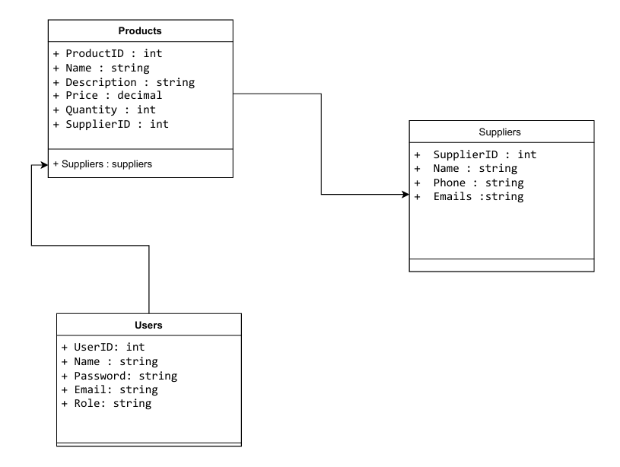

**Testing**

|  |  |  |  |  |  |  |
| --- | --- | --- | --- | --- | --- | --- |
| **Test case ID** | **Test case description** | **Test Steps** | **Test Data** | **Expected Result** | **Actual Result** | **Pass/Fail** |
| 1 | Test Login Page | Enter Vailed User Name  And Vailed Pass | UserName:Ahmed  Pass : 123 | Go To Admin Page | Go To Admin Page | Pass |
|  | Test Login Page | Enter Invailed UserName | UserName:You$ef  Pass : 456 | Error Message | Error Message | Pass |
|  | Test Login Page | Enter Vailed User Name and Pass | UserName:ahmed  Pass : 123 | Error Message | Go To Admin Page | Fail |
|  | Test Login Page | Enter Email in User Name input  Enter Vailed Pass | UserName  :ahmed@gmail.com  Pass :123 | Login To Admin Page | Error Message inviled User Name | Fail |
|  | Test Login Page | Enter UserName not exist in DB | UserName:Jasser  Pass : jass123 | Error Message | Error Message | pass |
|  | Test Login Page | Enter Empty UserName Failed | UserName:  Pass:123 | Error Message | Error  Message | Pass |