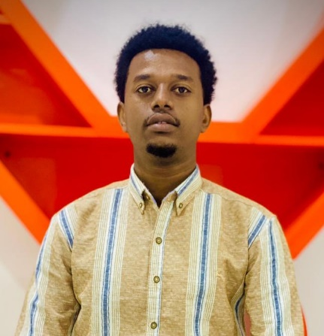V­­

**Contact**

**Address**

Mogadishu, Somali

**Phone**

+252 616739858

**Email**

cabdicasiismaxamed273@email.com

**Education**

**Bachelor’s Degree in Computer Science**  
Jobkey University, Mogadishu, Somalia  
**2021 – Present (Currently in 6th Semester, Expected Graduation: 2025)**

**v**

**Work Experience**

• Horumarinta iyo hagaajinta web-apps iyadoo la adeegsanayo **React** iyo **Node.js** si loo abuuro nidaamyo isku dhafan oo waxqabad sare leh.

• La shaqeynaya kooxaha UI/UX si loo hirgeliyo naqshad casri ah oo waxtar leh, loona horumariyo waayo-aragnimada isticmaalaha.

• Sameynta **RESTful APIs** si loo isku xiro **front-end** iyo **back-end** si sahlan.

• Xakameynta xogta isticmaalaya **MongoDB**, lana xaqiijiyo in xogta loo maareeyo si ammaan ah.

• Adeegsiga **Git** iyo **GitHub** si loo ilaaliyo tayada koodhka iyo kala socodsiinta horumarinta.

**Profile**

**Fullstack Developer** leh 3 sano oo waayo-aragnimo ah, ku takhasusay horumarinta **front-end** iyo **back-end** adeegyada webka adoo isticmaalaya **React.js**, **Node.js**, iyo **MongoDB**. Leh xirfad wanaagsan oo ku saabsan xallinta dhibaatooyinka iyo horumarinta codsiyo casri ah oo waxtar leh.

**Skills**

1. **Frontend:**

* HTML, CSS,

JavaScript,

Tailwind Css

and

React js

1. **Backend:**

* Node js , Express

1. **Database:**

* MongoDB, MySQL

And Oracle

1. **Version Control:**

* Git and GitHub

**A/aziiz Mohamed Ali**

Fullstack Developer