**Course Project First Semester-2024**

**Coffee Shop Project C#**

**Student names**

|  |  |
| --- | --- |
| **ID** | **Name** |
| **2109657** | **Jana Mahdi Aljehani** |
| **2205773** | **Lama Turki Alharbi** |
| **2205454** | **Mayar Hassan Alzibali** |
|  |  |
|  |  |

**1. Introduction:**

The Coffee Shop project, implemented in the coffewshop namespace, is a simple Windows Forms application developed by students Jana Mahdi Aljehani, Lama Turki Alharbi, and Mayar Hassan Alzibali for the Programming II course (Class AB). The main class, Form1, serves as the graphical user interface for managing orders in the coffee shop.

**Features:**

**User-Friendly Interface:** The application provides a visually appealing and user-friendly interface designed with various controls such as checkboxes, numericUpDowns, and a DataGridView.

**Menu Selection**: Users can choose from a selection of food items (Fried Rice, Chicken, Fish) and drinks (Tea, Coffee, Coca Cola) using checkboxes.

**Order Management:** The application allows users to specify the quantity of each selected item using numericUpDown controls and adds the items to a DataGridView to manage the order details.

**Total Calculation:** The total amount for the order is dynamically calculated and displayed, providing a clear overview of the cost.

**Clear and Print Options**: Users can easily clear the form to start a new order or print the bill information, which includes a detailed breakdown of the selected items, quantities, prices, and total amount.

**Guide Documentation and Output and test cases**

**1.Ordering Items**

**Food Selection:**

In the "Rice" section, check the boxes next to the food items you want to order: Fried Rice, Chicken, and Fish.

**Drink Selection:**

In the "Drink" section, check the boxes next to the drink items you want to order: Tea, Coffee, and Coca Cola.

**Quantity Input:**

For each selected item, use the numeric up-down controls to specify the quantity you wish to order.

**2.Managing the Order**

**Viewing the Order:**

The selected items and their details (Item, Price, Quantity, Total) will be displayed in the DataGridView at the bottom of the form.

**Total Calculation:**

The total amount for the order is dynamically calculated and displayed in the "Total" textbox.

**And Clearing and printing bills.**

1.First Select Products and quantity as tea or coffee and click Button Add and it is show total price to it bloew total price to as alone to every product and total as to all products as this :

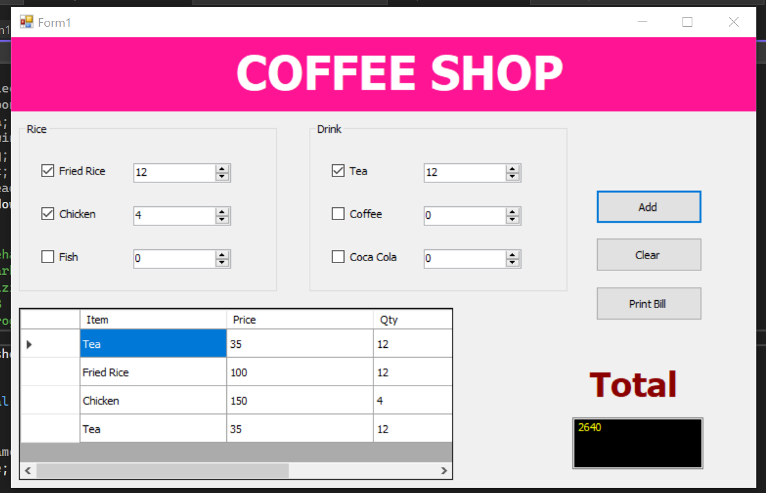

2.If user click Clear button it is clear all items or products from table to this us as this image

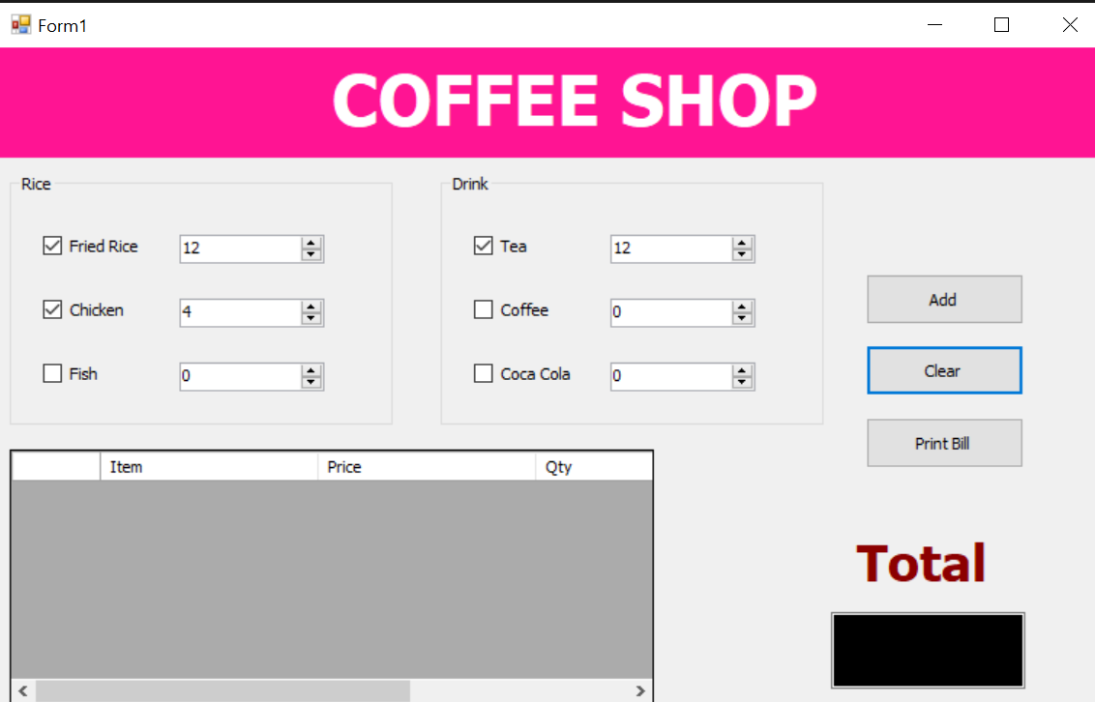

3.then when click print Bill it is will print bill information as message with total price as

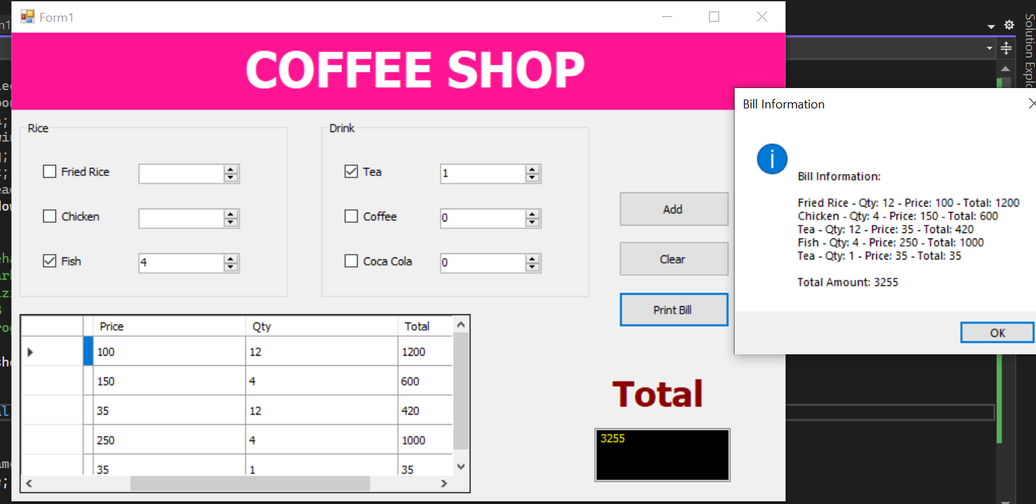

4.and validate and make handling and validation for user inputs as if don’t select any product and click Add it is show message error as

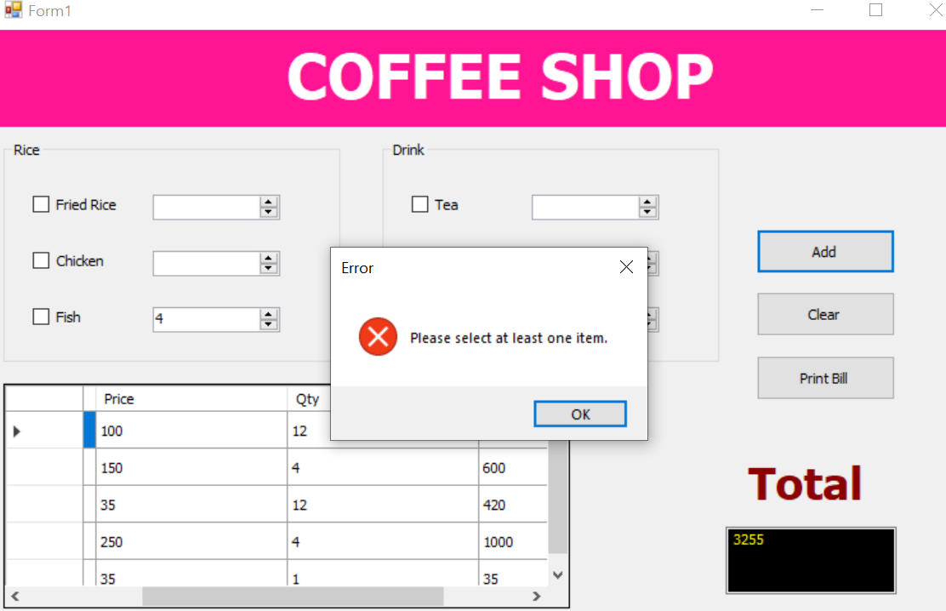

5.and handle if number or quantity is 0 or empty or less than 0 it shows error message as this

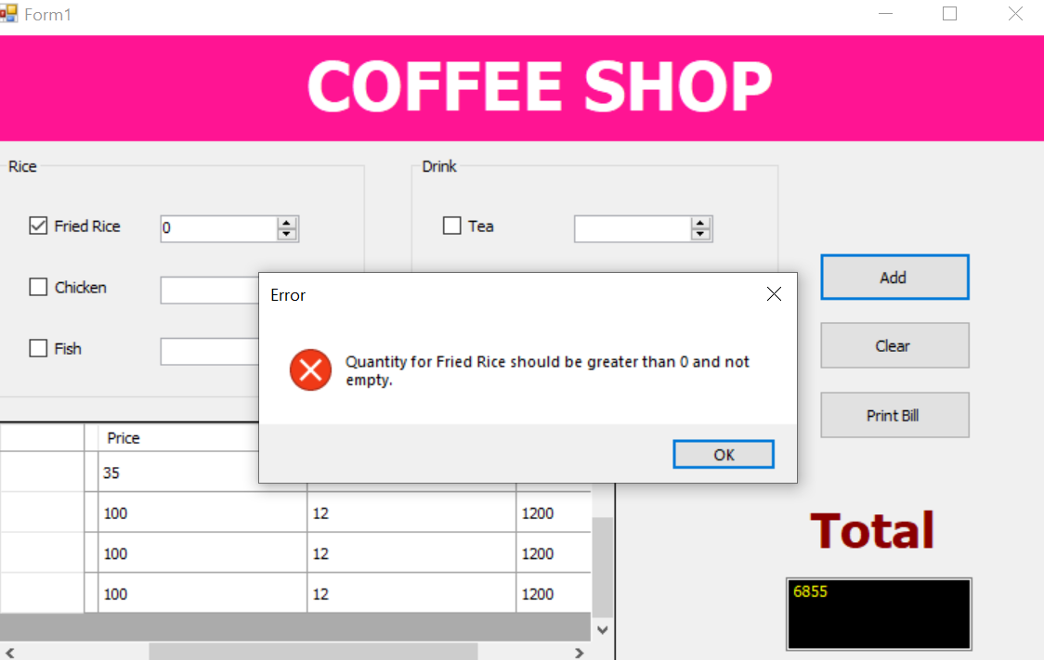

6.this output if all inputs and checkbox is correct it is make as correctly

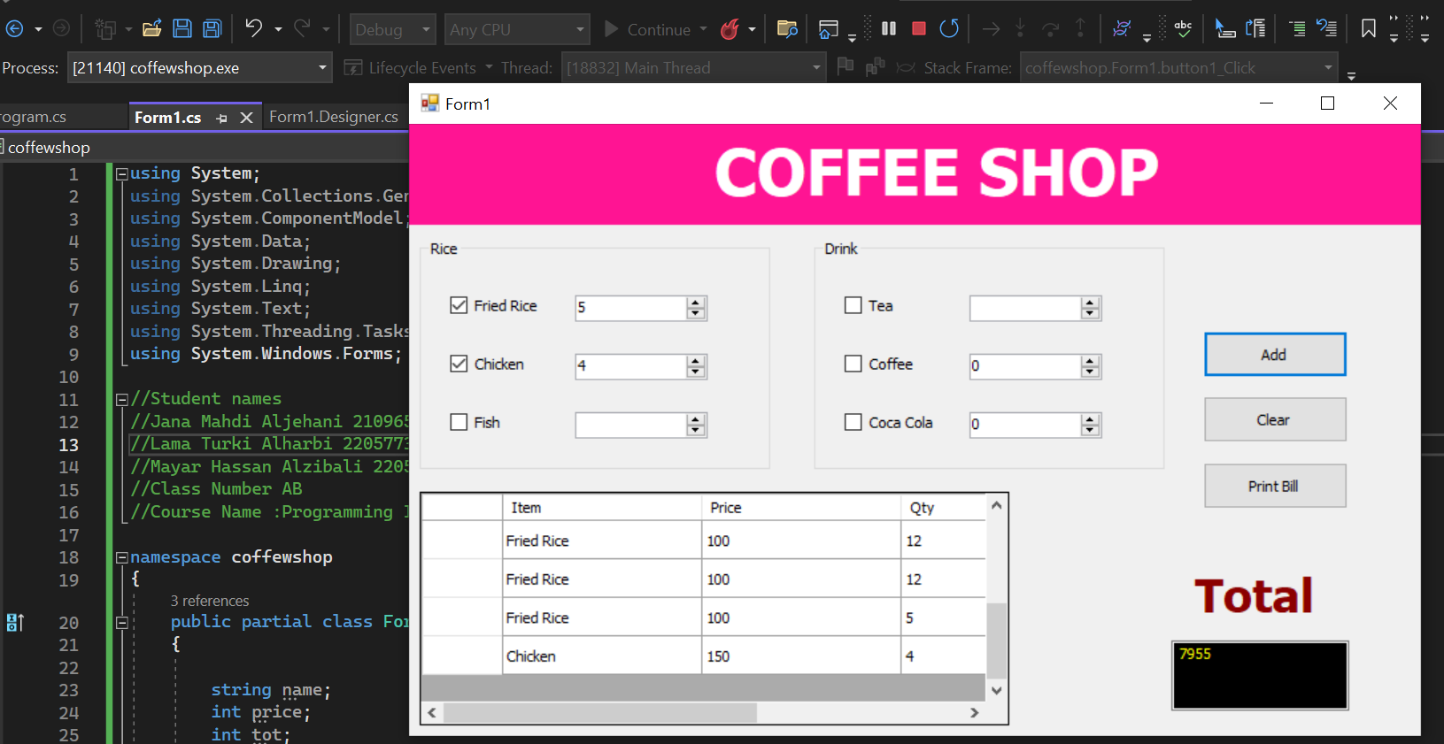

Appendix: The full listing of your code

Code:

Form1.cs

using System;

using System.Collections.Generic;

using System.ComponentModel;

using System.Data;

using System.Drawing;

using System.Linq;

using System.Text;

using System.Threading.Tasks;

using System.Windows.Forms;

//Student names

//Jana Mahdi Aljehani 2109657

//Lama Turki Alharbi 2205773

//Mayar Hassan Alzibali 2205454

//Class Number AB

//Course Name :Programming II

namespace coffewshop

{

public partial class Form1 : Form

{

string name;

int price;

int tot;

public Form1()

{

InitializeComponent();

}

private void button1_Click(object sender, EventArgs e)

{

if (!(chkfrice.Checked || chkchi.Checked || chkfish.Checked || chktea.Checked || chkcoffee.Checked || chkcock.Checked))

{

MessageBox.Show("Please select at least one item.", "Error", MessageBoxButtons.OK, MessageBoxIcon.Error);

return;

}

if (chkfrice.Checked)

{

if (!CheckAndAddItem("Fried Rice", numericUpDown1, 100))

{

return;

}

}

if (chkchi.Checked)

{

if (!CheckAndAddItem("Chicken", numericUpDown2, 150))

{

return;

}

}

if (chkfish.Checked)

{

if (!CheckAndAddItem("Fish", numericUpDown3, 250))

{

return;

}

}

if (chktea.Checked)

{

if (!CheckAndAddItem("Tea", numericUpDown6, 35))

{

return;

}

}

if (chkcoffee.Checked)

{

if (!CheckAndAddItem("Coffee", numericUpDown5, 50))

{

return;

}

}

if (chkcock.Checked)

{

if (!CheckAndAddItem("Coca Cola", numericUpDown4, 70))

{

return;

}

}

UpdateTotal();

}

private bool CheckAndAddItem(string itemName, NumericUpDown numericUpDown, int price)

{

int qty = (int)numericUpDown.Value;

if (qty <= 0)

{

MessageBox.Show($"Quantity for {itemName} should be greater than 0 and not empty.", "Error", MessageBoxButtons.OK, MessageBoxIcon.Error);

return false;

}

int tot = qty * price;

this.dataGridView1.Rows.Add(itemName, price, qty, tot);

return true;

}

private void UpdateTotal()

{

int sum = 0;

for (int row = 0; row < dataGridView1.Rows.Count; row++)

{

sum = sum + Convert.ToInt32(dataGridView1.Rows[row].Cells[3].Value);

}

textBox1.Text = sum.ToString();

}

private void btnClear_Click(object sender, EventArgs e)

{

ClearForm();

}

private void btnPrintBill_Click(object sender, EventArgs e)

{

PrintBill();

}

private void ClearForm()

{

foreach (Control control in Controls)

{

if (control is CheckBox checkbox)

checkbox.Checked = false;

else if (control is NumericUpDown numericUpDown)

numericUpDown.Value = 0;

}

dataGridView1.Rows.Clear();

textBox1.Clear();

}

private void PrintBill()

{

string billInfo = GetBillInfo();

MessageBox.Show($"\n\n{billInfo}", "Bill Information", MessageBoxButtons.OK, MessageBoxIcon.Information);

}

private string GetBillInfo()

{

string billInfo = "Bill Information:\n\n";

for (int row = 0; row < dataGridView1.Rows.Count; row++)

{

string itemName = dataGridView1.Rows[row].Cells[0].Value.ToString();

int itemPrice = Convert.ToInt32(dataGridView1.Rows[row].Cells[1].Value);

int itemQty = Convert.ToInt32(dataGridView1.Rows[row].Cells[2].Value);

int itemTotal = Convert.ToInt32(dataGridView1.Rows[row].Cells[3].Value);

billInfo += $"{itemName} - Qty: {itemQty} - Price: {itemPrice} - Total: {itemTotal}\n";

}

billInfo += $"\nTotal Amount: {textBox1.Text}";

return billInfo;

}

}

}

Form1.Designer.cs

namespace coffewshop

{

partial class Form1

{

private System.Windows.Forms.Button btnClear;

private System.Windows.Forms.Button btnPrintBill;

/// <summary>

/// Required designer variable.

/// </summary>

private System.ComponentModel.IContainer components = null;

/// <summary>

/// Clean up any resources being used.

/// </summary>

/// <param name="disposing">true if managed resources should be disposed; otherwise, false.</param>

protected override void Dispose(bool disposing)

{

if (disposing && (components != null))

{

components.Dispose();

}

base.Dispose(disposing);

}

#region Windows Form Designer generated code

/// <summary>

/// Required method for Designer support - do not modify

/// the contents of this method with the code editor.

/// </summary>

private void InitializeComponent()

{

this.panel1 = new System.Windows.Forms.Panel();

this.label1 = new System.Windows.Forms.Label();

this.groupBox1 = new System.Windows.Forms.GroupBox();

this.numericUpDown3 = new System.Windows.Forms.NumericUpDown();

this.numericUpDown2 = new System.Windows.Forms.NumericUpDown();

this.numericUpDown1 = new System.Windows.Forms.NumericUpDown();

this.chkfish = new System.Windows.Forms.CheckBox();

this.chkchi = new System.Windows.Forms.CheckBox();

this.chkfrice = new System.Windows.Forms.CheckBox();

this.groupBox2 = new System.Windows.Forms.GroupBox();

this.numericUpDown4 = new System.Windows.Forms.NumericUpDown();

this.numericUpDown5 = new System.Windows.Forms.NumericUpDown();

this.numericUpDown6 = new System.Windows.Forms.NumericUpDown();

this.chkcock = new System.Windows.Forms.CheckBox();

this.chkcoffee = new System.Windows.Forms.CheckBox();

this.chktea = new System.Windows.Forms.CheckBox();

this.dataGridView1 = new System.Windows.Forms.DataGridView();

this.Column1 = new System.Windows.Forms.DataGridViewTextBoxColumn();

this.Column2 = new System.Windows.Forms.DataGridViewTextBoxColumn();

this.Column3 = new System.Windows.Forms.DataGridViewTextBoxColumn();

this.Column4 = new System.Windows.Forms.DataGridViewTextBoxColumn();

this.button1 = new System.Windows.Forms.Button();

this.textBox1 = new System.Windows.Forms.TextBox();

this.label2 = new System.Windows.Forms.Label();

this.btnClear = new System.Windows.Forms.Button();

this.btnPrintBill = new System.Windows.Forms.Button();

this.panel1.SuspendLayout();

this.groupBox1.SuspendLayout();

((System.ComponentModel.ISupportInitialize)(this.numericUpDown3)).BeginInit();

((System.ComponentModel.ISupportInitialize)(this.numericUpDown2)).BeginInit();

((System.ComponentModel.ISupportInitialize)(this.numericUpDown1)).BeginInit();

this.groupBox2.SuspendLayout();

((System.ComponentModel.ISupportInitialize)(this.numericUpDown4)).BeginInit();

((System.ComponentModel.ISupportInitialize)(this.numericUpDown5)).BeginInit();

((System.ComponentModel.ISupportInitialize)(this.numericUpDown6)).BeginInit();

((System.ComponentModel.ISupportInitialize)(this.dataGridView1)).BeginInit();

this.SuspendLayout();

//

// panel1

//

this.panel1.BackColor = System.Drawing.Color.DeepPink;

this.panel1.Controls.Add(this.label1);

this.panel1.Location = new System.Drawing.Point(-10, -1);

this.panel1.Name = "panel1";

this.panel1.Size = new System.Drawing.Size(1157, 113);

this.panel1.TabIndex = 0;

//

// label1

//

this.label1.AutoSize = true;

this.label1.Font = new System.Drawing.Font("Tahoma", 36F, System.Drawing.FontStyle.Bold, System.Drawing.GraphicsUnit.Point, ((byte)(0)));

this.label1.ForeColor = System.Drawing.Color.Transparent;

this.label1.Location = new System.Drawing.Point(341, 10);

this.label1.Name = "label1";

this.label1.Size = new System.Drawing.Size(536, 87);

this.label1.TabIndex = 0;

this.label1.Text = "COFFEE SHOP";

//

// groupBox1

//

this.groupBox1.Controls.Add(this.numericUpDown3);

this.groupBox1.Controls.Add(this.numericUpDown2);

this.groupBox1.Controls.Add(this.numericUpDown1);

this.groupBox1.Controls.Add(this.chkfish);

this.groupBox1.Controls.Add(this.chkchi);

this.groupBox1.Controls.Add(this.chkfrice);

this.groupBox1.Location = new System.Drawing.Point(12, 127);

this.groupBox1.Name = "groupBox1";

this.groupBox1.Size = new System.Drawing.Size(396, 255);

this.groupBox1.TabIndex = 1;

this.groupBox1.TabStop = false;

this.groupBox1.Text = "Rice";

//

// numericUpDown3

//

this.numericUpDown3.Location = new System.Drawing.Point(176, 190);

this.numericUpDown3.Name = "numericUpDown3";

this.numericUpDown3.Size = new System.Drawing.Size(150, 27);

this.numericUpDown3.TabIndex = 6;

//

// numericUpDown2

//

this.numericUpDown2.Location = new System.Drawing.Point(176, 125);

this.numericUpDown2.Name = "numericUpDown2";

this.numericUpDown2.Size = new System.Drawing.Size(150, 27);

this.numericUpDown2.TabIndex = 5;

//

// numericUpDown1

//

this.numericUpDown1.Location = new System.Drawing.Point(176, 62);

this.numericUpDown1.Name = "numericUpDown1";

this.numericUpDown1.Size = new System.Drawing.Size(150, 27);

this.numericUpDown1.TabIndex = 0;

this.numericUpDown1.Value = new decimal(new int[] {

12,

0,

0,

0});

//

// chkfish

//

this.chkfish.AutoSize = true;

this.chkfish.Location = new System.Drawing.Point(34, 190);

this.chkfish.Name = "chkfish";

this.chkfish.Size = new System.Drawing.Size(63, 23);

this.chkfish.TabIndex = 4;

this.chkfish.Text = "Fish";

this.chkfish.UseVisualStyleBackColor = true;

//

// chkchi

//

this.chkchi.AutoSize = true;

this.chkchi.Location = new System.Drawing.Point(34, 125);

this.chkchi.Name = "chkchi";

this.chkchi.Size = new System.Drawing.Size(90, 23);

this.chkchi.TabIndex = 3;

this.chkchi.Text = "Chicken";

this.chkchi.UseVisualStyleBackColor = true;

//

// chkfrice

//

this.chkfrice.AutoSize = true;

this.chkfrice.Location = new System.Drawing.Point(34, 62);

this.chkfrice.Name = "chkfrice";

this.chkfrice.Size = new System.Drawing.Size(104, 23);

this.chkfrice.TabIndex = 2;

this.chkfrice.Text = "Fried Rice";

this.chkfrice.UseVisualStyleBackColor = true;

//

// groupBox2

//

this.groupBox2.Controls.Add(this.numericUpDown4);

this.groupBox2.Controls.Add(this.numericUpDown5);

this.groupBox2.Controls.Add(this.numericUpDown6);

this.groupBox2.Controls.Add(this.chkcock);

this.groupBox2.Controls.Add(this.chkcoffee);

this.groupBox2.Controls.Add(this.chktea);

this.groupBox2.Location = new System.Drawing.Point(457, 127);

this.groupBox2.Name = "groupBox2";

this.groupBox2.Size = new System.Drawing.Size(396, 255);

this.groupBox2.TabIndex = 2;

this.groupBox2.TabStop = false;

this.groupBox2.Text = "Drink";

//

// numericUpDown4

//

this.numericUpDown4.Location = new System.Drawing.Point(176, 190);

this.numericUpDown4.Name = "numericUpDown4";

this.numericUpDown4.Size = new System.Drawing.Size(150, 27);

this.numericUpDown4.TabIndex = 6;

//

// numericUpDown5

//

this.numericUpDown5.Location = new System.Drawing.Point(176, 125);

this.numericUpDown5.Name = "numericUpDown5";

this.numericUpDown5.Size = new System.Drawing.Size(150, 27);

this.numericUpDown5.TabIndex = 5;

//

// numericUpDown6

//

this.numericUpDown6.Location = new System.Drawing.Point(176, 62);

this.numericUpDown6.Name = "numericUpDown6";

this.numericUpDown6.Size = new System.Drawing.Size(150, 27);

this.numericUpDown6.TabIndex = 0;

this.numericUpDown6.Value = new decimal(new int[] {

12,

0,

0,

0});

//

// chkcock

//

this.chkcock.AutoSize = true;

this.chkcock.Location = new System.Drawing.Point(34, 190);

this.chkcock.Name = "chkcock";

this.chkcock.Size = new System.Drawing.Size(105, 23);

this.chkcock.TabIndex = 4;

this.chkcock.Text = "Coca Cola";

this.chkcock.UseVisualStyleBackColor = true;

//

// chkcoffee

//

this.chkcoffee.AutoSize = true;

this.chkcoffee.Location = new System.Drawing.Point(34, 125);

this.chkcoffee.Name = "chkcoffee";

this.chkcoffee.Size = new System.Drawing.Size(80, 23);

this.chkcoffee.TabIndex = 3;

this.chkcoffee.Text = "Coffee";

this.chkcoffee.UseVisualStyleBackColor = true;

//

// chktea

//

this.chktea.AutoSize = true;

this.chktea.Location = new System.Drawing.Point(34, 62);

this.chktea.Name = "chktea";

this.chktea.Size = new System.Drawing.Size(61, 23);

this.chktea.TabIndex = 2;

this.chktea.Text = "Tea";

this.chktea.UseVisualStyleBackColor = true;

//

// dataGridView1

//

this.dataGridView1.AllowUserToAddRows = false;

this.dataGridView1.ColumnHeadersHeightSizeMode = System.Windows.Forms.DataGridViewColumnHeadersHeightSizeMode.AutoSize;

this.dataGridView1.Columns.AddRange(new System.Windows.Forms.DataGridViewColumn[] {

this.Column1,

this.Column2,

this.Column3,

this.Column4});

this.dataGridView1.Location = new System.Drawing.Point(12, 405);

this.dataGridView1.Name = "dataGridView1";

this.dataGridView1.RowHeadersWidth = 62;

this.dataGridView1.RowTemplate.Height = 29;

this.dataGridView1.Size = new System.Drawing.Size(666, 257);

this.dataGridView1.TabIndex = 3;

//

// Column1

//

this.Column1.HeaderText = "Item";

this.Column1.MinimumWidth = 8;

this.Column1.Name = "Column1";

this.Column1.Width = 150;

//

// Column2

//

this.Column2.HeaderText = "Price";

this.Column2.MinimumWidth = 8;

this.Column2.Name = "Column2";

this.Column2.Width = 150;

//

// Column3

//

this.Column3.HeaderText = "Qty";

this.Column3.MinimumWidth = 8;

this.Column3.Name = "Column3";

this.Column3.Width = 150;

//

// Column4

//

this.Column4.HeaderText = "Total";

this.Column4.MinimumWidth = 8;

this.Column4.Name = "Column4";

this.Column4.Width = 150;

//

// button1

//

this.button1.Location = new System.Drawing.Point(897, 228);

this.button1.Name = "button1";

this.button1.Size = new System.Drawing.Size(163, 51);

this.button1.TabIndex = 4;

this.button1.Text = "Add";

this.button1.UseVisualStyleBackColor = true;

this.button1.Click += new System.EventHandler(this.button1_Click);

//

// textBox1

//

this.textBox1.BackColor = System.Drawing.Color.Black;

this.textBox1.ForeColor = System.Drawing.Color.Yellow;

this.textBox1.Location = new System.Drawing.Point(861, 569);

this.textBox1.Multiline = true;

this.textBox1.Name = "textBox1";

this.textBox1.Size = new System.Drawing.Size(199, 75);

this.textBox1.TabIndex = 5;

//

// label2

//

this.label2.AutoSize = true;

this.label2.Font = new System.Drawing.Font("Tahoma", 26F, System.Drawing.FontStyle.Bold, System.Drawing.GraphicsUnit.Point, ((byte)(0)));

this.label2.ForeColor = System.Drawing.Color.DarkRed;

this.label2.Location = new System.Drawing.Point(877, 486);

this.label2.Name = "label2";

this.label2.Size = new System.Drawing.Size(160, 63);

this.label2.TabIndex = 6;

this.label2.Text = "Total";

//

// btnClear

//

this.btnClear.Location = new System.Drawing.Point(897, 300);

this.btnClear.Name = "btnClear";

this.btnClear.Size = new System.Drawing.Size(163, 51);

this.btnClear.TabIndex = 7;

this.btnClear.Text = "Clear";

this.btnClear.UseVisualStyleBackColor = true;

this.btnClear.Click += new System.EventHandler(this.btnClear_Click);

//

// btnPrintBill

//

this.btnPrintBill.Location = new System.Drawing.Point(897, 372);

this.btnPrintBill.Name = "btnPrintBill";

this.btnPrintBill.Size = new System.Drawing.Size(163, 51);

this.btnPrintBill.TabIndex = 8;

this.btnPrintBill.Text = "Print Bill";

this.btnPrintBill.UseVisualStyleBackColor = true;

this.btnPrintBill.Click += new System.EventHandler(this.btnPrintBill_Click);

//

// Form1

//

this.AutoScaleDimensions = new System.Drawing.SizeF(9F, 19F);

this.AutoScaleMode = System.Windows.Forms.AutoScaleMode.Font;

this.ClientSize = new System.Drawing.Size(1143, 674);

this.Controls.Add(this.label2);

this.Controls.Add(this.textBox1);

this.Controls.Add(this.button1);

this.Controls.Add(this.dataGridView1);

this.Controls.Add(this.groupBox2);

this.Controls.Add(this.groupBox1);

this.Controls.Add(this.panel1);

this.Controls.Add(this.btnClear);

this.Controls.Add(this.btnPrintBill);

this.Name = "Form1";

this.StartPosition = System.Windows.Forms.FormStartPosition.CenterScreen;

this.Text = "Form1";

this.panel1.ResumeLayout(false);

this.panel1.PerformLayout();

this.groupBox1.ResumeLayout(false);

this.groupBox1.PerformLayout();

((System.ComponentModel.ISupportInitialize)(this.numericUpDown3)).EndInit();

((System.ComponentModel.ISupportInitialize)(this.numericUpDown2)).EndInit();

((System.ComponentModel.ISupportInitialize)(this.numericUpDown1)).EndInit();

this.groupBox2.ResumeLayout(false);

this.groupBox2.PerformLayout();

((System.ComponentModel.ISupportInitialize)(this.numericUpDown4)).EndInit();

((System.ComponentModel.ISupportInitialize)(this.numericUpDown5)).EndInit();

((System.ComponentModel.ISupportInitialize)(this.numericUpDown6)).EndInit();

((System.ComponentModel.ISupportInitialize)(this.dataGridView1)).EndInit();

this.ResumeLayout(false);

this.PerformLayout();

}

#endregion

private System.Windows.Forms.Panel panel1;

private System.Windows.Forms.Label label1;

private System.Windows.Forms.GroupBox groupBox1;

private System.Windows.Forms.CheckBox chkfish;

private System.Windows.Forms.CheckBox chkchi;

private System.Windows.Forms.CheckBox chkfrice;

private System.Windows.Forms.NumericUpDown numericUpDown3;

private System.Windows.Forms.NumericUpDown numericUpDown2;

private System.Windows.Forms.NumericUpDown numericUpDown1;

private System.Windows.Forms.GroupBox groupBox2;

private System.Windows.Forms.NumericUpDown numericUpDown4;

private System.Windows.Forms.NumericUpDown numericUpDown5;

private System.Windows.Forms.NumericUpDown numericUpDown6;

private System.Windows.Forms.CheckBox chkcock;

private System.Windows.Forms.CheckBox chkcoffee;

private System.Windows.Forms.CheckBox chktea;

private System.Windows.Forms.DataGridView dataGridView1;

private System.Windows.Forms.DataGridViewTextBoxColumn Column1;

private System.Windows.Forms.DataGridViewTextBoxColumn Column2;

private System.Windows.Forms.DataGridViewTextBoxColumn Column3;

private System.Windows.Forms.DataGridViewTextBoxColumn Column4;

private System.Windows.Forms.Button button1;

private System.Windows.Forms.TextBox textBox1;

private System.Windows.Forms.Label label2;

}

}