1- redirct to product category from home page when click on product

2- highlight the mail when read it on contact us page on admin panel

3-contact form for user that subscrube and admin can add other data

fame , last name , email , parthdate , address , gender , phone , notes , language

4- update user profile details add address like this

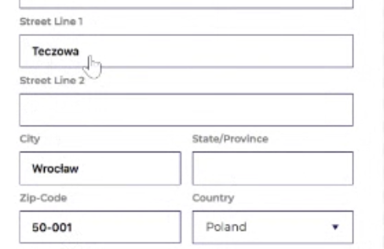

5- update user design in profile page

6- s-dragon Fury team

s-unicorn -> fantastic4  
 dragon -> dragon

unicorn -> popcorn

7- logo stretched on the phone screen

8- rewrite website content

9- filter when filter change filters item to be for the products that displayed not for all product   
10- sizes filter and color filter not work

11 - When select product go to self-customization for this product

Amr must resize all products image to be 600\*500

12- caching the user design if leave the page

13- payment , email , zoom 🡸 🡸🡸🡨

We will use clover for payment in the future

Save all design images   
 for the user order   
 and download all this files from dashboard

Member team details on order page on dashboard