
Class-Based SystemVerilog Verification Project
AXI4-Compliant Memory-Mapped Slave

Arsany Hany | 467
Ziad Ahmed | 438

Github Repo Link

Table of Contents
Introduction 1
Findings 1
Code Implementation 2
Coverage 3
Functional Coverage 3
Statement Coverage 4
Toggle Coverage 4
Conditional Coverage 4
Assertion Coverage 4
Do File 5
Waveforms 6

Introduction
Verifying components should be modular, reusable, and easy to maintain. It also should have clear separation and responsibilities between all its components. This lets the engineer focus on the verification intent of the project instead of testbench complexities, thus reducing wasted time.
These objectives could be achieved effectively using class-based SystemVerilog verification methods. By utilizing OOP principles, the verification environment achieves all the desired modularity, reusability, and maintainability objectives, as well as having a clear distinction between components’ functionality. This is achieved through the use of separate components such as generator, driver, monitor, scoreboard, and environment. This class-based verification acts as the starting point to UVM, the standard, widely used verification methodology
This project aims to verify an AXI4 Compliant Memory-Mapped Slave IP using class-based verification methods to achieve near perfect coverage metrics, as well as detect any bugs present in the RTL design.

Findings
The RTL provided is intentionally buggy to enhance the learning of verification concepts and improve the eye-for-detail skills. Below is a list of found bugs.
- Inverted reset polarity: the reset is treated as being active-high not active-low, which does not comply with the specs.
- Memory address of by one: mem_rdata <= memory[mem_addr-1] should be mem_rdata <= memory[mem_addr].
- Boundary/validity check uses the wrong address: write_boundary_cross & read_boundary_cross are not evaluated once from the burst’s start address but instead recomputed every cycle from the current, already-incremented write_addr/read_addr combined with the full original burst length. This induces double-counts and SLVERR, and causes BRESP MISMATCH.
- Missing address-alignment check: axi4.v never checks AWADDR/ARADDR against AWSIZE/ARSIZE. Causes mismatches on writes.

Coverage

Functional Coverage

Statement Coverage
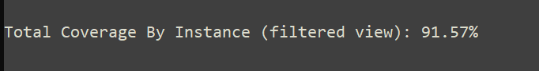

Toggle Coverage
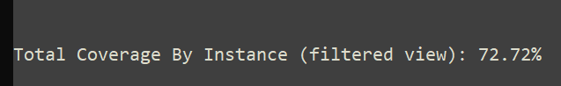

Conditional Coverage
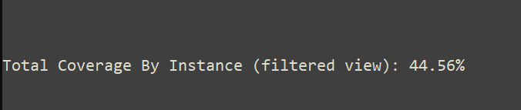

Assertion Coverage
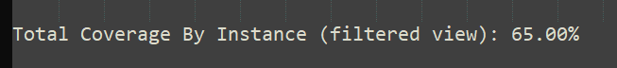

Do File
The run.do file is AI-generated to help with report organization, that is having a separate file housing each kind of coverage

Waveforms

