Task #7 – Job Scheduling
1. Problem Description
A company must schedule n jobs on a single machine. Each job i is characterized by three attributes: a processing time t[i] (the amount of time required to complete the job), a deadline d[i] (the time by which the job should be completed to avoid incurring a penalty), and a penalty p[i] (the cost incurred if the job finishes after its deadline). Only one job can run at a time, and the objective is to find a job ordering that minimizes the total accumulated penalty across all jobs.
2. Assumptions
- All jobs are available at time 0 (no release times).
- Jobs are non-preemptive: once started, a job runs to completion without interruption.
- Processing times, deadlines, and penalties are all positive integers.
- Each job must be scheduled exactly once.
- The machine processes jobs sequentially — no parallelism.
- There is no idle time inserted between jobs.
- Jobs are 1-indexed in output but 0-indexed internally in code.

3. Brute-Force Algorithm

3.1 Methodology
The Brute-Force approach exhaustively generates every possible permutation of the n jobs and evaluates the total penalty for each ordering. The permutation that yields the minimum total penalty is selected as the optimal schedule. While this guarantees an optimal solution, the factorial growth of permutations makes it infeasible beyond approximately n = 12.

3.2 Step-by-Step Description
- Read n, and the arrays t[], p[], d[].
- Initialize a job index array job[] = [0, 1, 2, …, n−1].
- Generate every permutation of the job array.
- For each permutation: simulate executing jobs in that order; accumulate time; if cumulative time exceeds d[job[i]], add p[job[i]] to the total penalty.
- Track the permutation with the minimum total penalty.
- Output the best ordering and minimum penalty.

3.3 Pseudocode

BruteForce(n, t[], p[], d[]):
job[] ← [0, 1, 2, …, n-1]
result[] ← []
min_penalties ← ∞

DO:
total_penalties ← 0
time ← 0

FOR i = 0 TO n-1:
time ← time + t[job[i]]
IF time > d[job[i]]:
total_penalties ← total_penalties + p[job[i]]

IF total_penalties < min_penalties:
min_penalties ← total_penalties
result[] ← copy of job[]

WHILE next_permutation(job[]) exists

PRINT result[], min_penalties

3.4 Implementation Code (C++)
#include <iostream>
#include <vector>
#include <algorithm>
#include <climits>
using namespace std;

int main()
{
int n;
cout << "enter number of jobs: " << endl;
cin >> n;
cout << "enter: " << endl;
cout << "(time) | (penalty) | (deadline) of each job " << endl;

vector<int>
t(n),
p(n), d(n), result(n), job(n);
int time = 0, total_penalties, min_penalties = INT_MAX;

for (int i = 0; i < n; i++)
{

cin >> t[i] >> p[i] >> d[i];
job[i] = i;
}

do
{
total_penalties = 0;
time = 0;
for (int i = 0; i < n; i++)
{
time += t[job[i]];
if (time > d[job[i]])
total_penalties += p[job[i]];
}

if (total_penalties < min_penalties)
{
min_penalties = total_penalties;
for (int i = 0; i < n; i++)
result[i] = job[i];
}
} while (next_permutation(job.begin(), job.end()));

for (int i = 0; i < n; i++)
cout << i + 1 << ". " << "(job number: " << result[i] + 1 << "), time: " << t[result[i]] << " penalty: " << p[result[i]] << " deadline: " << d[result[i]] << endl;
cout << "Minimum penalties could occur: " << min_penalties << endl;

return 0;
}

3.5 Test Cases
Test Case 1 – n = 3 (General Case)
Input: 3 jobs with data as shown in the table below.

Table: Test Case 1 Input: n = 3
Job # | Processing Time (t) | Deadline (d) | Penalty (p) | Penalty Incurred?
1 | 3 | 4 | 5 | No → Penalty = 0
2 | 2 | 5 | 3 | No → Penalty = 0
3 | 1 | 2 | 4 | No → Penalty = 0

Optimal schedule: Job 3 → Job 1 → Job 2
- Job 3: cumulative time = 1 ≤ 2 → no penalty
- Job 1: cumulative time = 4 ≤ 4 → no penalty
- Job 2: cumulative time = 6 > 5 → penalty = 3
Total Penalty = 3 (optimal)
Output:
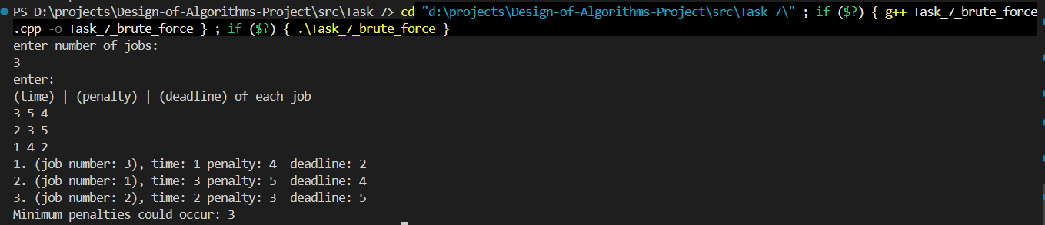

Test Case 2 – All Jobs Meet Deadlines (n = 3)

Table: Test Case 2 Input: All deadlines met
Job # | Processing Time (t) | Deadline (d) | Penalty (p) | Penalty Incurred?
1 | 1 | 5 | 10 | No → Penalty = 0
2 | 2 | 10 | 8 | No → Penalty = 0
3 | 3 | 15 | 6 | No → Penalty = 0

Cumulative times (1, 3, 6) all fall within deadlines (5, 10, 15). Total Penalty = 0.
Output:
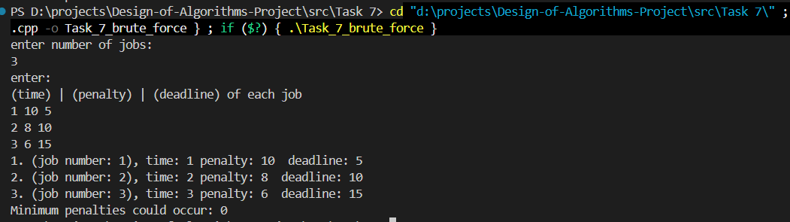

3.6 Complexity Analysis

Table: Brute-Force Complexity
Metric | Complexity
Time | O(n! × n) — Generates all n! permutations; each evaluation takes O(n)
Space | O(n) — Only stores job indices, current permutation, and best result

Note: Becomes completely infeasible for n > 12 due to factorial growth (12! = 479,001,600 permutations).

4. Divide and Conquer Algorithm

4.1 Methodology
The Divide and Conquer approach applies a modified Merge Sort to order jobs according to a pairwise penalty comparison. For any two jobs, the comparator firstJob determines which job should be scheduled first by computing the total penalty under each of the two possible orderings and placing the lower-penalty option first. This transforms the scheduling problem into a sort, running in O(n log n).

4.2 Step-by-Step Description
- Read n, and the arrays t[], p[], d[].
- Initialize a job index array result[] = [0, 1, …, n−1].
- Apply Merge Sort on result[] using a custom comparator firstJob(job1, job2): Divide: split the array at the midpoint. Conquer: recursively sort both halves. Combine (Merge): merge by comparing pairs using firstJob; compute penalty if job1 goes before job2 and vice versa; place the lower-penalty ordering first.
- Simulate the sorted schedule, accumulate time and penalties.
- Output the sorted job order and total minimum penalty.

4.3 Pseudocode

firstJob(job1, job2):
penalty_if_1_first ← (t[job1] > d[job1] ? p[job1] : 0)
+ (t[job1] + t[job2] > d[job2] ? p[job2] : 0)

penalty_if_2_first ← (t[job2] > d[job2] ? p[job2] : 0)
+ (t[job1] + t[job2] > d[job1] ? p[job1] : 0)

RETURN penalty_if_1_first <= penalty_if_2_first

────────────────────────────────────────────────
mergeSort(job[], l, r):
IF l >= r: RETURN

mid ← (l + r) / 2
mergeSort(job, l, mid)
mergeSort(job, mid + 1, r)

// Merge step
temp[] ← []
i ← l, j ← mid + 1

WHILE i <= mid AND j <= r:
IF firstJob(job[i], job[j]):
temp.append(job[i++])
ELSE:
temp.append(job[j++])

WHILE i <= mid: temp.append(job[i++])
WHILE j <= r: temp.append(job[j++])

Copy temp[] back into job[l..r]

────────────────────────────────────────────────
Main:
READ n, t[], p[], d[]
result[] ← [0, 1, …, n-1]
mergeSort(result, 0, n-1)

time ← 0, minPenalties ← 0
FOR i = 0 TO n-1:
time ← time + t[result[i]]
IF time > d[result[i]]:
minPenalties ← minPenalties + p[result[i]]
PRINT result[i]

PRINT minPenalties

4.4 Implementation Code (C++)

#include <iostream>
#include <vector>
#include <climits>
using namespace std;

int n;
vector<int> t(n), p(n), d(n);

bool firstJob(int job_1, int job_2)
{
int penalty_1 = (t[job_1] > d[job_1] ? p[job_1] : 0) + (t[job_1] + t[job_2] > d[job_2] ? p[job_2] : 0);
int penalty_2 = (t[job_2] > d[job_2] ? p[job_2] : 0) + (t[job_1] + t[job_2] > d[job_1] ? p[job_1] : 0);

return penalty_1 <= penalty_2;
}

void mergeSort(vector<int> &job, int l, int r)
{
if (l >= r)
return;

int mid = (l + r) / 2;
mergeSort(job, l, mid);
mergeSort(job, mid + 1, r);

vector<int> temp;
int i = l, j = mid + 1;

while (i <= mid && j <= r)
{
if (firstJob(job[i], job[j]))
temp.push_back(job[i++]);
else
temp.push_back(job[j++]);
}
while (i <= mid)
temp.push_back(job[i++]);
while (j <= r)
temp.push_back(job[j++]);

for (int k = l; k <= r; k++)
job[k] = temp[k - l];
}

int main()
{
cout << "enter number of jobs: " << endl;
cin >> n;

t.resize(n);
p.resize(n);
d.resize(n);
vector<int> result(n);
int time = 0, minPenalties = 0;

for (int i = 0; i < n; i++)
{
cin >> t[i] >> p[i] >> d[i];
result[i] = i;
}

mergeSort(result, 0, n - 1);

for (int i = 0; i < n; i++)
{
time += t[result[i]];
if (time > d[result[i]])
minPenalties += p[result[i]];

cout << i + 1 << ". " << "(job number: " << result[i] + 1 << "), time: " << t[result[i]] << " penalty: " << p[result[i]] << " deadline: " << d[result[i]] << endl;
}
cout << "Minimum penalties could occur: " << minPenalties << endl;

return 0;
}

4.5 Test Cases
Test Case 1 – n = 3 (General Case)
Input: 3 jobs with data as shown in the table below.

Table: Test Case 1 Input: n = 3
Job # | Processing Time (t) | Deadline (d) | Penalty (p) | Penalty Incurred?
1 | 3 | 4 | 5 | No → Penalty = 0
2 | 2 | 5 | 3 | No → Penalty = 0
3 | 1 | 2 | 4 | No → Penalty = 0

Optimal schedule: Job 3 → Job 1 → Job 2
- Job 3: cumulative time = 1 ≤ 2 → no penalty
- Job 1: cumulative time = 4 ≤ 4 → no penalty
- Job 2: cumulative time = 6 > 5 → penalty = 3
Total Penalty = 3 (optimal)
Output:
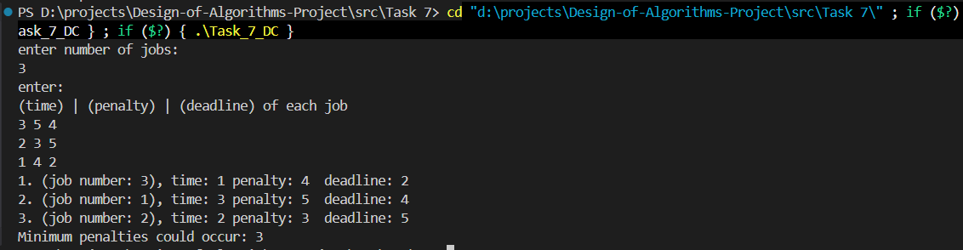
Test Case 2 – All Jobs Meet Deadlines (n = 3)

Table: Test Case 2 Input: All deadlines met
Job # | Processing Time (t) | Deadline (d) | Penalty (p) | Penalty Incurred?
1 | 1 | 5 | 10 | No → Penalty = 0
2 | 2 | 10 | 8 | No → Penalty = 0
3 | 3 | 15 | 6 | No → Penalty = 0

Cumulative times (1, 3, 6) all fall within deadlines (5, 10, 15). Total Penalty = 0.
Output:
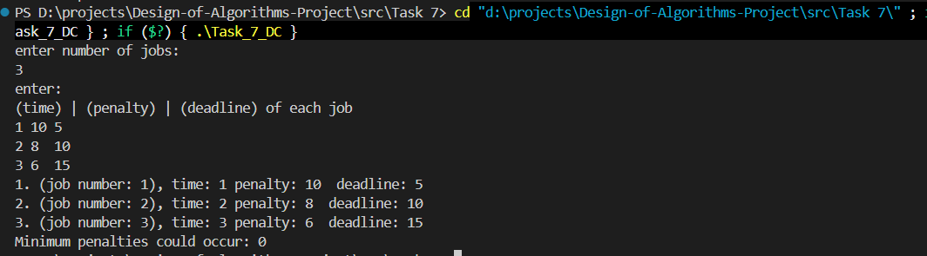

4.6 Complexity Analysis

Table: Divide and Conquer Complexity
Metric | Complexity
Time | O(n log n) — Standard Merge Sort with an O(1) comparator per comparison
Space | O(n) — Temporary array used during the merge step; O(log n) recursion stack

5. Dynamic Programming Algorithm

5.1 Methodology
The Dynamic Programming approach uses bitmask DP to represent every possible subset of scheduled jobs as an integer bitmask (0 to 2ⁿ − 1). For each state (subset), the algorithm tries appending each unscheduled job and records the minimum penalty achievable. Backtracking through the recorded transitions recovers the optimal job ordering. This guarantees a globally optimal solution at the cost of exponential memory.

5.2 Step-by-Step Description
- Read n, and the arrays t[], p[], d[].
- Represent every possible subset of jobs as a bitmask integer (0 to 2ⁿ − 1).
- Initialize: dp[0] = 0 (no jobs scheduled → no penalty); all other dp[mask] = ∞; timeUsed[mask] stores the cumulative processing time for state mask.
- For each state mask (from 0 to 2ⁿ − 1): for each job i not yet in mask, compute newMask = mask | (1 << i), newTime = timeUsed[mask] + t[i], and newPenalty = dp[mask] + (newTime > d[i] ? p[i] : 0). If newPenalty < dp[newMask], update dp[newMask], timeUsed[newMask], and record the transition.
- Backtrack from the full state (2ⁿ − 1) using last_state[] and last_Job[] to recover the optimal ordering.
- Output the optimal schedule and minimum penalty.

5.3 Pseudocode

DP_JobScheduling(n, t[], p[], d[]):
totalStates ← 2^n
dp[] ← array[totalStates], initialized to ∞
timeUsed[] ← array[totalStates], initialized to 0
last_state[] ← array[totalStates], initialized to -1
last_Job[] ← array[totalStates], initialized to -1

dp[0] ← 0

FOR mask = 0 TO totalStates - 1:
IF dp[mask] = ∞: CONTINUE

FOR i = 0 TO n-1:
IF bit i is set in mask: CONTINUE // job i already scheduled

newMask ← mask OR (1 << i)
newTime ← timeUsed[mask] + t[i]
newPenalty ← dp[mask] + (newTime > d[i] ? p[i] : 0)

IF newPenalty < dp[newMask]:
dp[newMask] ← newPenalty
timeUsed[newMask] ← newTime
last_state[newMask] ← mask
last_Job[newMask] ← i

// Backtrack to find optimal order
result[] ← []
current ← totalStates - 1
WHILE current ≠ 0:
result.prepend(last_Job[current])
current ← last_state[current]

PRINT result[], dp[totalStates - 1]

5.4 Implementation Code (C++)

#include <iostream>
#include <vector>
#include <climits>
#include <algorithm>
using namespace std;

int main()
{
cout << "enter number of jobs: " << endl;
int n;
cin >> n;
int totalStates = 1 << n;
cout << "enter: " << endl;
cout << "(time) | (penalty) | (deadline) of each job " << endl;
vector<int> t(n), p(n), d(n);
vector<int> dp(totalStates, INT_MAX);
vector<int> last_state(totalStates, -1);
vector<int> last_Job(totalStates, -1);
vector<int> timeUsed(totalStates, 0);

for (int i = 0; i < n; i++)
cin >> t[i] >> p[i] >> d[i];

dp[0] = 0;

for (int mask = 0; mask < totalStates; mask++)
{
if (dp[mask] == INT_MAX)
continue;

for (int i = 0; i < n; i++)
{
if (mask & (1 << i))
continue;

int newMask = mask | (1 << i);
int newTime = timeUsed[mask] + t[i];
int newPenalty = dp[mask];

if (newTime > d[i])
newPenalty += p[i];

if (newPenalty < dp[newMask])
{
dp[newMask] = newPenalty;
last_state[newMask] = mask;
last_Job[newMask] = i;
timeUsed[newMask] = newTime;
}
}
}

int allDone = totalStates - 1;
vector<int> result;
int current = allDone;

while (current != 0)
{
result.push_back(last_Job[current]);
current = last_state[current];
}
reverse(result.begin(), result.end());

int currentTime = 0, minPenalties = 0;
for (int i = 0; i < n; i++)
{

currentTime += t[result[i]];
if (currentTime > d[result[i]])
minPenalties += p[result[i]];

cout << i + 1 << ". "
<< "(job number: " << result[i] + 1 << "), "
<< "time: " << t[result[i]] << " "
<< "penalty: " << p[result[i]] << " "
<< "deadline: " << d[result[i]] << endl;
}
cout << "Minimum penalties could occur: " << minPenalties << endl;

return 0;
}

5.5 Test Cases
Test Case 1 – n = 3 (General Case)

Table: DP Test Case 1 – Schedule: Job3 → Job1 → Job2
Job # | Processing Time (t) | Deadline (d) | Penalty (p) | Penalty Incurred?
1 | 3 | 4 | 5 | No → Penalty = 0
2 | 2 | 5 | 3 | Yes → Penalty = 3
3 | 1 | 2 | 4 | No → Penalty = 0

- Job 3: cumulative time = 1 ≤ 2 → no penalty
- Job 1: cumulative time = 4 ≤ 4 → no penalty
- Job 2: cumulative time = 6 > 5 → penalty = 3
Total Penalty = 3 (optimal)
Output:
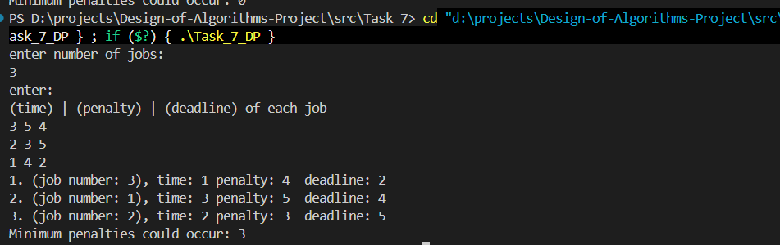

Test Case 2 – All Jobs Meet Deadlines (n = 3)

Table: DP Test Case 2 – All Deadlines Met
Job # | Processing Time (t) | Deadline (d) | Penalty (p) | Penalty Incurred?
1 | 1 | 5 | 10 | No → Penalty = 0
2 | 2 | 10 | 8 | No → Penalty = 0
3 | 3 | 15 | 6 | No → Penalty = 0

Cumulative times (1, 3, 6) all fall within deadlines (5, 10, 15). Total Penalty = 0.
Output:
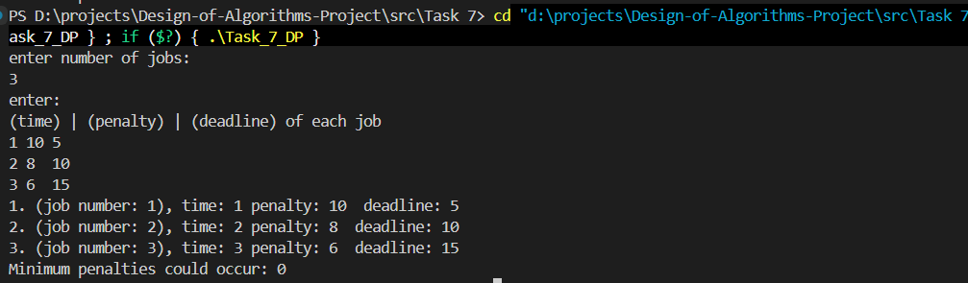

5.6 Complexity Analysis

Table: Dynamic Programming Complexity
Metric | Complexity
Time | O(2ⁿ × n) — 2ⁿ states × n transitions per state
Space | O(2ⁿ) — Arrays dp[], timeUsed[], last_state[], last_Job[] each of size 2ⁿ

Guaranteed optimal. Feasible up to approximately n = 20 before memory becomes prohibitive.

6. Technique Comparison

Table: Technique Comparison
Property | Brute Force | Divide & Conquer | Dynamic Programming
Time Complexity | O(n! × n) | O(n log n) | O(2ⁿ × n)
Space Complexity | O(n) | O(n) | O(2ⁿ)
Guarantees Optimal? | Yes | Not always | Yes
Practical for large n? | No (n > 12) | Yes | Limited (n ≤ 20)
Implementation | Low | Medium | High
Scalability | Very Poor | Excellent | Moderate

7. Alternative Approaches

7.1 Greedy – Earliest Deadline First (EDF)
Schedule jobs in ascending order of deadline. This approach is simple and runs in O(n log n), but it does not minimize the total weighted penalty. EDF only minimizes the number of late jobs, not the sum of penalties. It is therefore suboptimal for the general case of this problem.

7.2 Branch and Bound
Branch and Bound explores the scheduling search tree with pruning: if a partial schedule’s accumulated penalty already exceeds the best known solution, that branch is abandoned. This approach is optimal and generally faster than pure Brute Force in practice, but its worst-case complexity remains exponential.

7.3 Approximation Algorithms
For very large n (e.g., n > 20), exact algorithms are impractical. Approximation schemes such as PTAS (Polynomial-Time Approximation Schemes) can produce solutions within a guaranteed factor of the optimum in polynomial time, making them suitable for industrial-scale instances.

8. Summary
Task 7 addresses the classic single-machine job scheduling problem whose goal is to minimize the total weighted tardiness penalty across n jobs.
- Three approaches were implemented: Brute Force, Divide and Conquer (Merge Sort), and Dynamic Programming (bitmask DP).
- The Brute Force approach is correct but computationally expensive at O(n! × n), rendering it impractical beyond approximately 12 jobs.
- The Divide and Conquer (merge sort-based) approach runs efficiently at O(n log n) but applies only pairwise local comparisons, which can yield suboptimal results when the cumulative scheduling context is ignored.
- The Dynamic Programming (bitmask) approach guarantees the globally optimal solution by exploring all 2ⁿ subsets, at the cost of exponential memory, making it practical for up to approximately 20 jobs.
- No single polynomial-time algorithm is known to solve this problem optimally in the general case (it belongs to the NP-hard family for certain weighted variants), making the trade-off between optimality and efficiency a core design consideration.

9. References
- Levitin, A. (2012). Introduction to The Design and Analysis of Algorithms (3rd ed.). Pearson.
- Cormen, T. H., Leiserson, C. E., Rivest, R. L., & Stein, C. (2009). Introduction to Algorithms (3rd ed.). MIT Press.
- Pinedo, M. L. (2016). Scheduling: Theory, Algorithms, and Systems (5th ed.). Springer.
- GeeksforGeeks. (2024). Job Sequencing Problem. https://www.geeksforgeeks.org/job-sequencing-problem/

