Design and Analysis of Algorithms

Task 10: The Coin Removal Problem

Table of Contents
1. Problem Description 2
2. Underlying Assumptions 2
3. Algorithm Design 3
4. Correctness & Case Coverage 7
5. Complexity Analysis 8
6. Algorithms Comparative Analysis 8
7. Sample Outputs and Explanation 10
8. Approach Downsides 11
9. Improvements 12
10. Conclusion 12
11. References 12

Figure 1 Main function 6
Figure 2 Backtracking function solve 7
Figure 3 Test cases 11
Figure 4 Console outputs 11

Table 1 Algorithmic Comparison. 10

Problem Description
We are given a line of n coins. Each coin shows either Heads ‘H’ or Tails ‘T’ in an arbitrary order. The goal is to remove all coins using a sequence of moves. A move consists of:
- Choose a coin that is currently Heads-up.
- Remove that coin from the line.
- If the removed coin had an immediate neighbor on the left or right that is still present, flip that neighbor.

A gap is formed when a coin is removed. Neighbors are the coins immediately beside the removed coin, and you can’t flip past a gap.

The puzzle’s goal is to remove all coins on the table and output the sequence of moves done to reach the goal or output impossible if there is no possible sequence.

Underlying Assumptions
- The input is a string consisting only of the characters 'H' and 'T', with length n ≥ 1.
- Coin indices are 1-based in the output, matching the natural counting from left to right.
- Flipping happens only on the immediate original neighbors that are still present
- If a neighbor does not exist (edge coins) or has already been removed, no flip occurs for that side.
- The program must output one valid sequence if one exists; if multiple sequences exist, any is acceptable.
- The program outputs “Impossible” if no sequence can empty the board.

Algorithm Design
Backtracking (Brute Force with pruning) is chosen as it tries every legal move sequence, undoing choices when a dead end is reached. This makes sure that if a solution exists it will be found.

Step-by-step Execution:
- Base Case: If coins_left == 0, all coins have been removed, success.
- Iterate: For every index i from 0 to n−1:
- Check if coin i is still on the board (! removed[i]) and shows 'H'.
- Make a move:
- Mark removed[i] = true, record the 1-based index i+1 in path.
- Flip the left neighbor i-1 if it exists and is still present.
- Flip the right neighbor i+1 if it exists and is still present.
- Recurse: Call solve with coins_left - 1. If it returns true it means a solution is found so it returns true to the previous call.
- Backtrack if failure:
- Undo the flips in the exact reverse order (right neighbor then left neighbor) to restore the state.
- Mark removed[i] = false and remove the index from path.
- After loop: If no 'H' coin is available and coins_left > 0, return false.

Pseudocode:
Algorithm: Coin Removal Backtracking

function Solve(board, removed, path, coins_left)
if coins_left = 0 then
return true // all coins successfully removed

for each position i from 1 to n (1-based) do
if coin i is still present and shows Heads then
// choose coin i as the next move
mark coin i as removed
add i to the end of path

if coin i has a left or right neighbor that is still present then
flip those neighbors over

// try to continue from the new state
if Solve (board, removed, path, coins_left – 1) then
return true

// undo the move (backtrack)
if coin i has a right neighbor that is still present then
Turn that neighbor over
if coin i has a left neighbor that is still present then
turn that neighbor over
mark coin i as present again
remove the last index from path

return false // no move possible from this state

function Main()
for each test_case in test_cases do
path = empty list
removed = array of false
if Solve(test_case, removed, path, length of test_case) then
print elements of path separated by spaces
else
print "Impossible"

Code Implementation:

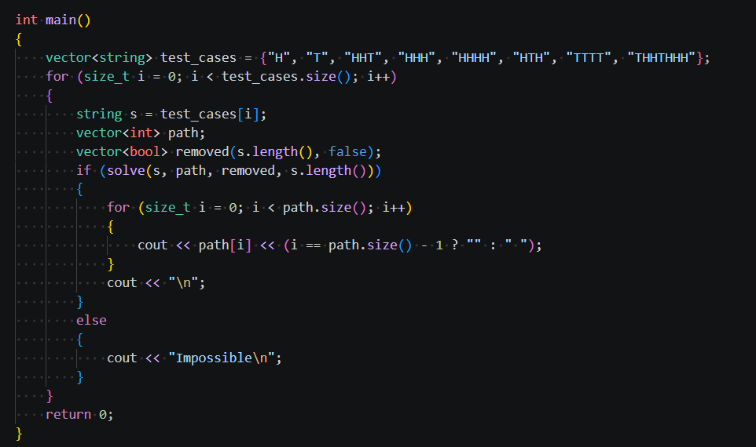

Figure 1 Main function

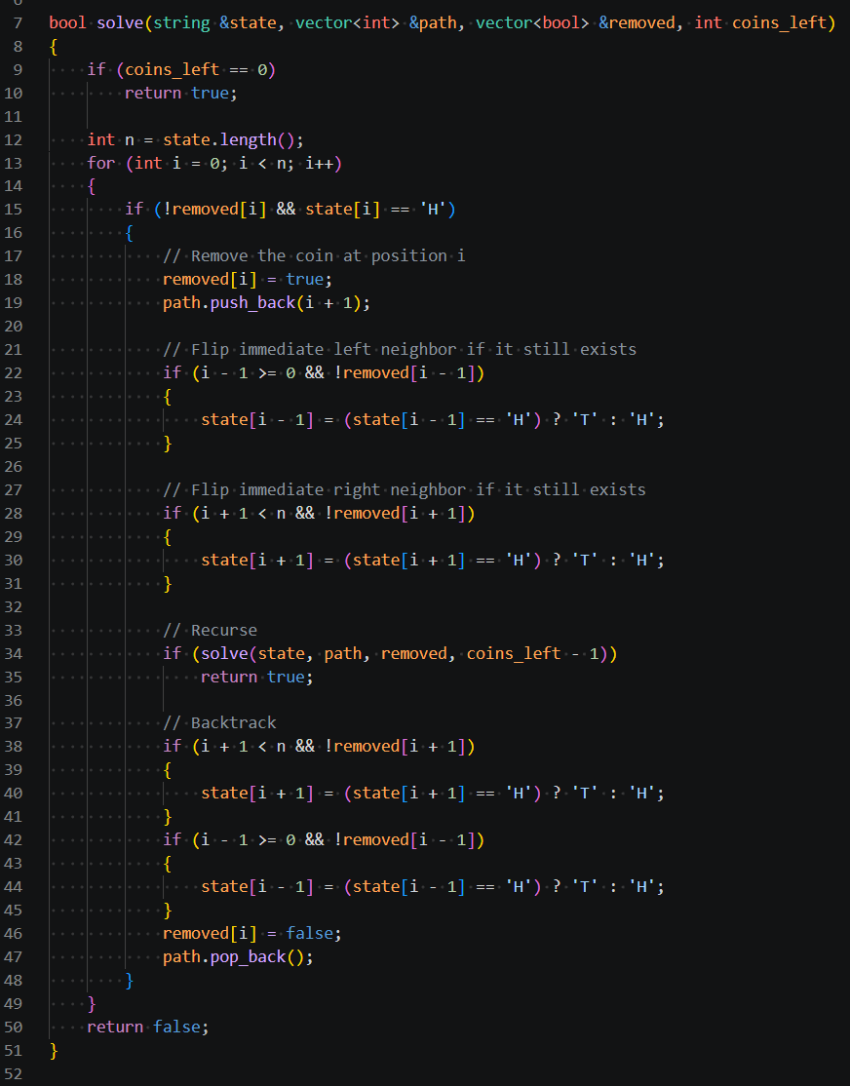

Figure 2 Backtracking function solve

Correctness & Case Coverage
Correctness:
Before removing coin i, the code verifies !removed[i] and state[i] == 'H'. Then flips its neighbors ‘i-1’ and ‘i+1’ but making sure that those positions are not empty or out of bounds first. The undo block re-flips the same two positions in the same conditional order, and since flipping is its own inverse, the state is restored exactly.

The algorithm iterates over every index from 0 to n-1 at each recursion level and attempts a move on every coin that is present and heads-up. A branch returns false only when the inner loop completes without finding any valid move while coins_left > 0. At that point no ‘H’ coin is present, which means no legal move exists in that state, so, no valid branch is ever skipped. If a solution exists anywhere in the search tree, the algorithm reaches it.

Each recursion level decrements coins_left by exactly one. The depth is therefore bounded by ‘n’, and at each level a finite loop runs. The algorithm always terminates.

Case Coverage:
- Single coin (H/T): If it's ‘H’ it gets removed immediately with no neighbors to flip, done in one move. If it's ‘T’ the algorithm has nothing to work with and returns Impossible straight away.
- All heads: Solvability depends on whether n is odd or even. When n is odd, a valid sequence always exists. When n is even, the puzzle is always Impossible. This parity rule arises because each removal flips one or two neighbors, and with an even-length all-heads line the flipping pattern always leaves at least one stranded T coin with no path to recovery.
- All tails: Nothing to remove from the start. Returns Impossible without doing any work

Complexity Analysis
Time Complexity:
In the worst case when the puzzle has no solution the code has to try every sequence of heads-up removals. At the first call, there can be up to n heads, after we remove one, up to n-1 remain, and so on. That gives a search tree of size O(n!). Fortunately, most configurations don’t stay that dense; many branches hit a dead end early because the board quickly turns all tails. In practice,

Space Complexity:
The recursion depth is at most n, because only one coin is removed per level. Each level only needs a few local variables plus our removed array and path list. So, the space usage is O(n).

Algorithms Comparative Analysis
Brute Force: A pure brute-force approach would generate all n! orderings of coins and simulate each one. This works but is wasteful as it explores sequences that contain moves on ‘T’ coins or already-removed coins, which are invalid and can be discarded immediately. The backtracking approach makes the search space bounded, and strict un-doing of local flips guarantees isolation between recursive states.

Greedy: A greedy approach picks one H coin at each step according to a fixed rule say, always the leftmost, or the one whose removal creates the newest ‘H’ coins. This runs in O(n²) and is simple to implement.

The problem is that greedy is not correct in general. Any greedy ordering gets stuck because every path leads to a configuration with no ‘H’ coins but coins still remaining. The greedy method cannot backtrack, so it cannot discover this. Only exhaustive search reveals that the configuration is impossible.

Divide and Conquer: Removing a coin creates a gap that splits the remaining coins into two independent subgames because the new gap prevents any future flip from crossing it. The left and right halves do not interact at all, a valid sequence in one cannot invalidate a sequence in the other. However, the two sequences produced independently must then be merged in order into a single chronological ordering. Finding a correct merging across potentially many split points is highly complex and is what makes divide-and-conquer an impractical compared to backtracking.

Iterative Improvement: It starts with some solution and refines it. This problem has no natural notion of a partial or approximate solution.

Dynamic Programming: Could work in theory since states can be cached, but maintaining the sequence order across subproblems makes it more complex to implement than backtracking.

this table summarizes the analysis of all algorithms discussed:

Table 1 Algorithmic Comparison.
Technique | Applicability | Advantages/Disadvantages
Brute Force  (full enumeration) | Generate all n! orderings and simulate each. | Simple to implement but so slow O(n!).
Backtracking | Explore moves, undo when stuck. | Always correct and far smaller search tree than naive enumeration but still worst-case exponential.
Greedy | Always pick a specific ‘H’  Like leftmost first | Very fast (O(n²)) but incorrect for many inputs because a wrong local choice can block the solution.
Divide & Conquer | Independent subgames are created after each removal, but merging the resulting sequences into one valid chronological ordering is complex | Correct in theory but harder to implement than backtracking.
Dynamic Programming | Use subproblem solvability on intervals with boundary conditions | Could reduce redundant work by caching already-explored states, avoiding re-exploration of the same configuration reached via different orderings. Still exponential in the worst case but significantly faster in practice, but sequence reconstruction across independent chunks is too complex
Iterative Improvement | Start with a solution and refine it. | there’s no way to take a partial solution and refine it.

Conclusion: Backtracking balances between correctness and implementation complexity for this task. The factorial worst-case time is acceptable for small n, and the algorithm is simple to understand, debug, and prove correct.

Sample Outputs and Explanation
Tests:
Figure 3 Test cases

Outputs:
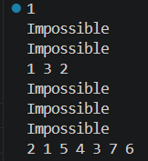

Figure 4 Console outputs

Explanation of selected cases:

- “H”: Only one coin, heads-up, removed immediately. Sequence: 1.
- “T”: No heads-up coin, Impossible.
- “HHT”: Unsolvable. Removing coin 1 leaves - T T. Removing coin 2 leaves T - T
- “HHH”: Works; sequence 1 3 2 is printed.
- “HHHH”: Unsolvable. Removing coin 1 leaves - T H H. The only valid next move is coin 3, which leaves - T - T. starting with any other coin also gives only 'T' configurations. The algorithm exhausts all paths and returns Impossible.
- “HTH”: Unsolvable. Removing coin 1 leaves - H H. Removing coin 3 leaves H H -. Removing the middle coin 2 leaves T - T.
- “TTTT”: No head so it’s Impossible.
- “THHTHHH” Backtracking finds a valid removal sequence: 2 1 5 4 3 7 6
Steps:
  - Remove coin 2, flips 1 and 3, state: H - T T H H H
  - Remove coin 1, state: - - T H H H
  - Remove coin 5, flips 4 and 6, state: - - T H - T H
  - Remove coin 4, flips 3, state: - - H - - T H
  - Remove coin 3, state: - - - - - T H
  - Remove coin 7, flips 6, state: - - - - - H -
  - Remove coin 6, state: - - - - - - -

Approach Downsides
The algorithm suffers from factorial worst-case time complexity, which makes it impractical for large inputs. As the string grows, the number of possible move sequences increases dramatically, and the algorithm attempts to explore them one by one. The main issue is that it does not keep track of states it has already seen. This means the same board configuration can be reached through different sequences of moves, yet each time it appears, the algorithm recomputes everything from scratch.

As a result, a significant amount of work is repeated unnecessarily. This becomes especially problematic in cases where no solution exists, because the algorithm is forced to go through every possible sequence before it can conclude failure and it ends up re-evaluating the same sub configurations many times, which is what makes it so inefficient in the worst case.

Improvements
A Dynamic Programming approach could reduce the redundant work by caching the states that have already been explored. Since the full state of the coins at any point is just which coins are still present and what face each one shows, it can be represented compactly and stored. If the algorithm reaches a state, it has seen before and already determined to be unsolvable, it can skip it immediately instead of re-exploring it. This would not change the worst case in theory but in practice would cut out a significant amount of repeated work, especially on larger inputs where the number of possible orderings explodes quickly.

Conclusion
The backtracking implementation correctly finds a valid solution sequence when one exists. The main limitation is the factorial worst-case time, which becomes a real problem as n grows since impossible configurations force the algorithm to exhaust every possible branch before concluding. A Dynamic Programming approach could improve this by caching already explored states and avoiding redundant work, since the same board configuration can be reached through different removal orderings.

References
Arora, A. (2017). Analysis and Design of Algorithms.
Dynamic Programming or DP. (n.d.). Retrieved from geeksforgeeks: https://www.geeksforgeeks.org/dsa/dynamic-programming/
Iacono, A. (2017, oct 7). Backtracking explained. Retrieved from medium: https://medium.com/@andreaiacono/backtracking-explained-7450d6ef9e1a
Levitin, A. (2012). Introduction to the Design and Analysis of Algorithms.

