INVENTION DISCLOSURE
SchemaBridge AI
Smart, High-Speed Data Translation Between Enterprise Systems
Project Name: | SchemaBridge AI
Inventor: | Baljinder Singh
Invention Title: | System and Method for Fast, Secure Data Translation Between Enterprise Systems
Core Idea: | Uses AI only once to generate rules, then runs 100% pure fast code in production (zero AI in live data flow)

1. The Core Idea
Enterprise systems (like an old billing system and a modern cloud CRM) cannot talk to each other because their field names, date formats, and structures don't match.
SchemaBridge AI solves this with a smart two-phase design:
• Phase 1 (Design Time): It uses AI only once at design-time to examine schemas and figure out translation rules.
• Phase 2 (Live Runtime): It executes the translation in pure code (<5ms) without calling AI. Live customer data never touches an AI model.
2. Problems With Existing Solutions
• Manual Hand-Coding is Slow & Fragile: Writing point-to-point integration code for hundreds of fields takes weeks and breaks every time an API updates.
• Sending Live Data to AI is Too Slow: Calling an LLM for each live transaction takes 1 to 5 seconds. Production systems need answers in under 10 milliseconds.
• AI is Unpredictable in Production: LLMs can hallucinate, change output formats, or drop fields randomly, which causes data corruption in financial or healthcare records.
• Data Privacy & Compliance Risks: Sending customer data (names, emails, credit cards) to external AI models violates privacy laws (GDPR, HIPAA).
• High Token Costs: Paying token fees for millions of daily live API calls is far too expensive.
3. Simple System Flow
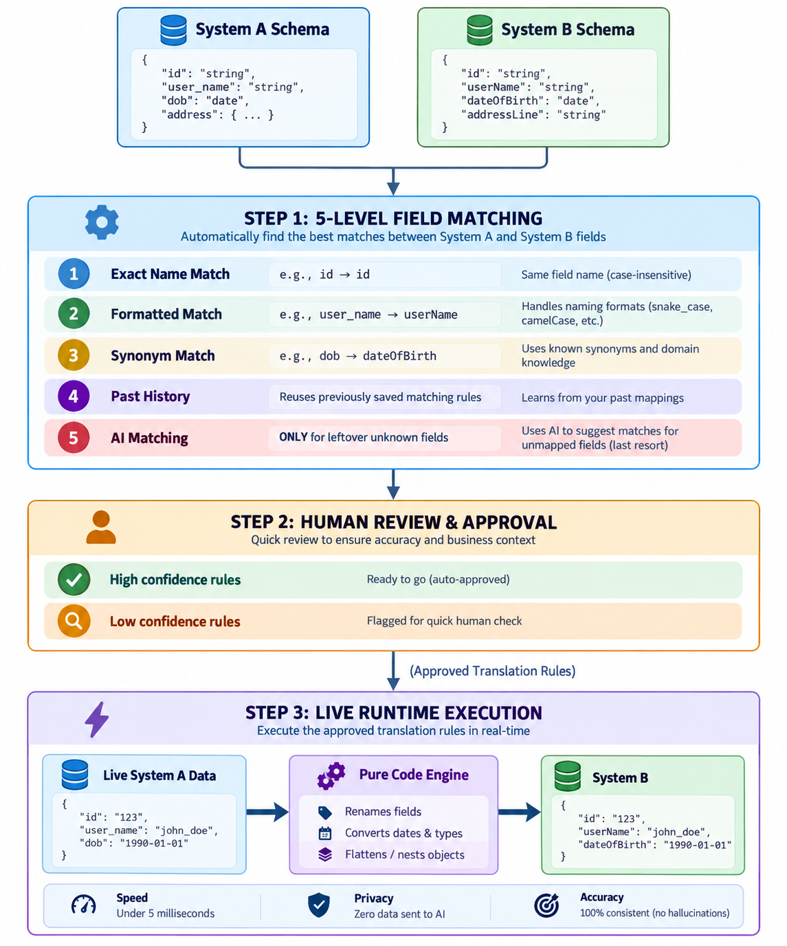

4. How the Steps Work (Step-by-Step)
• Step 1: The 5-Level Matching Pipeline: Checks exact names, case formatting (user_id to userId), known business synonyms (dob to dateOfBirth), and past approved rules. Calls AI only for the few remaining fields that couldn't be resolved deterministically.
• Step 2: Human-in-the-Loop Check: Safe rules with high confidence scores pass automatically. Lower confidence matches are held in a review queue for a quick 1-click human check before going live.
• Step 3: Zero-AI Runtime Engine: Live customer payloads run through pre-compiled algebraic rules (rename, date format, flatten, nest) in pure Java code (<5ms). Works offline even if the AI service goes down.
• Step 4: Automatic Schema Change Detection: Cryptographically hashes schemas to catch changes immediately. Highlights exactly which rule is broken (BROKEN_PATH) before bad data hits production.
5. Comparison with Other Approaches
Feature | Hand-Written Code | Calling AI on Live Data | SchemaBridge AI
Setup Time | Weeks or months | Fast (prompting) | Fast (minutes)
Live Speed | Fast (<10 ms) | Very slow (1-5 sec) | Ultra-fast (<5 ms)
Reliability | 100% consistent | Unpredictable (hallucinates) | 100% consistent
Customer Data Privacy | Safe | Risky (sent to cloud AI) | 100% safe (zero data to AI)
Cost Per Transaction | Free | Expensive token fees | Free (runs on local CPU)
Handling API Changes | Breaks silently | Unpredictable | Detects & alerts instantly

6. Key Patent Takeaways
These are the 5 core claims written in plain, straightforward terms so anyone can explain them:
1. The 5-Tier Residual Matching Cascade:
A method that maps data fields between two systems by checking exact matches e.g. username to username first, then normalized names e.g. user_name to username then a domain synonym dictionary e.g. dob to dateOfBirth, then past approved rules — and delegates only the leftover unmapped fields to an AI model with strict schema constraints, rather than wasting cost and risking errors on the whole dataset.
2. Decoupled AI-Advisory Rule Synthesis with Zero-AI Runtime:
An architecture that isolates generative AI strictly to an offline design-time assistant for discovering mapping rules, while routing all live production transactions through a pure, in-memory execution engine (<5ms) that never sends customer data to an AI model, eliminating latency, hallucination, and privacy risks.
3. Closed-Loop Cryptographic Schema Drift & Impact Mapping:
A monitoring system that fingerprints schemas using cryptographic hashes (SHA-256), detects additions, removals, or type changes via structural tree comparison, and automatically traces the change directly to affected transformation rules (BROKEN_PATH), alerting operators before broken data hits production.
4. Confidence-Gated Human-in-the-Loop Safeguard:
A verification gate that automatically scores every suggested mapping rule, allowing high-confidence rules to proceed while quarantining ambiguous or low-confidence rules into a review queue, preventing unverified or incorrect translations from entering live systems.
5. Automated Bi-Directional Schema Inversion:
A complete bi-directional integration system that takes forward transformation rules (such as legacy write into modern cloud) and automatically synthesizes the complementary reverse rules (such as modern cloud read back to legacy format), including automatic nesting, flattening, and format reversal without writing rules twice.

