**Download code files from GitHub:**

* Go to the GitHub BMSS2 folder and Download the code folder using Download ZIP, <https://github.com/russellnjk/BMSS2>, since this is currently private, you need to use the invitation link sent by Russell previously.
* Then just unzip the folder in your Download folder.

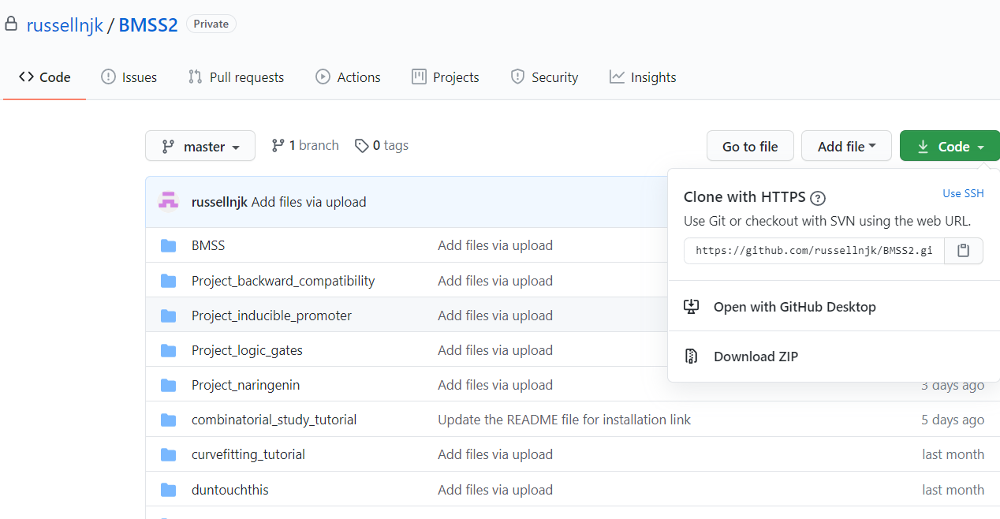

**Anaconda Installation:**

* Anaconda Installation: <https://www.anaconda.com/products/individual>, go to the Anaconda Installers at the bottom of this page and install the distribution based on your OS. Currently the latest one is Python 3.8.
* From the Start menu, you should be able to find the Spyder app , else you can launch the Spyder IDE from Anaconda Navigator (also from Start menu), especially for Mac.
* The Spyder IDE is used to open and run the .py file.

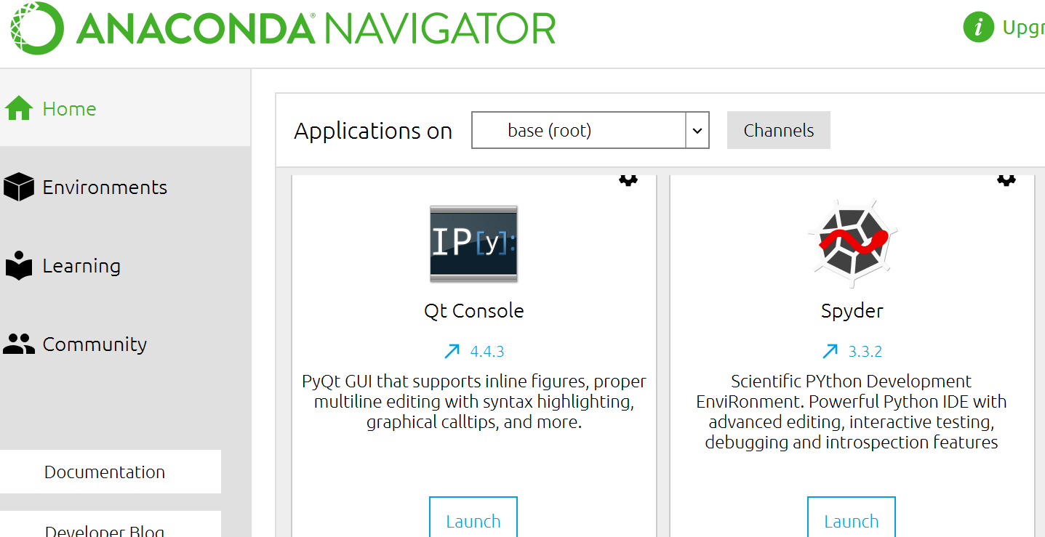

**To install additional packages:**

**For windows users:**

* From the Start menu, search for and open “Anaconda Prompt”

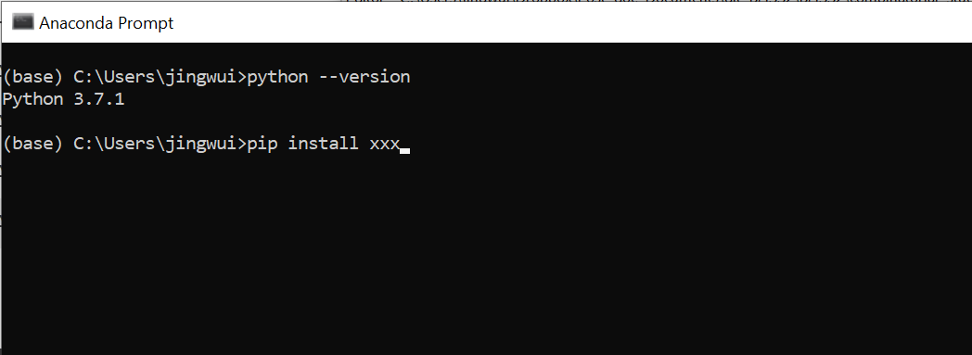

**For Mac users:**

* The pip install should be able to run on the terminal for Mac.
* Refer to <https://understandingdata.com/how-to-install-anaconda-mac-os/>
* There is a short video inside the link on the anaconda installation and open Jupyter notebook from the terminal. The pip install packages should be able to run on the terminal for Mac.

**Other additional links to refer to for Windows, Mac, and Linux OS:**

* <https://docs.anaconda.com/anaconda/user-guide/getting-started/>
* <https://docs.anaconda.com/anaconda/install/verify-install/>
* <https://problemsolvingwithpython.com/01-Orientation/01.04-Installing-Anaconda-on-MacOS/>

**Open the python .py file:**

* In the Spyder IDE, Under the File menu 🡪 Open to navigate to the downloaded BMSS2 folder to open the desired .py file. Click on the Run file button (green icon) to run the .py file.

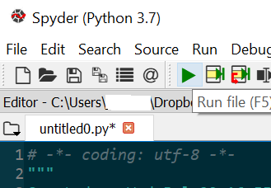

**Open Jupyter notebook:**

* From the Start menu, search, and launch the Jupyter Notebook App. The Jupyter Notebook can also be opened using Anaconda Prompt (Windows) or Terminal (Mac)



* Jupyter Notebook is a web application; thus, it will be opened on your browser.
* Navigate to the corresponding folder and open file with .ipynb extension.

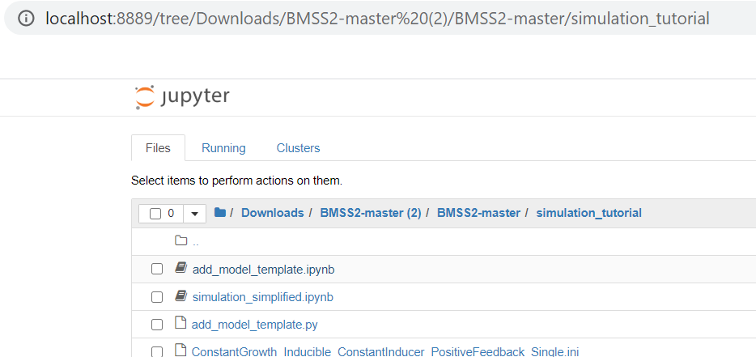

* To Run the file, click on the cell with *In []* and Under the *Cell* menu, you may click *Run Cells* to run the individual cell or *Run All* to run the whole jupyter notebook file.

