**1.3.2:**

**Does your university as a body have graduation/completion targets for students who fall into the bottom 20% of household income group (or a more tightly defined target) in the country? (domestic)**

**A N S W E R:**

**1. University Graduation/Completion Targets (2023)**

* **Graduation Targets for Low-Income Students**: In 2021, Alkafeel University initiated targeted programs to support students in the bottom 20% of the household income group (domestic). The university aims to ensure equitable completion rates across all income groups. For this year, they aim to increase the graduation rate for these students by **15%** compared to the previous year, by providing additional financial aid, academic support, and flexible study options.

*Key Initiatives for 2023*:

* Expansion of financial aid programs. Including full scholarships, throw out their academic study at our university, also many students get discounts, if they are from low to middle class
* Introduction of mentorship programs focused on at-risk students.

Select number of student who are under 20% of house hold income, get a private free student card in which he can gets free discounts for meals and book for his study

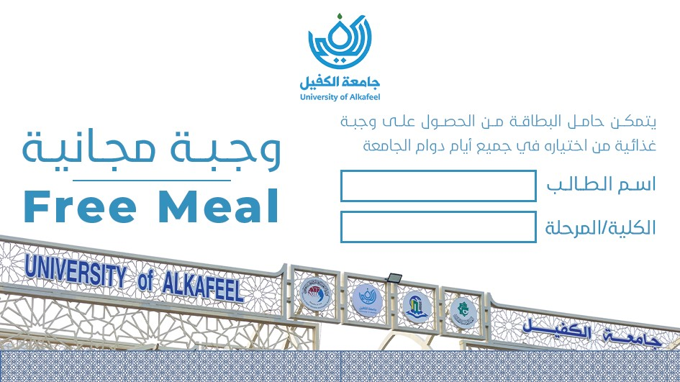

Student card for the free meal

* + Enhanced academic advising and tutoring services.

Our guiding unit, over free service and tours for all students, also they can offer their problems and together with the head of the university we aim to solve them.

Below are some of guiding unit activates

|  |  |
| --- | --- |
| Pic | University order |
|  | **Community service activity**  Based on the authority granted to us in accordance with Law No. 25 of 2016, we have decided to conduct a community service activity to visit children suffering from leukemia at the Cancer and Tumor Center to provide financial support for these categories. The visit is scheduled for Wednesday, 29/11/2023, at 10:00 AM, with participation from the teaching staff and students of the College of Medicine, second-year students listed in the attached list. |
|  | **Student trip**  Based on the authority granted to us in accordance with Law No. 25 of 2016, we have decided to organize a trip to the Holy Shrines in Karbala for third-year students of the College of Pharmacy, whose names are listed in the attached list. This is to participate in some activities to promote moral values, accompanied by their academic advisors. The trip will take place on Wednesday, 29/11/2023.  1. Dr. Hussam Ali Hassan Al-Ubaidi  2. Mrs. Hanaa Nouri Ahmed  3. Mr. Mohamed Jabbar Obeid |
|  | **Student trip**  Based on the authority granted to us in accordance with Law No. 25 of 2016, we have decided to organize a recreational trip to the city of Nuwaira, the tourist destination in Karbala, for third- and fourth-year students of the College of Health and Medical Technologies / Department of Laboratory Analysis. The trip will take place on Friday, 1/12/2023, accompanied by teachers and academic advisors. |
|  | **Visit**  Based on the authority granted to us in accordance with Law No. 25 of 2016, we have decided to organize a visit to the "Hakayati" Center and provide both financial and moral support for orphans. The visit will be accompanied by a group of teaching staff and some students from the College of Health and Medical Technologies. This will take place on Tuesday, 26/12/2023. |
|  | **Student trip**  Based on the authority granted to us in accordance with Law No. 25 of 2016, we have decided to organize a recreational trip to the city of Nuwaira, the tourist destination in Karbala, for the students of the College of Health and Medical Technologies / Department of Radiology and Anesthesia. The trip will take place on Thursday, 14/12/2023, accompanied by teachers and academic advisors. |
|  | **Student trip**  Based on the authority granted to us in accordance with Law No. 25 of 2016, we have decided to organize a recreational trip to the city of Nuwaira, the tourist destination in Karbala, for the students of the College of Dentistry. The trip will take place on Thursday, 7/12/2023, accompanied by teachers and academic advisors. |
|  | **Seminar**  Based on the authority granted to us in accordance with Law No. 25 of 2016 (as amended), we have decided to hold a symposium on Quranic recitation in collaboration with the Holy Quran Institute in Najaf - The Scientific Society for the Holy Quran / The Holy Al-Abass Shrine. The symposium is titled "The Quranic Vision in the Importance of Veil and Modesty and Its Reflection in the Blessed Biography of Lady Zainab Al-Kubra (Peace Be Upon Her)" and will be held with the honorable guest Sheikh Zaman Sahib Mahdi on the occasion of the blessed birth anniversary of Lady Zainab (Peace Be Upon Her). The symposium will take place in the building of the College of Medicine at 10:00 AM on Monday, 20/11/2023. |
|  | **Forum**  Based on the authority granted to us in accordance with Law No. 25 of 2016 (as amended), we have decided to organize a session for memorization, recitation, and study of the Holy Quran for female students every Monday of each week throughout the academic year 2023-2024, during free student hours. This will be in cooperation with the Holy Quran Institute in Najaf - The Scientific Society for the Holy Quran / The Holy Al-Abass Shrine. |
|  | **Training forums**  Based on the authority granted to us in accordance with Law No. 25 of 2016 (as amended), we have decided to organize training forums for the development of the capabilities and skills of our students during free hours, according to the academic schedules of the colleges and scientific departments, for the academic year 2023-2024. This will be with the participation of the advanced coach Mr. Safaa Muhammad Jawad. |
|  | **Forum**  Based on the authority granted to us in accordance with Law No. 25 of 2016 (as amended), we have decided to organize a student drawing forum every Monday and Wednesday of each week during the academic year 2023-2024, during free student hours, with the participation of instructor Dr. Bahaa Swadi from the Department of Art Education at the College of Mixed Education, the University of Kufa. |
|  | **Community service**  Based on the authority granted to us in accordance with Law No. 25 of 2016 (as amended), we have decided to organize a community service campaign by hosting a group of orphans (35 children) in coordination with the `Aein Foundation for Social Care, to attend a ceremony at our university on the occasion of the Prophet’s Birthday on Tuesday, 3/10/2023, at 10:00 AM. The event will include providing them with a meal and some gifts, with participation from teachers, staff, and academic advisors, whose names are listed in the attached list. |
|  | **Ceremony**  Based on the authority granted to us in accordance with Law No. 25 of 2016 (as amended), we have decided to hold a ceremony on the occasion of the Prophet’s Birthday on Tuesday, 3/10/2021, at 10:00 AM, according to the program outlined in the attached schedule. |
|  | **Ceremony**  Based on the authority granted to us in accordance with Law No. 25 of 2016, we have decided to hold a ceremony to celebrate the birth of Lady Fatima Al-Zahra (peace be upon her) on Wednesday, 20th of Jumada al-Akhira, 1445 AH, corresponding to 3/1/2024. The event will also include an exhibition of artistic and handcrafted works for students. |

**2. Employment Diversity and Equality Statistics (2023)**

* The Council conducted interviews in 2023 with an emphasis on diversity and equal opportunity in employment. This year, the focus remains on attracting top graduates and ensuring an inclusive hiring process.

|  |  |  |  |
| --- | --- | --- | --- |
| **Title** | **Male** | **Female** | **Total** |
| Top Graduates Applicants | 630 | 945 | 1575 |
| Graduate Applicants | 180 | 135 | 315 |
| Accepted for Interview Candidates | 450 | 290 | 740 |
| Accepted Candidates | 25 | 19 | 44 |

We have developed a dedicated job platform to connect graduates with career opportunities and provide ongoing support after graduation. Our goal is to empower graduates by advertising job openings and this is the link to it

**Links:** [**https://alkafeel.edu.iq/careers/user/login**](https://alkafeel.edu.iq/careers/user/login)

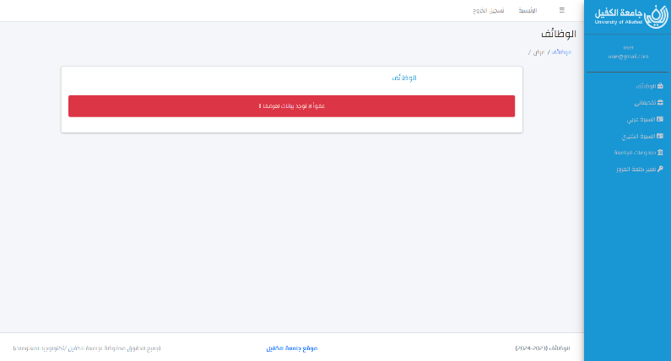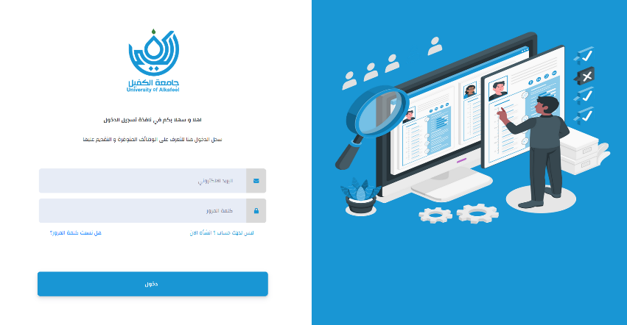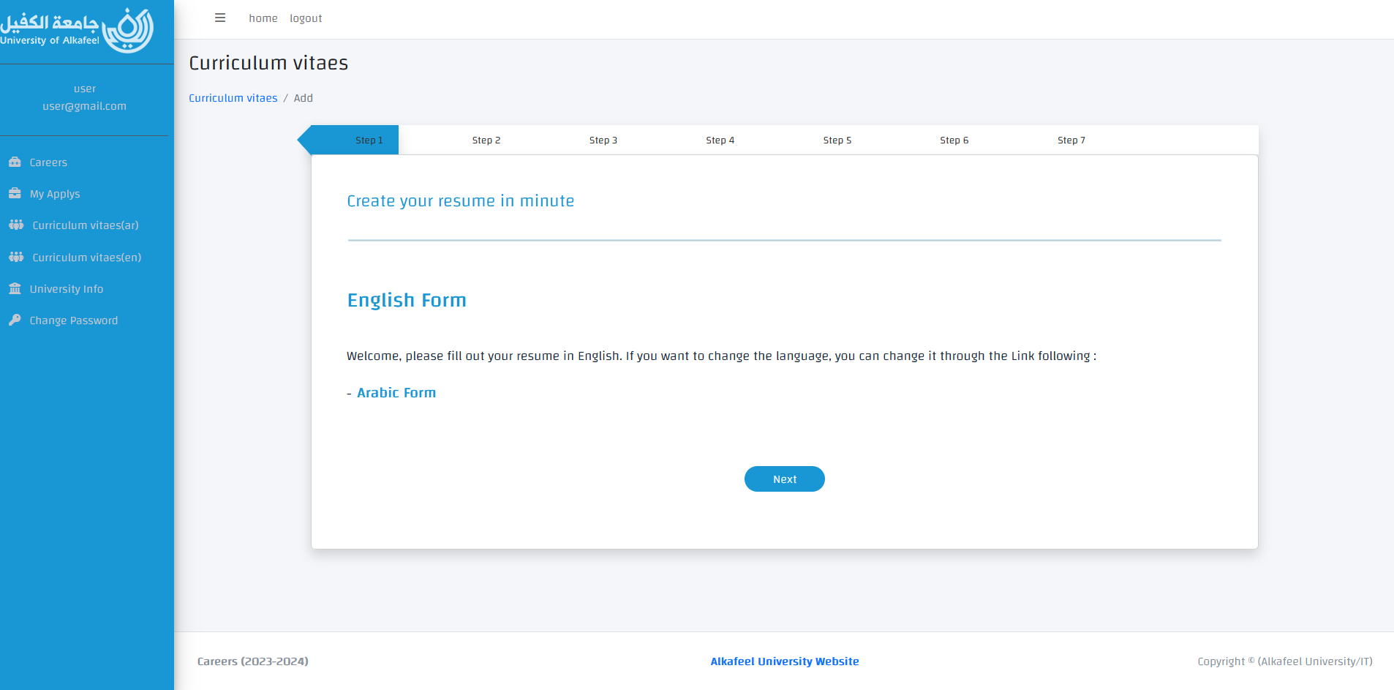Careers Website

**Employment Statistics for 2023**:

*Note*: This year, special attention was given to applicants from underrepresented groups, including those from remote areas and individuals with disabilities. **10%** of accepted candidates were from these backgrounds.

**3. University Academic Staff and Employee Diversity (2023)**

* Alkafeel University remains committed to diversity, as reflected in its academic and staff makeup.

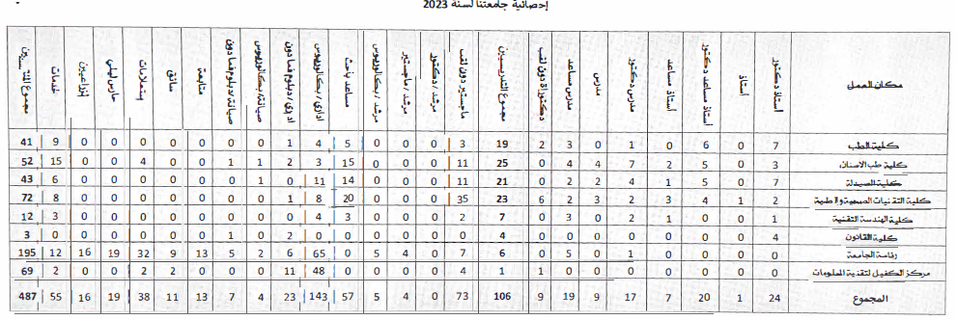**Academic Staff and Employee Statistics for 2023**:

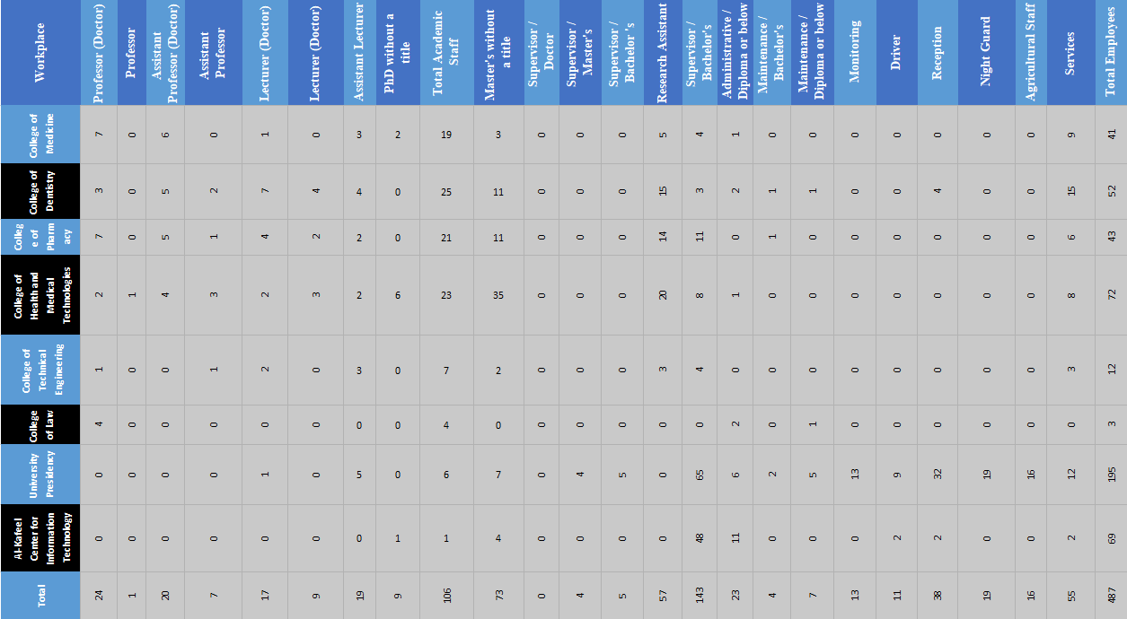

Diversity Initiatives: This year, the university launched initiatives to attract candidates with disabilities and special needs. **12%** of new hires were individuals from underrepresented groups.

Additional Details:

**Study Aid**: All students enrolled in the bottom 20% income group had their full tuition covered this year.