

Yarmouk university

Facility of Information Technology and computer science

Management Information System Department

Team member:

1. Dana amjad Muhammad Alshar'e
2. Rasha Hussain Muhammad Bani Irshed
3. Saja Kamal Muhammad magableh

**Supervisor Dr. Ali Alzahrawi**

**BACHELOR'S DEGREE**

Table of Contents

Chapter 1: 3

Introduction: 3

Problem statement and objective 3

Project plane: 4

System requirement: 4

Functional requirement: 4

Non-functional requirement: 4

Use case diagram: 5

References: 8

# Chapter 1:

## Introduction:

At First, we need to define what the Civil status and passport Department is, to get clear view about it. A Civil status and passport Department is one of the most system must Build in any country around word, It can be said that it is also the backbone of the country, As it carries citizens' information.

“Civil status and passport Department, represented by the Jordanian archiving for its services, and it must provide all the scientific requirements and pursue them for the advancement, achievement and optimal service of the citizen.” [1]

Now we have idea how system is critical, but we need to explanation more about The most important services it provides we will mention and focus in this project

- **Issuing** **Personal identity card** : It is the most important document for every citizen As everyone knows that this card is a sensitive matter, the holder can make sure of his identity . It is known to be a very sensitive responsibility.

- **Issuing a passpo**rt : A **passport** is a [travel document](https://en.wikipedia.org/wiki/Travel_document), usually issued by a [country](https://en.wikipedia.org/wiki/Country)'s [government](https://en.wikipedia.org/wiki/Government) to its citizens, that certifies the identity and [nationality](https://en.wikipedia.org/wiki/Nationality) of its holder primarily for the purpose of international travel. Standard passports may contain information such as the holder's name, place and date of birth, photograph, signature, and other relevant identifying information.

## Problem statement and objective:

Recently, with the increase in population overcrowding, there have been large gatherings in the existing branches to serve the citizens around the kingdom, and also what we see in terms of delay and waste of time and effort this is also a big reason for the spread of viruses in our time which makes injuries increase with crowding in a positive relationship, It is worth noting that there are many citizens who go to the branches without

Little feasibility due to the lack of required paperwork, because that we must view the most of service required, this is in order to save time, effort and disease, as we mentioned earlier.

Objective:

- Submit the application to obtain ID card electronically.

- Submit the application to obtain the passport electronically.

- increase awareness of citizen about our service and what is required or not when they should.

- Submit complaints and suggestions in easy way.

## Project plane:

To view the Gantt-chart In a nicer and interactive way, we was deployed it and prefer visit this link : <https://gant-chart.netlify.app/> .

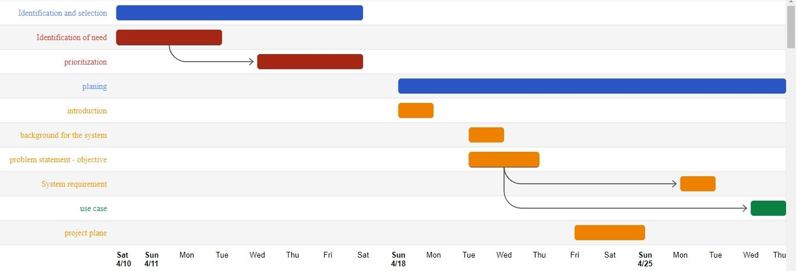

Chapter 1

## System requirement:

### Functional requirement:

In Software engineering and systems engineering, a functional requirement defines a function of a system or its component. A function is described as a set of inputs, the behavior, and outputs In our project the functional requirements are:

1 – user automatically can request order to create ID card

2 – user automatically can request order to create Passport

3 - Inquire about the validity of the personal identity.

-

### Non-functional requirement:

In systems engineering and requirements engineering, a non-functional requirement is a requirement that specifies criteria that can be used to judge the operation of a system, rather than specific behaviors. They are contrasted with functional requirements that define specific behavior or functions

Environmental

* Our Application Support the Jordanian citizen.
* Accessibility, Ability to access and benefit from system, because user didn’t need to space or specific OS to use system.

Performance:

* Accuracy in the information entered
* Fast and Easy Used.

Maintainability

* our Application must be developed from a time to another.
* avoid making the users feeling boring and save time and effort.

## Use case diagram:

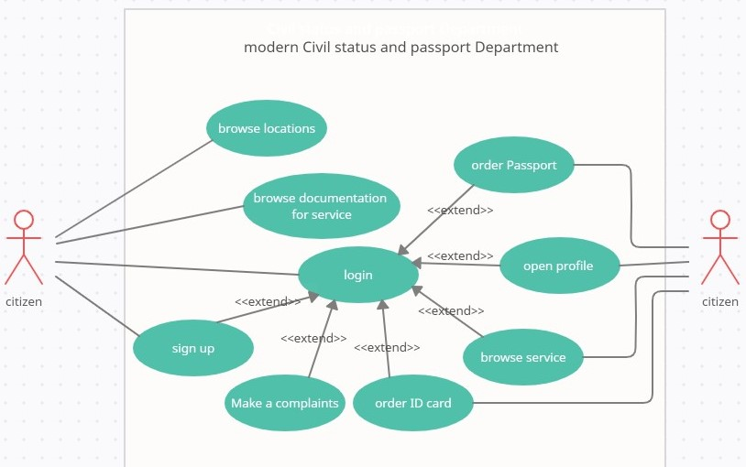

(citizen use case)

|  |  |  |  |
| --- | --- | --- | --- |
| Use case name | Use case description | Actor name | Normal step of Processing |
| Sign up | Make user create account to get specific service | citizen | Enter required registration form |
| login | To make user enter for his account | citizen | Enter required login form and check if it’s correct to access to account |
| Order passport | To apply for a passport, user must fill and submit Application | citizen | Enter the information completely and accurately, then confirm the order |
| order ID card | To apply for a ID card, user must fill and submit Application | citizen | Enter the information completely and accurately, then confirm the order |
| Browse documentation service | To make all citizen know what is necessary for him | citizen | Just enter to services page in website |
| browse service | To view what is service for registered citizen | citizen | After login user can open this page |
| browse locations | To make all citizen know where is Their nearest branch | citizen | By the map Exhibited in website |
| open profile | To make citizen open and view his profile | citizen | While citizen logged in to site he can enter |

(citizen use case)

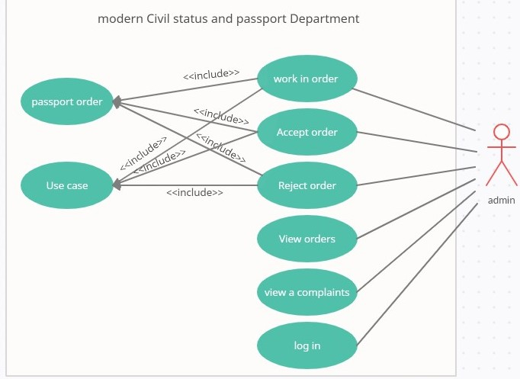

employee

(employee use case)

|  |  |  |  |
| --- | --- | --- | --- |
| Use case name | Use case description | Actor name | Normal step of Processing |
| login | To make employee enter for his account | employee | Enter required login form and check if it’s correct to access to employee account |
| Accept order | To give consent for citizen | employee | Check application  If is correct or not to start work in order |
| Reject order | The request is due to lack or there is unconfirmed or correct information | employee | Deleting the application from the list with returning a notice to the citizen |
| view order | To make the employee show order | employee | View all application for his job |
| browse service | To view what is service for registered citizen | citizen | After login user can open this page |

(employee use case)

# Chapter 2: **System Design**

## References:

1 - <https://www.ammonnews.net/article/572369> . Friday, March 5:03 PM.